Supplemental Table S1: Detailed anonymized description of individual patients.
Patient | Initial Histology | IDH Status | MGMT Status | ECOG at regorafenib initiation | Best response to regorafenib | Administered cycles of regorafenib | Reason discontinuitation | OS in months | High-grade side effects (CTCAE °III-IV)
1 | GBM | WT | negative | 1 | na | 1 | side-effect | 6,89 | none
2 | GBM | WT | methylated | 2 | PD | 5 | na | 6,49 | hypertension, HFSR
3 | GBM | WT | methylated | 2 | SD | 1 | side-effect | 9,74 | hypertension
4 | GBM | WT | methylated | 1 | na | 1 | side-effect | 4,82 | HFSR
5 | GBM | WT | methylated | 3 | na | 1 | palliation | 9,57 | none
6 | GBM | WT | methylated | 2 | PD | 2 | PD | 6,66 | hypertension
7 | GBM | WT | methylated | 1 | PD | 4 | side-effect* | 12,85 | none
8 | GBM | mut | methylated | 0 | SD | 6 | PD | 13,90 | none
9 | Astro III | mut | methylated | 1 | PR | 12 | side-effect | 18,03 | hypertension, thrombosis
10 | GBM | WT | negative | 0 | PD | 1 | side-effect | 16,10 | haematological
11 | GBM | mut | methylated | 1 | SD | 8 | PD | 14,30 | none
 |  |  |  |  |  |  | *due to patients wish

Supplemental Figure S1A: Influence of treatment initiation delay on overall survival.
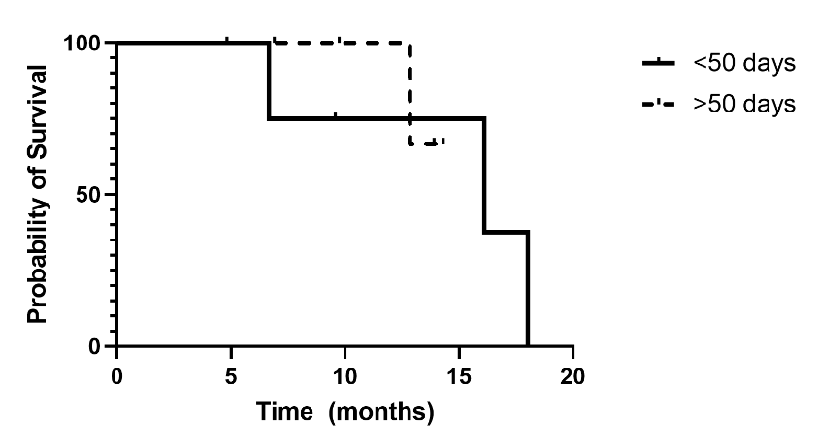
There is no statistically significant difference between early and late initiation in our cohort (p=0.8236).

Supplemental Figure S1B: Survival of only IDH wildtype tumours (n = 8).
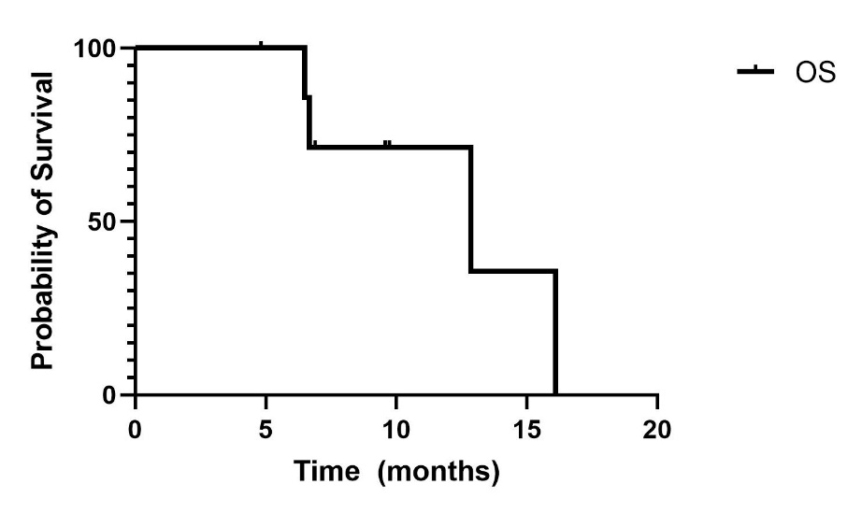
The median overall survival for this subgroup is 12.9 months.

