Supplemental Materials

Supplementary Table 1. Newcastle Ottawa Scale assessments......................................................................................................................................................2

Supplementary Table 2. Meta-regression analyses in prevalence of SAH patients with NPE.......................................................................................................3

Supplementary Table 3. Meta-regression analyses in-hospital mortality of SAH patients with NPE............................................................................................4

Supplemental Fig. 1 Sensitivity analysis of prevalence of NPE in SAH patients..........................................................................................................................5

Supplemental Fig. 2 Sensitivity analysis of in-hospital mortality of NPE in SAH patients...........................................................................................................6

Supplementary Table 1. Results of quality assessment using the Newcastle-Ottawa Scale.
Study | Selection |  |  | Comparability |  | Outcome |  |  | Scores
Study | Representativeness  of the exposed cohort | Selection of the non-exposed cohort | Ascertainment of exposure | Demonstration that outcome of interest was not present at start of study | Comparability of cohorts on the basis of design or analysis | Ascertainment of outcome | Was follow-up long enough for outcome | Adequace of follow-up of cohorts | Scores
Hidenobu OCHIAI, 2001 | ⭐ | ⭐ | ⭐ | ⭐ | ⭐⭐ | ⭐ |  |  | 7
Jonathan A. Friedman, 2003 | ⭐ | ⭐ | ⭐ | ⭐ | ⭐⭐ | ⭐ | ⭐ | ⭐ | 9
Carl Muroi, 2008 | ⭐ | ⭐ | ⭐ | ⭐ | ⭐⭐ | ⭐ |  |  | 7
I-Chang Su, 2009 | ⭐ | ⭐ | ⭐ | ⭐ | ⭐⭐ | ⭐ |  |  | 7
Joji Inamasu, 2012 | ⭐ | ⭐ | ⭐ | ⭐ | ⭐⭐ | ⭐ |  |  | 7
Eija Junttila, 2013 | ⭐ | ⭐ | ⭐ | ⭐ | ⭐⭐ | ⭐ | ⭐ | ⭐ | 9
Etsuko Satoh, 2014 | ⭐ | ⭐ | ⭐ | ⭐ | ⭐⭐ | ⭐ |  |  | 7
Wei-Lung Chen, 2016 | ⭐ | ⭐ | ⭐ | ⭐ | ⭐⭐ | ⭐ |  |  | 7
Wei-Lung Chen, 2016 | ⭐ | ⭐ | ⭐ | ⭐ | ⭐⭐ | ⭐ |  |  | 7
A. Saracen, 2016 | ⭐ | ⭐ | ⭐ | ⭐ | ⭐⭐ | ⭐ |  |  | 7
Limin Zhang, 2016 | ⭐ | ⭐ | ⭐ | ⭐ | ⭐⭐ | ⭐ |  |  | 7
Tijana Nastasovic, 2017 | ⭐ | ⭐ | ⭐ | ⭐ | ⭐⭐ | ⭐ |  |  | 7
Tatsuki Kimura, 2020 | ⭐ | ⭐ | ⭐ | ⭐ | ⭐⭐ | ⭐ |  |  | 7

Supplemental table 2. Results of meta-regression analyses in prevalence of SAH patients with NPE.
Factors | Coefficient | Standard error | P value
Year | 0.015306 | 0.04646 | 0.750
Age | 0.069295 | 0.0449674 | 0.162
Sex | 0.0175573 | 0.0238625 | 0.483
Sample size | -0.0010268 | 0.001264 | 0.440

Supplemental table 3. Results of meta-regression analyses of in-hospital mortality of SAH patients with NPE.
Factors | Coefficient | Standard error | P value
Year | 1.04981 | 0.0216976 | 0.241
Age | 1.006207 | 0.0216976 | 0.290
Sex | 1.018504 | 0.0133983 | 0.258
Sample size | 0.9861297 | 0.0125495 | 0.353

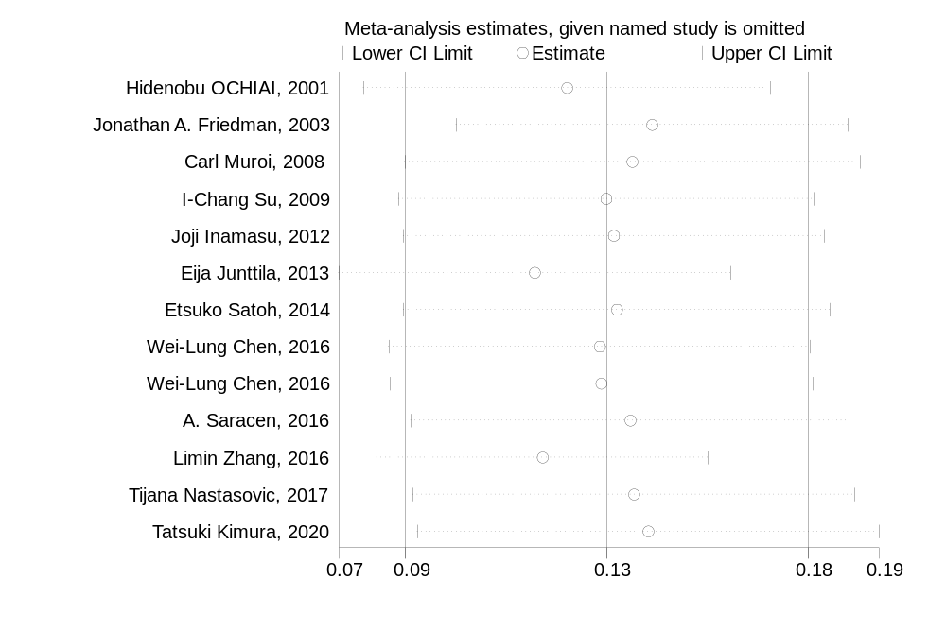
Supplemental Fig. 1 Sensitivity analysis of prevalence of NPE in SAH patients.

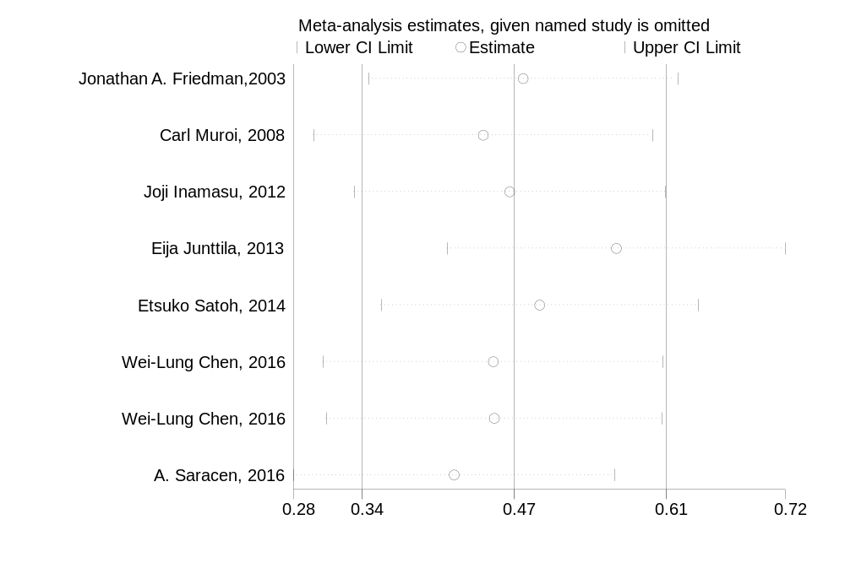
Supplemental Fig. 2 Sensitivity analysis of in-hospital mortality of NPE in SAH patients.

