Laser interstitial thermal therapy versus radiofrequency ablation and stereotactic radiosurgery in the treatment of intractable mesial temporal lobe epilepsy: A systematic review and meta-analysis
Youstina Mohsen¹, Khalid Sarhan², Ibrahim Saleh Alawadi¹, Reem Reda Elmahdi¹, Yasmeena Abdelall Kozaa¹, Menna A. Gomaa¹, Ibrahim Serag², Mostafa Shahein³
¹Mansoura Manchester Program for Medical Education (MMPME), Faculty of Medicine, Mansoura University, Mansoura, Egypt
²Faculty of Medicine, Mansoura University, Mansoura, Egypt
³Department of neurosurgery, Faculty of Medicine, Mansoura University, Egypt

CORRESPONDING AUTHOR:
Youstina Mohsen
Email: youstinamohsen1@std.mans.edu.eg, youstinamosensamir@gmail.com
ORCID: 0000-0002-5949-1794

Submitted to Neurosurgical Review journal

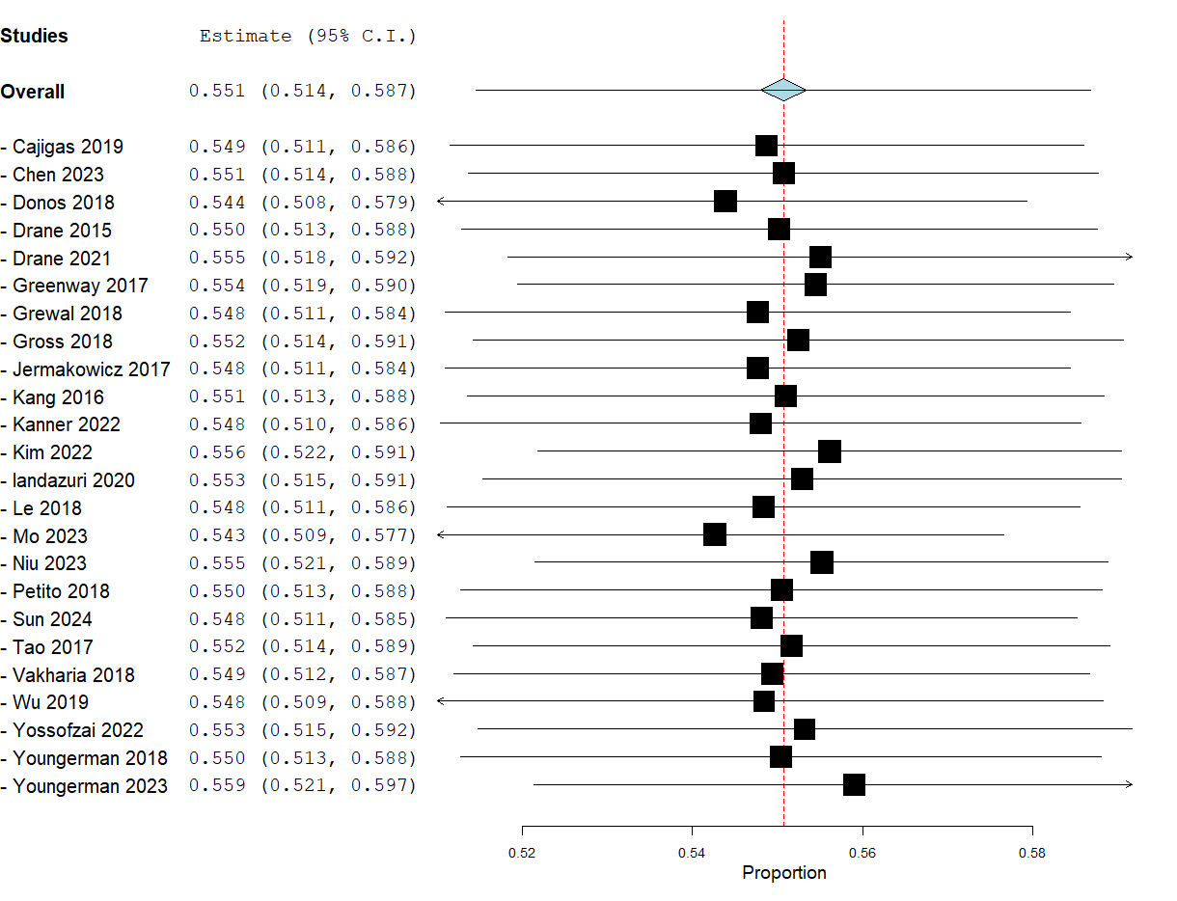
Figures for sensitivity analysis

Figure 1: Engel I outcome for LITT

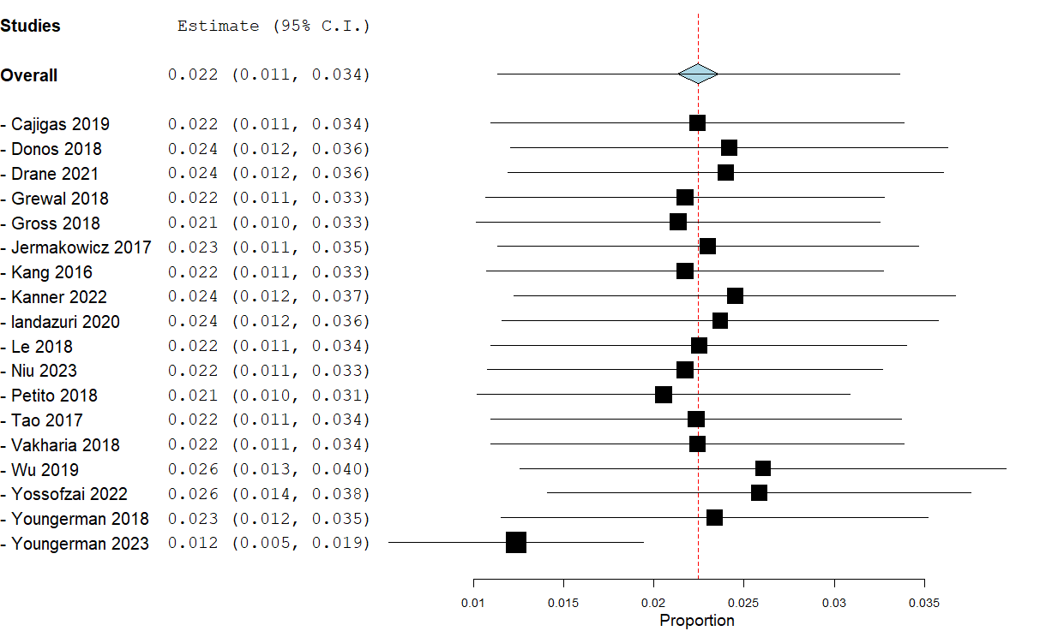

Figure 2: Complications rate for LITT

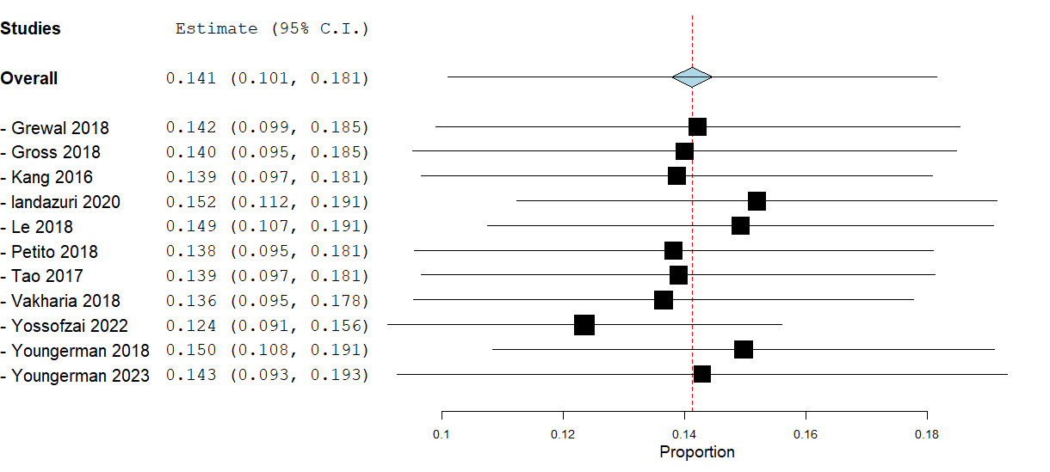

Figure 3: Reoperation rate for LITT

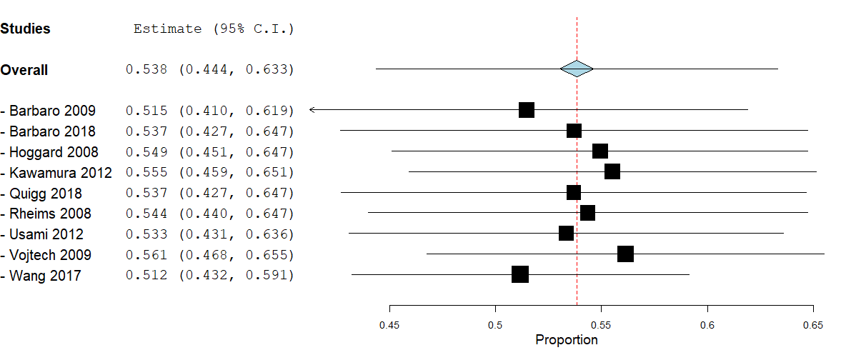

Figure 4: Engel I outcome for SRS
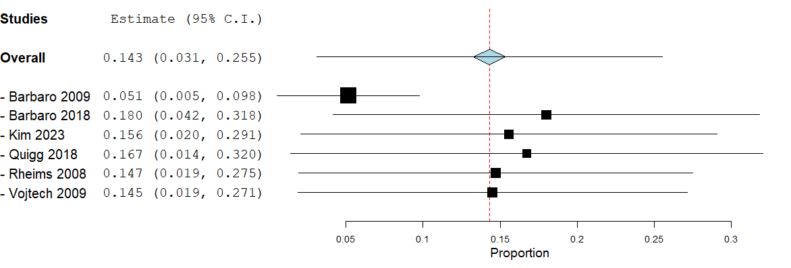

Figure 5: Complications rate for SRS

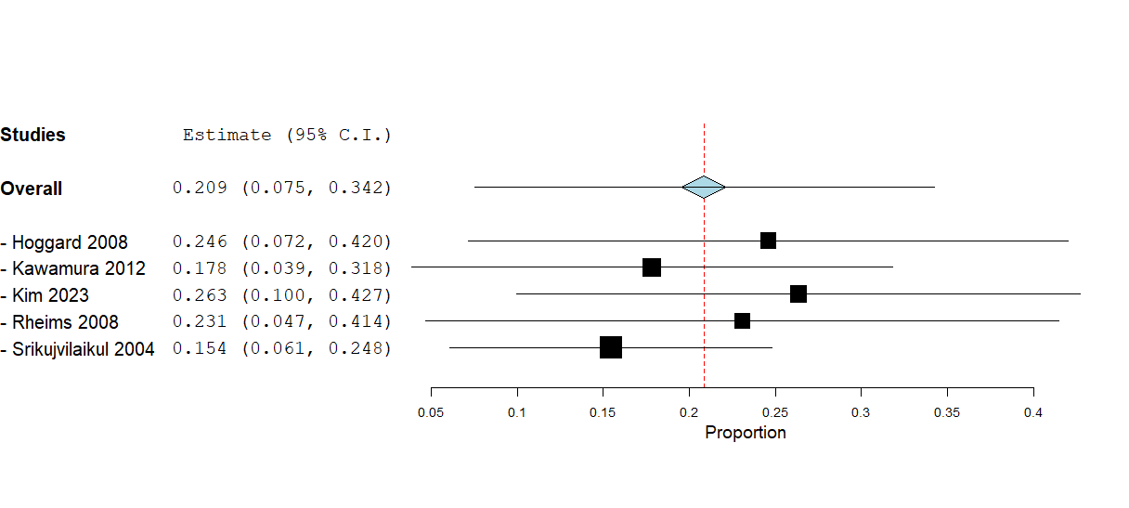

Figure 6: Reoperation rate for SRS

Figure 7: Engel I outcome for RFA

Figure 8: Complications rate for RFA
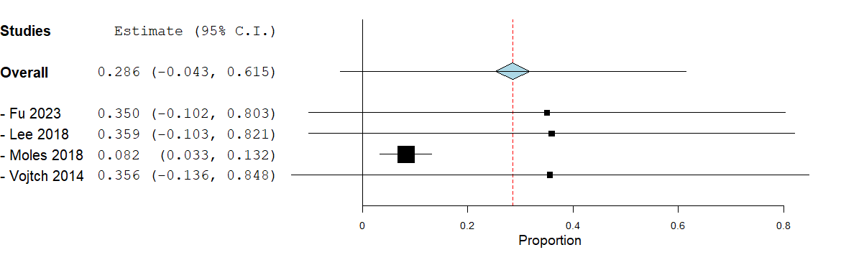

Figure 9: Reoperation rate for RFA

