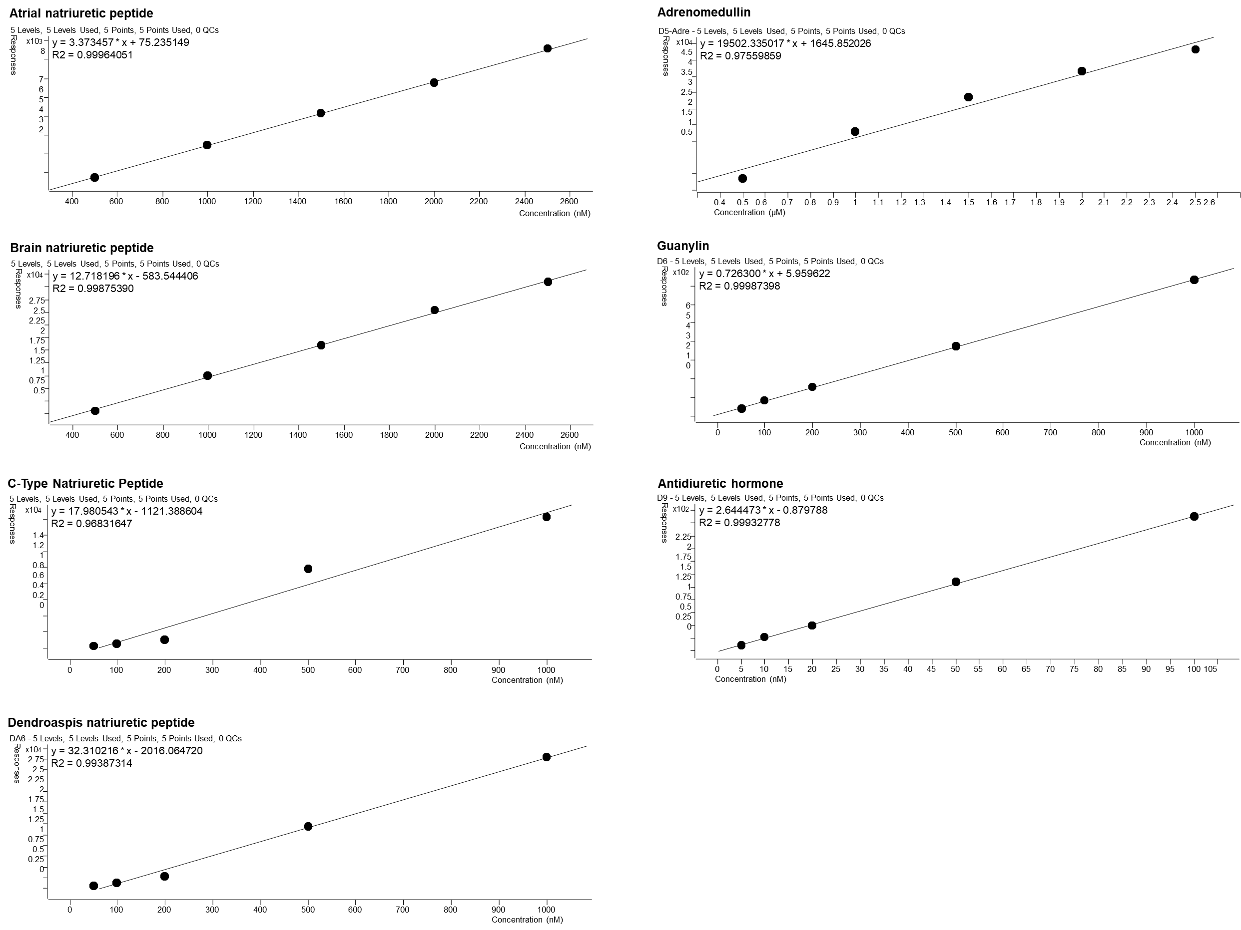
Figure S1. Calibration curves of neuroendocrine hormones standards.
Table S1. Gradient elution program of LC-MS.
Time (min) | H₂O  (0.1% CH3OH) | Acetonitrile  (0.1% CH3OH)
0 | 95 | 5
2 | 95 | 5
15 | 5 | 95
20 | 5 | 95

Table S2. Concentration of neuroendocrine hormones in plasma of patients with supratentorial non-midline tumors.
Patient no. | Group | ANP-T0  （nM） | ANP-T1  （nM） | BNP-T0  （nM） | BNP-T1  （nM） | CNP-T0  （nM） | CNP-T1  （nM） | DNP-T0  （nM） | DNP-T1  （nM） | ADM-T0  （nM） | ADM-T1  （nM） | GN-T0  （nM） | GN-T1  （nM） | ADH-T0  （nM） | ADH-T1  （nM）
1 | NU | 3.8894 | 0.0044 | 3.0929 | 1.9776 | 2.8482 | 2.5836 | 3.7379 | 2.5709 | 0.2321 | 0.00002 | 48.4047 | 2.2010 | 3.9182 | 0.7111
2 | PU | 0.0050 | 0.1181 | 1.9598 | 2.2214 | 2.5962 | 2.7863 | 2.5312 | 2.6120 | 0.0000 | 0.00005 | 0.6019 | 3.5750 | 0.5021 | 2.0719
3 | NU | 0.0055 | 0.0049 | 1.9015 | 1.9475 | 2.5239 | 2.5488 | 2.9176 | 2.7489 | 0.3387 | 0.0011 | 26.2094 | 13.7831 | 0.2890 | 0.4158
4 | NU | 1.4209 | 0.6946 | 2.0659 | 1.9897 | 2.5058 | 2.5253 | 3.0431 | 3.2640 | 0.0010 | 1.2617 | 31.1727 | 47.8069 | 0.2995 | 0.4705
5 | NU | 0.5161 | 0.0061 | 2.1056 | 1.9817 | 2.6154 | 2.5654 | 2.6834 | 2.5921 | 0.0002 | 0.00005 | 8.8674 | 4.0740 | 1.0384 | 0.6188
6 | NU | 0.0037 | 0.0052 | 1.9789 | 2.0171 | 2.5242 | 2.5695 | 2.6085 | 2.6400 | 0.0005 | 0.0005 | 5.1911 | 6.9420 | 0.4513 | 0.6170
7 | NU | 1.1450 | 0.1960 | 2.3001 | 2.0624 | 2.5435 | 2.5555 | 2.9063 | 2.9736 | 0.0011 | 0.0021 | 19.1934 | 27.9039 | 1.4959 | 0.7406
8 | NU | 1.8964 | 3.6944 | 2.1487 | 2.4687 | 2.5698 | 2.5922 | 5.0644 | 3.4618 | 11.9086 | 4.6972 | 142.6585 | 74.9508 | 1.0091 | 3.2962
9 | NU | 5.3275 | 1.5544 | 3.3881 | 2.1115 | 3.4325 | 2.5920 | 5.1150 | 3.0487 | 10.5611 | 0.0015 | 195.7806 | 46.3137 | 3.2181 | 1.2062
10 | NU | 5.8883 | 0.0015 | 3.5226 | 1.8835 | 5.2706 | 2.5695 | 3.6336 | 2.5950 | 3.9506 | 0.0002 | 70.2766 | 6.5674 | 4.6072 | 0.1749
11 | PU | 2.2206 | 3.9929 | 2.6072 | 2.4714 | 2.7729 | 2.5941 | 3.0060 | 2.8255 | 0.0013 | 0.0007 | 35.9531 | 38.4924 | 2.5190 | 3.1135
12 | PU | 9.4257 | 7.3315 | 3.7080 | 4.0745 | 2.7454 | 4.2109 | 2.9695 | 3.5543 | 0.0012 | 1.4299 | 54.7642 | 68.5756 | 6.5892 | 6.0327
13 | NU | 4.7433 | 1.0414 | 4.0947 | 2.1012 | 5.1580 | 2.5901 | 3.7807 | 2.7482 | 4.3095 | 0.0005 | 66.5343 | 14.9151 | 4.4737 | 1.0473
14 | NU | 0.0043 | 0.1832 | 1.8508 | 1.9415 | 2.4951 | 2.5020 | 2.5362 | 2.8182 | 0.0005 | 0.0016 | 3.8280 | 16.9643 | 0.0221 | 0.2374
15 | PU | 7.2265 | 3.1756 | 2.7058 | 2.1479 | 2.7016 | 2.5407 | 3.1549 | 2.7650 | 0.0020 | 0.0008 | 49.1059 | 22.0660 | 4.1499 | 1.8345
16 | NU | 0.8792 | 0.1781 | 2.0838 | 1.9148 | 2.5109 | 2.4984 | 3.1243 | 2.7906 | 0.0020 | 0.0014 | 26.2437 | 15.4672 | 0.3970 | 0.2130
17 | PU | 2.4071 | 2.1635 | 2.2232 | 2.2162 | 2.5840 | 2.5695 | 2.7524 | 2.6825 | 0.0006 | 0.0005 | 20.4963 | 16.5219 | 2.0416 | 1.9679
18 | NU | 0.6955 | 0.0000 | 2.1736 | 2.0399 | 2.6986 | 2.5845 | 2.7091 | 2.7048 | 0.0008 | 0.0006 | 16.0245 | 7.6057 | 1.0840 | 0.8360
19 | NU | 0.0000 | 0.0102 | 1.8375 | 2.0077 | 2.4979 | 2.5868 | 2.5051 | 2.7178 | 0.0002 | 0.0012 | 2.3762 | 11.8376 | 0.0364 | 0.4231
20 | NU | 2.6161 | 1.0794 | 2.4963 | 2.1121 | 2.9512 | 2.6376 | 3.1064 | 2.6716 | 0.1767 | 0.0007 | 48.3851 | 18.0131 | 1.8207 | 1.0390
21 | PU | 4.4821 | 1.8573 | 2.8822 | 2.2955 | 2.6147 | 2.6102 | 3.0519 | 2.7632 | 0.0126 | 0.0007 | 38.2814 | 18.7078 | 2.9371 | 1.5560
22 | NU | 6.1542 | 1.6374 | 3.0809 | 2.1558 | 2.5772 | 2.5460 | 2.7432 | 2.6667 | 0.0006 | 0.0005 | 19.3326 | 10.2882 | 3.1947 | 1.3028
23 | NU | 1.8226 | 0.0000 | 2.6412 | 1.8370 | 2.5841 | 2.5021 | 2.7538 | 2.5387 | 0.0007 | 0.0001 | 14.8590 | 0.8477 | 1.8730 | 0.0208
24 | NU | 0.0000 | 0.7031 | 1.8373 | 1.9589 | 2.4983 | 2.5014 | 2.5049 | 3.0123 | 0.0002 | 0.2177 | 1.0740 | 22.5770 | 0.0262 | 0.3250
25 | NU | 0.0000 | 0.0032 | 1.8395 | 1.8713 | 2.4984 | 2.5018 | 2.5149 | 2.6293 | 0.0003 | 0.0009 | 3.4383 | 5.6411 | 0.0240 | 0.0779
26 | PU | 0.0078 | 3.7030 | 1.9869 | 3.3415 | 2.5744 | 4.6619 | 2.6796 | 3.2452 | 0.0005 | 0.0413 | 7.4120 | 43.2133 | 0.4291 | 2.8908
27 | NU | 2.2720 | 0.0095 | 2.2051 | 1.8803 | 2.5339 | 2.5090 | 3.8178 | 2.6785 | 6.4180 | 0.0010 | 86.4970 | 9.5781 | 1.0764 | 0.2173
28 | PU | 2.1104 | 0.0098 | 2.3663 | 2.0088 | 2.5670 | 2.5279 | 2.6876 | 2.6403 | 0.0004 | 0.0003 | 10.1761 | 6.3918 | 1.6210 | 0.4778
29 | NU | 0.0140 | 0.0118 | 2.1336 | 1.9744 | 2.6270 | 2.5401 | 2.7318 | 2.5810 | 0.0003 | 0.0002 | 7.0900 | 7.2169 | 1.3860 | 0.6035
30 | NU | 0.0078 | 0.4530 | 1.9994 | 2.0186 | 2.5751 | 2.5349 | 2.6143 | 2.6298 | 0.0003 | 0.0002 | 5.2322 | 12.6060 | 0.4889 | 0.8982

