eAppendix

Retreatment Strategy for Aneurysm Recurrence After the Woven EndoBridge (WEB) Treatment: A Comprehensive Systematic Review and Meta-analysis With a Case Illustration

Supplementary SFigures Legend:
SFigure 1. Meta-analysis forest plot for retreated aneurysm location
SFigure 2. Meta-analysis forest plot for immediate adequate occlusion
SFigure 3. Meta-analysis forest plot for last follow-up adequate occlusion
SFigure 4. Forest plot for subgroup analysis of adequate occlusion rate post-operatively
SFigure 5. Forest plot for subgroup analysis of complete occlusion rate at last follow-up
SFigure 6. Forest plot for subgroup analysis of adequate occlusion rate at last follow-up
SFigure 7. Forest plot for subgroup analysis of types of WEB that led to aneurysm recurrence
SFigure 8. Traffic light plot showing the risk of bias of the included studies
SFigure 9. Bar plot showing the risk of bias of the included studies
SFigure 10. Contour-enhanced funnel plot for retreatment rate showing the risk of publication bias of the included studies
SFigure 11. Contour-enhanced funnel plot for initial treatment adequate occlusion at last follow-up showing the risk of publication bias of the included studies

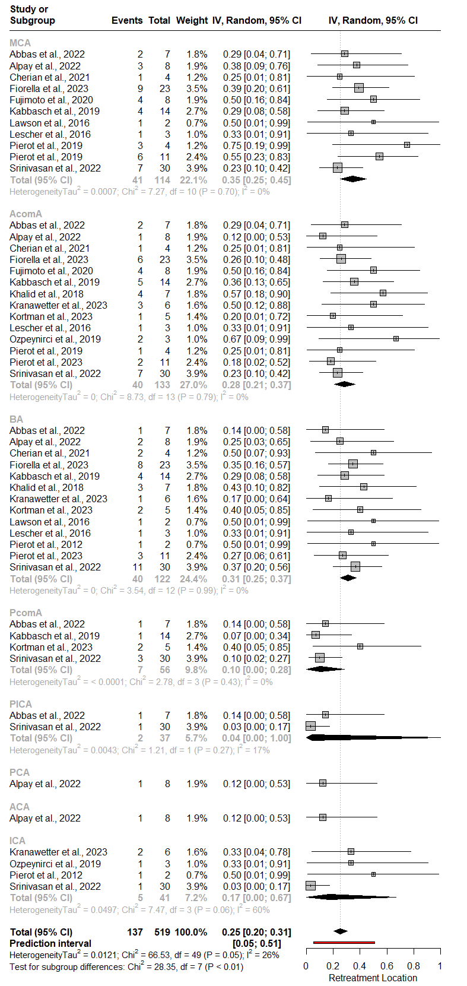
SFigure 1. Meta-analysis forest plot for retreated aneurysm location

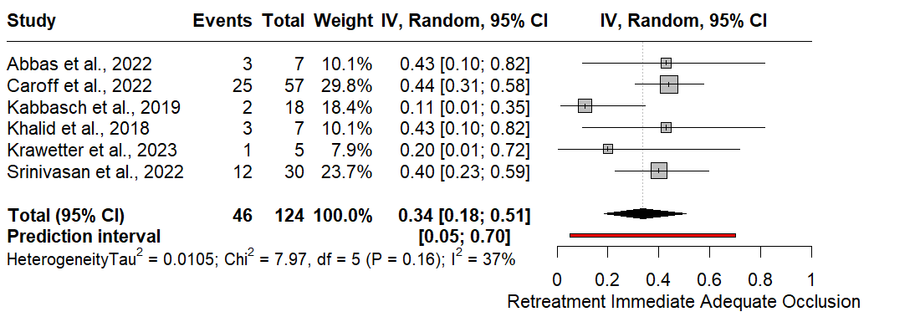
SFigure 2. Meta-analysis forest plot for immediate adequate occlusion

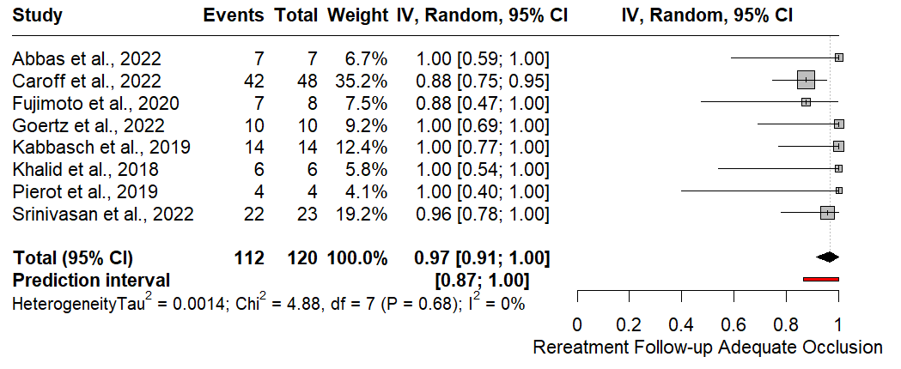
SFigure 3. Meta-analysis forest plot for last follow-up adequate occlusion

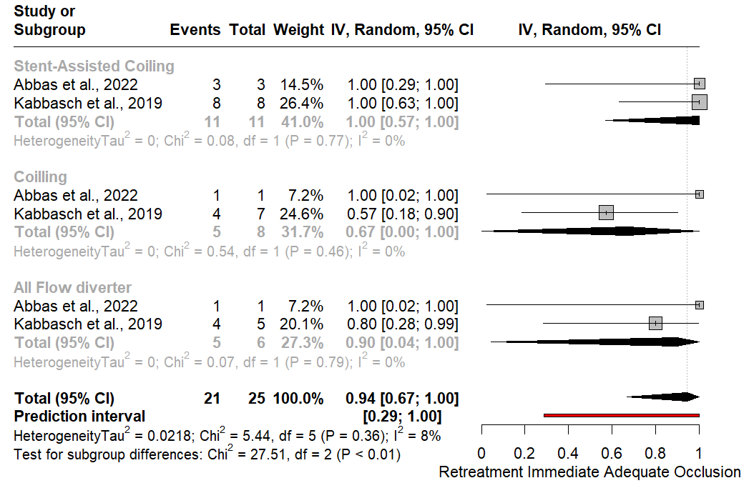
SFigure 4. Forest plot for subgroup analysis of adequate occlusion rate post-operatively

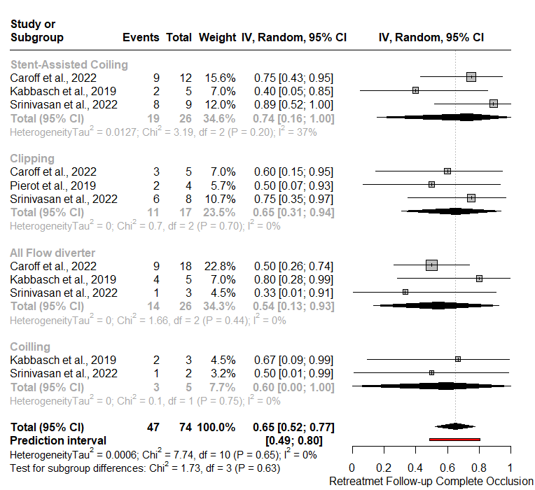
SFigure 5. Forest plot for subgroup analysis of complete occlusion rate at last follow-up

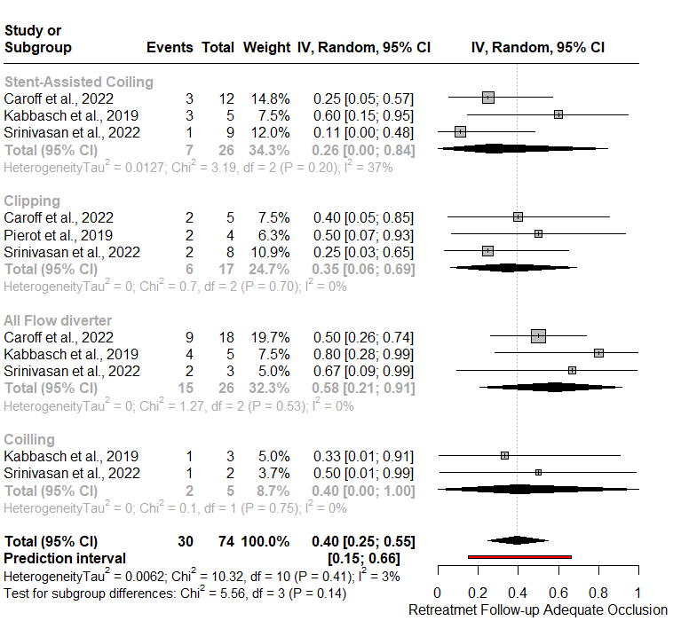
SFigure 6. Forest plot for subgroup analysis of adequate occlusion rate at last follow-up
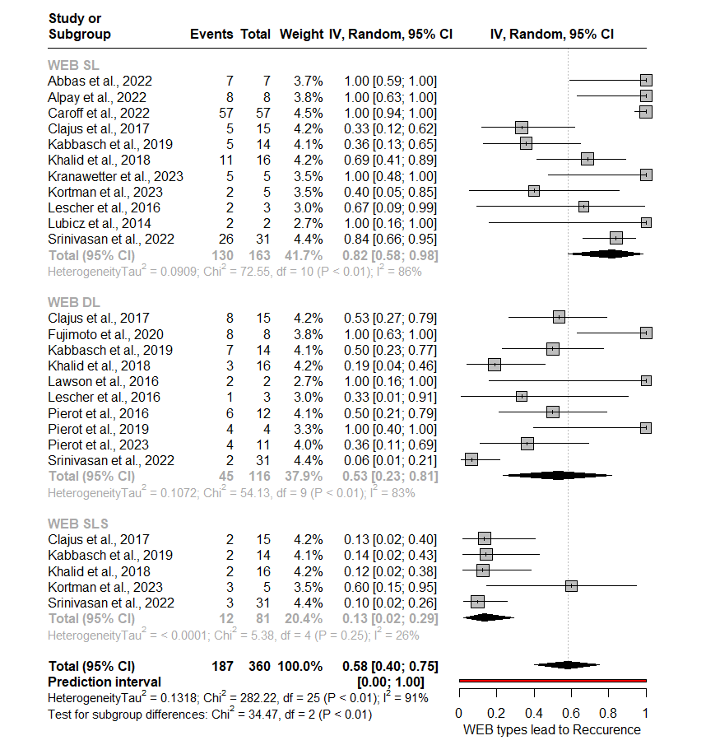

SFigure 7. Forest plot for subgroup analysis of types of WEB that led to aneurysm recurrence

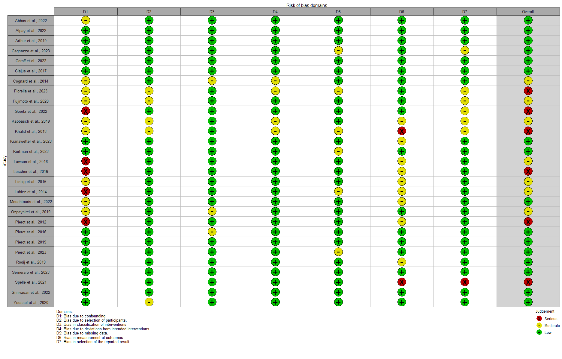 SFigure 8. Traffic light plot showing the risk of bias of the included studies

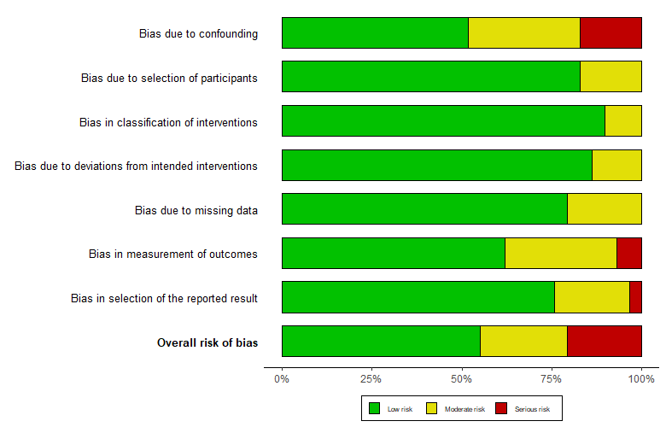
SFigure 9. Bar plot showing the risk of bias of the included studies

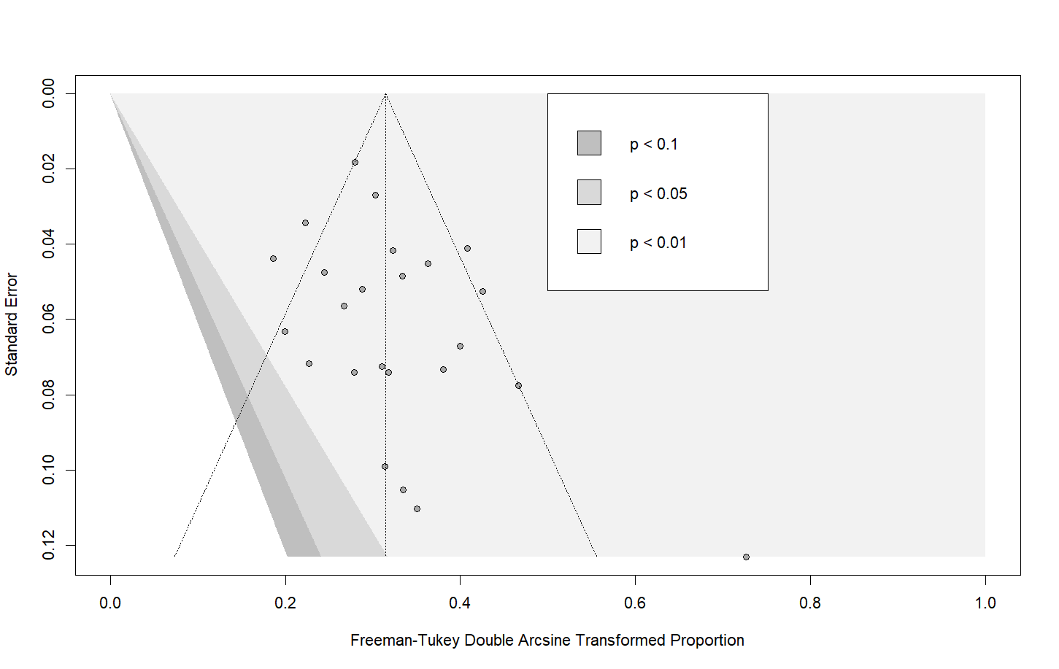
SFigure 10. Contour-enhanced funnel plot for retreatment rate showing the risk of publication bias of the included studies

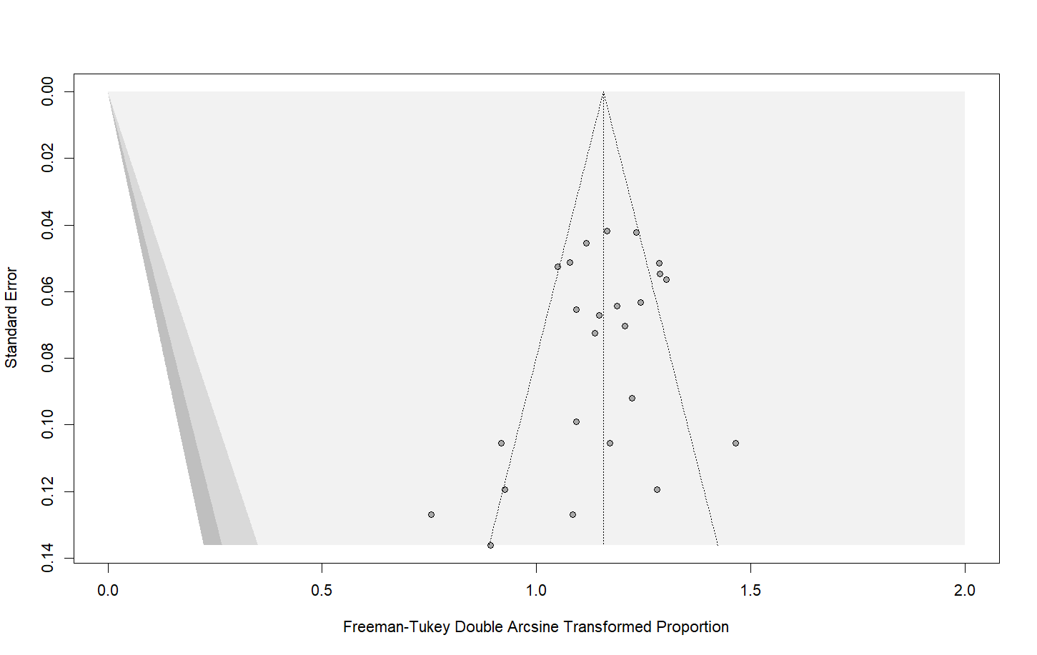
SFigure 11. Contour-enhanced funnel plot for initial treatment adequate occlusion at last follow-up showing the risk of publication bias of the included studies

STable 1. Search strategy for selection of the studies
Search | Database | Query | Date | Results | Duplicate | Excluded | Included
1 | Expert Recommendation and References search |  | May 16, 2024 | 0 | 0 | 0 | 0
2 | PubMed | (((("aneurysm*"[Title/Abstract]) OR ("Intracranial aneurysm*"[Title/Abstract])) OR ("brain aneurysm*"[Title/Abstract])) OR ("cerebral aneurysm*"[Title/Abstract])) AND ("Woven Endobridge"[Title/Abstract]) OR ("WEB"[Title/Abstract]) AND (("retreatment"[Title/Abstract]) OR ("re-treatment"[Title/Abstract])) OR ("recurrence"[Title/Abstract]) | May 16, 2024 | 130 | 12 | 110 | 8
3 | Web of Science | ((((TS=("aneurysm*")) OR TS=("Intracranial aneurysm*")) OR TS=("brain aneurysm*")) OR TS=("cerebral aneurysm*") )AND ((TS=("retreatment")) OR TS=("re-treatment")) OR TS=("recurrence") AND (TS=(Woven Endobridge )) OR TS=("WEB") | May 16, 2024 | 136 | 18 | 109 | 9
4 | Scopus | ( TITLE-ABS-KEY ( "aneurysm*" ) OR TITLE-ABS-KEY ( "Intracranial aneurysm*" ) OR TITLE-ABS-KEY ( "brain aneurysm*" ) OR TITLE-ABS-KEY ( "cerebral aneurysm*" ) ) AND ( TITLE-ABS-KEY ( "Woven Endobridge" ) OR TITLE-ABS-KEY ( "WEB" ) ) AND ( TITLE-ABS-KEY ( "retreatment" ) OR TITLE-ABS-KEY ( "re-treatment" ) OR TITLE-ABS-KEY ( "recurrence" ) ) | May 16, 2024 | 185 | 13 | 162 | 10
TOTAL |  |  |  | 451 | 43 | 384 | 24

