Supplementary Materials

Clinical, neuroradiological and pathological features of the tumour

Early postoperative MRI was routinely performed within 48 hours of surgery to assess the extent of tumour resection – near total (NTR) or subtotal (STR) if the tumour removal was greater or lesser than 95%, respectively [20] – and postoperative contrast enhancement of surgical cavity classified as “absent”, “linear” or “nodular”.
Tumour volumes were assessed on T1-weighted contrast enhanced volumetric images, retrieved from the institution’s digital archive system and stored as DICOM files. The imaging analysis was carried out using OsiriX MD (Osirix MD 9.0®, Pixmeo, Swiss). Tumour volume, expressed in cubic centimetres (cc), was computed with the Region of Interest (ROI) methodology. Tumour and postoperative pathologic enhancement of surgical cavity were segmented on axial images, then multiplied by the slice thickness through the software [20, 31, 32].

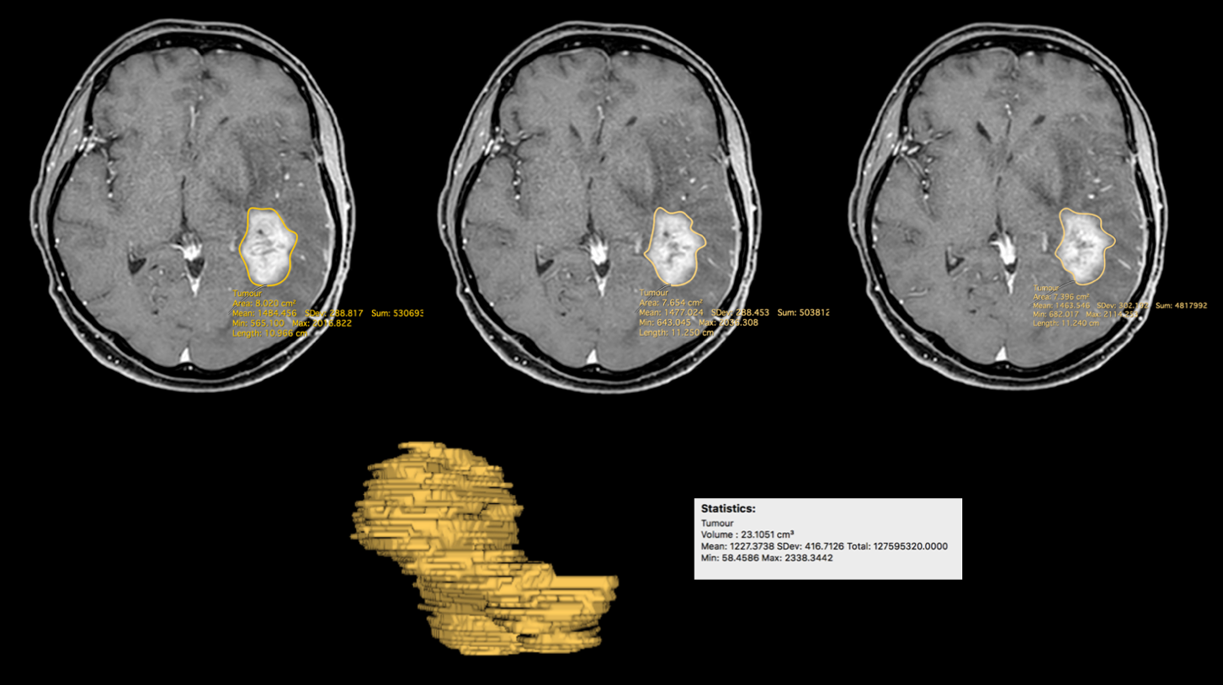
Figure 1S – Preoperative tumour volume computation by Osirix (Osirix MD 9.0®, Pixmeo, Swiss).

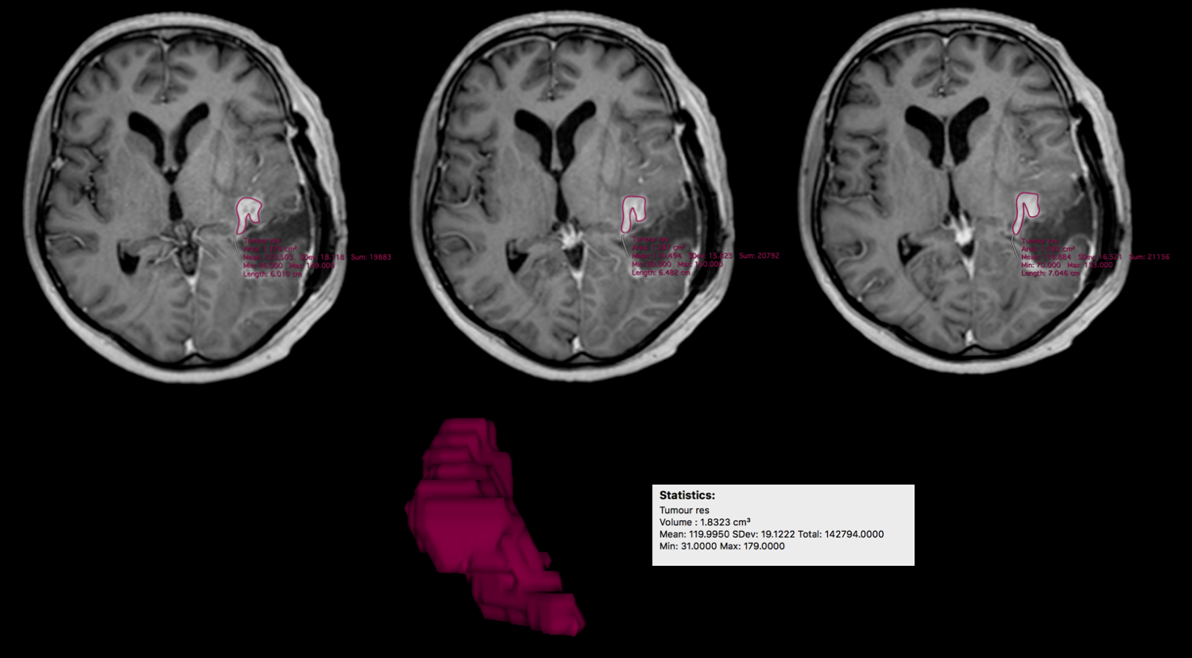
Figure 2S – Postoperative residual tumour volume computation by Osirix (Osirix MD 9.0®, Pixmeo, Swiss).

The percentage of tumour resection was computed according to the formula:

$$\frac{\left(preoperative tumour volume-postoperative tumour remnant volume\right)}{preoperative tumour volume} × 100$$

The histological diagnosis followed the fifth edition of the WHO Classification of Tumours of the CNS [24, 45]. In particular, for the molecular characteristics of the tumour, a Real Time PCR was performed on the platform RT800-96 (EasyPGX® qPCR instrument 96, Diatech Pharmacogenetics SRL, Jesi, Italy) to detect mutations on IDH1 (codon 105: G105G; codon 132: R132H, R132C, and R132S/G/L/I/V) and IDH2 (codon 140: R140G/W/Q/L; codon 172: R172K and R172G/W/T/M/S) [33].
Further, the O⁶-methylguanine methyltransferase (MGMT) promoter methylation status was assessed by pyrosequencing (Pyromark Q961.D, kit MGMT plus, Diatech Pharmacogenetics SRL; Jesi, Italy). According to the percentage of MGMT promoter methylation status, tumours were grouped in un-methylated (< 9%), and methylated (methylated 9-29% and hyper-methylated > 29%) [4].

