Supplementary Results

Table 1 – Comparison of miR-21-5p, miR-23b-3p and miR-34a-5p plasmatic concentrations at diagnosis with patients’ clinical features (23 patients).

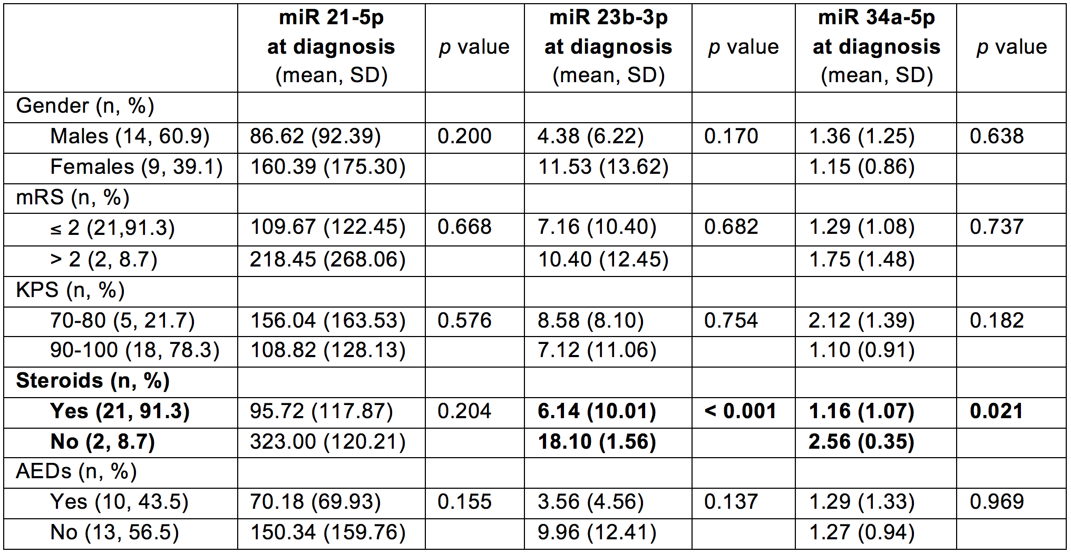
AEDs: anti-epileptic drugs; KPS: Karnofsky Performance Status; mRS: modified Ranking Score.

Table 2 – Comparison of miR-21-5p, miR-23b-3p and miR-34a-5p plasmatic concentrations at diagnosis with histological and radiological tumour’ features (23 patients).

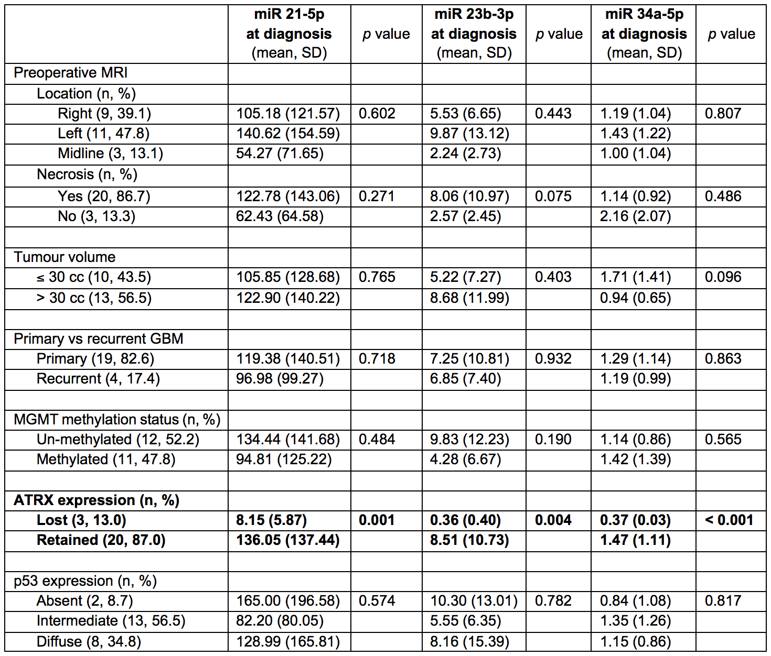
ATRX: alpha thalassemia/mental retardation syndrome X-linked; MGMT: O-6-methylguanine-DNA-methyltransferase.

Table 3 – Correlation analysis between miR-21-5p, miR-23b-3p and miR-34a-5p plasmatic concentrations at diagnosis and clinical, neuroradiological and pathological features.

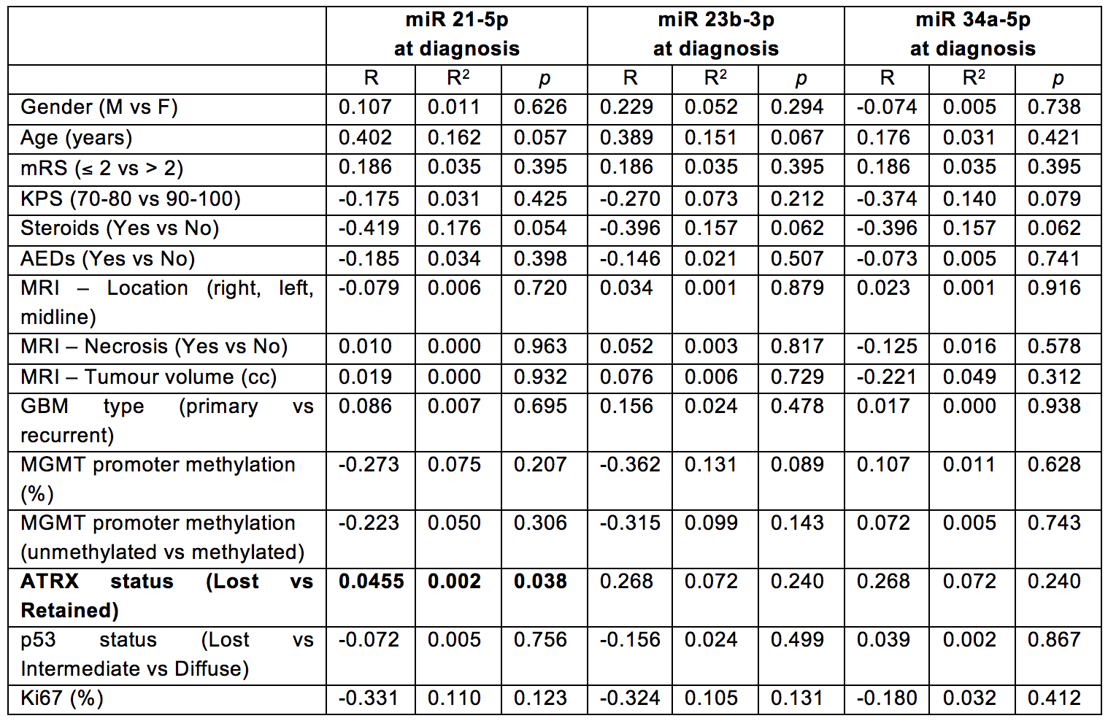
AEDs: anti-epileptic drugs; ATRX: alpha thalassemia/mental retardation syndrome X-linked; KPS: Karnofsky Performance Status; mRS: modified Ranking Score; MGMT: O-6-methylguanine-DNA-methyltransferase.

Table 4 – Multivariate linear regression analysis between miR-21-5p plasmatic concentrations at diagnosis and clinical, pathological and neuroradiological features.

ANOVA: R 0.768; R² 0.589; F 0.836; p value 0.626.
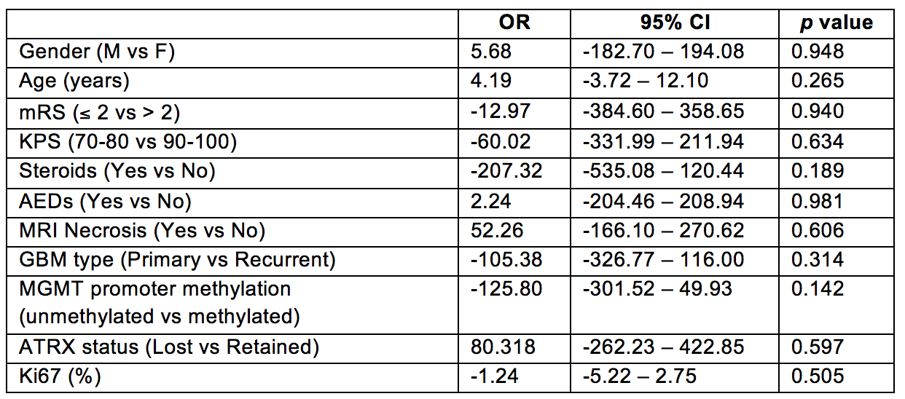
AEDs: anti-epileptic drugs; ATRX: alpha thalassemia/mental retardation syndrome X-linked; KPS: Karnofsky Performance Status; mRS: modified Ranking Score; MGMT: O-6-methylguanine-DNA-methyltransferase; OR: odd ratio.

Table 5 – Multivariate linear regression analysis between miR-23b-3p plasmatic concentrations at diagnosis and clinical, pathological and neuroradiological features.

ANOVA: R 0.724; R² 0.525; adjusted R² -0.290; F 0.644; p value 0.760.
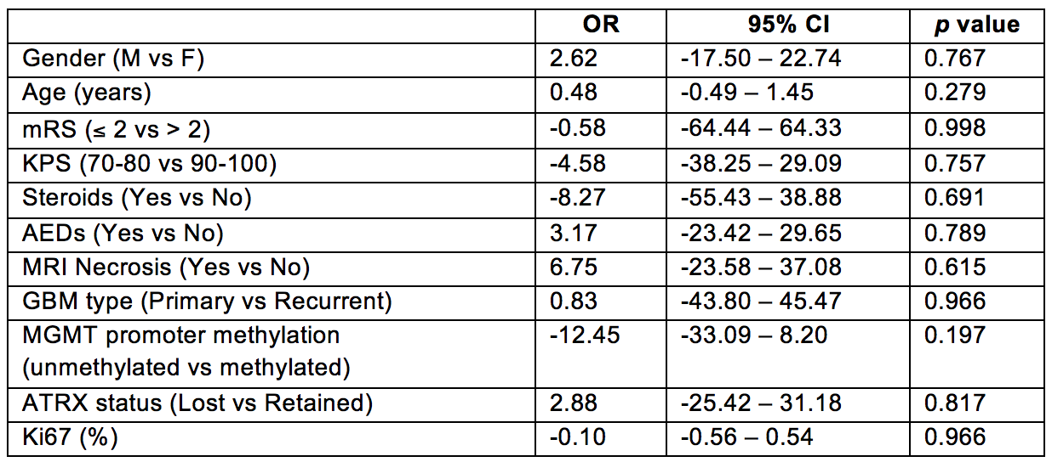
AEDs: anti-epileptic drugs; ATRX: alpha thalassemia/mental retardation syndrome X-linked; KPS: Karnofsky Performance Status; mRS: modified Ranking Score; MGMT: O-6-methylguanine-DNA-methyltransferase; OR: odd ratio.

Table 6 – Multivariate linear regression analysis between miR-34a-5p plasmatic concentrations at diagnosis and clinical, pathological and neuroradiological features.

ANOVA: R 0.881; R² 0.776; adjusted R² 0.392; F 2.022; p value 0.179.
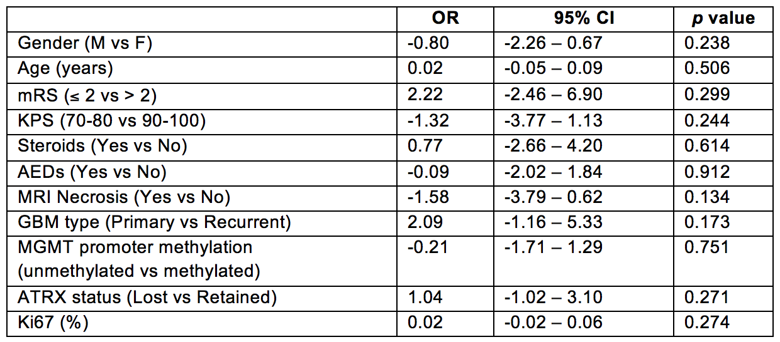
AEDs: anti-epileptic drugs; ATRX: alpha thalassemia/mental retardation syndrome X-linked; KPS: Karnofsky Performance Status; mRS: modified Ranking Score; MGMT: O-6-methylguanine-DNA-methyltransferase; OR: odd ratio.

Table 7 – Comparison of miR-21-5p, miR-23b-3p and miR-34a-5p plasmatic concentrations 1 month after surgery (FU1) according to extent of tumour resection (16 patients).

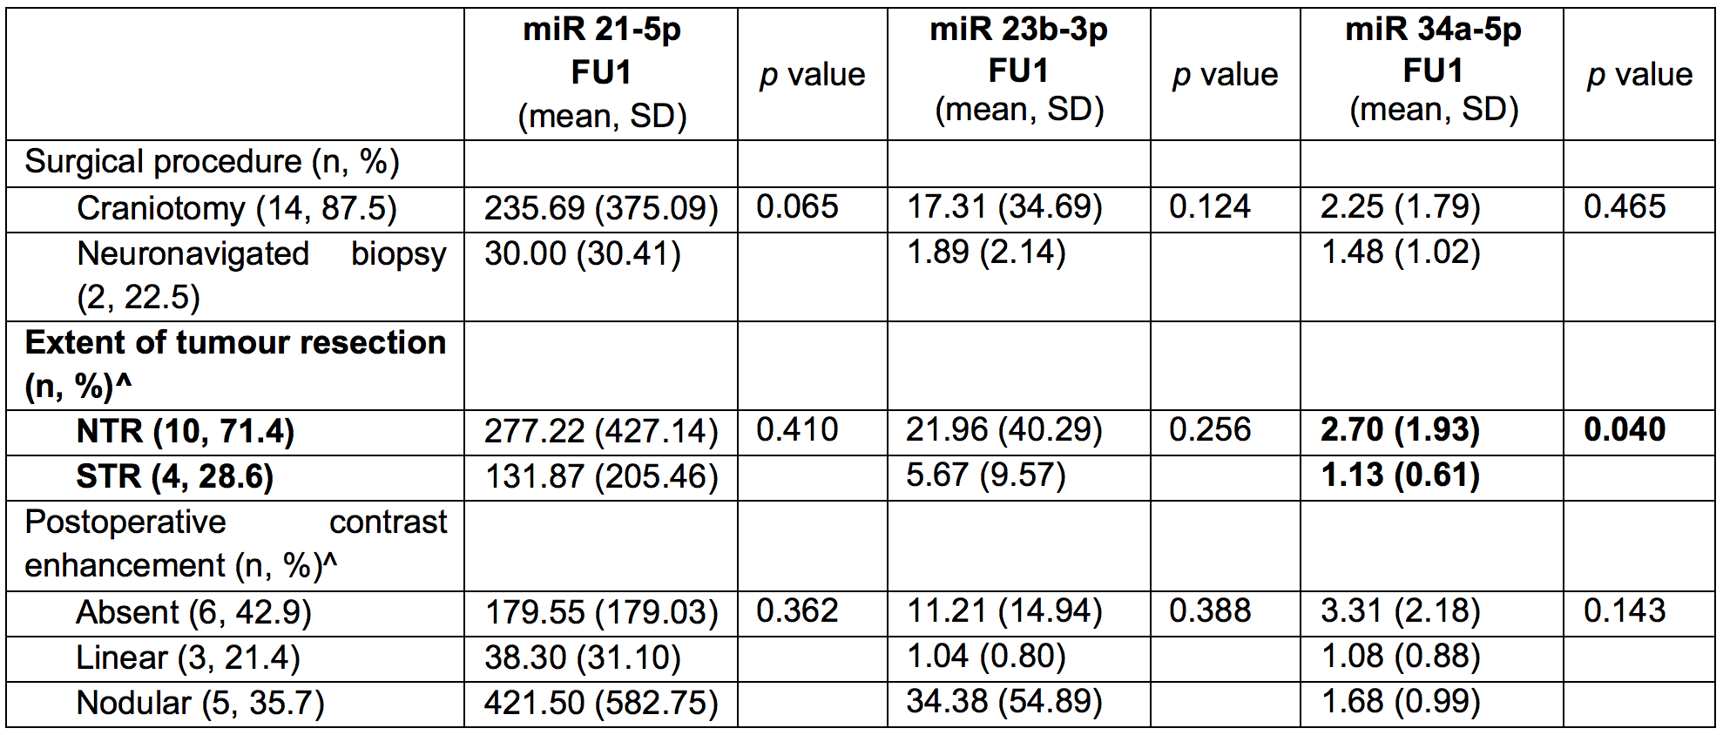

NTR: near total resection; STR: subtotal resection.

^ Extent of resection data analysed on 14 patients who underwent craniotomy.

Table 8 – Comparison of miR-21-5p, miR-23b-3p and miR-34a-5p plasmatic concentrations 3 months after surgery (FU3) according to extent of tumour resection and adjuvant therapies (8 patients).

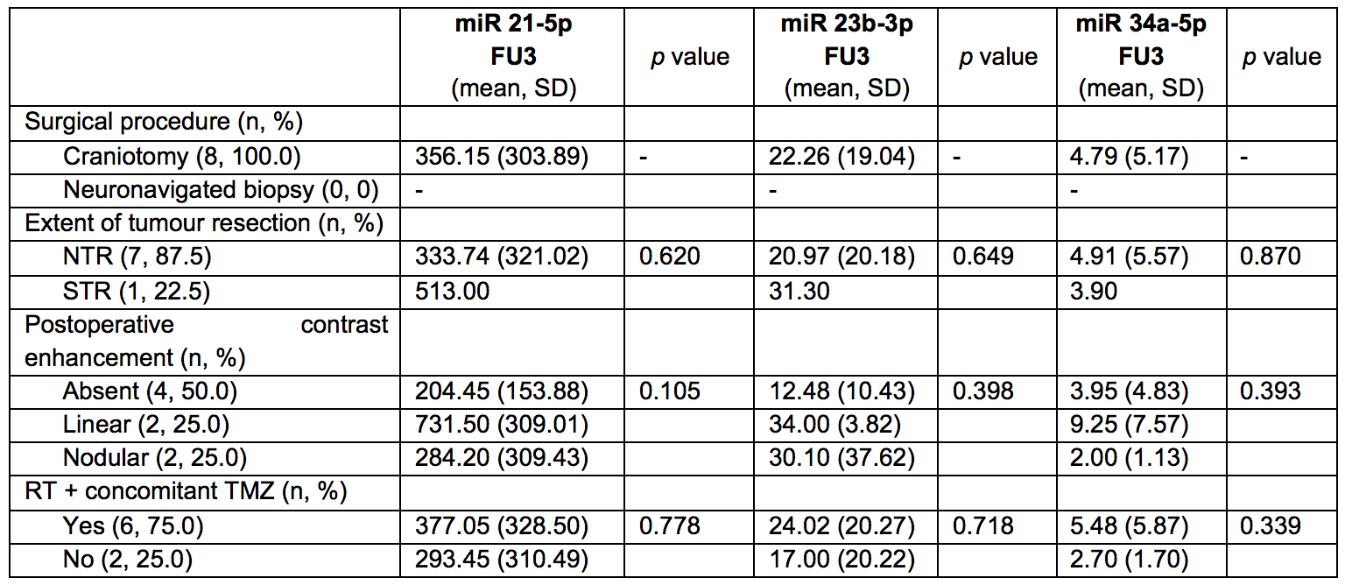
NTR: near total resection; RT: radiotherapy; STR: subtotal resection; TMZ: temozolomide.

Table 9 – Comparison of miR-21-5p, miR-23b-3p and miR-34a-5p plasmatic concentrations 6 months after surgery (FU6) according to extent of tumour resection and adjuvant therapies (9 patients).

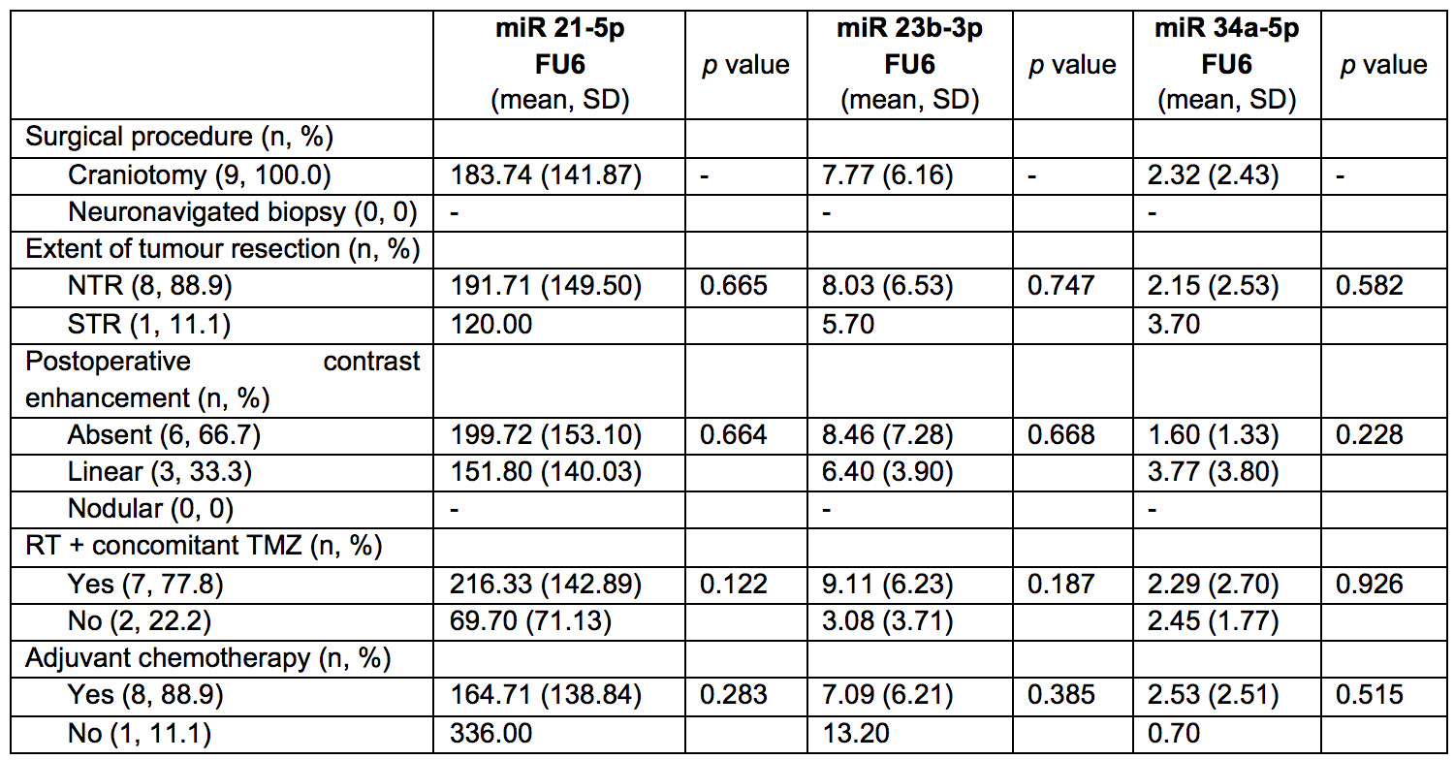
NTR: near total resection; RT: radiotherapy; STR: subtotal resection; TMZ: temozolomide.

Table 10 – Comparison of miR-21-5p, miR-23b-3p and miR-34a-5p plasmatic concentrations 12 months after surgery (FU12) according to extent of tumour resection and adjuvant therapies (5 patients).

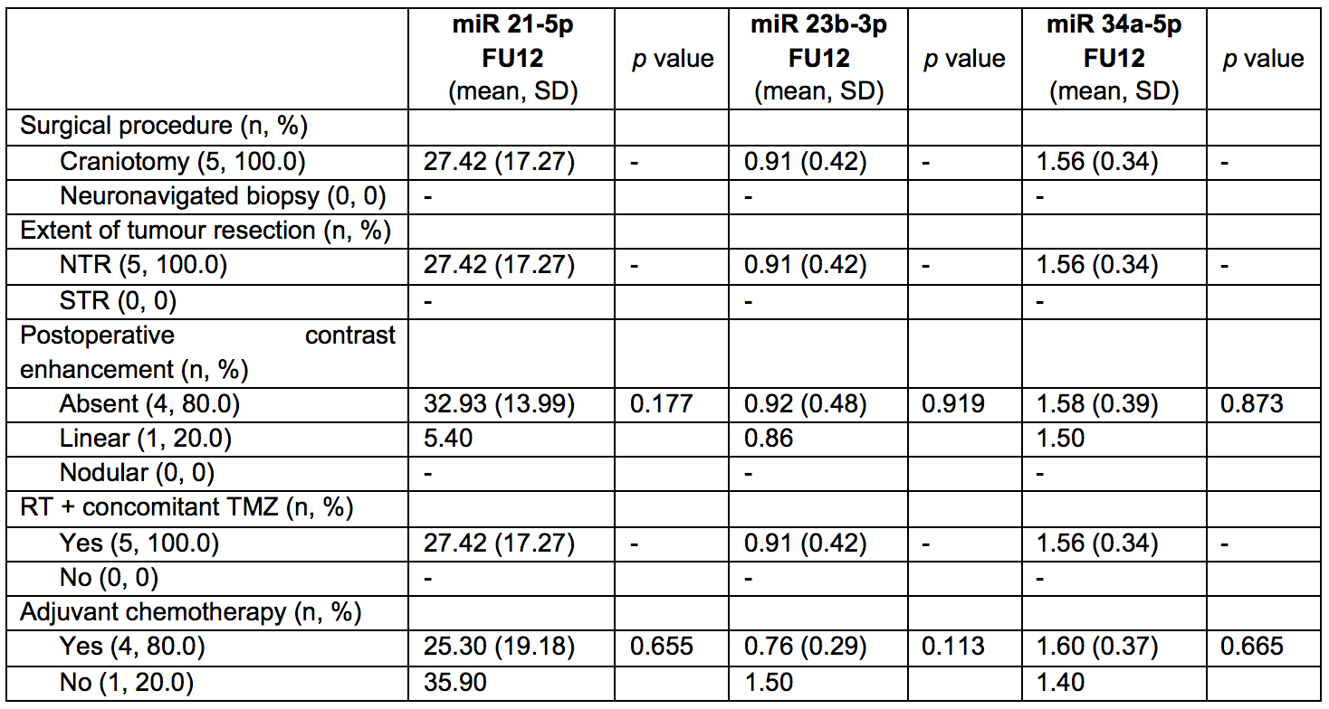
NTR: near total resection; RT: radiotherapy; STR: subtotal resection; TMZ: temozolomide.

Table 11 – Correlation analysis between miR-21-5p, miR-23b-3p and miR-34a-5p plasmatic concentrations 1 month after surgery (FU1) and extent of tumour resection.

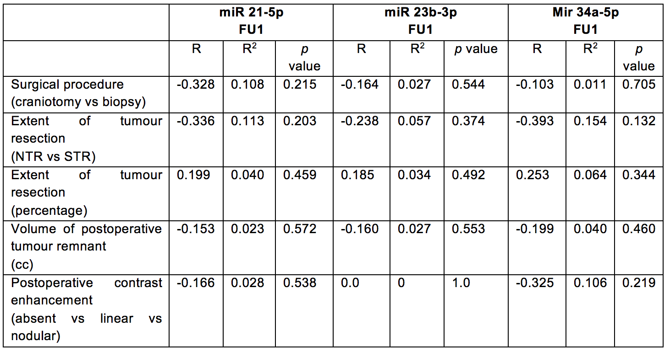
NTR: near total resection; STR: subtotal resection.

Table 12 – Correlation analysis between miR-21-5p, miR-23b-3p and miR-34a-5p plasmatic concentrations 3 months after surgery (FU3), extent of tumour resection and postoperative concomitant RT and chemotherapy.

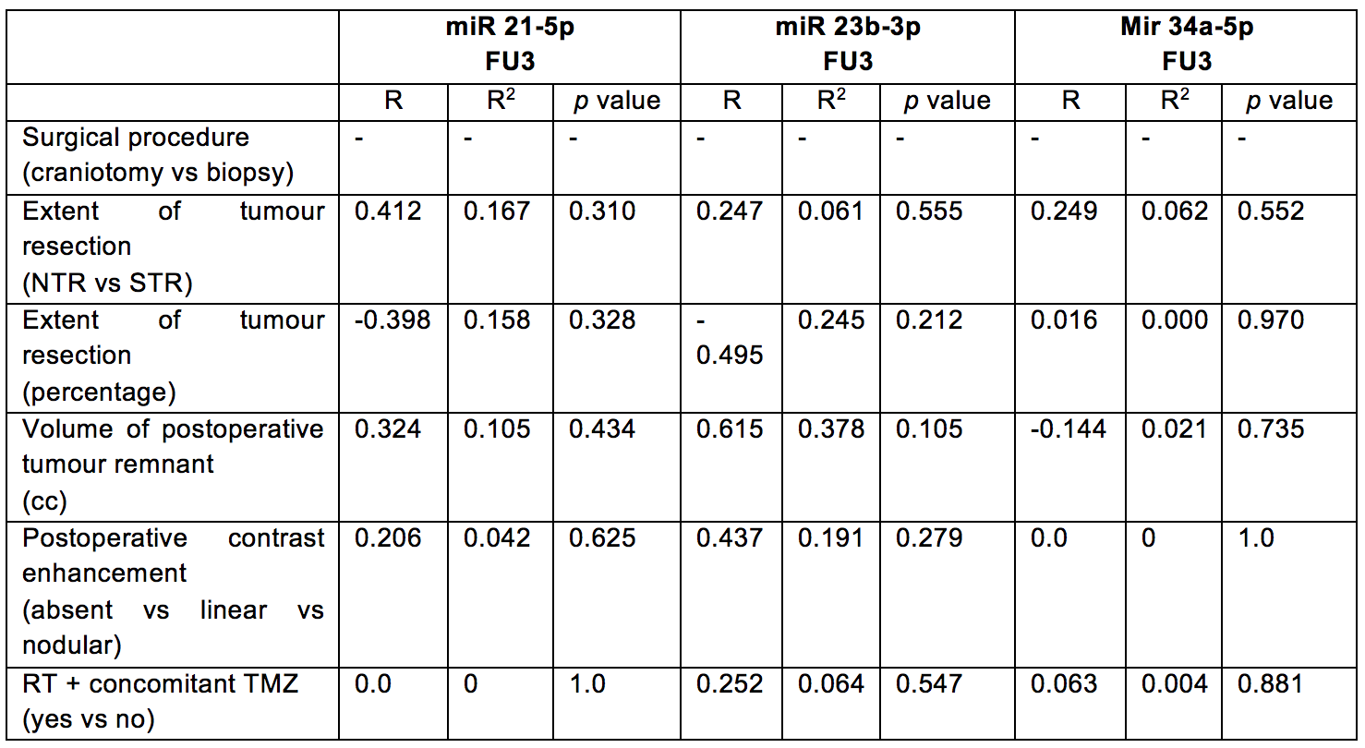
NTR: near total resection; RT: radiotherapy; STR: subtotal resection; TMZ: temozolomide.

Table 13 – Correlation analysis between miR-21-5p, miR-23b-3p and miR-34a-5p plasmatic concentrations 6 months after surgery (FU6), extent of tumour resection, postoperative concomitant RT and chemotherapy and adjuvant chemotherapy.

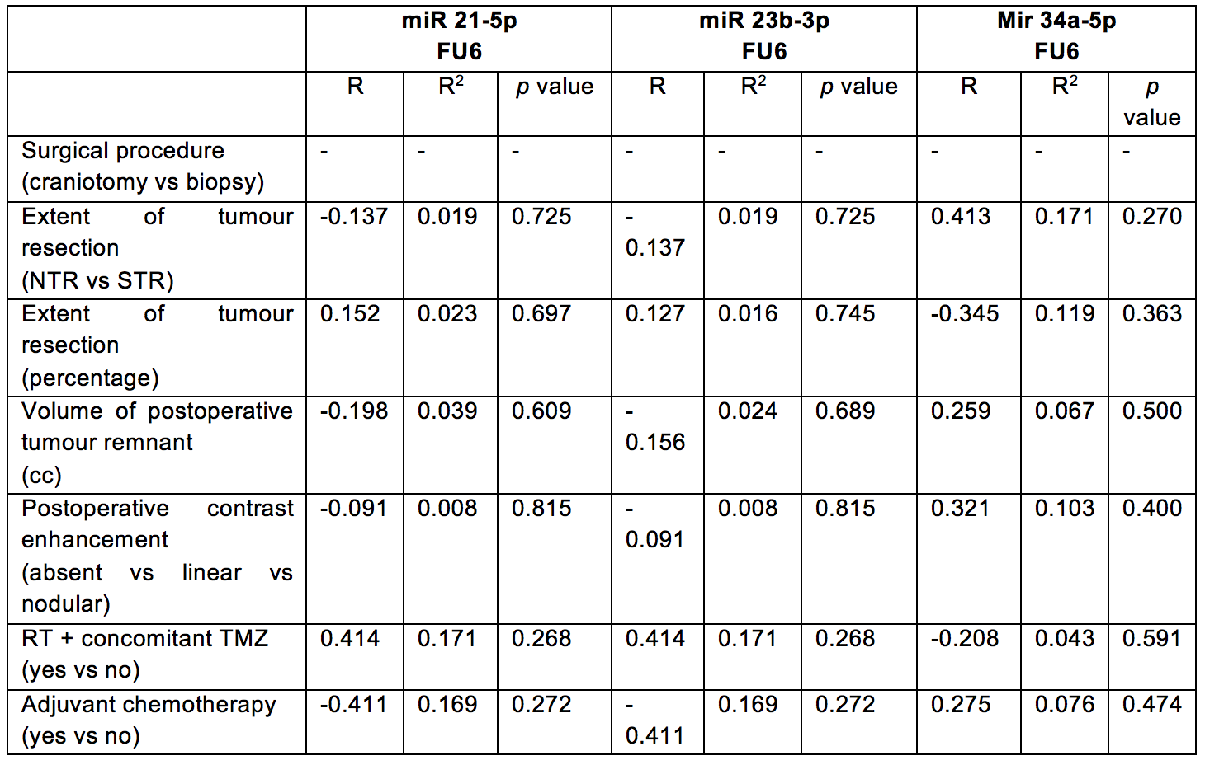
NTR: near total resection; RT: radiotherapy; STR: subtotal resection; TMZ: temozolomide.

Table 14 – Correlation analysis between miR-21-5p, miR-23b-3p and miR-34a-5p plasmatic concentrations 12 months after surgery (FU12), extent of tumour resection, postoperative concomitant RT and chemotherapy and adjuvant chemotherapy.

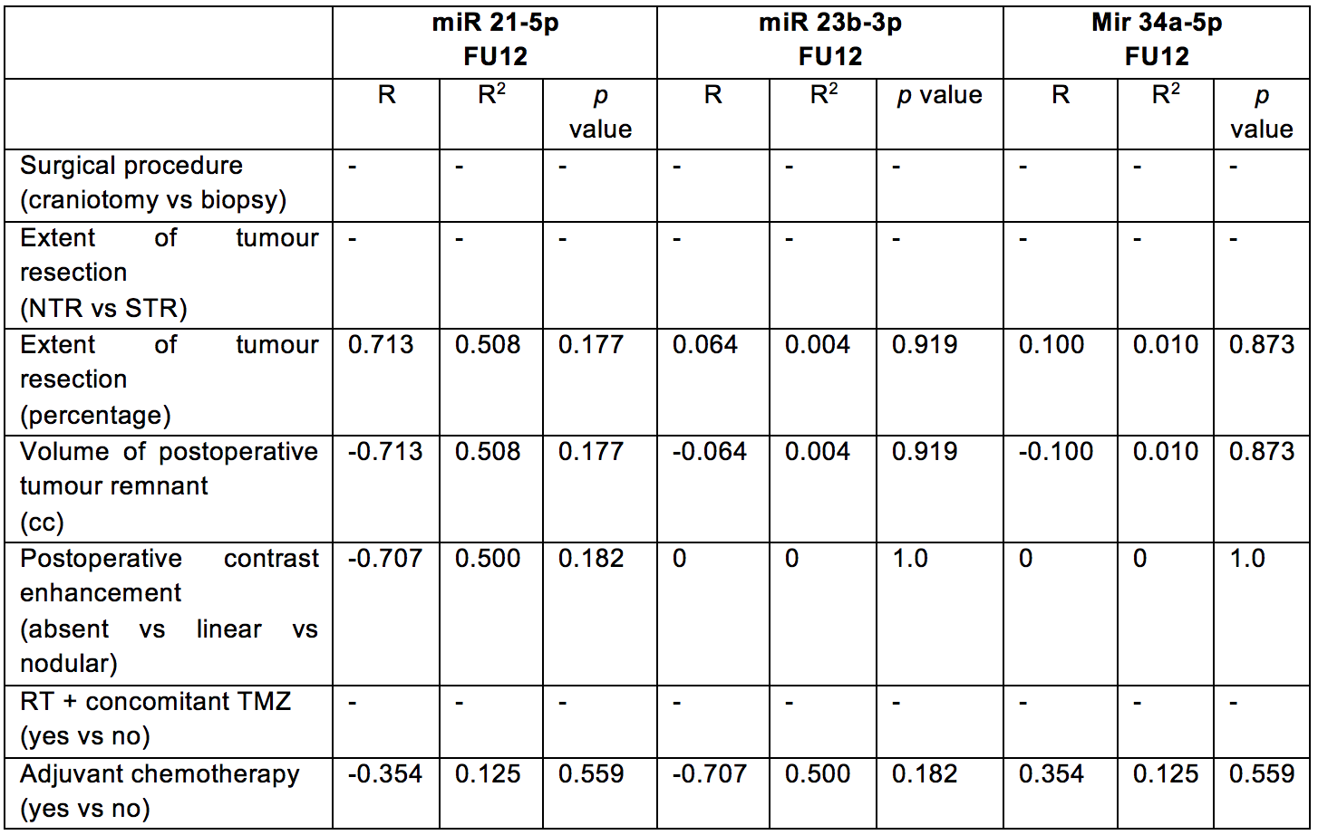
NTR: near total resection; RT: radiotherapy; STR: subtotal resection; TMZ: temozolomide.

Table 15 – Multivariate linear regression analysis between miR-21-5p plasmatic concentrations 1 (FU1), 3 (FU3), 6 (FU6) and 12 months (FU12) after surgery, extent of tumour resection, postoperative concomitant RT and chemotherapy and adjuvant chemotherapy.

FU1: ANOVA: R 0.600; R² 0.360; adjusted R² 0.040; F 1.125; p value 0.407.
FU3: ANOVA: R 0.962; R² 0.925; adjusted R² 0.738; F 4.952; p value 0.177.
FU6: ANOVA: R 0.770; R² 0.592; adjusted R² -0.087; F 0.872; p value 0.584.
FU12: ANOVA: R 0.719; R² 0.518; adjusted R² 0.035; F 1.073; p value 0.482.

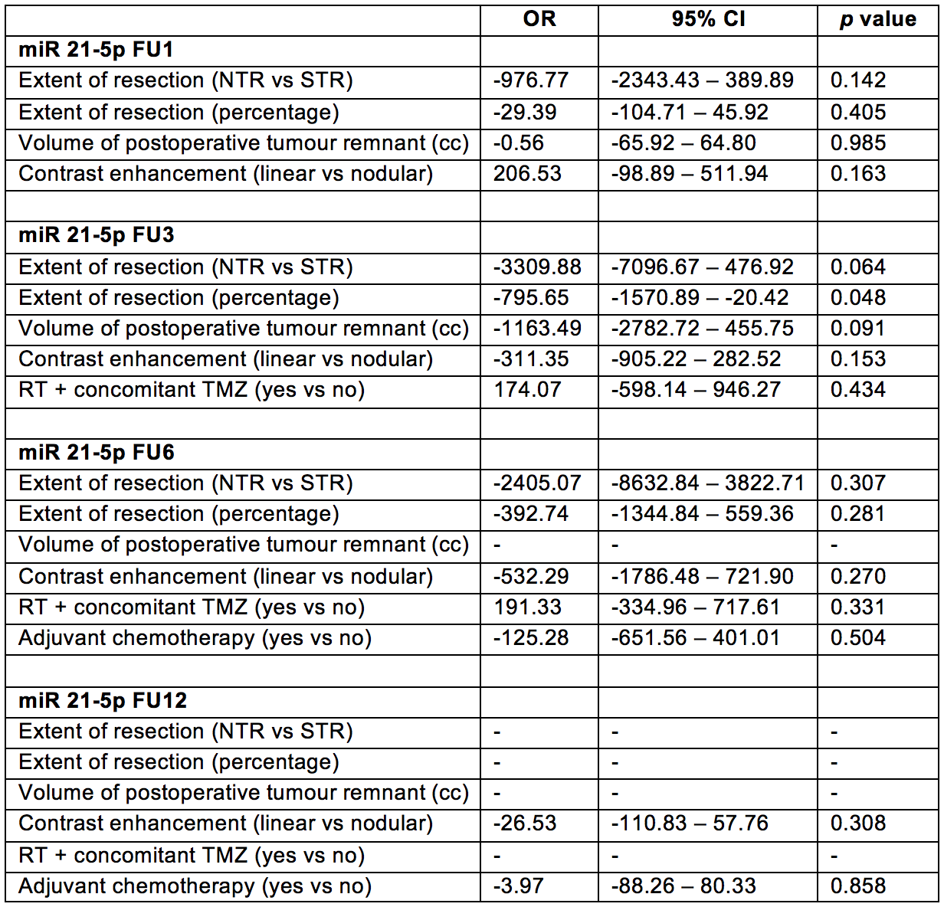
NTR: near total resection; RT: radiotherapy; STR: subtotal resection; TMZ: temozolomide.

Table 16 – Multivariate linear regression analysis between miR-23b-3p plasmatic concentrations 1 (FU1), 3 (FU3), 6 (FU6) and 12 months (FU12) after surgery, extent of tumour resection, postoperative concomitant RT and chemotherapy and adjuvant chemotherapy.

FU1: ANOVA: R 0.587; R² 0.345; adjusted R² 0.107; F 1.448; p value 0.283.
FU3: ANOVA: R 0.960; R² 0.922; adjusted R² 0.725; F 4.696; p value 0.185.
FU6: ANOVA: R 0.650; R² 0.422; adjusted R² -0.542; F 0.438; p value 0.804.
FU12: ANOVA: R 0.800; R² 0.640; adjusted R² 0.280; F 1.777; p value 0.360.

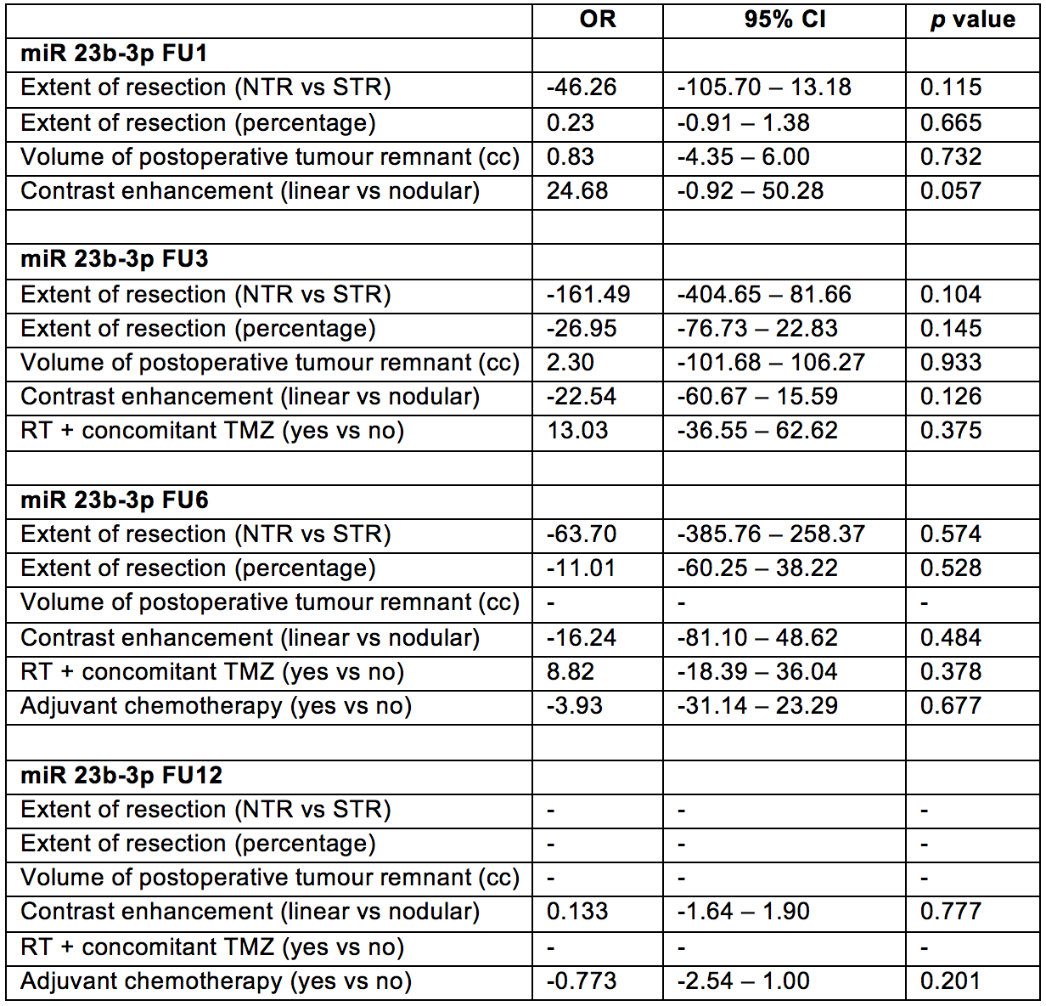
NTR: near total resection; RT: radiotherapy; STR: subtotal resection; TMZ: temozolomide.

Table 17 – Multivariate linear regression analysis between miR-34a-5p plasmatic concentrations 1 (FU1), 3 (FU3), 6 (FU6) and 12 months (FU12) after surgery, extent of tumour resection, postoperative concomitant RT and chemotherapy and adjuvant chemotherapy.

FU1: ANOVA: R 0.515; R² 0.266; adjusted R² -0.001; F 0.994; p value 0.451.
FU3: ANOVA: R 0.817; R² 0.668; adjusted R² -0.163; F 0.803; p value 0.636.
FU6: ANOVA: R 0.918; R² 0.843; adjusted R² 0.581; F 3.222; p value 0.182.
FU12: ANOVA: R 0.317; R² 0.100; adjusted R² -0.799; F 0.111; p value 0.900.

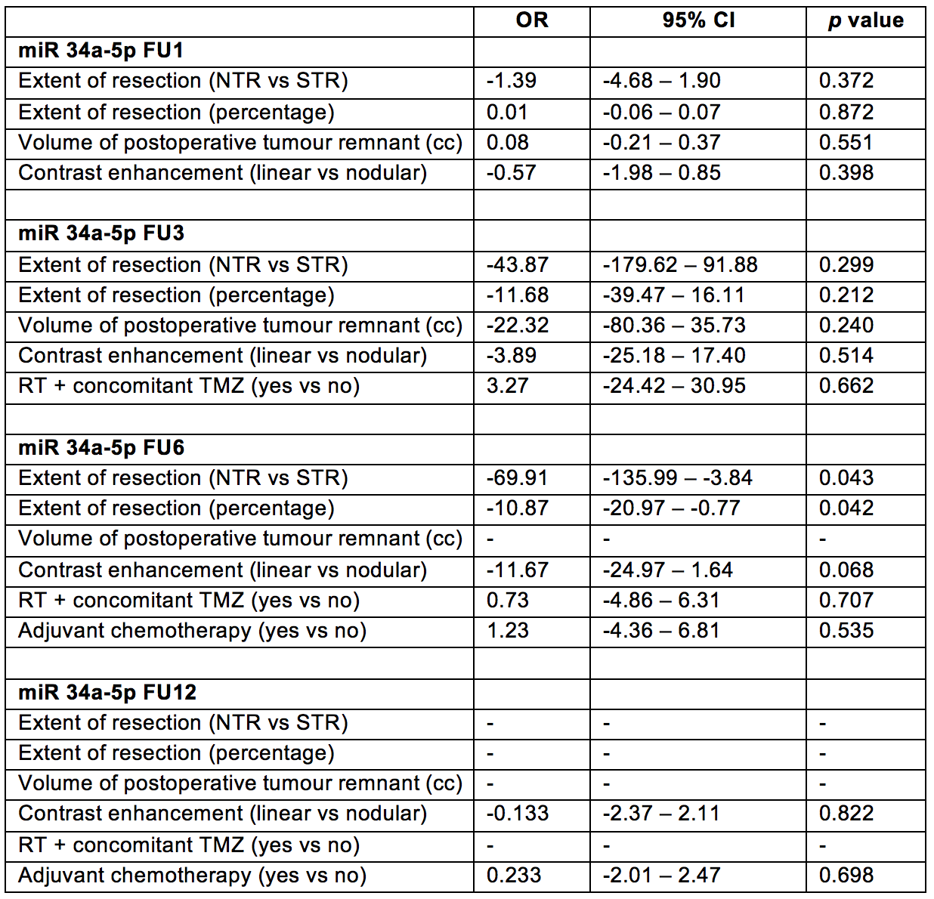
NTR: near total resection; RT: radiotherapy; STR: subtotal resection; TMZ: temozolomide.

