Supplementary Online Content

SFigure 1. Forest plot showed the meta-analysis of 90-day functional excellence (mRS 0-1)

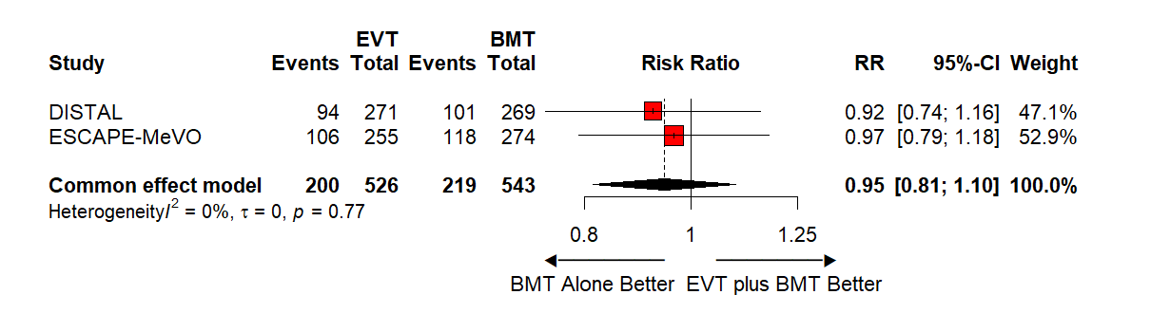

SFigure 2. Forest plot showed the meta-analysis of 90-day functional independence (mRS 0-2)
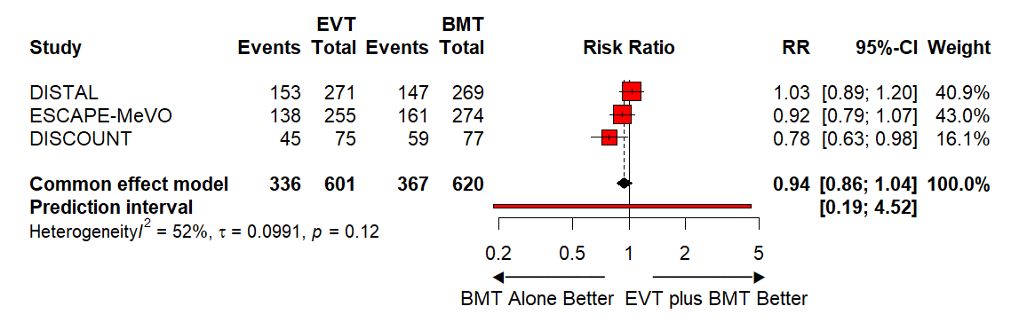

SFigure 3. Forest plot showed the meta-analysis of 90-day functional independence (mRS 0-3)
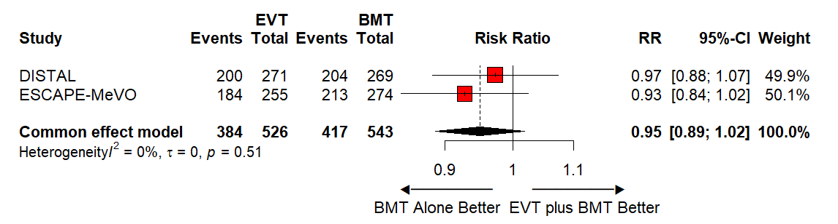

SFigure 4. Forest plot showed the meta-analysis of 90-day death or dependency (mRS 4-6)
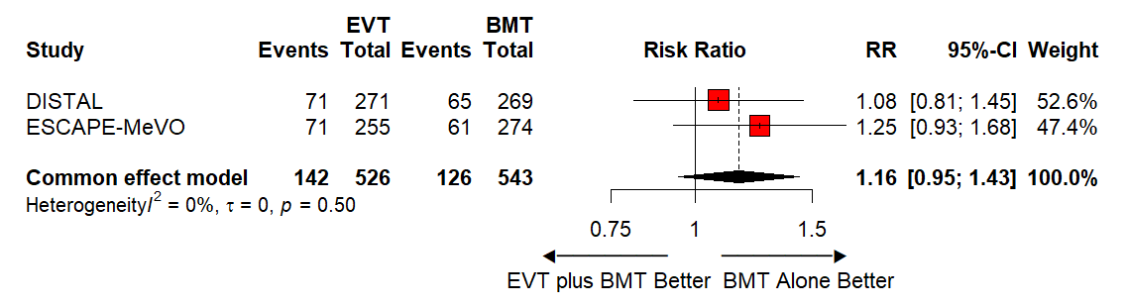

SFigure 5. Forest plot showed the meta-analysis of 90-day overall survival (mRS 0-5)
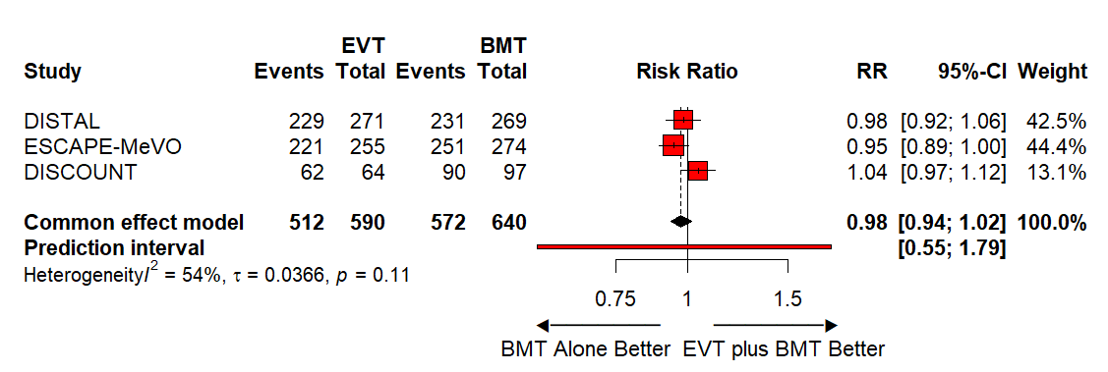

SFigure 6. Forest plot showed the meta-analysis of 90-day mortality (mRS 6)
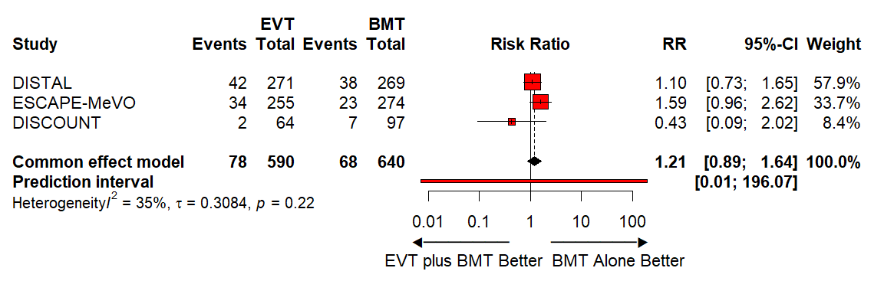

SFigure 7. Forest plot showed the meta-analysis of 90-day serious adverse events
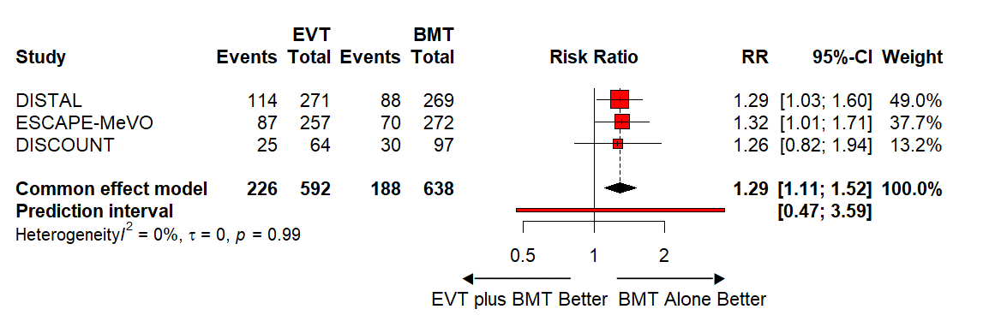
SFigure 8. Forest plot showed the meta-analysis of symptomatic intracranial hemorrhage
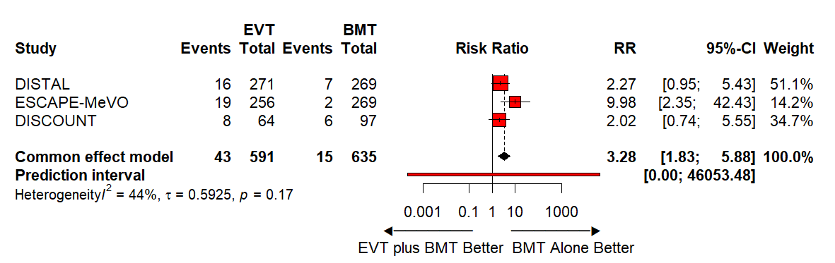

SFigure 9. Risk of Bias assessment traffic light plot
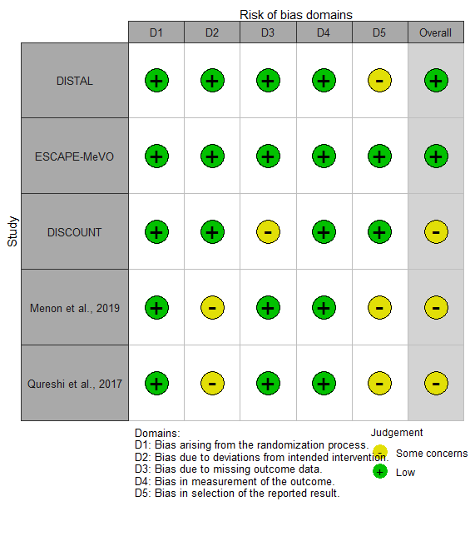
SFigure 10. Risk of Bias assessment bar plot
