Additional file

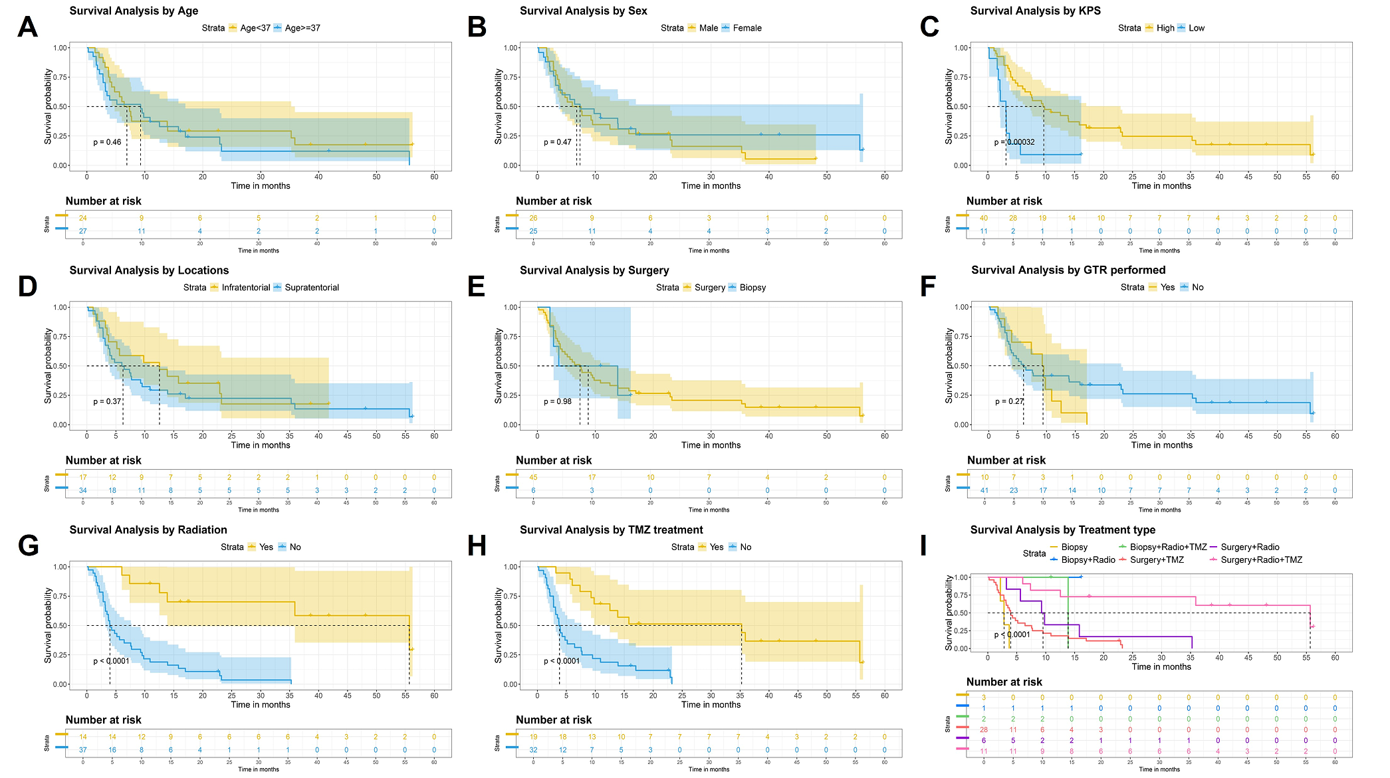
Figure S1 Overall survival analysis by various clinical factors in adult patients with H3K27M-DMG. (A) Age <37 vs. ≥37 years; (B) Male vs. female; (C) High vs. low KPS score; (D) Infratentorial vs. supratentorial region; (E) Surgery vs. biopsy; (F) Gross total resection (GTR) vs. non-GTR; (G) Radiation vs. no radiation; (H) TMZ chemotherapy vs. no TMZ chemotherapy; (I) Different treatment methods. p values were estimated using the log-rank test for the comparison of median OS between groups. The shaded areas represent the 95% confidence intervals.

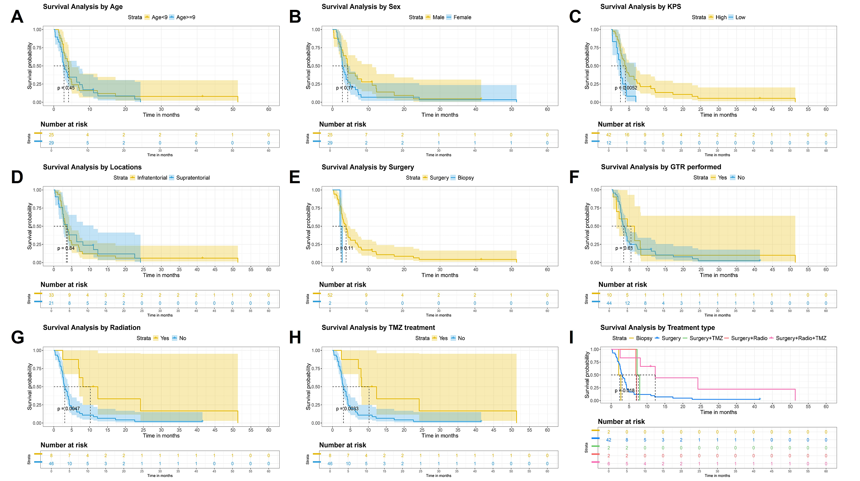
Figure S2 Overall survival analysis by various clinical factors in pediatric patients with H3K27M-DMG. (A) Age <9 vs. ≥9 years; (B) Male vs. female; (C) High vs. low KPS score; (D) Infratentorial vs. supratentorial region; (E) Surgery vs. biopsy; (F) Gross total resection (GTR) vs. non-GTR; (G) Radiation vs. no radiation; (H) TMZ chemotherapy vs. no TMZ chemotherapy; (I) Different treatment methods. p values were estimated using the log-rank test for the comparison of median OS between groups. The shaded areas represent the 95% confidence intervals.

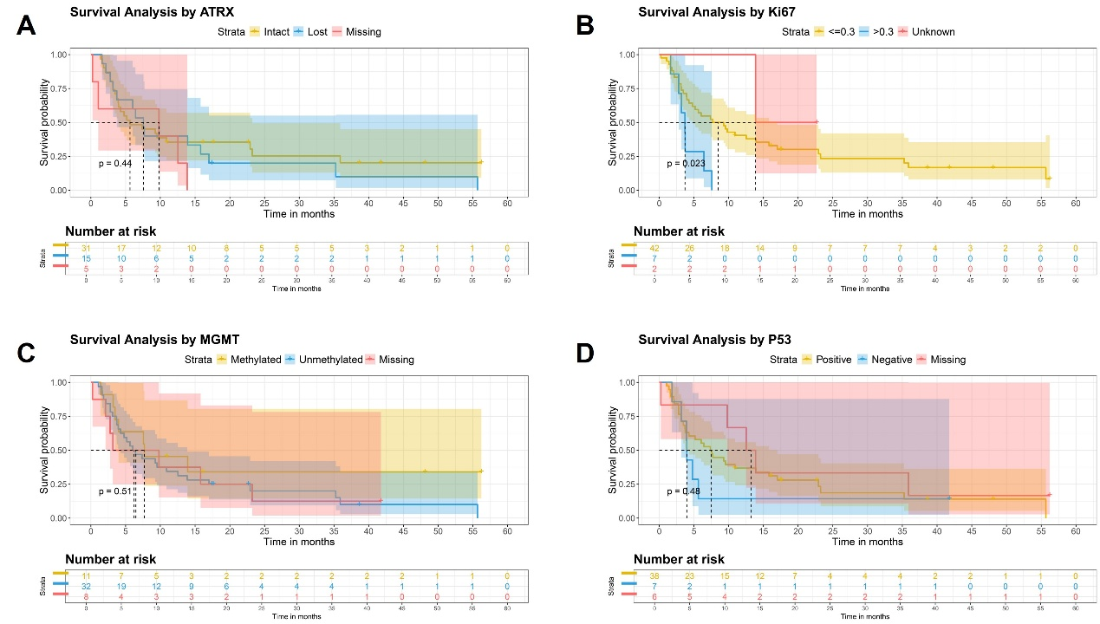
Figure S3 Overall survival analysis by molecular markers in adult patients with H3K27M-DMG.(A) ATRX expression status (intact, lost, or missing); (B) Ki67 expression level (>0.3, ≤0.3, or unknown); (C) MGMT promoter methylation status (methylated, unmethylated, or missing); (D) p53 overexpression status (positive, negative, or missing). p values were estimated using the log-rank test for the comparison of median OS among groups. The shaded areas represent the 95% confidence intervals.

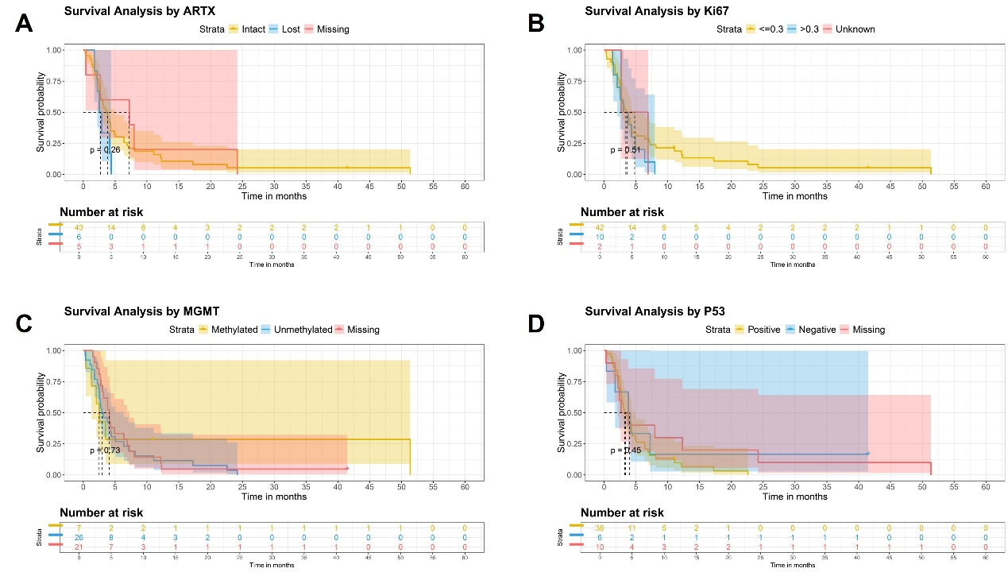
Figure S4 Overall survival analysis by molecular markers in pediatric patients with H3K27M-DMG. (A) ATRX expression status (intact, lost, or missing); (B) Ki67 expression level (>0.3, ≤0.3, or unknown); (C) MGMT promoter methylation status (methylated, unmethylated, or missing); (D) p53 overexpression status (positive, negative, or missing). p values were estimated using the log-rank test for the comparison of median OS among groups. The shaded areas represent the 95% confidence intervals.

Table S1 Summary of clinical features and treatments of adult patients
Variables | < 37  (N=24) | ≥ 37  (N=27) | Total  (N=51) | P-value
Age (years) |  |  |  | <0.001
Median [Min, Max] | 29.0 [18.0, 36.0] | 47.0 [37.0, 65.0] | 37.0 [18.0, 65.0]
Sex |  |  |  | 0.210
Female | 14 (58.3%) | 11 (40.7%) | 25 (49.0%)
Male | 10 (41.7%) | 16 (59.3%) | 26 (51.0%)
Locations |  |  |  | 0.074
Infratentorial | 5 (20.8%) | 12 (44.4%) | 17 (33.3%)
Supratentorial | 19 (79.2%) | 15 (55.6%) | 34 (66.7%)
Surgery |  |  |  | 0.106
Biopsy | 2 (8.3%) | 4 (14.8%) | 6 (11.8%)
GTR | 2 (8.3%) | 8 (29.6%) | 10 (19.6%)
PR | 8 (33.3%) | 9 (33.3%) | 17 (33.3%)
STR | 12 (50.0%) | 6 (22.2%) | 18 (35.3%)
Radiation |  |  |  | 0.375
No | 16 (66.7%) | 21 (77.8%) | 37 (72.5%)
Yes | 8 (33.3%) | 6 (22.2%) | 14 (27.5%)
TMZ |  |  |  | 0.539
No | 14 (58.3%) | 18 (66.7%) | 32 (62.7%)
Yes | 10 (41.7%) | 9 (33.3%) | 19 (37.3%)
Status |  |  |  | 0.718
Alive | 5 (20.8%) | 4 (14.8%) | 9 (17.6%)
Dead | 19 (79.2%) | 23 (85.2%) | 42 (82.4%)
ATRX expression |  |  |  | 0.533
Intact | 15 (62.5%) | 16 (59.3%) | 31 (60.8%)
Lost | 8 (33.3%) | 7 (25.9%) | 15 (29.4%)
Missing | 1 (4.2%) | 4 (14.8%) | 5 (9.8%)
p53 overexpression |  |  |  | 1.000
Missing | 3 (12.5%) | 3 (11.1%) | 6 (11.8%)
Negative | 3 (12.5%) | 4 (14.8%) | 7 (13.7%)
Positive | 18 (75.0%) | 20 (74.1%) | 38 (74.5%)
Ki67 expression |  |  |  | 0.095
<=0.3 | 17 (70.8%) | 25 (92.6%) | 42 (82.4%)
>0.3 | 5 (20.8%) | 2 (7.4%) | 7 (13.7%)
Unknown | 2 (8.3%) | 0 (0%) | 2 (3.9%)
MGMT promoter methylation |  |  |  | 0.072
Methylated | 7 (29.2%) | 4 (14.8%) | 11 (21.6%)
Missing | 1 (4.2%) | 7 (25.9%) | 8 (15.7%)
Unmethylated | 16 (66.7%) | 16 (59.3%) | 32 (62.7%)
KPS score |  |  |  | 0.422
High: >=70 | 20 (83.3%) | 20 (74.1%) | 40 (78.4%)
Low: <70 | 4 (16.7%) | 7 (25.9%) | 11 (21.6%)
H3K27M-DMG H3K27M-mutant diffuse midline glioma, GTR gross total resection, STR subtotal resection, PR partial resection, TMZ temozolomide, ATRX Alpha-thalassemia/mental retardation syndrome X-linked, p53 Tumor protein p53, MGMT O6-methylguanine DNA methyltransferase, KPS Karnofsky Performance Scale

Table S2 Summary of clinical features and treatments of pediatric patients
Variables | < 9  (N=25) | ≥ 9  (N=29) | Total  (N=54) | P-value
Age (years) |  |  |  | <0.001
Median [Min, Max] | 6.00 [1.00, 8.00] | 13.0 [9.00, 17.0] | 9.00 [1.00, 17.0]
Sex |  |  |  | 0.753
Female | 14 (56.0%) | 15 (51.7%) | 29 (53.7%)
Male | 11 (44.0%) | 14 (48.3%) | 25 (46.3%)
Locations |  |  |  | 0.001
Infratentorial | 21 (84.0%) | 12 (41.4%) | 33 (61.1%)
Supratentorial | 4 (16.0%) | 17 (58.6%) | 21 (38.9%)
Surgery |  |  |  | 0.163
Biopsy | 2 (8.0%) | 0 (0%) | 2 (3.7%)
GTR | 3 (12.0%) | 7 (24.1%) | 10 (18.5%)
PR | 18 (72.0%) | 16 (55.2%) | 34 (63.0%)
STR | 2 (8.0%) | 6 (20.7%) | 8 (14.8%)
Radiation |  |  |  | 0.711
No | 22 (88.0%) | 24 (82.8%) | 46 (85.2%)
Yes | 3 (12.0%) | 5 (17.2%) | 8 (14.8%)
TMZ |  |  |  | 0.056
No | 24 (96.0%) | 22 (75.9%) | 46 (85.2%)
Yes | 1 (4.0%) | 7 (24.1%) | 8 (14.8%)
Status |  |  |  | 1.000
Alive | 1 (4.0%) | 1 (3.4%) | 2 (3.7%)
Dead | 24 (96.0%) | 28 (96.6%) | 52 (96.3%)
ATRX expression |  |  |  | 0.540
Intact | 21 (84.0%) | 22 (75.9%) | 43 (79.6%)
Lost | 3 (12.0%) | 3 (10.3%) | 6 (11.1%)
Missing | 1 (4.0%) | 4 (13.8%) | 5 (9.3%)
p53 overexpression |  |  |  | 0.830
Missing | 5 (20.0%) | 5 (17.2%) | 10 (18.5%)
Negative | 2 (8.0%) | 4 (13.8%) | 6 (11.1%)
Positive | 18 (72.0%) | 20 (69.0%) | 38 (70.4%)
Ki67 expression |  |  |  | 0.317
<=0.3 | 18 (72.0%) | 24 (82.8%) | 42 (77.8%)
>0.3 | 5 (20.0%) | 5 (17.2%) | 10 (18.5%)
Unknown | 2 (8.0%) | 0 (0%) | 2 (3.7%)
MGMT promoter methylation |  |  |  | 0.008
Methylated | 1 (4.0%) | 6 (20.7%) | 7 (13.0%)
Missing | 15 (60.0%) | 6 (20.7%) | 21 (38.9%)
Unmethylated | 9 (36.0%) | 17 (58.6%) | 26 (48.1%)
KPS score |  |  |  | 0.770
High: >=70 | 19 (76.0%) | 23 (79.3%) | 42 (77.8%)
Low: <70 | 6 (24.0%) | 6 (20.7%) | 12 (22.2%)
H3K27M-DMG H3K27M-mutant diffuse midline glioma, GTR gross total resection, STR subtotal resection, PR partial resection, TMZ temozolomide, ATRX Alpha-thalassemia/mental retardation syndrome X-linked, p53 Tumor protein p53, MGMT O6-methylguanine DNA methyltransferase, KPS Karnofsky Performance Scale

