Supplementary Table 1. Study characteristics and baseline patient demographics.
Author | Country | Study design | Year | Cohort period | Age - ETS | Age - MTS | Male sex ETS (n) | Male sex MTS (n) | ETS (n) | MTS (n) | Tumor status
Agam | USA | Retrosp. | 2018 | 1992-2017 | Mean 53.3 ±13.5 | Mean 49.1 ± 16.6 | NR | NR | 170 | 983 | Mixed
Akbari | Iran | Retrosp. | 2018 | 2012-2014 | Mean 39.43 ± 15.21 | Mean 43.06 ± 11.29 | 9 | 10 | 16 | 19 | Primary
Alahmadi | Canada | Retrosp. | 2013 | 2000-2010 | NR | NR | 3 | 8 | 17 | 25 | Primary
Asemota | USA | Retrosp. | 2017 | 2010-2014 | Mean 45.14 ± 13.23 | Mean 45.21 ± 13.19 | 1194 | 1453 | 2679 | 3207 | Not defined
Castaño-Leon | Spain | Retrosp. | 2020 | 1995-2017 | 52 (IQR = 22) | 45 (IQR =24) | 39 | 36 | 97 | 90 | Primary
Chatzidakis | USA | Retrosp. | 2023 | 2004-2015 | Mean 54.6 ± 12.0 | Mean 59.5 ± 13.1 | 5 | 7 | 10 | 10 | Primary
Cheng | China | Retrosp. | 2011 | 2003-2009 | Mean 37.2 (13-69) | Mean 33.8 (11-71) | 31 | 20 | 68 | 59 | Primary
Cho | China | RCT | 2002 | 1996-2000 | Mean 45.3 (22-60) | Mean 46.7 (18-56) | 0 | 1 | 22 | 22 | Primary
Choe | South Korea | Retrosp. | 2008 | 1997-2004 | Mean 47 ± 12 | Mean 48± 10 | 5 | 2 | 12 | 11 | Primary
D’Haens | Belgium | Retrosp. | 2009 | 1995-2007 | Mean 37 (10-70) | Mean 35 (10-68) | NR | NR | 60 | 60 | Primary
Dallapiazza | USA | Prosp. | 2014 | 2010-2013 | Mean 56.2 ± 12.8 | Mean 56.7 ± 16.9 | 27 | 24 | 56 | 43 | Primary
Eseonu | USA | Retrosp. | 2017 | 2005-2015 | Mean 49.0 ± 16.2 | Mean 48.8 ± 15.8 | 115 | 48 | 275 | 109 | Primary
Fathalla | Canada | Retrosp. | 2015 | 2000-2013 | Mean 43.2 | Mean 42.1 | 21 | 7 | 42 | 23 | Primary
Findlay | USA | Retrosp. | 2023 | 2017-2020 | Mean 52.8 ± 16.3 | Mean 52.6 ± 16.3 | 123 | 133 | 300 | 300 | Mixed
Gao | China | Retrosp. | 2016 | 2012-2014 | Mean 44.6 (19-75) | Mean 48.8 (21-77) | 26 | 19 | 60 | 45 | Primary
Gompel | USA | Retrosp. | 2021 | 2014-2019 | Mean 51.7 ± 0.9 | Mean 50.3 ± 0.9 | NR | NR | 261 | 273 | Mixed
Guvenc | Turkey | Retrosp. | 2016 | 2000-2014 | Mean 48.28 ± 14.1 | Mean 36.95 ± 12.96 | 19 | 18 | 45 | 49 | Primary
Halvorsen | Norway | Retrosp. | 2014 | 2002-2011 | NR | NR | NR | NR | 268 | 238 | Mixed
Higgins | USA | Retrosp. | 2008 | 2002-2008 | 54.2 | 52.8 | 11 | 14 | 19 | 29 | Mixed
Hong | South Korea | Retrosp. | 2015 | 2012-2013 | Mean 50.8 ± 13.8 | Mean 58.5 ± 12.9 | 16 | 9 | 35 | 20 | Primary
Huang G. | China | Retrosp. | 2016 | 2007-2014 | Mean 43.4 ± 14.0 | Mean 40.4 ± 14.2 | 59 | 53 | 100 | 147 | Primary
Huang Y. | China | Retrosp. | 2023 | 2019-2021 | NR | NR | 30 | 20 | 73 | 54 | Primary
Jain | India | RCT | 2007 | NR | Mean 40.10 | Mean 31.60 | NR | NR | 10 | 10 | Primary
Kahilogullari | Turkey | Prosp. | 2013 | 2010-2012 | Mean 40.84 ± 12.56 | Mean 46.56 ± 7.75 | 4 | 6 | 25 | 25 | Primary
Karpinnen | Finland | Retrosp. | 2015 | 2000-2010 | Mean 58.5 ± 16 | Mean 58.4 ± 13 | 23 | 95 | 41 | 144 | Primary
Keshk | Egypt | Prosp. | 2020 | 2015-2019 | Mean 46.3 ± 10.45 | Mean 42.5 ± 12.1 | 7 | 9 | 18 | 16 | Recurrent
Kong | China | Retrosp. | 2024 | 2019-2022 | Mean 50.84 ± 12.65 | Mean 49.97 ± 12.00 | 16 | 16 | 58 | 35 | Primary
Krishna | India | Retrosp. | 2025 | 2019-2023 | Mean 48.67 ± 16.20 | Mean 44.32 ± 12.36 | 27 | 25 | 43 | 48 | Primary
Krishnakumar | USA | Retrosp. | 2024 | 2009-2021 | NR | NR | 20 | 32 | 36 | 57 | Primary
Levi | Italy | Retrosp. | 2017 | 2004-2012 | Median 58.5 | Median 52 | 86 | 44 | 140 | 81 | Primary
Little | USA | Prosp. | 2019 | 2015-2017 | Mean 58.1 ± 14.0 | Mean 58.6 ± 13.3 | 104 | 52 | 177 | 82 | Mixed
Mattogno | Italy | Retrosp. | 2017 | 2007-2012 | Mean 51.70 (21-78) | Mean 48.35 (15-83) | 36 | 19 | 72 | 42 | Primary
Messerer | France | Retrosp. | 2011 | 2006-2009 | Median 57 | Median 56.50 | 47 | 51 | 82 | 82 | Primary
Møller | Denmark | Retrosp. | 2020 | 2016-2017 | Median 61 | Median 58 | 25 | 107 | 45 | 195 | Mixed
Naimi | USA | Retrosp. | 2023 | 2010-2021 | Mean 58 ± 16.9 | Mean 58.6 ± 17.2 | 2680 | 1555 | 5470 | 3174 | Not defined
Neal | USA | Retrosp. | 2007 | 1990-2004 | NR | NR | NR | NR | 35 | 15 | Primary
Noiphithak | Thailand | Retrosp. | 2021 | 2010-2019 | Mean 48.8 ±13.9 | Mean 53.8 ± 15.6 | 77 | 44 | 138 | 72 | Mixed
O’Maley | USA | Retrosp. | 2008 | 2003-2008 | Mean 47.9 (18-73) | Mean 50.8 (23-78) | 15 | 16 | 25 | 25 | Primary
Ordóñez-Rubiano | Colombia | Prosp. | 2024 | 2018-2019 | Mean 50.2 ± 10.1 | Mean 52.3 ± 15.1 | 9 | 3 | 18 | 11 | Primary
Pablo | Argentina | Retrosp. | 2019 | 2006-2014 | Average 51 (17-90) | Average 48.5 (18-85) | 61 | 109 | 140 | 259 | Primary
Pala | Germany | RCT | 2025 | 2018-2022 | Mean 56.2 ± 14.7 | Mean 59.8 ± 15.3 | 7 | 4 | 17 | 19 | Primary
Phogat | India | Mix | 2021 | 2013-2018 | NR | NR | NR | NR | 119 | 79 | Primary
Prajapati | India | Prosp. | 2018 | NR | Mean 41.06 ± 11.75 | Mean 41.91 ± 13.23 | NR | NR | 17 | 13 | Primary
Qiao | China | RCT | 2021 | 2010-2019 | Mean 44.3 ± 12.7 | Mean 44.4 ± 11.8 | 185 | 334 | 424 | 694 | Mixed
Razak | United Kingdom | Prosp. | 2013 | 2008-2009 | Mean 47.4 (9-75) | Mean 49.3 (23-73) | 19 | 22 | 40 | 40 | Primary
Sarkar | India | Retrosp. | 2014 | 2005-2013 | Mean 37.6 ± 10.8 | Mean 38.7 ± 12.2 | 30 | 26 | 66 | 47 | Primary
Savik | Turkey | Retrosp. | 2025 | 2012-2018 | Mean 50.6 | Mean 50.2 | NR | NR | 26 | 26 | Primary
Shimony | Israel | Retrosp. | 2021 | 2006-2017 | Mean 57.79 ± 12.91 | Mean 52.75 ± 13.93 | NR | NR | 39 | 48 | Recurrent
Song | China | Retrosp. | 2022 | 2015-2020 | Mean 54 ± 12 | Mean 55 ± 12 | 100 | 147 | 210 | 304 | Primary
Starke | USA | Retrosp. | 2013 | 2004-2009 | Mean 49.2 ± 14.9 | Mean 47.5 ± 14.2 | 40 | 20 | 72 | 41 | Mixed
Trimpou | Sweden | Retrosp. | 2022 | 2003-2018 | Mean 48 | Mean 44 | 8 | 2 | 26 | 14 | Primary
Vassilyeva | Bulgaria | RCT | 2023 | 2017-2021 | Mean 43.26 ± 8.64 | Mean 44.12 ± 9.14 | 17 | 16 | 43 | 40 | Primary
Wang | USA | Retrosp. | 2018 | 2003-2012 | Mean 50 | Mean 52 | 54 | 10 | 117 | 37 | Primary
Zaidi | USA | Prosp. | 2016 | 2011-2014 | Mean 55.9 ± 13.8 | Mean 59.1 ± 14.6 | 35 | 50 | 55 | 80 | Mixed
Zhang C. | China | Retrosp. | 2025 | 2011-2021 | Mean 48 (37, 57) | Mean 47 (38, 58) | 480 | 419 | 1023 | 840 | Not defined
Zhang T. | China | Retrosp. | 2021 | 2017-2020 | 26-58(55.6) | 23-60 (53.2) | 13 | 12 | 23 | 23 | Primary
Abbreviations: Retrosp., retrospective; Prosp., prospective; RCT, randomized controlled trial; ETS, endoscopic transsphenoidal surgery; MTS, microscopic transsphenoidal surgery; NR, not reported.

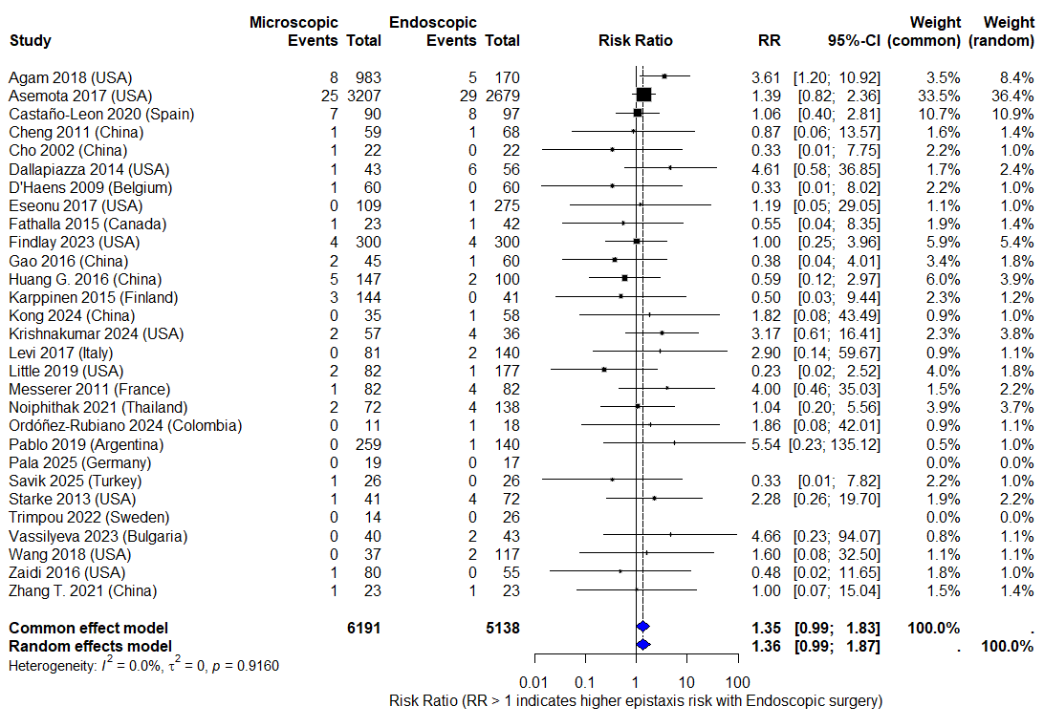
Supplementary Figure 1. Forest plot illustrating postoperative epistaxis comparing ETS and MTS. Individual study RRs with 95% CIs are shown, together with the number of events and total patients in each treatment arm. Study weights for both common- and random-effects models are displayed. The diamond represents the pooled effect estimate. Values greater than 1 indicate a higher risk of epistaxis with ETS.
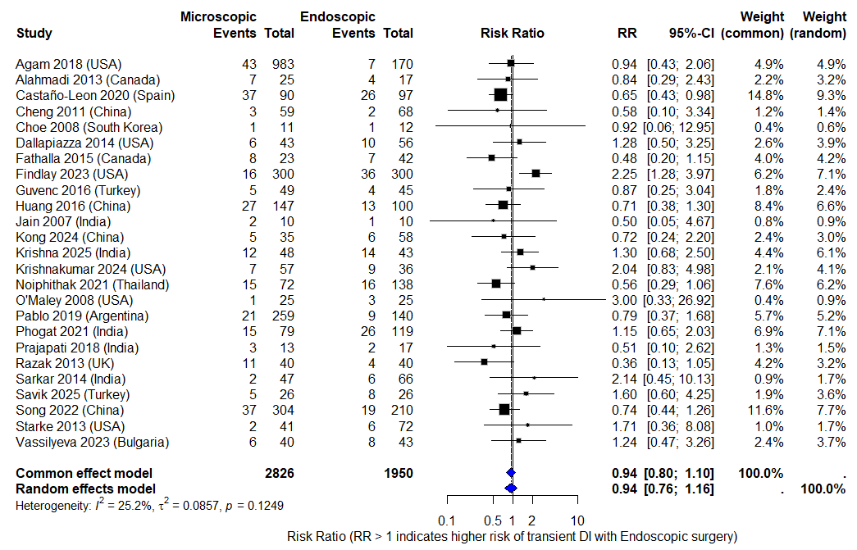
Supplementary Figure 2. Forest plot illustrating the risk of transient diabetes insipidus comparing ETS and MTS. Individual study RRs with 95% CIs are shown, together with the number of events and total patients in each treatment arm. Study weights for both common- and random-effects models are displayed. The diamond represents the pooled effect estimate. Values greater than 1 indicate a higher risk of transient diabetes insipidus with ETS.
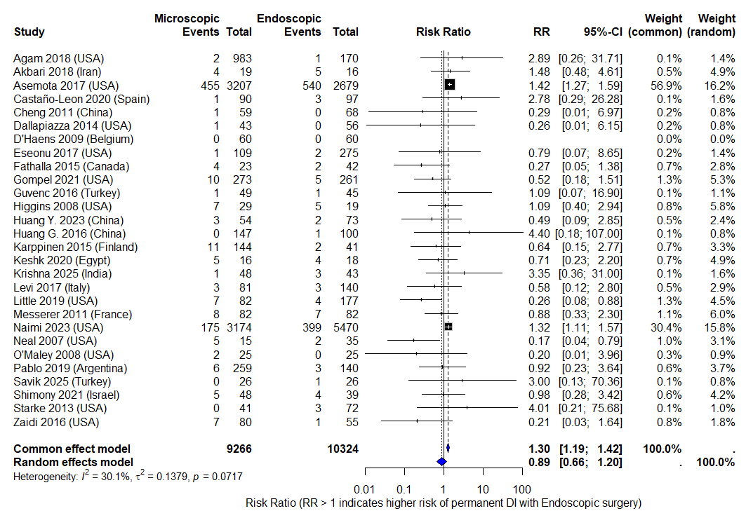
Supplementary Figure 3. Forest plot illustrating the risk of permanent diabetes insipidus comparing ETS and MTS. Individual study RRs with 95% CIs are shown, together with the number of events and total patients in each treatment arm. Study weights for both common- and random-effects models are displayed. The diamond represents the pooled effect estimate. Values greater than 1 indicate a higher risk of permanent diabetes insipidus with ETS.

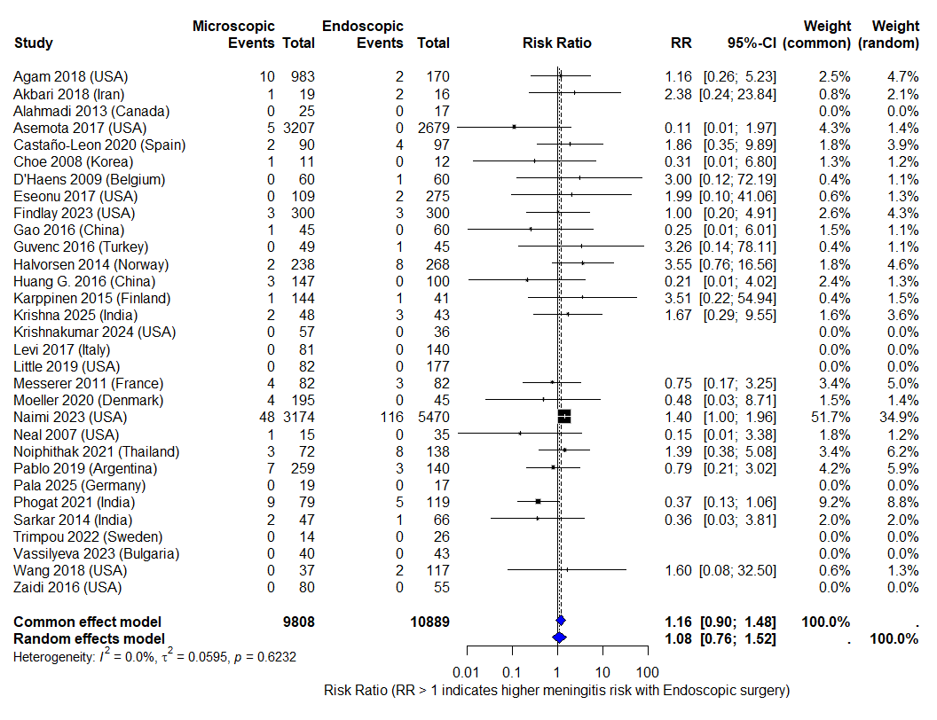
Supplementary Figure 4. Forest plot illustrating the risk of postoperative meningitis comparing ETS and MTS. Individual study RRs with 95% CIs are shown, together with the number of events and total patients in each treatment arm. Study weights for both common- and random-effects models are displayed. The diamond represents the pooled effect estimate. Values greater than 1 indicate a higher risk of permanent diabetes insipidus with ETS.

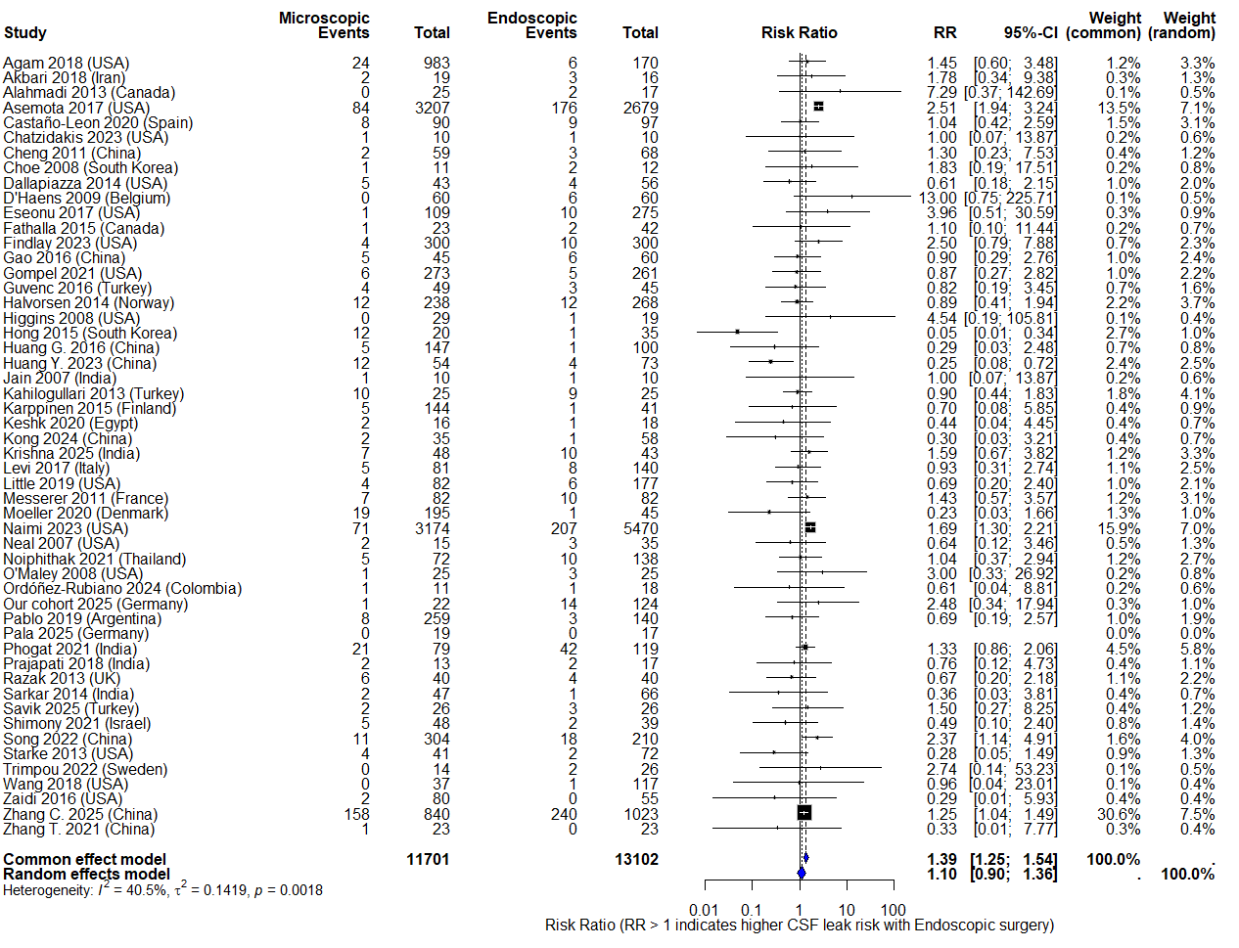
Supplementary Figure 5. Forest plot illustrating the risk of postoperative CSF leak comparing ETS and MTS. Individual study RRs with 95% CIs are shown, together with the number of events and total patients in each treatment arm. Study weights for both common- and random-effects models are displayed. The diamond represents the pooled effect estimate. Values greater than 1 indicate a higher risk of permanent diabetes insipidus with ETS.
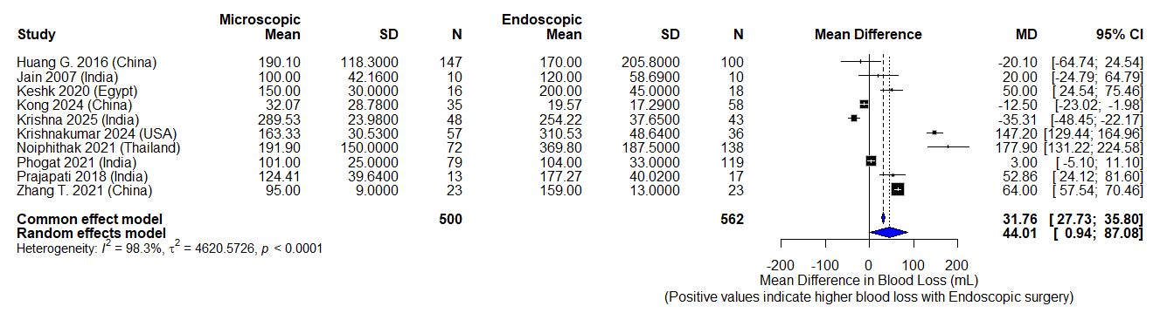
Supplementary Figure 6. Forest plot illustrating blood loss comparing ETS and MTS. Individual study MDs in minutes with 95% CIs are shown, together with study-specific means, standard deviations, and sample sizes. Study weights for both common- and random-effects models are displayed. The diamond represents the pooled effect estimate. Positive values indicate longer operative time with ETS.

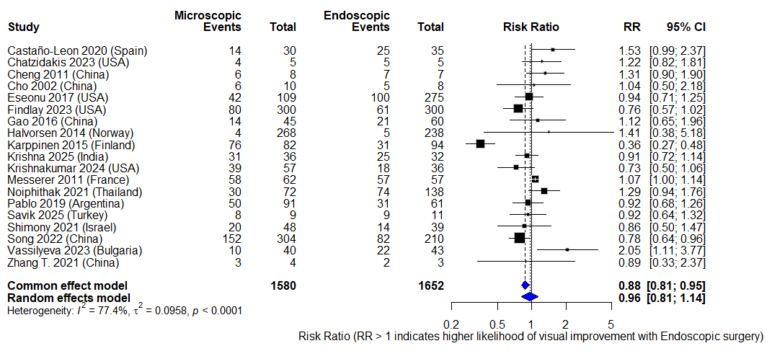
Supplementary Figure 7. Forest plot illustrating postoperative visual improvement comparing ETS and MTS. Individual study RRs with 95% CIs are shown, together with the number of events and total patients in each treatment arm. Study weights for both common- and random-effects models are displayed. The diamond represents the pooled effect estimate. Values greater than 1 indicate a higher risk of permanent diabetes insipidus with ETS.

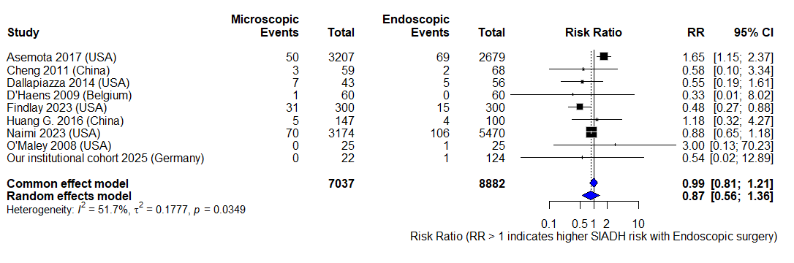
Supplementary Figure 8. Forest plot illustrating postoperative risk of SIADH comparing ETS and MTS. Individual study RRs with 95% CIs are shown, together with the number of events and total patients in each treatment arm. Study weights for both common- and random-effects models are displayed. The diamond represents the pooled effect estimate. Values greater than 1 indicate a higher risk of permanent diabetes insipidus with ETS.

Supplementary Table 2. NIH Quality Assessment of Observational Studies. This table summarizes the methodological quality assessment of included retrospective and prospective observational studies using the National Institutes of Health (NIH) Quality Assessment Tool. Each study was evaluated across predefined methodological domains and categorized as “Yes” (criterion met), “No” (criterion not met), or “Not reported (NR)” (insufficient or absent information in the original publication). The table provides an overview of methodological strengths, limitations, and reporting completeness across the included studies.
NIH Criteria | Agam MS et al. | Akbari H. et al. | Alahmadi H. et al. | Asemota AO et al. | Castaño-León AM et al. | Chatzidakis S. et al. | Cheng R-X et al. | Choe J-H et al. | D’Haens J. et al. | Dallapiazza R. et al. | Eseonu CI et al. | Fathalla H. et al. | Findlay MC et al. | Gao Y. et al. | van Gompel JJ et al. | Guvenc G. et al. | Halvorsen H. et al. | Higgins TS et al. | Hong SD et al. | Huang G-D et al. | Huang Y. et al. | Kahilogullari G. et al. | Karppinen A. et al. | Keshk M. et al. | Kong F et al.
Clearly stated research question | Yes | Yes | Yes | Yes | Yes | Yes | Yes | Yes | Yes | Yes | Yes | Yes | Yes | Yes | Yes | Yes | Yes | Yes | Yes | Yes | Yes | Yes | Yes | Yes | Yes
Defined study population | Yes | Yes | Yes | Yes | Yes | Yes | Yes | Yes | Yes | Yes | Yes | Yes | Yes | Yes | Yes | Yes | Yes | Yes | Yes | Yes | Yes | Yes | Yes | Yes | Yes
≥50% participation rate | Yes | Yes | NR | Yes | Yes | NR | Yes | NR | Yes | NR | Yes | NR | Yes | NR | Yes | NR | Yes | Yes | Yes | Yes | Yes | Yes | NR | NR | Yes
Uniform inclusion/exclusion criteria | Yes | Yes | Yes | Yes | Yes | NR | NR | Yes | Yes | Yes | Yes | Yes | Yes | Yes | Yes | NR | Yes | NR | Yes | Yes | Yes | Yes | Yes | Yes | Yes
Justification of sample size | No | No | No | No | No | No | No | No | No | No | No | No | No | No | No | No | No | No | No | No | No | No | No | No | No
Exposure assessed before outcome | Yes | Yes | Yes | Yes | Yes | Yes | Yes | Yes | Yes | Yes | Yes | Yes | Yes | Yes | Yes | Yes | Yes | Yes | Yes | Yes | Yes | Yes | Yes | Yes | Yes
Sufficient follow-up period | NR | Yes | Yes | NR | Yes | Yes | Yes | Yes | Yes | Yes | Yes | Yes | Yes | Yes | Yes | Yes | Yes | Yes | Yes | Yes | NR | Yes | Yes | Yes | Yes
Measurable/consistent exposure assessment | Yes | Yes | Yes | Yes | Yes | Yes | Yes | Yes | Yes | Yes | Yes | Yes | Yes | Yes | Yes | Yes | Yes | Yes | Yes | Yes | Yes | Yes | Yes | Yes | Yes
Clearly defined outcome measures | Yes | Yes | Yes | Yes | Yes | Yes | Yes | Yes | Yes | Yes | Yes | Yes | Yes | Yes | Yes | Yes | Yes | Yes | Yes | Yes | Yes | Yes | Yes | Yes | Yes
Blinded outcome assessment | No | No | No | No | No | No | No | No | No | No | Yes | No | No | No | Yes | No | No | No | No | No | No | No | No | No | No
≤20% loss to follow-up | NR | NR | NR | NR | NR | NR | NR | NR | NR | NR | NR | NR | NR | NR | NR | NR | Yes | NR | NR | Yes | NR | Yes | Yes | NR | Yes
Confounders measured and adjusted | Yes | Yes | Yes | Yes | Yes | Yes | Yes | Yes | Yes | Yes | Yes | Yes | Yes | Yes | Yes | Yes | Yes | Yes | Yes | Yes | Yes | Yes | Yes | Yes | Yes
NIH Criteria | Krishnakumar A. et al. | Levi V. et al. | Little AS et al. | Mattogno P.P. et al. | Messerer M. et al. | Møller M.W. et al. | Naimi B. et al. | Neal JG et al. | Noiphithak R. et al. | O’Malley B.W. Jr. et al. | Ordóñez-Rubiano E.G. et al. | Pablo et al. | Phogat V. et al. | Prajapati H.P. et al. | Razak A.A. et al. | Sarkar S. et al. | Savik R. et al. | Shimony N. et al. | Song S. et al. | Starke R.M. et al. | Trimpou P. et al. | Wang A.C. et al. | Zaidi H.A. et al. | Zhang C. et al. | Zhang T. et al.
Clearly stated research question | Yes | Yes | Yes | Yes | Yes | Yes | Yes | Yes | Yes | Yes | Yes | Yes | Yes | Yes | Yes | Yes | Yes | Yes | Yes | Yes | Yes | Yes | Yes | Yes | Yes
Defined study population | Yes | Yes | Yes | Yes | Yes | Yes | Yes | Yes | Yes | Yes | Yes | Yes | Yes | Yes | Yes | Yes | Yes | Yes | Yes | Yes | Yes | Yes | Yes | Yes | Yes
≥50% participation rate | NR | Yes | Yes | Yes | Yes | Yes | NR | NR | Yes | Yes | NR | Yes | Yes | NR | Yes | Yes | NR | Yes | Yes | Yes | Yes | Yes | Yes | Yes | NR
Uniform inclusion/exclusion criteria | NR | Yes | Yes | NR | Yes | Yes | Yes | NR | Yes | NR | Yes | Yes | Yes | Yes | NR | Yes | Yes | Yes | Yes | Yes | Yes | Yes | Yes | Yes | NR
Justification of sample size | No | No | No | No | No | No | No | No | No | No | No | No | No | No | No | No | No | No | No | No | No | No | Yes | No | No
Exposure assessed before outcome | Yes | Yes | Yes | Yes | Yes | Yes | Yes | Yes | Yes | Yes | Yes | Yes | Yes | Yes | Yes | Yes | Yes | Yes | Yes | Yes | Yes | Yes | Yes | Yes | Yes
Sufficient follow-up period | NR | NR | Yes | Yes | Yes | Yes | Yes | Yes | Yes | Yes | Yes | Yes | Yes | Yes | Yes | Yes | Yes | Yes | Yes | Yes | Yes | Yes | Yes | Yes | NR
Measurable/consistent exposure assessment | Yes | Yes | Yes | Yes | Yes | Yes | Yes | Yes | Yes | Yes | Yes | Yes | Yes | Yes | Yes | Yes | Yes | Yes | Yes | Yes | Yes | Yes | Yes | Yes | Yes
Clearly defined outcome measures | Yes | Yes | Yes | Yes | Yes | Yes | Yes | Yes | Yes | Yes | Yes | Yes | Yes | Yes | Yes | Yes | Yes | Yes | Yes | Yes | Yes | Yes | Yes | Yes | Yes
Blinded outcome assessment | No | No | Yes | No | No | No | No | No | No | No | No | No | No | No | Yes | No | No | Yes | No | No | No | Yes | No | No | No
≤20% loss to follow-up | NR | NR | Yes | NR | NR | NR | NR | NR | Yes | NR | NR | Yes | NR | NR | Yes | NR | NR | Yes | Yes | Yes | Yes | NR | Yes | Yes | NR
Confounders measured and adjusted | Yes | Yes | Yes | Yes | Yes | Yes | Yes | Yes | Yes | Yes | Yes | Yes | Yes | Yes | Yes | Yes | Yes | Yes | Yes | Yes | Yes | Yes | Yes | Yes | Yes

