Supplementary File

Table 1. Sensitivity, specificity and Youden's J
Interval | Sensitivity | Specificity | J-index
(>=0.2) | 100.00% | 0.00% | -
(>=0.5) | 95.52% | 5.00% | 0.01
(>=0.8) | 85.07% | 18.00% | 0.03
(>=1.5) | 82.09% | 19.50% | 0.02
(>=2) | 79.10% | 25.50% | 0.05
(>=2.5) | 70.15% | 32.50% | 0.03
(>=3) | 67.16% | 34.00% | 0.01
(>=3.5) | 65.67% | 45.50% | 0.11
(>=4) | 65.67% | 49.50% | 0.15
(>=4.5) | 59.70% | 59.00% | 0.19
(>=5) | 53.73% | 65.00% | 0.19
(>=5.5) | 47.76% | 68.50% | 0.16
(>=6) | 43.28% | 72.00% | 0.15
(>=6.5) | 38.81% | 77.50% | 0.16
(>=7) | 35.82% | 80.00% | 0.16
(>=7.5) | 32.84% | 83.50% | 0.16
(>=8) | 31.34% | 86.50% | 0.18
(>=8.5) | 25.37% | 88.50% | 0.14
(>=9) | 23.88% | 89.00% | 0.13
(>=10) | 22.39% | 90.50% | 0.13
(>=11) | 20.90% | 91.00% | 0.12
(>=11.5) | 14.93% | 92.50% | 0.07
(>=12) | 13.43% | 92.50% | 0.06
(>=13) | 8.96% | 93.50% | 0.02
(>=13.5) | 7.46% | 94.00% | 0.01
(>=14) | 7.46% | 94.50% | 0.02

Table 2. Univariable and multivariable analysis for Overall Survival (OS) in pT3N0

 | Univariable for OS |  |  |  | Multivariable for OS
 | HR | Lower IC 95% | Upper IC 95% | P-value | HR | Lower IC 95% | Upper IC 95% | P-value
Age | 4.588 | 1.618 | 13.010 | 0.004 | 2.139 | 0.667 | 6.859 | 0.201
Sex | 1.719 | 0.868 | 3.404 | 0.120
ASA score ≥ 3 | 4.891 | 2.441 | 9.798 | <0.001 | 3.235 | 1.457 | 7.186 | 0.004
BMI ≥24 | 0.942 | 0.479 | 1.853 | 0.862
CEA ≥5 | 1.234 | 0.637 | 2.391 | 0.533
Left colon site | 0.564 | 0.283 | 1.124 | 0.103
Laparoscopy | 0.795 | 0.371 | 1.703 | 0.555
Tumor ≥4cm | 0.711 | 0.368 | 1.374 | 0.310
High Grade | 0.942 | 0.365 | 2.432 | 0.902
Adjuvant CT | 0.330 | 0.144 | 0.756 | 0.009 | 0.684 | 0.275 | 1.701 | 0.414
VI | 0.973 | 0.500 | 1.894 | 0.936
LI | 1.026 | 0.465 | 2.266 | 0.950
PNI | 0.605 | 0.082 | 4.479 | 0.623
LN ≥12 | 0.576 | 0.297 | 1.118 | 0.103
pT3≥5mm | 1.130 | 0.582 | 2.191 | 0.719
ELI | 1.097 | 0.567 | 2.124 | 0.784

Table 3. Univariable analysis for Disease-free survival. (DFS) in pT3N0

 | HR | Lower IC 95% | Upper IC 95% | P-value
Age | 2.698 | 0.790 | 9.210 | 0.113
Sex | 1.983 | 0.762 | 5.162 | 0.161
ASA score ≥ 3 | 2.373 | 0.986 | 5.712 | 0.054
BMI ≥24 | 1.434 | 0.545 | 3.774 | 0.465
CEA ≥5 | 1.425 | 0.590 | 3.443 | 0.431
Left colon site | 1.424 | 0.573 | 3.542 | 0.447
Laparoscopy | 1.758 | 0.726 | 4.256 | 0.211
Tumor ≥4cm | 0.472 | 0.195 | 1.141 | 0.096
High Grade | 0.670 | 0.155 | 2.891 | 0.592
Adjuvant CT | 0.939 | 0.374 | 2.357 | 0.894
VI | 0.510 | 0.196 | 1.330 | 0.169
LI | 1.278 | 0.490 | 3.333 | 0.616
PNI | 1.634 | 0.376 | 7.092 | 0.512
LN ≥12 | 0.288 | 0.119 | 0.694 | 0.006
pT3≥5mm | 0.731 | 0.281 | 1.903 | 0.521
ELI | 1.083 | 0.443 | 2.650 | 0.861

Figure 1. Receiver Operating Curve (ROC) of the maximum depth of tumor invasion compared to Disease-Free Survival. Area Under Curve (AUC) 0.5916.

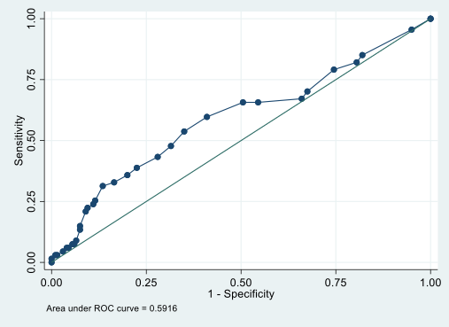

Figure 2a. Kaplan Meier Survival Estimates in pN0 patients for OS.

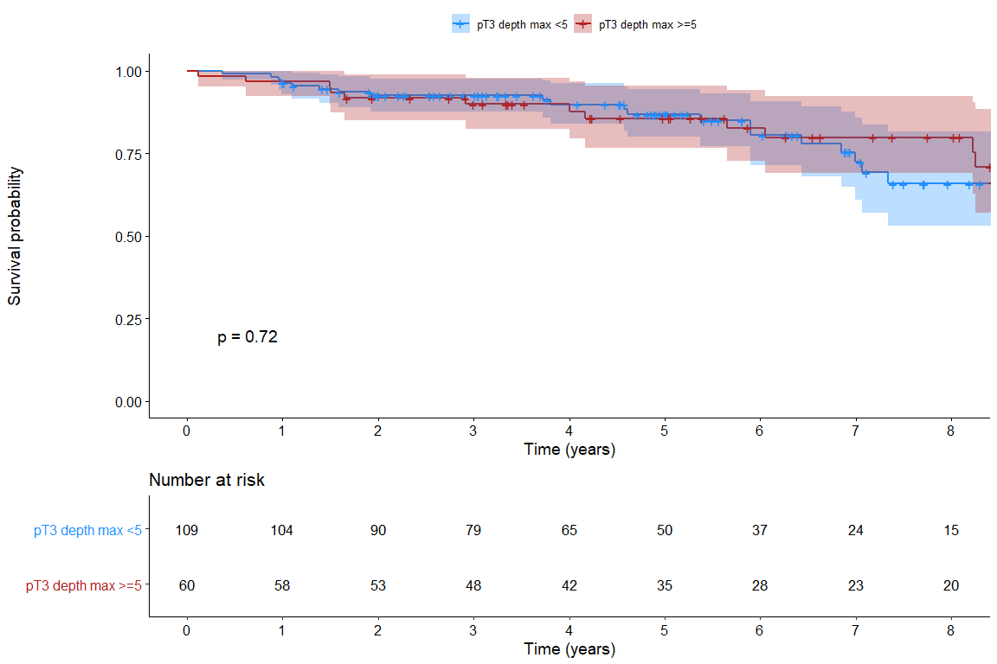

Figure 2b. Kaplan Meier Survival Estimates in pN0 patients for DFS.

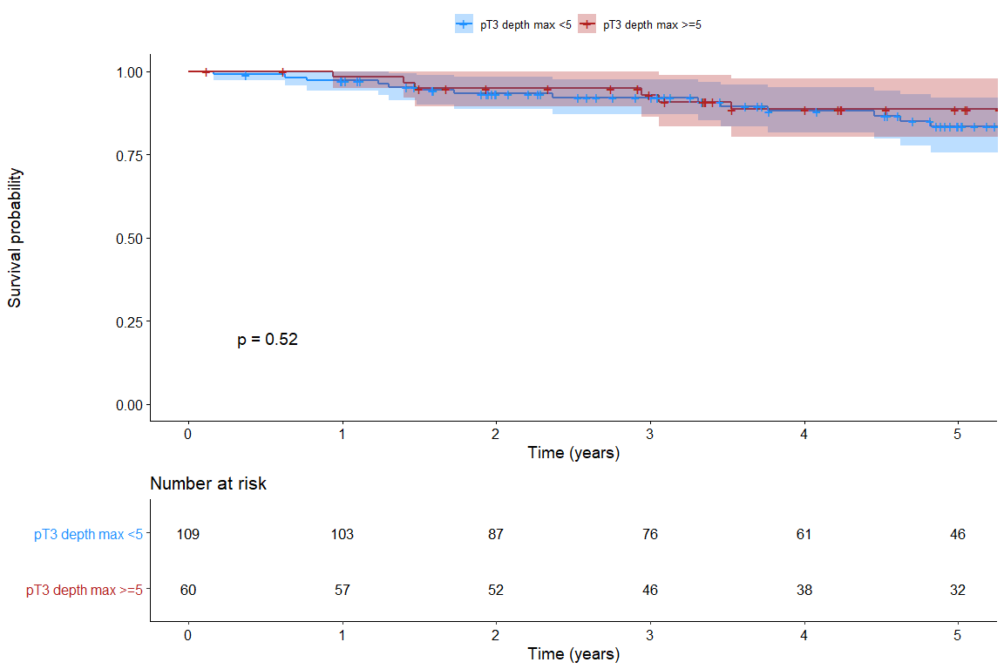

Figure 3a. Estimated Recurrence Risk (Cumulative incidence function) in N0 patients, in pT3>5mm and pT3<5mm
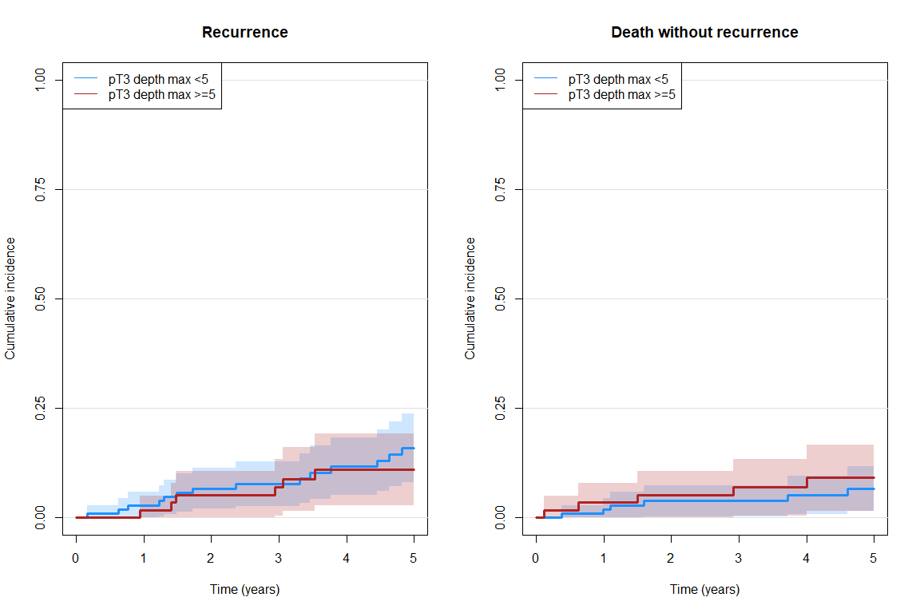
Event | Time | Group | Cumulative incidence | Lower 95% CI | Upper 95% CI | P-value
Recurrence | 3 years | pT3 <5 | 0.077 | 0.026 | 0.128 | 0.489
 |  | pT3 >=5 | 0.068 | 0.004 | 0.133
 | 5 years | pT3 <5 | 0.159 | 0.081 | 0.237
 |  | pT3 >=5 | 0.108 | 0.026 | 0.191
Death without recurrence | 3 years | pT3 <5 | 0.037 | 0.001 | 0.073 | 0.278
 |  | pT3 >=5 | 0.068 | 0.004 | 0.133
 | 5 years | pT3 <5 | 0.065 | 0.014 | 0.117
 |  | pT3 >=5 | 0.090 | 0.014 | 0.166

Figure 3b. Estimated Recurrence Risk (Cumulative incidence function) in N0 patients, in ELI+ and ELI-.
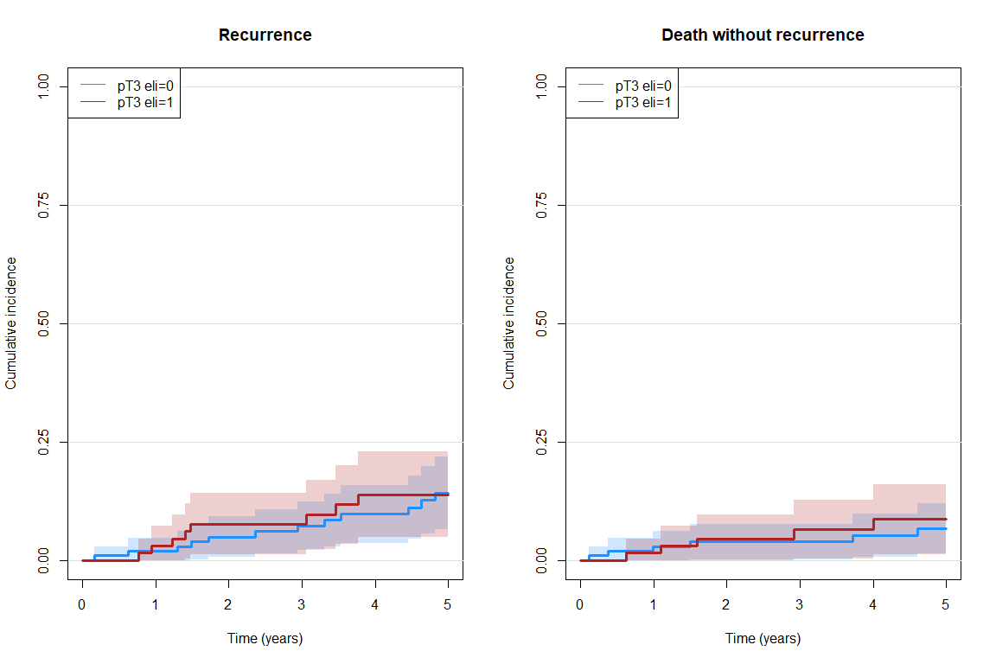
Event | Time | Group | Cumulative incidence | Lower 95% CI | Upper 95% CI | P-value
Recurrence | 3 years | pT3 eli=0 | 0.072 | 0.021 | 0.124 | 0.885
 |  | pT3 eli=1 | 0.077 | 0.012 | 0.141
 | 5 years | pT3 eli=0 | 0.142 | 0.066 | 0.218
 |  | pT3 eli=1 | 0.139 | 0.048 | 0.230
Death without recurrence | 3 years | pT3 eli=0 | 0.039 | 0.002 | 0.077 | 0.959
 |  | pT3 eli=1 | 0.065 | 0.003 | 0.127
 | 5 years | pT3 eli=0 | 0.068 | 0.014 | 0.121
 |  | pT3 eli=1 | 0.087 | 0.013 | 0.160

Figure 4a.. Kaplan Meier Survival Estimates in pN+ patients for OS in ELI+ and ELI-.
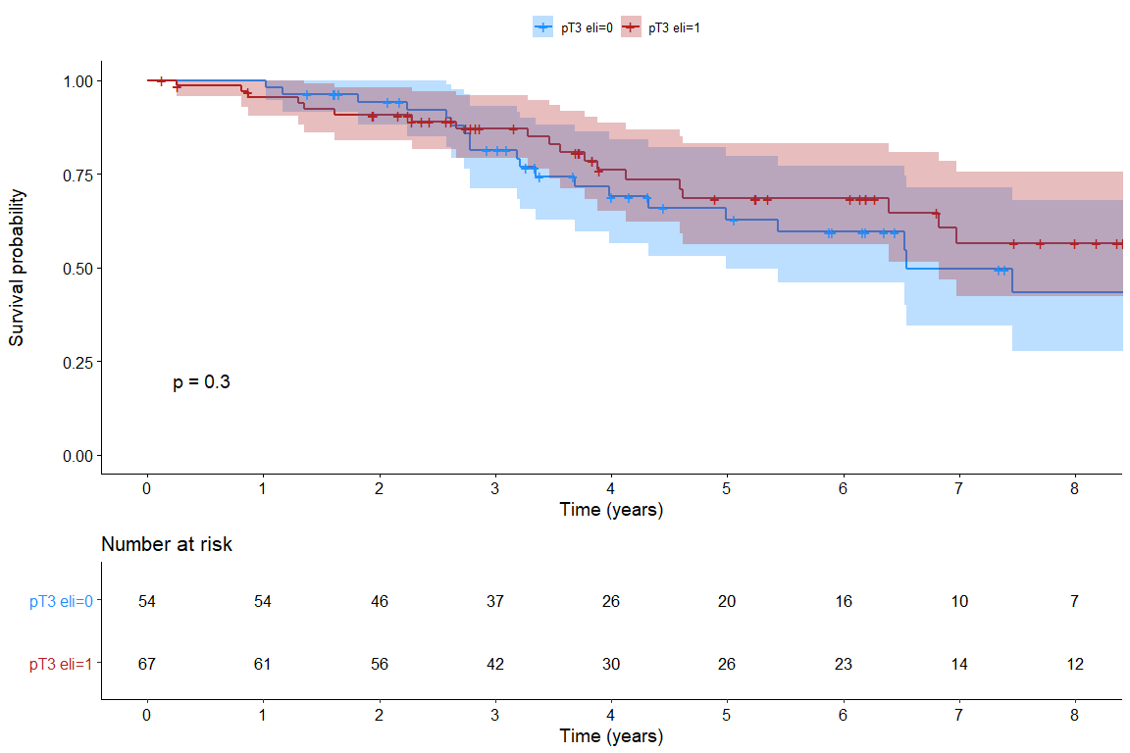

Figure 4b. Kaplan Meier Survival Estimates in pN+ patients for DFS in ELI+ and ELI-.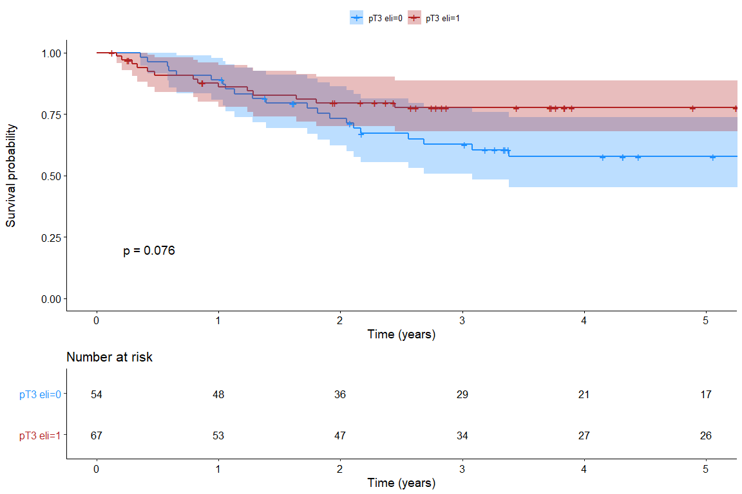

Figure 5a. Estimated Recurrence Risk (Cumulative incidence function) in N+ patients, in pT3>5mm and pT3<5mm 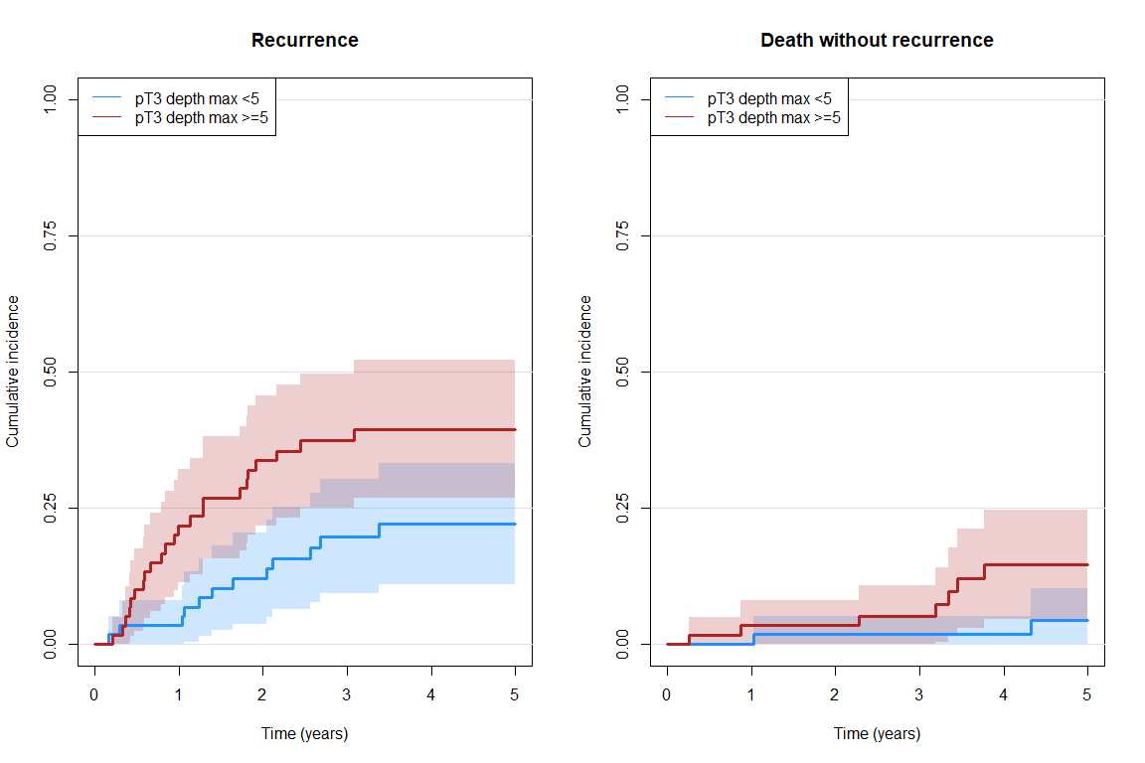
Event | Time | Group | Cumulative incidence | Lower 95% CI | Upper 95% CI | P-value
Recurrence | 3 years | pT3 <5 | 0.197 | 0.092 | 0.303 | 0.023
 |  | pT3 >=5 | 0.373 | 0.249 | 0.497
 | 5 years | pT3 <5 | 0.220 | 0.109 | 0.331
 |  | pT3 >=5 | 0.394 | 0.268 | 0.521
Death without recurrence | 3 years | pT3 <5 | 0.017 | 0.000 | 0.050 | 0.025
 |  | pT3 >=5 | 0.051 | 0.000 | 0.107
 | 5 years | pT3 <5 | 0.042 | 0.000 | 0.101
 |  | pT3 >=5 | 0.145 | 0.044 | 0.246

Figure 5b. Estimated Recurrence Risk (Cumulative incidence function) in N+ patients, in ELI+ and ELI-
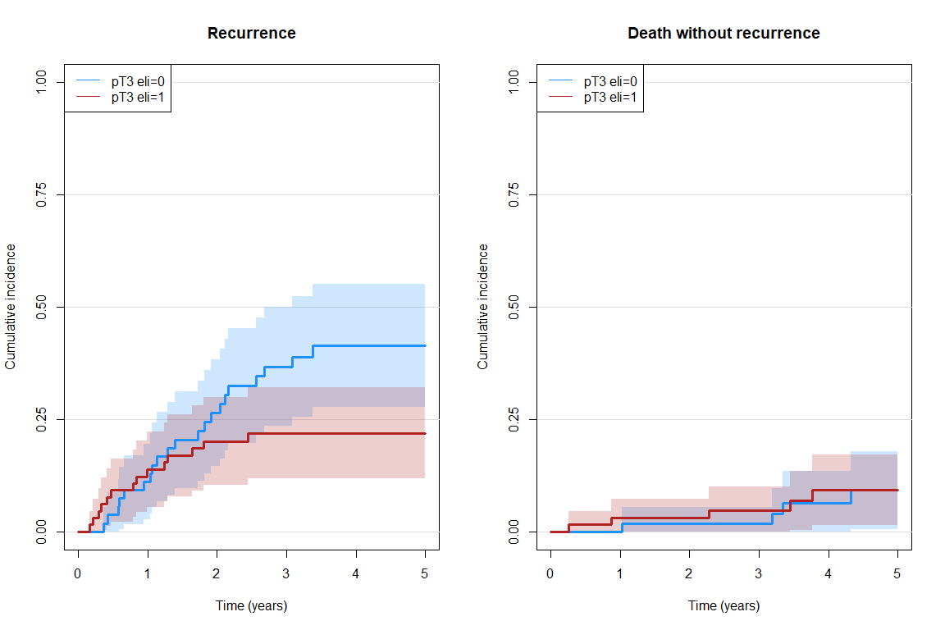
Event | Time | Group | Cumulative incidence | Lower 95% CI | Upper 95% CI | P-value
Recurrence | 3 years | pT3 eli=0 | 0.367 | 0.235 | 0.500 | 0.069
 |  | pT3 eli=1 | 0.219 | 0.117 | 0.321
 | 5 years | pT3 eli=0 | 0.414 | 0.276 | 0.552
 |  | pT3 eli=1 | 0.219 | 0.117 | 0.321
Death without recurrence | 3 years | pT3 eli=0 | 0.019 | 0.000 | 0.055 | 0.746
 |  | pT3 eli=1 | 0.048 | 0.000 | 0.100
 | 5 years | pT3 eli=0 | 0.092 | 0.005 | 0.178
 |  | pT3 eli=1 | 0.092 | 0.014 | 0.170

