Aflibercept with FOLFIRI in Japanese patients with metastatic colorectal cancer: results of a post-marketing surveillance

Jun Watanabe ¹, Tetsuji Terazawa ², Shiho Yamane ³, Hirotaka Kazama ⁴, Hiroyuki Uetake ⁵, Takayuki Yoshino ^{6*}
¹ Department of Surgery, Gastroenterological Center, Yokohama City University Medical Center, Yokohama, Japan,
² Cancer Chemotherapy Center, Osaka Medical and Pharmaceutical University, Osaka, Japan,
³ Sanofi, Medical Affairs, Tokyo, Japan,
⁴ Sanofi, Specialty Care Oncology Medical, Tokyo, Japan,
⁵ Department of Clinical Research, National Disaster Medical Center, Tokyo, Japan,
⁶ Department of Gastrointestinal Oncology, National Cancer Center Hospital East, Kashiwa, Japan
International Journal of Clinical Oncology
Corresponding author*
Dr. Takayuki Yoshino,
Department of Gastroenterology and Gastrointestinal Oncology,
National Cancer Center Hospital
East, Kashiwa, Chiba 277-8577,
Japan
Email: tyoshino@east.ncc.go.jp

Table S1 Treatment emergent adverse events of special interest
Adverse event, n (%) | Patients with any grade (N=235) | Grade ≥3 (n=235) | Patients with  DCR (n=97) |  | Patients without DCR (n=106)
Adverse event, n (%) |  | Grade ≥3 (n=235) | Any grade | Grade ≥3 | Any grade | Grade ≥3
Hypertensions related | 42 (17.9) | 26 (11.1) | 25 (25.8) | 3 (3.1) | 16 (15.1) | 2 (1.9)
Blood pressure increase | 2 (0.9) | 2 (0.9) | 1 (1.0) | - | 1 (0.9) | -
Hypertension | 40 (17.0) | 24 (10.2) | 21 (21.7) | - | 15 (14.2) | -
Hypertension crisis | 1 (0.4) | - | - | - | 1 (0.9) | 1 (0.9)
Proteinuria-related | 74 (31.5) | 25 (10.6) | - | - | - | -
Nephrotic syndrome | 1 (0.4) | 1 (0.4) | - | - | - | -
Protein urine | 13 (5.5) | 1 (0.4) | 8 | - | 3 | -
Proteinuria | 58 (24.7) | 22 (9.36) | 32 (33.0) | - | 23 (21.7) | -
Protein urine present | 4 (1.7) | 1 (0.4) | 2 | - | 2 | -
Urine protein/creatinine ratio increased | 1 (0.4) | - | 3 (3.1) | - | 1 | -
Neutropenia related | 95 (40.4) | 70 (29.8) | - | - | - | -
Febrile neutropenia | 6 (2.6) | 5 (2.1) | - | - | - | -
Neutropenia | 14 (6.0) | 11 (4.7) | - | - | - | -
Neutrophil count decreased | 81 (34.5) | 58 (24.7) | 43 (44.3) | 6 (6.2) | 33 (31.1) | 11 (10.4)
DCR, disease control rate,

Table S2 Number of aflibercept treatment cycles and proportion of patients with controlled disease
Total number of cycles | Effectiveness analysis set, n | DCR, n (%)
All | 198 | 94 (47.5)
1–5 | 81 | 23 (28.4) | p<.0001*
6–10 | 72 | 36 (50.0)
11–15 | 34 | 24 (70.6)
16–20 | 9 | 9 (100.0)
>20 | 2 | 2 (100.0)
DCR, disease control rate, *Chi-square test against All

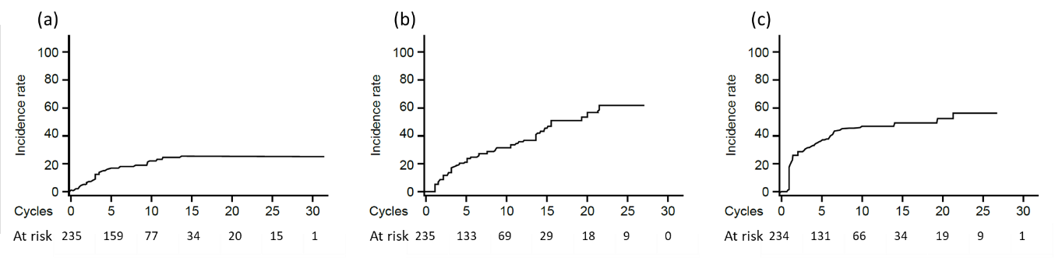
Figure S1 Time to first occurrence of adverse events of special interest: (a) hypertension related (i.e., blood pressure increase, hypertension, hypertension crisis); (b) proteinuria-related (i.e., nephrotic syndrome, protein urine, proteinuria, protein urine present, urine protein/creatinine ratio increased); (c) neutropenia-related (i.e., febrile neutropenia, neutropenia, neutrophil count decreased).

