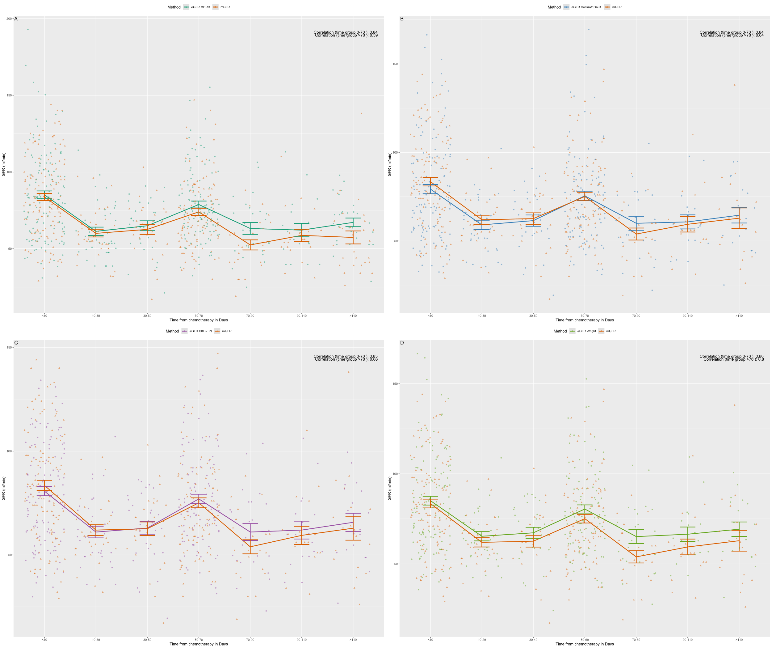
Figure S1: mGFR and eGFR by different formulas plotted longitudinally with Pearson's correlation for agreement between eGFR and mGFR within <70 days from chemo and >70 days from chemo (top-right corner of each graph). A: MDRD calculated eGFR, B: Cockroft-Gault calculated eGFR, C: CKD-EPI calculated eGFR, D: Wright calculated eGFR. All surface normalization has been removed for formulas standardized to a surface area of 1.73m². All correlations are highly statistically significant (top right corner of each graph).

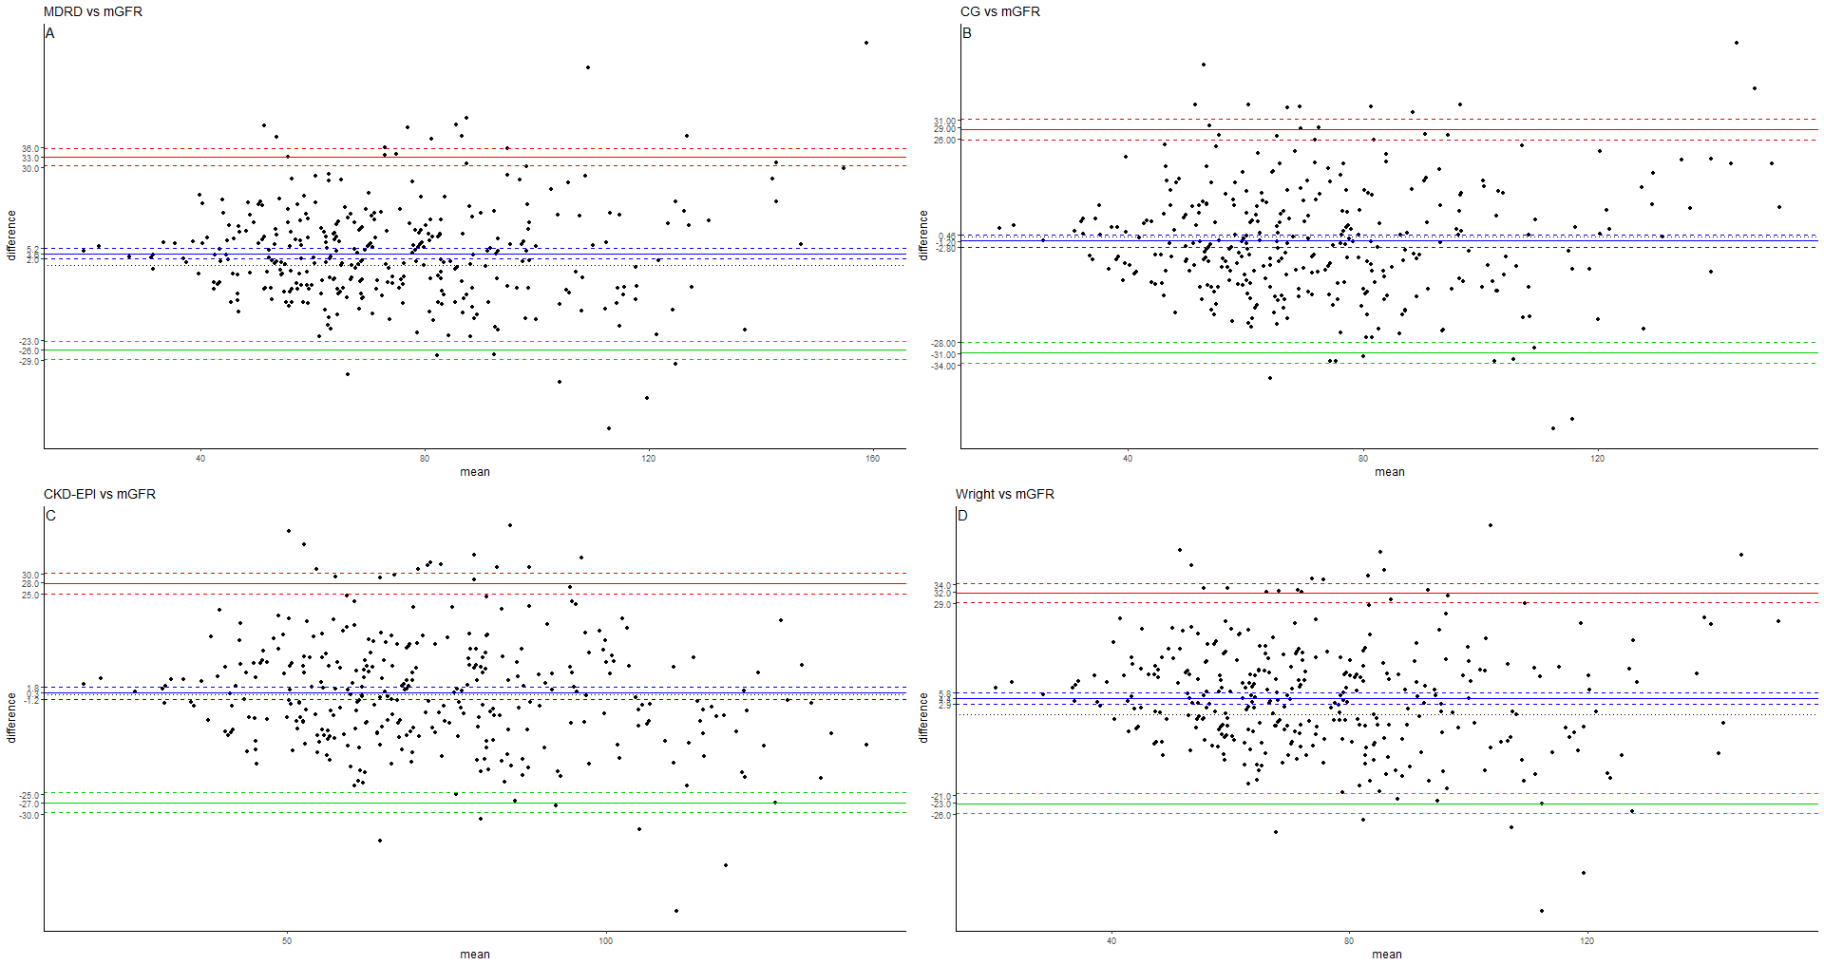
Figure S2: All measurements: Bland-Altmann plots showing mean of measurements eGFR and mGFR by difference between measurements. A: eGFR calculated by MDRD and mGFR, B: eGFR calculated by Cockroft Gault and mGFR, C: eGFR calculated by CKD-EPI and mGFR, D: eGFR calculated by Wright and mGFR. Dashed lines represent 95% Confidence intervals.

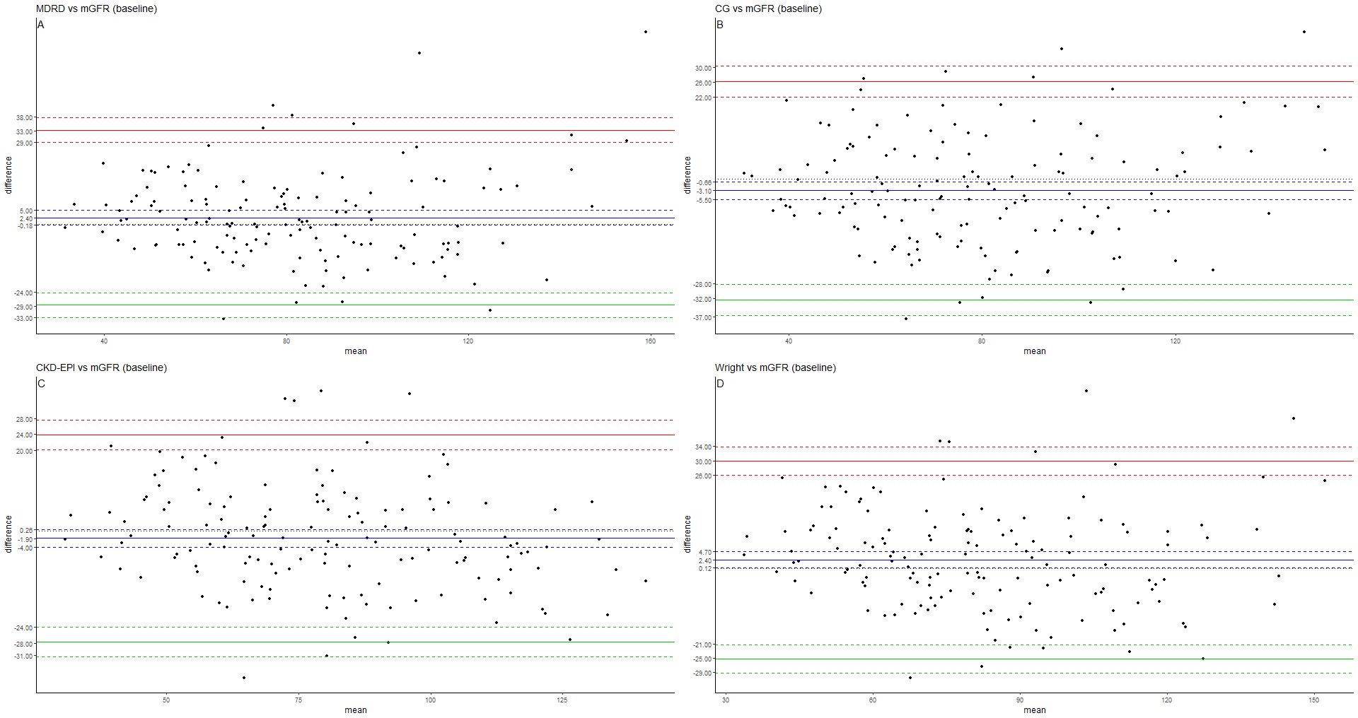
Figure S3 : Bland altman plot of baseline values of eGFR vs mGFR for the four different equations. A: eGFR calculated by MDRD and mGFR, B: eGFR calculated by Cockroft Gault and mGFR, C: eGFR calculated by CKD-EPI and mGFR, D: eGFR calculated by Wright and mGFR. Dashed lines represent 95% Confidence intervals.

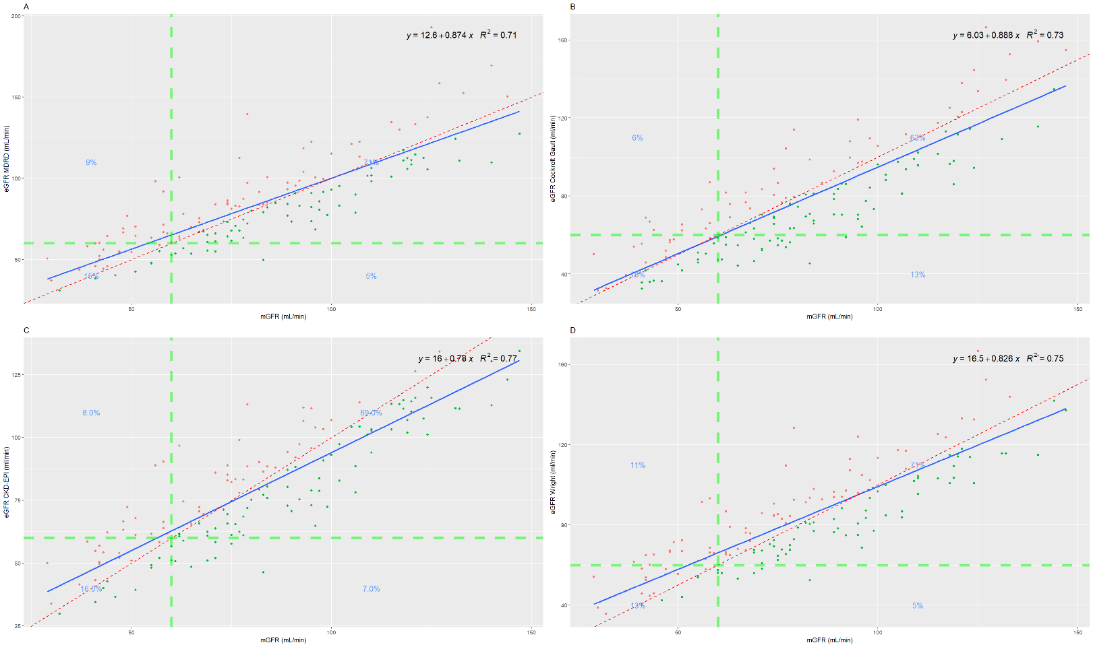
Figure S4: Baseline values of eGFR vs mGFR by A: MDRD, B: Cockroft Gault, C: CKD-EPI, D: Wright. Regression line with intercept, coefficient and R-squared in top right corner of each XY-plot. Green line represents cut-off at 60mL/min and percentages in each graph quadrant represents total % of measurements within quadrant representing agreement (upper right and lower left) between methods. Dotted-red line represents perfect alignment, blue line represent best linear regression line.

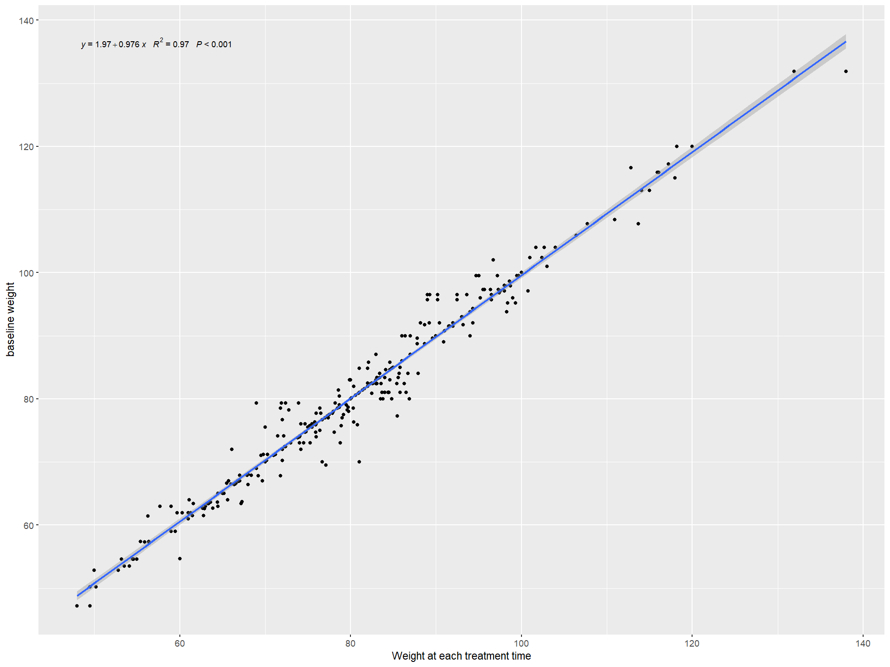

Figure S5, Baseline weight for each patient (Y-axis) against longitudinal weights for each patient showing a good linear relationship with little discrepancy between longitudinal weight and baseline weight with R-squared at 0.97

Table S1
MDRD | eGFR(mL/min/1.73 m2)=175×(SCr×0.0113)−1.154 × Age−0.203 ×(0.742 if female) ×(1.212 if African American)
Cockroft-Gault | eCrCl(mL/min)=(140−Age)×Weight×(1−0.15×Sex)/72×SCr×0.0113 | Sex = 1 if female, 0 if male.
Wright enzymatic | eGFR(mL/min)=(6230−32.8×age)×BSA×(1−0.23×Sex)/SCr
CKD-EPI | eGFR(mL/min/1.73 m2)= 141×min((SCr×0.0113)/κ, 1)α × max((SCr×0.0113)/κ,1)−1.209 ×0.993Age×1.018[ if female]×1.159[ if black] | κ is 0.7 for females and 0.9 for males, α is –0.329 for females and –0.411 for males, min indicates the minimum of SCr × 0.0113/κ or 1, and max indicates the maximum of SCr × 0.0113/κ or 1

Table S1 : Formulas used for estimating GFR.

Table S2
age | crea | sex | mGFR | BSA | eGFR MDRD (mL/min) | eGFR Cockroft Gault (ml/min) | eGFR CKD-EPI (ml/min) | eGFR Wright (ml/min)
67 | 81 | M | 56 | 1.77 | 89.68 | 73.5 | 88.20 | 88.12
74 | 74 | M | 56 | 1.78 | 98.10 | 73.1 | 88.88 | 91.47
74 | 92 | M | 55 | 2.12 | 90.88 | 83.7 | 86.22 | 87.63
65 | 94 | M | 58 | 2.14 | 91.87 | 86.9 | 90.33 | 93.29
Table S2, 4 patients with estimated GFR of >85, and mGFR < 60 but still close to 60, making cisplatin's delivery feasible to these patients.

Chemo cycle number | Mean Cisplatin Dose | Mean mGFR (ml/min) | Mean eGFR CKD-EPI (ml/min) | Mean eGFR Cockroft-Gault (ml/min) | CCC  mGFR vs CKD-EPI | CCC mGFR vs Cockroft-gault
1 | 130.0 | 88.1 | 85.8 | 82.6 | 0.84 | 0.78
2 | 98.0 | 58.7 | 58.5 | 57.3 | 0.67 | 0.68
3 | 109.4 | 68.8 | 72.4 | 71.9 | 0.74 | 0.71
4 | 107.2 | 74.6 | 78.7 | 75.4 | 0.61 | 0.52
Table S3, Cisplatin treated patients, with an overview of the first four cycles, mean cisplatin dose, mean mGFR, mean estimated GFR for CKD-EPI and Cockroft-Gault and Concordance Correlation Coefficient (CCC) at each treatment cycle.

Chemo cycle number | Mean Carboplatin Dose | Mean mGFR (ml/min) | Mean eGFR CKD-EPI (ml/min) | Mean eGFR Cockroft-Gault (ml/min) | CCC  mGFR vs CKD-EPI | CCC mGFR vs Cockroft-gault
1 | 325.4 | 64.6 | 66.4 | 64.6 | 0.84 | 0.84
2 | 286.4 | 60.4 | 56.3 | 54.6 | 0.86 | 0.83
3 | 281.4 | 57.0 | 59.5 | 56.6 | 0.81 | 0.81
4 | 270.6 | 67.8 | 70.4 | 70.8 | 0.90 | 0.92

Table S4: Carboplatin treated patients, with overview of the first four cycles, mean carboplatin dose, mean mGFR, mean estimated GFR for CKD-EPI and Cockroft-Gault and Concordance Correlation Coefficient (CCC) at each treatment cycle.

