Supplementary Table 1. Evaluation of the PD-L1 subgroups in the PACIFIC trial
A. Required factors
- Does the primary outcome of the study show the meaningful benefit based on the intention-to-treat analysis?  - Was the subgroup variable a pre-randomized factor?  - Was there a meaningful difference between the subgroups in the interaction test?  (p < 0.05: surely; 0.05 ≤ p < 0.15: plausible ) |  |  |  |  |  | Yes  Yes  Yes  p = 0.005
B. Credibility Assessment
Design | 1. Was the subgroup hypothesis predetermined?  2. Was the subgroup factor a stratified allocation factor or adjusted for important prognostic factors? |  |  |  |  | No  No
Analysis | 1. Was the subgroup analysis performed on the basis of Intention-to-treat?  2. Was the subgroup analysis consistent with the relevant outcomes in this trial? |  |  |  |  | No  No
Context | 1. Was the subgroup analysis consistent with other independent clinical trials?  2. Was there a basic research context that could explain the subgroup effects obtained? |  |  |  |  | NE  Yes
Very high (+3) |  |  | High (+2) | Moderate (+1) | Low (0)
C. Clinical Assessment
Indirectness of CQ |  | Is the subgroup non-directive to the assumed clinical question? |  |  | High (0)
Clinical impact |  | Does the subgroup have a greater clinical impact on treatment decisions? |  |  | High (+1)
Risk evaluation |  | Does the subgroup influence treatment decisions due to risk of harm? |  |  | High (+1)
Final Decision |  |  | Applicable (≥4) | Partially applicable (2–3) | Not applicable (≤1)
Supplementary Table 2. Evaluation of the PD-L1 subgroups in the IMpower010 trial
A. Required Factors
- Does the primary outcome of the study show the meaningful benefit based on the intention-to-treat analysis?  - Was the subgroup variable a pre-randomized factor?  - Was there a meaningful difference between the subgroups in the interaction test?  (p < 0.05: surely; 0.05 ≤ p < 0.15: plausible ) |  |  |  |  |  | Yes  Yes  Yes  p = 0.041
B. Credibility Assessment
Design | 1. Was the subgroup hypothesis predetermined?  2. Was the subgroup factor a stratified allocation factor or adjusted for important prognostic factors? |  |  |  |  | Yes  No
Analysis | 1. Was the subgroup analysis performed on the basis of intention-to-treat?  2. Was the subgroup analysis consistent with the relevant outcomes in this trial? |  |  |  |  | Yes  Yes
Context | 1. Was the subgroup analysis consistent with other independent clinical trials?  2. Was there a basic research context that could explain the subgroup effects obtained? |  |  |  |  | No  Yes
Very high (+3) |  |  | High (+2) | Moderate (+1) | Low (0)
C. Clinical Assessment
Indirectness of CQ |  | Is the subgroup non-directive to the assumed clinical question? |  |  | Not evaluable
Clinical impact |  | Does the subgroup have a greater clinical impact on treatment decisions? |  |  | High (+1)
Risk evaluation |  | Does the subgroup influence treatment decisions due to risk of harm? |  |  | High (+1)
Final Decision |  |  | Applicable (≥4) | Partially applicable (2–3) | Not applicable (≤1)
Supplementary Figure 1. Interaction test of the PD-L1 subgroups in the PACIFIC trial

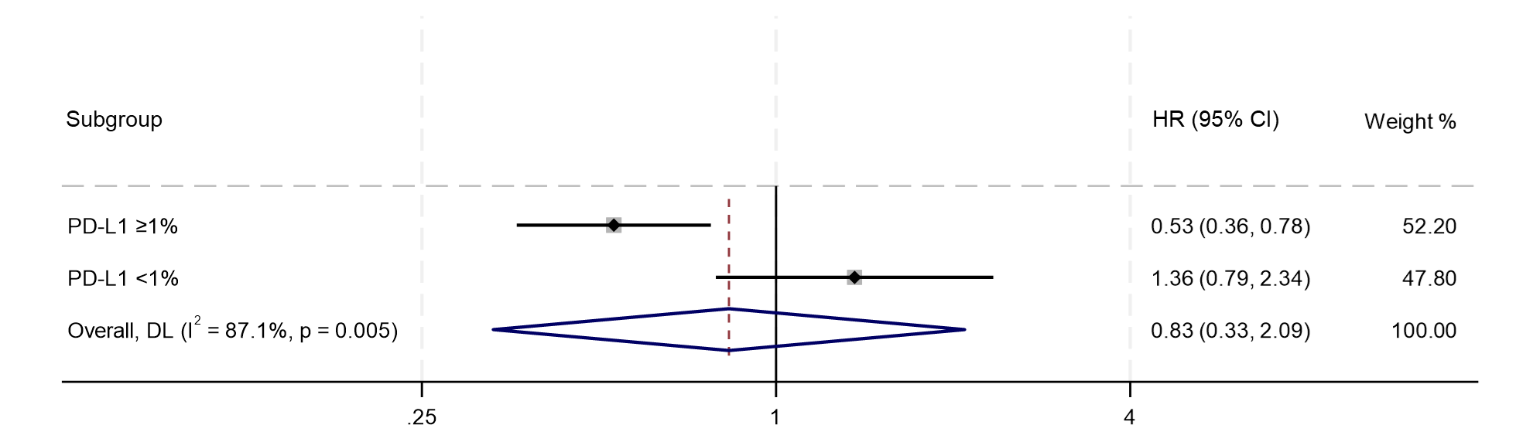
Supplementary Figure 2. Interaction test of the PD-L1 subgroups in the IMpower010 trial

