Supplementary Materials
Supplementary Fig. S1
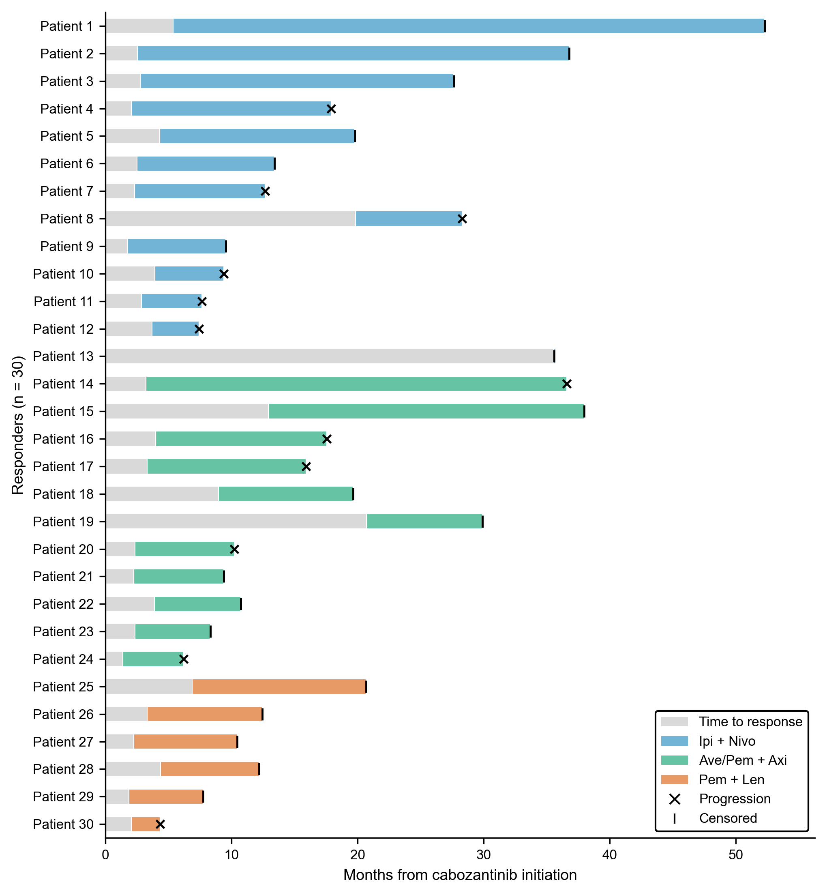

Supplementary Table S1 —Time to response and duration of response among the 30 responders with a retrievable date of first documented response, overall and by the preceding first-line regimen.
Group | Responders, n | With response date, n | Median TTR, months (IQR) | DOR events | Median DOR, months (95% CI)
Overall | 33 | 30 | 3.3 (2.3–4.4) | 12 | 15.9 (10.3–NR)
Ipi + Nivo | 14 | 13 | 2.9 (2.5–4.3) | 6 | 15.9 (4.8–NR)
Ave/Pem + Axi | 13 | 11 | 3.3 (2.3–6.5) | 5 | 13.6 (7.9–33.3)
Pem + Len | 6 | 6 | 2.8 (2.1–4.1) | 1 | NR (2.3–NR)
TTR time to response; DOR duration of response; NR not reached. DOR was estimated by the Kaplan–Meier method among responders with documented response dates. Individual patient data are shown in anonymized form in Supplementary Fig. S1 (Patient 1–30).

Supplementary Table S2 — Third-line therapy after cabozantinib discontinuation, including the proportion of patients proceeding to third-line treatment, the regimens administered, best objective response, and duration of third-line therapy, stratified by the preceding first-line regimen.
A. Proportion proceeding to third-line therapy
Group | N | Third-line, n (%) of all | Third-line, % of known | Unknown, n
Overall | 96 | 40 (41.7) | 44.9 | 7
Ipi + Nivo | 36 | 14 (38.9) | 40.0 | 1
Ave/Pem + Axi | 30 | 16 (53.3) | 57.1 | 2
Pem + Len | 30 | 10 (33.3) | 38.5 | 4
Between-group P value (Fisher exact, known cases) = 0.31.
B. Third-line regimens
Group | Regimen | N
Overall | Axitinib | 15
Overall | Nivolumab | 14
Overall | Everolimus | 4
Overall | Sunitinib | 3
Overall | Belzutifan | 3
Overall | Pazopanib | 1
Ipi + Nivo | Axitinib | 9
Ipi + Nivo | Sunitinib | 1
Ipi + Nivo | Nivolumab | 1
Ipi + Nivo | Everolimus | 1
Ipi + Nivo | Belzutifan | 1
Ipi + Nivo | Pazopanib | 1
Ave/Pem + Axi | Nivolumab | 10
Ave/Pem + Axi | Everolimus | 2
Ave/Pem + Axi | Sunitinib | 2
Ave/Pem + Axi | Belzutifan | 1
Ave/Pem + Axi | Axitinib | 1
Pem + Len | Axitinib | 5
Pem + Len | Nivolumab | 3
Pem + Len | Everolimus | 1
Pem + Len | Belzutifan | 1

C. Third-line outcomes
Group | Treated, n | Evaluable, n | ORR, % | DCR, % | Median duration, months (95% CI) | PR/SD/PD/NE/Unknown | Duration n
Overall | 40 | 35 | 8.6 | 34.3 | 2.4 (1.1–3.9) | 3/9/23/4/1 | 34
Ipi + Nivo | 14 | 13 | 23.1 | 61.5 | 3.9 (1.1–9.8) | 3/5/5/1/0 | 11
Ave/Pem + Axi | 16 | 16 | 0.0 | 18.8 | 2.4 (0.5–2.8) | 0/3/13/0/0 | 15
Pem + Len | 10 | 6 | 0.0 | 16.7 | 1.4 (0.2–5.7) | 0/1/5/3/1 | 8
ORR objective response rate; DCR disease control rate. Median duration was estimated by Kaplan–Meier among patients with available duration data; patients with blank treatment-status fields were treated as discontinued for this estimate.

