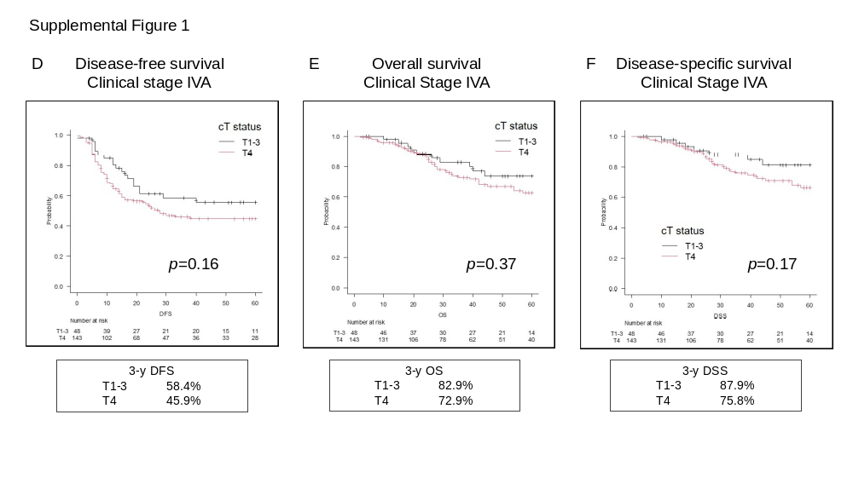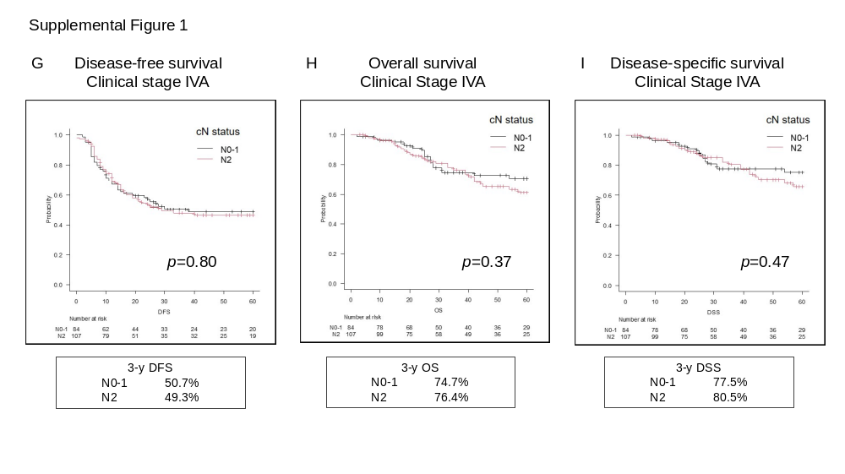
Supplemental Figure 1. Kaplan-Meier survival curves according to age (<72 years versus ≥72 years), T status (T1-3 versus T4), and N status (N0-1 versus N2) in patients with stage IVA disease. (A–C) Disease-free survival (DFS), overall survival (OS), and disease-specific survival (DSS) according to age. (D–F) Survival outcomes according to T status. (G–I) Survival outcomes according to N status. Three-year survival rates and log-rank P values are shown.

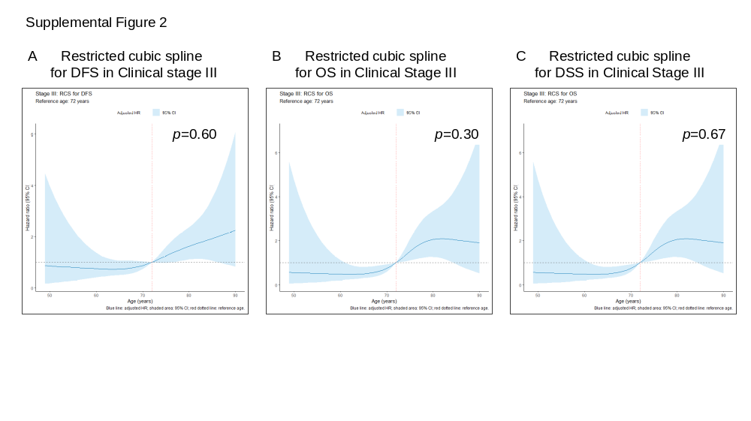
Supplemental Figure 2. Restricted cubic spline analyses of the association between age and survival outcomes in patients with stage III laryngeal squamous cell carcinoma. Hazard ratios (HRs) were estimated using Cox proportional hazards models adjusted for primary tumor site and clinical N status. HRs were normalized to 1.0 at age 72 years. The solid blue lines represent adjusted HRs, and the shaded areas represent 95% confidence intervals. The red dotted lines indicate the reference age of 72 years, and the gray dashed lines indicate HR = 1.0. (A) Disease-free survival (DFS), P for nonlinearity = 0.603; (B) overall survival (OS), P for nonlinearity = 0.304; and (C) disease-specific survival (DSS), P for nonlinearity = 0.678.

Supplemental Table 1. Comparison of patient characteristics between the surgery and chemoradiotherapy groups

Characteristics | Surgery (n = 381) | Chemoradiotherapy (n = 206) | P
Age, median (range), y | 72 (41–94) | 66 (31–83) | < 0.001
Sex, no. (%)
Male | 361 (94.8) | 181 (87.9) | 0.0051
Female | 20 (5.2) | 25 (12.1) | 0.0051
Primary tumor site, no. (%)
Glottic | 202 (53.0) | 83 (40.2) | < 0.001
Supraglottic | 147 (38.6) | 119 (57.8) | < 0.001
Subglottic | 32 (8.4) | 4 (1.9) | < 0.001
Clinical T status, no. (%)
cT1 | 3 (0.8) | 6 (2.9) | < 0.001
cT2 | 14 (3.7) | 35 (17.0) | < 0.001
cT3 | 221 (58.0) | 139 (67.5) | < 0.001
cT4a | 143 (37.5) | 26 (12.6) | < 0.001
Clinical N status, no. (%)
cN0 | 228 (59.8) | 108 (52.4) | 0.12
cN1 | 46 (12.1) | 32 (15.5) | 0.12
cN2 | 107 (28.1) | 66 (32.0) | 0.12
Clinical stage, no. (%)
III | 190 (49.9) | 126 (61.1) | 0.0093
IVA | 191 (50.1) | 80 (38.8) | 0.0093

