Tables

Damage category | Unit | Lap. ICR | Lap. STC | LIFT
Human health | DALY | 0,000215 | 0,000235 | 0,000090
Eco systems | species.yr | 4,74E-07 | 5,19E-07 | 2,08E-07
Resources | USD2013 | 12,68 | 13,83 | 5,47

Table 1 Endpoint analysis focusing on the effect and damage on three
aggregation levels (‘areas of protection’): the impact on our ecosystem (in species per year), human
health (in DALY’s: disability-adjusted life years) and resources (in dollars) as a result of one single
surgery.

Figures

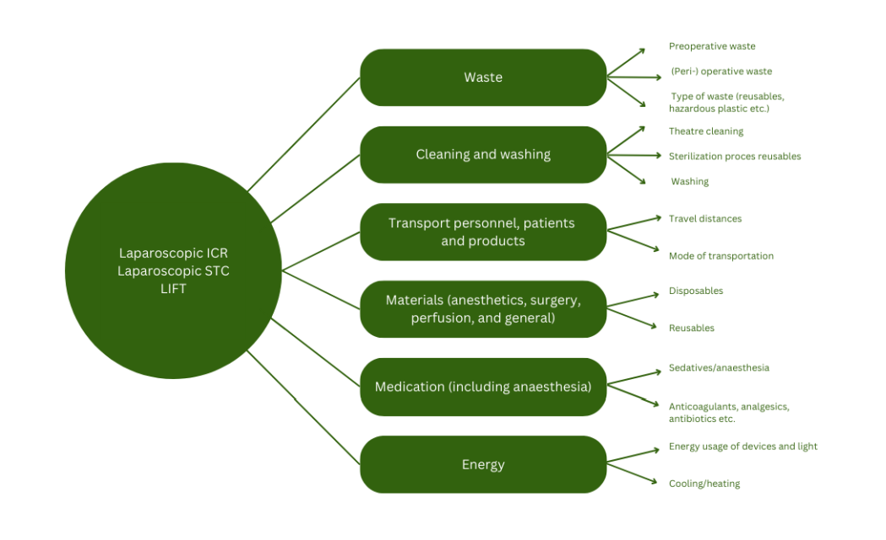

Figure 1 System boundary showing all included aspects as observed during a single
laparoscopic ICR, a single laparoscopic STC, and a single LIFT procedure

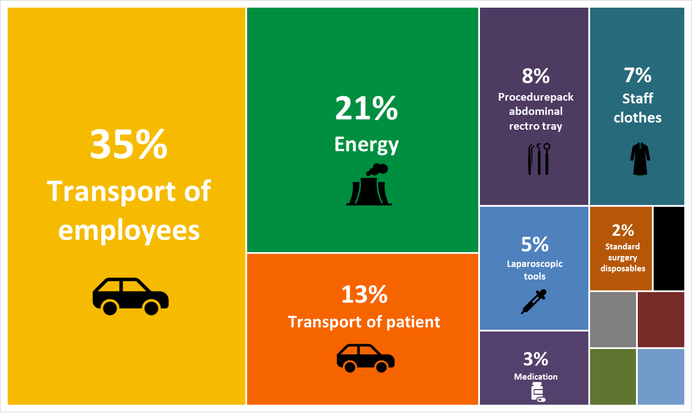
Figure 2a Tree map of the LCA of laparoscopic ICR for terminal ileitis in CD (total CO2eq emission = 104kg)

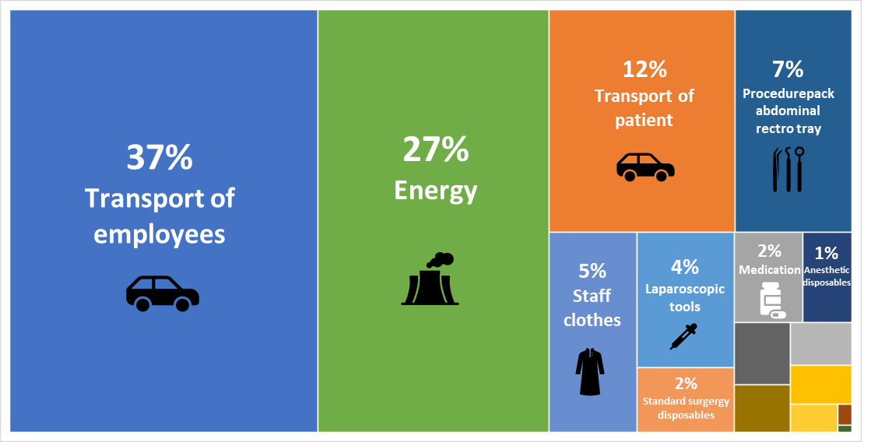

Figure 2b Tree map of the LCA of laparoscopic STC in UC patients (total CO2eq emission = 116kg)

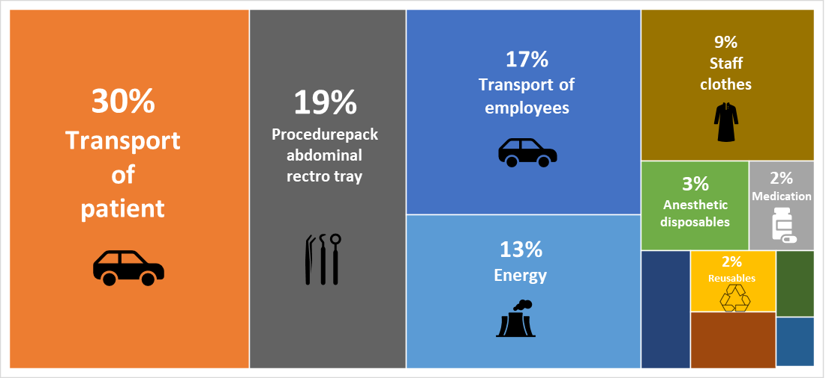

Figure 2c Tree map of the LCA of LIFT procedures in Crohn’s PAF patients (total CO2eq emission = 43.6kg)

Figure 3a Midpoint analysis showing the impact on specific environmental factors (e.g. water consumption or global warming) of all separate items from the LCA of one laparoscopic ICR for terminal ileitis in a CD patient

Figure 3b Midpoint analysis showing the impact on specific environmental factors (e.g. water consumption or global warming) of all separate items from the LCA of one laparoscopic STC in a UC patient

Figure 3c Midpoint analysis showing the impact on specific environmental factors (e.g. water consumption or global warming) of all separate items from the LCA of one LIFT procedure in a Crohn’s PAF patient

Supplementary Figures

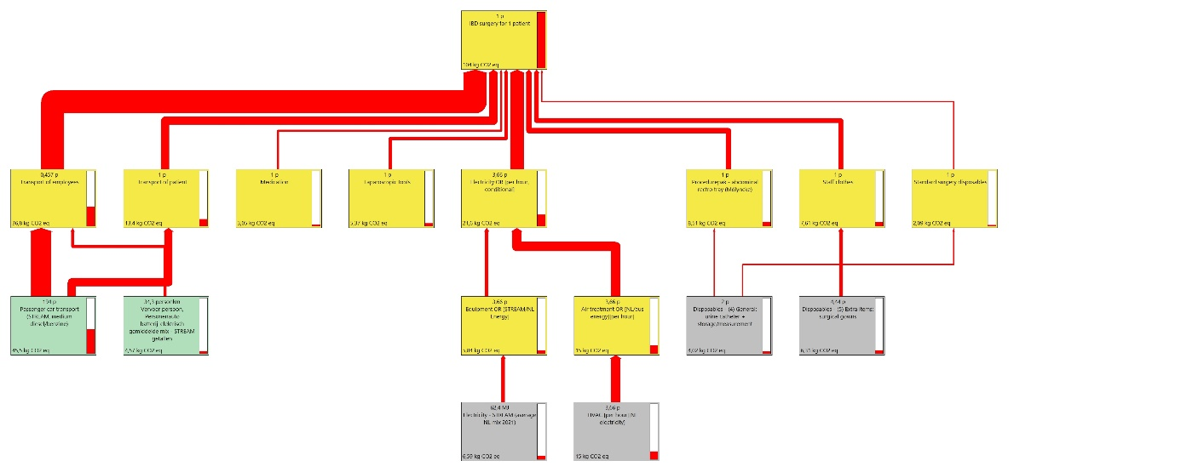
Supplementary Figure 1a LCA process tree illustrating the impact assessment (1.5% cut-off) expressed in CO2eq of one laparoscopic ICR for terminal ileitis in CD. Thickness of the red lines shows the impact of each input. Eq: equivalents, GLO: Global Emission Averages, MJ: mega joule, RoW: Rest of World emission averages, HVAC: heating, ventilation and air conditioning.

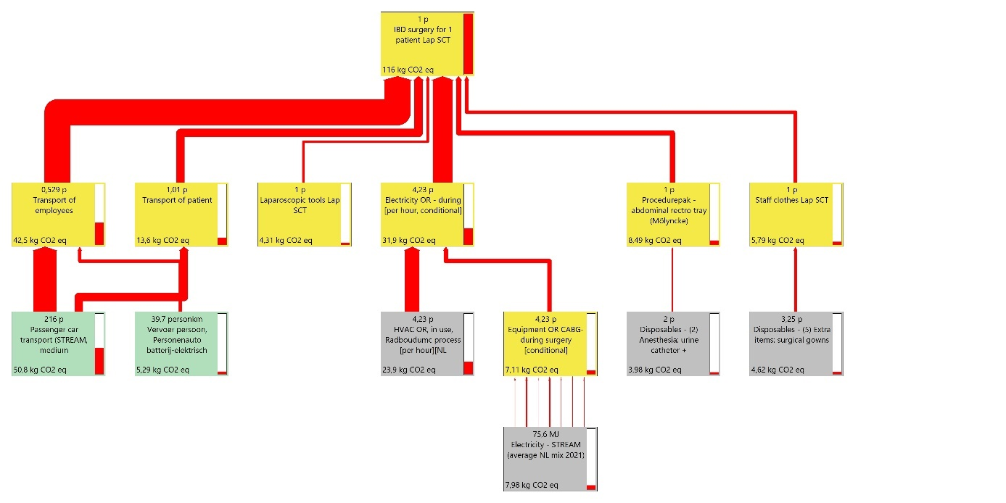
Supplementary Figure 1b LCA process tree illustrating the impact assessment (1.5% cut-off) expressed in CO2eq of one laparoscopic STC in UC. Thickness of the red lines shows the impact of each input. Eq: equivalents, GLO: Global Emission Averages, MJ: mega joule, RoW: Rest of World emission averages, HVAC: heating, ventilation and air conditioning.

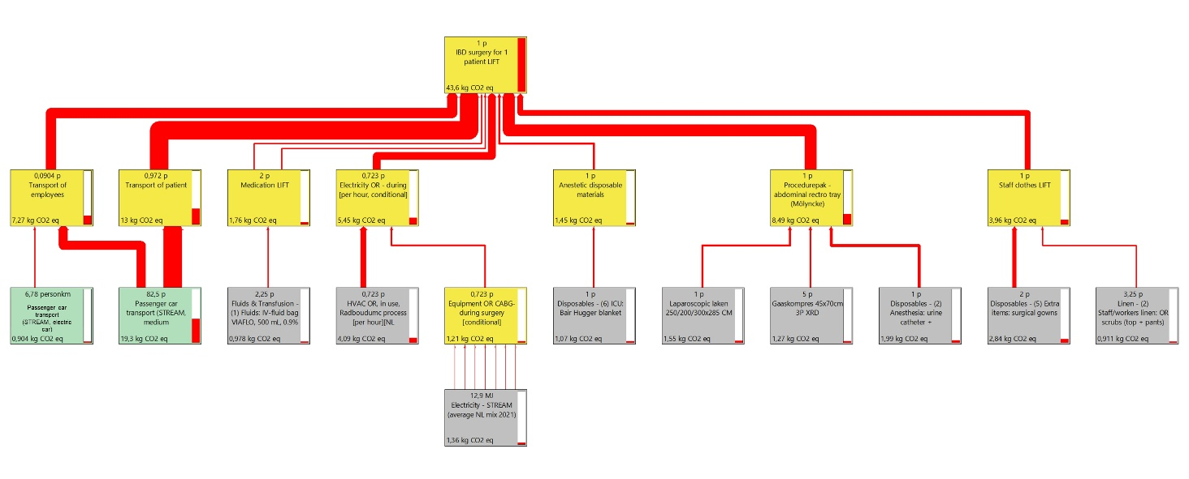
Supplementary Figure 1c LCA process tree illustrating the impact assessment (1.5% cut-off) expressed in CO2eq of one LIFT procedure in a Crohn’s PAF patient. Thickness of the red lines shows the impact of each input. Eq: equivalents, GLO: Global Emission Averages, MJ: mega joule, RoW: Rest of World emission averages, HVAC: heating, ventilation and air conditioning.

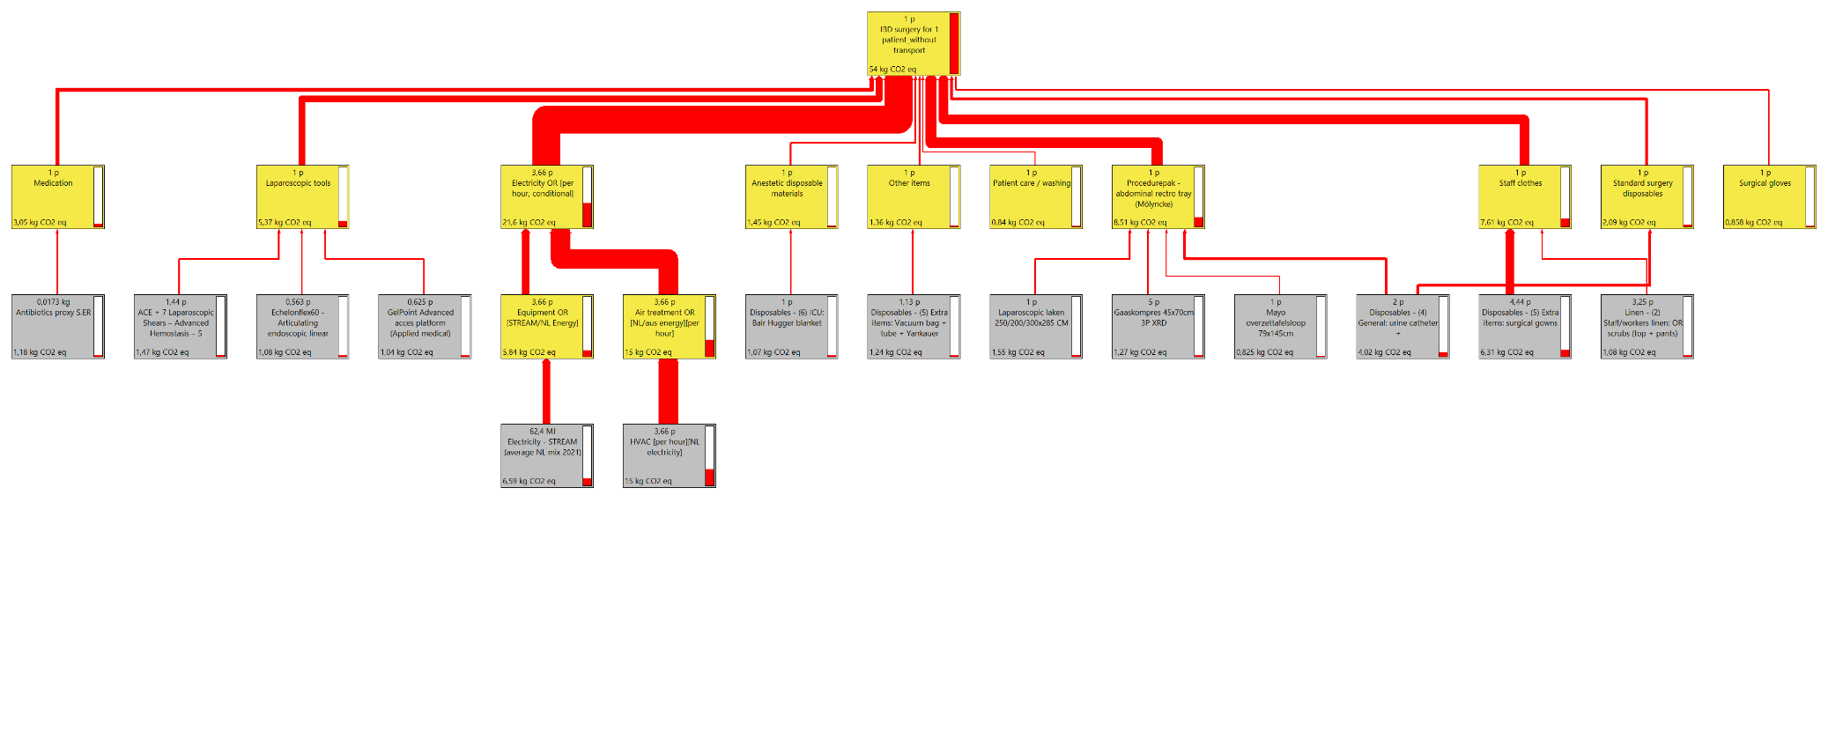
Supplementary Figure 2a LCA process tree illustrating the impact assessment (1.5% cut-off) expressed in CO2eq of one laparoscopic ICR for terminal ileitis in CD (without transport of personnel and patients). Thickness of the red lines shows the impact of each input. Eq: equivalents, GLO: Global Emission Averages, MJ: mega joule, RoW: Rest of World emission averages, HVAC: heating, ventilation and air conditioning.

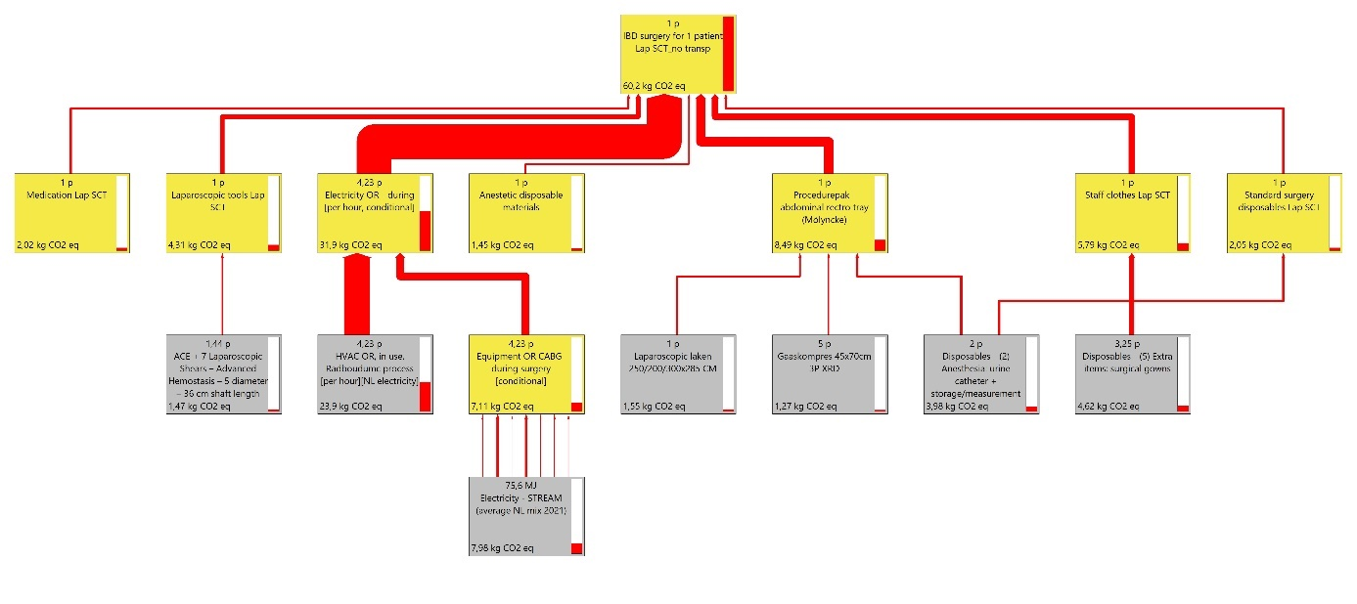
Supplementary Figure 2b LCA process tree illustrating the impact assessment (1.5% cut-off) expressed in CO2eq of one laparoscopic STC in UC (without transport of personnel and patients). Thickness of the red lines shows the impact of each input. Eq: equivalents, GLO: Global Emission Averages, MJ: mega joule, RoW: Rest of World emission averages, HVAC: heating, ventilation and air conditioning.

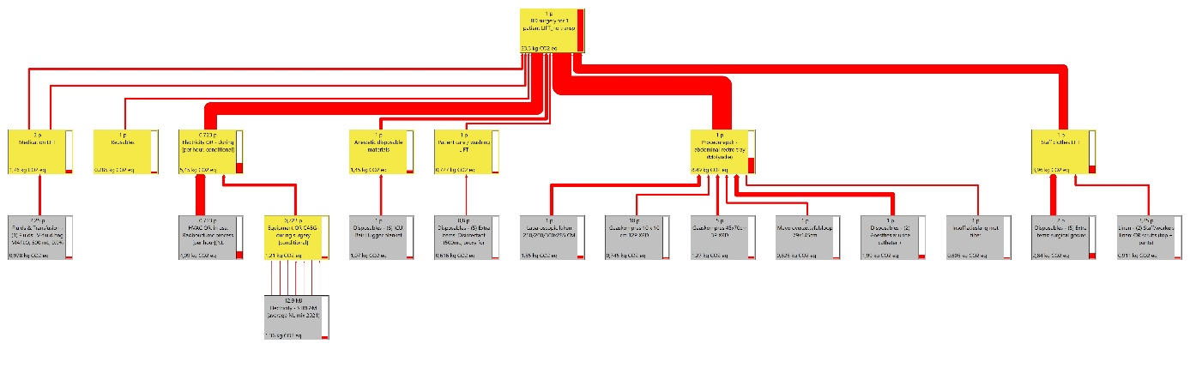

Supplementary Figure 2c LCA process tree illustrating the impact assessment (1.5% cut-off) expressed in CO2eq of one LIFT procedure in a Crohn’s PAF patient (without transport of personnel and patients). Thickness of the red lines shows the impact of each input. Eq: equivalents, GLO: Global Emission Averages, MJ: mega joule, RoW: Rest of World emission averages, HVAC: heating, ventilation and air conditioning.

Supplementary Figure 3a Endpoint analysis of laparoscopic ICR for terminal ileitis in CD patients – damage assessment

Supplementary Figure 3b Endpoint analysis of laparoscopic STC in UC – damage assessment

Supplementary Figure 3c Endpoint analysis of LIFT procedures in Crohn’s PAF patients – damage assessment

