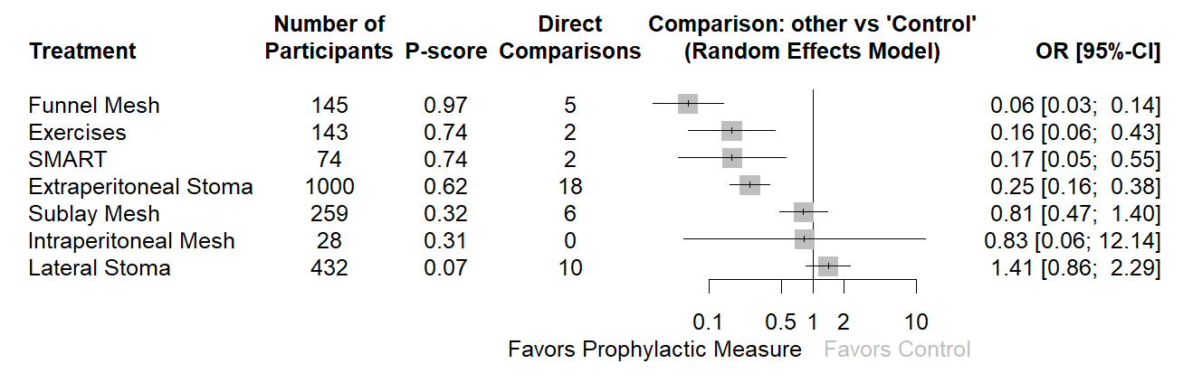
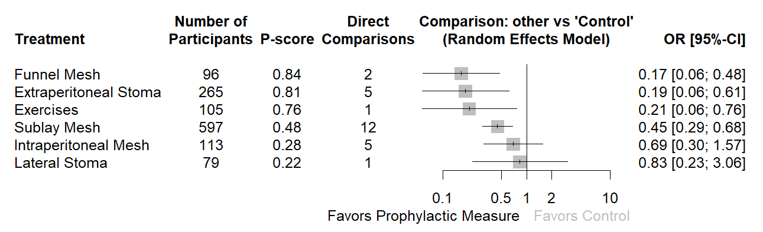
Figure 1. Forest plot depicting the network model for Randomized Clinical Trials.

Figure 2. Forest plot depicting the network model for Non Randomized Clinical Trials.

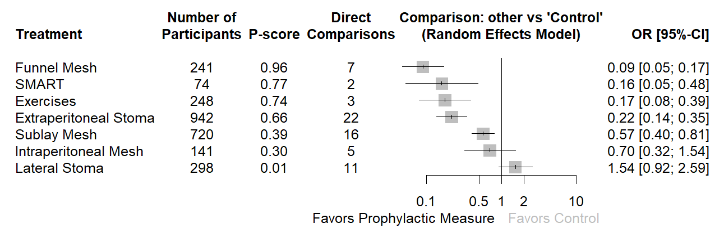Figure 3. Forest plot depicting the network model for digestive stomas.

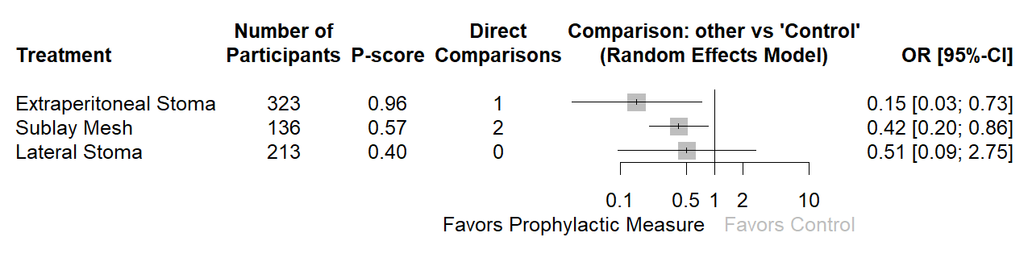Figure 4. Forest plot depicting the network model for ileal conduit.

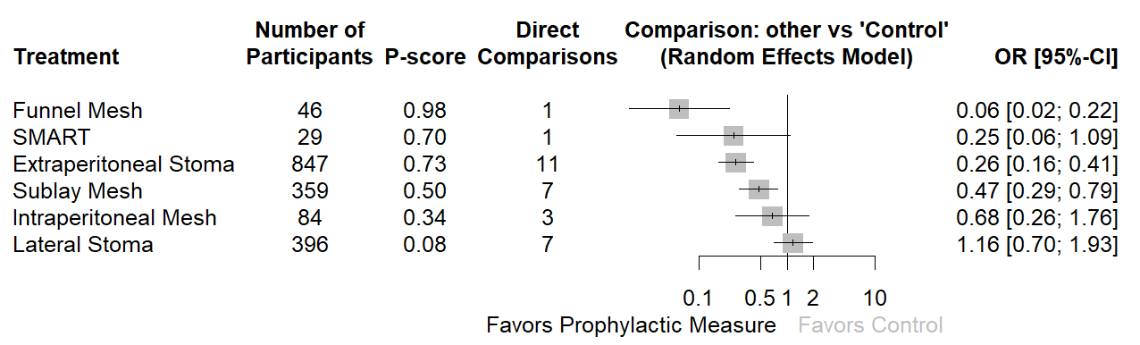Figure 5. Forest plot depicting the network model for follow-up ≥ 24 months.

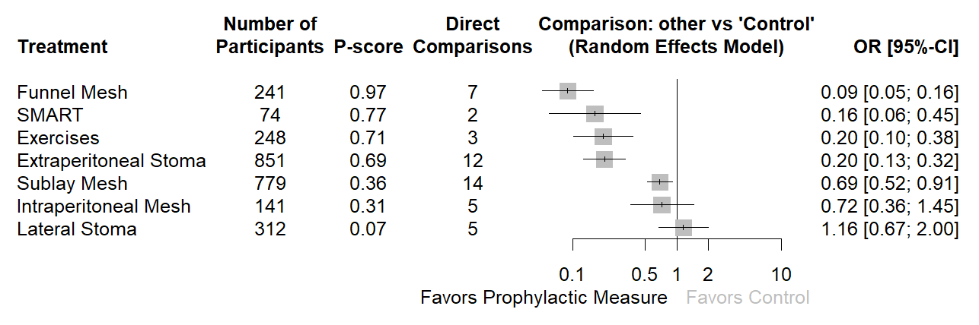

Figure 6. Forest plot depicting the model for Computed Tomography (CT) diagnosis of parastomal hernia.

