Operative time | Beta | p-val | LL | UL
Raw | 2.837 | 0.557 | -6.630 | 12.304
Multi | 4.394 | 0.341 | -4.652 | 13.440
g-comp | 4.394 | 0.177 | -5.180 | 13.586
PSM | 5.150 | 0.397 | -6.786 | 17.086
30-day post operative complication | OR | p-val | LL | UL
Raw | 1.320 | 0.084 | 0.962 | 1.809
Multi | 1.213 | 0.300 | 0.841 | 1.747
g-comp | 1.206 | 0.287 | 0.854 | 1.704
PSM | 1.185 | 0.384 | 0.809 | 1.737
30-day readmission | OR | p-val | LL | UL
Raw | 0.637 | 0.262 | 0.270 | 1.335
Multi | 0.602 | 0.276 | 0.227 | 1.434
g-comp | 0.610 | 0.266 | 0.256 | 1.456
PSM | 0.654 | 0.365 | 0.251 | 1.617
Serious complications | OR | p-val | LL | UL
Raw | 1.513 | 0.108 | 0.903 | 2.487
Multi | 1.451 | 0.231 | 0.781 | 2.647
g-comp | 1.436 | 0.219 | 0.807 | 2.555
PSM | 1.504 | 0.208 | 0.803 | 2.875
30-day reoperation | OR | p-val | LL | UL
Raw | 1.364 | 0.357 | 0.685 | 2.599
Multi | 1.671 | 0.194 | 0.753 | 3.579
g-comp | 1.653 | 0.181 | 0.792 | 3.451
PSM | 1.593 | 0.290 | 0.682 | 3.910
Length of hospital stay | OR | p-val | LL | UL
Raw | 2.048 | 0.000 | 1.079 | 3.017
Multi | 1.915 | 0.000 | 0.848 | 2.982
g-comp | 1.915 | 0.000 | 0.881 | 3.071
PSM | 2.145 | 0.002 | 0.825 | 3.466
Supplementary Table 1: Full Adjusted Associations of Age at Diagnosis (Vienna Classification) with Surgical Outcomes

Supplementary Table 2: Full Adjusted Associations of Age at Diagnosis (Montreal Classification) with Surgical Outcomes.
Operative time | β from A1 to A2 |  | p-value | LL | UL | β from A1 to A3 | p-value | LL | UL
Raw | 9.726 | 0.144 |  | -3.343 | 22.795 | 10.038 | 0.174 | -4.450 | 24.526
Multi | 12.480 | 0.032 |  | 1.059 | 23.901 | 14.028 | 0.042 | 0.503 | 27.553
g-comp | 12.480 | 0.017 |  | 0.536 | 23.835 | 14.028 | 0.023 | 0.218 | 27.733
PSM | 10.251 | 0.043 |  | 0.327 | 20.175 | 10.837 | 0.049 | 0.064 | 21.610
Postop compl | OR A2 vs A1 | p-value |  | LL | UL | OR A3 vs A1 | p-value | LL | UL
Raw | 0.724 | 0.147 |  | 0.470 | 1.124 | 1.003 | 0.989 | 0.622 | 1.625
Multi | 0.734 | 0.184 |  | 0.466 | 1.163 | 0.916 | 0.751 | 0.534 | 1.576
g-comp | 0.740 | 0.076 |  | 0.465 | 1.179 | 0.919 | 0.385 | 0.544 | 1.662
PSM | 0.789 | 0.173 |  | 0.561 | 1.109 | 0.906 | 0.588 | 0.633 | 1.295
Readmission | OR 2 vs 1 | p-value |  | LL | UL | OR 3 vs 1 | p-value | LL | UL
Raw | 0.740 | 0.494 |  | 0.328 | 1.893 | 0.529 | 0.232 | 0.185 | 1.550
Multi | 0.891 | 0.808 |  | 0.368 | 2.429 | 0.584 | 0.379 | 0.175 | 1.986
g-comp | 0.894 | 0.500 |  | 0.395 | 2.922 | 0.593 | 0.500 | 0.167 | 2.147
PSM | 1.168 | 0.687 |  | 0.551 | 2.542 | 0.885 | 0.777 | 0.371 | 2.069
Srs-compl | OR 2 vs 1 | p-val |  | LL | UL | OR 3 vs 1 | p-val | LL | UL
Raw | 0.433 | 0.011 |  | 0.231 | 0.849 | 0.736 | 0.386 | 0.371 | 1.500
Multi | 0.466 | 0.029 |  | 0.239 | 0.949 | 0.690 | 0.377 | 0.304 | 1.594
g-comp | 0.476 | 0.003 |  | 0.246 | 0.996 | 0.697 | 0.159 | 0.331 | 1.535
PSM | 0.548 | 0.036 |  | 0.308 | 0.956 | 0.619 | 0.109 | 0.340 | 1.103
Reop | OR 2 vs 1 | p-value |  | LL | UL | OR 3 vs 1 | p-value | LL | UL
Raw | 0.262 | 0.001 |  | 0.122 | 0.580 | 0.487 | 0.087 | 0.213 | 1.123
Multi | 0.281 | 0.003 |  | 0.124 | 0.655 | 0.562 | 0.250 | 0.209 | 1.516
g-comp | 0.287 | 0.000 |  | 0.123 | 0.687 | 0.568 | 0.101 | 0.228 | 1.496
PSM | 0.361 | 0.006 |  | 0.168 | 0.732 | 0.482 | 0.047 | 0.227 | 0.969
LOS | β from A1 to A2 | p-value |  | LL | UL | β from A1 to A3 | p-val | LL | UL
Raw | -1.045 | 0.126 |  | -2.385 | 0.294 | 1.052 | 0.165 | -0.433 | 2.538
Multi | -1.014 | 0.141 |  | -2.365 | 0.337 | 0.872 | 0.285 | -0.729 | 2.473
g-comp | -1.014 | 0.078 |  | -2.532 | 0.273 | 0.872 | 0.159 | -0.992 | 2.480
PSM | -0.819 | 0.126 |  | -1.869 | 0.232 | 0.570 | 0.313 | -0.539 | 1.679

Vienna Classification
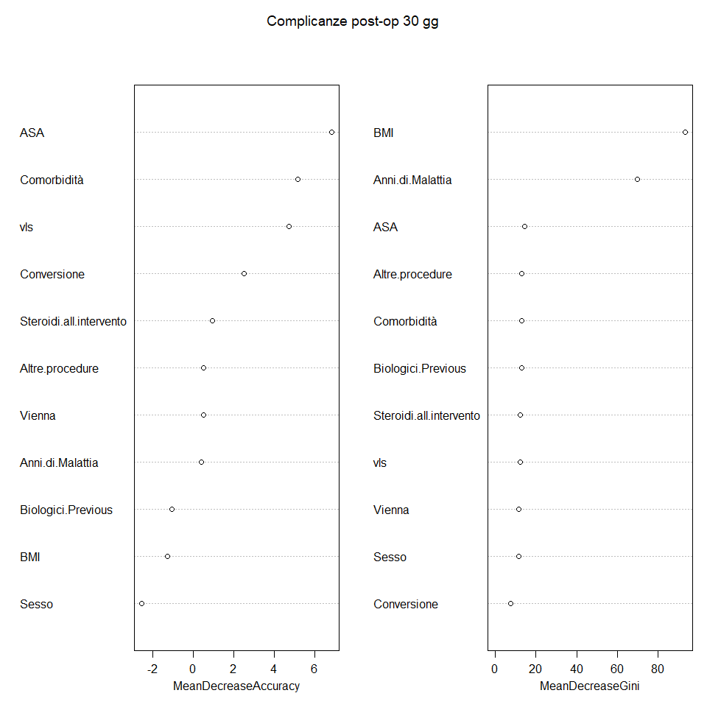
Supplementary Figure 1. 30-day postoperative complications
ASA
Comorbidities
Surgical approach
Conversion to open
Steroids at surgery
Additional procedures
Vienna Classification
Years of disease
Previous use of biologics
BMI
Gender

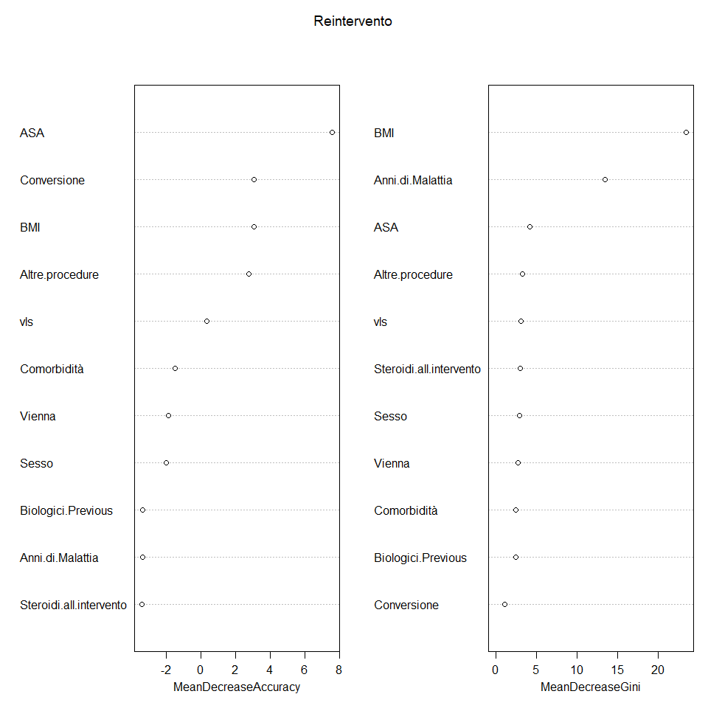
Supplementary Figure 2. 30-day reoperation
ASA
Conversion to open
BMI
Additional procedures
Surgical approach
Comorbidities
Vienna Classification
Gender
Previous use of biologics
Years of disease
Steroids at surgery

Supplementary Figure 3. 30-day postoperative serious complications
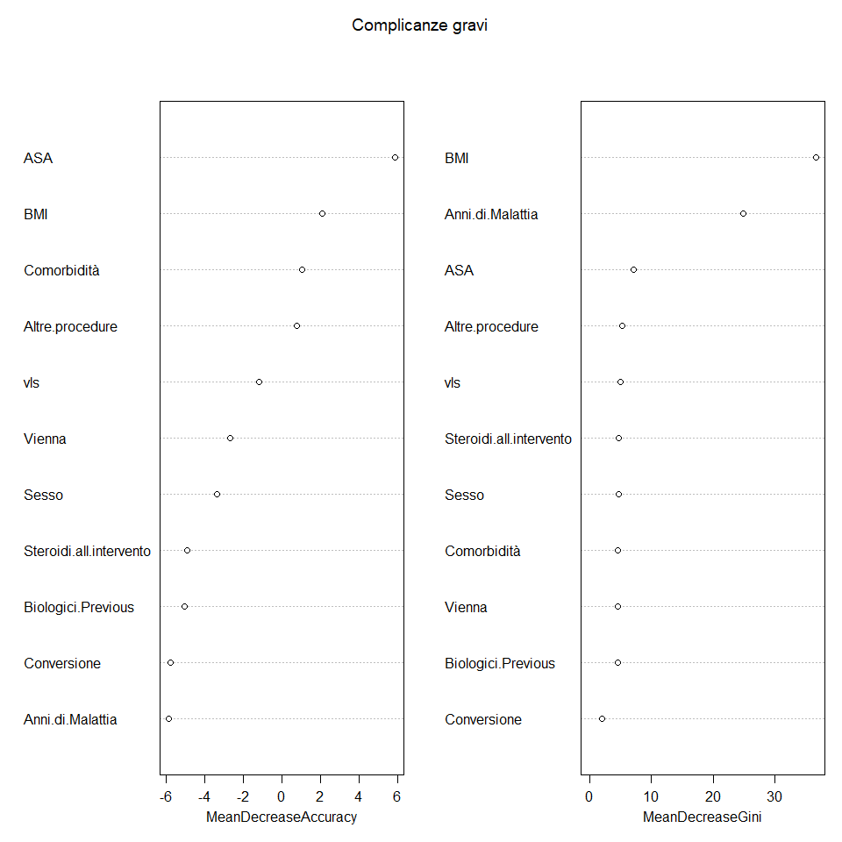
ASA
BMI
Comorbidities
Additional procedures
Surgical approach
Vienna Classification
Gender
Steroids at surgery
Previous use of biologics
Conversion to open
Years of disease

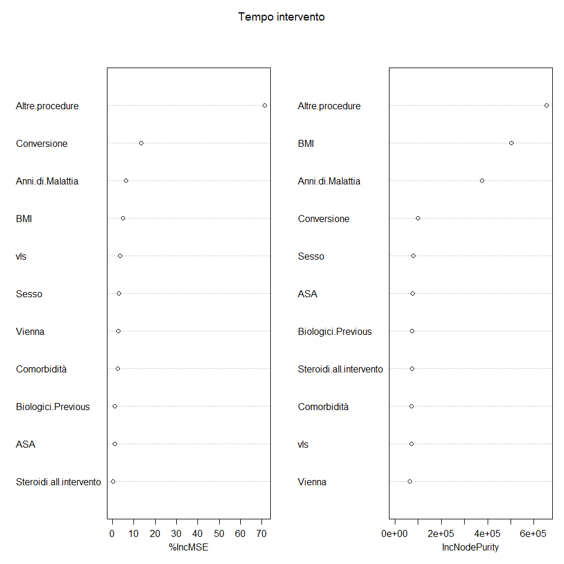
Supplementary Figure 4. Operative time
Additional procedures
Conversion to open
Years of disease
BMI
Surgical approach
Gender
Vienna Classification
Comorbidities
Previous use of biologics
ASA
Steroids at surgery

Supplementary Figure 5. Length of stay
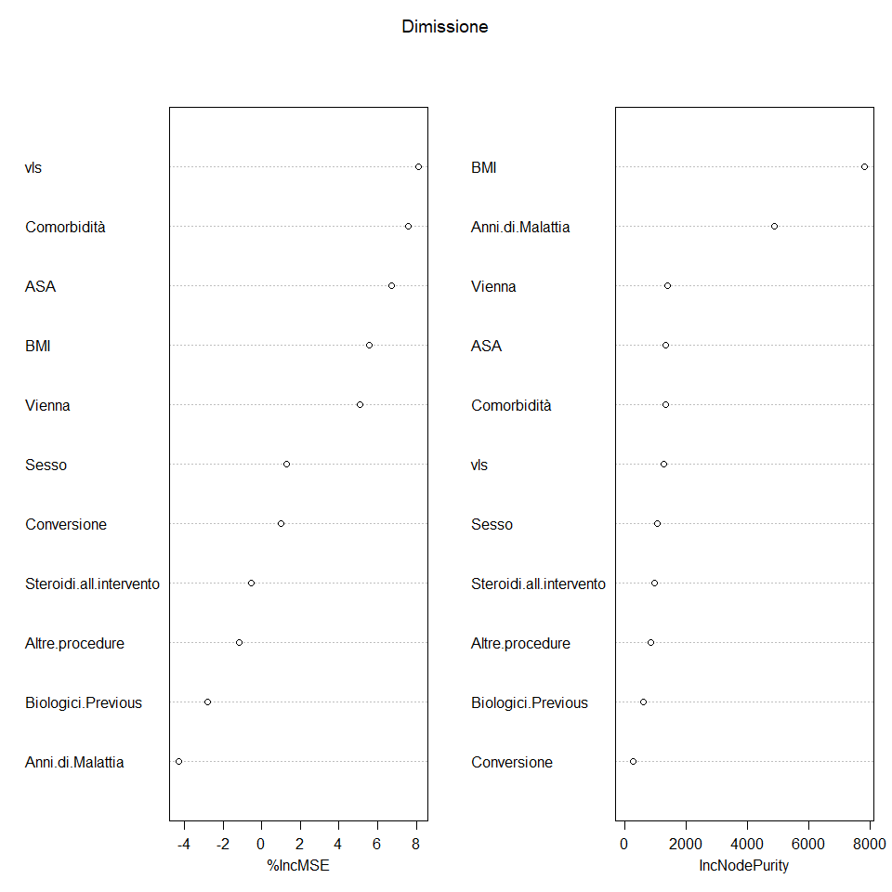
Surgical approach
Comorbidities
ASA
BMI
Vienna Classification
Gender
Conversion to open
Steroids at surgery
Additional procedures
Previous use of biologics
Years of disease

Montreal Classification

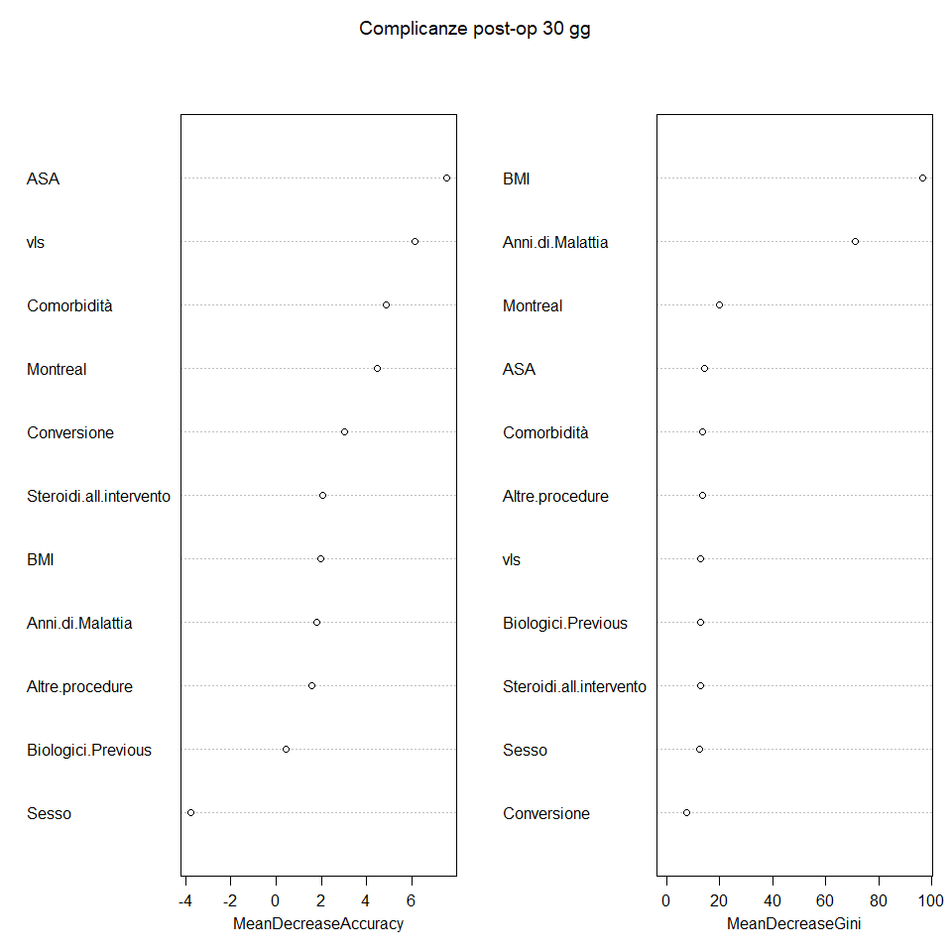
Supplementary Figure 6. 30-day postoperative complications
ASA
Surgical approach
Comorbidities
Montreal Classification
Conversion to open
Steroids at surgery
BMI
Years of disease
Additional procedures
Previous use of biologics
Gender

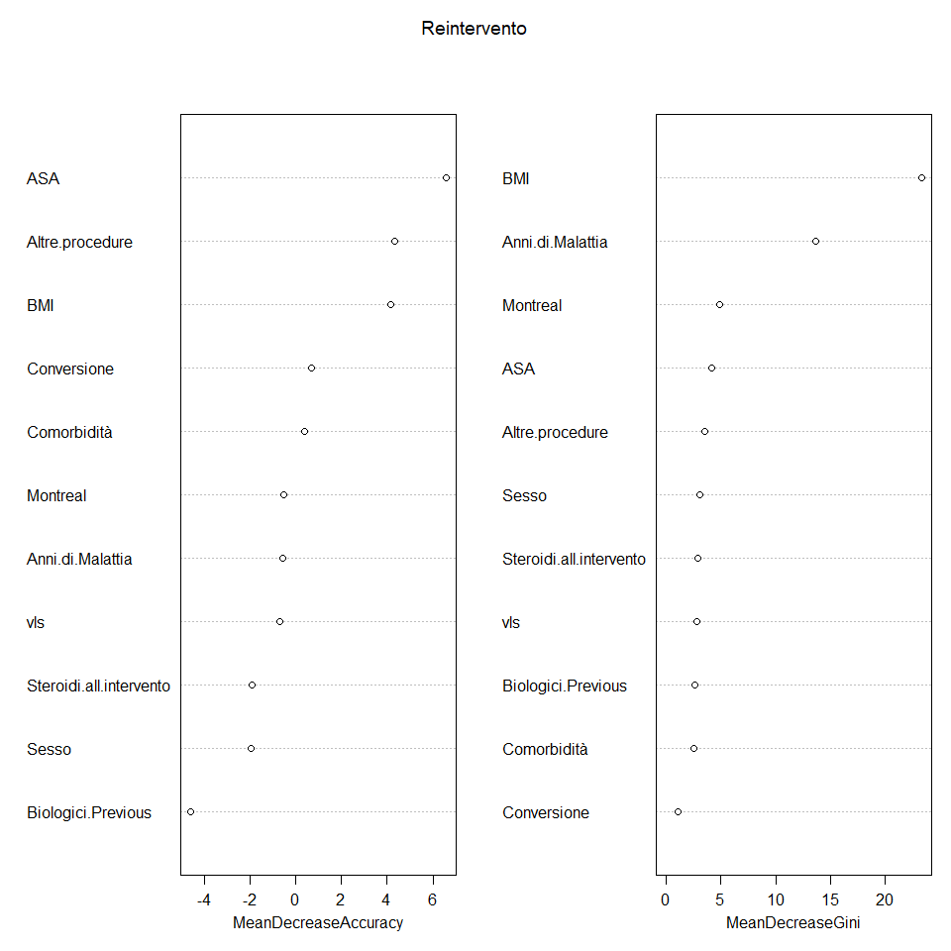
Supplementary Figure 7. 30-day reoperation
ASA
Additional procedures
BMI
Conversion to open
Comorbidities
Montreal Classification
Years of disease
Surgical approach
Steroids at surgery
Gender
Previous use of biologics

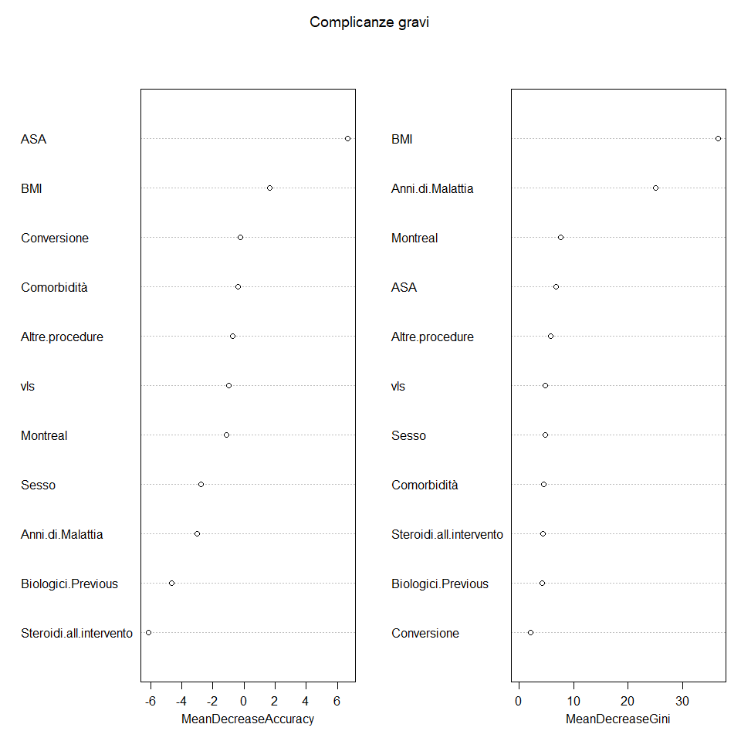
Supplementary Figure 8. 30-day postoperative serious complications
ASA
BMI
Conversion to open
Comorbidities
Additional procedures
Surgical approach
Montreal Classification
Gender
Years of disease
Previous use of biologics
Steroids at surgery

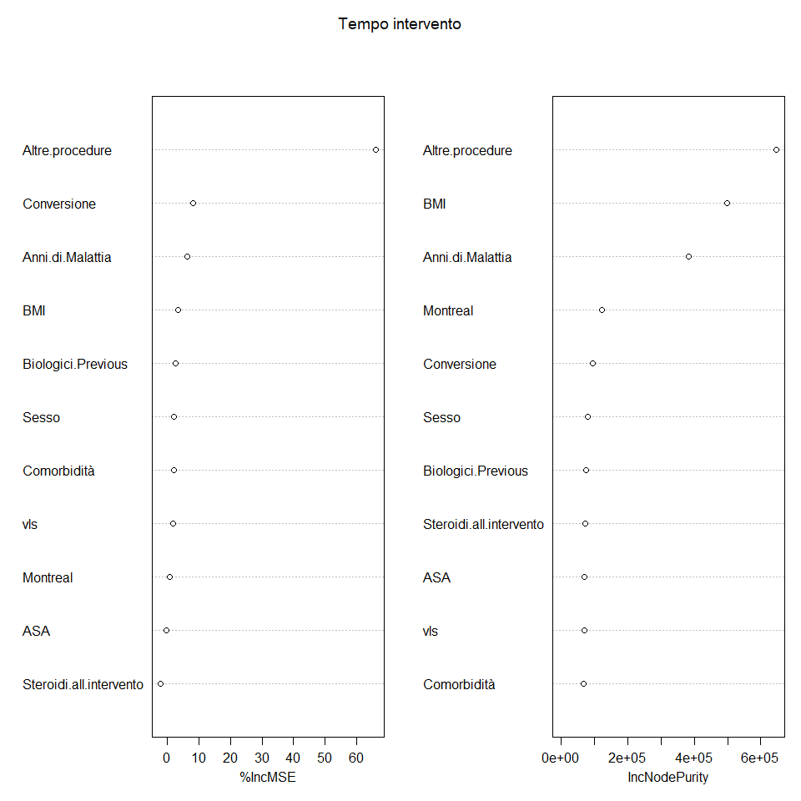
Supplementary Figure 9. Operative time
Additional procedures
Conversion to open
Years of disease
BMI
Previous use of biologics
Gender
Comorbidities
Surgical approach
Montreal Classification
ASA
Steroids at surgery

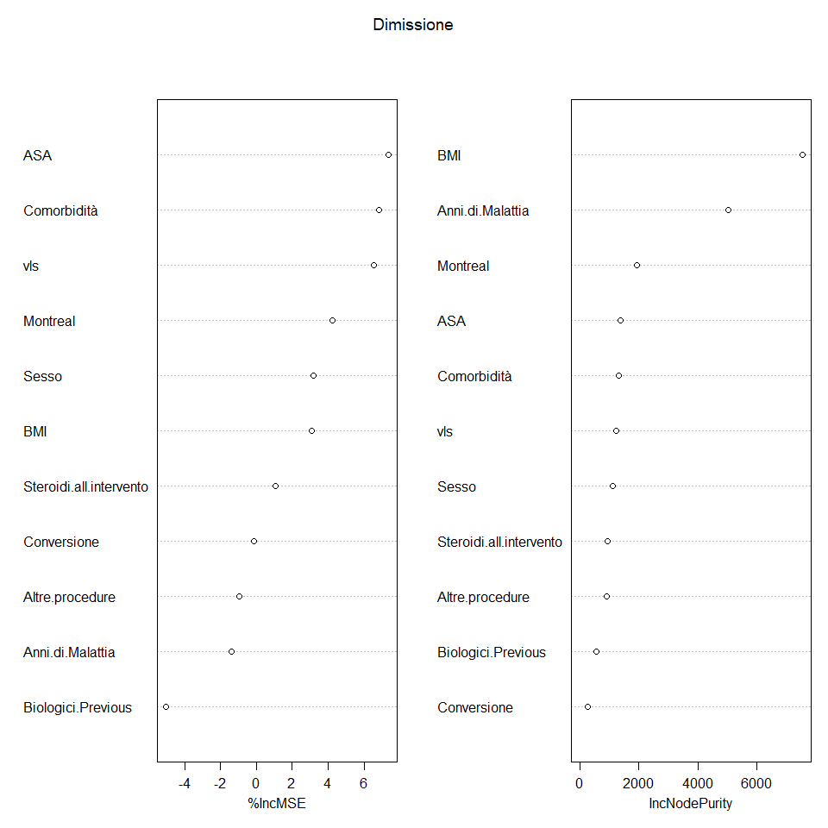
Supplementary Figure 10. Length of stay
ASA
Comorbidities
Surgical approach
Montreal Classification
Gender
BMI
Steroids at surgery
Conversion to open
Additional procedures
Years of disease
Previous use of biologics

