Supplemental Tables

Supplemental Table 1. Brief summary of TKV and eGFR measurements
 |  |  | Median (IQR) | Mean | SD
TKV measurements (1240 measurements of 296 patients)
 | Observed period per patient | (year /patient) | 2.75 (1.08-5.25) | 3.30 | 2.37
 | Frequency | (times/patient) | 4 (2-5) | 4.19 | 2.14
 | Interval between measurements | (year) | 1.00 (0.83-1.08) | 1.06 | 0.66
eGFR measurements (1495 measurements of 289 patients)
 | Observed period per patient | (year/patient) | 2.58 (1.08-5.92) | 3.68 | 2.94
 | Frequency | (time/patient) | 4 (3-7) | 5.29 | 3.20
 | Interval between measurements | (year) | 0.92 (0.50-1.00) | 0.86 | 0.69
TKV, total kidney volume; eGFR, estimated glomerular filtration rate; IQR, interquartile range.

Supplemental Table 2. Cox multivariate hazard ratios according to sex and classifications
Classification |  | Range | Male |  |  |  | Female |  |  | P for interaction
 |  | Range | Subjects (n) | HR (95% CI) | P value |  | Subjects (n) | HR (95% CI) | P value | P for interaction
MIC based on AHTKV-α* (%/year) |  |  |  |  |  |  |  |  |  | 0.1840
 | 1A + 1B | < 3.0 | 22 |  |  |  | 58
 | 1C | 3.0 - 4.5 | 41 | 0.93 (0.09-20.08) | 0.96 |  | 71 | 5.41 (1.44-36.03) | 0.0107
 | 1D + 1E | 4.5 ≤ | 49 | 7.85 (1.26-75.20) | 0.0273 |  | 55 | 7.64 (2.81-21.23) | <0.0001
Equally divided 3 groups by AHTKV-α (%/year) |  |  |  |  |  |  |  |  |  | 0.2320
 | A | < 3.18 | 28 |  |  |  | 71
 | B | 3.18 - 4.575 | 37 | 1.49 (0.14-32.37) | 0.74 |  | 61 | 6.67 (1.95-30.59) | 0.0021
 | C | 4.575 ≤ | 47 | 7.41 (1.16-75.90) | 0.0337 |  | 52 | 6.26 (2.31-17.47) | 0.0004
Equally divided 3 groups by baseline measured HtTKV slope (%/year) |  |  |  |  |  |  |  |  |  | 0.6068
 | A | < 1.7 | 28 |  |  |  | 71
 | B | 1.7 -7.91 | 42 | 2.25 (0.28-45.73) | 0.46 |  | 56 | 1.11 (0.43-2.71) | 0.82
 | C | 7.91 ≤ | 42 | 1.37(0.25-7.50) | 0.71 |  | 57 | 0.23 (0.03-0.90) | 0.0343
MIC, Mayo Image Classification for ADPKD; AHTKV-α, age- and height-adjusted TKV growth rate as described in the text; TKV, total kidney volume; HtTKV, height-adjusted TKV. Multivariate hazard ratios (HRs) were for adjacent worse subgroups. P for interaction was for difference in Cox hazard ratio between two genders.

Supplemental Figures

Supplemental Figure 1. Comparison of repeatability between AHTKV-α, measured HtTKV slope, and LogTKV slope.
The regression line of the LogTKV slope (baseline LogTKV slope vs. difference in LogTKV slope from baseline) was significant. R²=0.532, slope=-0.961 (SE, 0.035), and P<0.0001. The distribution range of the baseline LogTKV slope became narrower than the measured HtTKV slope due to log conversion, but significant bias remained.
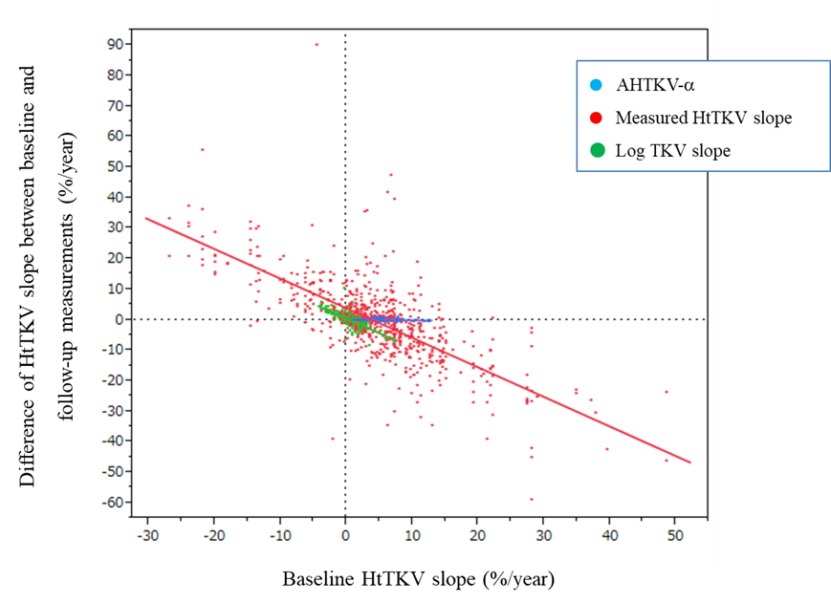

Supplemental Figure 2. eGFR slopes according to classifications and sex.
eGFR slopes were evaluated using a mixed-effects model for repeated measures, including age and interaction between group and age. Slope is indicated by mean (SE).
A) MIC based on AHTKV-α
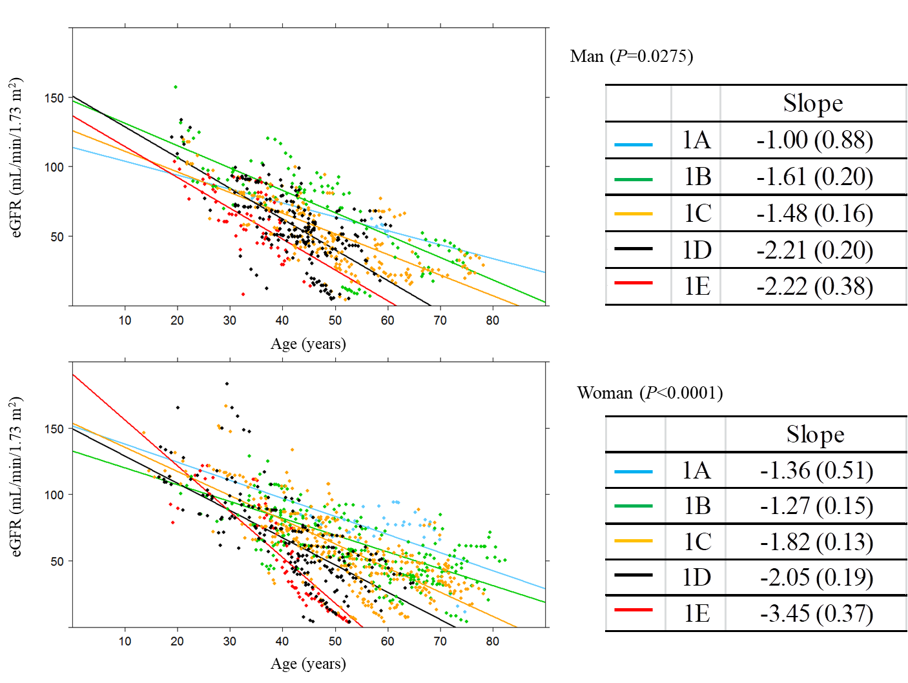
B) Five equally divided subgroups for AHTKV-α
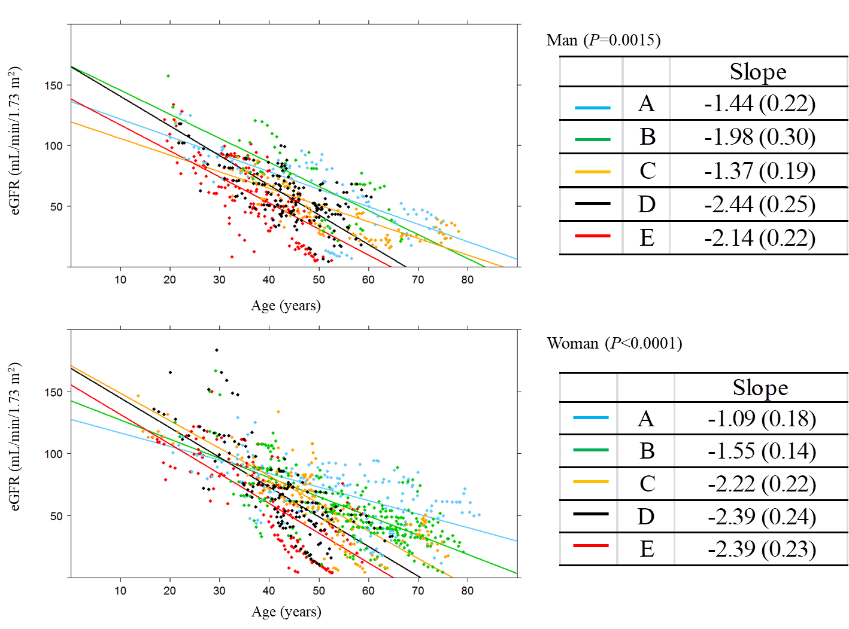
C) Five equally divided subgroups for baseline-measured HtTKV slope
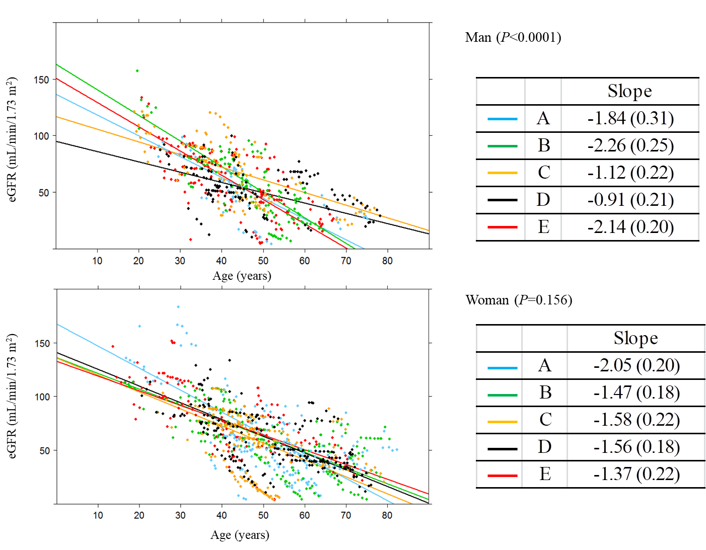

Supplemental Figure 3. Kaplan-Meier renal survival curves until RRT.
The ranges of each subgroup are shown in Table 3.
A) Five MIC subgroups were combined into three subgroups (1A+1B, 1C, and D+1E)
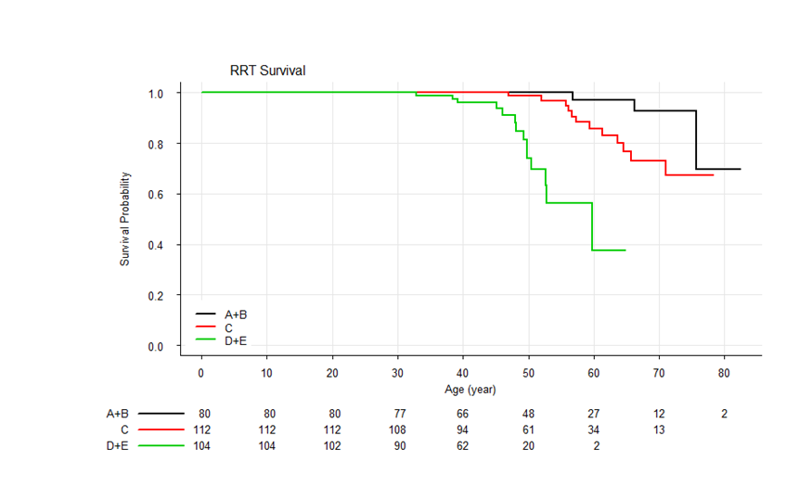
B) Three subgroups equally divided for AHTKV-α
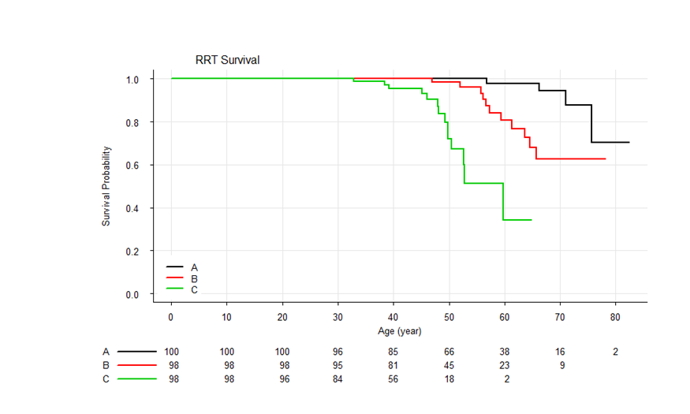

C) Three subgroups equally divided for the baseline-measured HtTKV slope
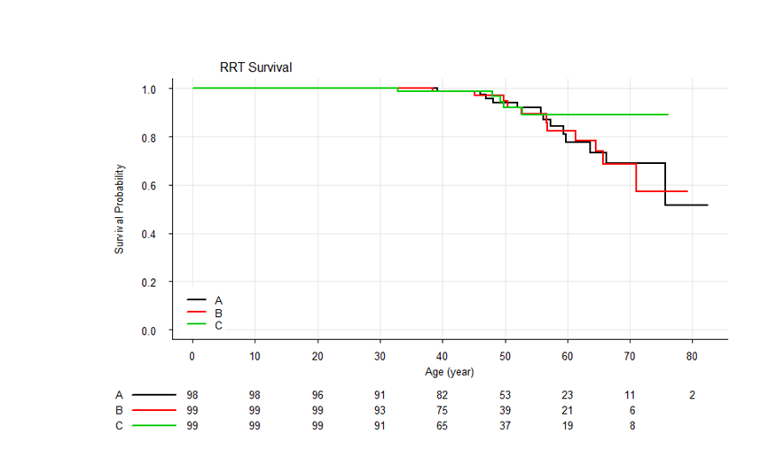

Supplemental Figure 4. Actual pattern of HtTKV changes in three patients with TKV measured for 10 years.
Measured slopes fluctuated widely from positive to negative slopes. In contrast, AHTKV-α varied within a narrow range between 4.2% and 5.2 % per year, and changes remained within less than 1 % per year.

