Development and Validation of Algorism for Database Research to Classify Patients undergoing Dialysis: Analysis from Rinchu net

Supplementary Material

Supplementary Tables
Supplementary Table 1. Medicine list
Supplementary Table 2. Disease names and their International Classification of Diseases 10th Revision (ICD–10) codes
Supplementary Table 3. Baseline characteristics and modality of kidney replacement therapy
Supplementary Table 4. Logistic regression analysis to develop a classification model
Supplementary Table 5. The model performance at each hospital
Supplementary Table 6. Performance of other Models
Supplementary Table 7. Performance of classification models after excluding hospitalized patients

Supplementary Figures
Supplementary Fig. 1 Distribution of prediction scores 4 and receiver operating characteristic curves in the derivation and validation cohorts
Supplementary Fig. 2 Calibration plots for observed frequency and predicted probability of prediction model 4

Supplementary Table 1. Medicine list
Type of medicine | Medicinal classification | World Health Organization Anatomical Therapeutic Chemical (WHO–ATC) codes
Antihypertensive agents | Calcium–channel blockers | C08CA
Antihypertensive agents | Angiotensin receptor blockers | C09CA, C09DA, C09DB, C09DX
Antihypertensive agents | Angiotensin–converting enzyme inhibitors | C09AA
Antihypertensive agents | Diuretics | C03AA, C03AX, C03BA, C03CA, C03DB
Antihypertensive agents | Mineralocorticoid receptor blockers | C03DA
Antihypertensive agents | β blockers | C07AA, C07AB, C07AG
Antihypertensive agents | α blockers | C02CA
Antidiabetic agents | Insulin | A10A
Antidiabetic agents | Biguanide | A10BA
Antidiabetic agents | Sulfonylurea | A10BB
Antidiabetic agents | Combinations of oral blood glucose lowering drugs | A10BD
Antidiabetic agents | α–glucosidase inhibitors | A10BF
Antidiabetic agents | Thiazolidine | A10BG
Antidiabetic agents | DPP4–i | A10BH
Antidiabetic agents | GLP–1 receptor agonist | A10BJ
Antidiabetic agents | SGLT2–i | A10BK
Antidiabetic agents | Glinide | A10BX
NSAIDs |  | M01A
Potassium binders | Polystyrene sulfonate | V03AE01
Potassium binders | Sodium zirconium cyclosilicate | V03AE10
DPP4–i, Dipeptidyl peptidase-4 inhibitors; GLP–1, Glucagon-like peptide-1; SGLT2–i, Sodium glucose cotransporter inhibitors; NSAIDs, non-steroidal anti-inflammatory drugs

Supplementary Table 2. Disease names and their International Classification of Diseases 10th Revision (ICD–10) codes
ICD–10 code | Disease name
N18.0 | End–stage kidney disease
N18.5 | Chronic kidney disease, stage 5
Z94.0 | Kidney transplant status
T85.7 | Infection and inflammatory reaction due to other internal prosthetic devices, implants and grafts
ICD-10, International Classification of Diseases 10th Revision

Supplementary Table 3. Baseline characteristics and modality of kidney replacement therapy
 | N | Total (N=7,435) | eGFR, mL/min/1.73 m² |  |  | P value
 | N | Total (N=7,435) | >60 (N=1,253) | 15–60 (N=5,965) | 15< (N=217) | P value
Age, years | 7,435 | 69.1 (11.7) | 65.7 (12.4) | 70.0 (11.3) | 64.4 (13.6) | <0.001
Male sex | 7,435 | 4,262 (57) | 617 (49) | 3,495 (59) | 150 (69) | <0.001
White blood cell, ×10⁶/μl | 7,191 | 6.11 (2.79) | 6.10 (2.47) | 6.11 (2.86) | 6.31 (2.41) | 0.57
Red blood cell, ×10⁶/μl | 7,191 | 4.25 (0.62) | 4.23 (0.63) | 4.28 (0.61) | 3.76 (0.63) | <0.001
Hemoglobin, g/dL | 7,191 | 13.0 (1.8) | 12.9 (1.9) | 13.1 (1.8) | 11.3 (1.6) | <0.001
Hematocrit, % | 7,191 | 39 (5) | 39 (5) | 40 (5) | 35 (5) | <0.001
MCH, pg | 7,191 | 31 (2) | 31 (3) | 31 (2) | 30 (2) | 0.020
MCHC, % | 7,191 | 33 (1) | 33 (1) | 33 (1) | 32 (1) | <0.001
MCV, fL | 7,191 | 93 (6) | 93 (6) | 93 (6) | 93 (6) | 0.48
Platelet, ×1000/μl | 7,191 | 208 (74) | 217 (81) | 207 (69) | 205 (135) | <0.001
Total Protein, mg/dL | 7,385 | 6.9 (0.5) | 6.8 (0.6) | 6.9 (0.5) | 6.6 (0.7) | <0.001
Albumin, g/dL | 7,394 | 4.0 (0.4) | 3.9 (0.5) | 4.0 (0.4) | 3.6 (0.5) | <0.001
HbA1c, % | 2,953 | 6.2 (5.8–6.9) | 6.3 (5.7–7.1) | 6.2 (5.8–6.9) | 6.1 (5.5–7.0) | 0.58
ALT, U/L | 7,390 | 21 (88) | 24 (40) | 21 (96) | 13 (10) | 0.23
AST, U/L | 7,389 | 25 (144) | 26 (33) | 26 (160) | 16 (8) | 0.60
ALP, U/L | 7,285 | 223 (179–278) | 229 (182–291) | 222 (179–275) | 234 (185–321) | <0.001
γ–GTP, U/L | 7,261 | 23 (16–38) | 24 (17–42) | 23 (16–37) | 19 (13–33) | <0.001
LDH, U/L | 7,316 | 190 (168–218) | 192 (167–221) | 189 (168–217) | 198 (171–232) | 0.021
BUN, mg/dL | 7,428 | 20.7 (9.5) | 16.3 (4.3) | 20.5 (7.3) | 52.3 (19.6) | <0.001
eGFR, mL/min/1.73 m² | 7,435 | 52.4 (43.0–58.4) | 64.6 (62.0–69.6) | 50.4 (42.0–55.9) | 6.8 (5.1–10.0) | <0.001
Uric acid, mg/dL | 7,357 | 5.9 (5.0–6.8) | 5.2 (4.4–6.1) | 6.0 (5.1–6.9) | 6.0 (4.8–7.3) | <0.001
Sodium, mEq/L | 7,388 | 141 (140–143) | 141 (140–143) | 141 (140–143) | 140 (137–141) | <0.001
Chloride, mEq/L | 7,382 | 105 (103–107) | 105 (103–106) | 105 (103–107) | 102 (98–105) | <0.001
Na-Cl gap, mEq/L | 7,382 | 36 (35–38) | 37 (35–38) | 36 (35–38) | 37 (35–40) | <0.001
Potassium, mEq/L | 7,396 | 4.4 (0.4) | 4.2 (0.4) | 4.4 (0.4) | 4.6 (0.6) | <0.001
Calcium, mg/dL | 6,666 | 9.2 (8.9–9.5) | 9.2 (8.9–9.4) | 9.2 (9.0–9.5) | 8.8 (8.4–9.2) | <0.001
Phosphorus, mg/dL | 3,694 | 3.3 (2.9–3.7) | 3.2 (2.8–3.7) | 3.3 (2.9–3.7) | 4.5 (3.9–5.3) | <0.001
Magnesium, mg/dL | 3,459 | 2.0 (1.9–2.1) | 2.0 (1.9–2.1) | 2.0 (1.9–2.1) | 2.1 (1.9–2.2) | 0.019
CK, U/L | 5,998 | 91 (64–133) | 84 (59–120) | 93 (65–135) | 96 (66–156) | <0.001
BNP, pg/ml | 876 | 69 (29–187) | 58 (24–174) | 69 (29–185) | 93 (49–260) | 0.039
CRP, mg/dL | 5,715 | 0.08 (0.04–0.24) | 0.09 (0.04–0.32) | 0.08 (0.04–0.22) | 0.12 (0.04–0.43) | <0.001
Cholinesterase, U/L | 2,797 | 290 (244–337) | 286 (230–340) | 294 (249–337) | 240 (201–284) | <0.001
Total cholesterol, mg/dL | 5,248 | 189 (164–215) | 191 (164–221) | 189 (164–214) | 172 (147–203) | <0.001
HDL cholesterol, mg/dL | 4,063 | 52 (42–64) | 54 (44–66) | 52 (42–64) | 46 (39–58) | <0.001
LDL cholesterol, mg/dL | 4,186 | 104 (84–125) | 107 (86–129) | 104 (84–124) | 90 (72–116) | <0.001
Triglyceride, mg/dL | 4,528 | 118 (84–172) | 114 (79–168) | 119 (85–172) | 121 (87–176) | 0.065
Total bilirubin, mg/dL | 6,716 | 0.7 (0.5–0.9) | 0.7 (0.5–0.9) | 0.7 (0.6–0.9) | 0.5 (0.4–0.6) | <0.001
Disease code (ICD 10 code)
N18.0 | 7,435 | 54 (1) | 2 (0) | 26 (0) | 26 (12) | <0.001
N18.5 | 7,435 | 4 (0) | 0 (0) | 2 (0) | 2 (1) | <0.001
Z94.0 | 7,435 | 99 (1) | 8 (1) | 86 (1) | 5 (2) | 0.035
T85.7 | 7,435 | 60 (1) | 0 (0) | 10 (0) | 50 (23) | <0.001
Prescription medicine
RAS inhibitors | 7,435 | 1,586 (21) | 258 (21) | 1,247 (21) | 81 (37) | <0.001
α blockers | 7,435 | 123 (2) | 18 (1) | 79 (1) | 26 (12) | <0.001
β blockers | 7,435 | 754 (10) | 103 (8) | 599 (10) | 52 (24) | <0.001
CCB | 7,435 | 1,411 (19) | 225 (18) | 1,091 (18) | 95 (44) | <0.001
Diuretics | 7,435 | 757 (10) | 120 (10) | 563 (9) | 74 (34) | <0.001
MRB | 7,435 | 371 (5) | 61 (5) | 253 (4) | 57 (26) | <0.001
Anti diabetics | 7,435 | 1,089 (15) | 215 (17) | 829 (14) | 45 (21) | <0.001
NSAIDs | 7,435 | 511 (7) | 173 (14) | 329 (6) | 9 (4) | <0.001
Potassium binders | 7,435 | 91 (1) | 7 (1) | 63 (1) | 21 (10) | <0.001
PD solutions | 7,435 | 74 (1) | 0 (0) | 8 (0) | 66 (30) | <0.001
Clinical setting | 7,435 |  |  |  |  | <0.001
Outpatient |  | 6936 (93) | 5794 (86) | 5660 (95) | 194 (89)
Hospitalized |  | 499 (7) | 171 (14) | 305 (5) | 23 (11)
Modality of KRT at baseline
HD | 7,435 | 69 (0.93%) | 0 (0%) | 3 (0.05%) | 66 (30.4%) | <0.001
PD | 7,435 | 48 (0.65%) | 0 (0%) | 0 (0%) | 48 (22.1%) | <0.001
Transplantation | 7,435 | 94 (1.26%) | 9 (0.72%) | 85 (1.42%) | 0 (%) | <0.001
Data are expressed as the mean (SD) or median (IQR) for continuous variables and n (%) for categorical variables. Statistical significance was set at P < 0.05. WBC, White blood cell; RBC, Red blood cell; MCH, Mean corpuscular hemoglobin; MCHC, Mean corpuscular hemoglobin concentration; MCV, Mean corpuscular volume; TP, Total protein; AST, Aspartate aminotransferase; ALT, Alanine aminotransferase; ALP, Alkaline phosphatase; JSCC, Japan Society of Clinical Chemistry; γ-GTP, Gamma-glutamyl transpeptidase; LDH, Lactate dehydrogenase; BUN, Blood urea nitrogen; eGFR, Estimated glomerular filtration rate; Mg, Magnesium; CK, Creatine kinase; BNP, Brain natriuretic peptide; CRP, C-reactive protein; HDL, High-density lipoprotein; LDL, Low-density lipoprotein; RAS, Renin-angiotensin system; CCB, Calcium-channel blockers; MRB, Mineralocorticoid receptor blockers; NSAIDs, Non-steroidal anti-inflammatory drugs; KRT, kidney replacement therapy; HD, hemodialysis; PD, peritoneal dialysis

Supplementary Table 4. Logistic regression analysis to develop a classification model
 | Obs | Univariate |  | Multivariable model (adjusted for age, sex, and eGFR)
 | Obs | OR (95% CI) | P value | OR (95% CI) | P value
WBC, per 10⁶/µL | 726 | 0.96 (0.90–1.02) | 0.19 | 0.95 (0.88–1.03) | 0.24
RBC, per 10⁶/µL | 726 | 1.66 (1.28–2.15) | <0.001 | 1.61 (1.16–2.24) | 0.004
Hemoglobin, per 1 g/dL | 726 | 1.33 (1.21–1.48) | <0.001 | 1.34 (1.18–1.53) | <0.001
Hematocrit, per 1% | 726 | 1.11 (1.07–1.14) | <0.001 | 1.12 (1.07–1.17) | <0.001
MCH, per 1 pg | 720 | 1.09 (1.03–1.16) | 0.006 | 1.12 (1.03–1.21) | 0.006
MCHC, per 1% | 718 | 0.86 (0.75–0.97) | 0.016 | 0.75 (0.62–0.89) | 0.001
MCV, per 1 fL | 721 | 1.05 (1.03–1.08) | <0.001 | 1.08 (1.04–1.11) | <0.001
Platelet, per 10⁴/µL | 726 | 1.01 (1.00–1.03) | 0.079 | 1.02 (1.00–1.04) | 0.069
TP, per 1 g/dL | 469 | 0.77 (0.58–1.01) | 0.055 | 0.96 (0.69–1.34) | 0.82
Albumin, per 1 g/dL | 701 | 0.58 (0.43–0.80) | 0.001 | 0.67 (0.45–0.98) | 0.041
HbA1c, per 1% | 317 | 0.94 (0.77–1.16) | 0.58 | 0.87 (0.67–1.14) | 0.32
AST* | 676 | 0.51 (0.36–0.72) | <0.001 | 0.98 (0.63–1.52) | 0.92
ALT* | 702 | 0.72 (0.55–0.93) | 0.013 | 0.77 (0.55–1.10) | 0.15
ALP (JSCC)* | 621 | 1.74 (1.17–2.60) | 0.007 | 2.63 (1.56–4.46) | <0.001
γ-GTP* | 653 | 1.03 (0.84–1.26) | 0.79 | 1.42 (1.09–1.85) | 0.009
LDH (JSCC)* | 624 | 0.66 (0.36–1.21) | 0.18 | 0.55 (0.25–1.22) | 0.14
BUN, per 1 mg/dL | 724 | 0.95 (0.95–0.96) | <0.001 | 0.92 (0.90–0.93) | <0.001
eGFR, per 1 mL/min/1.73 m² | 763 | 0.59 (0.55–0.64) | <0.001 | 0.59 (0.55–0.64) | <0.001
Uric acid, per 1 mg/dL | 657 | 0.64 (0.58–0.72) | <0.001 | 0.56 (0.49–0.64) | <0.001
Sodium, per 1 mEq/L | 678 | 0.95 (0.90–0.99) | 0.029 | 1.04 (0.98–1.11) | 0.19
Chloride, per 1 mEq/L | 645 | 0.79 (0.76–0.83) | <0.001 | 0.89 (0.85–0.94) | <0.001
Na – Cl, per 1 mEq/L | 645 | 1.45 (1.36–1.54) | <0.001 | 1.28 (1.20–1.37) | <0.001
Potassium, per 1 mEq/L | 721 | 0.76 (0.61–0.95) | 0.015 | 0.53 (0.39–0.72) | <0.001
Calcium, per 1 mg/dL | 628 | 1.17 (0.93–1.48) | 0.18 | 1.33 (0.99–1.79) | 0.059
Phosphorus, per 1 mg/dL | 540 | 1.41 (1.19–1.66) | <0.001 | 0.64 (0.51–0.79) | <0.001
Mg, per 1 mg/dL | 304 | 3.18 (1.50–6.71) | 0.002 | 2.24 (0.94–5.32) | 0.068
CK* | 475 | 0.43 (0.32–0.56) | <0.001 | 0.25 (0.17–0.38) | <0.001
BNP* | 259 | 1.17 (0.97–1.41) | 0.11 | 1.30 (1.00–1.70) | 0.054
CRP*, per 1 mg/dL | 603 | 1.10 (1.00–1.21) | 0.062 | 1.18 (1.04–1.33) | 0.012
Cholinesterase, per 1 U/L | 270 | 0.999 (0.996–1.002) | 0.62 | 0.998 (0.994–1.002) | 0.33
Total cholesterol, per 1 mg/dL | 445 | 0.998 (0.993–1.002) | 0.37 | 1.003 (0.997–1.01) | 0.36
HDL cholesterol, per 1 mg/dL | 413 | 1.001 (0.992–1.011) | 0.79 | 1.017 (1.003–1.031) | 0.02
LDL cholesterol, per 1 mg/dL | 376 | 1.004 (0.997–1.01) | 0.26 | 1.006 (0.996–1.015) | 0.24
Triglyceride, per 1 mg/dL | 475 | 0.998 (0.996–1.00) | 0.076 | 0.998 (0.995–1.00) | 0.091
Total bililubin, per 1 mg/dL | 543 | 0.81 (0.54–1.22) | 0.31 | 1.25 (0.87–1.78) | 0.23
N18.0 | 763 | 5.16 (3.66–7.28) | <0.001 | 3.70 (2.44–5.61) | <0.001
N18.5 | 763 | 0.89 (0.53–1.50) | 0.67 | 1.05 (0.54–2.04) | 0.90
T85.7 | 763 | 16.1 (5.81–44.6) | <0.001 | 3.76 (1.29–11.0) | 0.016
RAS inhibitors | 763 | 0.24 (0.17–0.33) | <0.001 | 0.21 (0.14–0.33) | <0.001
α blockers | 763 | 0.43 (0.27–0.71) | 0.001 | 0.38 (0.20–0.72) | 0.003
β blockers | 763 | 0.59 (0.39–0.88) | 0.010 | 0.38 (0.22–0.64) | <0.001
CCB | 763 | 0.23 (0.16–0.31) | <0.001 | 0.18 (0.11–0.28) | <0.001
Diuretics | 763 | 0.48 (0.34–0.68) | <0.001 | 0.40 (0.25–0.63) | <0.001
MRB | 763 | 1.69 (1.01–2.85) | 0.047 | 0.81 (0.40–1.66) | 0.57
Anti diabetics | 763 | 0.77 (0.54–1.10) | 0.16 | 0.84 (0.53–1.32) | 0.44
NSAIDs | 763 | 0.89 (0.34–2.33) | 0.81 | 0.54 (0.18–1.63) | 0.28
Potassium binders | 763 | 0.11 (0.06–0.21) | <0.001 | 0.13 (0.06–0.27) | <0.001
Multivariable model was adjusted for age, sex, and eGFR.
*Logarithmic transformations were performed and included in the models.
WBC, White blood cell; RBC, Red blood cell; MCH, Mean corpuscular hemoglobin; MCHC, Mean corpuscular hemoglobin concentration; MCV, Mean corpuscular volume; TP, Total protein; AST, Aspartate aminotransferase; ALT, Alanine aminotransferase; ALP, Alkaline phosphatase; JSCC, Japan Society of Clinical Chemistry; γ-GTP, Gamma-glutamyl transpeptidase; LDH, Lactate dehydrogenase; BUN, Blood urea nitrogen; eGFR, Estimated glomerular filtration rate; Mg, Magnesium; CK, Creatine kinase; BNP, Brain natriuretic peptide; CRP, C-reactive protein; HDL, High–density lipoprotein; LDL, Low-density lipoprotein; RAS, Renin-angiotensin system; CCB, Calcium–channel blockers; MRB, Mineralocorticoid receptor blockers; NSAIDs, Non-steroidal anti-inflammatory drugs.

Supplementary Table 5. The model performance at each hospital
 | HD or PD | Not on dialysis | Sensitivity | Specificity | PPV | NPV
Hospital 1
≥Cut point | 104 | 24 | 93.7% | 76.2% | 81.2% | 91.7%
<Cut point | 7 | 77
Hospital 2
≥Cut point | 53 | 6 | 86.9% | 91.2% | 89.8% | 88.6%
<Cut point | 8 | 62
Hospital 3
≥Cut point | 79 | 3 | 95.2% | 94.9% | 96.3% | 93.3%
<Cut point | 4 | 56
Hospital 4
≥Cut point | 162 | 7 | 94.7% | 93.6% | 95.9% | 91.9%
<Cut point | 9 | 102
Hospital 5
≥Cut point | 62 | 2 | 91.2% | 96.8 | 96.9% | 90.9%
<Cut point | 6 | 60
Hospital 6
≥Cut point | 143 | 6 | 97.9% | 94.2% | 96.0% | 97%
<Cut point | 3 | 97
HD, Hemodialysis; PD, Peritoneal dialysis; PPV, Positive predictive value; NPV, Negative predictive value

Supplementary Table 6. Performance of other Models
 | HD or PD | Not on dialysis | Sensitivity | Specificity | PPV | NPV
Model 2: eGFR, BUN, UA, Na–Cl gap, and Alb
Derivation cohort: AUC = 0.9487 (95% confidence interval: 0.9315–0.9658)
≥Cut point | 395 | 41 | 92.7% | 87.8% | 90.6% | 90.5%
<Cut point | 31 | 296
Validation cohort: AUC = 0.9755 (95% confidence interval: 0.9580–0.9929)
≥Cut point | 202 | 5 | 94.4% | 97.0% | 97.6% | 93.0%
<Cut point | 12 | 160
Model 3: Model 2 + RBC and hematocrit
Derivation cohort: AUC = 0.9500 (95% confidence interval: 0.9331–0.9669)
≥Cut point | 389 | 35 | 91.3% | 89.6% | 91.7% | 89.1%
<Cut point | 37 | 302
Validation cohort: AUC = 0.9772 (95% confidence interval: 0.9605–0.9939)
≥Cut point | 200 | 5 | 93.5% | 97.0% | 97.6% | 92.0%
<Cut point | 14 | 160
Model 4: Model 1 + N18.0, T85.7, and use of calcium-channel blockers
Derivation cohort: AUC = 0.9593 (95% confidence interval: 0.9449–0.9737)
≥Cut point | 397 | 31 | 93.2% | 90.8% | 92.8% | 91.3%
<Cut point | 29 | 306
Validation cohort: AUC = 0.9787 (95% confidence interval: 0.9630–0.9944)
≥Cut point | 194 | 5 | 90.7% | 97.0% | 97.5% | 88.9%
<Cut point | 20 | 160
HD, Hemodialysis; PD, Peritoneal dialysis; PPV, Positive predictive value; NPV, Negative predictive value

Supplementary Table 7. Performance of classification models after excluding hospitalized patients
 | HD or PD | Not on dialysis | Sensitivity | Specificity | PPV | NPV
Model 1: eGFR, BUN, UA, Na–Cl gap, Alb, MCH, and MCHC
Derivation cohort: AUC = 0.9536 (95% confidence interval: 0.9357–0.9715)
≥Cut point | 344 | 31 | 94.2% | 89.7% | 91.7% | 92.8%
<Cut point | 21 | 269
Validation cohort: AUC = 0.9755 (95% confidence interval: 0.9580–0.9929)
≥Cut point | 177 | 8 | 95.2% | 94.5% | 95.%7 | 93.8%
<Cut point | 9 | 137
Model 2: eGFR, BUN, UA, Na–Cl gap, and Alb
Derivation cohort: AUC = 0.9522 (95% confidence interval: 0.9338–0.9707)
≥Cut point | 342 | 31 | 93.7% | 89.7% | 91.7% | 92.1%
<Cut point | 23 | 269
Validation cohort: AUC = 0.9723 (95% confidence interval: 0.952405–0.9922)
≥Cut point | 175 | 5 | 94.1% | 96.6% | 97.2% | 92.7%
<Cut point | 11 | 140
Model 3: Model 2 + RBC and hematocrit
Derivation cohort: AUC = 0.9593 (95% confidence interval: 0.9449–0.9737)
≥Cut point | 337 | 26 | 92.3% | 91.3% | 92.8% | 90.7%
<Cut point | 28 | 274
Validation cohort: AUC = 0.9787 (95% confidence interval: 0.9630–0.9944)
≥Cut point | 173 | 5 | 93.0% | 96.6% | 97.2% | 91.5%
<Cut point | 13 | 140
Model 4: Model 1 + N18.0, T85.7, and use of calcium-channel blockers
Derivation cohort: AUC = 0.9593 (95% confidence interval: 0.9449–0.9737)
≥Cut point | 345 | 27 | 94.5% | 91.0% | 92.7% | 93.2%
<Cut point | 20 | 273
Validation cohort: AUC = 0.9787 (95% confidence interval: 0.9630–0.9944)
≥Cut point | 167 | 6 | 89.8% | 95.9% | 96.5% | 88.0%
<Cut point | 19 | 139
After excluding hospitalized patients, the derivation cohort contains 665 patients and the validation cohort contains 331 patients. HD, Hemodialysis; PD, Peritoneal dialysis; PPV, Positive predictive value; NPV, Negative predictive value

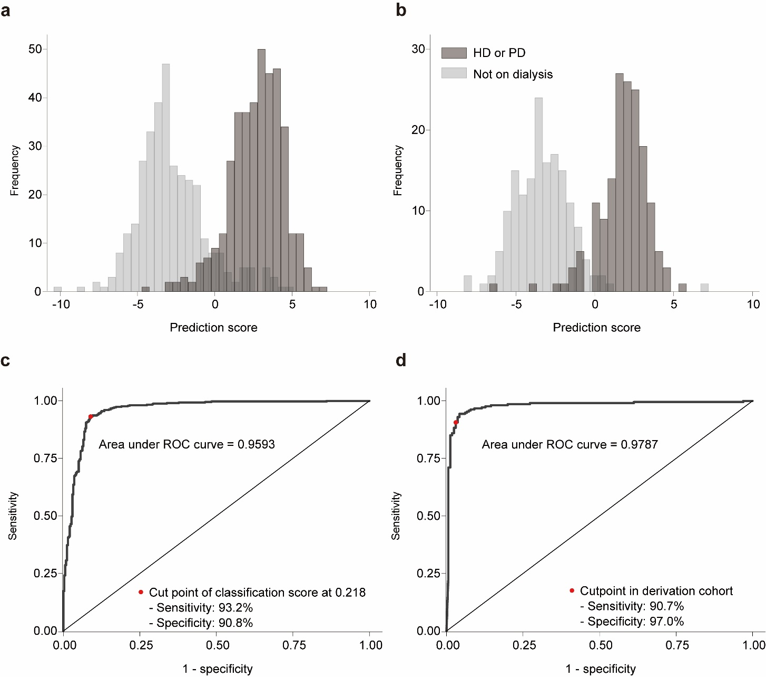

Supplementary Fig. 1 Distribution of prediction scores 4 and receiver operating characteristic curves in the derivation and validation cohorts
Distributions of the prediction score in the derivation and validation cohorts (A and B, respectively). The scores were calculated using the following equation: Prediction score 4 = 0.1688315× MCH – 0.3714643× MCHC –0.8296468× Alb – 0.0752203× BUN – 0.5031476× eGFR + 0.1839276× Na–Cl gap – 0.2339113× UA + 1.357285× T85.7 + 1.467646× N18.0 – 0.7974775× CCB + 12.27361.
The receiver operating characteristic curves show excellent discrimination performance of the model at the cut point of 0.218 in both derivation and validation cohorts (C and D, respectively).

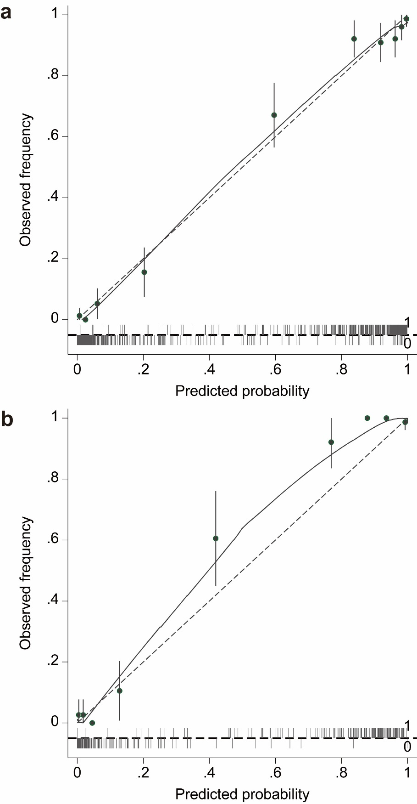

Supplementary Fig. 2 Calibration plots for observed frequency and predicted probability of prediction model 4
A. Derivation cohort. B. Validation cohort.

