Longitudinal changes in the abundance of IgA1 O- and N-glycoforms in IgA nephropathy

Clinical and Experimental Nephrology
Supplementary Information

Masaya Hirayama^{1,2}, Yukako Ohyama^{1,3}, Yudai Tsuji¹, Tetsuro Enomoto⁴, Midori Hasegawa³, Naotake Tsuboi³, Jan Novak⁵, Kazuo Takahashi^{1,3}

¹Department of Biomedical Molecular Sciences, Fujita Health University School of Medicine, 1-98 Dengakugakubo, Kutsukake-cho, Toyoake, Aichi 470-1192, Japan.
²Department of Pathology and Cytopathology, Fujita Health University School of Medical Sciences, 1-98 Dengakugakubo, Kutsukake-cho, Toyoake, Aichi 470-1192, Japan.
³Department of Nephrology, Fujita Health University School of Medicine, 1-98 Dengakugakubo, Kutsukake-cho, Toyoake, Aichi 470-1192, Japan.
⁴Oriental Yeast Co., Ltd., 50 Kanou-cho, Nagahama, Shiga 526-0804, Japan.
⁵Department of Microbiology, University of Alabama at Birmingham, 1720 2nd Ave South, Birmingham, AL 35294, USA

*Correspondence to:
E-mail: kazuot@fujita-hu.ac.jp (K. Takahashi)
Tel: +81-562-93-2430 (Office), -2431 (Lab), -9245 (Nephrology)
Fax: +81-562-93-1830

Supplementary Table and Figure Legends

Supplementary Figure S1. Flowchart of the selection of treatment options.
IgAN, IgA nephropathy; eGFR, estimated glomerular filtration rate; CKD, chronic kidney disease; UP, urinary protein; RASI, renin-angiotensin-system inhibitors; RBC, red blood cell; WBC, white blood cell.
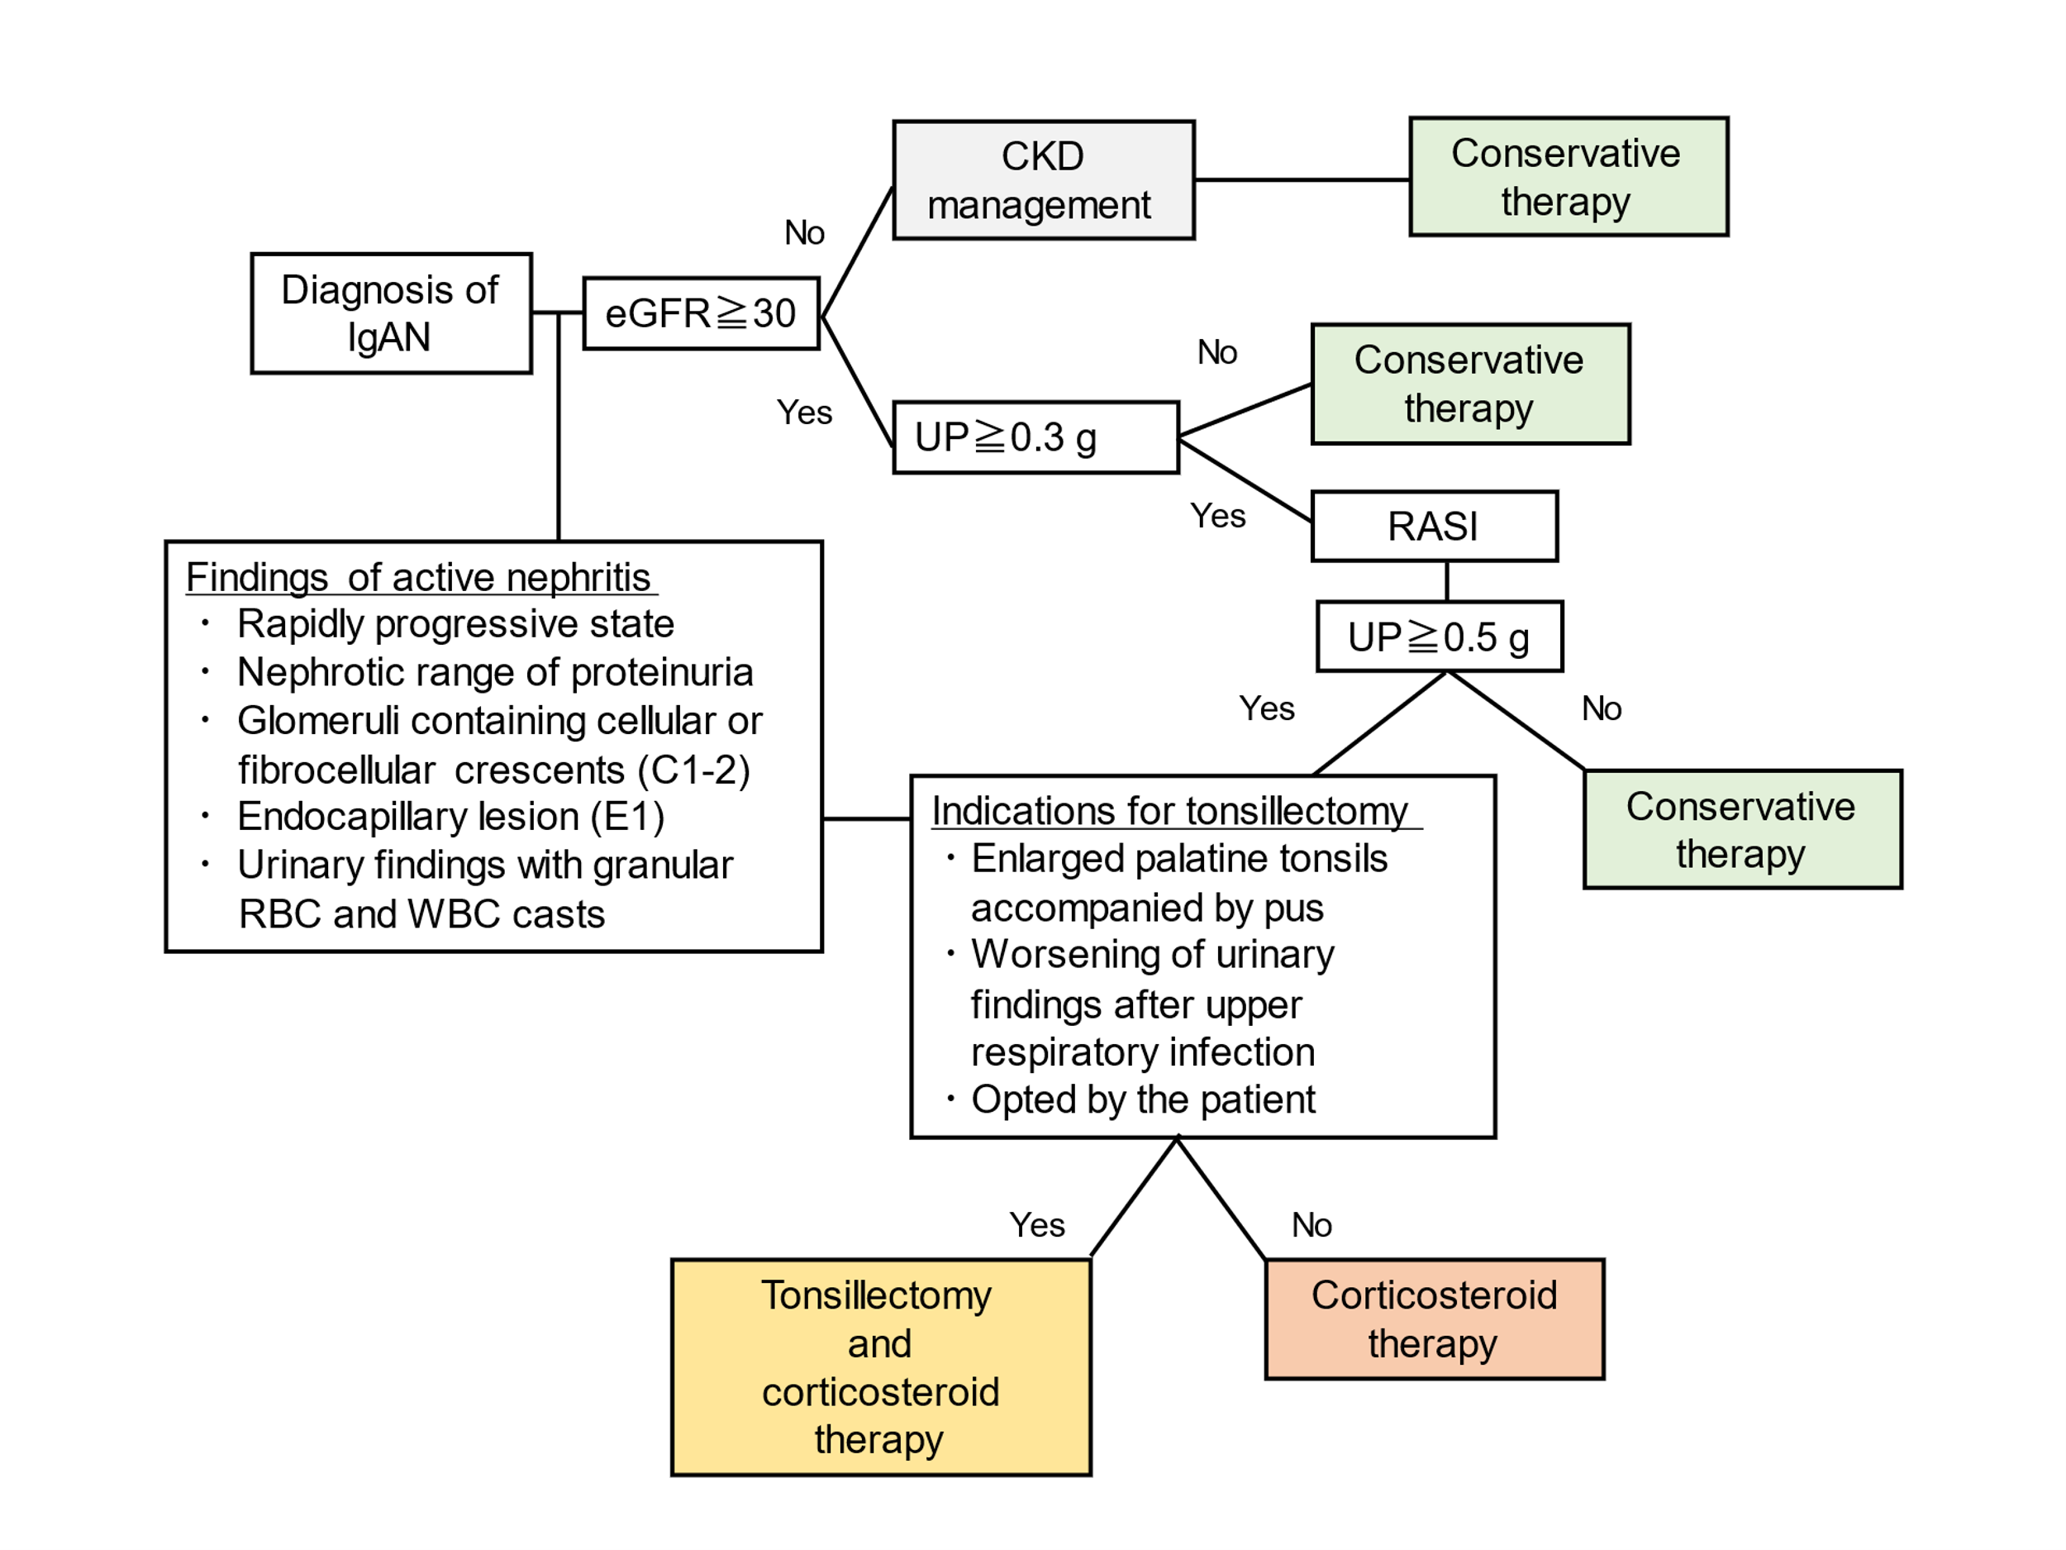
Supplementary Table S1.

Supplementary Table S1. The data set supporting the findings of this study.
Gd-IgA1, galactose-deficient IgA1; MAP, mean arterial pressure; Cr, serum creatinine concentration; eGFR, estimated glomerular filtration rate; HPF, high power field; RA, relative abundance; GalNAc, N-acetylglucosamine; Gal, galactose; Gd-glycan, galactose-deficient glycan; HR, hinge region; H, hexose; N, N-acetylhexosamine; F, fucose; M, mesangial proliferation; E, endocapillary proliferation; S, segmental glomerulosclerosis; T, interstitial fibrosis/tubular atrophy; C, crescents.

