Supplementary materials
Effectiveness and safety of ravulizumab for Japanese patients with atypical hemolytic uremic syndrome switched from eculizumab: an analysis of a post-marketing surveillance

Content | Page
Online Resource 1. Characteristics of the individual patients | 2, 3
Online Resource 2. Gene variants and allele frequency in the gnomAD database | 4
Online Resource 3. Underlying complications | 5
Online Resource 4. Timing of ravulizumab infusion | 6
Online Resource 5. Details of the patient who discontinued ravulizumab | 7

Online Resource 1. Characteristics of the individual patients
Patient No. | Pediatric/Adult (Age) | Sex | Family history | Previous diagnosis of aHUS | Genetic variant | History of kidney transplant | History of dialysis before ravulizumab | On dialysis before ravulizumab initiation | Days of eculizumab treatment before switching to ravulizumab | Time from the last administration of eculizumab to the first administration of ravulizumab | Days of ravulizumab treatment
1 | Pediatric (11) | Male |  |  | Negative |  |  |  | 1996 | 15 | 365
2 | Pediatric (7) | Female |  |  | NA |  |  |  | 2731 | 22 | 350
3 | Pediatric (11) | Male |  |  | Positive  (MCP) |  | Yes |  | 2928 | 16 | 351
4 | Pediatric (5) | Female | Yes |  | Positive  (CFH) |  | Yes |  | 1987 | 16 | 351
5 | Pediatric (0) | Female | Yes |  | Positive  (CFH) |  |  |  | 196 | 22 | 351
6ª | Pediatric (5) | Male | Yes |  | Positive  (CFH) |  | Yes |  | 1064 | 784 | 337
7ª | Pediatric (3) | Male | Yes |  | Negative |  |  |  | 234 | 737 | 365
8ª | Pediatric (11) | Male | Yes |  | Positive  (CFB) |  | Yes |  | 1702 | 815 | 337
9ª | Pediatric (14) | Male |  |  | Positive  (MCP) |  | Yes |  | 1511 | 808 | 337
10 | Pediatric (1) | Female |  |  | Positive  (CFH) |  |  |  | 217 | 22 | 351
11 | Pediatric (3) | Female |  |  | Positive  (C3) |  | Yes |  | 251 | 15 | 350
12 | Pediatric (12) | Female |  |  | Positive  (C3) |  |  |  | 1188 | 16 | 365
13 | Pediatric (17) | Female |  |  | Negative |  |  |  | 1233 | 15 | 351
14 | Pediatric (14) | Male |  |  | Positive  (C3, MCP) |  |  |  | 2437 | 43 | 358
15 | Pediatric (10) | Male |  |  | Positive  (CFHR1 del, CFHR3 del) |  |  |  | 1677 | 36 | 358
16 | Pediatric (15) | Male |  |  | Positive  (C3) |  |  |  | 980 | 15 | 344
17 | Pediatric (8) | Male |  |  | Positive  (DGKε) |  | Yes |  | 3096 | 14 | 357
18 | Pediatric (3) | Male |  |  | Positive  (C3) |  | Yes |  | 846 | 15 | 351
19 | Pediatric (7) | Male |  |  | Negative |  | Yes |  | 1466 | 12 | 351
20 | Adult (40s) | Male |  |  | NA | Yes | Yes | Yes | 1171 | 15 | 351
21 | Adult (70s) | Female |  |  | NA |  | Yes |  | 180 | 15 | 365
22 | Adult (30s) | Female |  |  | Positive  (C3) |  |  |  | 185 | 13 | 365
23 | Adult (60s) | Male |  |  | NA |  | Yes |  | 2605 | 15 | 351
24 | Adult (30s) | Female |  |  | Positive  (C3, CFB) |  | Yes | Yes | 281 | 16 | 353
25 | Adult (70s) | Male | Yes |  | Positive  (CFH) |  | Yes |  | 1479 | 15 | 350
26 | Adult (40s) | Male |  |  | Negative |  | Yes |  | 113 | 15 | 127  (Discontinued)
27 | Adult (20s) | Female |  |  | Negative |  | Yes |  | 118 | 15 | 349
28 | Adult (50s) | Female |  |  | Negative |  | Yes |  | 549 | 15 | 351
29 | Adult (50s) | Male |  |  | Positive  (CFH-CFHR fusion) |  | Yes |  | 1220 | 15 | 351
30 | Adult (40s) | Male | Yes |  | Positive  (C3) | Yes | Yes |  | 1388 | 16 | 351
31 | Adult (30s) | Male | Yes |  | Positive  (CFH) |  | Yes |  | 2080 | 15 | 351
32 | Adult (40s) | Male |  |  | Negative | Yes | Yes |  | 1743 | 15 | 351
33 | Adult (40s) | Male |  |  | Positive  (CFH) | Yes | Yes |  | 3240 | 17 | 365
ªPatients who had been enrolled in the phase 3 clinical trial of ravulizumab before PMS registration were registered in the PMS after the clinical trial.
aHUS atypical hemolytic uremic syndrome, CFB complement factor B, CFH complement factor H, CFHR complement factor H-related, DGKε diacylglycerol kinase ε, MCP membrane cofactor protein, NA not available, PMS post-marketing surveillance.

Online Resource 2. Gene variants and allele frequency in the gnomAD database
Allele | gnomAD  (East Asian) | Note [reference]
C3 p.Ile1157Thr | None | Pathogenic [1]
C3 p.Met1604Thr | 0.0005268
C3 p.Ser182Pro | None
C3 p.Arg1042Leu | None
C3 p.Lys1105Gln+ p.Trp1077Arg | None | Lys1105Gln [2]
Factor H p.Ser1191Trp | None | Pathogenic CFH variant [3]
Factor H p.Arg1215Gln | None | Pathogenic CFH variant [3]
Factor H p.Val62Ile | 0.4155 | Benign CFH variant [3]
Factor H p.His402Tyr | 0.9410 | Benign CFH variant [3]
Factor H exon21-2212CNV | None
Factor H p.Phe176Leu | 0.0003126
Factor B p.Lys350Asn | None | Pathogenic [4]
Factor B p.Ile502Thr | 0.00002519
1. Matsumoto T, Fan X, Ishikawa E, et al. Analysis of patients with atypical hemolytic uremic syndrome treated at the Mie University Hospital: concentration of C3 p.I1157T mutation. Int J Hematol. 2014;100:437–42.
2. Yoshida Y, Miyata T, Matsumoto M, et al. A novel quantitative hemolytic assay coupled with restriction fragment length polymorphisms analysis enabled early diagnosis of atypical hemolytic uremic syndrome and identified unique predisposing mutations in Japan. PLOS One. 2015;10:e0124655.
3. Merinero HM, Zhang Y, Arjona E, et al. Functional characterization of 105 factor H variants associated with aHUS: lessons for variant classification. Blood. 2021;138:2185–201.
4. Funato M, Uemura O, Ushijima K, et al. A complement factor B mutation in a large kindred with atypical hemolytic uremic syndrome. J Clin Immunol. 2014;34:691–5.
CFH complement factor H.

Online Resource 3. Underlying complications
Pediatric (n = 4/19)
Hypertension
Cardiac failure, protein urine present
Cardiac failure congestive, congenital megacolon, renal dysplasia, renal transplant, short bowel syndrome, single functional kidney
Membranoproliferative glomerulonephritis, renal hypertension
Adult (n = 14/14)
Hyperkalemia, hyperphosphatemia, hypertension, chronic kidney disease, type 2 diabetes mellitus
Mitral valve incompetence, acute kidney injury
Hypertension, adjustment disorder
Depression, gastroesophageal reflux disease, hypertension, hyperuricemia, insomnia, chronic kidney disease
Cardiac failure acute, hypertension, hyperuricemia, left ventricular hypertrophy, nephrogenic anemia, chronic kidney disease, acute kidney injury
Constipation, Henoch–Schönlein purpura, hypertension, hyperuricemia
Diabetes mellitus, hypertension, hyperuricemia, dyslipidemia, diabetic nephropathy
Cardiac failure, dysmenorrhea, hypertension, chronic kidney disease
Collagen disorder, mitral valve incompetence, peripheral arterial occlusive disease, microscopic polyangiitis
Hypertension, hyperuricemia
Adrenal insufficiency, angina pectoris, extrasystoles, hypertension, hyperuricemia, neurogenic bladder, osteoporosis, renal transplant, dyslipidemia
Gastroesophageal reflux disease, hypertension, hyperuricemia
Hypertension
Chronic gastritis, hemorrhoids, hiatus hernia, renal hypertension, renal transplant, rhinitis allergic, nephrogenic anemia, chronic kidney disease

Online Resource 4. Timing of ravulizumab infusion
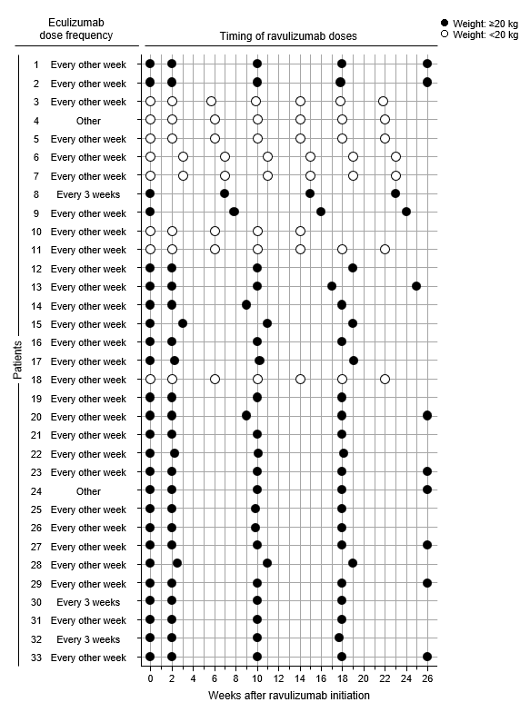

Online Resource 5. Details of the patient who discontinued ravulizumab
Patient background and clinical course
Man in his 40s with no family history of TMA, previous diagnosis of TMA or aHUS before eculizumab treatment, or genetic variant. Anti-CFH antibody was positive at the initiation of eculizumab treatment.
Patient was treated with eculizumab for 113 days and switched to ravulizumab. Ravulizumab treatment was stopped after 127 days because anti-CFH antibody became negative. Patient died at home 478 days later from an unknown cause. No relationship between ravulizumab and death was reported.
Underlying complications at ravulizumab initiation
Diabetes mellitus, hypertension, hyperuricemia, dyslipidemia, diabetic nephropathy
Adverse events during ravulizumab treatment
Lipids increased, dyslipidemia aggravated, hyperuricemia, hypertension
aHUS atypical hemolytic uremic syndrome, CFH complement factor H, TMA thrombotic microangiopathy.

