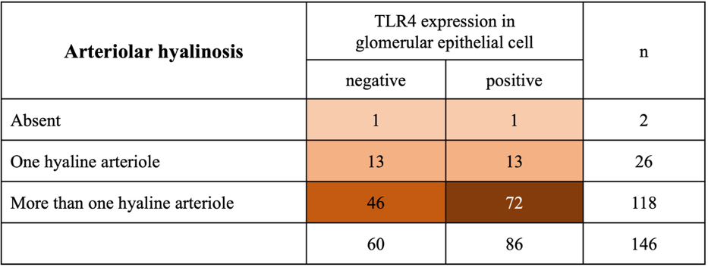
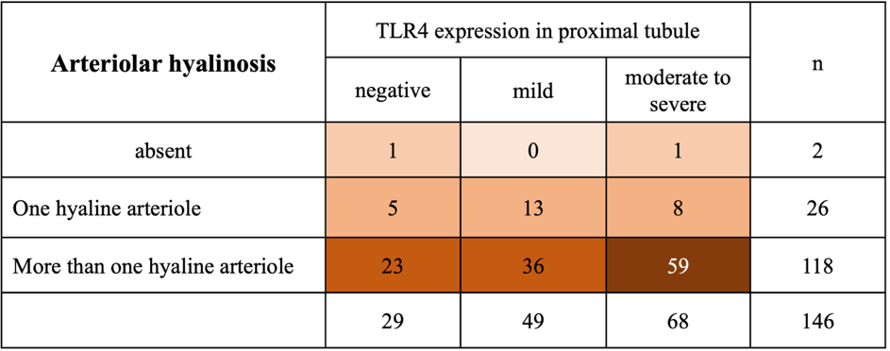
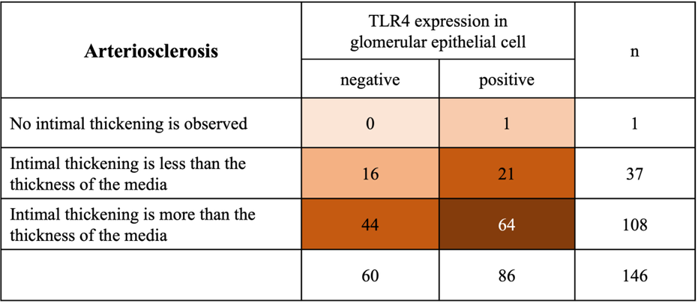
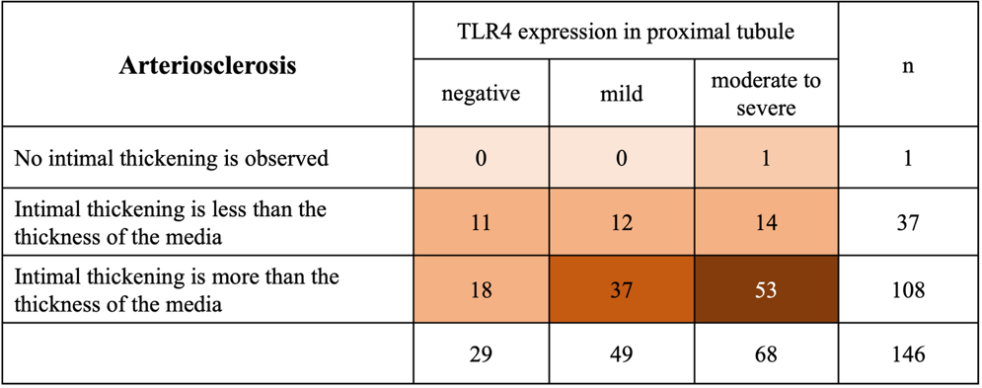
Supplementary Figure 1
Supplementary Fig. 1
Relationship between TLR4 expression and the histological features of DN.
TLR, Toll-like receptor; DN, diabetic nephropathy; IFTA, interstitial fibrosis and tubular atrophy; LM, light microscopy

