a
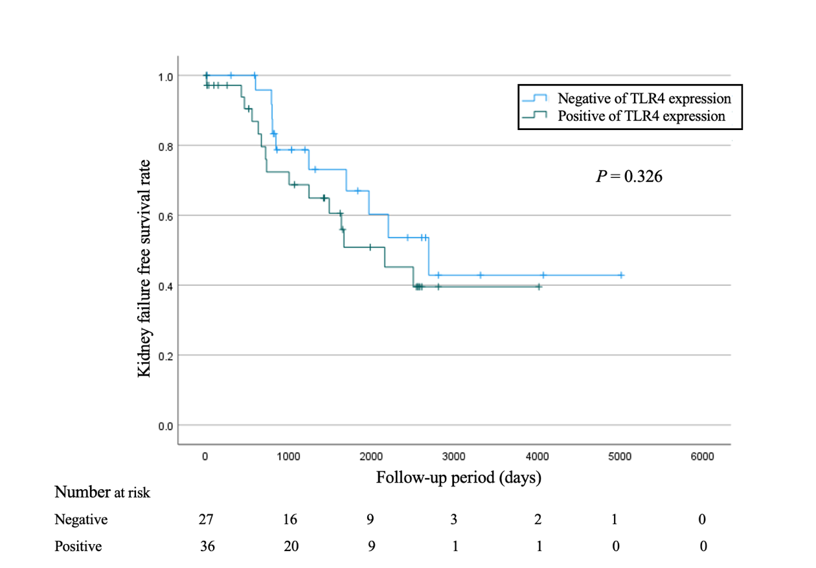
b
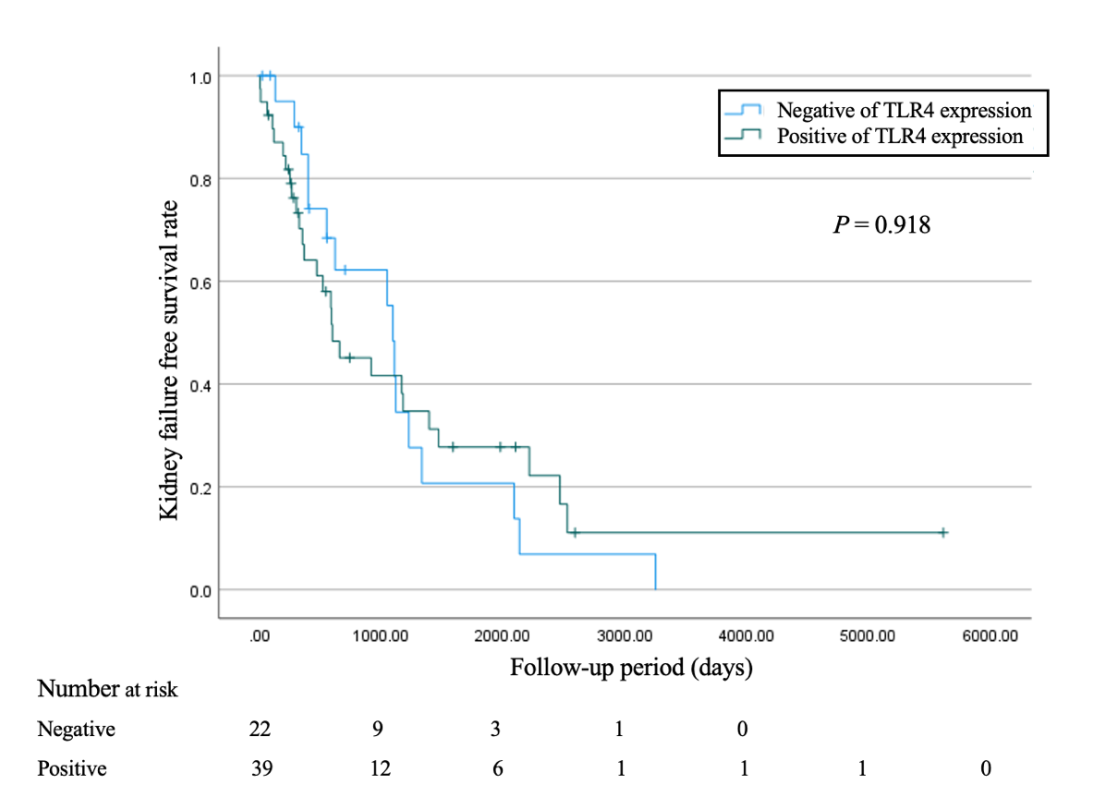
c
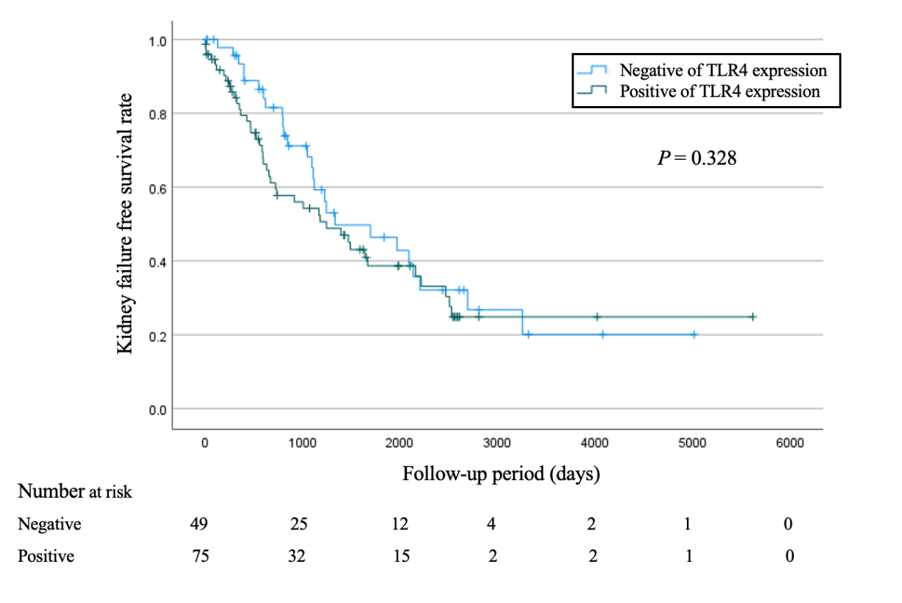

Supplementary Figure 2

Supplementary Fig. 2 Kidney failure-free survival rates in patients with DN
(A) Patients with IFTA < 50%: Compared with the group with negative and positive TLR4 expression in the glomeruli.
(B) Patients with IFTA ≥ 50%: Compared with the group with negative and positive TLR4 expression in the glomeruli.
(C) Comparison of kidney failure-free survival between patients with negative and positive glomerular TLR4 expression in the entire cohort.
DN, diabetic nephropathy; TLR, Toll-like receptor; IFTA, interstitial fibrosis and tubular atrophy

