Supplementary Figure 1. CI outcomes per cochlear site-of-lesion according to Tropitzsch et al.’s classification system

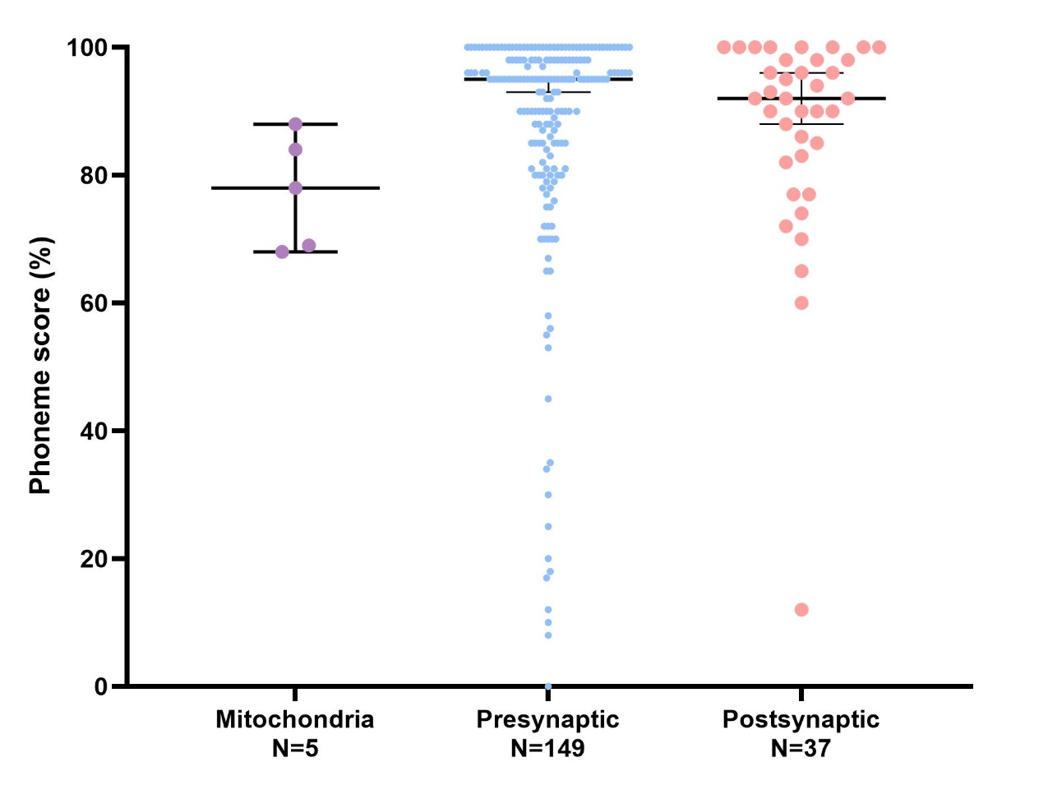

Scatterplots of the last measured phoneme scores at 65 dB SPL in quiet, broken down by subgroup. Each plot represents the median with interquartile ranges. There was no significant difference in the last measured phoneme score at 65 dB SPL between the pre-synaptic and post-synaptic group (p=0.594).

