Supplementary information for:
Generational Differences in Audiometric and Self-Reported Hearing and Hearing Aid Use

Supplementary text, tables, and figures:
- Supplementary Text S1: Supplementary methods on the measurement of speech perception in noise (SPIN).
- Supplementary Table S1: Demographic characteristics by generation, presented as n (%) or mean (SD).
- Supplementary Figure S1: Relationships of PTA and age for each generation in males and females, separately.
- Supplementary Table S2: Linear regression coefficients (95% confidence interval) for relationships of age with pure-tone average and Revised Hearing Handicap Inventory, separately, for each generation.
- Supplementary Table S3: Prevalence of audiometric hearing loss and mean pure-tone average by generation and age group, in males only.
- Supplementary Table S4: Prevalence of audiometric hearing loss and mean pure-tone average by generation and age group, in females only.
- Supplementary Table S5: Study sample characteristics for supplementary analyses focused on the speech perception in noise (SPIN) test (n=640).
- Supplementary Table S6: Mean speech perception in noise (SPIN) observed – predicted scores by generation and age group.
- Supplementary Table S7: Associations of generation with speech perception in noise (SPIN) observed – predicted scores. Results are presented as linear regression coefficients with corresponding 95% confidence intervals.

Supplementary Text S1: Supplementary methods on the measurement of speech perception in noise (SPIN)
Participants underwent the Speech Perception in Noise (SPIN) test.¹ Fifty-item lists of intermingled high- and low-context sentences were presented in each ear 50 dB above the estimated babble threshold at a +8 dB signal to-babble ratio.² Babble thresholds were estimated based on pure-tone thresholds at frequencies 0.5, 1.0, 2.0, and 4.0 kHz.³ Participants repeated the last word of each sentence. To control for audibility, SPIN scores are compared to scores predicted by the articulation index (AI) speech-audibility metric.⁴⁻⁵ SPIN scores from low-context sentences only (the more challenging condition) are presented as observed minus predicted values in the worse ear. A positive difference indicates that observed scores are better than predicted and a negative difference indicates scores are poorer than predicted. To be included in these analyses, participants must have had SPIN scores within 1 year of their baseline audiogram. SPIN scores were treated as a continuous outcome measure.

References
- Kalikow DN, Stevens KN, Elliott LL. Development of a test of speech intelligibility in noise using sentence materials with controlled word predictability. J Acoust Soc Am. 1977;61(5):1337–51.
- Bilger RC, Nuetzel JM, Rabinowitz WM, Rzeczkowski C. Standardization of a test of speech perception in noise. J Speech Hear Res. 1984;27(1):32–48.
- Bilger RC. Manual for the clinical use of the revised SPIN test. 1984. (Appendix 1).
- Dubno JR, Lee FS, Matthews LJ, Ahlstrom JB, Horwitz AR, Mills JH. Longitudinal changes in speech recognition in older persons. J Acoust Soc Am. 2008;123(1):462–75.
- ANSI. ANSI S3.5-1997 (R, Methods for calculation of the speech intelligibility index. American National Standards Institute. 2020), (2020). American National Standard Methods for Calculation of the Speech Intelligibility Index (American National Standards Institute, New York). 2020.

Supplementary Table S1: Demographic characteristics by generation, presented as n (%) or mean (SD).

 | Greatest  (1901-1924) | Silent  (1925-1945) | Baby Boom (1946-1964) | Gen X  (1965-1980) | Millennial  (1981-1996) or Gen Z (1997-2012)
Characteristic
Age (years) | 75.2 (6.6) | 69.1 (6.6) | 59.2 (7.6) | 42.7 (6.9) | 25.3 (4.1)
Female sex | 147 (53.3%) | 414 (57.6%) | 212 (56.2%) | 50 (54.4%) | 60 (66.7%)
Racial minority | 17 (6.2%) | 99 (13.8%) | 128 (34.0%) | 42 (45.7%) | 24 (26.7%)

Supplementary Figure S1: Relationships of pure-tone average and age for each generation in males and females, separately
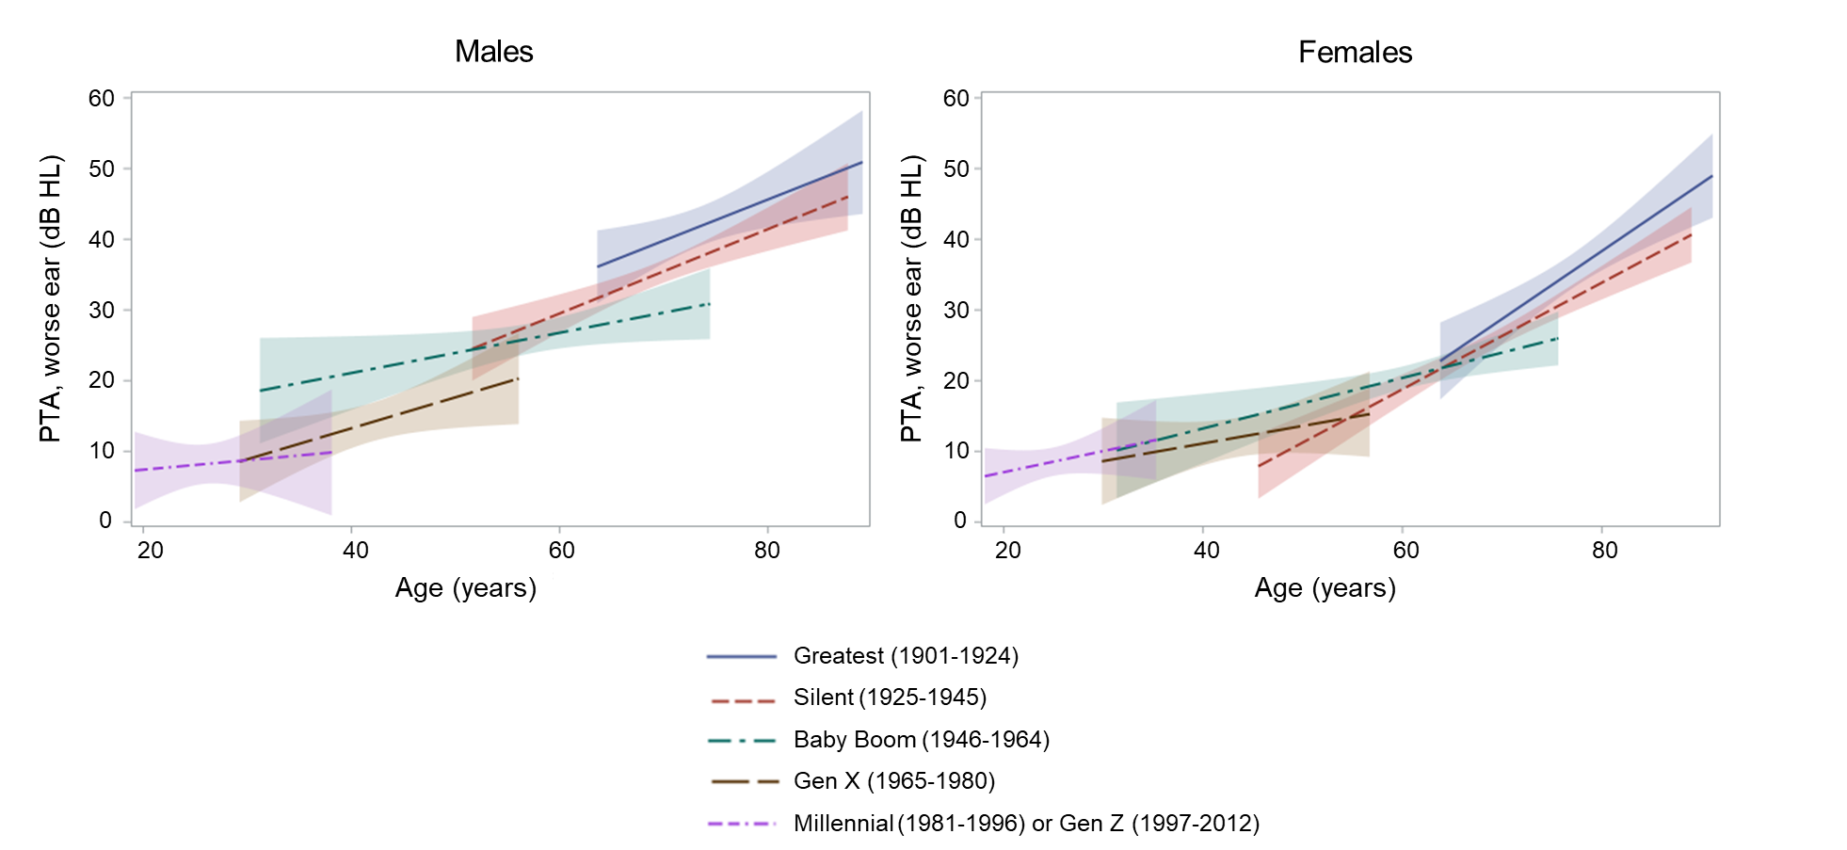
Abbreviations: PTA: pure-tone average, dB HL: decibel hearing level

Supplementary Table S2: Linear regression coefficients (95% confidence interval) for relationships of age with pure-tone average and Revised Hearing Handicap Inventory, separately, for each generation.

 | Greatest  (1901-1924) | Silent  (1925-1945) | Baby Boom (1946-1964) | Gen X  (1965-1980) | Millennial  (1981-1996) or Gen Z (1997-2012)
Pure-tone average
Entire sample | 0.10  (0.05, 0.15) | 0.13  (0.10, 0.17) | 0.08  (0.02, 0.14) | 0.16  (0.01, 0.31) | 0.07  (-0.04, 0.18)
Males | 0.09  (0.02, 0.16) | 0.12  (0.07, 0.17) | 0.09  (0.004, 0.18) | 0.24  (0.02, 0.46) | 0.04  (-0.17, 0.25)
Females | 0.15  (0.09, 0.22) | 0.17  (0.13, 0.22) | 0.12  (0.05, 0.20) | 0.12  (-0.08, 0.32) | 0.08  (-0.05, 0.21)
Revised Hearing Handicap Inventory
Entire sample | 0.004  (-0.05, 0.05) | 0.06  (0.03, 0.10) | -0.01  (-0.07, 0.05) | -0.01  (-0.17, 0.15) | 0.05  (-0.06, 0.17)

Supplementary Table S3: Prevalence of audiometric hearing loss and mean pure-tone average by generation and age group, in males only.

 | 18 to <50 years | 50 to <60 years | 60 to <70 years | 70 to <80 years | 80+  years | All ages
Greatest (1901-1924)
n | -- | -- | 46 | 57 | 26 | 129
Prevalence | -- | -- | 80.4% | 87.7% | 92.3% | 86.1%
Mean (SD) | -- | -- | 38.6 (16.9) | 43.2 (17.0) | 45.0 (12.8) | 41.9 (16.3)
Silent (1925-1945)
n | -- | 19 | 155 | 114 | 17 | 305
Prevalence | -- | 58.0% | 61.3% | 81.6% | 88.2% | 70.2%
Mean (SD) | -- | 33.8 (15.7) | 31.2 (13.7) | 38.3 (13.9) | 47.1 (16.3) | 34.9 (14.7)
Baby Boom (1946-1964)
n | 23 | 78 | 56 | -- | -- | 165
Prevalence | 52.2% | 32.1% | 55.4% | -- | -- | 44.9%
Mean (SD) | 28.4 (16.9) | 21.8 (11.2) | 30.0 (14.7) | -- | -- | 26.1 (14.0)
Gen X (1965-1980)
n | 38 | -- | -- | -- | -- | 38
Prevalence | 5.3% | -- | -- | -- | -- | 5.3%
Mean (SD) | 13.0 (8.8) | -- | -- | -- | -- | 13.0 (8.8)
Millennial (1981-1996) or Gen Z (1997-2012)
n | 30 | -- | -- | -- | -- | 30
Prevalence | 3.3% | -- | -- | -- | -- | 3.3%
Mean (SD) | 8.2 (7.4) | -- | -- | -- | -- | 14.0 (9.1)

Note. Cells with participants < 10 are not shown.

Supplementary Table S4: Prevalence of audiometric hearing loss and mean pure-tone average by generation and age group, in females only

 | 18 to <50 years | 50 to <60 years | 60 to <70 years | 70 to <80 years | 80+  years | All ages
Greatest (1901-1924)
n | -- | -- | 25 | 73 | 49 | 147
Prevalence | -- | -- | 44.0% | 63.0% | 95.9% | 70.8%
Mean (SD) | -- | -- | 25.7 (13.3) | 33.0 (17.6) | 43.2 (11.1) | 35.2 (16.2)
Silent (1925-1945)
n | -- | 16 | 212 | 161 | 22 | 414
Prevalence | -- | 12.5% | 32.3% | 56.5% | 90.9% | 44.7%
Mean (SD) | -- | 17.1 (8.7) | 21.7 (11.9) | 29.5 (13.2) | 38.8 (12.5) | 25.7 (13.6)
Baby Boom (1946-1964)
n | 19 | 75 | 101 | 17 | -- | 212
Prevalence | 21.1% | 25.3% | 30.7% | 47.1% | -- | 29.3%
Mean (SD) | 55.8 (15.3) | 17.7 (11.4) | 22.1 (11.5) | 28.5 (14.7) | -- | 20.5 (12.2)
Gen X (1965-1980)
n | 40 | 10 | -- | -- | -- | 50
Prevalence | 10.0% | 0% | -- | -- | -- | 8.0%
Mean (SD) | 12.0 (10.6) | 11.8 (5.9) | -- | -- | -- | 12.0 (9.8)
Millennial (1981-1996) or Gen Z (1997-2012)
n | 60 | -- | -- | -- | -- | 60
Prevalence | 3.3% | -- | -- | -- | -- | 3.3%
Mean (SD) | 8.5 (7.8) | -- | -- | -- | -- | 8.5 (7.8)

Note. Cells with participants < 10 are not shown.

Supplementary Table S5: Study sample characteristics for supplementary analyses focused on the speech perception in noise (SPIN) test (n=640).

Characteristic | n (%) or mean (SD)
Age (years) | 62.2 (15.5)
18-<50 | 108 (16.9%)
50-<60 | 96 (15.0%)
60-<70 | 213 (33.3%)
70-<80 | 183 (28.6%)
80+ | 40 (6.3%)
Generation (birth year)
Greatest (1901-1924) | 80 (12.5%)
Silent (1925-1945) | 257 (40.2%)
Baby Boom (1946-1964) | 204 (31.9%)
Gen X (1965-1980) | 43 (6.7%)
Millennial (1981-1996) or Gen Z (1997-2012) | 56 (8.8%)
Female sex | 359 (56.1%)
Racial minority | 131 (20.5%)
PTA, worse ear | 26.7 (15.7)
Audiometric hearing loss (PTA >25 dB HL) | 309 (48.3%)
RHHI score | 10.7 (13.9)
RHHI self-reported hearing difficulty (score ≥6) | 310 (48.4%)
SPIN observed – predicted, worse ear | -6.4 (17.5)

Abbreviations: PTA: pure-tone average

Supplementary Table S6: Mean speech perception in noise (SPIN) observed – predicted scores by generation and age group.

 | 18 to <50 years | 50 to <60 years | 60 to <70 years | 70 to <80 years | 80+  years | All ages
Greatest (1901-1924)
n | -- | -- | 22 | 37 | 21 | 80
Mean (SD) | -- | -- | -14.5 (16.2) | -26.7 (20.0) | -31.5 (14.5) | -27.6 (18.7)
Silent (1925-1945)
n | -- | 11 | 100 | 127 | 19 | 257
Mean (SD) | -- | -11.3 (14.8) | -6.3 (15.8) | -6.1 (15.6) | -19.3 (19.6) | -7.3 (16.2)
Baby Boom (1946-1964)
n | 16 | 78 | 91 | 19 | -- | 204
Mean (SD) | -13.4 (20.5) | -2.2 (15.1) | -2.6 (14.6) | -2.7 (14.4) | -- | -3.3 (15.5)
Gen X (1965-1980)
n | 36 | -- | -- | -- | -- | 36
Mean (SD) | 2.4 (12.9) | -- | -- | -- | -- | 2.4 (12.9)
Millennial (1981-1996) or Gen Z (1997-2012)
n | 56 | -- | -- | -- | -- | 56
Mean (SD) | 5.5 (9.5) | -- | -- | -- | -- | 5.5 (9.5)

Note. Cells with participants < 10 are not shown.

Supplementary Table S7: Associations of generation with speech perception in noise (SPIN) observed – predicted scores. Results are presented as linear regression coefficients with corresponding 95% confidence intervals.

 | Greatest  (1901-1924) | Silent  (1925-1945) | Baby Boom (1946-1964) | Gen X  (1965-1980) | Millennial  (1981-1996) or Gen Z (1997-2012)
Audiometric hearing loss
Entire sampleª | REF | 16.98  (12.99, 20.96) | 20.80  (15.94, 25.65) | 25.75  (17.62, 33.88) | 25.69  (15.44, 35.93)
Males^{b} | REF | 12.28  (5.94, 18.63) | 16.36  (8.57, 24.15) | 19.50  (6.65, 32.34) | 23.64  (7.84, 39.43)
Females^{b} | REF | 20.68  (15.61, 25.75) | 23.75  (17.54, 29.96) | 29.97  (19.44, 40.50) | 26.60  (13.01, 40.19)

ªAdjusted for age, sex, and race
^{b}Adjusted for age and race

