Supplemental Material

Table 1 Comparison of voltage output between the surface microphone and the ER7c probe microphone on the human head specimen.
Freq. [Hz] | 100 | 125 | 150 | 163 | 175 | 200 | 250 | 275
Diff. [dB] | 2.5 | 0.5 | -0.7 | -1.1 | -1.6 | -2.2 | -2.8 | -3.0
Freq. [Hz] | 300 | 313 | 325 | 350 | 375 | 400 | 425 | 450 | 475 | 500
Diff. [dB] | -3.1 | -3.1 | -3.1 | -3.0 | -3.1 | -3.2 | -3.3 | -3.3 | -3.3 | -3.3
Freq. [Hz] | 525 | 575 | 625 | 675 | 725 | 775 | 788 | 825 | 875 | 925
Diff. [dB] | -3.3 | -3.2 | -3.1 | -3.0 | -2.9 | -2.8 | -2.8 | -2.7 | -2.6 | -2.6
Freq. [Hz] | 1000 | 1088 | 1175 | 1263 | 1350 | 1438 | 1525 | 1588 | 1613 | 1700
Diff. [dB] | -2.5 | -2.5 | -2.5 | -2.5 | -2.6 | -2.6 | -2.7 | -2.8 | -2.8 | -3.0
Freq. [Hz] | 1788 | 1875 | 1963 | 2000 | 2050 | 2213 | 2375 | 2525 | 2538 | 2700
Diff. [dB] | -3.0 | -3.0 | -3.1 | -3.1 | -3.1 | -3.2 | -3.3 | -3.4 | -3.4 | -3.5
Freq. [Hz] | 2863 | 3000 | 3025 | 3175 | 3188 | 3350 | 3513 | 3675 | 3838 | 4000
Diff. [dB] | -3.7 | -4.1 | -4.2 | -4.5 | -4.5 | -4.6 | -4.8 | -5.1 | -5.4 | -5.6
Freq. [Hz] | 4313 | 4625 | 4938 | 5038 | 5250 | 5563 | 5875 | 6000 | 6188 | 6350
Diff. [dB] | -6.0 | -6.9 | -6.2 | -5.7 | -4.2 | 1.5 | -13.2 | -20.4 | -16.6 | -15.4
Freq. [Hz] | 6500 | 6812 | 7125 | 7438 | 7750 | 8000 | 8350 | 8950 | 9550
Diff. [dB] | -14.9 | -13.9 | -12.7 | -11.6 | -10.9 | -11.0 | -12.2 | -16.4 | -12.9

Table 2: Mean experimental results and linear predicted values assuming a slope of one and a frequency independent constant of 166.7 dB. The emphasis was calculated as the mean difference to the linear prediction at each frequency.
Freq. | SM | CP | Emphasis | RMSE | MAE |  | Freq. | SM | CP | Emphasis | RMSE | MAE
[Hz] | [dB SPL] | [dB m/s] | [dB SPL] | [dB SPL] | [dB SPL] |  | [Hz] | [dB SPL] | [dB m/s] | [dB SPL] | [dB SPL] | [dB SPL]
88 | 31.0 | -109.4 | -26.4 | 27.7 | 26.4 |  | 1788 | 91.3 | -78.7 | 3.3 | 9.0 | 8.0
100 | 37.2 | -105.8 | -23.7 | 25.0 | 23.7 |  | 1875 | 90.8 | -78.5 | 2.5 | 8.3 | 7.5
125 | 48.0 | -101.5 | -17.1 | 20.0 | 18.0 |  | 1963 | 90.7 | -78.9 | 2.9 | 8.2 | 7.1
150 | 58.1 | -97.8 | -10.8 | 13.0 | 11.8 |  | 2006 | 90.6 | -79.3 | 3.1 | 8.0 | 6.7
163 | 61.3 | -96.3 | -9.1 | 11.5 | 9.4 |  | 2050 | 90.3 | -80.0 | 3.5 | 7.7 | 6.2
175 | 63.6 | -95.1 | -8.0 | 11.5 | 8.2 |  | 2213 | 88.3 | -81.2 | 2.9 | 7.2 | 5.1
200 | 66.2 | -93.0 | -7.5 | 12.9 | 7.5 |  | 2375 | 86.7 | -80.9 | 0.9 | 5.4 | 4.7
250 | 71.6 | -90.3 | -4.8 | 12.4 | 9.0 |  | 2456 | 83.4 | -81.7 | -1.6 | 9.7 | 7.5
275 | 75.2 | -89.4 | -2.1 | 9.9 | 7.2 |  | 2538 | 80.8 | -82.0 | -3.9 | 16.0 | 10.2
300 | 76.8 | -88.6 | -1.3 | 9.4 | 6.5 |  | 2700 | 83.8 | -82.0 | -0.9 | 6.0 | 5.0
313 | 77.2 | -88.4 | -1.1 | 9.1 | 6.4 |  | 2863 | 80.6 | -82.2 | -3.9 | 9.1 | 6.6
325 | 77.8 | -88.0 | -0.9 | 8.8 | 6.3 |  | 2944 | 78.9 | -83.4 | -4.4 | 9.4 | 8.0
350 | 78.4 | -88.2 | -0.1 | 8.9 | 6.6 |  | 3025 | 78.9 | -83.8 | -3.9 | 8.4 | 7.5
375 | 79.2 | -87.0 | -0.5 | 7.6 | 6.0 |  | 3106 | 79.0 | -84.0 | -3.7 | 7.8 | 7.0
400 | 79.9 | -86.4 | -0.4 | 7.0 | 6.0 |  | 3188 | 79.3 | -84.0 | -3.4 | 7.4 | 6.7
425 | 80.7 | -86.2 | 0.2 | 7.5 | 6.5 |  | 3350 | 79.6 | -84.3 | -2.8 | 7.9 | 6.4
450 | 81.4 | -85.8 | 0.5 | 10.3 | 8.8 |  | 3513 | 79.6 | -86.6 | -0.5 | 8.0 | 6.8
475 | 83.6 | -86.0 | 2.9 | 7.8 | 6.3 |  | 3675 | 79.1 | -87.4 | -0.2 | 8.1 | 6.9
500 | 81.3 | -86.1 | 0.7 | 8.8 | 7.6 |  | 3838 | 78.8 | -89.0 | 1.1 | 13.7 | 10.6
525 | 80.1 | -85.6 | -1.0 | 6.2 | 5.6 |  | 4000 | 79.0 | -86.9 | -0.8 | 11.9 | 9.9
575 | 83.7 | -84.4 | 1.3 | 5.7 | 4.7 |  | 4313 | 81.1 | -87.3 | 1.7 | 9.4 | 8.6
625 | 86.8 | -80.8 | 0.9 | 4.8 | 4.3 |  | 4625 | 77.4 | -87.7 | -1.7 | 12.3 | 8.4
675 | 88.8 | -77.9 | 0.1 | 5.4 | 4.8 |  | 4938 | 75.5 | -88.4 | -2.8 | 10.4 | 8.8
725 | 91.0 | -75.7 | 0.0 | 6.7 | 6.3 |  | 5094 | 75.7 | -88.7 | -2.3 | 8.8 | 7.9
775 | 94.7 | -72.5 | 0.5 | 8.7 | 8.0 |  | 5250 | 73.0 | -89.1 | -4.6 | 8.8 | 7.3
800 | 95.4 | -72.5 | 1.1 | 9.7 | 8.7 |  | 5563 | 68.7 | -89.9 | -8.1 | 11.4 | 9.9
825 | 96.6 | -71.3 | 1.1 | 10.8 | 9.4 |  | 5875 | 82.2 | -89.3 | 4.8 | 9.5 | 7.6
875 | 97.5 | -69.9 | 0.7 | 9.4 | 8.1 |  | 6031 | 89.5 | -90.1 | 12.9 | 14.8 | 12.9
925 | 97.8 | -70.5 | 1.5 | 7.7 | 6.5 |  | 6188 | 85.7 | -89.8 | 8.9 | 10.5 | 8.9
1000 | 97.2 | -71.8 | 2.3 | 7.8 | 6.9 |  | 6344 | 83.9 | -89.8 | 7.0 | 8.8 | 7.4
1088 | 97.8 | -72.9 | 4.1 | 8.4 | 6.9 |  | 6500 | 82.8 | -89.9 | 6.0 | 7.8 | 6.5
1175 | 98.1 | -74.1 | 5.4 | 8.6 | 6.8 |  | 6812 | 79.8 | -90.6 | 3.7 | 6.8 | 6.1
1263 | 97.3 | -77.8 | 8.4 | 12.5 | 9.3 |  | 7125 | 77.9 | -91.7 | 2.9 | 6.8 | 5.2
1350 | 96.4 | -76.3 | 6.0 | 9.0 | 6.5 |  | 7438 | 76.3 | -95.0 | 4.6 | 10.7 | 6.1
1438 | 95.7 | -76.3 | 5.3 | 7.7 | 6.4 |  | 7750 | 76.5 | -96.2 | 6.0 | 8.0 | 6.2
1525 | 95.0 | -77.2 | 5.5 | 8.4 | 7.4 |  | 8050 | 77.5 | -95.5 | 6.4 | 7.9 | 6.6
1569 | 94.1 | -78.0 | 5.3 | 8.6 | 7.9 |  | 8350 | 78.6 | -95.7 | 7.5 | 9.3 | 7.5
1613 | 93.8 | -78.1 | 5.2 | 8.6 | 8.0 |  | 8950 | 80.1 | -95.5 | 8.9 | 10.9 | 9.5
1700 | 92.4 | -78.8 | 4.5 | 8.9 | 7.9 |  | 9550 | 72.8 | -95.8 | 1.9 | 5.1 | 4.0

Table 3: Mean RMSE and MAE as a function of frequency assuming a slope of one and a frequency dependent constant of 166.7 dB SPL + (from Table 2).
Freq. | RMSE | MAE |  | Freq. | RMSE | MAE
[Hz] | [dB SPL] | [dB SPL] |  | [Hz] | [dB SPL] | [dB SPL]
88 | 8.6 | 7.0 |  | 1788 | 8.3 | 7.3
100 | 8.0 | 6.5 |  | 1875 | 7.9 | 7.0
125 | 10.4 | 8.2 |  | 1963 | 7.7 | 6.5
150 | 7.1 | 5.7 |  | 2006 | 7.4 | 6.1
163 | 7.0 | 6.1 |  | 2050 | 6.8 | 5.5
175 | 8.2 | 6.9 |  | 2213 | 6.6 | 4.9
200 | 10.4 | 7.8 |  | 2375 | 5.3 | 4.6
250 | 11.4 | 9.4 |  | 2456 | 9.6 | 7.7
275 | 9.7 | 7.2 |  | 2538 | 15.5 | 11.0
300 | 9.3 | 6.6 |  | 2700 | 5.9 | 5.0
313 | 9.1 | 6.4 |  | 2863 | 8.3 | 6.3
325 | 8.8 | 6.3 |  | 2944 | 8.2 | 6.5
350 | 8.9 | 6.6 |  | 3025 | 7.5 | 6.0
375 | 7.6 | 6.1 |  | 3106 | 6.8 | 6.2
400 | 7.0 | 6.0 |  | 3188 | 6.6 | 6.0
425 | 7.5 | 6.5 |  | 3350 | 7.4 | 6.4
450 | 10.3 | 8.9 |  | 3513 | 8.0 | 6.8
475 | 7.3 | 6.1 |  | 3675 | 8.1 | 6.8
500 | 8.8 | 7.7 |  | 3838 | 13.7 | 10.9
525 | 6.1 | 5.3 |  | 4000 | 11.9 | 9.9
575 | 5.6 | 4.9 |  | 4313 | 9.3 | 8.6
625 | 4.7 | 4.3 |  | 4625 | 12.2 | 9.1
675 | 5.4 | 4.8 |  | 4938 | 10.0 | 8.0
725 | 6.7 | 6.3 |  | 5094 | 8.5 | 7.0
775 | 8.7 | 7.9 |  | 5250 | 7.5 | 5.5
800 | 9.6 | 8.5 |  | 5563 | 8.0 | 6.4
825 | 10.8 | 9.2 |  | 5875 | 8.2 | 7.0
875 | 9.3 | 7.9 |  | 6031 | 7.3 | 6.9
925 | 7.6 | 6.5 |  | 6188 | 5.7 | 5.2
1000 | 7.5 | 6.5 |  | 6344 | 5.4 | 4.6
1088 | 7.4 | 6.6 |  | 6500 | 5.0 | 4.0
1175 | 6.7 | 5.2 |  | 6812 | 5.7 | 5.0
1263 | 9.2 | 7.3 |  | 7125 | 6.2 | 4.6
1350 | 6.7 | 5.7 |  | 7438 | 9.7 | 6.6
1438 | 5.6 | 5.0 |  | 7750 | 5.3 | 4.5
1525 | 6.3 | 5.4 |  | 8050 | 4.6 | 4.1
1569 | 6.7 | 5.4 |  | 8350 | 5.4 | 4.4
1613 | 6.9 | 5.6 |  | 8950 | 6.3 | 4.9
1700 | 7.7 | 6.7 |  | 9550 | 4.8 | 4.1

Figure 6: (a) Sound field stimulation in sound proof booth. (b) Ponto stimulation. Both recordings were performed with the surface microphone and the probe microphone recording close to the surface microphone on the forehead.

Table 4: SM housing attenuation
Frequency | Ponto @1 V | Loud speaker @ 1 V
[Hz] | SM - ER7C Mic [dB] | SM - ER7C Mic [dB]
100 | -24 | -1.0
125 | -33 | -1.4
162.5 | -38 | -2.9
200 | -44 | -2.6
250 | -42 | -4.3
312.5 | -40 | -5.5
400 | -41 | -6.8
500 | -22 | -7.0
625 | -23 | -11.3
787.5 | -25 | -14.9
1000 | -37 | -12.9
1262.5 | -30 | -12.7
1587.5 | -27 | -20.0
2000 | -22 | -20.2
2525 | -21 | -29.1
3000 | -14 | -29.0
3175 | -14 | -29.3
4000 | -9 | -34.6
5037.5 | 2 | -43.7
6000 | -25 | -24.9
6350 | -14 | -23.1
8000 | -19 | -32.3

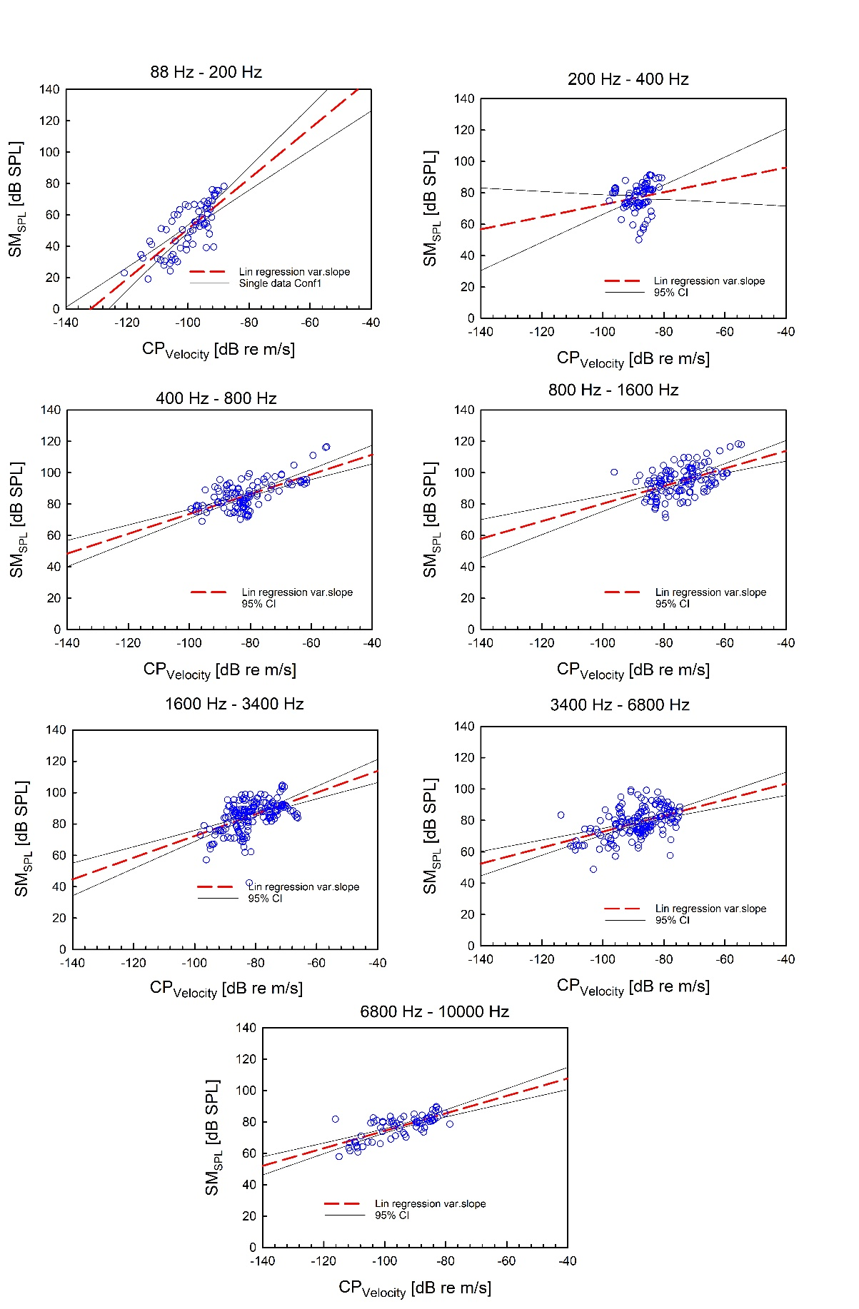
Figure 7: Octave band linear regression analysis. At all octave bands the regression slopes and constants were significantly different from zero (F-test; p < 0.0001) except the slope of second frequency band (p=0.12).

Table 5: The linear regression parameters acquired from the octave band analysis using SM_{SPL} and CP_{Velocity} Pooled data.
Freq. [Hz] | R² | f = y₀+a*x | Coefficients | Std. Error | t | P | CI Lower Limit | CI Upper Limit
88-200 | 0.57 | y₀ | 210.98 | 17.27 | 12.21 | <0.0001 | 176.47 | 245.48
88-200 | 0.57 | a | 1.60 | 0.17 | 9.27 | <0.0001 | 1.25 | 1.94
200-400 | 0.03 | y₀ | 111.89 | 22.53 | 4.97 | <0.0001 | 67.04 | 156.75
200-400 | 0.03 | a | 0.39 | 0.26 | 1.54 | 0.13 | -0.11 | 0.90
400-800 | 0.42 | y₀ | 136.82 | 5.82 | -24.83 | <0.0001 | 125.29 | 148.35
400-800 | 0.42 | a | 0.63 | 0.07 | 1.54 | <0.0001 | 0.49 | 0.77
800-1600 | 0.23 | y₀ | 136.39 | 7.03 | 23.52 | <0.0001 | 122.47 | 150.30
800-1600 | 0.23 | a | 0.56 | 0.09 | 8.88 | <0.0001 | 0.37 | 0.75
1600-3400 | 0.26 | y₀ | 141.41 | 7.29 | 19.41 | <0.0001 | 127.02 | 155.79
1600-3400 | 0.26 | a | 0.69 | 0.09 | 5.97 | <0.0001 | 0.51 | 0.87
3400-6800 | 0.22 | y₀ | 123.71 | 6.74 | 18.35 | <0.0001 | 110.39 | 137.02
3400-6800 | 0.22 | a | 0.51 | 0.08 | 6.73 | <0.0001 | 0.36 | 0.66
6800-10000 | 0.53 | y₀ | 130.01 | 6.07 | 21.42 | <0.0001 | 117.90 | 142.12
6800-10000 | 0.53 | a | 0.56 | 0.06 | 8.76 | <0.0001 | 0.43 | 0.68
*Std: Standard; CI: confidence interval.

