Discovering age- and sex-specific genetic risk factors in sensorineural hearing loss: genome-wide evidence from large-scale biobanks
Argyro Bizaki-Vallaskangas^{1*}, Eeva Sliz², Tuuli Lankinen³, Elmo Saarentaus⁴, Ville Salo², Kristi Krebs⁵, Tytti Willberg⁶, Ilkka Kivekäs¹, Joel Rämö⁴, Sanna Toppila-Salmi^{7,8}, Aarno Dietz⁷, Vesa Hytönen⁹, Aarno Palotie^{4,10,11}, Lili Milani⁵, Antti Mäkitie^{12,13}, Johannes Kettunen²
1 Faculty of Medicine and Health Technology, Department of Otolaryngology, University of Tampere, Tampere, Finland
2 Research Unit of Population Health, Biocenter Oulu, and Medical Research Center Oulu, University of Oulu and Oulu University Hospital, Oulu, Finland
3 Faculty of Medicine, University of Helsinki, Helsinki, Finland
4 Institute for Molecular Medicine Finland (FIMM), HiLIFE, University of Helsinki, Helsinki, Finland.
5 Estonian Genome Centre, Institute of Genomics, University of Tartu, Tartu, Estonia
6 Turku University Hospital, Department of Otolaryngology, Turku, Finland
7 Department of Otorhinolaryngology, University of Eastern Finland, Joensuu and Kuopio, Finland ,Wellbeing services county of Pohjois-Savo, Kuopio, Finland
8 Department of Allergology, Inflammation Center, Helsinki University Hospital and University of Helsinki, Helsinki, Finland
9 Department of Medicine and Health Technology, University of Tampere, Tampere, Finland and Fimlab Laboratories, Tampere, Finland
10 The Stanley Center for Psychiatric Research and Program in Medical and Population Genetics, The Broad Institute of MIT and Harvard, Cambridge, MA, USA.
11 Analytic and Translational Genetics Unit, Department of Medicine, Department of Neurology and Department of Psychiatry Massachusetts General Hospital, Boston, MA, USA.
12 Department of Otorhinolaryngology – Head and Neck Surgery, Helsinki University Hospital and University of Helsinki, Helsinki, Finland
13 Research Program in Systems Oncology, Faculty of Medicine, University of Helsinki, Helsinki, Finland
*Corresponding author: Argyro Bizaki-Vallaskangas (arbizaki@gmail.com)

Table of contents
Figure S1. Lead variant effect estimates in every dataset
Figure S2. Previously unreported SNHL association on chromosome 13 in general population
Figure S3. Previously unreported SNHL association on chromosome 16 in general population
Figure S4. Previously unreported SNHL association on chromosome 20 in general population
Figure S5. Previously unreported SNHL association on chromosome 5 in cases diagnosed at the age of 55 or older
Figure S6. Previously unreported SNHL association on chromosome 10 in cases diagnosed at the age of 55 or older
Figure S7. Previously unreported SNHL association on chromosome 18 in cases diagnosed before the age of 55
Figure S8. Previously unreported SNHL association on chromosome 11 in females
Figure S9. Previously unreported SNHL association on chromosome 14 in females
Figure S10. Previously unreported SNHL association on chromosome 13 in males
Figure S11. Magma gene-set analysis in subgroups
Figure S12. Gene expression profiles for candidate genes in ear related cell types
Figure S13. eQTL colocalization results

Table S1. A list of FinnGen authors and their affiliations
Table S2. A list of Estonian Biobank Research Team members and their affiliations
Table S3. Lead variants of the SNHL associated loci identified in the genome-wide meta-analysis focusing general population
Table S4. The lead variants of the SNHL-associated loci associated in the genome-wide meta-analysis focusing cases diagnosed at the age of 55 or older
Table S5. The lead variants of the SNHL-associated loci associated in the genome-wide meta-analysis focusing cases diagnosed before the age of 55
Table S6. Lead variants of the SNHL associated loci identified in the genome-wide meta-analysis focusing female subgroup
Table S7. Lead variants of the SNHL associated loci identified in the genome-wide meta-analysis focusing male subgroup

Tables S8 and S9 are provided in a separate excel file.

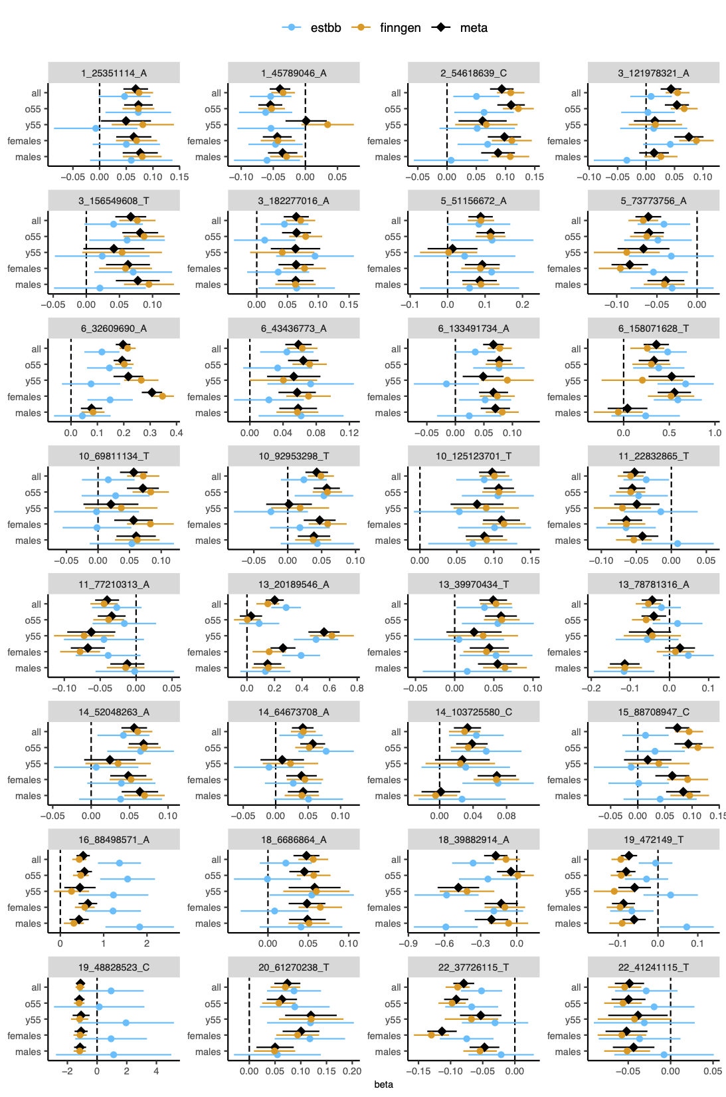

Figure S1. The effect estimates and 95% confidence intervals for SNHL-associated lead variants in each meta-analysis [black] and each cohort separately FinnGen [orange], Estonian Biobank [blue] are shown. Chromosome, position and effect allele were used as lead variant identifiers.

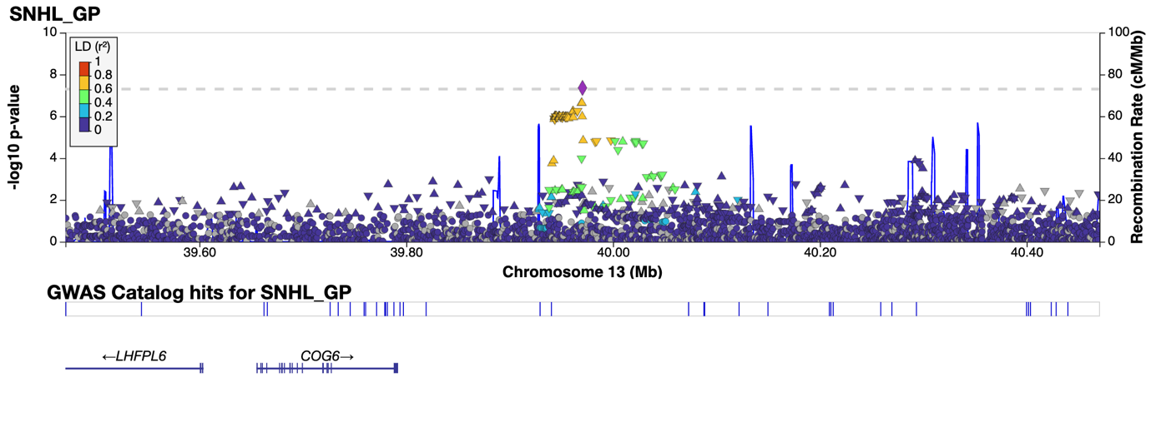

Figure S2. Regional association plot of previously unreported SNHL association on chromosome 13 area of 39.5-40.5 MB, which was observed in meta-analysis focusing general population. Our results suggest that COG6 (component of oligomeric golgi complex 6) is the gene most likely responsible for the association of the locus. Plot was generated by using Locuszoom https://my.locuszoom.org/. For LD estimations, the 1000G data-based LD reference panel with a European subpopulation was utilised.

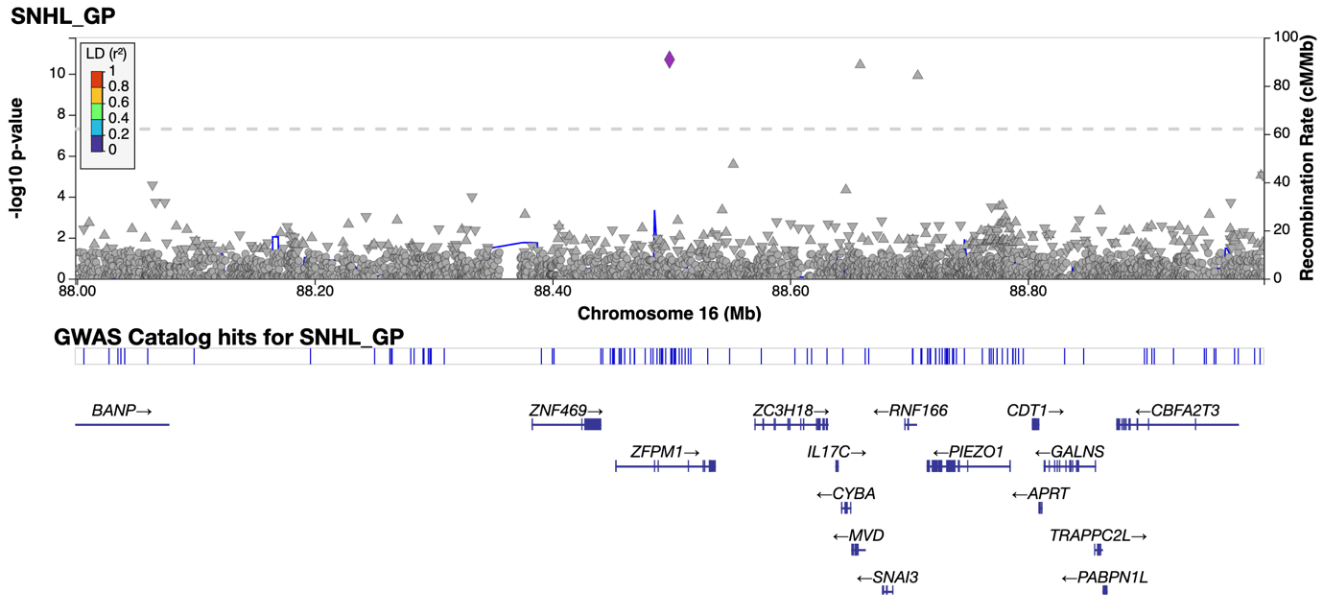

Figure S3. Regional association plot of previously unreported SNHL association on chromosome 16 area of 88.0-89.0 MB, which was observed in meta-analysis focusing general population. Our results suggest that PIEZO1 (piezo type mechanosensitive ion channel component 1) is the gene most likely responsible for the association of the locus. Plot was generated by using Locuszoom https://my.locuszoom.org/. For LD estimations, the 1000G data-based LD reference panel with a European subpopulation was utilised.

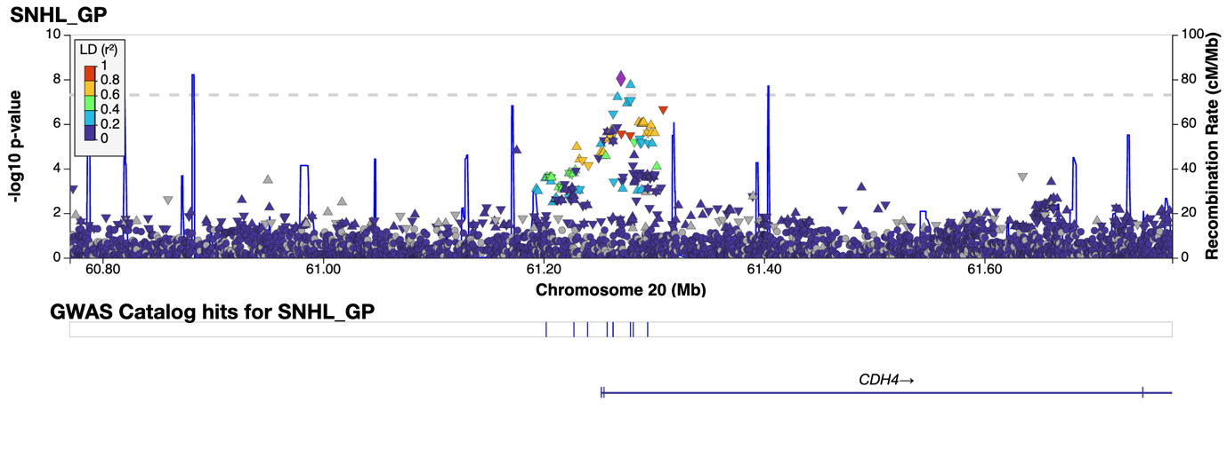

Figure S4. Regional association plot of previously unreported SNHL association on chromosome 20 area of 60.7-61.7 MB, which was observed in meta-analysis focusing general population. Our results suggest that CDH4 (cadherin 4) is the gene most likely responsible for the association of the locus. Plot was generated by using Locuszoom https://my.locuszoom.org/. For LD estimations, the 1000G data-based LD reference panel with a European subpopulation was utilised.

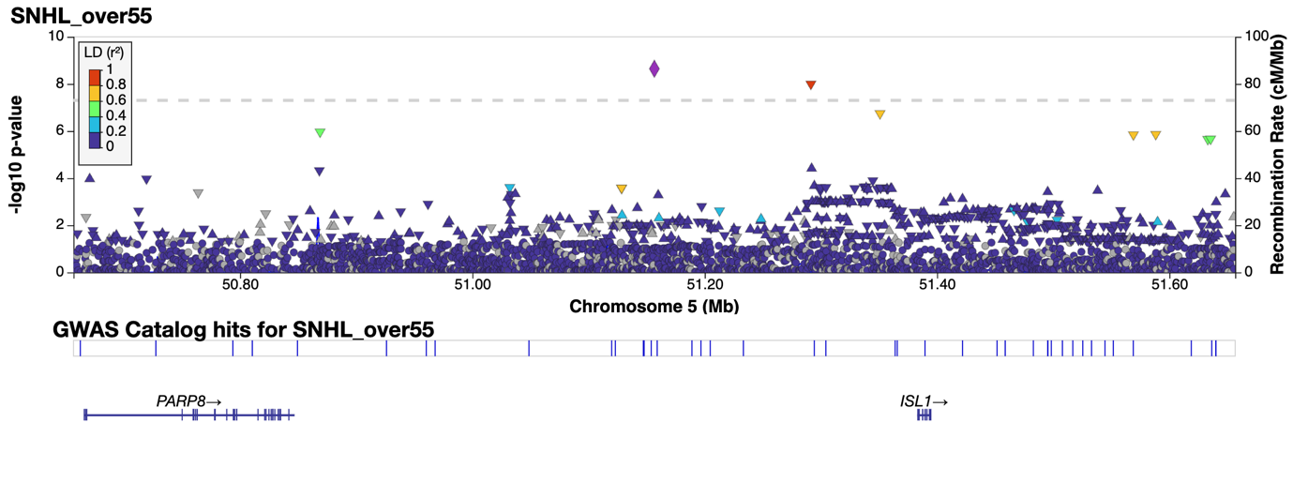

Figure S5. Regional association plot of previously unreported SNHL association on chromosome 5 area of 50.7-51.7 MB, which was observed in meta-analysis focusing cases diagnosed at the age of 55 or older. Our results suggest that ISL1 (ISL LIM homeobox 1) is the gene most likely responsible for the association of the locus. Plot was generated by using Locuszoom https://my.locuszoom.org/. For LD estimations, the 1000G data-based LD reference panel with a European subpopulation was utilised.

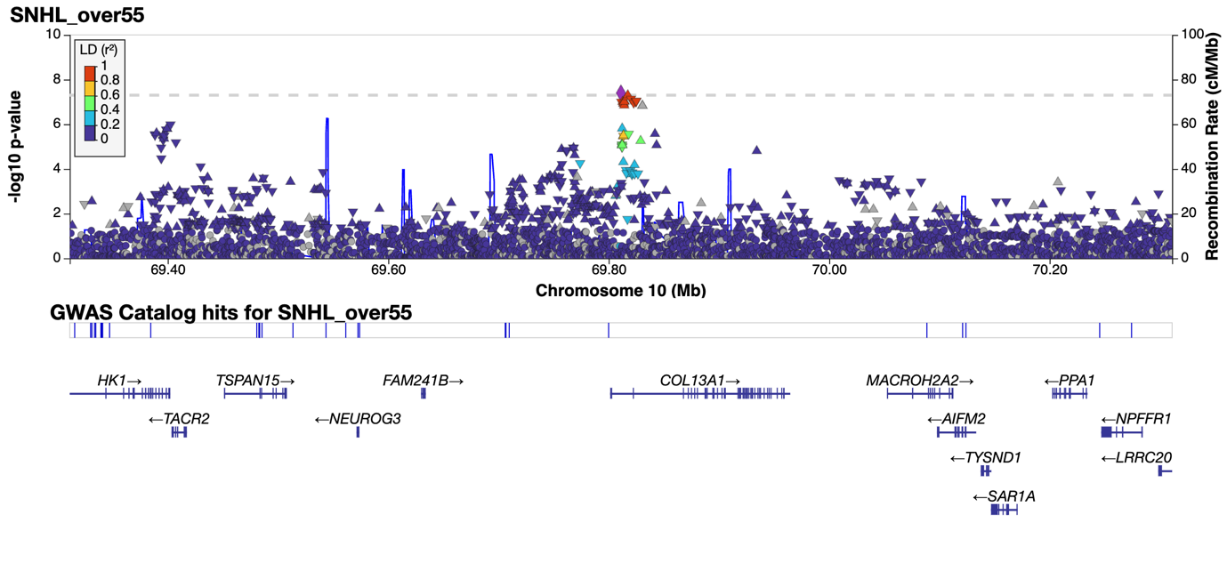

Figure S6. Regional association plot of previously unreported SNHL association on chromosome 10 area of 69.3-70.3 MB, which was observed in meta-analysis focusing cases diagnosed at the age of 55 or older. Our results suggest that COL13A1 (collagen type XIII alpha 1 chain) is the gene most likely responsible for the association of the locus. Plot was generated by using Locuszoom https://my.locuszoom.org/. For LD estimations, the 1000G data-based LD reference panel with a European subpopulation was utilised.

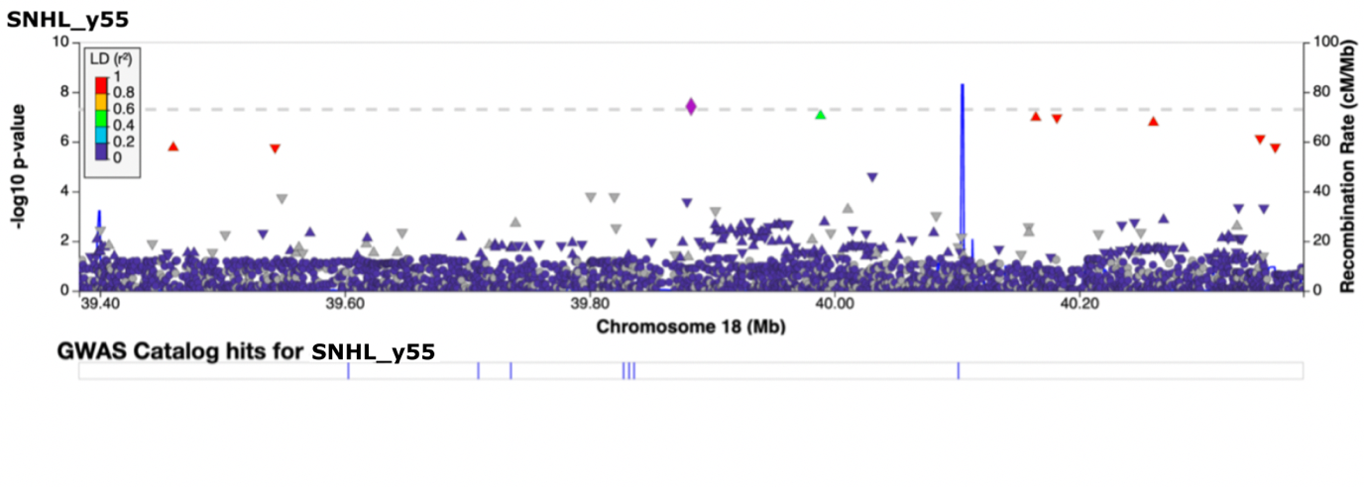

Figure S7 Regional association plot of previously unreported SNHL association on chromosome 18 area of 39.4-40.4 MB, which was observed in meta-analysis focusing cases diagnosed before the age of 55. There was not any protein coding gene in this locus, so it was classified as LINC01901 (long intergenic non-protein coding RNA 1901). Plot was generated by using Locuszoom https://my.locuszoom.org/. For LD estimations, the 1000G data-based LD reference panel with a European subpopulation was utilised.

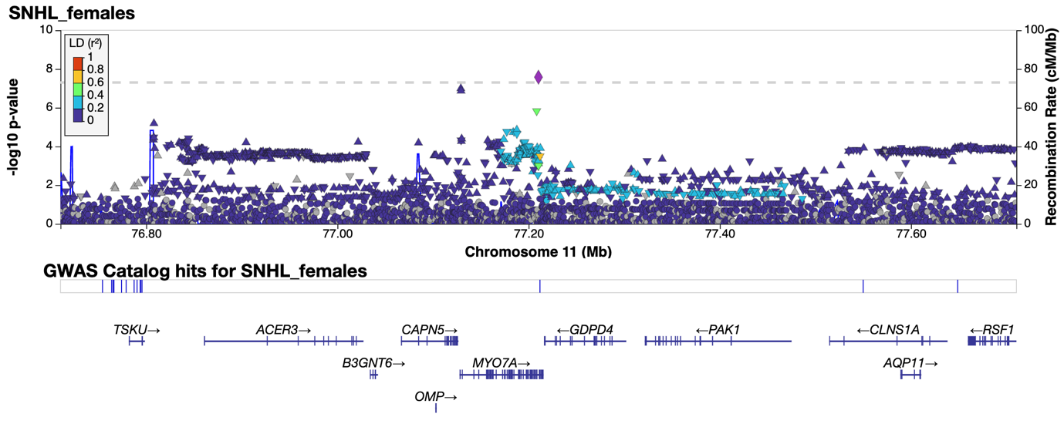

Figure S8. Regional association plot of previously unreported SNHL association on chromosome 11 area of 76.7-77.7 MB, which was observed in meta-analysis focusing female subgroup. Our results suggest that MYO7A (myosin VIIA) is the gene most likely responsible for the association of the locus. Plot was generated by using Locuszoom https://my.locuszoom.org/. For LD estimations, the 1000G data-based LD reference panel with a European subpopulation was utilised.

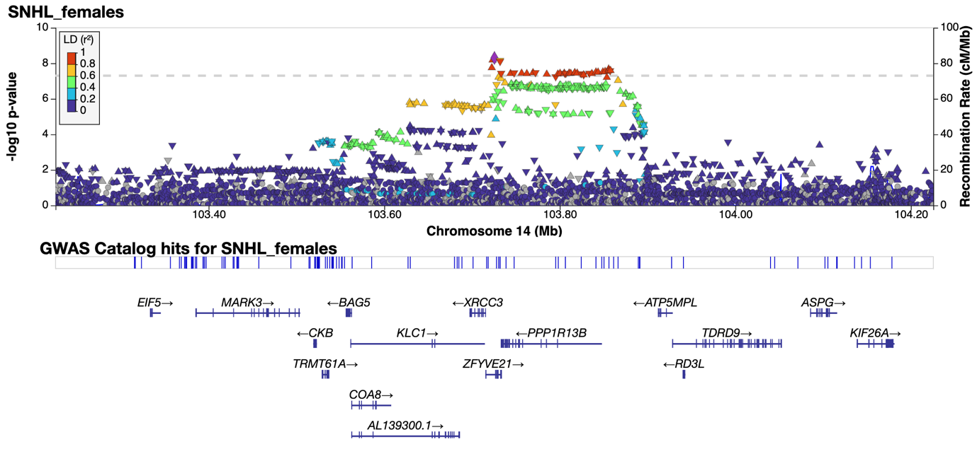

Figure S9. Regional association plot of previously unreported SNHL association on chromosome 14 area of 103.2-104.2 MB, which was observed in meta-analysis focusing female subgroup. Our results suggest that KLC1 (kinesin light chain 1) is the gene most likely responsible for the association of the locus. Plot was generated by using Locuszoom https://my.locuszoom.org/. For LD estimations, the 1000G data-based LD reference panel with a European subpopulation was utilised.

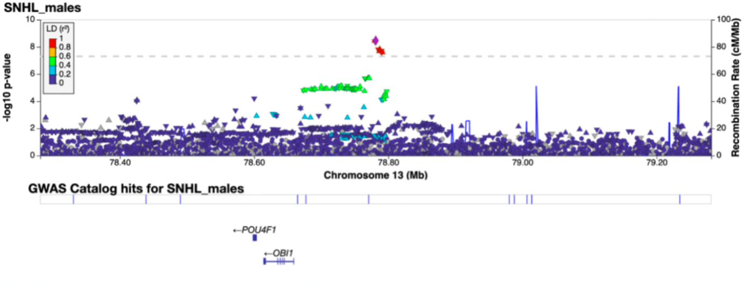

Figure S10. Regional association plot of previously unreported SNHL association on chromosome 13 area of 78.3-79.3 MB, which was observed in meta-analysis focusing male subgroup. Our results suggest that POU4F1 (
POU class 4 homeobox 1) is the gene most likely responsible for the association of the locus. Plot was generated by using Locuszoom https://my.locuszoom.org/. For LD estimations, the 1000G data-based LD reference panel with a European subpopulation was utilised.

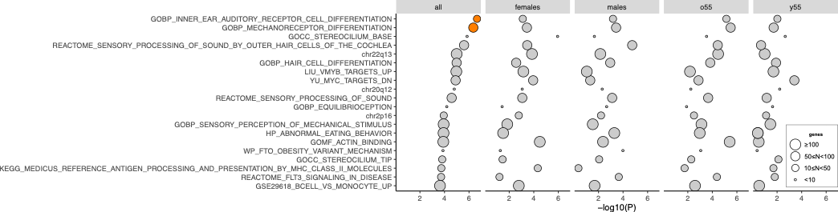
Figure S11. MAGMA gene-set analysis. We conducted MAGMA gene-set analysis using 34,494 curated gene sets and Gene Ontology (GO) terms from the MSigDB (Liberzon et al., 2011) (version 2023.3). The plot displays the 20 most significant gene sets, with two highlighted in orange, indicating significance following false discovery rate (FDR) correction. All, full sample; o55, older than 55; y55, younger than 55.

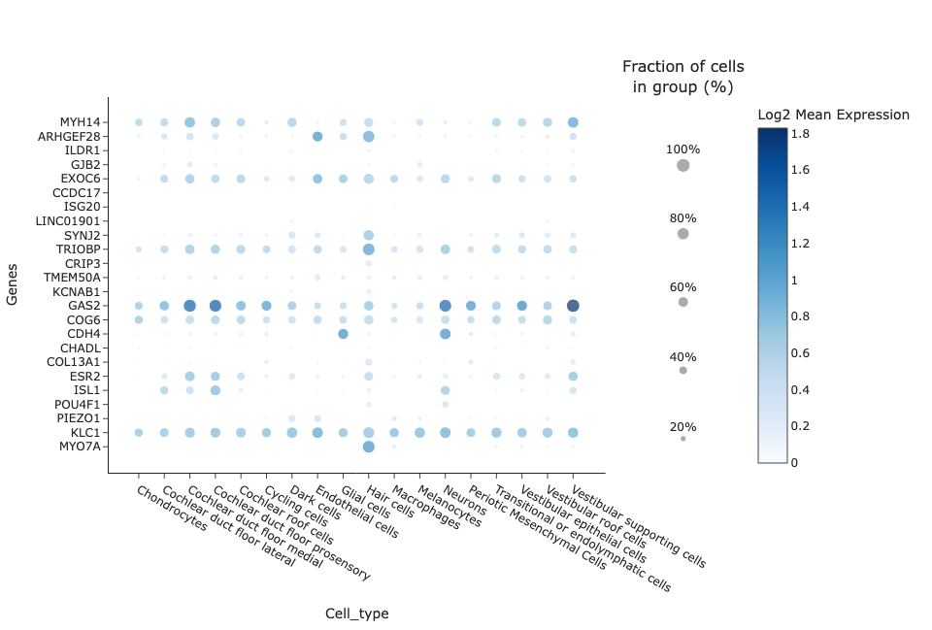
Figure S12. Gene expression profiles for 24 candidate genes in ear related cell types. Gene expression profiles were retrieved from the eEAR¹, using the Human inner ear atlas datasets². In total, information on the expression of candidate genes was obtained from 18 different cell types. In the plot, the size of the dot indicates how large a fraction of cells of that cell type express the gene, and the intensity of the color indicates the log2 mean expression of the gene.

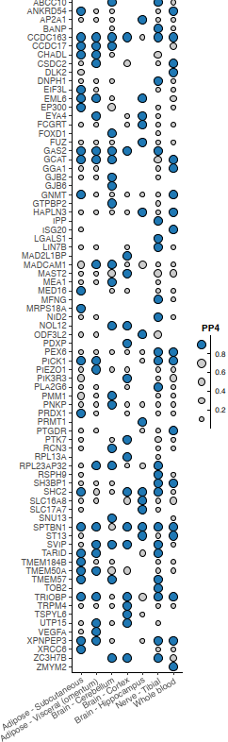
Figure S13. Gene expression and observed SNHL associations were colocalized using the "coloc" R-library function ‘coloc.abf’³. For every lead variant, colocalization was evaluated for every gene within a 1MB window. From the GTExportal (https://www.gtexportal.org/home/datasets), we downloaded variant-gene expression associations (GTEx v8, accessed on 19/05/2022) for the analysis. SNHL-relevant tissues were used in the analysis, including whole blood, brain (cerebellum, cortex, and hippocampus), adipose (subcutaneous, visceral), and tibial nerve. We utilised ≥ 0.8 posterior probabilities for the shared causal variant (PP4) as a limit for significant results⁴.

Table S1. A list of FinnGen authors and their affiliations
Full Name | Affiliation | Role 1 | Role 2
Aarno Palotie | Institute for Molecular Medicine Finland (FIMM), HiLIFE, University of Helsinki, Helsinki, Finland; Broad Institute of MIT and Harvard; Massachusetts General Hospital | Steering Committee | Steering Committee
Mark Daly | Institute for Molecular Medicine Finland (FIMM), HiLIFE, University of Helsinki, Helsinki, Finland; Broad Institute of MIT and Harvard; Massachusetts General Hospital | Steering Committee | Steering Committee
Bridget Riley-Gills | Abbvie, Chicago, IL, United States | Steering Committee | Pharmaceutical companies
Howard Jacob | Abbvie, Chicago, IL, United States | Steering Committee | Pharmaceutical companies
Dirk Paul | Astra Zeneca, Cambridge, United Kingdom | Steering Committee | Pharmaceutical companies
Slavé Petrovski | Astra Zeneca, Cambridge, United Kingdom | Steering Committee | Pharmaceutical companies
Heiko Runz | Biogen, Cambridge, MA, United States | Steering Committee | Pharmaceutical companies
Sally John | Biogen, Cambridge, MA, United States | Steering Committee | Pharmaceutical companies
George Okafo | Boehringer Ingelheim, Ingelheim am Rhein, Germany | Steering Committee | Pharmaceutical companies
Nathan Lawless | Boehringer Ingelheim, Ingelheim am Rhein, Germany | Steering Committee | Pharmaceutical companies
Heli Salminen-Mankonen | Boehringer Ingelheim, Ingelheim am Rhein, Germany | Steering Committee | Pharmaceutical companies
Robert Plenge | Bristol Myers Squibb, New York, NY, United States | Steering Committee | Pharmaceutical companies
Joseph Maranville | Bristol Myers Squibb, New York, NY, United States | Steering Committee | Pharmaceutical companies
Mark McCarthy | Genentech, San Francisco, CA, United States | Steering Committee | Pharmaceutical companies
Margaret G. Ehm | GlaxoSmithKline, Collegeville, PA, United States | Steering Committee | Pharmaceutical companies
Kirsi Auro | GlaxoSmithKline, Espoo, Finland | Steering Committee | Pharmaceutical companies
Simonne Longerich | Merck, Kenilworth, NJ, United States | Steering Committee | Pharmaceutical companies
Anders Mälarstig | Pfizer, New York, NY, United States | Steering Committee | Pharmaceutical companies
Katherine Klinger | Translational Sciences, Sanofi R&D, Framingham, MA, USA | Steering Committee | Pharmaceutical companies
Clement Chatelain | Translational Sciences, Sanofi R&D, Framingham, MA, USA | Steering Committee | Pharmaceutical companies
Matthias Gossel | Translational Sciences, Sanofi R&D, Framingham, MA, USA | Steering Committee | Pharmaceutical companies
Karol Estrada | Maze Therapeutics, San Francisco, CA, United States | Steering Committee | Pharmaceutical companies
Robert Graham | Maze Therapeutics, San Francisco, CA, United States | Steering Committee | Pharmaceutical companies
Robert Yang | Janssen Biotech, Beerse, Belgium | Steering Committee | Pharmaceutical companies
Chris O´Donnell | Novartis Institutes for BioMedical Research, Cambridge, MA, United States | Steering Committee | Pharmaceutical companies
Tomi P. Mäkelä | HiLIFE, University of Helsinki, Finland, Finland | Steering Committee | University of Helsinki & Biobanks
Jaakko Kaprio | Institute for Molecular Medicine Finland (FIMM), HiLIFE, University of Helsinki, Helsinki, Finland | Steering Committee | University of Helsinki & Biobanks
Petri Virolainen | Auria Biobank / University of Turku / Hospital District of Southwest Finland, Turku, Finland | Steering Committee | University of Helsinki & Biobanks
Antti Hakanen | Auria Biobank / University of Turku / Hospital District of Southwest Finland, Turku, Finland | Steering Committee | University of Helsinki & Biobanks
Terhi Kilpi | THL Biobank / Finnish Institute for Health and Welfare (THL), Helsinki, Finland | Steering Committee | University of Helsinki & Biobanks
Markus Perola | THL Biobank / Finnish Institute for Health and Welfare (THL), Helsinki, Finland | Steering Committee | University of Helsinki & Biobanks
Jukka Partanen | Finnish Red Cross Blood Service / Finnish Hematology Registry and Clinical Biobank, Helsinki, Finland | Steering Committee | University of Helsinki & Biobanks
Anne Pitkäranta | Helsinki Biobank / Helsinki University and Hospital District of Helsinki and Uusimaa, Helsinki | Steering Committee | University of Helsinki & Biobanks
Taneli Raivio | Helsinki Biobank / Helsinki University and Hospital District of Helsinki and Uusimaa, Helsinki | Steering Committee | University of Helsinki & Biobanks
Jani Tikkanen | Northern Finland Biobank Borealis / University of Oulu / Northern Ostrobothnia Hospital District, Oulu, Finland | Steering Committee | University of Helsinki & Biobanks
Raisa Serpi | Northern Finland Biobank Borealis / University of Oulu / Northern Ostrobothnia Hospital District, Oulu, Finland | Steering Committee | University of Helsinki & Biobanks
Tarja Laitinen | Finnish Clinical Biobank Tampere / University of Tampere / Pirkanmaa Hospital District, Tampere, Finland | Steering Committee | University of Helsinki & Biobanks
Veli-Matti Kosma | Biobank of Eastern Finland / University of Eastern Finland / Northern Savo Hospital District, Kuopio, Finland | Steering Committee | University of Helsinki & Biobanks
Jari Laukkanen | Central Finland Biobank / University of Jyväskylä / Central Finland Health Care District, Jyväskylä, Finland | Steering Committee | University of Helsinki & Biobanks
Marco Hautalahti | FINBB - Finnish biobank cooperative | Steering Committee | University of Helsinki & Biobanks
Outi Tuovila | Business Finland, Helsinki, Finland | Steering Committee | Other Experts/ Non-Voting Members
Raimo Pakkanen | Business Finland, Helsinki, Finland | Steering Committee | Other Experts/ Non-Voting Members
Jeffrey Waring | Abbvie, Chicago, IL, United States | Scientific Committee | Pharmaceutical companies
Bridget Riley-Gillis | Abbvie, Chicago, IL, United States | Scientific Committee | Pharmaceutical companies
Fedik Rahimov | Abbvie, Chicago, IL, United States | Scientific Committee | Pharmaceutical companies
Ioanna Tachmazidou | Astra Zeneca, Cambridge, United Kingdom | Scientific Committee | Pharmaceutical companies
Chia-Yen Chen | Biogen, Cambridge, MA, United States | Scientific Committee | Pharmaceutical companies
Heiko Runz | Biogen, Cambridge, MA, United States | Scientific Committee | Pharmaceutical companies
Zhihao Ding | Boehringer Ingelheim, Ingelheim am Rhein, Germany | Scientific Committee | Pharmaceutical companies
Marc Jung | Boehringer Ingelheim, Ingelheim am Rhein, Germany | Scientific Committee | Pharmaceutical companies
Shameek Biswas | Bristol Myers Squibb, New York, NY, United States | Scientific Committee | Pharmaceutical companies
Rion Pendergrass | Genentech, San Francisco, CA, United States | Scientific Committee | Pharmaceutical companies
Margaret G. Ehm | GlaxoSmithKline, Collegeville, PA, United States | Scientific Committee | Pharmaceutical companies
David Pulford | GlaxoSmithKline, Stevenage, United Kingdom | Scientific Committee | Pharmaceutical companies
Neha Raghavan | Merck, Kenilworth, NJ, United States | Scientific Committee | Pharmaceutical companies
Adriana Huertas-Vazquez | Merck, Kenilworth, NJ, United States | Scientific Committee | Pharmaceutical companies
Jae-Hoon Sul | Merck, Kenilworth, NJ, United States | Scientific Committee | Pharmaceutical companies
Anders Mälarstig | Pfizer, New York, NY, United States | Scientific Committee | Pharmaceutical companies
Xinli Hu | Pfizer, New York, NY, United States | Scientific Committee | Pharmaceutical companies
Åsa Hedman | Pfizer, New York, NY, United States | Scientific Committee | Pharmaceutical companies
Katherine Klinger | Translational Sciences, Sanofi R&D, Framingham, MA, USA | Scientific Committee | Pharmaceutical companies
Robert Graham | Maze Therapeutics, San Francisco, CA, United States | Scientific Committee | Pharmaceutical companies
Manuel Rivas | Maze Therapeutics, San Francisco, CA, United States | Scientific Committee | Pharmaceutical companies
Dawn Waterworth | Janssen Research & Development, LLC, Spring House, PA, United States | Scientific Committee | Pharmaceutical companies
Nicole Renaud | Novartis Institutes for BioMedical Research, Cambridge, MA, United States | Scientific Committee | Pharmaceutical companies
Ma´en Obeidat | Novartis Institutes for BioMedical Research, Cambridge, MA, United States | Scientific Committee | Pharmaceutical companies
Samuli Ripatti | Institute for Molecular Medicine Finland (FIMM), HiLIFE, University of Helsinki, Helsinki, Finland | Scientific Committee | University of Helsinki & Biobanks
Johanna Schleutker | Auria Biobank / Univ. of Turku / Hospital District of Southwest Finland, Turku, Finland | Scientific Committee | University of Helsinki & Biobanks
Markus Perola | THL Biobank / Finnish Institute for Health and Welfare (THL), Helsinki, Finland | Scientific Committee | University of Helsinki & Biobanks
Mikko Arvas | Finnish Red Cross Blood Service / Finnish Hematology Registry and Clinical Biobank, Helsinki, Finland | Scientific Committee | University of Helsinki & Biobanks
Olli Carpén | Helsinki Biobank / Helsinki University and Hospital District of Helsinki and Uusimaa, Helsinki | Scientific Committee | University of Helsinki & Biobanks
Reetta Hinttala | Northern Finland Biobank Borealis / University of Oulu / Northern Ostrobothnia Hospital District, Oulu, Finland | Scientific Committee | University of Helsinki & Biobanks
Johannes Kettunen | Northern Finland Biobank Borealis / University of Oulu / Northern Ostrobothnia Hospital District, Oulu, Finland | Scientific Committee | University of Helsinki & Biobanks
Arto Mannermaa | Biobank of Eastern Finland / University of Eastern Finland / Northern Savo Hospital District, Kuopio, Finland | Scientific Committee | University of Helsinki & Biobanks
Katriina Aalto-Setälä | Faculty of Medicine and Health Technology, Tampere University, Tampere, Finland | Scientific Committee | University of Helsinki & Biobanks
Mika Kähönen | Finnish Clinical Biobank Tampere / University of Tampere / Pirkanmaa Hospital District, Tampere, Finland | Scientific Committee | University of Helsinki & Biobanks
Jari Laukkanen | Central Finland Biobank / University of Jyväskylä / Central Finland Health Care District, Jyväskylä, Finland | Scientific Committee | University of Helsinki & Biobanks
Johanna Mäkelä | FINBB - Finnish biobank cooperative | Scientific Committee | University of Helsinki & Biobanks
Reetta Kälviäinen | Northern Savo Hospital District, Kuopio, Finland | Clinical Groups | Neurology Group
Valtteri Julkunen | Northern Savo Hospital District, Kuopio, Finland | Clinical Groups | Neurology Group
Hilkka Soininen | Northern Savo Hospital District, Kuopio, Finland | Clinical Groups | Neurology Group
Anne Remes | Northern Ostrobothnia Hospital District, Oulu, Finland | Clinical Groups | Neurology Group
Mikko Hiltunen | University of Eastern Finland, Kuopio, Finland | Clinical Groups | Neurology Group
Jukka Peltola | Pirkanmaa Hospital District, Tampere, Finland | Clinical Groups | Neurology Group
Minna Raivio | Hospital District of Helsinki and Uusimaa, Helsinki, Finland | Clinical Groups | Neurology Group
Pentti Tienari | Hospital District of Helsinki and Uusimaa, Helsinki, Finland | Clinical Groups | Neurology Group
Juha Rinne | Hospital District of Southwest Finland, Turku, Finland | Clinical Groups | Neurology Group
Roosa Kallionpää | Hospital District of Southwest Finland, Turku, Finland | Clinical Groups | Neurology Group
Juulia Partanen | Institute for Molecular Medicine Finland, HiLIFE, University of Helsinki, Finland | Clinical Groups | Neurology Group
Ali Abbasi | Abbvie, Chicago, IL, United States | Clinical Groups | Neurology Group
Adam Ziemann | Abbvie, Chicago, IL, United States | Clinical Groups | Neurology Group
Nizar Smaoui | Abbvie, Chicago, IL, United States | Clinical Groups | Neurology Group
Anne Lehtonen | Abbvie, Chicago, IL, United States | Clinical Groups | Neurology Group
Susan Eaton | Biogen, Cambridge, MA, United States | Clinical Groups | Neurology Group
Heiko Runz | Biogen, Cambridge, MA, United States | Clinical Groups | Neurology Group
Sanni Lahdenperä | Biogen, Cambridge, MA, United States | Clinical Groups | Neurology Group
Shameek Biswas | Bristol Myers Squibb, New York, NY, United States | Clinical Groups | Neurology Group
Natalie Bowers | Genentech, San Francisco, CA, United States | Clinical Groups | Neurology Group
Edmond Teng | Genentech, San Francisco, CA, United States | Clinical Groups | Neurology Group
Rion Pendergrass | Genentech, San Francisco, CA, United States | Clinical Groups | Neurology Group
Fanli Xu | GlaxoSmithKline, Brentford, United Kingdom | Clinical Groups | Neurology Group
David Pulford | GlaxoSmithKline, Stevenage, United Kingdom | Clinical Groups | Neurology Group
Kirsi Auro | GlaxoSmithKline, Espoo, Finland | Clinical Groups | Neurology Group
Laura Addis | GlaxoSmithKline, Brentford, United Kingdom | Clinical Groups | Neurology Group
John Eicher | GlaxoSmithKline, Brentford, United Kingdom | Clinical Groups | Neurology Group
Qingqin S Li | Janssen Research & Development, LLC, Titusville, NJ 08560, United States | Clinical Groups | Neurology Group
Karen He | Janssen Research & Development, LLC, Spring House, PA, United States | Clinical Groups | Neurology Group
Ekaterina Khramtsova | Janssen Research & Development, LLC, Spring House, PA, United States | Clinical Groups | Neurology Group
Neha Raghavan | Merck, Kenilworth, NJ, United States | Clinical Groups | Neurology Group
Martti Färkkilä | Hospital District of Helsinki and Uusimaa, Helsinki, Finland | Clinical Groups | Gastroenterology Group
Jukka Koskela | Hospital District of Helsinki and Uusimaa, Helsinki, Finland | Clinical Groups | Gastroenterology Group
Sampsa Pikkarainen | Hospital District of Helsinki and Uusimaa, Helsinki, Finland | Clinical Groups | Gastroenterology Group
Airi Jussila | Pirkanmaa Hospital District, Tampere, Finland | Clinical Groups | Gastroenterology Group
Katri Kaukinen | Pirkanmaa Hospital District, Tampere, Finland | Clinical Groups | Gastroenterology Group
Timo Blomster | Northern Ostrobothnia Hospital District, Oulu, Finland | Clinical Groups | Gastroenterology Group
Mikko Kiviniemi | Northern Savo Hospital District, Kuopio, Finland | Clinical Groups | Gastroenterology Group
Markku Voutilainen | Hospital District of Southwest Finland, Turku, Finland | Clinical Groups | Gastroenterology Group
Mark Daly | Institute for Molecular Medicine, Finland (FIMM), HiLIFE, University of Helsinki, Helsinki, Finland; Broad Institute of MIT and Harvard; Massachusetts General Hospital | Clinical Groups | Gastroenterology Group
Ali Abbasi | Abbvie, Chicago, IL, United States | Clinical Groups | Gastroenterology Group
Jeffrey Waring | Abbvie, Chicago, IL, United States | Clinical Groups | Gastroenterology Group
Nizar Smaoui | Abbvie, Chicago, IL, United States | Clinical Groups | Gastroenterology Group
Fedik Rahimov | Abbvie, Chicago, IL, United States | Clinical Groups | Gastroenterology Group
Anne Lehtonen | Abbvie, Chicago, IL, United States | Clinical Groups | Gastroenterology Group
Tim Lu | Genentech, San Francisco, CA, United States | Clinical Groups | Gastroenterology Group
Natalie Bowers | Genentech, San Francisco, CA, United States | Clinical Groups | Gastroenterology Group
Rion Pendergrass | Genentech, San Francisco, CA, United States | Clinical Groups | Gastroenterology Group
Linda McCarthy | GlaxoSmithKline, Brentford, United Kingdom | Clinical Groups | Gastroenterology Group
Amy Hart | Janssen Research & Development, LLC, Spring House, PA, United States | Clinical Groups | Gastroenterology Group
Meijian Guan | Janssen Research & Development, LLC, Spring House, PA, United States | Clinical Groups | Gastroenterology Group
Jason Miller | Merck, Kenilworth, NJ, United States | Clinical Groups | Gastroenterology Group
Kirsi Kalpala | Pfizer, New York, NY, United States | Clinical Groups | Gastroenterology Group
Melissa Miller | Pfizer, New York, NY, United States | Clinical Groups | Gastroenterology Group
Xinli Hu | Pfizer, New York, NY, United States | Clinical Groups | Gastroenterology Group
Kari Eklund | Hospital District of Helsinki and Uusimaa, Helsinki, Finland | Clinical Groups | Rheumatology Group
Antti Palomäki | Hospital District of Southwest Finland, Turku, Finland | Clinical Groups | Rheumatology Group
Pia Isomäki | Pirkanmaa Hospital District, Tampere, Finland | Clinical Groups | Rheumatology Group
Laura Pirilä | Hospital District of Southwest Finland, Turku, Finland | Clinical Groups | Rheumatology Group
Oili Kaipiainen-Seppänen | Northern Savo Hospital District, Kuopio, Finland | Clinical Groups | Rheumatology Group
Johanna Huhtakangas | Northern Ostrobothnia Hospital District, Oulu, Finland | Clinical Groups | Rheumatology Group
Nina Mars | Institute for Molecular Medicine Finland (FIMM), HiLIFE, University of Helsinki, Helsinki, Finland | Clinical Groups | Rheumatology Group
Ali Abbasi | Abbvie, Chicago, IL, United States | Clinical Groups | Rheumatology Group
Jeffrey Waring | Abbvie, Chicago, IL, United States | Clinical Groups | Rheumatology Group
Fedik Rahimov | Abbvie, Chicago, IL, United States | Clinical Groups | Rheumatology Group
Apinya Lertratanakul | Abbvie, Chicago, IL, United States | Clinical Groups | Rheumatology Group
Nizar Smaoui | Abbvie, Chicago, IL, United States | Clinical Groups | Rheumatology Group
Anne Lehtonen | Abbvie, Chicago, IL, United States | Clinical Groups | Rheumatology Group
Coralie Viollet | AstraZeneca, Cambridge, United Kingdom | Clinical Groups | Rheumatology Group
Marla Hochfeld | Bristol Myers Squibb, New York, NY, United States | Clinical Groups | Rheumatology Group
Natalie Bowers | Genentech, San Francisco, CA, United States | Clinical Groups | Rheumatology Group
Rion Pendergrass | Genentech, San Francisco, CA, United States | Clinical Groups | Rheumatology Group
Jorge Esparza Gordillo | GlaxoSmithKline, Brentford, United Kingdom | Clinical Groups | Rheumatology Group
Kirsi Auro | GlaxoSmithKline, Espoo, Finland | Clinical Groups | Rheumatology Group
Dawn Waterworth | Janssen Research & Development, LLC, Spring House, PA, United States | Clinical Groups | Rheumatology Group
Fabiana Farias | Merck, Kenilworth, NJ, United States | Clinical Groups | Rheumatology Group
Kirsi Kalpala | Pfizer, New York, NY, United States | Clinical Groups | Rheumatology Group
Nan Bing | Pfizer, New York, NY, United States | Clinical Groups | Rheumatology Group
Xinli Hu | Pfizer, New York, NY, United States | Clinical Groups | Rheumatology Group
Tarja Laitinen | Pirkanmaa Hospital District, Tampere, Finland | Clinical Groups | Pulmonology Group
Margit Pelkonen | Northern Savo Hospital District, Kuopio, Finland | Clinical Groups | Pulmonology Group
Paula Kauppi | Hospital District of Helsinki and Uusimaa, Helsinki, Finland | Clinical Groups | Pulmonology Group
Hannu Kankaanranta | University of Gothenburg, Gothenburg, Sweden/ Seinäjoki Central Hospital, Seinäjoki, Finland/ Tampere University, Tampere, Finland | Clinical Groups | Pulmonology Group
Terttu Harju | Northern Ostrobothnia Hospital District, Oulu, Finland | Clinical Groups | Pulmonology Group
Riitta Lahesmaa | Hospital District of Southwest Finland, Turku, Finland | Clinical Groups | Pulmonology Group
Nizar Smaoui | Abbvie, Chicago, IL, United States | Clinical Groups | Pulmonology Group
Coralie Viollet | AstraZeneca, Cambridge, United Kingdom | Clinical Groups | Pulmonology Group
Susan Eaton | Biogen, Cambridge, MA, United States | Clinical Groups | Pulmonology Group
Hubert Chen | Genentech, San Francisco, CA, United States | Clinical Groups | Pulmonology Group
Rion Pendergrass | Genentech, San Francisco, CA, United States | Clinical Groups | Pulmonology Group
Natalie Bowers | Genentech, San Francisco, CA, United States | Clinical Groups | Pulmonology Group
Joanna Betts | GlaxoSmithKline, Brentford, United Kingdom | Clinical Groups | Pulmonology Group
Kirsi Auro | GlaxoSmithKline, Espoo, Finland | Clinical Groups | Pulmonology Group
Rajashree Mishra | GlaxoSmithKline, Brentford, United Kingdom | Clinical Groups | Pulmonology Group
Majd Mouded | Novartis, Basel, Switzerland | Clinical Groups | Pulmonology Group
Debby Ngo | Novartis, Basel, Switzerland | Clinical Groups | Pulmonology Group
Teemu Niiranen | Finnish Institute for Health and Welfare (THL), Helsinki, Finland | Clinical Groups | Cardiometabolic Diseases Group
Felix Vaura | Finnish Institute for Health and Welfare (THL), Helsinki, Finland | Clinical Groups | Cardiometabolic Diseases Group
Veikko Salomaa | Finnish Institute for Health and Welfare (THL), Helsinki, Finland | Clinical Groups | Cardiometabolic Diseases Group
Kaj Metsärinne | Hospital District of Southwest Finland, Turku, Finland | Clinical Groups | Cardiometabolic Diseases Group
Jenni Aittokallio | Hospital District of Southwest Finland, Turku, Finland | Clinical Groups | Cardiometabolic Diseases Group
Mika Kähönen | Pirkanmaa Hospital District, Tampere, Finland | Clinical Groups | Cardiometabolic Diseases Group
Jussi Hernesniemi | Pirkanmaa Hospital District, Tampere, Finland | Clinical Groups | Cardiometabolic Diseases Group
Daniel Gordin | Hospital District of Helsinki and Uusimaa, Helsinki, Finland | Clinical Groups | Cardiometabolic Diseases Group
Juha Sinisalo | Hospital District of Helsinki and Uusimaa, Helsinki, Finland | Clinical Groups | Cardiometabolic Diseases Group
Marja-Riitta Taskinen | Hospital District of Helsinki and Uusimaa, Helsinki, Finland | Clinical Groups | Cardiometabolic Diseases Group
Tiinamaija Tuomi | Hospital District of Helsinki and Uusimaa, Helsinki, Finland | Clinical Groups | Cardiometabolic Diseases Group
Timo Hiltunen | Hospital District of Helsinki and Uusimaa, Helsinki, Finland | Clinical Groups | Cardiometabolic Diseases Group
Jari Laukkanen | Central Finland Health Care District, Jyväskylä, Finland | Clinical Groups | Cardiometabolic Diseases Group
Amanda Elliott | Institute for Molecular Medicine Finland (FIMM), HiLIFE, University of Helsinki, Helsinki, Finland; Broad Institute, Cambridge, MA, USA and Massachusetts General Hospital, Boston, MA, USA | Clinical Groups | Cardiometabolic Diseases Group
Mary Pat Reeve | Institute for Molecular Medicine Finland (FIMM), HiLIFE, University of Helsinki, Helsinki, Finland | Clinical Groups | Cardiometabolic Diseases Group
Sanni Ruotsalainen | Institute for Molecular Medicine Finland (FIMM), HiLIFE, University of Helsinki, Helsinki, Finland | Clinical Groups | Cardiometabolic Diseases Group
Dirk Paul | Astra Zeneca, Cambridge, United Kingdom | Clinical Groups | Cardiometabolic Diseases Group
Natalie Bowers | Genentech, San Francisco, CA, United States | Clinical Groups | Cardiometabolic Diseases Group
Rion Pendergrass | Genentech, San Francisco, CA, United States | Clinical Groups | Cardiometabolic Diseases Group
Audrey Chu | GlaxoSmithKline, Brentford, United Kingdom | Clinical Groups | Cardiometabolic Diseases Group
Kirsi Auro | GlaxoSmithKline, Espoo, Finland | Clinical Groups | Cardiometabolic Diseases Group
Dermot Reilly | Janssen Research & Development, LLC, Boston, MA, United States | Clinical Groups | Cardiometabolic Diseases Group
Mike Mendelson | Novartis, Boston, MA, United States | Clinical Groups | Cardiometabolic Diseases Group
Jaakko Parkkinen | Pfizer, New York, NY, United States | Clinical Groups | Cardiometabolic Diseases Group
Melissa Miller | Pfizer, New York, NY, United States | Clinical Groups | Cardiometabolic Diseases Group
Tuomo Meretoja | Hospital District of Helsinki and Uusimaa, Helsinki, Finland | Clinical Groups | Oncology Group
Heikki Joensuu | Hospital District of Helsinki and Uusimaa, Helsinki, Finland | Clinical Groups | Oncology Group
Olli Carpén | Hospital District of Helsinki and Uusimaa, Helsinki, Finland | Clinical Groups | Oncology Group
Johanna Mattson | Hospital District of Helsinki and Uusimaa, Helsinki, Finland | Clinical Groups | Oncology Group
Eveliina Salminen | Hospital District of Helsinki and Uusimaa, Helsinki, Finland | Clinical Groups | Oncology Group
Annika Auranen | Pirkanmaa Hospital District , Tampere, Finland | Clinical Groups | Oncology Group
Peeter Karihtala | Northern Ostrobothnia Hospital District, Oulu, Finland | Clinical Groups | Oncology Group
Päivi Auvinen | Northern Savo Hospital District, Kuopio, Finland | Clinical Groups | Oncology Group
Klaus Elenius | Hospital District of Southwest Finland, Turku, Finland | Clinical Groups | Oncology Group
Johanna Schleutker | Hospital District of Southwest Finland, Turku, Finland | Clinical Groups | Oncology Group
Esa Pitkänen | Institute for Molecular Medicine Finland (FIMM), HiLIFE, University of Helsinki, Helsinki, Finland | Clinical Groups | Oncology Group
Nina Mars | Institute for Molecular Medicine Finland (FIMM), HiLIFE, University of Helsinki, Helsinki, Finland | Clinical Groups | Oncology Group
Mark Daly | Institute for Molecular Medicine Finland (FIMM), HiLIFE, University of Helsinki, Helsinki, Finland; Broad Institute of MIT and Harvard; Massachusetts General Hospital | Clinical Groups | Oncology Group
Relja Popovic | Abbvie, Chicago, IL, United States | Clinical Groups | Oncology Group
Jeffrey Waring | Abbvie, Chicago, IL, United States | Clinical Groups | Oncology Group
Bridget Riley-Gillis | Abbvie, Chicago, IL, United States | Clinical Groups | Oncology Group
Anne Lehtonen | Abbvie, Chicago, IL, United States | Clinical Groups | Oncology Group
Margarete Fabre | AstraZeneca, Cambridge, United Kingdom | Clinical Groups | Oncology Group
Jennifer Schutzman | Genentech, San Francisco, CA, United States | Clinical Groups | Oncology Group
Natalie Bowers | Genentech, San Francisco, CA, United States | Clinical Groups | Oncology Group
Rion Pendergrass | Genentech, San Francisco, CA, United States | Clinical Groups | Oncology Group
Diptee Kulkarni | GlaxoSmithKline, Brentford, United Kingdom | Clinical Groups | Oncology Group
Kirsi Auro | GlaxoSmithKline, Espoo, Finland | Clinical Groups | Oncology Group
Alessandro Porello | Janssen Research & Development, LLC, Spring House, PA, United States | Clinical Groups | Oncology Group
Andrey Loboda | Merck, Kenilworth, NJ, United States | Clinical Groups | Oncology Group
Heli Lehtonen | Pfizer, New York, NY, United States | Clinical Groups | Oncology Group
Stefan McDonough | Pfizer, New York, NY, United States | Clinical Groups | Oncology Group
Sauli Vuoti | Janssen-Cilag Oy, Espoo, Finland | Clinical Groups | Oncology Group
Kai Kaarniranta | Northern Savo Hospital District, Kuopio, Finland; Department of Molecular Genetics, University of Lodz, Lodz, Poland | Clinical Groups | Opthalmology Group
Joni A Turunen | Helsinki University Hospital and University of Helsinki, Helsinki, Finland; Eye Genetics Group, Folkhälsan Research Center, Helsinki, Finland | Clinical Groups | Opthalmology Group
Terhi Ollila | Hospital District of Helsinki and Uusimaa, Helsinki, Finland | Clinical Groups | Opthalmology Group
Hannu Uusitalo | Pirkanmaa Hospital District, Tampere, Finland | Clinical Groups | Opthalmology Group
Juha Karjalainen | Institute for Molecular Medicine Finland (FIMM), HiLIFE, University of Helsinki, Helsinki, Finland | Clinical Groups | Opthalmology Group
Esa Pitkänen | Institute for Molecular Medicine Finland (FIMM), HiLIFE, University of Helsinki, Helsinki, Finland | Clinical Groups | Opthalmology Group
Mengzhen Liu | Abbvie, Chicago, IL, United States | Clinical Groups | Opthalmology Group
Heiko Runz | Biogen, Cambridge, MA, United States | Clinical Groups | Opthalmology Group
Stephanie Loomis | Biogen, Cambridge, MA, United States | Clinical Groups | Opthalmology Group
Erich Strauss | Genentech, San Francisco, CA, United States | Clinical Groups | Opthalmology Group
Natalie Bowers | Genentech, San Francisco, CA, United States | Clinical Groups | Opthalmology Group
Hao Chen | Genentech, San Francisco, CA, United States | Clinical Groups | Opthalmology Group
Rion Pendergrass | Genentech, San Francisco, CA, United States | Clinical Groups | Opthalmology Group
Kaisa Tasanen | Northern Ostrobothnia Hospital District, Oulu, Finland | Clinical Groups | Dermatology Group
Laura Huilaja | Northern Ostrobothnia Hospital District, Oulu, Finland | Clinical Groups | Dermatology Group
Katariina Hannula-Jouppi | Hospital District of Helsinki and Uusimaa, Helsinki, Finland | Clinical Groups | Dermatology Group
Teea Salmi | Pirkanmaa Hospital District, Tampere, Finland | Clinical Groups | Dermatology Group
Sirkku Peltonen | Hospital District of Southwest Finland, Turku, Finland | Clinical Groups | Dermatology Group
Leena Koulu | Hospital District of Southwest Finland, Turku, Finland | Clinical Groups | Dermatology Group
Nizar Smaoui | Abbvie, Chicago, IL, United States | Clinical Groups | Dermatology Group
Fedik Rahimov | Abbvie, Chicago, IL, United States | Clinical Groups | Dermatology Group
Anne Lehtonen | Abbvie, Chicago, IL, United States | Clinical Groups | Dermatology Group
David Choy | Genentech, San Francisco, CA, United States | Clinical Groups | Dermatology Group
Rion Pendergrass | Genentech, San Francisco, CA, United States | Clinical Groups | Dermatology Group
Dawn Waterworth | Janssen Research & Development, LLC, Spring House, PA, United States | Clinical Groups | Dermatology Group
Kirsi Kalpala | Pfizer, New York, NY, United States | Clinical Groups | Dermatology Group
Ying Wu | Pfizer, New York, NY, United States | Clinical Groups | Dermatology Group
Pirkko Pussinen | Hospital District of Helsinki and Uusimaa, Helsinki, Finland | Clinical Groups | Odontology Group
Aino Salminen | Hospital District of Helsinki and Uusimaa, Helsinki, Finland | Clinical Groups | Odontology Group
Tuula Salo | Hospital District of Helsinki and Uusimaa, Helsinki, Finland | Clinical Groups | Odontology Group
David Rice | Hospital District of Helsinki and Uusimaa, Helsinki, Finland | Clinical Groups | Odontology Group
Pekka Nieminen | Hospital District of Helsinki and Uusimaa, Helsinki, Finland | Clinical Groups | Odontology Group
Ulla Palotie | Hospital District of Helsinki and Uusimaa, Helsinki, Finland | Clinical Groups | Odontology Group
Maria Siponen | Northern Savo Hospital District, Kuopio, Finland | Clinical Groups | Odontology Group
Liisa Suominen | Northern Savo Hospital District, Kuopio, Finland | Clinical Groups | Odontology Group
Päivi Mäntylä | Northern Savo Hospital District, Kuopio, Finland | Clinical Groups | Odontology Group
Ulvi Gursoy | Hospital District of Southwest Finland, Turku, Finland | Clinical Groups | Odontology Group
Vuokko Anttonen | Northern Ostrobothnia Hospital District, Oulu, Finland | Clinical Groups | Odontology Group
Kirsi Sipilä | Research Unit of Oral Health Sciences Faculty of Medicine, University of Oulu, Oulu, Finland; Medical Research Center, Oulu, Oulu University Hospital and University of Oulu, Oulu, Finland | Clinical Groups | Odontology Group
Rion Pendergrass | Genentech, San Francisco, CA, United States | Clinical Groups | Odontology Group
Hannele Laivuori | Institute for Molecular Medicine Finland (FIMM), HiLIFE, University of Helsinki, Helsinki, Finland | Clinical Groups | Women’s Health and Reproduction Group
Venla Kurra | Pirkanmaa Hospital District, Tampere, Finland | Clinical Groups | Women’s Health and Reproduction Group
Laura Kotaniemi-Talonen | Pirkanmaa Hospital District, Tampere, Finland | Clinical Groups | Women’s Health and Reproduction Group
Oskari Heikinheimo | Hospital District of Helsinki and Uusimaa, Helsinki, Finland | Clinical Groups | Women’s Health and Reproduction Group
Ilkka Kalliala | Hospital District of Helsinki and Uusimaa, Helsinki, Finland | Clinical Groups | Women’s Health and Reproduction Group
Lauri Aaltonen | Hospital District of Helsinki and Uusimaa, Helsinki, Finland | Clinical Groups | Women’s Health and Reproduction Group
Varpu Jokimaa | Hospital District of Southwest Finland, Turku, Finland | Clinical Groups | Women’s Health and Reproduction Group
Johannes Kettunen | Northern Ostrobothnia Hospital District, Oulu, Finland | Clinical Groups | Women’s Health and Reproduction Group
Marja Vääräsmäki | Northern Ostrobothnia Hospital District, Oulu, Finland | Clinical Groups | Women’s Health and Reproduction Group
Outi Uimari | Northern Ostrobothnia Hospital District, Oulu, Finland | Clinical Groups | Women’s Health and Reproduction Group
Laure Morin-Papunen | Northern Ostrobothnia Hospital District, Oulu, Finland | Clinical Groups | Women’s Health and Reproduction Group
Maarit Niinimäki | Northern Ostrobothnia Hospital District, Oulu, Finland | Clinical Groups | Women’s Health and Reproduction Group
Terhi Piltonen | Northern Ostrobothnia Hospital District, Oulu, Finland | Clinical Groups | Women’s Health and Reproduction Group
Katja Kivinen | Institute for Molecular Medicine Finland (FIMM), HiLIFE, University of Helsinki, Helsinki, Finland | Clinical Groups | Women’s Health and Reproduction Group
Elisabeth Widen | Institute for Molecular Medicine Finland (FIMM), HiLIFE, University of Helsinki, Helsinki, Finland | Clinical Groups | Women’s Health and Reproduction Group
Taru Tukiainen | Institute for Molecular Medicine Finland (FIMM), HiLIFE, University of Helsinki, Helsinki, Finland | Clinical Groups | Women’s Health and Reproduction Group
Mary Pat Reeve | Institute for Molecular Medicine Finland (FIMM), HiLIFE, University of Helsinki, Helsinki, Finland | Clinical Groups | Women’s Health and Reproduction Group
Mark Daly | Institute for Molecular Medicine Finland (FIMM), HiLIFE, University of Helsinki, Helsinki, Finland; Broad Institute of MIT and Harvard; Massachusetts General Hospital | Clinical Groups | Women’s Health and Reproduction Group
Niko Välimäki | University of Helsinki, Helsinki, Finland | Clinical Groups | Women’s Health and Reproduction Group
Eija Laakkonen | University of Jyväskylä, Jyväskylä, Finland | Clinical Groups | Women’s Health and Reproduction Group
Jaakko Tyrmi | University of Oulu, Oulu, Finland / University of Tampere, Tampere, Finland | Clinical Groups | Women’s Health and Reproduction Group
Heidi Silven | University of Oulu, Oulu, Finland | Clinical Groups | Women’s Health and Reproduction Group
Eeva Sliz | University of Oulu, Oulu, Finland | Clinical Groups | Women’s Health and Reproduction Group
Riikka Arffman | University of Oulu, Oulu, Finland | Clinical Groups | Women’s Health and Reproduction Group
Susanna Savukoski | University of Oulu, Oulu, Finland | Clinical Groups | Women’s Health and Reproduction Group
Triin Laisk | Estonian biobank, Tartu, Estonia | Clinical Groups | Women’s Health and Reproduction Group
Natalia Pujol | Estonian biobank, Tartu, Estonia | Clinical Groups | Women’s Health and Reproduction Group
Mengzhen Liu | Abbvie, Chicago, IL, United States | Clinical Groups | Women’s Health and Reproduction Group
Bridget Riley-Gillis | Abbvie, Chicago, IL, United States | Clinical Groups | Women’s Health and Reproduction Group
Rion Pendergrass | Genentech, San Francisco, CA, United States | Clinical Groups | Women’s Health and Reproduction Group
Janet Kumar | GlaxoSmithKline, Collegeville, PA, United States | Clinical Groups | Women’s Health and Reproduction Group
Kirsi Auro | GlaxoSmithKline, Espoo, Finland | Clinical Groups | Women’s Health and Reproduction Group
Iiris Hovatta | University of Helsinki, Finland | Clinical Groups | Depression group
Chia-Yen Chen | Biogen, Cambridge, MA, United States | Clinical Groups | Depression group
Erkki Isometsä | Hospital District of Helsinki and Uusimaa, Helsinki, Finland | Clinical Groups | Depression group
Hanna Ollila | Institute for Molecular Medicine Finland (FIMM), HiLIFE, University of Helsinki, Helsinki, Finland | Clinical Groups | Depression group
Jaana Suvisaari | Finnish Institute for Health and Welfare (THL), Helsinki, Finland | Clinical Groups | Depression group
Thomas Damm Als | Aarhus University, Denmark | Clinical Groups | Depression group
Antti Mäkitie | Department of Otorhinolaryngology - Head and Neck Surgery, University of Helsinki and Helsinki University Hospital, Helsinki, Finland | Clinical Groups | ENT (ear, nose and throath) Group
Argyro Bizaki-Vallaskangas | Pirkanmaa Hospital District, Tampere, Finland | Clinical Groups | ENT (ear, nose and throath) Group
Sanna Toppila-Salmi | University of Eastern Finland and Kuopio University Hospital, Department of Otorhinolaryngology, Kuopio, Finland and Department of Allergy, Helsinki University Hospital and University of Helsinki, Finland | Clinical Groups | ENT (ear, nose and throath) Group
Tytti Willberg | Hospital District of Southwest Finland, Turku, Finland | Clinical Groups | ENT (ear, nose and throath) Group
Elmo Saarentaus | Institute for Molecular Medicine Finland (FIMM), HiLIFE, University of Helsinki, Helsinki, Finland | Clinical Groups | ENT (ear, nose and throath) Group
Antti Aarnisalo | Hospital District of Helsinki and Uusimaa, Helsinki, Finland | Clinical Groups | ENT (ear, nose and throath) Group
Eveliina Salminen | Hospital District of Helsinki and Uusimaa, Helsinki, Finland | Clinical Groups | ENT (ear, nose and throath) Group
Elisa Rahikkala | Northern Ostrobothnia Hospital District, Oulu, Finland | Clinical Groups | ENT (ear, nose and throath) Group
Johannes Kettunen | Northern Ostrobothnia Hospital District, Oulu, Finland | Clinical Groups | ENT (ear, nose and throath) Group
Kristiina Aittomäki | Department of Medical Genetics, Helsinki University Central Hospital, Helsinki, Finland | Clinical Groups | POI (premature ovarian failure) Group
Fredrik Åberg | Transplantation and Liver Surgery Clinic, Helsinki University Hospital, Helsinki University, Helsinki, Finland | Clinical Groups | LiverScore Group
Mitja Kurki | Institute for Molecular Medicine Finland (FIMM), HiLIFE, University of Helsinki, Helsinki, Finland; Broad Institute, Cambridge, MA, United States | FinnGen Analysis working group | FinnGen Analysis working group
Samuli Ripatti | Institute for Molecular Medicine Finland (FIMM), HiLIFE, University of Helsinki, Helsinki, Finland | FinnGen Analysis working group | FinnGen Analysis working group
Mark Daly | Institute for Molecular Medicine, Finland (FIMM), HiLIFE, University of Helsinki, Helsinki, Finland; Broad Institute of MIT and Harvard; Massachusetts General Hospital | FinnGen Analysis working group | FinnGen Analysis working group
Juha Karjalainen | Institute for Molecular Medicine Finland (FIMM), HiLIFE, University of Helsinki, Helsinki, Finland | FinnGen Analysis working group | FinnGen Analysis working group
Aki Havulinna | Institute for Molecular Medicine Finland (FIMM), HiLIFE, University of Helsinki, Helsinki, Finland; Finnish Institute for Health and Welfare (THL), Helsinki, Finland | FinnGen Analysis working group | FinnGen Analysis working group
Juha Mehtonen | Institute for Molecular Medicine Finland (FIMM), HiLIFE, University of Helsinki, Helsinki, Finland | FinnGen Analysis working group | FinnGen Analysis working group
Priit Palta | Institute for Molecular Medicine Finland (FIMM), HiLIFE, University of Helsinki, Helsinki, Finland | FinnGen Analysis working group | FinnGen Analysis working group
Shabbeer Hassan | Institute for Molecular Medicine Finland (FIMM), HiLIFE, University of Helsinki, Helsinki, Finland | FinnGen Analysis working group | FinnGen Analysis working group
Pietro Della Briotta Parolo | Institute for Molecular Medicine Finland (FIMM), HiLIFE, University of Helsinki, Helsinki, Finland | FinnGen Analysis working group | FinnGen Analysis working group
Wei Zhou | Broad Institute, Cambridge, MA, United States | FinnGen Analysis working group | FinnGen Analysis working group
Mutaamba Maasha | Broad Institute, Cambridge, MA, United States | FinnGen Analysis working group | FinnGen Analysis working group
Shabbeer Hassan | Institute for Molecular Medicine Finland (FIMM), HiLIFE, University of Helsinki, Helsinki, Finland | FinnGen Analysis working group | FinnGen Analysis working group
Susanna Lemmelä | Institute for Molecular Medicine Finland (FIMM), HiLIFE, University of Helsinki, Helsinki, Finland | FinnGen Analysis working group | FinnGen Analysis working group
Manuel Rivas | University of Stanford, Stanford, CA, United States | FinnGen Analysis working group | FinnGen Analysis working group
Aarno Palotie | Institute for Molecular Medicine Finland (FIMM), HiLIFE, University of Helsinki, Helsinki, Finland | FinnGen Analysis working group | FinnGen Analysis working group
Aoxing Liu | Institute for Molecular Medicine Finland (FIMM), HiLIFE, University of Helsinki, Helsinki, Finland | FinnGen Analysis working group | FinnGen Analysis working group
Arto Lehisto | Institute for Molecular Medicine Finland (FIMM), HiLIFE, University of Helsinki, Helsinki, Finland | FinnGen Analysis working group | FinnGen Analysis working group
Andrea Ganna | Institute for Molecular Medicine Finland (FIMM), HiLIFE, University of Helsinki, Helsinki, Finland | FinnGen Analysis working group | FinnGen Analysis working group
Vincent Llorens | Institute for Molecular Medicine Finland (FIMM), HiLIFE, University of Helsinki, Helsinki, Finland | FinnGen Analysis working group | FinnGen Analysis working group
Hannele Laivuori | Institute for Molecular Medicine Finland (FIMM), HiLIFE, University of Helsinki, Helsinki, Finland | FinnGen Analysis working group | FinnGen Analysis working group
Taru Tukiainen | Institute for Molecular Medicine Finland (FIMM), HiLIFE, University of Helsinki, Helsinki, Finland | FinnGen Analysis working group | FinnGen Analysis working group
Mary Pat Reeve | Institute for Molecular Medicine Finland (FIMM), HiLIFE, University of Helsinki, Helsinki, Finland | FinnGen Analysis working group | FinnGen Analysis working group
Henrike Heyne | Institute for Molecular Medicine Finland (FIMM), HiLIFE, University of Helsinki, Helsinki, Finland | FinnGen Analysis working group | FinnGen Analysis working group
Nina Mars | Institute for Molecular Medicine Finland (FIMM), HiLIFE, University of Helsinki, Helsinki, Finland | FinnGen Analysis working group | FinnGen Analysis working group
Joel Rämö | Institute for Molecular Medicine Finland (FIMM), HiLIFE, University of Helsinki, Helsinki, Finland | FinnGen Analysis working group | FinnGen Analysis working group
Elmo Saarentaus | Institute for Molecular Medicine Finland (FIMM), HiLIFE, University of Helsinki, Helsinki, Finland | FinnGen Analysis working group | FinnGen Analysis working group
Hanna Ollila | Institute for Molecular Medicine Finland (FIMM), HiLIFE, University of Helsinki, Helsinki, Finland | FinnGen Analysis working group | FinnGen Analysis working group
Rodos Rodosthenous | Institute for Molecular Medicine Finland (FIMM), HiLIFE, University of Helsinki, Helsinki, Finland | FinnGen Analysis working group | FinnGen Analysis working group
Satu Strausz | Institute for Molecular Medicine Finland (FIMM), HiLIFE, University of Helsinki, Helsinki, Finland | FinnGen Analysis working group | FinnGen Analysis working group
Tuula Palotie | University of Helsinki and Hospital District of Helsinki and Uusimaa, Helsinki, Finland | FinnGen Analysis working group | FinnGen Analysis working group
Kimmo Palin | University of Helsinki, Helsinki, Finland | FinnGen Analysis working group | FinnGen Analysis working group
Javier Garcia-Tabuenca | University of Tampere, Tampere, Finland | FinnGen Analysis working group | FinnGen Analysis working group
Harri Siirtola | University of Tampere, Tampere, Finland | FinnGen Analysis working group | FinnGen Analysis working group
Tuomo Kiiskinen | Institute for Molecular Medicine Finland (FIMM), HiLIFE, University of Helsinki, Helsinki, Finland | FinnGen Analysis working group | FinnGen Analysis working group
Jiwoo Lee | Institute for Molecular Medicine Finland (FIMM), HiLIFE, University of Helsinki, Helsinki, Finland; Broad Institute, Cambridge, MA, United States | FinnGen Analysis working group | FinnGen Analysis working group
Kristin Tsuo | Institute for Molecular Medicine Finland (FIMM), HiLIFE, University of Helsinki, Helsinki, Finland; Broad Institute, Cambridge, MA, United States | FinnGen Analysis working group | FinnGen Analysis working group
Amanda Elliott | Institute for Molecular Medicine Finland (FIMM), HiLIFE, University of Helsinki, Helsinki, Finland; Broad Institute, Cambridge, MA, USA and Massachusetts General Hospital, Boston, MA, USA | FinnGen Analysis working group | FinnGen Analysis working group
Kati Kristiansson | THL Biobank / Finnish Institute for Health and Welfare (THL), Helsinki, Finland | FinnGen Analysis working group | FinnGen Analysis working group
Mikko Arvas | Finnish Red Cross Blood Service / Finnish Hematology Registry and Clinical Biobank, Helsinki, Finland | FinnGen Analysis working group | FinnGen Analysis working group
Kati Hyvärinen | Finnish Red Cross Blood Service, Helsinki, Finland | FinnGen Analysis working group | FinnGen Analysis working group
Jarmo Ritari | Finnish Red Cross Blood Service, Helsinki, Finland | FinnGen Analysis working group | FinnGen Analysis working group
Olli Carpén | Helsinki Biobank / Helsinki University and Hospital District of Helsinki and Uusimaa, Helsinki | FinnGen Analysis working group | FinnGen Analysis working group
Johannes Kettunen | Northern Finland Biobank Borealis / University of Oulu / Northern Ostrobothnia Hospital District, Oulu, Finland | FinnGen Analysis working group | FinnGen Analysis working group
Katri Pylkäs | University of Oulu, Oulu, Finland | FinnGen Analysis working group | FinnGen Analysis working group
Eeva Sliz | University of Oulu, Oulu, Finland | FinnGen Analysis working group | FinnGen Analysis working group
Minna Karjalainen | University of Oulu, Oulu, Finland | FinnGen Analysis working group | FinnGen Analysis working group
Tuomo Mantere | Northern Finland Biobank Borealis / University of Oulu / Northern Ostrobothnia Hospital District, Oulu, Finland | FinnGen Analysis working group | FinnGen Analysis working group
Eeva Kangasniemi | Finnish Clinical Biobank Tampere / University of Tampere / Pirkanmaa Hospital District, Tampere, Finland | FinnGen Analysis working group | FinnGen Analysis working group
Sami Heikkinen | University of Eastern Finland, Kuopio, Finland | FinnGen Analysis working group | FinnGen Analysis working group
Arto Mannermaa | Biobank of Eastern Finland / University of Eastern Finland / Northern Savo Hospital District, Kuopio, Finland | FinnGen Analysis working group | FinnGen Analysis working group
Eija Laakkonen | University of Jyväskylä, Jyväskylä, Finland | FinnGen Analysis working group | FinnGen Analysis working group
Nina Pitkänen | Auria Biobank / University of Turku / Hospital District of Southwest Finland, Turku, Finland | FinnGen Analysis working group | FinnGen Analysis working group
Samuel Lessard | Translational Sciences, Sanofi R&D, Framingham, MA, USA | FinnGen Analysis working group | FinnGen Analysis working group
Clément Chatelain | Translational Sciences, Sanofi R&D, Framingham, MA, USA | FinnGen Analysis working group | FinnGen Analysis working group
Lila Kallio | Auria Biobank / University of Turku / Hospital District of Southwest Finland, Turku, Finland | Biobank directors | Biobank directors
Tiina Wahlfors | THL Biobank / Finnish Institute for Health and Welfare (THL), Helsinki, Finland | Biobank directors | Biobank directors
Jukka Partanen | Finnish Red Cross Blood Service / Finnish Hematology Registry and Clinical Biobank, Helsinki, Finland | Biobank directors | Biobank directors
Eero Punkka | Helsinki Biobank / Helsinki University and Hospital District of Helsinki and Uusimaa, Helsinki | Biobank directors | Biobank directors
Raisa Serpi | Northern Finland Biobank Borealis / University of Oulu / Northern Ostrobothnia Hospital District, Oulu, Finland | Biobank directors | Biobank directors
Sanna Siltanen | Finnish Clinical Biobank Tampere / University of Tampere / Pirkanmaa Hospital District, Tampere, Finland | Biobank directors | Biobank directors
Veli-Matti Kosma | Biobank of Eastern Finland / University of Eastern Finland / Northern Savo Hospital District, Kuopio, Finland | Biobank directors | Biobank directors
Teijo Kuopio | Central Finland Biobank / University of Jyväskylä / Central Finland Health Care District, Jyväskylä, Finland | Biobank directors | Biobank directors
Anu Jalanko | Institute for Molecular Medicine Finland (FIMM), HiLIFE, University of Helsinki, Helsinki, Finland | FinnGen Teams | Administration
Huei-Yi Shen | Institute for Molecular Medicine Finland (FIMM), HiLIFE, University of Helsinki, Helsinki, Finland | FinnGen Teams | Administration
Risto Kajanne | Institute for Molecular Medicine Finland (FIMM), HiLIFE, University of Helsinki, Helsinki, Finland | FinnGen Teams | Administration
Mervi Aavikko | Institute for Molecular Medicine Finland (FIMM), HiLIFE, University of Helsinki, Helsinki, Finland | FinnGen Teams | Administration
Helen Cooper | Institute for Molecular Medicine Finland (FIMM), HiLIFE, University of Helsinki, Helsinki, Finland | FinnGen Teams | Administration
Denise Öller | Institute for Molecular Medicine Finland (FIMM), HiLIFE, University of Helsinki, Helsinki, Finland | FinnGen Teams | Administration
Rasko Leinonen | Institute for Molecular Medicine Finland (FIMM), HiLIFE, University of Helsinki, Helsinki, Finland; European Molecular Biology Laboratory, European Bioinformatics Institute, Cambridge, UK | FinnGen Teams | Administration
Henna Palin | Finnish Clinical Biobank Tampere / University of Tampere / Pirkanmaa Hospital District, Tampere, Finland | FinnGen Teams | Administration
Malla-Maria Linna | Helsinki Biobank / Helsinki University and Hospital District of Helsinki and Uusimaa, Helsinki | FinnGen Teams | Administration
Mitja Kurki | Institute for Molecular Medicine Finland (FIMM), HiLIFE, University of Helsinki, Helsinki, Finland; Broad Institute, Cambridge, MA, United States | FinnGen Teams | Analysis
Juha Karjalainen | Institute for Molecular Medicine Finland (FIMM), HiLIFE, University of Helsinki, Helsinki, Finland | FinnGen Teams | Analysis
Pietro Della Briotta Parolo | Institute for Molecular Medicine Finland (FIMM), HiLIFE, University of Helsinki, Helsinki, Finland | FinnGen Teams | Analysis
Arto Lehisto | Institute for Molecular Medicine Finland (FIMM), HiLIFE, University of Helsinki, Helsinki, Finland | FinnGen Teams | Analysis
Juha Mehtonen | Institute for Molecular Medicine Finland (FIMM), HiLIFE, University of Helsinki, Helsinki, Finland | FinnGen Teams | Analysis
Wei Zhou | Broad Institute, Cambridge, MA, United States | FinnGen Teams | Analysis
Masahiro Kanai | Broad Institute, Cambridge, MA, United States | FinnGen Teams | Analysis
Mutaamba Maasha | Broad Institute, Cambridge, MA, United States | FinnGen Teams | Analysis
Zhili Zheng | Broad Institute, Cambridge, MA, United States | FinnGen Teams | Analysis
Hannele Laivuori | Institute for Molecular Medicine Finland (FIMM), HiLIFE, University of Helsinki, Helsinki, Finland | FinnGen Teams | Clinical Endpoint Development
Aki Havulinna | Institute for Molecular Medicine Finland (FIMM), HiLIFE, University of Helsinki, Helsinki, Finland; Finnish Institute for Health and Welfare (THL), Helsinki, Finland | FinnGen Teams | Clinical Endpoint Development
Susanna Lemmelä | Institute for Molecular Medicine Finland (FIMM), HiLIFE, University of Helsinki, Helsinki, Finland | FinnGen Teams | Clinical Endpoint Development
Tuomo Kiiskinen | Institute for Molecular Medicine Finland (FIMM), HiLIFE, University of Helsinki, Helsinki, Finland | FinnGen Teams | Clinical Endpoint Development
L. Elisa Lahtela | Institute for Molecular Medicine Finland (FIMM), HiLIFE, University of Helsinki, Helsinki, Finland | FinnGen Teams | Clinical Endpoint Development
Mari Kaunisto | Institute for Molecular Medicine Finland (FIMM), HiLIFE, University of Helsinki, Helsinki, Finland | FinnGen Teams | Communication
Elina Kilpeläinen | Institute for Molecular Medicine Finland (FIMM), HiLIFE, University of Helsinki, Helsinki, Finland | FinnGen Teams | E-Science
Timo P. Sipilä | Institute for Molecular Medicine Finland (FIMM), HiLIFE, University of Helsinki, Helsinki, Finland | FinnGen Teams | E-Science
Oluwaseun Alexander Dada | Institute for Molecular Medicine Finland (FIMM), HiLIFE, University of Helsinki, Helsinki, Finland | FinnGen Teams | E-Science
Awaisa Ghazal | Institute for Molecular Medicine Finland (FIMM), HiLIFE, University of Helsinki, Helsinki, Finland | FinnGen Teams | E-Science
Anastasia Kytölä | Institute for Molecular Medicine Finland (FIMM), HiLIFE, University of Helsinki, Helsinki, Finland | FinnGen Teams | E-Science
Rigbe Weldatsadik | Institute for Molecular Medicine Finland (FIMM), HiLIFE, University of Helsinki, Helsinki, Finland | FinnGen Teams | E-Science
Sanni Ruotsalainen | Institute for Molecular Medicine Finland (FIMM), HiLIFE, University of Helsinki, Helsinki, Finland | FinnGen Teams | E-Science
Kati Donner | Institute for Molecular Medicine Finland (FIMM), HiLIFE, University of Helsinki, Helsinki, Finland | FinnGen Teams | Genotyping
Timo P. Sipilä | Institute for Molecular Medicine Finland (FIMM), HiLIFE, University of Helsinki, Helsinki, Finland | FinnGen Teams | Genotyping
Anu Loukola | Helsinki Biobank / Helsinki University and Hospital District of Helsinki and Uusimaa, Helsinki | FinnGen Teams | Sample Collection Coordination
Päivi Laiho | THL Biobank / Finnish Institute for Health and Welfare (THL), Helsinki, Finland | FinnGen Teams | Sample Logistics
Tuuli Sistonen | THL Biobank / Finnish Institute for Health and Welfare (THL), Helsinki, Finland | FinnGen Teams | Sample Logistics
Essi Kaiharju | THL Biobank / Finnish Institute for Health and Welfare (THL), Helsinki, Finland | FinnGen Teams | Sample Logistics
Markku Laukkanen | THL Biobank / Finnish Institute for Health and Welfare (THL), Helsinki, Finland | FinnGen Teams | Sample Logistics
Elina Järvensivu | THL Biobank / Finnish Institute for Health and Welfare (THL), Helsinki, Finland | FinnGen Teams | Sample Logistics
Sini Lähteenmäki | THL Biobank / Finnish Institute for Health and Welfare (THL), Helsinki, Finland | FinnGen Teams | Sample Logistics
Lotta Männikkö | THL Biobank / Finnish Institute for Health and Welfare (THL), Helsinki, Finland | FinnGen Teams | Sample Logistics
Regis Wong | THL Biobank / Finnish Institute for Health and Welfare (THL), Helsinki, Finland | FinnGen Teams | Sample Logistics
Auli Toivola | THL Biobank / Finnish Institute for Health and Welfare (THL), Helsinki, Finland | FinnGen Teams | Sample Logistics
Minna Brunfeldt | THL Biobank / Finnish Institute for Health and Welfare (THL), Helsinki, Finland | FinnGen Teams | Registry Data Operations
Hannele Mattsson | THL Biobank / Finnish Institute for Health and Welfare (THL), Helsinki, Finland | FinnGen Teams | Registry Data Operations
Kati Kristiansson | THL Biobank / Finnish Institute for Health and Welfare (THL), Helsinki, Finland | FinnGen Teams | Registry Data Operations
Susanna Lemmelä | Institute for Molecular Medicine Finland (FIMM), HiLIFE, University of Helsinki, Helsinki, Finland | FinnGen Teams | Registry Data Operations
Sami Koskelainen | THL Biobank / Finnish Institute for Health and Welfare (THL), Helsinki, Finland | FinnGen Teams | Registry Data Operations
Tero Hiekkalinna | THL Biobank / Finnish Institute for Health and Welfare (THL), Helsinki, Finland | FinnGen Teams | Registry Data Operations
Teemu Paajanen | THL Biobank / Finnish Institute for Health and Welfare (THL), Helsinki, Finland | FinnGen Teams | Registry Data Operations
Priit Palta | Institute for Molecular Medicine Finland (FIMM), HiLIFE, University of Helsinki, Helsinki, Finland | FinnGen Teams | Sequencing Informatics
Kalle Pärn | Institute for Molecular Medicine Finland (FIMM), HiLIFE, University of Helsinki, Helsinki, Finland | FinnGen Teams | Sequencing Informatics
Mart Kals | Institute for Molecular Medicine Finland (FIMM), HiLIFE, University of Helsinki, Helsinki, Finland | FinnGen Teams | Sequencing Informatics
Shuang Luo | Institute for Molecular Medicine Finland (FIMM), HiLIFE, University of Helsinki, Helsinki, Finland | FinnGen Teams | Sequencing Informatics
Tarja Laitinen | Pirkanmaa Hospital District, Tampere, Finland | FinnGen Teams | Trajectory
Mary Pat Reeve | Institute for Molecular Medicine Finland (FIMM), HiLIFE, University of Helsinki, Helsinki, Finland | FinnGen Teams | Trajectory
Shanmukha Sampath Padmanabhuni | Institute for Molecular Medicine Finland (FIMM), HiLIFE, University of Helsinki, Helsinki, Finland | FinnGen Teams | Trajectory
Marianna Niemi | University of Tampere, Tampere, Finland | FinnGen Teams | Trajectory
Harri Siirtola | University of Tampere, Tampere, Finland | FinnGen Teams | Trajectory
Javier Gracia-Tabuenca | University of Tampere, Tampere, Finland | FinnGen Teams | Trajectory
Mika Helminen | University of Tampere, Tampere, Finland | FinnGen Teams | Trajectory
Tiina Luukkaala | University of Tampere, Tampere, Finland | FinnGen Teams | Trajectory
Iida Vähätalo | University of Tampere, Tampere, Finland | FinnGen Teams | Trajectory
Jyrki Tammerluoto | Institute for Molecular Medicine Finland (FIMM), HiLIFE, University of Helsinki, Helsinki, Finland | FinnGen Teams | Data protection officer
Marco Hautalahti | Finnish Biobank Cooperative - FINBB | FinnGen Teams | FINBB - Finnish biobank cooperative
Johanna Mäkelä | Finnish Biobank Cooperative - FINBB | FinnGen Teams | FINBB - Finnish biobank cooperative
Sarah Smith | Finnish Biobank Cooperative - FINBB | FinnGen Teams | FINBB - Finnish biobank cooperative
Tom Southerington | Finnish Biobank Cooperative - FINBB | FinnGen Teams | FINBB - Finnish biobank cooperative
Petri Lehto | Finnish Biobank Cooperative - FINBB | FinnGen Teams | FINBB - Finnish biobank cooperative
Table S2. A list of Estonian Biobank Research Team members and their affiliations
Full Name | Affiliation
Andres Metspalu | Estonian Genome Centre, Institute of Genomics, University of Tartu, Tartu, Estonia
Mari Nelis | Estonian Genome Centre, Institute of Genomics, University of Tartu, Tartu, Estonia
Lili Milani | Estonian Genome Centre, Institute of Genomics, University of Tartu, Tartu, Estonia
Reedik Mägi | Estonian Genome Centre, Institute of Genomics, University of Tartu, Tartu, Estonia
Georgi Hudjashov | Estonian Genome Centre, Institute of Genomics, University of Tartu, Tartu, Estonia
Tõnu Esko | Estonian Genome Centre, Institute of Genomics, University of Tartu, Tartu, Estonia

Table S3. The lead variants of the SNHL-associated loci (P<5x10⁻⁸, we defined the locus with a 1 MB window) identified in the genome-wide meta-analysis focusing on general population of 35 960 SNHL cases and 495 099 controls from the FinnGen and the Estonian Biobank. Loci with a grey background were located in the HLA region and were counted as one locus.
RSID | CHR:POS (hg38) | EA/NEA | Population | EAF | OR (95% CI) | P | HetPVal | Fin Enric.
rs72660919 | 1:25351114 | A/G | Meta | 0.134 | 1.070 (1.046-1.095)  1.048 (0.998-1.100)  1.077 (1.049-1.106) | 1.10x10⁻⁸  0.058  4.33x10⁻⁸ | 0.337 | 1.015
 |  |  | EstBB | 0.128
 |  |  | FinnGen | 0.137
 |  |  | European | 0.135
rs6690926 | 1:45669306 | T/C | Meta | 0.721 | 0.952 (0.935-0.969)  0.930 (0.898-0.963)  0.959 (0.940-0.979) | 3.94x10⁻⁸  4.87x10⁻⁵  6.66x10⁻⁵ | 0.136 | 1.031
rs6690926 | 1:45669306 | T/C | EstBB | 0.711
rs6690926 | 1:45669306 | T/C | FinnGen | 0.725
rs6690926 | 1:45669306 | T/C | European | 0.703
rs10176445 | 2:54618639 | C/G | Meta | 0.186 | 1.098 (1.076-1.121)  1.052 (1.011-1.094)  1.115 (1.089-1.141) | 9.88x10⁻²⁰  0.013  9.80x10⁻²⁰ | 0.013 | 0.784
rs10176445 | 2:54618639 | C/G | EstBB | 0.202
rs10176445 | 2:54618639 | C/G | FinnGen | 0.178
rs10176445 | 2:54618639 | C/G | European | 0.227
rs4680280 | 3:156532919 | A/G | Meta | 0.826 | 1.065 (1.042-1.087)  1.057 (1.014-1.102)  1.067 (1.041-1.094) | 7.24x10⁻⁹  0.009  2.37x10⁻⁷ | 0.712 | 1.021
rs4680280 | 3:156532919 | A/G | EstBB | 0.816
rs4680280 | 3:156532919 | A/G | FinnGen | 0.832
rs4680280 | 3:156532919 | A/G | European | 0.815
rs72622586 | 3:182277016 | A/G | Meta | 0.802 | 1.066 (1.045-1.088)  1.046 (1.006-1.088)  1.074 (1.049-1.100) | 5.67x10⁻¹⁰  0.024  4.08x10⁻⁹ | 0.258 | 1.014
rs72622586 | 3:182277016 | A/G | EstBB | 0.776
rs72622586 | 3:182277016 | A/G | FinnGen | 0.815
rs72622586 | 3:182277016 | A/G | European | 0.804
rs4704097 | 5:73773756 | A/G | Meta | 0.465 | 0.941 (0.926-0.956)  0.960 (0.929-0.992)  0.935 (0.918-0.953) | 1.50x10⁻¹³  0.013  1.34x10⁻¹² | 0.180 | 1.009
 | 5:73773756 | A/G | EstBB | 0.481
 | 5:73773756 | A/G | FinnGen | 0.457
 | 5:73773756 | A/G | European | 0.453
rs201654808 | 6:26430520 | CA/C | Meta | 0.980 | 0.852 (0.808-0.900)  0.957 (0.811-1.129)  0.841 (0.795-0.890) | 5.46x10⁻⁹  0.604  2.12x10⁻⁹ | 0.146 | 0.980
rs201654808 | 6:26430520 | CA/C | EstBB | 0.990
rs201654808 | 6:26430520 | CA/C | FinnGen | 0.974
rs201654808 | 6:26430520 | CA/C | European | 0.994
rs146891690 | 6:27549594 | A/G | Meta | 0.030 | 1.178 (1.126-1.232)  1.122 (1.012-1.245)  1.191 (1.133-1.252) | 8.66x10⁻¹³  0.029  5.80x10-¹² | 0.312 | 4.857
rs146891690 | 6:27549594 | A/G | EstBB | 0.023
rs146891690 | 6:27549594 | A/G | FinnGen | 0.034
rs146891690 | 6:27549594 | A/G | European | 0.007
rs187298284 | 6:29570199 | T/C | Meta | 0.017 | 1.207 (1.138-1.279)  1.038 (0.818-1.317)  1.218 (1.147-1.294) | 2.83x1⁰⁻¹⁰  0.757  1.29x10⁻¹⁰ | 0.201 | 46.00
rs187298284 | 6:29570199 | T/C | EstBB | 0.005
rs187298284 | 6:29570199 | T/C | FinnGen | 0.023
rs187298284 | 6:29570199 | T/C | European | 0.0005
rs193150789 | 6:30914729 | T/C | Meta | 0.981 | 0.812 (0.769-0.858)  0.967 (0.814-1.147)  0.796 (0.751-0.843) | 9.90x10⁻¹⁴  0.697  1.13x10⁻¹⁴ | 0.035 | 0.978
rs193150789 | 6:30914729 | T/C | EstBB | 0.991
rs193150789 | 6:30914729 | T/C | FinnGen | 0.976
rs193150789 | 6:30914729 | T/C | European | 0.998
rs192376296 | 6:32609690 | A/G | Meta | 0.081 | 1.218 (1.185-1.253)  1.124 (1.052-1.201)  1.239 (1.202-1.278) | 6.47x10⁻⁴⁴  0.0005  8.51x10⁻⁴³ | 0.009 | 3.50
rs192376296 | 6:32609690 | A/G | EstBB | 0.059
rs192376296 | 6:32609690 | A/G | FinnGen | 0.091
rs192376296 | 6:32609690 | A/G | European | 0.026
rs76635845 | 6:33667339 | CA/C | Meta | 0.967 | 0.884 (0.846-0.924)  0.900 (0.822-0.985)  0.879 (0.836-0.924) | 3.54x10⁻⁸  0.023  4.66x10⁻⁷ | 0.657 | 0.978
rs76635845 | 6:33667339 | CA/C | EstBB | 0.970 |  | 3.54x10⁻⁸  0.023  4.66x10⁻⁷ |  | 0.978
rs76635845 | 6:33667339 | CA/C | FinnGen | 0.966
rs76635845 | 6:33667339 | CA/C | European | 0.988
rs9349256 | 6:43436773 | A/G | Meta | 0.541 | 1.060 (1.044-1.077)  1.046 (1.012-1.080)  1.065 (1.046-1.085) | 5.83x10⁻¹³  0.007  1.51x10⁻¹¹ | 0.327 | 1.134
rs9349256 | 6:43436773 | A/G | EstBB | 0.522
rs9349256 | 6:43436773 | A/G | FinnGen | 0.550
rs9349256 | 6:43436773 | A/G | European | 0.485
rs7764488 | 6:133491734 | A/G | Meta | 0.262 | 1.069 (1.050-1.088)  1.035 (1.000-1.073)  1.081 (1.059-1.104) | 4.57x10⁻¹³  0.053  3.61x10⁻¹³ | 0.040 | 0.784
rs7764488 | 6:133491734 | A/G | EstBB | 0.287
rs7764488 | 6:133491734 | A/G | FinnGen | 0.250
rs7764488 | 6:133491734 | A/G | European | 0.319
rs10901863 | 10:125123701 | T/C | Meta | 0.282 | 1.103 (1.083-1.123)  1.091 (1.051-1.133)  1.106 (1.084-1.129) | 3.04x10⁻²⁷  6.45x10⁻⁶  7.17x10⁻²³ | 0.529 | 1.050
rs10901863 | 10:125123701 | T/C | EstBB | 0.257
rs10901863 | 10:125123701 | T/C | FinnGen | 0.294
rs10901863 | 10:125123701 | T/C | European | 0.280
rs4922629 | 11:22832865 | T/G | Meta | 0.449 | 0.949 (0.934-0.964)  0.965 (0.934-0.997)  0.944 (0.926-0.961) | 1.30x10⁻¹⁰  0.031  7.07x10⁻¹⁰ | 0.243 | 1.064
rs4922629 | 11:22832865 | T/G | EstBB | 0.478
rs4922629 | 11:22832865 | T/G | FinnGen | 0.435
rs4922629 | 11:22832865 | T/G | European | 0.409
rs80338939 | 13:20189546 | A/AC | Meta | 0.015 | 1.223 (1.145-1.306)  1.329 (1.193-1.480)  1.163 (1.070-1.264) | 2.20x10⁻⁹  2.29x10⁻⁷  0.0004 | 0.055 | 1.20
rs80338939 | 13:20189546 | A/AC | EstBB | 0.022
rs80338939 | 13:20189546 | A/AC | FinnGen | 0.012
rs80338939 | 13:20189546 | A/AC | European | 0.010
rs9532483 | 13:39970434 | T/G | Meta | 0.706 | 1.050 (1.032-1.069)  1.039 (1.002-1.077)  1.054 (1.033-1.076) | 4.40x10⁻⁸  0.037  3.23x10⁻⁷ | 0.481 | 0.997
rs9532483 | 13:39970434 | T/G | EstBB | 0.706
rs9532483 | 13:39970434 | T/G | FinnGen | 0.706
rs9532483 | 13:39970434 | T/G | European | 0.708
rs2749882 | 14:52048541 | T/G | Meta | 0.349 | 1.058 (1.040-1.075)  1.043 (1.009-1.079)  1.062 (1.042-1.083) | 3.42x10⁻¹¹  0.014  4.89x10⁻¹⁰ | 0.360 | 0.850
rs2749882 | 14:52048541 | T/G | EstBB | 0.346
rs2749882 | 14:52048541 | T/G | FinnGen | 0.350
rs2749882 | 14:52048541 | T/G | European | 0.412
rs12594617 | 15:88715387 | C/G | Meta | 0.854 | 1.083 (1.058-1.109)  1.018 (0.974-1.064)  1.109 (1.079-1.140) | 1.51x10⁻¹¹  0.436  9.86x10⁻¹⁴ | 0.001 | 1.073
rs12594617 | 15:88715387 | C/G | EstBB | 0.836
rs12594617 | 15:88715387 | C/G | FinnGen | 0.864
rs12594617 | 15:88715387 | C/G | European | 0.805
rs1297538889 | 16:88498571 | A/G | Meta | 0.002 | 1.694 (1.452-1.976)  3.917 (2.384-6.433)  1.549 (1.317-1.821) | 2.03x10⁻¹¹  6.98x10⁻⁸  1.21x10⁻⁷ | 0.0005 | 40.82
rs1297538889 | 16:88498571 | A/G | EstBB | 0.001
rs1297538889 | 16:88498571 | A/G | FinnGen | 0.003
rs1297538889 | 16:88498571 | A/G | European | 7.4x10⁻⁵
rs2228712 | 18:6686864 | A/C | Meta | 0.563 | 1.049 (1.032-1.066)  1.022 (0.990-1.056)  1.058 (1.038-1.078) | 5.60x10⁻⁹  0.178  2.73x10⁻⁹ | 0.073 | 1.122
rs2228712 | 18:6686864 | A/C | EstBB | 0.550
rs2228712 | 18:6686864 | A/C | FinnGen | 0.570
rs2228712 | 18:6686864 | A/C | European | 0.508
rs2392794 | 19:472149 | T/C | Meta | 0.816 | 0.930 (0.911-0.949)  0.994 (0.953-1.037)  0.911 (0.890-0.932) | 3.12x10⁻¹²  0.783  5.29x10⁻¹⁵ | 0.0004 | 1.030
rs2392794 | 19:472149 | T/C | EstBB | 0.814
rs2392794 | 19:472149 | T/C | FinnGen | 0.817
rs2392794 | 19:472149 | T/C | European | 0.793
rs62128118 | 19:49602713 | A/G | Meta | 0.002 | 1.753 (1.454-2.113)  0.895 (0.658-1.219)  2.585 (2.044-3.268) | 3.93x10⁻⁹  0.483  2.18x10⁻¹⁵ | 8.32x10⁻⁸ | 0.333
rs62128118 | 19:49602713 | A/G | EstBB | 0.003
rs62128118 | 19:49602713 | A/G | FinnGen | 0.001
rs62128118 | 19:49602713 | A/G | European | 0.003
rs78892715 | 20:61270238 | T/C | Meta | 0.110 | 1.077 (1.050-1.104)  1.091 (1.035-1.150)  1.073 (1.042-1.104) | 9.10x10⁻⁹  0.001  1.81x10⁻⁶ | 0.580 | 1.273
rs78892715 | 20:61270238 | T/C | EstBB | 0.105
rs78892715 | 20:61270238 | T/C | FinnGen | 0.112
rs78892715 | 20:61270238 | T/C | European | 0.088
rs5756795 | 22:37726115 | T/C | Meta | 0.594 | 0.924 (0.909-0.939)  0.949 (0.920-0.980)  0.915 (0.898-0.932) | 7.71x10⁻²²  0.001  1.82x10⁻²⁰ | 0.050 | 1.124
rs5756795 | 22:37726115 | T/C | EstBB | 0.530
rs5756795 | 22:37726115 | T/C | FinnGen | 0.626
rs5756795 | 22:37726115 | T/C | European | 0.557
rs4820434 | 22:41241115 | T/G | Meta | 0.302 | 0.953 (0.936-0.969)  0.972 (0.937-1.008)  0.947 (0.929-0.966) | 4.17x10⁻⁸  0.126  6.71x10⁻⁸ | 0.234 | 1.059
rs4820434 | 22:41241115 | T/G | EstBB | 0.260
rs4820434 | 22:41241115 | T/G | FinnGen | 0.322
rs4820434 | 22:41241115 | T/G | European | 0.304
RSID; SNP markers identification number; CHR:POS(hg38) chromosome and position; EA, effect allele; NEA, other allele; Population, study cohorts and European frequencies have been extracted form GnomAD (European (non-Finnish)); EAF; effect allele frequency; OR (95%CI) odds ratio and its 95% confidence interval; P, p-value; HetPVal, p-value of heterogeneity; Fin Enric., enrichment in Finns (calculated FinnGen EAF/European EAF, FinnGen EAF is the allele frequency in FinnGen and European EAF is the allele frequency in Europeans (does not include Finns).

Table S4. The lead variants of the SNHL-associated loci (P<5x10⁻⁸, we defined the locus with a 1 MB window) associated in the genome-wide meta-analysis of 28 198 SNHL cases and 495 099 controls from the FinnGen and Estonian Biobank who were diagnosed at the age of 55 or older. Loci with a grey background were located in the HLA region and were counted as one locus.
RSID | CHR:POS(hg38) | EA/NEA | Population | EAF | OR (95% CI) | P | HetPVal | Fin Enric
rs11211188 | 1:45789046 | A/G | Meta | 0.443 | 0.947 (0.929-0.965)  0.949 (0.929-0.969)  0.940 (0.902-0.980) | 9.22x10⁻⁹  7.07x10⁻⁷  0.0034 | 0.697 | 0.976
rs11211188 | 1:45789046 | A/G | FinnGen | 0.438
rs11211188 | 1:45789046 | A/G | EstBB | 0.451
rs11211188 | 1:45789046 | A/G | European | 0.449
rs10176445 | 2:54618639 | C/G | Meta | 0.186 | 1.116 (1.090-1.142)  1.130 (1.100-1.160)  1.065 (1.013-1.121) | 5.22x10⁻²⁰  1.39x10⁻¹⁹  0.015 | 0.045 | 0.784
rs10176445 | 2:54618639 | C/G | FinnGen | 0.178
rs10176445 | 2:54618639 | C/G | EstBB | 0.202
rs10176445 | 2:54618639 | C/G | European | 0.227
rs9820091 | 3:156549608 | T/C | Meta | 0.861 | 1.085 (1.056-1.115)  1.091 (1.058-1.125)  1.064 (1.004-1.126) | 4.22x10⁻⁹  3.10x10⁻⁸  0.035 | 0.440 | 1.038
rs9820091 | 3:156549608 | T/C | FinnGen | 0.868
rs9820091 | 3:156549608 | T/C | EstBB | 0.848
rs9820091 | 3:156549608 | T/C | European | 0.836
rs116773267 | 5:51156672 | A/G | Meta | 0.936 | 1.122 (1.080-1.165)  1.121 (1.077-1.167)  1.126 (1.008-1.257) | 2.27x10⁻⁹  2.24x10⁻⁸  0.035 | 0.942 | 0.941
rs116773267 | 5:51156672 | A/G | FinnGen | 0.924
rs116773267 | 5:51156672 | A/G | EstBB | 0.960
rs116773267 | 5:51156672 | A/G | European | 0.982
rs2161095 | 5:73656208 | T/C | Meta | 0.482 | 0.942 (0.925-0.960)  0.940 (0.921-0.960)  0.951 (0.913-0.992) | 3.25x10⁻¹⁰  4.99x10⁻⁹  0.018 | 0.614 | 1.105
rs2161095 | 5:73656208 | T/C | FinnGen | 0.474
rs2161095 | 5:73656208 | T/C | EstBB | 0.497
rs2161095 | 5:73656208 | T/C | European | 0.429
rs187576526 | 6:26336881 | T/C | Meta | 0.016 | 1.217 (1.136-1.304)  1.231 (1.148-1.321)  0.961 (0.701-1.319) | 2.21x10⁻⁸  7.16x10⁻⁹  0.806 | 0.134 | 55.00
rs187576526 | 6:26336881 | T/C | FinnGen | 0.022
rs187576526 | 6:26336881 | T/C | EstBB | 0.004
rs187576526 | 6:26336881 | T/C | European | 0.0004
rs181707255 | 6:27396159 | T/C | Meta | 0.018 | 1.261 (1.183-1.344)  1.274 (1.193-1.360)  0.994 (0.727-1.359) | 1.24x10⁻¹²  3.81x10⁻¹³  0.969 | 0.128 | 50.00
rs181707255 | 6:27396159 | T/C | FinnGen | 0.025
rs181707255 | 6:27396159 | T/C | EstBB | 0.005
rs181707255 | 6:27396159 | T/C | European | 0.0005
rs149383874 | 6:28706589 | A/G | Meta | 0.982 | 0.804 (0.754-0.857)  0.796 (0.746-0.850)  0.984 (0.727-1.331) | 1.79x10⁻¹¹  7.21x10⁻¹²  0.917 | 0.180 | 0.976
rs149383874 | 6:28706589 | A/G | FinnGen | 0.975
rs149383874 | 6:28706589 | A/G | EstBB | 0.995
rs149383874 | 6:28706589 | A/G | European | 0.999
rs144200919 | 6:29747323 | A/G | Meta | 0.017 | 1.237 (1.158-1.322)  1.248 (1.166-1.336)  1.035 (0.764-1.403) | 3.32x10⁻¹⁰  1.67x10⁻¹⁰  0.824 | 0.239 | 46.00
rs144200919 | 6:29747323 | A/G | FinnGen | 0.023
rs144200919 | 6:29747323 | A/G | EstBB | 0.005
rs144200919 | 6:29747323 | A/G | European | 0.0005
rs190777367 | 6:30939492 | T/G | Meta | 0.981 | 0.793 (0.744-0.844)  0.775 (0.726-0.828)  1.016 (0.814-1.267) | 4.53x10⁻¹³  3.19x10⁻¹⁴  0.891 | 0.022 | 0.978
rs190777367 | 6:30939492 | T/G | FinnGen | 0.976
rs190777367 | 6:30939492 | T/G | EstBB | 0.991
rs190777367 | 6:30939492 | T/G | European | 0.998
rs192376296 | 6:32609690 | A/G | Meta | 0.080 | 1.214 (1.175-1.254)  1.224 (1.182-1.267)  1.157 (1.063-1.260) | 5.04x10⁻³²  7.24x10⁻³⁰  0.00078 | 0.231 | 3.033
rs192376296 | 6:32609690 | A/G | FinnGen | 0.091
rs192376296 | 6:32609690 | A/G | EstBB | 0.059
rs192376296 | 6:32609690 | A/G | European | 0.030
rs2242416 | 6:43305866 | A/G | Meta | 0.369 | 0.933 (0.915-0.951)  0.924 (0.904-0.944)  0.965 (0.926-1.007) | 1.02x10⁻¹²  7.53x10⁻¹³  0.102 | 0.070 | 0.875
rs2242416 | 6:43305866 | A/G | FinnGen | 0.356
rs2242416 | 6:43305866 | A/G | EstBB | 0.396
rs2242416 | 6:43305866 | A/G | European | 0.407
rs7764488 | 6:133491734 | A/G | Meta | 0.262 | 1.080 (1.057-1.103)  1.080 (1.055-1.106)  1.079 (1.032-1.129) | 7.51x10⁻¹³  2.08x10⁻¹⁰  0.00090 | 0.981 | 0.784
rs7764488 | 6:133491734 | A/G | FinnGen | 0.250
rs7764488 | 6:133491734 | A/G | EstBB | 0.287
rs7764488 | 6:133491734 | A/G | European | 0.319
rs12772368 | 10:69811134 | T/C | Meta | 0.158 | 1.074 (1.047-1.101)  1.087 (1.056-1.119)  1.028 (0.974-1.085) | 3.99x10⁻⁸  1.30x10⁻⁸  0.310 | 0.0734 | 0.907
rs12772368 | 10:69811134 | T/C | FinnGen | 0.147
rs12772368 | 10:69811134 | T/C | EstBB | 0.179
rs12772368 | 10:69811134 | T/C | European | 0.162
rs7909581 | 10:92953298 | T/C | Meta | 0.347 | 1.059 (1.039-1.080)  1.060 (1.038-1.083)  1.055 (1.010-1.101) | 6.04x10⁻⁹  1.20x10⁻⁷  0.016 | 0.834 | 1.085
rs7909581 | 10:92953298 | T/C | FinnGen | 0.345
rs7909581 | 10:92953298 | T/C | EstBB | 0.352
rs7909581 | 10:92953298 | T/C | European | 0.318
rs10901863 | 10:125123701 | T/C | Meta | 0.281 | 1.113 (1.090-1.136)  1.113 (1.088-1.139)  1.111 (1.058-1.167) | 2.06x10⁻²⁴  1.84x10⁻²⁰  2.20x10⁻⁵ | 0.953 | 1.050
rs10901863 | 10:125123701 | T/C | FinnGen | 0.294
rs10901863 | 10:125123701 | T/C | EstBB | 0.256
rs10901863 | 10:125123701 | T/C | European | 0.280
rs4922629 | 11:22832865 | T/G | Meta | 0.450 | 0.946 (0.928-0.964)  0.944 (0.924-0.963)  0.954 (0.915-0.995) | 4.43x10⁻⁹  4.68x10⁻⁸  0.028 | 0.633 | 1.064
rs4922629 | 11:22832865 | T/G | FinnGen | 0.435
rs4922629 | 11:22832865 | T/G | EstBB | 0.478
rs4922629 | 11:22832865 | T/G | European | 0.409
rs9532483 | 13:39970434 | T/G | Meta | 0.706 | 1.061 (1.039-1.083)  1.062 (1.038-1.087)  1.057 (1.009-1.106) | 1.43x10⁻⁸  2.44x10⁻⁷  0.019 | 0.847 | 0.997
rs9532483 | 13:39970434 | T/G | FinnGen | 0.706
rs9532483 | 13:39970434 | T/G | EstBB | 0.706
rs9532483 | 13:39970434 | T/G | European | 0.708
rs1566128 | 14:52048263 | A/G | Meta | 0.349 | 1.070 (1.050-1.091)  1.072 (1.049-1.095)  1.066 (1.021-1.114) | 3.90x10⁻¹²  2.85x10⁻¹⁰  0.0037 | 0.846 | 0.850
rs1566128 | 14:52048263 | A/G | FinnGen | 0.350
rs1566128 | 14:52048263 | A/G | EstBB | 0.347
rs1566128 | 14:52048263 | A/G | European | 0.412
rs12372879 | 14:64673708 | A/G | Meta | 0.358 | 1.059 (1.039-1.079)  1.053 (1.031-1.076)  1.081 (1.036-1.128) | 7.01x10⁻⁹  2.79x10⁻⁶  0.00036 | 0.287 | 0.902
rs12372879 | 14:64673708 | A/G | FinnGen | 0.351
rs12372879 | 14:64673708 | A/G | EstBB | 0.372
rs12372879 | 14:64673708 | A/G | European | 0.389
rs34295421 | 15:88708947 | C/G | Meta | 0.838 | 1.098 (1.070-1.126)  1.117 (1.085-1.150)  1.032 (0.977-1.090) | 1.37x10⁻¹²  1.12x10⁻¹³  0.258 | 0.013 | 1.089
rs34295421 | 15:88708947 | C/G | FinnGen | 0.847
rs34295421 | 15:88708947 | C/G | EstBB | 0.821
rs34295421 | 15:88708947 | C/G | European | 0.778
rs1297538889 | 16:88498571 | A/G | Meta | 0.002 | 1.743 (1.464-2.075)  1.606 (1.339-1.925)  4.722 (2.512-8.879) | 4.20x10⁻¹⁰  3.14x10⁻⁷  1.44x10⁻⁶ | 0.001 | 40.82
rs1297538889 | 16:88498571 | A/G | FinnGen | 0.003
rs1297538889 | 16:88498571 | A/G | EstBB | 0.001
rs1297538889 | 16:88498571 | A/G | European | 7.4x10⁻⁵
rs199827975 | 19:460292 | T/TC | Meta | 0.117 | 1.101 (1.070-1.133)  1.115 (1.080-1.151)  1.050 (0.986-1.118) | 3.72x10⁻¹¹  2.86x10⁻¹¹  0.131 | 0.095 | 0.927
rs199827975 | 19:460292 | T/TC | FinnGen | 0.114
rs199827975 | 19:460292 | T/TC | EstBB | 0.123
rs199827975 | 19:460292 | T/TC | European | 0.123
rs199600574 | 19:50301724 | T/C | Meta | 0.014 | 1.239 (1.152-1.332)  1.248 (1.159-1.344)  1.073 (0.775-1.486) | 6.70x10⁻⁹  4.90x10⁻⁹  0.672 | 0.375 | 36.00
rs199600574 | 19:50301724 | T/C | FinnGen | 0.018
rs199600574 | 19:50301724 | T/C | EstBB | 0.005
rs199600574 | 19:50301724 | T/C | European | 0.0005
rs5756795 | 22:37726115 | T/C | Meta | 0.594 | 0.913 (0.896-0.930) | 2.35x10⁻²¹ | 0.198 | 1.124
 |  |  | FinnGen | 0.626 | 0.907 (0.888-0.926) | 1.78x10⁻¹⁹
 |  |  | EstBB | 0.530 | 0.935 (0.897-0.974) | 0.0014
 |  |  | European | 0.557
RSID; SNP markers identification number; CHR:POS(hg38) chromosome and position; EA, effect allele; NEA, other allele; Population, study cohorts and European frequencies have been extracted form GnomAD (European (non-Finnish)); EAF; effect allele frequency; OR (95%CI) odds ratio and its 95% confidence interval; P, p-value; HetPVal, p-value of heterogeneity; Fin Enric., enrichment in Finns (calculated FinnGen EAF/European EAF, FinnGen EAF is the allele frequency in FinnGen and European EAF is the allele frequency in Europeans (does not include Finns).

Table S5. The lead variants of the SNHL-associated loci (P<5x10⁻⁸, we defined the locus with a 1 MB window) associated in the genome-wide meta-analysis of 7762 SNHL cases and 495 099 controls from the FinnGen and Estonian Biobank who were diagnosed before the age of 55. Locus with a grey background were located in the HLA region.
RSID | CHR:POS (hg38) | EA/NEA | Population | EAF | OR (95% CI) | P | HetPVal | Fin Enric.
rs116239570 | 6:32376554 | A/G | Meta | 0.082 | 1.250 (1.184-1.321)  1.296 (1.215-1.382)  1.142 (1.030-1.266) | 1.10x10⁻¹⁵  3.49x10⁻¹⁵  0.0113 | 0.042 | 2.818
rs116239570 | 6:32376554 | A/G | FinnGen | 0.093
rs116239570 | 6:32376554 | A/G | EstBB | 0.064
rs116239570 | 6:32376554 | A/G | European | 0.033
rs80338939 | 13:20189546 | A/AC | Meta | 0.015 | 1.749 (1.562-1.960)  1.852 (1.579-2.173)  1.651 (1.405-1.939) | 4.16x10⁻²²  3.79x10⁻¹⁴  1.09x10⁻⁹ | 0.320 | 1.200
rs80338939 | 13:20189546 | A/AC | FinnGen | 0.012
rs80338939 | 13:20189546 | A/AC | EstBB | 0.022
rs80338939 | 13:20189546 | A/AC | European | 0.010
rs182243786 | 18:39882914 | A/T | Meta | 0.993 | 0.616 (0.518-0.732)  0.662 (0.527-0.830)  0.558 (0.428-0.729) | 3.81x10⁻⁸  0.00036  1.77x10⁻⁵ | 0.341 | 0.999
rs182243786 | 18:39882914 | A/T | FinnGen | 0.994
rs182243786 | 18:39882914 | A/T | EstBB | 0.992
rs182243786 | 18:39882914 | A/T | European | 0.995

RSID; SNP markers identification number; CHR:POS(hg38) chromosome and position; EA, effect allele; NEA, other allele; Population, study cohorts and European frequencies have been extracted form GnomAD (European (non-Finnish)); EAF; effect allele frequency; OR (95%CI) odds ratio and its 95% confidence interval; P, p-value; HetPVal, p-value of heterogeneity; Fin Enric., enrichment in Finns (calculated FinnGen EAF/European EAF, FinnGen EAF is the allele frequency in FinnGen and European EAF is the allele frequency in Europeans (does not include Finns).

Table S6. The lead variants of the SNHL-associated loci (P<5x10⁻⁸, we defined the locus with a 1 MB window) associated in the genome-wide meta-analysis of 17 761 SNHL female cases and 295 740 same-sex controls from the FinnGen and Estonian Biobank. Loci with a grey background were located in the HLA region and were counted as one locus.
RSID | CHR:POS (hg38) | EA/NEA | Population | EAF |  | OR (95% CI) | P | Het  Pval | FIn Enric.
rs10176445 | 2:54618639 | C/G | Meta | 0.186 | 1.103 (1.072-1.135)  1.117 (1.080-1.156)  1.072 (1.018-1.128) |  | 1.36x10⁻¹¹  2.04x10⁻¹⁰  0.0080 | 0.189 | 0.780
rs10176445 | 2:54618639 | C/G | FinnGen | 0.177
rs10176445 | 2:54618639 | C/G | EstBB | 0.202
rs10176445 | 2:54618639 | C/G | European | 0.227
rs7640872 | 3:121978321 | A/C | Meta | 0.254 | 1.078 (1.051-1.106)  1.093 (1.060-1.126)  1.043 (0.995-1.094) |  | 8.43x10⁻⁹  1.10x10⁻⁸  0.080 | 0.111 | 0.973
rs7640872 | 3:121978321 | A/C | FinnGen | 0.251
rs7640872 | 3:121978321 | A/C | EstBB | 0.258
rs7640872 | 3:121978321 | A/C | European | 0.258
rs4704097 | 5:73773756 | A/G | Meta | 0.465 | 0.920 (0.899-0.941)  0.909 (0.885-0.934)  0.947 (0.907-0.989) |  | 5.65x10⁻¹³  3.60x10⁻¹²  0.013 | 0.111 | 1.009
rs4704097 | 5:73773756 | A/G | FinnGen | 0.457
rs4704097 | 5:73773756 | A/G | EstBB | 0.481
rs4704097 | 5:73773756 | A/G | European | 0.453
rs181556321 | 6:27734302 | T/C | Meta | 0.031 | 1.205 (1.131-1.283)  1.229 (1.146-1.318)  1.112 (0.967-1.279) |  | 6.04x10⁻⁹  8.34x10⁻⁹  0.138 | 0.210 | 5.00
rs181556321 | 6:27734302 | T/C | FinnGen | 0.035
rs181556321 | 6:27734302 | T/C | EstBB | 0.023
rs181556321 | 6:27734302 | T/C | European | 0.007
rs9257453 | 6:29001153 | A/G | Meta | 0.873 | 0.911 (0.882-0.942)  0.913 (0.878-0.948)  0.908 (0.851-0.969) |  | 3.44x10⁻⁸  2.85x10⁻⁶  0.0035 | 0.889 | 0.941
rs9257453 | 6:29001153 | A/G | FinnGen | 0.864
rs9257453 | 6:29001153 | A/G | EstBB | 0.887
rs9257453 | 6:29001153 | A/G | European | 0.918
rs2517600 | 6:30106386 | A/G | Meta | 0.281 | 0.929 (0.905-0.953)  0.929 (0.902-0.957)  0.927 (0.879-0.978) |  | 2.51x10⁻⁸  1.39x10⁻⁶  0.005 | 0.940 | 1.171
rs2517600 | 6:30106386 | A/G | FinnGen | 0.287
rs2517600 | 6:30106386 | A/G | EstBB | 0.270
rs2517600 | 6:30106386 | A/G | European | 0.245
rs191912046 | 6:31498278 | A/T | Meta | 0.017 | 1.290 (1.188-1.401) |  | 1.42x10⁻⁹ | 0.391 | 2.222
rs191912046 | 6:31498278 | A/T | FinnGen | 0.020 | 1.311 (1.198-1.435) |  | 4.16x10⁻⁹
rs191912046 | 6:31498278 | A/T | EstBB | 0.011 | 1.190 (0.972-1.457) |  | 0.093
rs191912046 | 6:31498278 | A/T | European | 0.009
rs192376296 | 6:32609690 | A/G | Meta | 0.080 | 1.359 (1.308-1.413)  1.415 (1.355-1.477)  1.160 (1.064-1.264) |  | 1.22x10⁻⁵⁴  1.00x10⁻⁵⁵  0.00074 | 5.2x10⁻⁵ | 3.538
rs192376296 | 6:32609690 | A/G | FinnGen | 0.092
rs192376296 | 6:32609690 | A/G | EstBB | 0.059
rs192376296 | 6:32609690 | A/G | European | 0.026
rs9369409 | 6:43378724 | C/G | Meta | 0.382 | 0.936 (0.914-0.958)  0.918 (0.893-0.944)  0.979 (0.938-1.022) |  | 2.59x10⁻⁸  1.77x10⁻⁹  0.336 | 0.013 | 0.880
rs9369409 | 6:43378724 | C/G | FinnGen | 0.368
rs9369409 | 6:43378724 | C/G | EstBB | 0.407
rs9369409 | 6:43378724 | C/G | European | 0.418
rs146694394 | 6:158071628 | T/C | Meta | 0.003 | 1.742 (1.451-2.091)  1.681 (1.304-2.166)  1.810 (1.391-2.355) |  | 2.60x10⁻⁹  6.08x10⁻⁵  9.82x10⁻⁶ | 0.691 | 0.400
rs146694394 | 6:158071628 | T/C | FinnGen | 0.002
rs146694394 | 6:158071628 | T/C | EstBB | 0.005
rs146694394 | 6:158071628 | T/C | European | 0.005
rs10901863 | 10:125123701 | T/C | Meta | 0.280 | 1.117 (1.089-1.145)  1.121 (1.088-1.154)  1.106 (1.053-1.162) |  | 6.54x10⁻¹⁸  2.08x10⁻¹⁴  6.05x10⁻⁵ | 0.663 | 1.050
rs10901863 | 10:125123701 | T/C | FinnGen | 0.294
rs10901863 | 10:125123701 | T/C | EstBB | 0.257
rs10901863 | 10:125123701 | T/C | European | 0.280
rs4922629 | 11:22832865 | T/G | Meta | 0.451 | 0.938 (0.917-0.959)  0.938 (0.913-0.963)  0.937 (0.898-0.978) |  | 3.05x10⁻⁸  3.07x10⁻⁶  0.0028 | 0.982 | 1.064
rs4922629 | 11:22832865 | T/G | FinnGen | 0.435
rs4922629 | 11:22832865 | T/G | EstBB | 0.477
rs4922629 | 11:22832865 | T/G | European | 0.409
rs12793619 | 11:77210313 | A/G | Meta | 0.372 | 0.935 (0.913-0.957)  0.925 (0.900-0.951)  0.962 (0.919-1.006) |  | 2.64x10⁻⁸  3.91x10⁻⁸  0.091 | 0.148 | 1.343
rs12793619 | 11:77210313 | A/G | FinnGen | 0.388
rs12793619 | 11:77210313 | A/G | EstBB | 0.344
rs12793619 | 11:77210313 | A/G | European | 0.289
rs80338939 | 13:20189546 | A/AC | Meta | 0.015 | 1.299 (1.186-1.422)  1.175 (1.041-1.325)  1.481 (1.291-1.700) |  | 1.59x10⁻⁸  0.0088  2.28x10⁻⁸ | 0.013 | 1.200
rs80338939 | 13:20189546 | A/AC | FinnGen | 0.012
rs80338939 | 13:20189546 | A/AC | EstBB | 0.022
rs80338939 | 13:20189546 | A/AC | European | 0.010
rs7143885 | 14:103725580 | C/G | Meta | 0.399 | 1.071 (1.047-1.096)  1.070 (1.041-1.100)  1.072 (1.028-1.119) |  | 5.02x10⁻⁹  1.03x10⁻⁶  0.0013 | 0.936 | 1.147
rs7143885 | 14:103725580 | C/G | FinnGen | 0.399
rs7143885 | 14:103725580 | C/G | EstBB | 0.398
rs7143885 | 14:103725580 | C/G | European | 0.348
rs1267664387 | 16:88658954 | A/C | Meta | 0.002 | 1.821 (1.489-2.226)  1.731 (1.395-2.148)  2.542 (1.461-4.422) |  | 5.21x10⁻⁹  6.34x10⁻⁷  0.00096 | 0.205 | 5.00
rs1267664387 | 16:88658954 | A/C | FinnGen | 0.003
rs1267664387 | 16:88658954 | A/C | EstBB | 0.001
rs1267664387 | 16:88658954 | A/C | European | 0.0006
rs2392794 | 19:472149 | T/C | Meta | 0.816 | 0.917 (0.891-0.944)  0.909 (0.879-0.941)  0.937 (0.887-0.989) |  | 4.16x10⁻⁹  4.81x10⁻⁸  0.018 | 0.370 | 1.030
rs2392794 | 19:472149 | T/C | FinnGen | 0.817
rs2392794 | 19:472149 | T/C | EstBB | 0.814
rs2392794 | 19:472149 | T/C | European | 0.793
rs78892715 | 20:61270238 | T/C | Meta | 0.109 | 1.106 (1.067-1.146)  1.098 (1.054-1.145)  1.125 (1.051-1.205) |  | 3.25x10⁻⁸  1.01x10⁻⁵  0.00074 | 0.561 | 1.273
rs78892715 | 20:61270238 | T/C | FinnGen | 0.112
rs78892715 | 20:61270238 | T/C | EstBB | 0.105
rs78892715 | 20:61270238 | T/C | European | 0.088
rs5756795 | 22:37726115 | T/C | Meta | 0.591 | 0.893 (0.873-0.914)  0.878 (0.855-0.903)  0.928 (0.890-0.967) |  | 2.23x10⁻²²  1.09x10⁻²⁰  0.00044 | 0.031 | 1.124
rs5756795 | 22:37726115 | T/C | FinnGen | 0.626
rs5756795 | 22:37726115 | T/C | EstBB | 0.531
rs5756795 | 22:37726115 | T/C | European | 0.557
RSID; SNP markers identification number; CHR:POS(hg38) chromosome and position; EA, effect allele; NEA, other allele; Population, study cohorts and European frequencies have been extracted form GnomAD (European (non-Finnish)); EAF; effect allele frequency; OR (95%CI) odds ratio and its 95% confidence interval; P, p-value; HetPVal, p-value of heterogeneity; Fin Enric., enrichment in Finns (calculated FinnGen EAF/European EAF, FinnGen EAF is the allele frequency in FinnGen and European EAF is the allele frequency in Europeans (does not include Finns).

Table S7. The lead variants of the SNHL-associated loci (P<5x10⁻⁸, we defined the locus with a 1 MB window) associated in the genome-wide meta-analysis of 18 199 SNHL male cases and 199 359 same-sex controls from the FinnGen and Estonian Biobank.
RSID | CHR:POS (hg38) | EA/NEA | Population | EAF | OR (95% CI) | P | HetPVal | Fin Enric.
rs7608414 | 2:54617858 | A/G | Meta | 0.187 | 1.091 (1.060-1.123)  1.114 (1.078-1.150)  1.009 (0.947-1.075) | 2.69x10⁻⁹  6.47x10⁻¹¹  0.776 | 0.007 | 0.786
rs7608414 | 2:54617858 | A/G | FinnGen | 0.180
rs7608414 | 2:54617858 | A/G | EstBB | 0.203
rs7608414 | 2:54617858 | A/G | European | 0.229
rs10901863 | 10:125123701 | T/C | Meta | 0.283 | 1.091 (1.064-1.119)  1.095 (1.065-1.125)  1.074 (1.011-1.141) | 1.20x10⁻¹¹  1.63x10⁻¹⁰  0.020 | 0.577 | 1.050
rs10901863 | 10:125123701 | T/C | FinnGen | 0.294
rs10901863 | 10:125123701 | T/C | EstBB | 0.255
rs10901863 | 10:125123701 | T/C | European | 0.280
rs756330 | 13:78781316 | A/G | Meta | 0.905 | 0.892 (0.859-0.926)  0.892 (0.854-0.932)  0.890 (0.824-0.962) | 3.45x10⁻⁹  3.01x10⁻⁷  0.003 | 0.962 | 1.046
rs756330 | 13:78781316 | A/G | FinnGen | 0.913
rs756330 | 13:78781316 | A/G | EstBB | 0.883
rs756330 | 13:78781316 | A/G | European | 0.873
rs987473446 | 19:48828523 | C/G | Meta | 0.9995 | 0.319 (0.212-0.478) | 3.29x10⁻⁸ | 0.252 | 0.999
rs987473446 | 19:48828523 | C/G | FinnGen | 0.9993 | 0.311 (0.207-0.467) | 1.97x10⁻⁸
rs987473446 | 19:48828523 | C/G | EstBB | 0.9998 | 3.053 (0.063-148) | 0.574
rs987473446 | 19:48828523 | C/G | European | 0.9999
RSID; SNP markers identification number; CHR:POS(hg38) chromosome and position; EA, effect allele; NEA, other allele; Population, study cohorts and European frequencies have been extracted form GnomAD (European (non-Finnish)); EAF; effect allele frequency; OR (95%CI) odds ratio and its 95% confidence interval; P, p-value; HetPVal, p-value of heterogeneity; Fin Enric., enrichment in Finns (calculated FinnGen EAF/European EAF, FinnGen EAF is the allele frequency in FinnGen and European EAF is the allele frequency in Europeans (does not include Finns).

References

1. Orvis, J. et al. gEAR: Gene Expression Analysis Resource portal for community-driven, multi-omic data exploration. Nat. Methods 18, 843–844 (2021).
2. van der Valk, W. H. et al. A single-cell level comparison of human inner ear organoids with the human cochlea and vestibular organs. Cell Rep. 42, 112623 (2023).
3. Giambartolomei, C. et al. Bayesian test for colocalisation between pairs of genetic association studies using summary statistics. PLoS Genet. 10, e1004383 (2014).
4. Sliz, E. et al. Evidence of a causal effect of genetic tendency to gain muscle mass on uterine leiomyomata. Nat. Commun. 14, 542 (2023).

