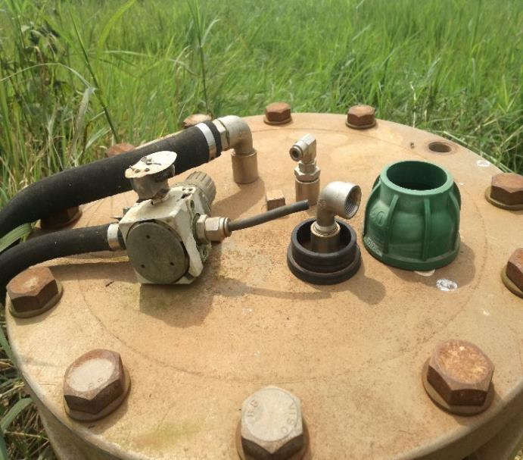

Image 1: An example of a poorly managed extractoin well
(Source: Nkolfoulou Landfill Site, March 2021)

