Supplementary Materials 1 – Questionnaire Design
- Questions to Identify Demographic and General Information Related to Plastic Waste from the Respondents
Variable Code | Questions | Options
Demographic Questions:
GENDER | What is your gender? | Male/female
EDU | What is your latest education level? | elementary school/ junior high school/ senior high school/ bachelor degree/ master degree/ doctor degree
OCCUP | What is your occupation? | Students/ housewives/ governmental officer/ private enterprise employees/ state-owned enterprise employees/ entrepreneurs/ army or police/ professional such as doctor, lawyer or architect
INCOME | How much is your monthly income? | less than IDR 5 million/ IDR 5 to 10 million/ IDR 10 to 15 million/ IDR 15 to 20 million/ more than IDR 20 million
EXP | How much is your monthly expenses for household products? | Less than IDR 1 million/ IDR 1 to 2 million/ IDR 2 to 3 million/ IDR 3 to 4 million/ IDR 4 to 5 million/ more than IDR 5 million
ORIGIN | Where do you live? | Jakarta/ Bogor/ Depok/ Tangerang/ Bekasi/ Bandung
Plastic Waste Management Questions:
MANAGE | Is your waste managed by the neighborhood leader? | Yes/ No/ Maybe
FEE | How much is tipping fee applied in the area you live? | Open ended questions, limited to be filled by number only
TYPE | What are the most waste types you often dispose? (You may select max. 3 types) | Food waste/ plastic/ clothes/ electronic and electronical equipment/ medical waste/ paper/ metal/ building materials
PLASTIC | What are the most plastic waste types you often dispose? (You may choose max 3 types) | Plastic bottle/ multilayer plastic or sachet/ plastic pouch for refill products/ food packaging/ plastic shopping bag/ plastic cutlery/ plastic glass/ medical mask
TIMES | How many times your waste is picked? | 1 to 3 times per month/ 1 time a week/ 2 times a week/ 3 times a week/ 4 times a week/ 5 times a week/ 6 times a week/ every day
DISTANCE | Is your house located far away from temporary disposal site? (Your house indicated as far from temporary disposal site if the distance minimum 1 km) | Yes/ No/ Maybe
WBANK | Have you ever exchanged your waste with money in waste bank or scavenger or another services? | Yes, I have/ No, I haven’t

- List of Questions and Variable Represented
Variable Code | Variable Name | Question Code | Question Statement
OHS | Occupational health and safety risk for waste workers | OHS-S1 | Currently, the workers who pick up your waste are protected from the risk of disease from the waste that you produce.
OHS | Occupational health and safety risk for waste workers | OHS-S2 | Currently, the workers who pick up your waste are wearing sufficient safety protection equipment.
OHS | Occupational health and safety risk for waste workers | OHS-P1 | In the future, the workers who pick up your waste should be protected from the risk of disease from the waste that you produce.
OHS | Occupational health and safety risk for waste workers | OHS-P2 | In the future, the workers who pick up your waste should wear sufficient safety protection equipment.
LOAD | Excessive workload for waste workers | LOAD-S1 | Currently, the workers who pick up your waste have an acceptable working hour.
LOAD | Excessive workload for waste workers | LOAD-S2 | Currently, the workers who pick up your waste have an appropriate workload, for instance, the number of residents they are serving are adequate with the capacity of the workers serve for them.
LOAD | Excessive workload for waste workers | LOAD-P1 | In the future, the workers who pick up your waste should have an acceptable working hour.
LOAD | Excessive workload for waste workers | LOAD-P2 | In the future, the workers who pick up your waste should have an appropriate workload, for instance, the number of residents they are serving are adequate with the capacity of the workers serve for them.
SEG | Unwillingness to segregate waste | SEG-S1 | Currently, you have segregated your waste according to its types (e.g., segregating food waste and plastic waste).
SEG | Unwillingness to segregate waste | SEG-P1 | In the future, you are willing to segregate your waste according to its types (e.g., segregating food waste and plastic waste).
RED | Unwillingness to reduce waste | RED-S1 | Currently, you have brought your own shopping bag that can be used several times (e.g., tote bag) to reduce the waste from plastic shopping bag.
RED | Unwillingness to reduce waste | RED-S2 | Currently, you have bought your household products without plastic packaging, for instance, by buying mineral water with refillable gallon.
RED | Unwillingness to reduce waste | RED-P1 | In the future, you are willing to bring your own shopping bag that can be used several times (e.g., tote bag) to reduce the waste from plastic shopping bag.
RED | Unwillingness to reduce waste | RED-P2 | In the future, you are willing to buy your household products without plastic packaging, for instance, by buying mineral water with refillable gallon.
DEP | Over dependencies to use or buy product with packaging | DEP-S1 | Currently, you have bought your household products without plastic packaging, for instance, by bringing tumbler to be refilled by the coffee from the café.
DEP | Over dependencies to use or buy product with packaging | DEP-P1 | In the future, you are willing to buy your household products without plastic packaging, for instance, by bringing tumbler to be refilled by the coffee from the café.
WAGE | Wages and income issue for waste workers | WAGE-S1 | Currently, the workers who pick up your waste already have an appropriate and stable wages.
WAGE | Wages and income issue for waste workers | WAGE-P1 | In the future, the workers who pick up your waste should have an appropriate and stable wages.
DEM | Demand risk of the product and service from circular plastic waste businesses | DEM-S1 | Currently, you have bought several products from plastic recycling.
DEM |  | DEM-P1 | In the future, you are willing to buy several products from plastic recycling.
PRICE | Price risk of the product and service from circular plastic waste businesses | PRICE-S1 | Currently, you think that the price for products from plastic recycling are affordable.
PRICE |  | PRICE-P1 | In the future, you expect the price for products from plastic recycling should be more affordable.
COST | Operational cost related to plastic waste segregation and recycling | COST-S1 | Currently, you think the cost for waste management in the area you live have been affordable.
COST |  | COST-P1 | In the future, you think the cost for waste management in the area you live should be more affordable.
SUPP | Supply risk of plastic waste | SUPP-S1 | Currently, you think the number of plastic wastes has been reduced.
SUPP | Supply risk of plastic waste | SUPP-P1 | In the future, you expect the number of plastic wastes should be reduced more.
MICRO | Microplastic pollutants as the potential residual in recycled product from plastic waste | MICRO-S1 | Currently, you are aware about the danger from microplastic pollutants from plastic waste.
MICRO |  | MICRO-P1 | In the future, the awareness about the danger from microplastic pollutants should be improved.
RIVER | River and ocean pollutants from plastic waste | RIVER-S1 | Currently, you think the plastic waste you are disposing is not contaminating the river and ocean.
RIVER | River and ocean pollutants from plastic waste | RIVER-P1 | In the future, you expect the plastic waste that contaminate the river and ocean can be reduced.
REG | Regulation to promote plastic waste reduction, recycling and segregation | REG-S1 | Currently, you think the government has applied supporting regulation for reducing plastic waste in the area where you live.
REG |  | REG-S2 | Currently, you think the government has applied supporting regulation for promote community behavior to segregate waste according to its type, for instance, segregating food waste and plastic waste.
REG |  | REG-S3 | Currently, you think the government has applied incentives to promote community to segregate their waste according to its types.
REG |  | REG-P1 | In the future, you expect the government should apply stricter regulation in order to reduce plastic waste in the area where you live.
REG |  | REG-P2 | In the future, you expect the government should apply stricter regulation in order to support community behavior to segregate their waste according to its types, for instance, segregating food waste and plastic waste.
REG |  | REG-P3 | In the future, you expect the government should give incentives to promote community to segregate their waste according to its types.
DEL | Deliberation of waste management process from local government authority to local private sector | DEL-S1 | Currently, you think a lot of waste banks accepting the waste you produce and exchanging it with money.
DEL |  | DEL-S2 | Currently, you think a lot of businesses offering products from plastic recycling.
DEL |  | DEL-S3 | Currently, you think a lot of businesses offering waste management service that promote you to segregate waste according to its types.
DEL |  | DEL-S4 | Currently, you think a lot of businesses offering household products without single-use plastic packaging.
DEL |  | DEL-P1 | In the future, you expect more waste banks that able to exchange the waste you produce with money.
DEL |  | DEL-P2 | In the future, you expect more businesses offering products from plastic recycling.
DEL |  | DEL-P3 | In the future, you expect more businesses offering waste management service that promote you to segregate waste according to its types.
DEL |  | DEL-P4 | In the future, you expect more businesses offering household products without single-use plastic packaging.
INFRA | Availability of technology and infrastructure to support plastic waste recycling | INFRA-S1 | Currently, you think separatable waste bin has been available in the area where you live.
INFRA |  | INFRA-S2 | Currently, you think infrastructure such as dump truck has segregated waste according to its types appropriately.
INFRA |  | INFRA-S3 | Currently, you think plastic waste recycling infrastructure has been sufficiently available.
INFRA |  | INFRA-P1 | In the future, you expect more separatable waste bin should be sufficiently available.
INFRA |  | INFRA-P2 | In the future, you expect infrastructure such as dump truck has segregated waste according its types way better.
INFRA |  | INFRA-P3 | In the future, you expect plastic waste recycling infrastructure should be sufficiently available.

Supplementary Materials 2 – Principal Component Analysis

Stage 1 – Assessment of Sufficiency of Samples and Variables to be Further Analysed Using Principal Component Analysis
  - KMO and Bartlett’s Test
KMO and Bartlett's Test
Kaiser-Meyer-Olkin Measure of Sampling Adequacy. |  | 0.950
Bartlett's Test of Sphericity | Approx. Chi-Square | 7186.435
 | Df | 231
 | Sig. | 0.000
From the table above, we have:
H₀: sample (variables) is not sufficient to be further analysed by principal component analysis
H₁: sample (variables) is sufficient to be further analysed by principal component analysis
Rejection criteria: reject null hypothesis if the Sig. value lower than 0.05
Conclusion: null hypothesis is rejected since the Sig. value is 0.000 or lower than 0.05, then it concludes that the sample (variables) is sufficient to be further analysed by principal component analysis

  - Anti-image Metrices or Measure of Sampling Adequacy for Each Variable
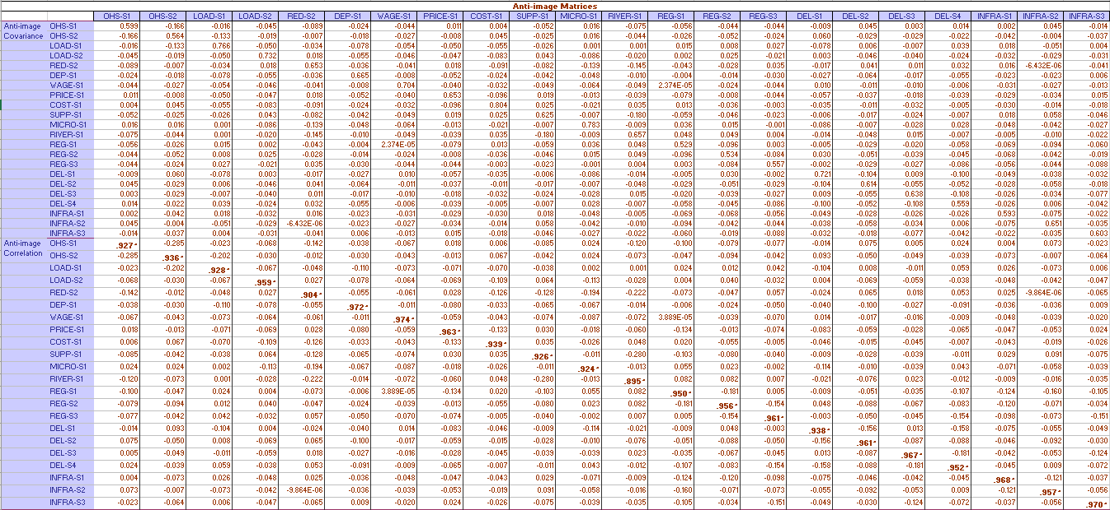

From the anti-image correlation metrices above, all of the measure of sampling adequacy (in the bold text) for all variables are higher than 0.5. Therefore, all of the variables are able to be included in the factor extraction stage for the next stage of principal component analysis.

Stage 2 – Factoring and Rotating Processes
  - Communalities
Communalities
 | Initial | Extraction |  | Initial | Extraction
OHS-S1 | 1.000 | 0.560 | RIVER-S1 | 1.000 | 0.531
OHS-S2 | 1.000 | 0.532 | REG-S1 | 1.000 | 0.556
LOAD-S1 | 1.000 | 0.312 | REG-S2 | 1.000 | 0.571
LOAD-S2 | 1.000 | 0.379 | REG-S3 | 1.000 | 0.541
RED-S2 | 1.000 | 0.562 | DEL-S1 | 1.000 | 0.396
DEP-S1 | 1.000 | 0.403 | DEL-S2 | 1.000 | 0.465
WAGE-S1 | 1.000 | 0.377 | DEL-S3 | 1.000 | 0.446
PRICE-S1 | 1.000 | 0.434 | DEL-S4 | 1.000 | 0.545
COST-S1 | 1.000 | 0.384 | INFRA-S1 | 1.000 | 0.491
SUPP-S1 | 1.000 | 0.548 | INFRA-S2 | 1.000 | 0.440
MICRO-S1 | 1.000 | 0.462 | INFRA-S3 | 1.000 | 0.463

The table above shows the extraction result from Principal Component Analysis. For instance, OHS-S1 has extraction value of 0.560 means that 56.0% of the OHS-S1 variation can be described by the factors extracted from the analysis. The larger the value then the stronger the relationship between the variable and the factors created by the analysis.

  - Total Variance Explained and Scree Plot

Total Variance Explained
Component | Initial Eigenvalues |  |  | Extraction Sums of Squared Loadings |  |  | Rotation Sums of Squared Loadings
 | Total | % of Variance | Cumulative % | Total | % of Variance | Cumulative % | Total | % of Variance | Cumulative %
1 | 7.624 | 34.656 | 34.656 | 7.624 | 34.656 | 34.656 | 4.812 | 21.875 | 21.875
2 | 1.583 | 7.195 | 41.850 | 1.583 | 7.195 | 41.850 | 3.035 | 13.796 | 35.670
3 | 1.191 | 5.413 | 47.263 | 1.191 | 5.413 | 47.263 | 2.550 | 11.593 | 47.263
4 | 0.935 | 4.251 | 51.514
5 | 0.853 | 3.877 | 55.391
6 | 0.799 | 3.631 | 59.022
7 | 0.766 | 3.483 | 62.505
8 | 0.705 | 3.206 | 65.711
9 | 0.670 | 3.046 | 68.757
10 | 0.660 | 2.999 | 71.755
11 | 0.655 | 2.977 | 74.733
12 | 0.602 | 2.738 | 77.471
13 | 0.581 | 2.641 | 80.113
14 | 0.567 | 2.577 | 82.690
15 | 0.554 | 2.517 | 85.206
16 | 0.540 | 2.454 | 87.661
17 | 0.510 | 2.317 | 89.978
18 | 0.501 | 2.276 | 92.254
19 | 0.470 | 2.137 | 94.391
20 | 0.426 | 1.934 | 96.325
21 | 0.422 | 1.919 | 98.245
22 | 0.386 | 1.755 | 100.000

The table above shows the total variance explained if certain number of factors extracted. For instance, if only one factor extracted from Principal Component Analysis, then 34.656% of variance from the data can be explained. If two factors extracted then total of variance explained is 41.850% and if three factors extracted then total of variance explained is 47.263%. The table is not showing the next scenario of factoring since the change of total variance is no longer significant. Its significance can be seen in scree plot of percentage of variance in the figure below. It shows that the slope of line graph starting to be straight or not longer has a significant slope in component number of 4 and 5. Therefore, the optimal number of factors that can be created is three.

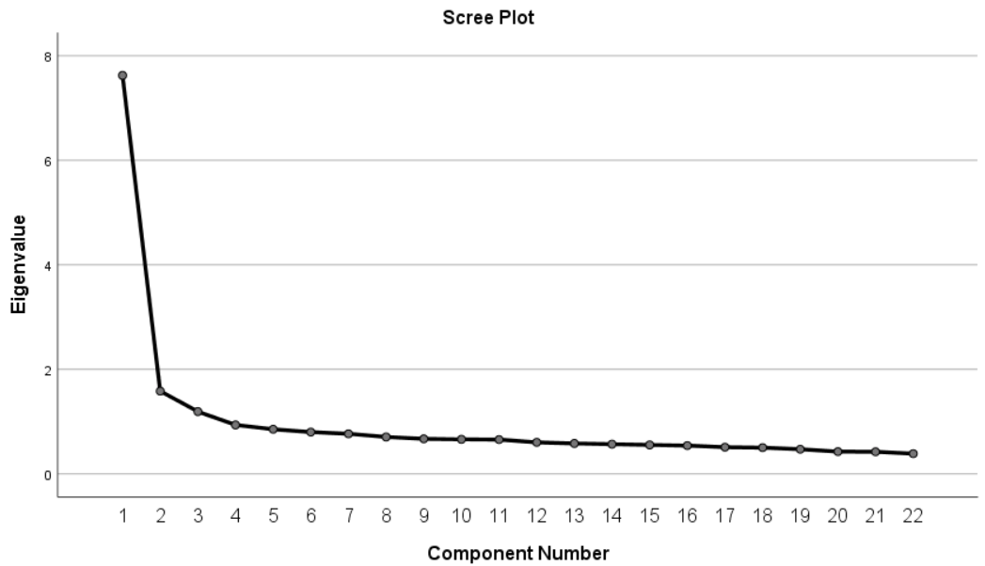

  - Initial Component Matrix
From previous scree plot and total variance explained, this study finds that the factors that can be extracted is three. Then, the PCA presents the initial component matrix to categorise the variables into three factors extracted from the analysis. This calculation is shown by the table below. From this initial component matrix, this research finds that most variables are still categorised as Factor 1. Furthermore, several of the variables still have similar value in more than one factor. For instance, the component value of SUPP-S1 in Factor 1 and Factor 2 are 0.553 and 0.459 that seems to have a close gap and the categorisation is not distinctively differentiated. Therefore, the rotated component matrix is necessary.

Component Matrixª
 | Component
 | 1 | 2 | 3
OHS-S1 | 0.577 | 0.425 | -0.217
OHS-S2 | 0.639 | 0.244 | -0.255
LOAD-S1 | 0.459 | 0.182 | 0.261
LOAD-S2 | 0.533 | -0.097 | 0.292
RED-S2 | 0.496 | 0.528 | 0.196
DEP-S1 | 0.619 | -0.008 | 0.138
WAGE-S1 | 0.578 | 0.183 | 0.094
PRICE-S1 | 0.611 | -0.193 | 0.154
COST-S1 | 0.428 | -0.125 | 0.430
SUPP-S1 | 0.553 | 0.459 | -0.177
MICRO-S1 | 0.430 | 0.113 | 0.514
RIVER-S1 | 0.483 | 0.545 | 0.024
REG-S1 | 0.693 | -0.119 | -0.246
REG-S2 | 0.690 | -0.110 | -0.289
REG-S3 | 0.682 | -0.171 | -0.218
DEL-S1 | 0.512 | -0.195 | 0.310
DEL-S2 | 0.635 | -0.249 | 0.006
DEL-S3 | 0.624 | -0.209 | -0.116
DEL-S4 | 0.660 | -0.285 | -0.166
INFRA-S1 | 0.662 | -0.223 | -0.057
INFRA-S2 | 0.594 | -0.291 | 0.055
INFRA-S3 | 0.665 | -0.027 | -0.143

  - Rotated Component Matrix
Rotated Component Matrixª
 | Component
 | 1 | 2 | 3
OHS-S1 | 0.310 | 0.681 | 0.028
OHS-S2 | 0.463 | 0.562 | 0.043
LOAD-S1 | 0.132 | 0.342 | 0.421
LOAD-S2 | 0.313 | 0.135 | 0.512
RED-S2 | 0.013 | 0.666 | 0.344
DEP-S1 | 0.401 | 0.276 | 0.407
WAGE-S1 | 0.294 | 0.427 | 0.329
PRICE-S1 | 0.481 | 0.112 | 0.437
COST-S1 | 0.188 | 0.038 | 0.589
SUPP-S1 | 0.257 | 0.693 | 0.049
MICRO-S1 | 0.032 | 0.230 | 0.639
RIVER-S1 | 0.072 | 0.701 | 0.185
REG-S1 | 0.683 | 0.276 | 0.114
REG-S2 | 0.695 | 0.288 | 0.074
REG-S3 | 0.687 | 0.222 | 0.139
DEL-S1 | 0.339 | 0.038 | 0.529
DEL-S2 | 0.593 | 0.098 | 0.323
DEL-S3 | 0.618 | 0.146 | 0.207
DEL-S4 | 0.706 | 0.105 | 0.187
INFRA-S1 | 0.627 | 0.143 | 0.277
INFRA-S2 | 0.561 | 0.034 | 0.352
INFRA-S3 | 0.569 | 0.326 | 0.182

The rotated component matrix above is developed with Kaiser Normalisation. The total rotation converged in seven iterations. In this rotated component matrix, clearer categorisation has been developed compare in the initial component matrix. According to the largest component value of each variable, Factor 1 includes PRICE-S1, REG-S1, REG-S2, REG-S3, DEL-S2, DEL-S3, DEL-S4, INFRA-S1, INFRA-S2, and INFRA-S3. Furthermore, Factor 2 includes OHS-S1, OHS-S2, RED-S2, WAGE-S1, SUPP-S1, and RIVER-S1. Last, Factor 3 includes LOAD-S1, LOAD-S2, DEP-S1, COST-S1, MICRO-S1, and DEL-S1. The naming process of each factor is described by Table 8 in the main article.

  - Component Transformation Matrix: How Well the Categorisation?
Component Transformation Matrix
Component | 1 | 2 | 3
1 | 0.740 | 0.492 | 0.459
2 | -0.504 | 0.857 | -0.107
3 | -0.446 | -0.152 | 0.882

From the table above, it shows that the diagonal value with the bold text is higher than 0.5. Therefore, all factors are categorised well and each factor is distinctively differentiated with other factors.

Stage 3 – Factor Validation (Split Sample)
In validating the factors extracted by the Principal Component Analysis, this study performs PCA to several group of sample or split sample into several dataset. First, this study split the sample into two datasets with 500 sample each (1 to 500 case in the first dataset and 501 to 1000 case in the second dataset). The result of the PCA for both samples are different. First dataset categorises the variables into four factors while the second dataset categorises the variables into three factors. The results can be seen from two tables below.

Component Matrixª for Case 1 to 500
 | Component
 | 1 | 2 | 3 | 4
OHS-S1 | 0.632 | 0.364 | -0.312 | 0.093
OHS-S2 | 0.739 | 0.083 | -0.218 | 0.058
LOAD-S1 | 0.454 | 0.009 | 0.431 | 0.064
LOAD-S2 | 0.538 | -0.081 | 0.255 | 0.191
RED-S2 | 0.399 | 0.705 | 0.085 | 0.163
DEP-S1 | 0.686 | 0.010 | 0.127 | -0.101
WAGE-S1 | 0.617 | 0.171 | 0.029 | 0.099
PRICE-S1 | 0.642 | -0.246 | 0.146 | 0.057
COST-S1 | 0.319 | -0.073 | 0.272 | 0.725
SUPP-S1 | 0.568 | 0.487 | -0.039 | -0.172
MICRO-S1 | 0.338 | 0.323 | 0.423 | 0.042
RIVER-S1 | 0.461 | 0.548 | 0.089 | -0.324
REG-S1 | 0.722 | -0.105 | -0.248 | 0.028
REG-S2 | 0.735 | -0.034 | -0.331 | 0.052
REG-S3 | 0.695 | -0.190 | -0.253 | -0.032
DEL-S1 | 0.454 | -0.136 | 0.485 | -0.320
DEL-S2 | 0.618 | -0.245 | 0.173 | -0.344
DEL-S3 | 0.647 | -0.209 | -0.066 | 0.002
DEL-S4 | 0.688 | -0.294 | -0.029 | -0.228
INFRA-S1 | 0.655 | -0.255 | -0.103 | 0.041
INFRA-S2 | 0.560 | -0.342 | 0.125 | 0.093
INFRA-S3 | 0.635 | 0.060 | -0.196 | 0.117
Extraction Method: Principal Component Analysis.
a. 4 components extracted.

Component Matrixª for Case 501 to 1000
 | Component
 | 1 | 2 | 3
OHS-S1 | 0.498 | 0.534 | 0.016
OHS-S2 | 0.503 | 0.524 | -0.104
LOAD-S1 | 0.467 | 0.427 | 0.209
LOAD-S2 | 0.540 | -0.084 | 0.354
RED-S2 | 0.599 | 0.208 | 0.043
DEP-S1 | 0.532 | -0.046 | 0.385
WAGE-S1 | 0.527 | 0.158 | 0.204
PRICE-S1 | 0.573 | -0.099 | 0.251
COST-S1 | 0.550 | -0.127 | 0.319
SUPP-S1 | 0.521 | 0.390 | -0.397
MICRO-S1 | 0.521 | -0.105 | 0.414
RIVER-S1 | 0.497 | 0.492 | -0.025
REG-S1 | 0.655 | -0.162 | -0.293
REG-S2 | 0.630 | -0.198 | -0.150
REG-S3 | 0.672 | -0.151 | -0.128
DEL-S1 | 0.579 | -0.197 | 0.077
DEL-S2 | 0.656 | -0.206 | -0.075
DEL-S3 | 0.607 | -0.201 | -0.207
DEL-S4 | 0.630 | -0.277 | -0.232
INFRA-S1 | 0.675 | -0.123 | 0.000
INFRA-S2 | 0.632 | -0.195 | -0.078
INFRA-S3 | 0.699 | -0.073 | -0.288
Extraction Method: Principal Component Analysis.
a. 3 components extracted.

Since the number of factors extracted is different, this study tries to split another different dataset once more. At this time, this research split the sample into four datasets with each dataset consists of 250 samples. The results shows that case 1 to 250 has extracted four factors, case 251 to 500 has extracted five factors, case 501 to 750 has extracted three factors, and case 751 to 1000 has extracted five factors. These results is shown by four tables below.

Component Matrixª for Case 1 to 250
 | Component
 | 1 | 2 | 3 | 4
OHS-S1 | 0.668 | 0.248 | -0.371 | 0.077
OHS-S2 | 0.798 | 0.000 | -0.149 | -0.018
LOAD-S1 | 0.365 | 0.031 | 0.497 | 0.068
LOAD-S2 | 0.531 | 0.062 | 0.148 | 0.288
RED-S2 | 0.235 | 0.768 | -0.170 | 0.140
DEP-S1 | 0.678 | 0.008 | 0.221 | -0.115
WAGE-S1 | 0.599 | 0.043 | -0.076 | 0.064
PRICE-S1 | 0.681 | -0.115 | 0.129 | 0.207
COST-S1 | 0.238 | 0.044 | -0.014 | 0.778
SUPP-S1 | 0.501 | 0.534 | -0.071 | -0.195
MICRO-S1 | 0.144 | 0.456 | 0.367 | 0.312
RIVER-S1 | 0.310 | 0.626 | 0.065 | -0.401
REG-S1 | 0.748 | -0.100 | -0.218 | -0.003
REG-S2 | 0.763 | -0.015 | -0.324 | -0.064
REG-S3 | 0.747 | -0.210 | -0.197 | -0.127
DEL-S1 | 0.505 | 0.124 | 0.534 | -0.033
DEL-S2 | 0.635 | -0.144 | 0.321 | -0.297
DEL-S3 | 0.670 | -0.193 | 0.124 | -0.050
DEL-S4 | 0.769 | -0.185 | 0.188 | -0.157
INFRA-S1 | 0.739 | -0.214 | -0.116 | 0.054
INFRA-S2 | 0.586 | -0.293 | 0.039 | 0.134
INFRA-S3 | 0.646 | -0.010 | -0.250 | 0.046
Extraction Method: Principal Component Analysis.
a. 4 components extracted.

Component Matrixª for Case 251 to 500
 | Component
 | 1 | 2 | 3 | 4 | 5
OHS-S1 | 0.530 | -0.574 | 0.154 | 0.043 | -0.049
OHS-S2 | 0.624 | -0.361 | -0.126 | 0.073 | 0.013
LOAD-S1 | 0.564 | 0.052 | -0.184 | 0.502 | -0.130
LOAD-S2 | 0.473 | 0.281 | -0.155 | 0.513 | -0.034
RED-S2 | 0.608 | -0.457 | 0.174 | -0.050 | -0.259
DEP-S1 | 0.693 | -0.068 | -0.062 | 0.208 | -0.261
WAGE-S1 | 0.646 | -0.219 | 0.162 | 0.130 | 0.140
PRICE-S1 | 0.522 | 0.383 | 0.040 | -0.076 | -0.022
COST-S1 | 0.454 | 0.303 | -0.282 | 0.080 | -0.338
SUPP-S1 | 0.612 | -0.435 | -0.015 | 0.095 | 0.020
MICRO-S1 | 0.623 | -0.064 | 0.241 | -0.076 | 0.467
RIVER-S1 | 0.640 | -0.309 | 0.247 | -0.118 | 0.022
REG-S1 | 0.624 | 0.105 | 0.114 | -0.272 | -0.338
REG-S2 | 0.635 | 0.046 | -0.241 | -0.247 | -0.080
REG-S3 | 0.544 | 0.071 | -0.226 | 0.144 | 0.533
DEL-S1 | 0.321 | 0.410 | 0.546 | 0.266 | 0.000
DEL-S2 | 0.551 | 0.371 | 0.217 | -0.151 | -0.183
DEL-S3 | 0.570 | 0.161 | -0.429 | -0.316 | 0.056
DEL-S4 | 0.501 | 0.273 | -0.271 | 0.009 | 0.226
INFRA-S1 | 0.436 | 0.332 | 0.314 | -0.049 | 0.198
INFRA-S2 | 0.487 | 0.475 | 0.189 | -0.184 | -0.029
INFRA-S3 | 0.649 | -0.114 | -0.194 | -0.296 | 0.090
Extraction Method: Principal Component Analysis.
a. 5 components extracted.

Component Matrixª for Case 501 to 750
 | Component
 | 1 | 2 | 3
OHS-S1 | 0.569 | 0.384 | 0.023
OHS-S2 | 0.603 | 0.401 | -0.162
LOAD-S1 | 0.554 | 0.338 | 0.372
LOAD-S2 | 0.653 | -0.244 | 0.026
RED-S2 | 0.629 | -0.270 | 0.455
DEP-S1 | 0.674 | -0.042 | 0.251
WAGE-S1 | 0.612 | -0.083 | 0.174
PRICE-S1 | 0.649 | -0.054 | 0.197
COST-S1 | 0.613 | -0.191 | 0.342
SUPP-S1 | 0.581 | 0.575 | 0.105
MICRO-S1 | 0.549 | -0.376 | 0.184
RIVER-S1 | 0.522 | 0.469 | 0.128
REG-S1 | 0.717 | -0.044 | -0.146
REG-S2 | 0.708 | 0.001 | -0.154
REG-S3 | 0.698 | -0.114 | -0.082
DEL-S1 | 0.650 | -0.123 | -0.118
DEL-S2 | 0.734 | -0.027 | -0.153
DEL-S3 | 0.607 | -0.125 | -0.229
DEL-S4 | 0.674 | -0.200 | -0.179
INFRA-S1 | 0.767 | -0.055 | -0.208
INFRA-S2 | 0.722 | 0.029 | -0.264
INFRA-S3 | 0.720 | -0.023 | -0.273
Extraction Method: Principal Component Analysis.
a. 3 components extracted.

Component Matrixª
 | Component
 | 1 | 2 | 3 | 4 | 5
OHS-S1 | 0.455 | 0.589 | 0.073 | -0.250 | 0.051
OHS-S2 | 0.435 | 0.586 | -0.047 | -0.408 | 0.182
LOAD-S1 | 0.357 | 0.493 | 0.252 | -0.265 | 0.122
LOAD-S2 | 0.385 | 0.037 | 0.482 | -0.318 | -0.174
RED-S2 | 0.591 | 0.345 | -0.249 | 0.173 | -0.203
DEP-S1 | 0.361 | -0.053 | 0.482 | 0.166 | 0.076
WAGE-S1 | 0.402 | 0.276 | 0.020 | 0.490 | 0.134
PRICE-S1 | 0.476 | -0.126 | 0.223 | 0.397 | 0.254
COST-S1 | 0.454 | -0.139 | 0.375 | 0.151 | 0.427
SUPP-S1 | 0.502 | 0.230 | -0.518 | 0.182 | 0.087
MICRO-S1 | 0.473 | 0.033 | 0.379 | 0.144 | -0.457
RIVER-S1 | 0.475 | 0.493 | -0.076 | 0.359 | -0.054
REG-S1 | 0.596 | -0.238 | -0.324 | -0.117 | -0.020
REG-S2 | 0.545 | -0.308 | -0.070 | -0.162 | 0.230
REG-S3 | 0.656 | -0.219 | -0.116 | -0.048 | 0.100
DEL-S1 | 0.471 | -0.165 | 0.224 | -0.105 | -0.179
DEL-S2 | 0.547 | -0.318 | 0.032 | -0.108 | 0.349
DEL-S3 | 0.614 | -0.197 | -0.089 | -0.113 | -0.204
DEL-S4 | 0.593 | -0.332 | -0.164 | -0.100 | 0.062
INFRA-S1 | 0.538 | -0.062 | 0.057 | 0.101 | -0.196
INFRA-S2 | 0.521 | -0.236 | -0.008 | 0.060 | -0.386
INFRA-S3 | 0.707 | -0.101 | -0.246 | -0.140 | -0.067
Extraction Method: Principal Component Analysis.
a. 5 components extracted.

From these different results of PCA from different group of datasets, it concludes that 3 to 5 factors are the most significant classification of the PCA. It also aligned with the scree plot that described in the previous sub-chapter.

Stage 4 – Factors Score
After, the variables included in each factor has been identified. Then, the factor scores are calculated based on the score of the variables included in the respected factor. This study uses the mean value of the variables to identify the factor score of each respondent. These factor scores is used as the independent variable score for the linear regression analysis in predicting SEG-S1, RED-S1, and DEM-S1.

Supplementary Materials 3 – Regression Plots
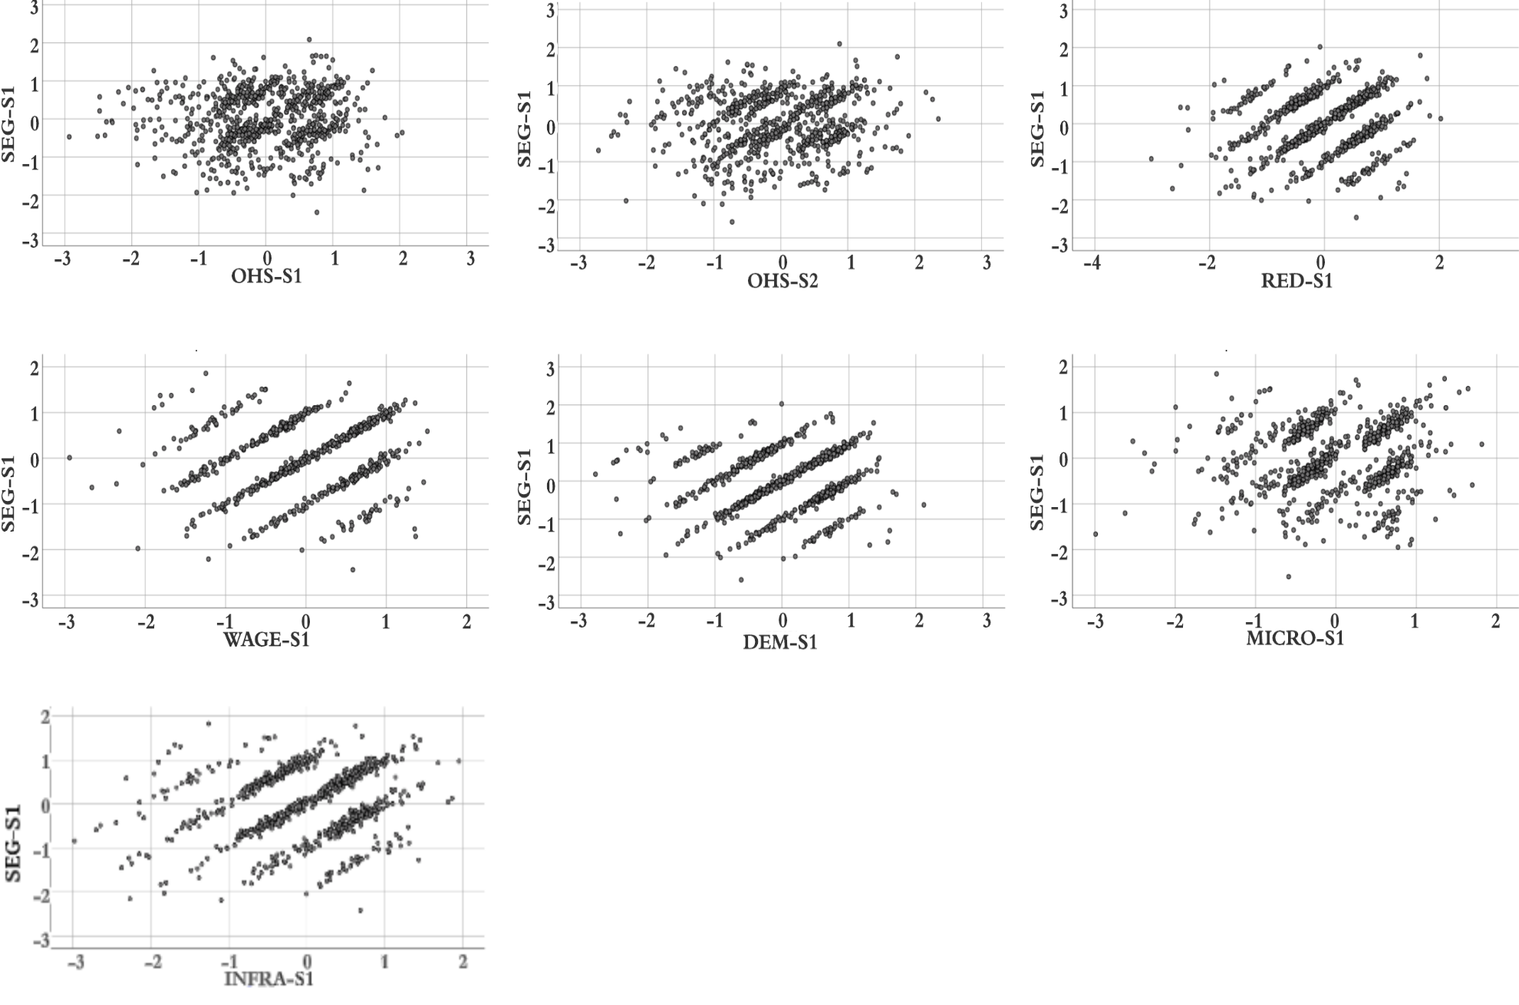
Figure 1. Regression plot for linear model predicting SEG-S1 with its predictors.
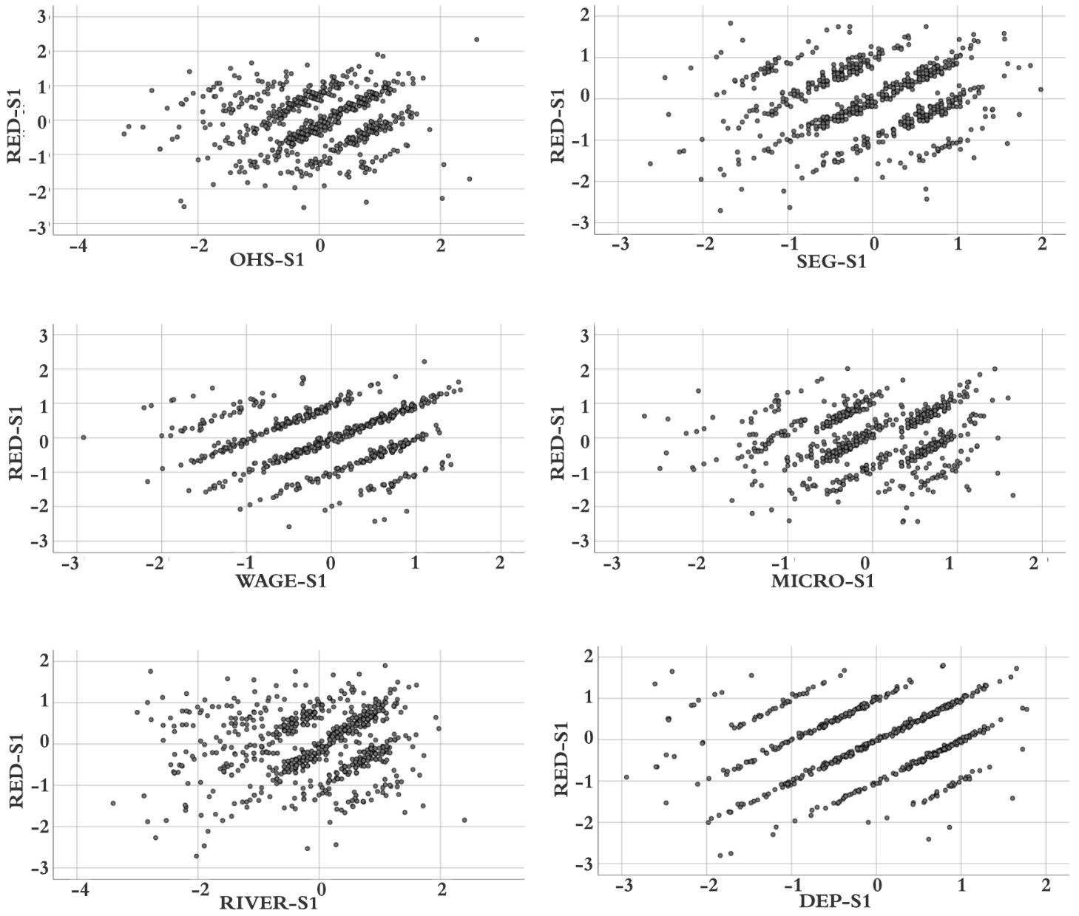
Figure 2. Regression plot for linear model predicting RED-S1 with its predictors.

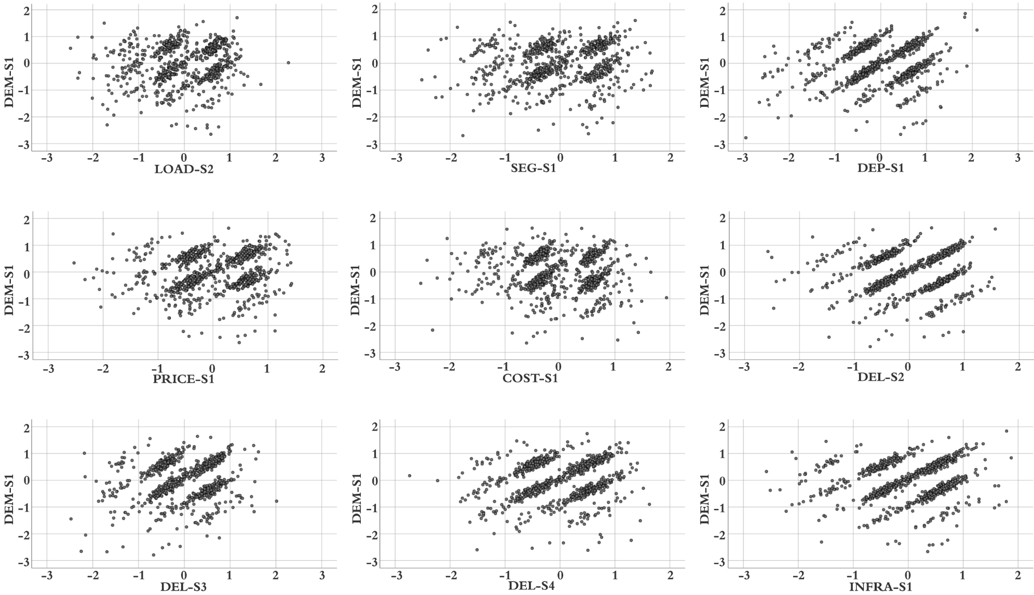
Figure 3. Regression plot for linear model predicting DEM-S1 with its predictors.

