ENHANCING SLUDGE STABILIZATION AND METHANE PRODUCTION IN THE ANAEROBIC DIGESTION OF PALM OIL MILL EFFLUENT USING CARBON CONDUCTIVE MATERIALS

Ayik Abdillah¹, Taira Hidaka^{1, 2}, Taku Fujiwara^{1, 2}, Naoko Yoshida^{3, 4, 5}, Ibnu Maulana Hidayatullah^{7, 8},
Nopa Dwi Maulidiany^{6, 8}
¹Department of Environmental Engineering, Graduate School of Engineering, Kyoto University, Japan
²Department of Global Ecology, Graduate School of Global Environmental Studies, Kyoto University, Japan
³Institute of Materials and Systems for Sustainability, Nagoya University, Japan
⁴Department of Civil Engineering, Graduate School of Engineering, Nagoya University, Japan
⁵Department of Civil Engineering, Nagoya Institute of Technology, Japan
⁶Department of Civil Engineering, Faculty of Engineering, Universitas Indonesia, Indonesia
⁷Department of Chemical Engineering, Faculty of Engineering, Universitas Indonesia, Indonesia
⁸Research Center for Biomass Valorization, Faculty of Engineering, Universitas Indonesia, Indonesia

*Corresponding author: Taira Hidaka, E-mail: hidaka.taira.4e@kyoto-u.ac.jp
SUPPLEMENTARY DATA
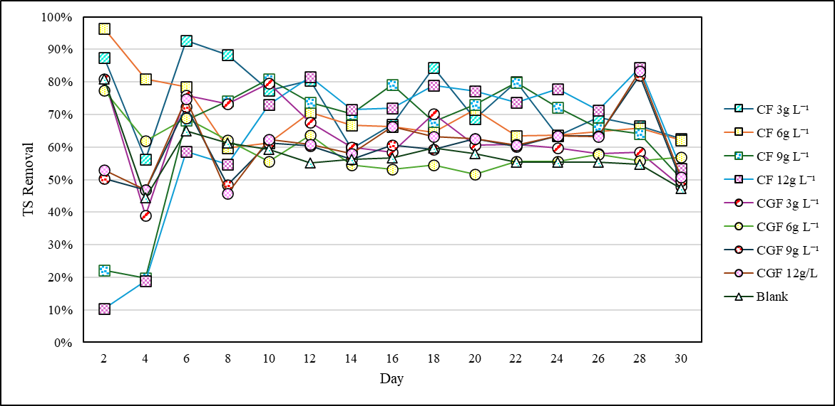
Fig. S1. Temporal Profile of TS Removal Efficiency with Varying CM-Dosages
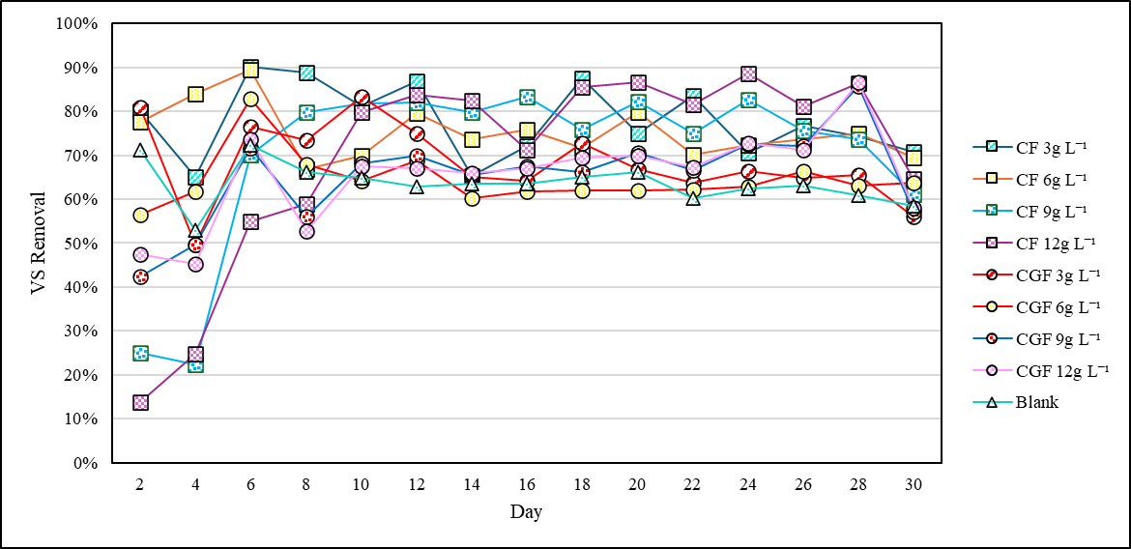
Fig. S2. Temporal Profile of VS Removal Efficiency with Varying CM-Dosages
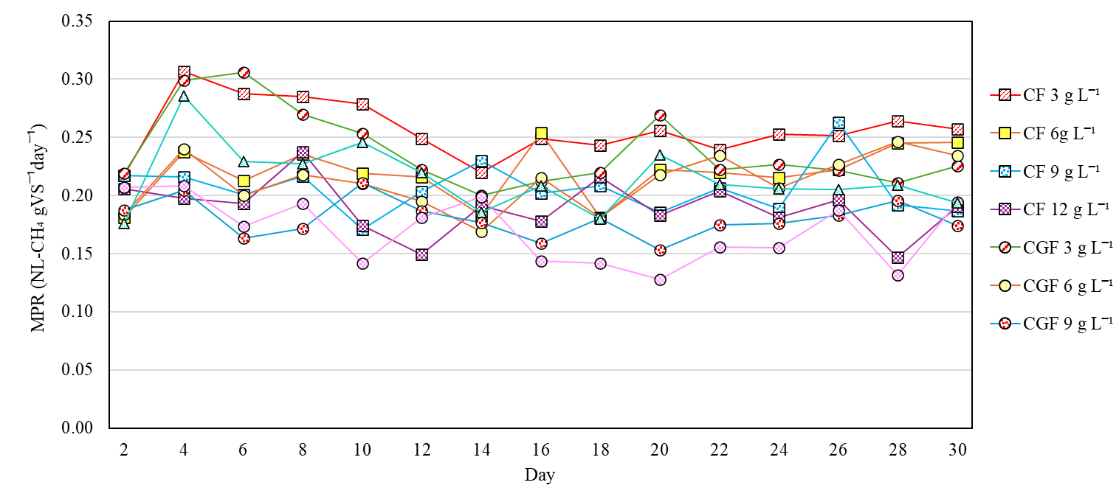
Fig. S3. Temporal Variation of Methane Production Rate (NL-CH₄/gVS/day) in Anaerobic Digestion of POME with Varying Conductive Material Dosages
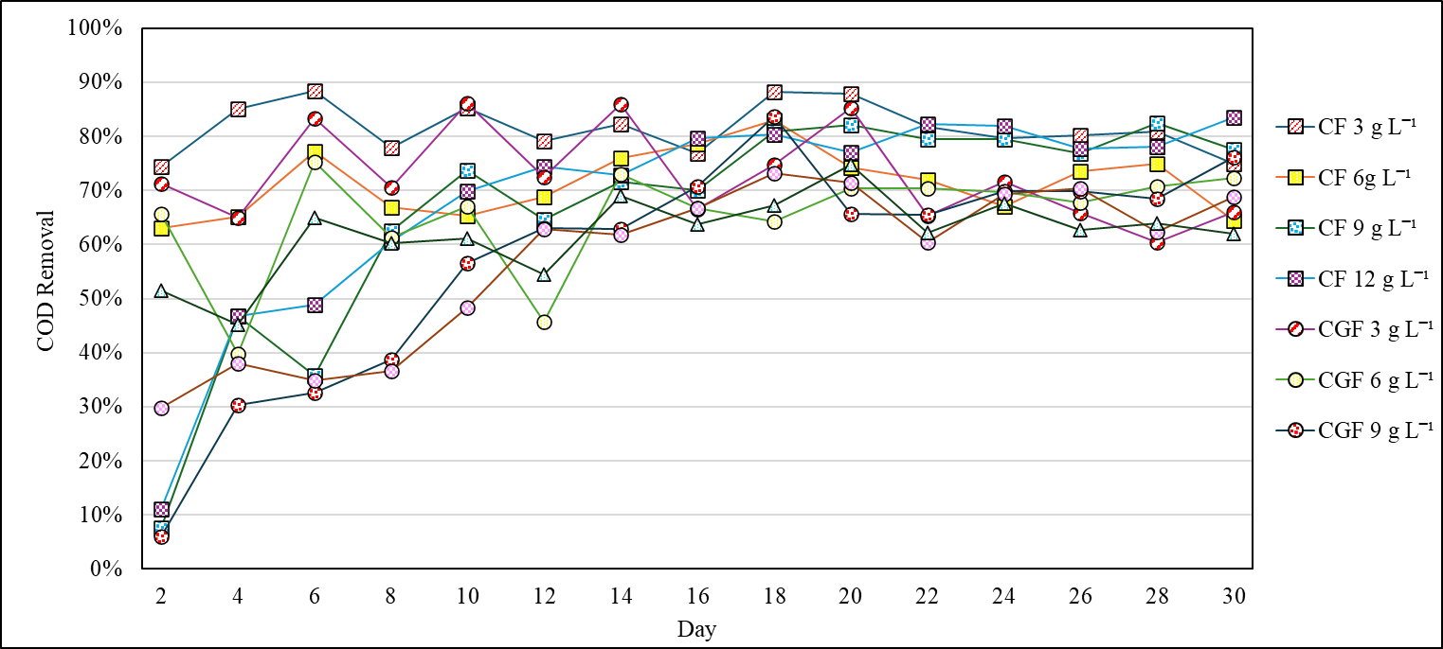
Fig. S4. Temporal Trends of COD Removal During Anaerobic Digestion of POME with Varying Carbon-Based Conductive Material Dosages
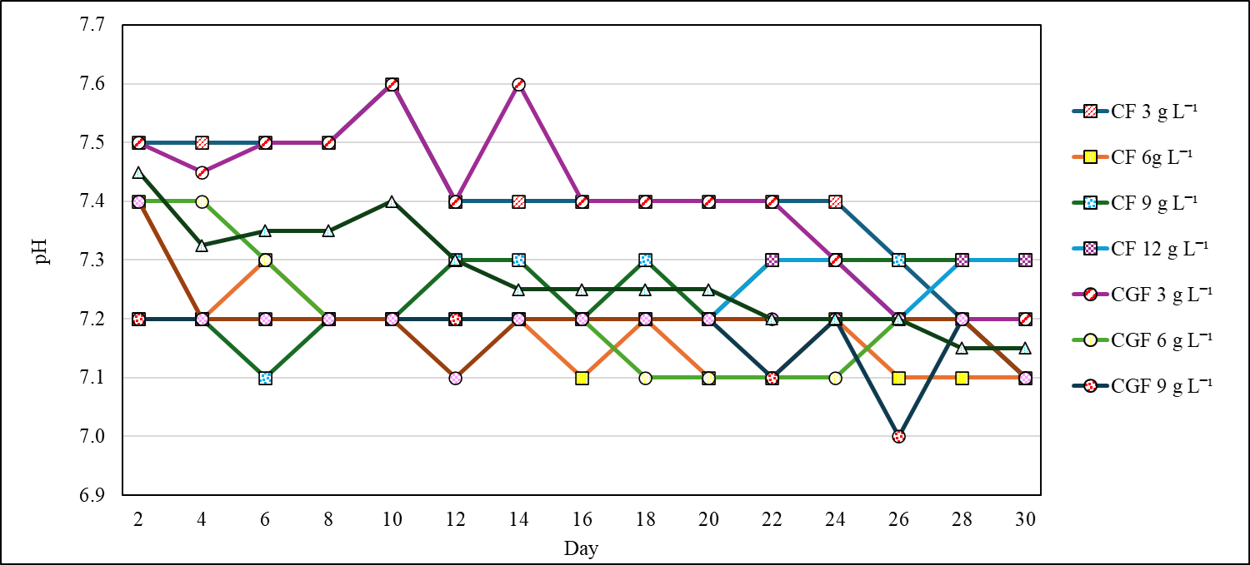
Fig. S5. Temporal Profile of pH Stability in Anaerobic Reactors Treated with Varying Dosages of Carbon Felt and Carbon Graphite Felt

