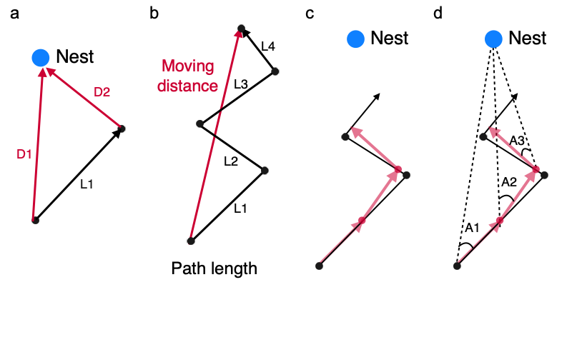

Fig S1. (a) Approach speed was calculated from a difference between D1 and D2. Instantaneous transport speed was calculated from L1. (b) “Moving distance” is the length between the star position and the end position during a period. “Path length” is the total path length traveled (L1 + L2 + L3 + L4) (c) A trajectory in a period (5 s) was resampled to a fixed step length (0.5 mm) (d) Angle error from the direction to the nest is median value of angle error at every resampled step (median value of A1, A2 and A3).

Fig S2. Approach and instantaneous transport speeds with different number of transporters. A plot represents median value of speed in a trial. red bars show the standard deviation and red rhombuses represents the mean value of median values of speed. (a, b) (Instantaneous) transport speed of different numbers of transporters. (c, d) (Instantaneous) approach speed of different numbers of transporters. (a, c) In colony A, the number of replicates was n = 2, 14, 15, 15, 14, 12, 9, 6, 5 and 2 for experiments with transporter numbers of 1, 2, 3, 4, 5, 6, 7, 8 and 9 respectively. (b, d) In colony B, the number of replicates was n = 7, 11, 15, 15, 15, 15, 15, 15, 12, 9, 6, 4, 2 and 2 for experiments with transporter numbers of 1, 2, 3, 4, 5, 6, 7, 8, 9,10,11,12,13 and 14 respectively.

Simulation
To investigate if reassessment could potentially improve the transport speed depending on the transporter number, we constructed a simple simulation, as follows: (i) A group of transporters consists of n normal ants and one reassessing ant. In each trial, a single reassessment was performed. (ii) We classified behavior of the transport into two phases: a releasing phase when a reassessing ant leaves away from the food; and a touching phase when a reassessing ant joins the transport (Fig. S3a). (iii) In the release phase, the approach speed is 1 mm/s and the transporter number is n. In touching phase, the approach speed is 3 mm/s and the transporter number is n + 1. We obtained two sets of data, in which the speed is 1 mm/s at n transporters and 3 mm/s at n + 1 transporters from each trial. (iv) n is a natural number that is generated by the floor function from a random number following a normal distribution with a mean of 4 and a standard deviation of 1:
$n= \left\lfloor N(μ=4,σ=1)\right\rfloor$+ 1,
where N ($μ,σ$) represents the normal distribution with mean of $μ$ and standard deviation of $σ$ (Fig. S3b). This simulation was performed by R 3.6.1.
Fig. S3c shows the result from 1000 trials. Although the rule that approach speed is dependent on the transporter number was not introduced, the mean value of the speed increased with the number of transporters. This result suggests that reassessment potentially improved the tendency that speed increased with an increase in the transporter number.
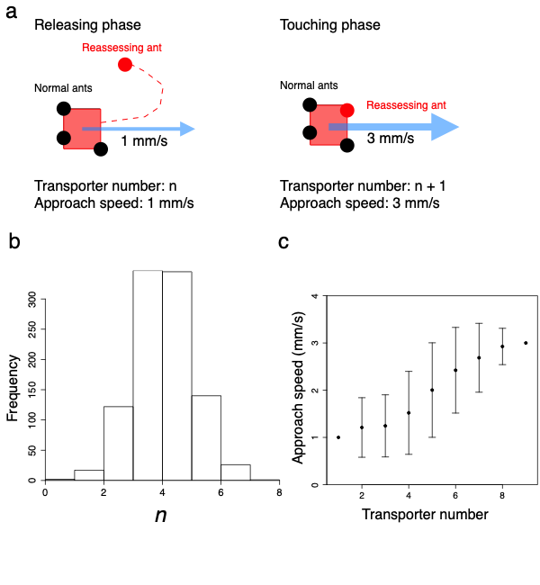

Fig. S3 (a) The two phases during transport. The pink square is a food item, black circles are normal ants, and the red circle is the reassessing ant. (b) Distribution of n at 1000 trials. (c) The approach speed of different numbers of transporters. Bars show the standard deviation and plots represent the mean value.

Fig S4. Approach and instantaneous transport speeds with different number of transporters. without reassessment ants. A plot represents median value of speed in a trial. Red bars show the standard deviation and red rhombuses represents the mean value of median values of speed. (a, b) Transport speed of different numbers of transporters. (c, d) approach speed of different numbers of transporters. (a, c) In colony A, the number of replicates was n = 14, 15, 15, 13, 12, 9, 4, 5 and 2 for experiments with transporter numbers of 1, 2, 3, 4, 5, 6, 7, 8 and 9 respectively. (b, d) In colony B, the number of replicates was n = 9, 12, 15, 15, 15, 15, 15, 14, 11, 8, 6, 4, 2 and 2 for experiments with transporter numbers of 1, 2, 3, 4, 5, 6, 7, 8, 9,10,11,12,13 and 14 respectively.

Movie S1 Representative reassessment behavior with a single pulling ant. A pulling ant repeats reassessments behaviors three times to bring the food item toward the nest. Blue line is a trajectory of a pulling ant.

Movie S2 rarely observed reassessment behavior with two pulling ants. Two pulling ants perform reassessments almost at the same time.

