Supplement

Title: The cost-effectiveness of interventions targeting lifestyle change for the prevention of diabetes in a Swedish primary care and community based prevention program

Journal name: The European Journal of Health Economics

Authors: Anne Neumann^{1,2}, Lars Lindholm¹, Margareta Norberg¹, Olaf Schoffer³, Stefanie J Klug³, Fredrik Norström¹
Affiliations:
¹ Epidemiology and Global Health, Department of Public Health and Clinical Medicine, Umeå University, SE-901 87, Umeå, Sweden
² Center of Evidence-Based Healthcare, University Hospital, Technische Universität Dresden, Fetscherstr. 74, 01307 Dresden, Germany
³ Cancer Epidemiology, University Cancer Center, University Hospital, Technische Universität Dresden, Fetscherstr. 74, 01307 Dresden, Germany

E-Mail address of corresponding author: Anne.Neumann@uniklinikum-dresden.de

Table S1: Sensitivity analysis: Cost, QALY and ICER, deterministic, when transition from type 2 diabetes to any pre-diabetic states was not possible
 | Male |  |  | Female
 | Cost | QALY | ICER | Cost | QALY | ICER
Age 30
No Intervention | 54 449 | 19.9 |  | 46 119 | 20.0
Intervention | 78 063 | 19.9 | 6 817 620 | 67 241 | 20.1 | 348 442
Age 50
No Intervention | 65 331 | 14.5 |  | 59 724 | 15.1
Intervention | 75 640 | 14.7 | 45 389 | 69 339 | 15.4 | 38 943
Age 70
No Intervention | 44 350 | 7.4 |  | 47 343 | 8.3
Intervention | 46 008 | 7.7 | 7 570 | 48 362 | 8.6 | 3 900

Table S2: Sensitivity analysis: Cost, QALY and ICER, deterministic, with 10% increase in cost in states
 | Male |  |  | Female
 | Cost | QALY | ICER | Cost | QALY | ICER
Age 30
No Intervention | 59 306 | 19.9 |  | 50 641 | 20.1
Intervention | 61 912 | 20.5 | 4 338 | 53 081 | 20.7 | 4 035
Age 50
No Intervention | 71 514 | 14.5 |  | 65 716 | 15.2
Intervention | 74 351 | 14.9 | 6 449 | 68 466 | 15.6 | 5 984
Age 70
No Intervention | 49 193 | 7.5 |  | 52 512 | 8.3
Intervention | 51 398 | 7.7 | 9 688 | 54 847 | 8.6 | 9 188

Table S3: Sensitivity analysis: Cost, QALY and ICER, deterministic, with 10% decrease in cost in states
 | Male |  |  | Female
 | Cost | QALY | ICER | Cost | QALY | ICER
Age 30
No Intervention | 48 523 | 19.9 |  | 41 434 | 20.1
Intervention | 50 854 | 20.5 | 3 881 | 43 629 | 20.7 | 3 631
Age 50
No Intervention | 58 512 | 14.5 |  | 53 768 | 15.2
Intervention | 61 030 | 14.9 | 5 726 | 56 216 | 15.6 | 5 328
Age 70
No Intervention | 40 249 | 7.5 |  | 42 965 | 8.3
Intervention | 42 239 | 7.7 | 8 742 | 45 066 | 8.6 | 8 268

Table S4: Sensitivity analysis: Cost, QALY and ICER, deterministic, with 10% increase in cost of intervention
 | Male |  |  | Female
 | Cost | QALY | ICER | Cost | QALY | ICER
Age 30
No Intervention | 53 915 | 19.9 |  | 46 037 | 20.1
Intervention | 56 492 | 20.5 | 4 292 | 48 464 | 20.7 | 4 014
Age 50
No Intervention | 65 013 | 14.5 |  | 59 742 | 15.2
Intervention | 67 799 | 14.9 | 6 335 | 62 450 | 15.6 | 5 893
Age 70
No Intervention | 44 721 | 7.5 |  | 47 739 | 8.3
Intervention | 46 921 | 7.7 | 9 664 | 50 061 | 8.6 | 9 141

Table S5: Sensitivity analysis: Cost, QALY and ICER, deterministic, with 10% decrease in cost of intervention
 | Male |  |  | Female
 | Cost | QALY | ICER | Cost | QALY | ICER
Age 30
No Intervention | 53 915 | 19.9 |  | 46 037 | 20.1
Intervention | 56 273 | 20.5 | 3 927 | 48 245 | 20.7 | 3 652
Age 50
No Intervention | 65 013 | 14.5 |  | 59 742 | 15.2
Intervention | 67 582 | 14.9 | 5 840 | 62 232 | 15.6 | 5 419
Age 70
No Intervention | 44 721 | 7.5 |  | 47 739 | 8.3
Intervention | 46 716 | 7.7 | 8 767 | 49 852 | 8.6 | 8 315

Table S6: Sensitivity analysis: Cost, QALY and ICER, deterministic, with assumed 14-year effectiveness
 | Male |  |  | Female
 | Cost | QALY | ICER | Cost | QALY | ICER
Age 30
No Intervention | 53 915 | 19.9 |  | 46 037 | 20.1
Intervention | 56 074 | 20.5 | 3 569 | 48 134 | 20.7 | 3 447
Age 50
No Intervention | 65 013 | 14.5 |  | 59 742 | 15.2
Intervention | 67 339 | 14.9 | 5 240 | 62 025 | 15.6 | 4 923
Age 70
No Intervention | 44 721 | 7.5 |  | 47 739 | 8.3
Intervention | 46 851 | 7.7 | 8 590 | 49 805 | 8.6 | 8 076

Table S7: Sensitivity analysis: Cost, QALY and ICER, deterministic, with 3.3% change in weight loss
 | Male |  |  | Female
 | Cost | QALY | ICER | Cost | QALY | ICER
Age 30
No Intervention | 53 915 | 19.9 |  | 46 037 | 20.1
Intervention | 56 427 | 20.5 | 4 189 | 48 393 | 20.7 | 3 901
Age 50
No Intervention | 65 013 | 14.5 |  | 59 742 | 15.2
Intervention | 67 740 | 14.9 | 6 215 | 62 386 | 15.6 | 5 767
Age 70
No Intervention | 44 721 | 7.5 |  | 47 739 | 8.3
Intervention | 46 851 | 7.7 | 9 387 | 49 990 | 8.6 | 8 884

Table S8: Sensitivity analysis: Cost, QALY and ICER, deterministic, with 3.3% change in weight loss only
 | Male |  |  | Female
 | Cost | QALY | ICER | Cost | QALY | ICER
Age 30
No Intervention | 53 915 | 19.9 |  | 46 037 | 20.1
Intervention | 56 542 | 20.5 | 4 392 | 48 440 | 20.7 | 3 985
Age 50
No Intervention | 65 013 | 14.5 |  | 59 742 | 15.2
Intervention | 67 959 | 14.9 | 6 744 | 62 539 | 15.6 | 6 127
Age 70
No Intervention | 44 721 | 7.5 |  | 47 739 | 8.3
Intervention | 47 027 | 7.7 | 10 230 | 50 160 | 8.6 | 9 621

Figure S1: Cost-effectiveness planes by age (younger (30), middle (50), older (70)) and sex (male, female), 1 000 simulations, when transition from type 2 diabetes to any pre-diabetic states was not possible
 | Male | Female
30 | 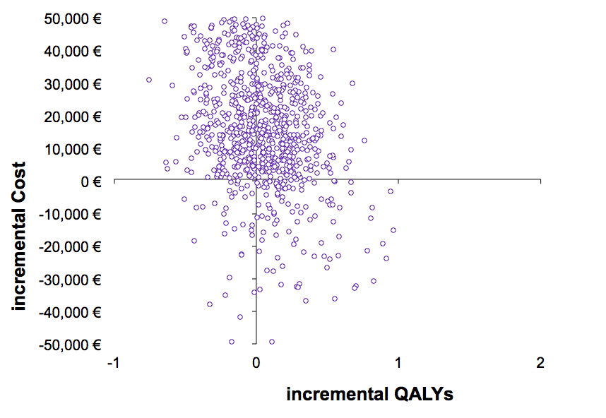 | 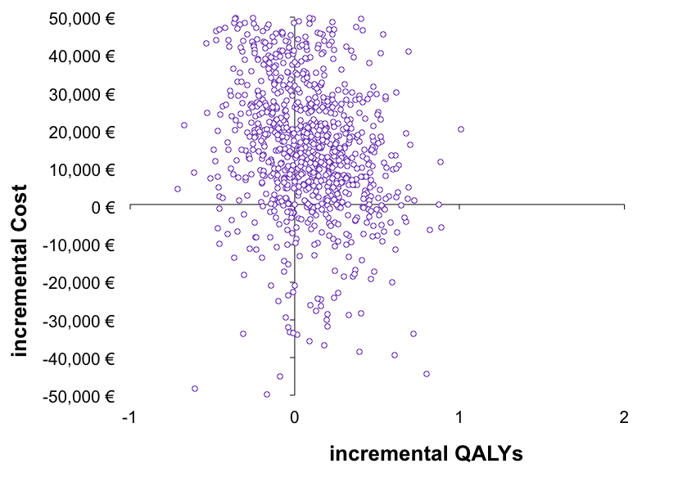
50 | 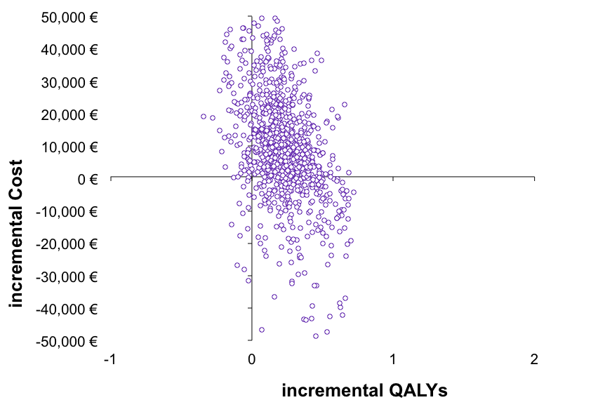 | 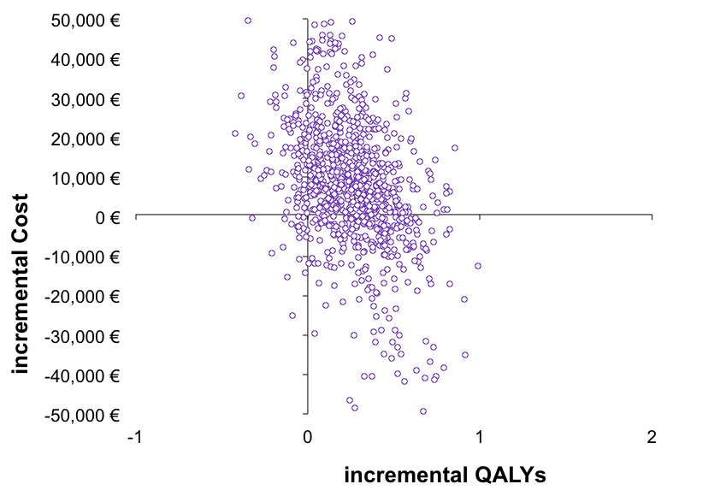
70 | 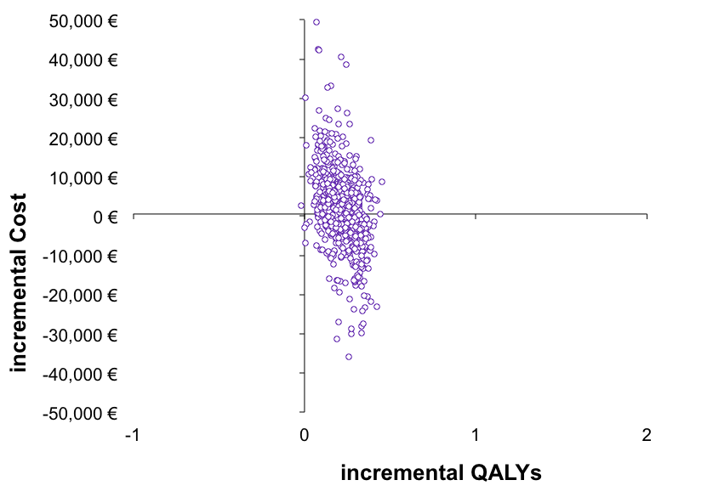 | 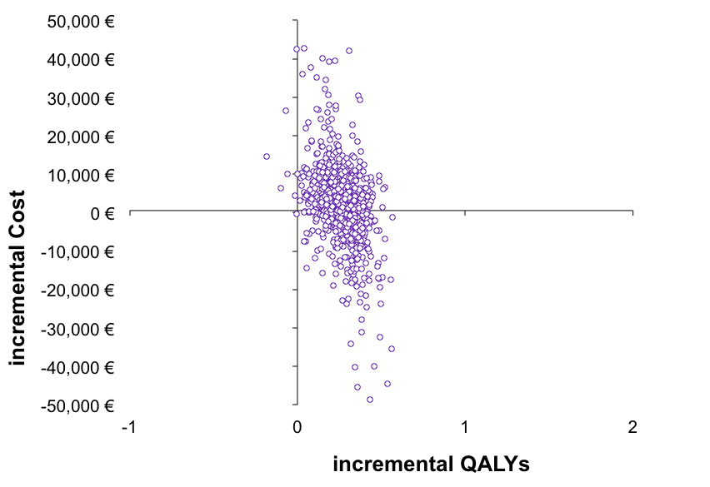

Figure S2: Cost-effectiveness acceptability curves by age (younger (30), middle (50), older (70)) and sex (male, female), 1 000 simulations, with 3.3% change in weight loss
 | Male | Female
30 | 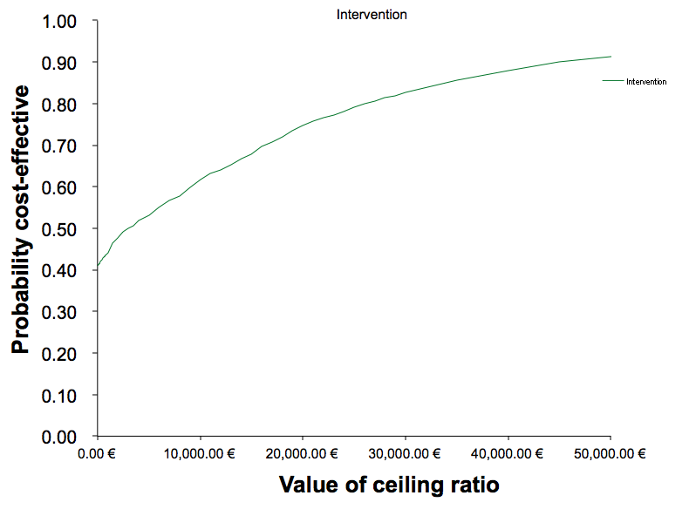 | 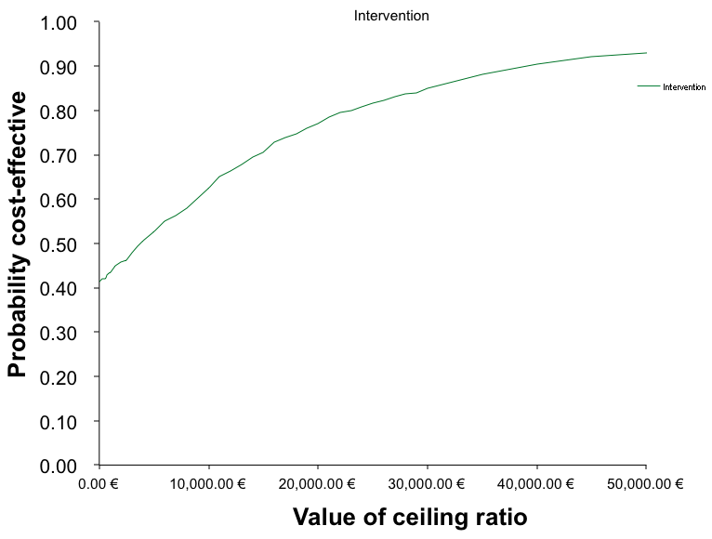
50 | 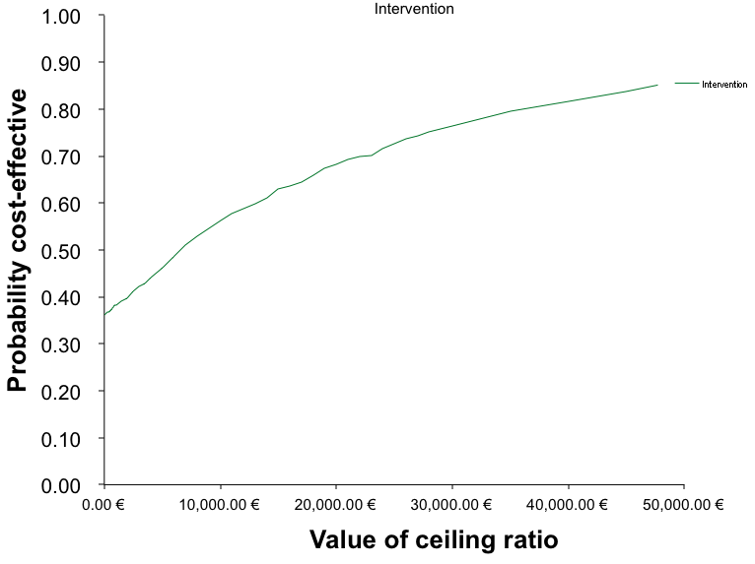 | 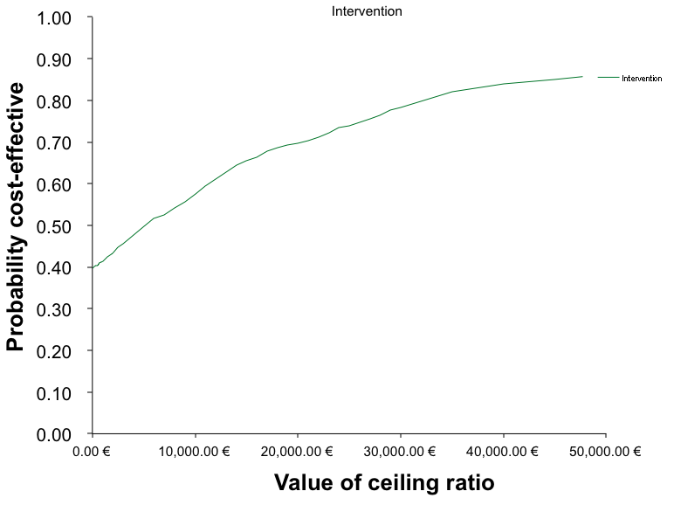
70 | 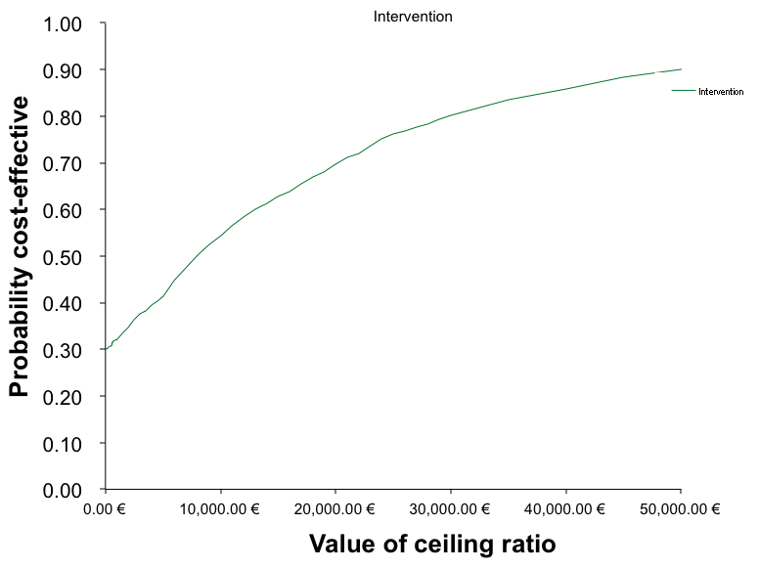 | 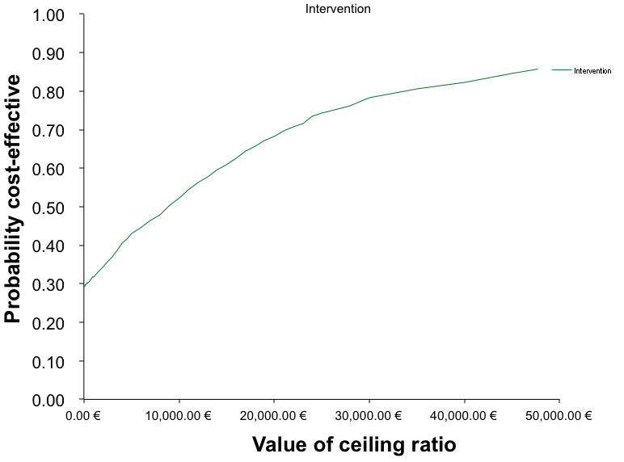

Figure S3: Cost-effectiveness acceptability curves by age (younger (30), middle (50), older (70)) and sex (male, female), 1 000 simulations, with 3.3% change in weight loss only
 | Male | Female
30 | 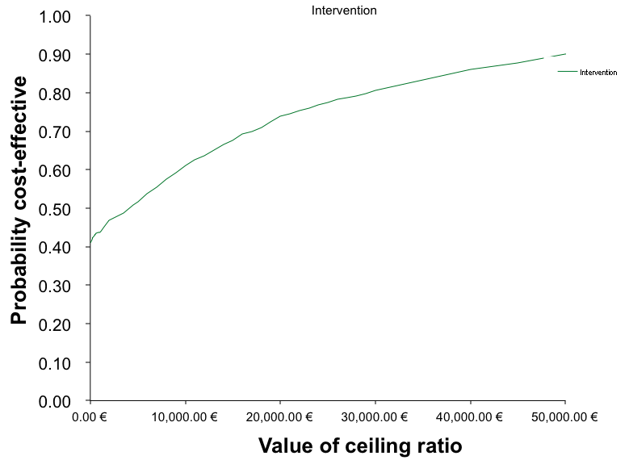 | 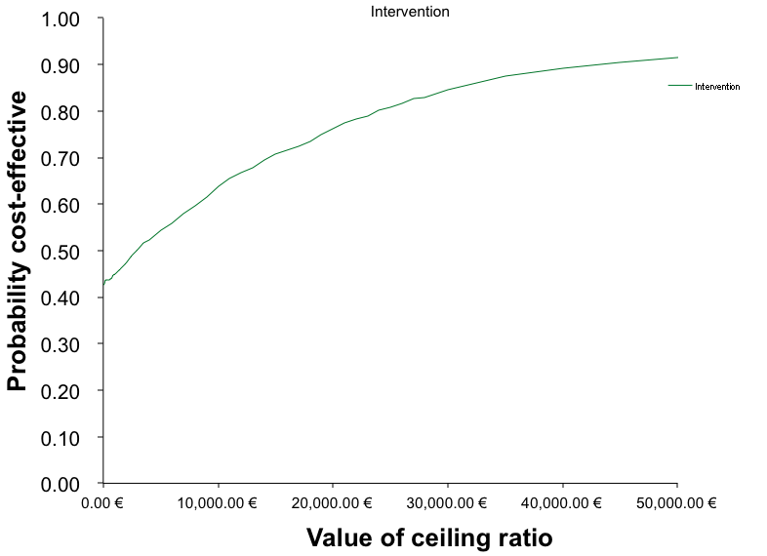
50 | 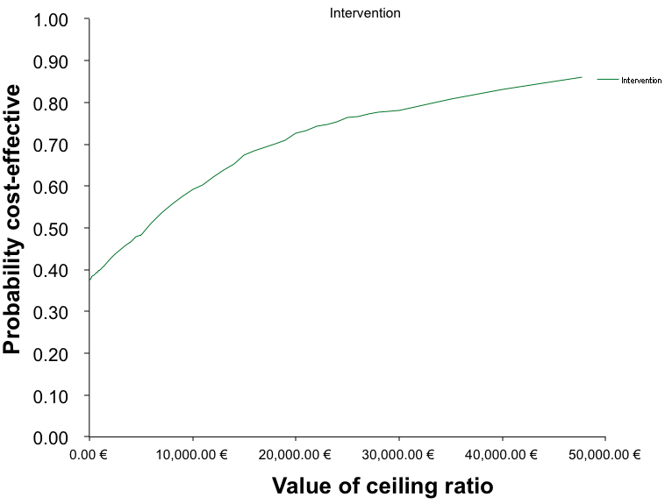 | 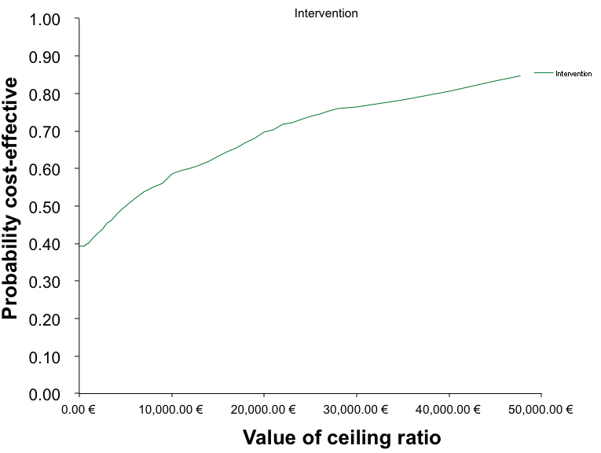
70 | 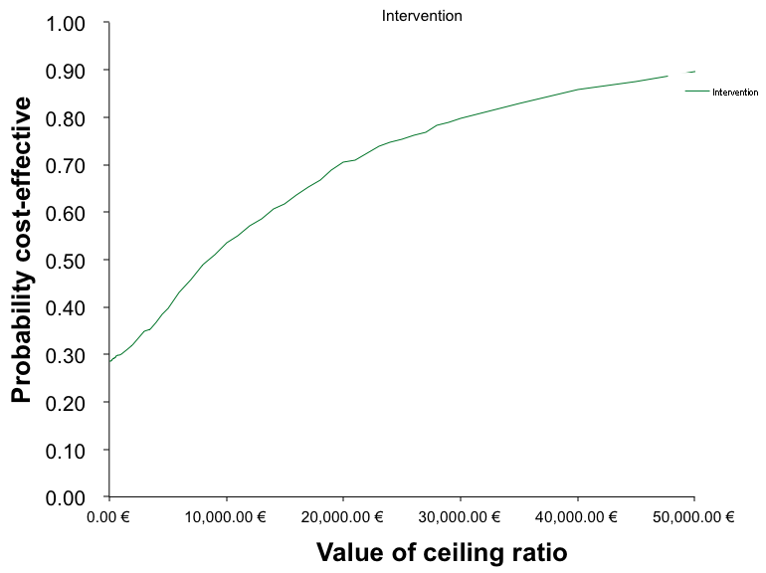 | 