Supplementary Appendix

The effects of patient cost-sharing on health expenditure and health among older people: Heterogeneity across income groups

A. Stop-loss 3
Table S1. Effects of the cost-sharing reduction on the utilization of outpatient care (full results of Table 3). 5
Table S2. Effects of the cost-sharing reduction on the utilization of inpatient care (full results of Table 4). 6
Table S3. Effects of the cost-sharing reduction on self-reported health (full results of Table 5). 7
Table S4. Effects of turning 70 years on health expenditure, among people not subjected to the cost-sharing reduction. 8
Table S5. Effect of turning 70 years on self-reported health, among people not subjected to the cost-sharing reduction. 9
Table S6. Effects of the cost-sharing reduction on the utilization of outpatient care, using a quadratic age trend. 10
Table S7. Effects of the cost-sharing reduction on the utilization of outpatient care, using one-year window. 11
Table S8. Effects of the cost-sharing reduction on the utilization of inpatient care, using a quadratic age trend. 12
Table S9. Effects of the cost-sharing reduction on the utilization of inpatient care, using one-year window. 13
Table S10. Effects of the cost-sharing reduction on self-reported health, using a quadratic age trend. 14
Table S11. Effects of the cost-sharing reduction on self-reported health, using one-year window. 15
Table S12. Effects of the cost-sharing reduction on the utilization of outpatient care, using local linear regression. 16
Table S13. Effects of the cost-sharing reduction on the utilization of inpatient care, using local linear regression. 17
Table S14. Effects of the cost-sharing reduction on self-reported health, using local linear regression. 18
Table S15. Effects of the cost-sharing reduction on the utilization of outpatient care, additionally adjusting for individual fixed effects. 19
Table S16. Effects of the cost-sharing reduction on the utilization of inpatient care, additionally adjusting for individual fixed effects. 20
Table S17. Effects of the cost-sharing reduction on self-reported health, additionally adjusting for individual characteristics. 21
Table S18. Effects of the cost-sharing reduction on the utilization of outpatient care, using data for 2012. 22
Table S19. Effects of the cost-sharing reduction on the utilization of inpatient care, using data for 2012. 23
Table S20. Effects of the cost-sharing reduction on the utilization of outpatient care, using a generalized linear model. 24
Table S21. Effects of the cost-sharing reduction on the utilization of inpatient care, using a generalized linear model. 25
Table S22. Effects of the cost-sharing reduction on the utilization of outpatient care, including two months of data before and after individuals turn 70 years. 26
Table S23. Effects of the cost-sharing reduction on the utilization of inpatient care, including two months of data before and after individuals turn 70 years. 27
Table S24. Effects of the cost-sharing reduction on the utilization of outpatient care, excluding four months of data before and after individuals turn 70 years. 28
Table S25. Effects of the cost-sharing reduction on the utilization of inpatient care, excluding four months of data before and after individuals turn 70 years. 29
Table S26. Effect of turning 70 years on income. 30
Figure S1. Distribution of outpatient expenditure. 31
Figure S2. Distribution of inpatient expenditure. 32
Figure S3. Proportions of lower-income or higher-income individuals by age. 33
References 34

A. Stop-loss
There is a stop-loss in Japanese public health insurance system, to protect patients against catastrophic health expenditure; when the monthly out-of-pocket payment exceeds a threshold value, cost-sharing is reduced, as described in Table 1. This stop-loss may pose a challenge for calculating demand elasticity if patients are forward-looking and know with certainty that their out-of-pocket payment is likely to exceed the threshold. However, the effect of the stop-loss on overutilization would be much smaller in our case, for the following two reasons as well-discussed in Fukushima et al. (2016) and Shigeoka (2014) [1, 2]. First, very few patients exceeded the threshold. For example, only 1.3% of enrollee-months exceeded the threshold value in our data for those aged 69 years. Second, the stop-loss is set monthly in Japan, unlike in the U.S., where the stop-loss is set annually. This shorter interval may make it more difficult for patients to overuse healthcare. In addition, evidence suggests that even under an annual stop-loss, people myopically responded to the stop-loss [3].
Nonetheless, to take the stop-loss into account, we calculated the average cost-sharing percentages before and after 70 years. First, we used our data of individuals aged 69 and calculated the actual cost-sharing percentage for each individual at age 69, based on the rules in Table 1. Next, we computed the hypothetical cost-sharing percentages for those above age 70, using the same data on those aged 69 years, under the assumption that they were subjected to the cost-sharing rule above age 70. We then took the average cost-sharing percentages. From the above calculation, the average cost-sharing percentages before and after 70 years were 29.3% and 9.8% for the overall sample; 28.6% and 9.6% for lower-income individuals; 29.6% and 9.9% for middle-income individuals; and 29.5% and 9.8% for higher-income individuals, respectively. These figures were close to 30% and 10%, respectively (the coinsurance rates without the stop-loss). This is not surprising because few patients qualified for the stop-loss. We used these calculated figures when estimating the price elasticity.

Table S1. Effects of the cost-sharing reduction on the utilization of outpatient care (full results of Table 3).
 | 1 | 2 | 3 | 4
 | Overall sample | Lower income | Middle income | Higher income
Age70 | 947.4** | -21.4 | 1020.8** | 1466.3**
 | (268.3) | (769.2) | (370.8) | (370.3)
Age | 55.4** | 34.9 | 52.7** | 69.7**
 | (14.8) | (44.0) | (20.4) | (19.6)
Age*Age70 | 73.1** | 118.7* | 76.0* | 43.8
 | (22.1) | (57.8) | (33.5) | (31.3)
Gender | -3148.9** | -4079.3** | -2457.2* | -2801.9**
(Reference: Male) | (410.2) | (889.9) | (1036.2) | (414.7)
Income
Category 3 | Reference | Reference
Category 4 | 2033.6** | 1645.3*
 | (714.8) | (824.0)
Category 5 | -735.9 |  | Reference
 | (511.3)
Category 6 | -319.0 |  | 494.7
 | (614.0) |  | (504.7)
Category 7 | -2464.9** |  |  | Reference
 | (614.0)
Category 8 | -2040.0** |  |  | 481.3
 | (702.8) |  |  | (422.4)
Include year-month fixed effects | Yes | Yes | Yes | Yes
Constant | 20405.1** | 20959.7** | 19378.7** | 17576.6**
 | (748.4) | (1401.8) | (1098.3) | (442.3)
Note: Column 1 presents the full results from the RD regression for the overall sample. Columns 2-4 present the results for lower-, middle-, and higher-income individuals, respectively. Robust standard errors corrected for clustering at the individual level are in parentheses. **: 1%, *: 5%.

Table S2. Effects of the cost-sharing reduction on the utilization of inpatient care (full results of Table 4).
 | 1 | 2 | 3 | 4
 | Overall sample | Lower income | Middle income | Higher income
Age70 | 505.0 | 1809.4 | 648.0 | -433.0
 | (638.1) | (1479.3) | (898.8) | (1071.3)
Age | 37.1 | -13.7 | 23.4 | 83.4
 | (31.6) | (73.3) | (44.6) | (53.5)
Age*Age70 | 5.0 | 30.3 | 29.2 | -34.2
 | (48.0) | (112.6) | (68.4) | (79.2)
Gender | -10160.0** | -12652.8** | -10696.6** | -8200.0**
(Reference: Male) | (554.3) | (1135.7) | (1444.2) | (610.8)
Income
Category 3 | Reference | Reference
Category 4 | 1242.1 | 156.0
 | (1005.4) | (1055.6)
Category 5 | -2288.5** |  | Reference
 | (705.4)
Category 6 | -2489.2** |  | -257.9
 | (745.5) |  | (551.1)
Category 7 | -5798.3** |  |  | Reference
 | (782.1)
Category 8 | -6976.5** |  |  | -868.2
 | (914.8) |  |  | (679.2)
Include year-month fixed effects | Yes | Yes | Yes | Yes
Constant | 17905.9** | 18047.0** | 16824.0** | 12001.0**
 | (1013.1) | (1926.1) | (1717.0) | (1146.0)
Note: Column 1 presents the full results from the RD regression for the overall sample. Columns 2-4 present the results for lower-, middle-, and higher-income individuals, respectively. Robust standard errors corrected for clustering at the individual level are in parentheses. **: 1%, *: 5%.

Table S3. Effects of the cost-sharing reduction on self-reported health (full results of Table 5).
 | 1 | 2 | 3 | 4
 | Overall sample | Lower income | Middle income | Higher income
Age70 | 4.8* | 11.6* | 4.8 | 1.3
 | (2.3) | (5.0) | (3.5) | (3.9)
Age | -0.2* | -0.4 | -0.2 | -0.2
 | (0.1) | (0.3) | (0.2) | (0.2)
Age*Age70 | 0.2 | 0.2 | 0.1 | 0.3
 | (0.2) | (0.3) | (0.3) | (0.3)
Gender | 8.4** | 11.9** | 8.7* | 6.4**
(Reference: Male) | (1.8) | (3.8) | (3.9) | (2.2)
Income
Category 3 | Reference | Reference
Category 4 | -0.9 | 0.5
 | (3.1) | (3.6)
Category 5 | -1.0 |  | Reference
 | (2.4)
Category 6 | 1.7 |  | 2.7
 | (2.4) |  | (2.0)
Category 7 | 1.9 |  |  | Reference
 | (2.6)
Category 8 | 7.1* |  |  | 5.0*
 | (2.8) |  |  | (2.1)
Survey year | -1.6 | 0.3 | -2.0 | -2.4
(Reference: 2011) | (1.1) | (2.4) | (1.7) | (1.8)
Constant | 76.3** | 69.1** | 75.9** | 80.7
 | (3.0) | (5.1) | (4.8) | (3.1)
Note: Column 1 presents the full results from the RD regression for the overall sample. Columns 2-4 present the results for lower-, middle-, and higher-income individuals, respectively. Robust standard errors corrected for clustering at the individual level are in parentheses. **: 1%, *: 5%.

Table S4. Effects of turning 70 years on health expenditure, among people not subjected to the cost-sharing reduction.
 | Coef.
Outpatient expenditure, JPY | 41.7
 | (755.9)
Inpatient expenditure, JPY | -2518.8
 | (2156.9)
Note: To save space, this table only reports the estimated coefficients for the RD dummy variables (1=age 70 and above, 0=otherwise). Robust standard errors corrected for clustering at the individual level are in parentheses. **: 1%, *: 5%.

Table S5. Effect of turning 70 years on self-reported health, among people not subjected to the cost-sharing reduction.
 | Coef.
Self-reported health, % | 3.7
 | (5.8)
Note: To save space, this table only reports the estimated coefficients for the RD dummy variables (1=age 70 and above, 0=otherwise). Robust standard errors corrected for clustering at the individual level are in parentheses. **: 1%, *: 5%.

Table S6. Effects of the cost-sharing reduction on the utilization of outpatient care, using a quadratic age trend.
 | Cost-sharing effect, JPY | Mean health expenditure at age 69, JPY | Difference in health expenditure, % | Elasticity
Panel A: Overall sample | 1612.3** | 19,719 | 8.2 | -0.12
 | (274.5)
Panel B: Lower income | 536.7 | 22,049 | 2.4 | -0.04
 | (632.2)
Panel C: Middle income | 1201.1** | 18,899 | 6.4 | -0.10
 | (425.7)
Panel D: Higher income | 2665.9** | 19,155 | 13.9 | -0.21
 | (427.9)
Note: To save space, this table only reports the estimated coefficients for the RD dummy variables (1=age 70 and above, 0=otherwise). Robust standard errors corrected for clustering at the individual level are in parentheses. **: 1%, *: 5%.

Table S7. Effects of the cost-sharing reduction on the utilization of outpatient care, using one-year window.
 | Cost-sharing effect, JPY | Mean health expenditure at age 69, JPY | Difference in health expenditure, % | Elasticity
Panel A: Overall sample | 1708.2** | 19,719 | 8.7 | -0.13
 | (240.0)
Panel B: Lower income | 872.9 | 22,049 | 4.0 | -0.06
 | (539.3)
Panel C: Middle income | 1285.0** | 18,899 | 6.8 | -0.10
 | (374.8)
Panel D: Higher income | 2634.6** | 19,155 | 13.8 | -0.21
 | (379.4)
Note: To save space, this table only reports the estimated coefficients for the RD dummy variables (1=age 70 and above, 0=otherwise). Robust standard errors corrected for clustering at the individual level are in parentheses. **: 1%, *: 5%.

Table S8. Effects of the cost-sharing reduction on the utilization of inpatient care, using a quadratic age trend.
 | Cost-sharing effect, JPY | Mean health expenditure at age 69, JPY | Difference in health expenditure, % | Elasticity
Panel A: Overall sample | 2047.2* | 11,646 | 17.6 | -0.26
 | (945.5)
Panel B: Lower income | 3727.3 | 14,903 | 25.0 | -0.38
 | (2117.2)
Panel C: Middle income | 2562.7 | 8,824 | 29.0 | -0.44
 | (1334.8)
Panel D: Higher income | 577.5 | 12,535 | 4.6 | -0.07
 | (1622.9)
Note: To save space, this table only reports the estimated coefficients for the RD dummy variables (1=age 70 and above, 0=otherwise). Robust standard errors corrected for clustering at the individual level are in parentheses. **: 1%, *: 5%.

Table S9. Effects of the cost-sharing reduction on the utilization of inpatient care, using one-year window.
 | Cost-sharing effect, JPY | Mean health expenditure at age 69, JPY | Difference in health expenditure, % | Elasticity
Panel A: Overall sample | 2592.1** | 11,646 | 22.3 | -0.33
 | (864.5)
Panel B: Lower income | 4535.5* | 14,903 | 30.4 | -0.46
 | (1909.1)
Panel C: Middle income | 2635.8* | 8,824 | 29.9 | -0.45
 | (1206.7)
Panel D: Higher income | 1400.0 | 12,535 | 11.2 | -0.17
 | (1507.9)
Note: To save space, this table only reports the estimated coefficients for the RD dummy variables (1=age 70 and above, 0=otherwise). Robust standard errors corrected for clustering at the individual level are in parentheses. **: 1%, *: 5%.

Table S10. Effects of the cost-sharing reduction on self-reported health, using a quadratic age trend.
 | Cost-sharing effect, % | Mean at age 69, % | Difference in health, %
Panel A: Overall sample | 4.4 | 82.3 | 5.3
 | (3.4)
Panel B: Lower income | 18.1** | 78.1 | 23.2
 | (6.7)
Panel C: Middle income | 2.3 | 84.0 | 2.7
 | (5.3)
Panel D: Higher income | -1.3 | 82.7 | -1.6
 | (5.6)
Note: To save space, this table only reports the estimated coefficients for the RD dummy variables (1=age 70 and above, 0=otherwise). Robust standard errors corrected for clustering at the individual level are in parentheses. **: 1%, *: 5%.

Table S11. Effects of the cost-sharing reduction on self-reported health, using one-year window.
 | Cost-sharing effect, % | Mean at age 69, % | Difference in health, %
Panel A: Overall sample | 4.5 | 82.3 | 4.0
 | (3.2)
Panel B: Lower income | 20.2** | 78.1 | 19.2
 | (6.3)
Panel C: Middle income | 0.8 | 84.0 | 1.8
 | (4.8)
Panel D: Higher income | -0.5 | 82.7 | -1.8
 | (5.4)
Note: To save space, this table only reports the estimated coefficients for the RD dummy variables (1=age 70 and above, 0=otherwise). Robust standard errors corrected for clustering at the individual level are in parentheses. **: 1%, *: 5%.

Table S12. Effects of the cost-sharing reduction on the utilization of outpatient care, using local linear regression.
 | Cost-sharing effect, JPY | Mean health expenditure at age 69, JPY | Difference in health expenditure, % | Elasticity
Panel A: Overall sample | 2765.7** | 19,719 | 14.0 | -0.21
 | (482.5)
Panel B: Lower income | 2155.9 | 22,049 | 9.8 | -0.15
 | (1249.7)
Panel C: Middle income | 2259.5** | 18,899 | 12.0 | -0.18
 | (626.6)
Panel D: Higher income | 3281.3** | 19,155 | 17.1 | -0.26
 | (662.8)
Note: To save space, this table only reports the estimated coefficients for the RD dummy variables (1=age 70 and above, 0=otherwise). We used a local linear RD estimation with a triangular kernel. We used a data-driven approach to choose a bandwidth, which yielded an optimal bandwidth of 7.8, 10.0, 8.8, and 9.7 months for overall sample, lower-income individuals, middle-income individuals, and higher-income individuals, respectively. Robust standard errors corrected for clustering at the individual level are in parentheses. **: 1%, *: 5%.

Table S13. Effects of the cost-sharing reduction on the utilization of inpatient care, using local linear regression.
 | Cost-sharing effect, JPY | Mean health expenditure at age 69, JPY | Difference in health expenditure, % | Elasticity
Panel A: Overall sample | 3357.1* | 11,646 | 28.8 | -0.43
 | (1485.8)
Panel B: Lower income | 5474.5 | 14,903 | 36.7 | -0.55
 | (3216.5)
Panel C: Middle income | 2629.5 | 8,824 | 29.8 | -0.45
 | (2035.1)
Panel D: Higher income | 2984.5 | 12,535 | 23.8 | -0.36
 | (2543.0)
Note: To save space, this table only reports the estimated coefficients for the RD dummy variables (1=age 70 and above, 0=otherwise). We used a local linear RD estimation with a triangular kernel. We used a data-driven approach to choose a bandwidth, which yielded an optimal bandwidth of 8.6, 9.0, 9.3, and 8.5 months for overall sample, lower-income individuals, middle-income individuals, and higher-income individuals, respectively. Robust standard errors corrected for clustering at the individual level are in parentheses. **: 1%, *: 5%.

Table S14. Effects of the cost-sharing reduction on self-reported health, using local linear regression.
 | Cost-sharing effect, % | Mean at age 69, % | Difference in health, %
Panel A: Overall sample | -1.7 | 82.3 | -2.1
 | (4.0)
Panel B: Lower income | 14.3 | 78.1 | 18.3
 | (8.2)
Panel C: Middle income | -2.6 | 84.0 | -3.1
 | (8.0)
Panel D: Higher income | -6.2 | 82.7 | -7.5
 | (7.8)
Note: To save space, this table only reports the estimated coefficients for the RD dummy variables (1=age 70 and above, 0=otherwise). We used a local linear RD estimation with a triangular kernel. We used a data-driven approach to choose a bandwidth, which yielded an optimal bandwidth of 8.6, 9.9, 8.9, and 9.0 months for overall sample, lower-income individuals, middle-income individuals, and higher-income individuals, respectively. Robust standard errors corrected for clustering at the individual level are in parentheses. **: 1%, *: 5%.

Table S15. Effects of the cost-sharing reduction on the utilization of outpatient care, additionally adjusting for individual fixed effects.
 | Cost-sharing effect, JPY | Mean health expenditure at age 69, JPY | Difference in health expenditure, % | Elasticity
Panel A: Overall sample | 1256.2** | 19,719 | 6.4 | -0.10
 | (223.1)
Panel B: Lower income | 829.2 | 22,049 | 3.8 | -0.06
 | (587.0)
Panel C: Middle income | 1162.6** | 18,899 | 6.2 | -0.09
 | (315.7)
Panel D: Higher income | 1608.7** | 19,155 | 8.4 | -0.13
 | (337.3)
Note: To save space, this table only reports the estimated coefficients for the RD dummy variables (1=age 70 and above, 0=otherwise). Robust standard errors corrected for clustering at the individual level are in parentheses. **: 1%, *: 5%.

Table S16. Effects of the cost-sharing reduction on the utilization of inpatient care, additionally adjusting for individual fixed effects.
 | Cost-sharing effect, JPY | Mean health expenditure at age 69, JPY | Difference in health expenditure, % | Elasticity
Panel A: Overall sample | 158.7 | 11,646 | 1.4 | -0.02
 | (663.5)
Panel B: Lower income | 1681.6 | 14,903 | 11.3 | -0.17
 | (1508.4)
Panel C: Middle income | -45.0 | 8,824 | -0.5 | 0.01
 | (954.3)
Panel D: Higher income | -572.6 | 12,535 | -4.6 | 0.07
 | (1112.9)
Note: To save space, this table only reports the estimated coefficients for the RD dummy variables (1=age 70 and above, 0=otherwise). Robust standard errors corrected for clustering at the individual level are in parentheses. **: 1%, *: 5%.

Table S17. Effects of the cost-sharing reduction on self-reported health, additionally adjusting for individual characteristics.
 | Cost-sharing effect, % | Mean at age 69, % | Difference in health, %
Panel A: Overall sample | 6.0* | 82.3 | 7.3
 | (2.5)
Panel B: Lower income | 13.9* | 78.1 | 17.8
 | (5.5)
Panel C: Middle income | 7.2 | 84.0 | 8.6
 | (3.8)
Panel D: Higher income | 2.8 | 82.7 | 3.4
 | (4.1)
Note: To save space, this table only reports the estimated coefficients for the RD dummy variables (1=age 70 and above, 0=otherwise). Robust standard errors corrected for clustering at the individual level are in parentheses. For this analysis, we additionally adjusted for individual characteristics, including education (<6 years, 6-9 years, 10-12 years, ≥13 years, others), family structure (marital status [married, widowed, divorced, unmarried, others] and fixed effects for the number of household members), and occupation (working status [currently working, retired, no work experience] and size of the company individuals worked for the longest [<10 workers, 10-49 workers, 50-499 workers, 500-9999 workers, ≥10000 workers, not sure, no work experience]). However, due to missing data on the individual characteristics, we excluded 529, 124, 267, and 138 observations for the overall, lower-, middle-, and higher-income individuals, respectively. **: 1%, *: 5%.

Table S18. Effects of the cost-sharing reduction on the utilization of outpatient care, using data for 2012.
 | Cost-sharing effect, JPY | Mean health expenditure at age 69, JPY | Difference in health expenditure, % | Elasticity
Panel A: Overall sample | 1532.5** | 19,719 | 7.8 | -0.12
 | (451.0)
Panel B: Lower income | 1130.8 | 22,049 | 5.1 | -0.08
 | (1043.4)
Panel C: Middle income | 1328.4* | 18,899 | 7.0 | -0.11
 | (667.3588)
Panel D: Higher income | 1981.1** | 19,155 | 10.3 | -0.16
 | (730.4)
Note: To save space, this table only reports the estimated coefficients for the RD dummy variables (1=age 70 and above, 0=otherwise). Robust standard errors corrected for clustering at the individual level are in parentheses. **: 1%, *: 5%.

Table S19. Effects of the cost-sharing reduction on the utilization of inpatient care, using data for 2012.
 | Cost-sharing effect, JPY | Mean health expenditure at age 69, JPY | Difference in health expenditure, % | Elasticity
Panel A: Overall sample | 540.2 | 11,646 | 4.6 | -0.07
 | (1031.0)
Panel B: Lower income | 2709.4 | 14,903 | 18.2 | -0.27
 | (2530.3)
Panel C: Middle income | -375.2 | 8,824 | -4.3 | 0.06
 | (1446.5)
Panel D: Higher income | 70.6 | 12,535 | 0.6 | -0.01
 | (1649.9)
Note: To save space, this table only reports the estimated coefficients for the RD dummy variables (1=age 70 and above, 0=otherwise). Robust standard errors corrected for clustering at the individual level are in parentheses. **: 1%, *: 5%.

Table S20. Effects of the cost-sharing reduction on the utilization of outpatient care, using a generalized linear model.
 | Coef. | Marginal effect, JPY | Mean health expenditure at age 69, JPY | Elasticity
Panel A: Overall sample | 0.053** | 1087.9** | 19,719 | -0.08
 | (0.012) | (251.3)
Panel B: Lower income | 0.011 | 250.3 | 22,049 | -0.02
 | (0.031) | (692.8)
Panel C: Middle income | 0.057** | 1125.7** | 18,899 | -0.09
 | (0.018) | (360.5)
Panel D: Higher income | 0.074** | 1498.7** | 19,155 | -0.12
 | (0.018) | (363.0)
Note: To save space, this table only reports the estimated coefficients for the RD dummy variables (1=age 70 and above, 0=otherwise). We used a generalized linear model (GLM) with a log link and gamma distribution. Robust standard errors corrected for clustering at the individual level are in parentheses. **: 1%, *: 5%.

Table S21. Effects of the cost-sharing reduction on the utilization of inpatient care, using a generalized linear model.
 | Coef. | Marginal effect, JPY | Mean health expenditure at age 69, JPY | Elasticity
Panel A: Overall sample | 0.066 | 799.2 | 11,646 | -0.10
 | (0.056) | (675.8)
Panel B: Lower income | 0.161 | 2535.6 | 14,903 | -0.26
 | (0.100) | (1568.0)
Panel C: Middle income | 0.081 | 758.4 | 8,824 | -0.13
 | (0.098) | (910.4)
Panel D: Higher income | 0.010 | 126.7 | 12,535 | -0.02
 | (0.087) | (1114.9)
Note: To save space, this table only reports the estimated coefficients for the RD dummy variables (1=age 70 and above, 0=otherwise). We used a generalized linear model (GLM) with a log link and gamma distribution. Robust standard errors corrected for clustering at the individual level are in parentheses. **: 1%, *: 5%.

Table S22. Effects of the cost-sharing reduction on the utilization of outpatient care, including two months of data before and after individuals turn 70 years.
 | Cost-sharing effect, JPY | Mean health expenditure at age 69, JPY | Difference in health expenditure, % | Elasticity
Panel A: Overall sample | 1528.2** | 19,719 | 7.7 | -0.12
 | (234.4)
Panel B: Lower income | 849.2 | 22,049 | 3.9 | -0.06
 | (658.7)
Panel C: Middle income | 1493.1** | 18,899 | 7.9 | -0.12
 | (332.0)
Panel D: Higher income | 1978.6** | 19,155 | 10.3 | -0.16
 | (325.2)
Note: To save space, this table only reports the estimated coefficients for the RD dummy variables (1=age 70 and above, 0=otherwise). Robust standard errors corrected for clustering at the individual level are in parentheses. **: 1%, *: 5%.

Table S23. Effects of the cost-sharing reduction on the utilization of inpatient care, including two months of data before and after individuals turn 70 years.
 | Cost-sharing effect, JPY | Mean health expenditure at age 69, JPY | Difference in health expenditure, % | Elasticity
Panel A: Overall sample | 585.0 | 11,646 | 5.0 | -0.08
 | (571.1)
Panel B: Lower income | 1360.0 | 14,903 | 9.1 | -0.14
 | (1341.7)
Panel C: Middle income | 810.8 | 8,824 | 9.2 | -0.14
 | (809.6)
Panel D: Higher income | -106.3 | 12,535 | -0.8 | 0.01
 | (946.1)
Note: To save space, this table only reports the estimated coefficients for the RD dummy variables (1=age 70 and above, 0=otherwise). Robust standard errors corrected for clustering at the individual level are in parentheses. **: 1%, *: 5%.

Table S24. Effects of the cost-sharing reduction on the utilization of outpatient care, excluding four months of data before and after individuals turn 70 years.
 | Cost-sharing effect, JPY | Mean health expenditure at age 69, JPY | Difference in health expenditure, % | Elasticity
Panel A: Overall sample | 703.2* | 19,719 | 3.6 | -0.05
 | (305.1)
Panel B: Lower income | -379.6 | 22,049 | -1.7 | 0.03
 | (890.7)
Panel C: Middle income | 825.6* | 18,899 | 4.4 | -0.07
 | (415.2)
Panel D: Higher income | 1248.8** | 19,155 | 6.5 | -0.10
 | (414.9)
Note: To save space, this table only reports the estimated coefficients for the RD dummy variables (1=age 70 and above, 0=otherwise). Robust standard errors corrected for clustering at the individual level are in parentheses. **: 1%, *: 5%.

Table S25. Effects of the cost-sharing reduction on the utilization of inpatient care, excluding four months of data before and after individuals turn 70 years.
 | Cost-sharing effect, JPY | Mean health expenditure at age 69, JPY | Difference in health expenditure, % | Elasticity
Panel A: Overall sample | 145.2 | 11,646 | 1.2 | -0.02
 | (705.0)
Panel B: Lower income | 1397.5 | 14,903 | 9.4 | -0.14
 | (1651.3)
Panel C: Middle income | 436.7 | 8,824 | 4.9 | -0.07
 | (988.3)
Panel D: Higher income | -923.4 | 12,535 | -7.4 | 0.11
 | (1177.8)
Note: To save space, this table only reports the estimated coefficients for the RD dummy variables (1=age 70 and above, 0=otherwise). Robust standard errors corrected for clustering at the individual level are in parentheses. **: 1%, *: 5%.

Table S26. Effect of turning 70 years on income.
 | Coef.
Proportion of lower-income individuals, % | -0.52
 | (0.79)
Proportion of higher-income individuals, % | 0.45
 | (0.77)
Note: To test whether there is a discontinuity in income at age 70, we conducted two types of regression analyses. First, we regressed an indicator for lower-income on the explanatory variables in Eq. (1) except the income category indicators, using a linear age trend. Second, we regressed an indicator for higher-income on the explanatory variables in Eq. (1) except the income category indicators, using a linear age trend. Robust standard errors corrected for clustering at the individual level are in parentheses. **: 1%, *: 5%.

Figure S1. Distribution of outpatient expenditure.
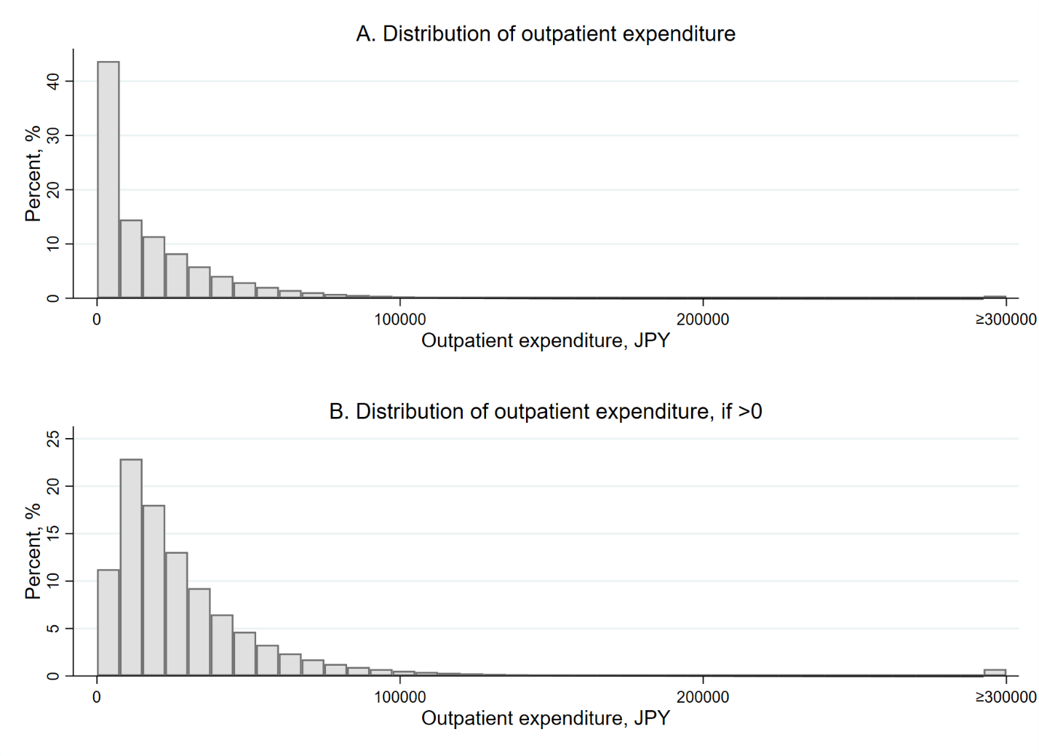
A: Full histogram including zeros. B: Histogram of only the positive values.

Figure S2. Distribution of inpatient expenditure.
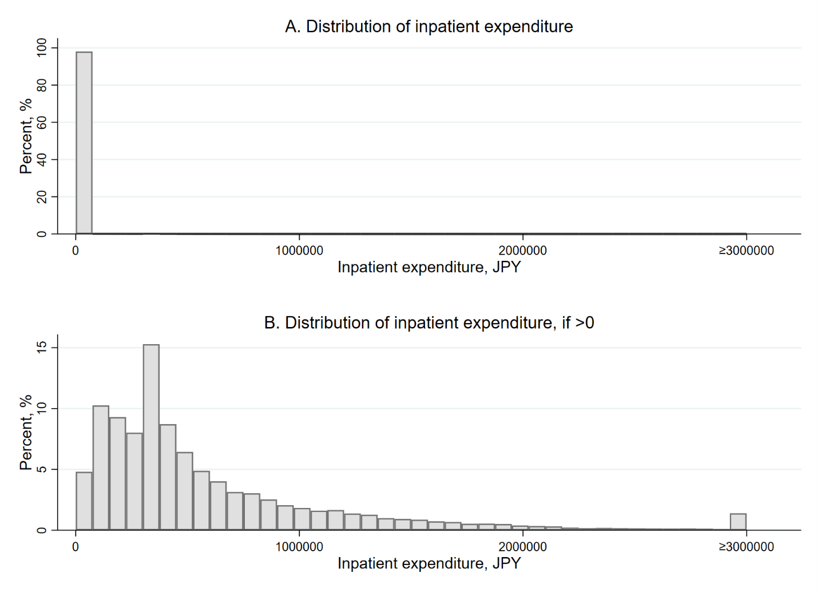
A: Full histogram including zeros. B: Histogram of only the positive values.

Figure S3. Proportions of lower-income or higher-income individuals by age.
Note: Dots represent the proportion of lower-income or higher-income individuals by age. The vertical dotted lines indicate the age threshold of 70 years. The coinsurance rate was 30% before age 70 and 10% after age 70. Dark lines are from fitting a linear function of age in months, separately for before and after age 70.

References
1. Fukushima, K., et al., Patient cost sharing and medical expenditures for the Elderly. Journal of Health Economics, 2016. 45: p. 115-130.
2. Shigeoka, H., The Effect of Patient Cost Sharing on Utilization, Health, and Risk Protection. American Economic Review, 2014. 104(7): p. 2152-84.
3. Keeler, E.B. and J.E. Rolph, The demand for episodes of treatment in the health insurance experiment. Journal of Health Economics, 1988. 7(4): p. 337-367.

