Online Resource 5
Quality assessment based on response times
We explored the association of preferences (measured as the probability of yes answers) and mean response time in joint evaluation (JE) via locally weighted scatterplot smoothing [48] (Fig. S3). Despite a slight breakpoint noticeable at 8s mean response time, we found no evidence of notably different preference patterns across different response times.
Fig S3 Probability of yes (acceptable) answers by mean response time in joint evaluation
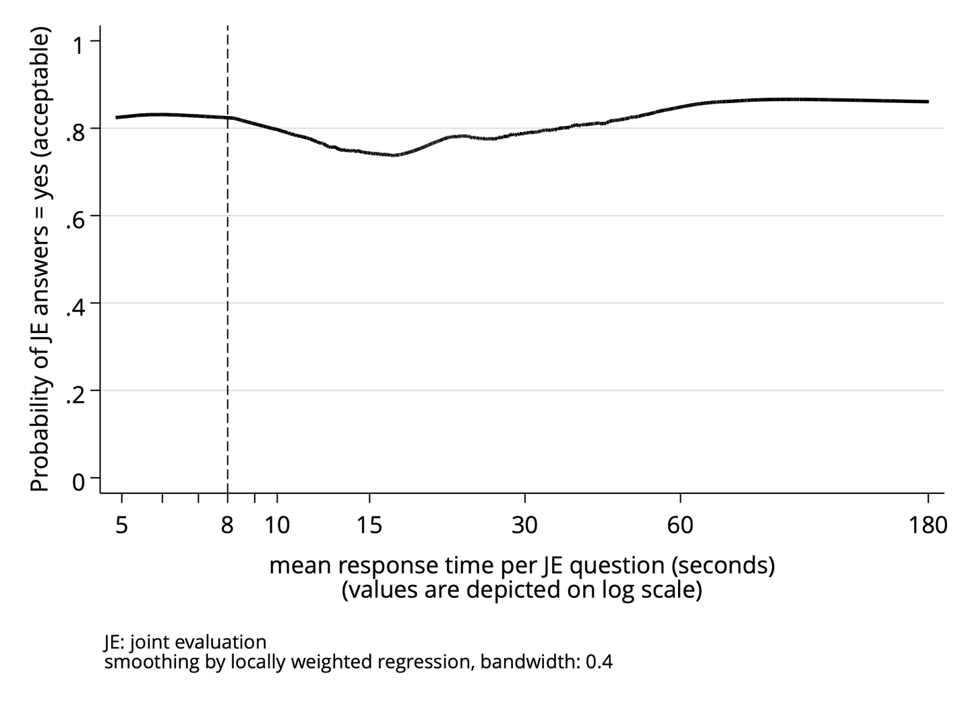

We hypothesized that “all yes” answers in JE may be a signal of low respondent effort. Therefore, we also explored the association of “all yes” answers with mean response time in JE via locally weighted scatterplot smoothing (Fig. S4). Although a breakpoint was noticeable at 8s response time, and we observed a convex pattern, there was no evidence for a markedly different preference pattern at short response times.
Fig S4 Probability of yes (acceptable) answers for all questions by mean response time in joint evaluation

