Annex 2: Additional detail on the methods

Table 1: Estimates of model parameters, the corresponding mathematical distributions for probabilistic sensitivity analyses and their data sources
Model parameters | Most likely value and range values by study arms |  | Mathematical distributions | Sources
 | A1 | A2
Start-up cost (€) | 40.290 (±20%) | 40.290 (±20%) | Gamma | own costing
Implementation costs (€) | 88.343 (±20%) | 73.328 (±20%) | Gamma | own costing
Response rate (%) | 41,2 | 36,2 | Beta | Cov-Surv-Study trial
Implementation period (month) | 1 - 60 | 1 - 60 | Uniform | Assumption
Prevalence (%) | 0,31 (0,01-4) | 0,35 (0,01-4) | Beta | Cov-Surv-Study trial

Figure 1: Structure of the decision tree assessing the cost-effectiveness of the two active surveillance strategies (A1 and A2) in the Cov-Surv-Study trial and the status quo of having no active surveillance for cost per sample tested
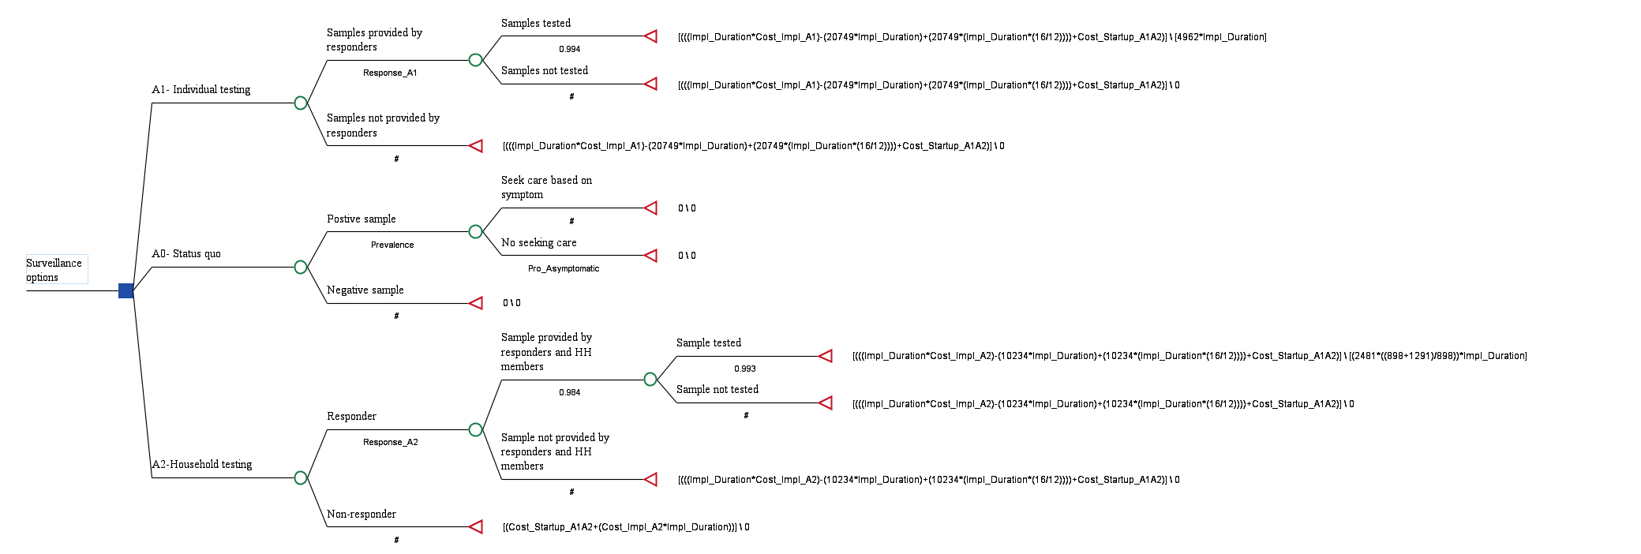

Figure 2: Structure of the decision tree assessing the cost-effectiveness of the two active surveillance strategies (A1 and A2) in the Cov-Surv-Study trial and the status quo of having no active surveillance for cost per case detected
