Braving the waves – A descriptive study of capability well-being patterns in seven European countries during the COVID-19 pandemic

Online supplementary materials

Appendix 1
Education categorization for the seven included countries
Table A1 Education categorisation
UK |  | 1 |  | Combined Junior and Infant School/ Infant School |  | Low
 |  | 2 |  | Junior School
 |  | 3 |  | Comprehensive School
 |  | 4 |  | Comprehensive School (GCSE)/ Secondary Modern (GCSE)/ Grammar School (GSCE)/ City Technology College (CGSE)/ Sixth Form |  | Middle
 |  | 5 |  | College and Institution of Higher education |  | High
 |  | 6 |  | Open College -College of Technology - Institute/ Teacher Training College
 |  | 7 |  | University/ Open University
Portugal |  | 1 |  | Sem Estudos |  | Low
 |  | 2 |  | Primário Incompleto
 |  | 3 |  | Primário Completo
 |  | 4 |  | Nível Médio Incompleto |  | Middle
 |  | 5 |  | Nível Médio Completo
 |  | 6 |  | Superior Incompleto |  | High
 |  | 7 |  | Superior Completo
Netherlands | 1 |  | LO (lagere school, LAVO, VGLO) |  | Low
Netherlands | 2 |  | LBO (LBO, LTS, ITO, LEAO, Huishoudschool, LLO)
Netherlands | 3 |  | MAO (MAVO, IVO, MULO, ULO, 3jr HBS, 3jr VWO, 3jr VHMO)
Netherlands | 4 |  | MBO (MTS, UTS, MEAO) |  | Middle
Netherlands | 5 |  | HAO (HAVO, VWO, Atheneum, Gymnasium, NMS, HBS, Lyceum)
Netherlands | 6 |  | HBO (HTS, HEAO, Wetensch. kand., Univers. onderwijs kand.) |  | High
Netherlands | 7 |  | WO (Universitair onderwijs, Doctoraalopleiding, TH)
Italy |  | 1 |  | scuola elementare |  | Low
 |  | 2 |  | scuola media inferiore
 |  | 3 |  | istituto professionale |  | Middle
 |  | 4 |  | scuola superiore
 |  | 5 |  | università |  | High
 |  | 6 |  | master
 |  | 7 |  | dottorato

Table A1 continued.
Germany | 1 | Grundschule | Low
Germany | 2 | Hauptschule | Low
Germany | 3 | Realschule | Low
Germany | 4 | Gymnasium/ Berufliches Gymnasium/ Fachgymnasium, Gesamtschule | Middle
Germany | 5 | Fachoberschule, Fachschule, Berufsschule, Berufsfachschule | Middle
Germany | 6 | Technische Hochschule, Pädagogische Hochschule, Kunsthochschule/ Musikhochschule | High
Germany | 7 | Fachhochschule | High
Germany | 8 | Universität, Technische Universität | High
France | 1 | École Primaire | Low
France | 2 | Collège | Low
France | 3 | Lycée d`Enseignement général et technologique | Middle
France | 4 | Lycée professionnel | Middle
France | 5 | Grande École de Commerce et de Gestion/ scientifique, Établissement d`Enseignement supérieur catholique/ artistique/ agricole | High
France | 6 | Grand Établissement/ École normale supérieure/ d`Ingénieur/ d`Architecture/ nationale vétérinaire | High
France | 7 | Université, Institut universitaire de Technologie/ national polytechnique/ d`Études politiques/ universitaire de Formation des Maîtres | High
Denmark | 1 | Folkeskolen - f.eks. 9. eller 10. klasse | Low
Denmark | 2 | Gymnasial uddannelse - f.eks. Almen Gymnasium, HHX, HTX osv. | Middle
Denmark | 3 | En videregående erhvervsuddannelse - f.eks. landbrugs-, social- og sundheds uddannelser, produktionsskole | High
Denmark | 4 | En mellemlang videregående uddannelse | High
Denmark | 5 | Universitets uddannelse | High

Appendix 2
Table A2 Demographic characteristics of country samples – proportions and means (SD).
 | UK | PT | NL | IT | GER | FR | DK | Total
Female | 0.51 | 0.51 | 0.52 | 0.52 | 0.51 | 0.53 | 0.52 | 0.52
Age
Age in years | 49.3 (17.2) | 44.0 (15.1) | 48.6 (16.5) | 48.9 (16.3) | 49.9 (16.3) | 48.2 (16.5) | 48.9 (16.5) | 48.3 (16.5)
<35 | 0.26 | 0.34 | 0.26 | 0.25 | 0.24 | 0.27 | 0.25 | 0.27
35-64 | 0.5 | 0.54 | 0.53 | 0.51 | 0.51 | 0.5 | 0.52 | 0.52
65+ | 0.24 | 0.12 | 0.21 | 0.24 | 0.26 | 0.22 | 0.23 | 0.22
Education
Low educ | 0.14 | 0.12 | 0.28 | 0.26 | 0.19 | 0.14 | 0.13 | 0.18
Med educ | 0.39 | 0.38 | 0.41 | 0.51 | 0.52 | 0.5 | 0.33 | 0.43
High educ | 0.47 | 0.5 | 0.31 | 0.23 | 0.3 | 0.36 | 0.54 | 0.39
Financial security
Insecure | 0.37 | 0.34 | 0.41 | 0.58 | 0.44 | 0.55 | 0.38 | 0.44
Secure | 0.63 | 0.66 | 0.59 | 0.42 | 0.56 | 0.45 | 0.62 | 0.56
Health
EQ-5D-5L* | 7.87 (3.54) | 6.76 (2.17) | 7.47 (3.07) | 7.10 (2.63) | 7.91 (3.40) | 7.44 (3.04) | 7.91 (3.29) | 7.49 (3.08)
Low health | 0.24 | 0.096 | 0.21 | 0.14 | 0.25 | 0.18 | 0.25 | 0.19
Healthy | 0.44 | 0.57 | 0.43 | 0.53 | 0.44 | 0.49 | 0.46 | 0.48
Full health | 0.32 | 0.33 | 0.36 | 0.33 | 0.31 | 0.33 | 0.29 | 0.32
Observations | 9181 | 9214 | 9129 | 9238 | 9170 | 9260 | 9111 | 64303
SD=standard deviation; EQ-5D-5L=European Quality of Life 5 Dimensions 5 Level Version
*Sum score from 5 (full health) to 25.
Table A3 ICECAP dimension scores and overall capability well-being in wave 1 (April 2020).
 | Stability |  | Attachement |  | Autonomy |  | Achievement |  | Enjoyment |  | Capability well-being |  | N
 | Mean | SD | Mean | SD | Mean | SD | Mean | SD | Mean | SD | Mean | SD
UK | 2.84 | 0.85 | 3.11 | 0.83 | 3.30 | 0.77 | 2.85 | 0.79 | 3.00 | 0.79 | 0.78 | 0.19 | 1009
PT | 2.70 | 0.80 | 3.15 | 0.78 | 3.23 | 0.74 | 2.76 | 0.71 | 2.72 | 0.79 | 0.75 | 0.18 | 1064
NL | 3.16 | 0.70 | 3.20 | 0.75 | 3.27 | 0.71 | 2.87 | 0.75 | 3.13 | 0.77 | 0.82 | 0.15 | 1012
IT | 2.53 | 0.90 | 3.12 | 0.81 | 3.07 | 0.89 | 2.74 | 0.81 | 2.86 | 0.80 | 0.73 | 0.20 | 1077
GER | 2.96 | 0.77 | 3.00 | 0.82 | 3.08 | 0.76 | 2.74 | 0.79 | 2.77 | 0.76 | 0.75 | 0.18 | 1002
FR | 2.95 | 0.70 | 3.19 | 0.76 | 3.25 | 0.73 | 2.91 | 0.71 | 3.16 | 0.76 | 0.81 | 0.16 | 1000
DK | 3.18 | 0.69 | 3.13 | 0.80 | 3.26 | 0.71 | 3.01 | 0.72 | 3.28 | 0.73 | 0.83 | 0.17 | 1000
Note: N, number of observations. Dimension scores range from 1 (worst) to 4 (best).

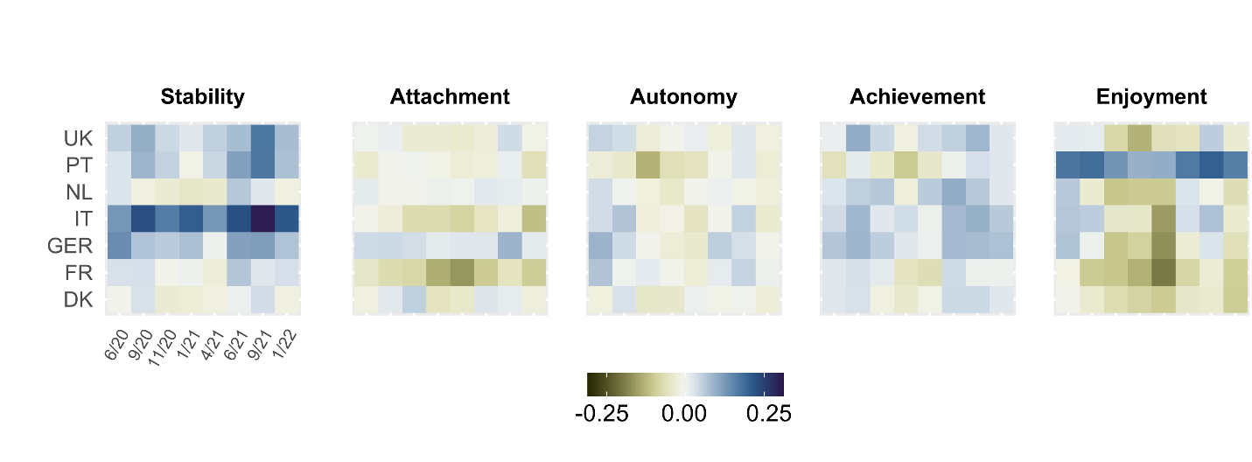
Figure A 1 Difference in mean score per well-being dimension compared to 1st wave (April 2020) across countries and waves of data collection. ICECAP-A dimension scores range from 1 (worst) to 4 (best). Number of observations per cell ~1,000.

Regarding the stability dimension, there was large variation in differences across countries as compared to April 2020. While there was a general upward trend in Italy over time (e.g., +0.30 in September 2021), there were also temporal declines in scores on stability in the Winter of 2020/21, most pronounced in countries like the Netherlands (up to -0.05) and Denmark (up to -0.03). Largest declines in scores on the attachment dimension were observed in France (up to -0.16) and Italy (up to -0.11), mostly concentrated in the Winter and spring 2021. Other countries did not experience a noteworthy decline in attachment as compared to April 2020. Negative changes in scores on the autonomy dimension could be observed for all countries for autumn 2020 and winter 2021, while the largest decline was found for Portugal (-0.13 in November 2020). Reductions in the achievement dimension were observed in Portugal (-0.10), France (-0.07) and Denmark (-0.04) in autumn 2020 and winter 2021. The overall largest declines in well-being were found in the enjoyment dimension. While for Portugal changes were still positive as compared to the very low score observed in April 2020 (2.72, SD=0.79), enjoyment notably declined with the start of autumn 2020, with the largest and longest declines observed in France (up to -0.20) and Germany (up to -0.17).
Appendix 3
Changes in well-being dimensions across subgroups
Age groups
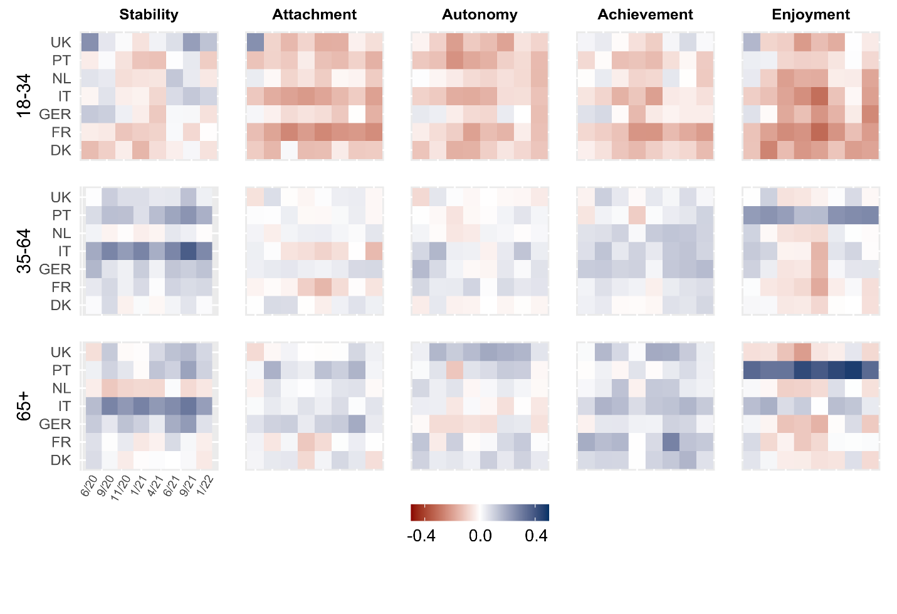
Fig A 2 Difference in mean ICECAP-A dimension scores compared to April 2020 across age groups. Mean number of observations per cell for the three age groups is 272 (18-34), 526 (35-64), and 222 (65+).

Gender
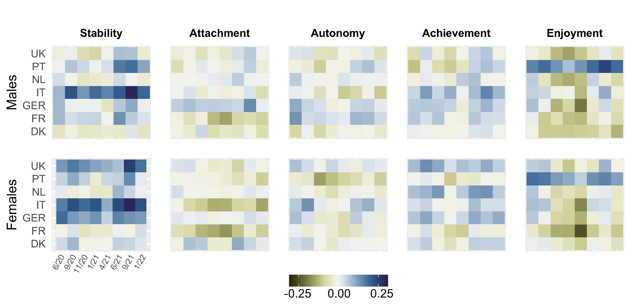
Fig A 3 Difference in mean ICECAP-A dimension scores compared to April 2020 across gender. Mean number of observations per cell for the two groups is 530 (female), and 491 (male).
Education
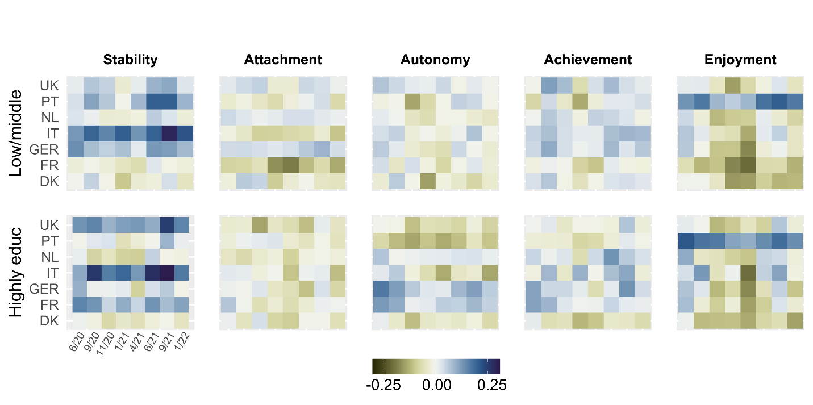
Fig A 4 Difference in mean ICECAP-A dimension scores compared to April 2020 across education levels. Mean number of observations per cell for the two education groups is 617 (Low & middle) and 387 (Highly).

Health status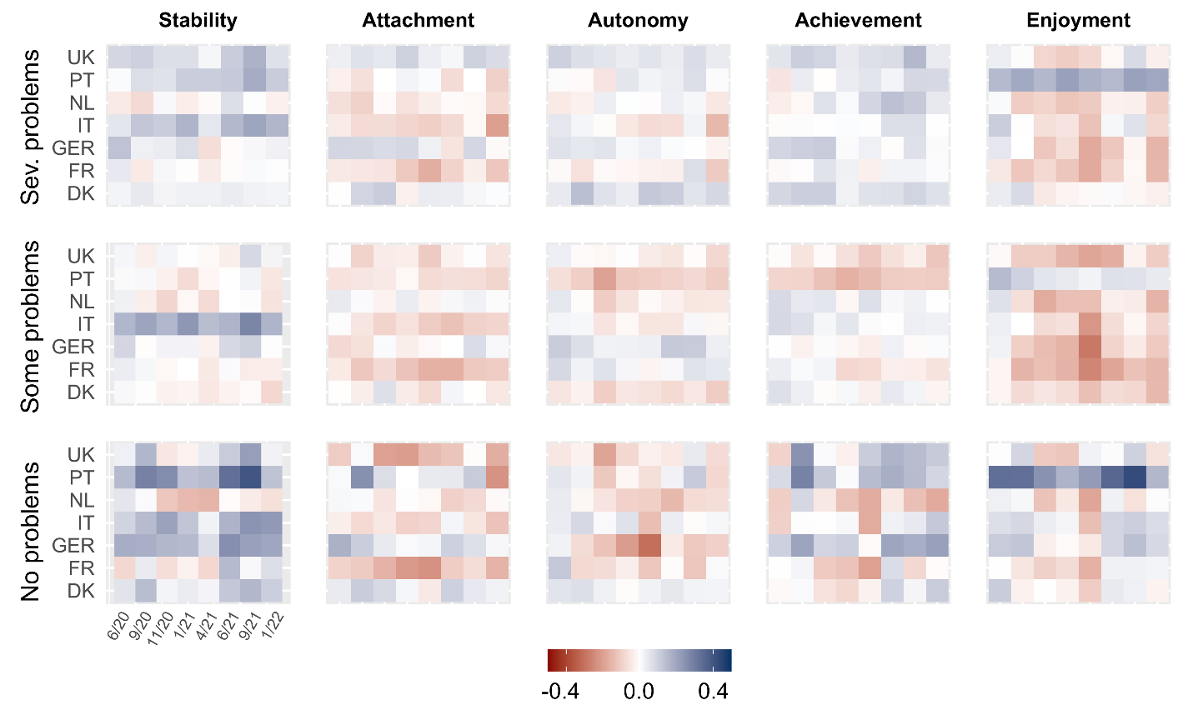
Fig A 5 Difference in mean ICECAP-A dimension scores compared to April 2020 differentiated by health status measured using EQ-5D sum score. Full health (5), Healthy (6-9), Lower health (10+) on a theoretical range of 5 to 25. Mean number of observations per cell for the three groups is 331 (Full health), 492 (Healthy), and 198 (Lower health).

Financial security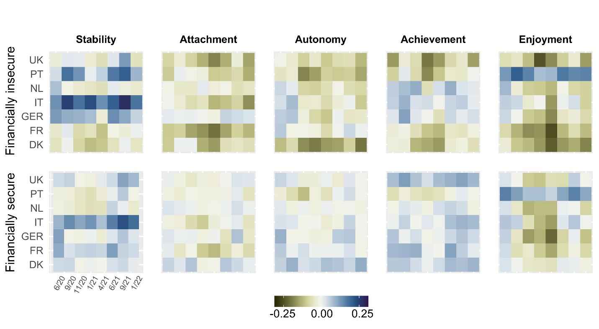
Fig A 6 Difference in mean ICECAP-A dimension scores (1 lowest, 4 highest) compared to April 2020 differentiated by financial situation. “Unstable” defined as having some or great difficulties with making ends meet. Mean number of observations per cell for the two groups is 448 (secure), and 573 (insecure).

Appendix 4
Regression results for ICECAP-A dimensions
Table A4 Associations of incidence, mortality and stringency with the ICECAP-A stability dimension.
 | Overall | Age | Gender | Education | Health | Income
Increase in 7-day incidence by 100 per 100k | -0.0002 | -0.0002 | -0.0004 | -0.0002 | -0.0007* | -0.0001
Increase in 7-day mortality by 10 per million | -0.0154* | -0.0139* | -0.0170* | -0.0143* | -0.0139* | -0.0163*
Increase in Stringency Index by 10 points | 0.0009 | 0.0004 | 0.0005 | 0.0007 | -0.0005 | 0.0024⁺
Incidence × Age < 35 |  | 0.0008⁺
Mortality × Age < 35 |  | -0.0130⁺
Stringency × Age < 35 |  | 0.0004
Incidence × Age >= 65 |  | -0.0005
Mortality × Age >= 65 |  | 0.0089
Stringency × Age >= 65 |  | 0.0010
Incidence × Female |  |  | 0.0004
Mortality × Female |  |  | 0.0033
Stringency × Female |  |  | 0.0008
Incidence × Tertiary educated |  |  |  | 0.0001
Mortality × Tertiary educated |  |  |  | -0.0026
Stringency × Tertiary educated |  |  |  | 0.0005
Incidence × No health problems¹ |  |  |  |  | 0.0016*
Mortality × No health problems |  |  |  |  | -0.0121*
Stringency × No health problems |  |  |  |  | 0.0089*
Incidence × More severe health problems² |  |  |  |  | 0.0001
Mortality × More severe health problems |  |  |  |  | 0.0242*
Stringency × More severe health problems |  |  |  |  | -0.0098*
Incidence × Financal insecure³ |  |  |  |  |  | -0.0001
Mortality × Financal insecure |  |  |  |  |  | 0.0030
Stringency × Financal insecure |  |  |  |  |  | -0.0037*
Observations | 64,046 | 64,046 | 64,046 | 64,046 | 64,046 | 64,046
Individuals | 24,992 | 24,992 | 24,992 | 24,992 | 24,992 | 24,992
Note: Results from individual fixed regression, controlling for wave fixed effects. ¹ EQ-5D sum score =5, ² EQ-5D sum score >= 10, ³ Having some or great difficulties with making ends meet. Reference groups are age between 35 and 64, male, non-tertiary educated, some health problems (EQ-5D sum score between 6 and 9), financial secure. ⁺ p < 0.10, * p < 0.05

Table A5 Associations of incidence, mortality and stringency with the ICECAP-A attachement dimension.
 | Overall | Age | Gender | Education | Health | Income
Increase in 7-day incidence by 100 per 100k | 0.0000 | 0.0001 | 0.0002 | -0.0004 | 0.0001 | 0.0002
Increase in 7-day mortality by 10 per million | -0.0008 | -0.0024 | 0.0017 | -0.0027 | 0.0018 | 0.0012
Increase in Stringency Index by 10 points | -0.0007 | -0.0004 | -0.0008 | -0.0003 | -0.0018 | -0.0004
Incidence × Age < 35 |  | -0.0004
Mortality × Age < 35 |  | 0.0075
Stringency × Age < 35 |  | -0.0009
Incidence × Age >= 65 |  | -0.0001
Mortality × Age >= 65 |  | -0.0009
Stringency × Age >= 65 |  | -0.0006
Incidence × Female |  |  | -0.0002
Mortality × Female |  |  | -0.0050
Stringency × Female |  |  | 0.0001
Incidence × Tertiary educated |  |  |  | 0.0007⁺
Mortality × Tertiary educated |  |  |  | 0.0045
Stringency × Tertiary educated |  |  |  | -0.0008
Incidence × No health problems¹ |  |  |  |  | 0.0002
Mortality × No health problems |  |  |  |  | -0.0113*
Stringency × No health problems |  |  |  |  | 0.0067*
Incidence × More severe health problems² |  |  |  |  | -0.0004
Mortality × More severe health problems |  |  |  |  | 0.0105
Stringency × More severe health problems |  |  |  |  | -0.0070*
Incidence × Financal insecure³ |  |  |  |  |  | -0.0005
Mortality × Financal insecure |  |  |  |  |  | -0.0049
Stringency × Financal insecure |  |  |  |  |  | -0.0005
Observations | 64,046 | 64,046 | 64,046 | 64,046 | 64,046 | 64,046
Individuals | 24,992 | 24,992 | 24,992 | 24,992 | 24,992 | 24,992
Note: Results from individual fixed regression, controlling for wave fixed effects. ¹ EQ-5D sum score =5, ² EQ-5D sum score >= 10, ³ Having some or great difficulties with making ends meet. Reference groups are age between 35 and 64, male, non-tertiary educated, some health problems (EQ-5D sum score between 6 and 9), financial secure. ⁺ p < 0.10, * p < 0.05

Table A6 Associations of incidence, mortality and stringency with the ICECAP-A autonomy dimension.
 | Overall | Age | Gender | Education | Health | Income
Increase in 7-day incidence by 100 per 100k | -0.0001 | 0.0001 | 0.0001 | 0.0000 | -0.0002 | 0.0003
Increase in 7-day mortality by 10 per million | -0.0115* | -0.0144* | -0.0132* | -0.0128* | -0.0121* | -0.0098*
Increase in Stringency Index by 10 points | 0.0025⁺ | 0.0029* | 0.0028⁺ | 0.0026* | 0.0024⁺ | 0.0034*
Incidence × Age < 35 |  | -0.0007
Mortality × Age < 35 |  | 0.0064
Stringency × Age < 35 |  | -0.0031*
Incidence × Age >= 65 |  | -0.0002
Mortality × Age >= 65 |  | 0.0103⁺
Stringency × Age >= 65 |  | 0.0002
Incidence × Female |  |  | -0.0004
Mortality × Female |  |  | 0.0031
Stringency × Female |  |  | -0.0006
Incidence × Tertiary educated |  |  |  | -0.0002
Mortality × Tertiary educated |  |  |  | 0.0027
Stringency × Tertiary educated |  |  |  | -0.0005
Incidence × No health problems¹ |  |  |  |  | 0.0002
Mortality × No health problems |  |  |  |  | -0.0039
Stringency × No health problems |  |  |  |  | 0.0056*
Incidence × More severe health problems² |  |  |  |  | -0.0002
Mortality × More severe health problems |  |  |  |  | 0.0155*
Stringency × More severe health problems |  |  |  |  | -0.0109*
Incidence × Financal insecure³ |  |  |  |  |  | -0.0011*
Mortality × Financal insecure |  |  |  |  |  | -0.0041
Stringency × Financal insecure |  |  |  |  |  | -0.0018*
Observations | 64,046 | 64,046 | 64,046 | 64,046 | 64,046 | 64,046
Individuals | 24,992 | 24,992 | 24,992 | 24,992 | 24,992 | 24,992
Note: Results from individual fixed regression, controlling for wave fixed effects. ¹ EQ-5D sum score =5, ² EQ-5D sum score >= 10, ³ Having some or great difficulties with making ends meet. Reference groups are age between 35 and 64, male, non-tertiary educated, some health problems (EQ-5D sum score between 6 and 9), financial secure. ⁺ p < 0.10, * p < 0.05

Table A7 Associations of incidence, mortality and stringency with the ICECAP-A achievement dimension.
 | Overall | Age | Gender | Education | Health | Income
Increase in 7-day incidence by 100 per 100k | 0.0001 | 0.0004 | 0.0001 | 0.0004 | -0.0002 | 0.0002
Increase in 7-day mortality by 10 per million | -0.0122* | -0.0124* | -0.0128* | -0.0165* | -0.0104* | -0.0107*
Increase in Stringency Index by 10 points | -0.0010 | -0.0010 | -0.0003 | -0.0010 | -0.0016 | -0.0003
Incidence × Age < 35 |  | -0.0010*
Mortality × Age < 35 |  | 0.0007
Stringency × Age < 35 |  | 0.0005
Incidence × Age >= 65 |  | -0.0005
Mortality × Age >= 65 |  | -0.0010
Stringency × Age >= 65 |  | -0.0001
Incidence × Female |  |  | -0.0000
Mortality × Female |  |  | 0.0012
Stringency × Female |  |  | -0.0014
Incidence × Tertiary educated |  |  |  | -0.0006
Mortality × Tertiary educated |  |  |  | 0.0093⁺
Stringency × Tertiary educated |  |  |  | -0.0005
Incidence × No health problems¹ |  |  |  |  | 0.0010*
Mortality × No health problems |  |  |  |  | -0.0152*
Stringency × No health problems |  |  |  |  | 0.0074*
Incidence × More severe health problems² |  |  |  |  | -0.0005
Mortality × More severe health problems |  |  |  |  | 0.0239*
Stringency × More severe health problems |  |  |  |  | -0.0112*
Incidence × Financal insecure³ |  |  |  |  |  | -0.0005
Mortality × Financal insecure |  |  |  |  |  | -0.0034
Stringency × Financal insecure |  |  |  |  |  | -0.0016*
Observations | 64,046 | 64,046 | 64,046 | 64,046 | 64,046 | 64,046
Individuals | 24,992 | 24,992 | 24,992 | 24,992 | 24,992 | 24,992
Note: Results from individual fixed regression, controlling for wave fixed effects. ¹ EQ-5D sum score =5, ² EQ-5D sum score >= 10, ³ Having some or great difficulties with making ends meet. Reference groups are age between 35 and 64, male, non-tertiary educated, some health problems (EQ-5D sum score between 6 and 9), financial secure. ⁺ p < 0.10, * p < 0.05

Table A8 Associations of incidence, mortality and stringency with the ICECAP-A enjoyment dimension.
 | Overall | Age | Gender | Education | Health | Income
Increase in 7-day incidence by 100 per 100k | -0.0004 | -0.0002 | -0.0003 | -0.0003 | -0.0006⁺ | -0.0003
Increase in 7-day mortality by 10 per million | -0.0073⁺ | -0.0074⁺ | -0.0110* | -0.0083⁺ | -0.0038 | -0.0053
Increase in Stringency Index by 10 points | -0.0020 | -0.0021 | -0.0013 | -0.0019 | -0.0031* | -0.0012
Incidence × Age < 35 |  | -0.0007
Mortality × Age < 35 |  | -0.0001
Stringency × Age < 35 |  | -0.0001
Incidence × Age >= 65 |  | -0.0001
Mortality × Age >= 65 |  | 0.0007
Stringency × Age >= 65 |  | 0.0004
Incidence × Female |  |  | -0.0002
Mortality × Female |  |  | 0.0073
Stringency × Female |  |  | -0.0015
Incidence × Tertiary educated |  |  |  | -0.0001
Mortality × Tertiary educated |  |  |  | 0.0022
Stringency × Tertiary educated |  |  |  | -0.0003
Incidence × No health problems¹ |  |  |  |  | 0.0009*
Mortality × No health problems |  |  |  |  | -0.0146*
Stringency × No health problems |  |  |  |  | 0.0080*
Incidence × More severe health problems² |  |  |  |  | -0.0003
Mortality × More severe health problems |  |  |  |  | 0.0127⁺
Stringency × More severe health problems |  |  |  |  | -0.0094*
Incidence × Financal insecure³ |  |  |  |  |  | -0.0002
Mortality × Financal insecure |  |  |  |  |  | -0.0044
Stringency × Financal insecure |  |  |  |  |  | -0.0020*
Observations | 64,046 | 64,046 | 64,046 | 64,046 | 64,046 | 64,046
Individuals | 24,992 | 24,992 | 24,992 | 24,992 | 24,992 | 24,992
Note: Results from individual fixed regression, controlling for wave fixed effects. ¹ EQ-5D sum score =5, ² EQ-5D sum score >= 10, ³ Having some or great difficulties with making ends meet. Reference groups are age between 35 and 64, male, non-tertiary educated, some health problems (EQ-5D sum score between 6 and 9), financial secure. ⁺ p < 0.10, * p < 0.05

