Appendix A: Brief clinical guideline descriptions in laymen’s terms

Treatment options
This appendix briefly describes in laymen’s terms the treatment options available to patients diagnosed with subfertility in Europe, and the basic progression of these treatment options. As appendix A figure 1 shows, the actual process of delivering care determines the results; the medal metro lines, and treatment protocols were foundational to the costing analysis. For detailed descriptions of the process, please refer to appendix B. The treatment guidelines described here and depicted in the medical metro line are subject to regulatory guidelines published by the European Society of Human Reproduction and Embryology (ESHRE) and the Dutch professional association for Obstetrics and Gynecology (Nederlandse Vereniging voor Obstetrie en Gynaecologie; NVOG). For detailed clinical guidelines, please refer to the published clinical guidelines from ESHRE or NVOG (available online; for references and links please refer to the study protocol).

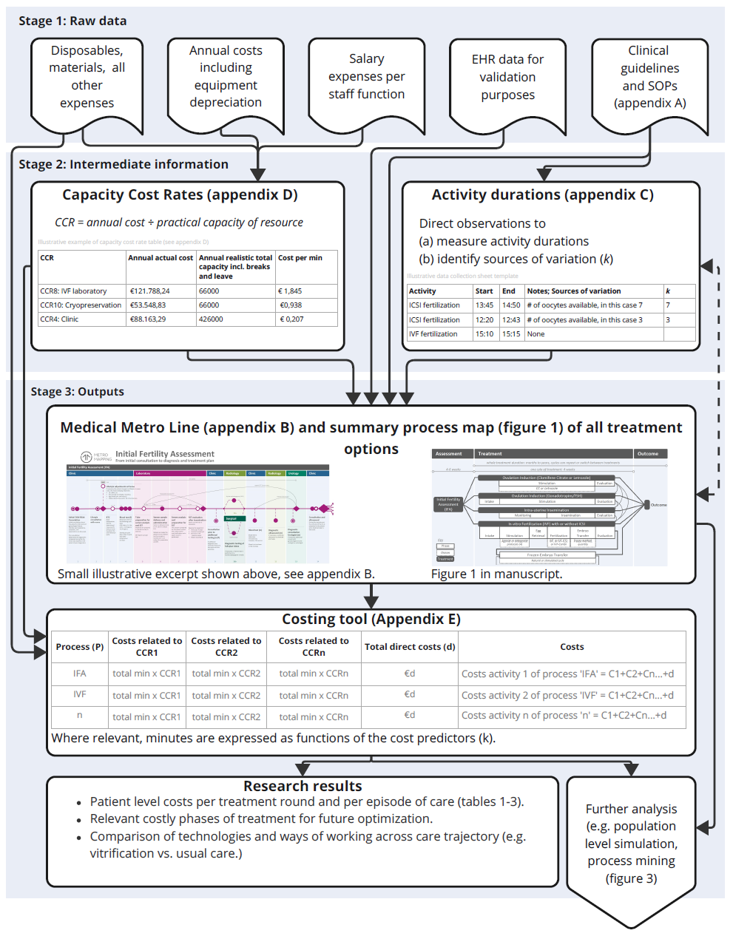
Appendix A figure 1: Description of data collection and analysis, with reference to the appendices of the study.
Patients begin with a general diagnostics phase, the initial fertility assessment (IFA), to determine the potential cause of subfertility to inform the treatment plan. This can last 4 to 6 weeks and greatly depends on the case-mix and prior gynecological history of both patients. Some patients require a consultation with a Urologist, a diagnostic laparoscopic operation or a hysterosalpingogram (HSG), whilst others may only require several consultations and an ultrasound. In all cases, patients start with an initial consultation with a gynecologist and a lifestyle consultation with a nurse, and minimally one vaginal ultrasound.
For patients diagnosed with female and/or male subfertility, or those dealing with prolonged unexplained subfertility, treatment is recommended to start as soon as possible. In case of female subfertility due to anovulation (WHO group II), and without the presence of male-factor infertility, ovulation induction (OI) with clomiphene citrate (CC) is indicated. This is a non-invasive, home-based, medication-based treatment, during which patients require minimal assistance or monitoring. In case of prolonged anovulation with CC, low-dose FSH stimulation is the second line of treatment. OI with FSH stimulation requires significantly more monitoring and is therefore more invasive.
Patients using donor sperm, or with mild male factor or cervical factor subfertility, are recommended intra-uterine insemination (IUI) in the natural menstrual cycle before attempting more invasive options. IUI involves a specifically timed placement of prewashed sperm directly into the uterine cavity using a small catheter. It can be combined with an OI treatment regimen in case of anovulation. In case of unexplained subfertility or mild endometriosis IUI treatment is combined with hormonal stimulation to increase pregnancy chance by a double ovulation. Each month of treatment of OI or IUI ends with a pregnancy test and ultrasound. After 6 cycles of unsuccessful OI or IUI, patients are advised on whether to continue with their current treatment, or whether to switch to in-vitro-fertilization (IVF), which is more invasive. IVF is suitable for persistent, unexplained infertility, endometriosis, ovulatory dysfunction, or male factor infertility.

Ovulation induction (OI) and Intra-uterine insemination (IUI)
Ovulation induction medication simulate natural hormone secretion during the menstrual cycle, and encourage the production of a single dominant follicle, which needs to reach a required size before it can be released by the ovary (ovulation). The ovary releases the egg on about day 14 of the menstrual cycle.
Ovulation induction may be performed with two types of medication regimens:
- Clomiphene citrate (CC) or Letrozol tablets, daily, from 3nd to 7th day of the menstrual cycle.
- Gonadotropin injections, daily, from day 3nd of the menstrual cycle until ovulation may be induced by human Chorionic Gonadotropin (hCG).
The regimens have implications for the patient journey and clinic. In case of Clomid or Letrozole, patients can pick up their medication (in the form of tablets), follow the regimen at home, and come back to the clinic after 4-6 weeks for a consultation and ultrasound. The ultrasound is used to determine whether ovarian response is sufficient, or whether an increased dosage of medication is necessary. After one blood test, the patient may follow several treatment cycles at home at fixed dosage, without needing ultrasounds. If treatment is unsuccessful after 6 months, an evaluation consultation is scheduled to determine whether treatment should be continued or stopped in favor of a more invasive approach. In case of poor response at maximum dosage, further fallopian tube diagnostics may be required (laparoscopy or hysterosalpingogram). Ovulation induction can be attempted for a maximum of 12 ovulatory cycles. If, at any point, treatment is stopped, an evaluation consultation is scheduled during which a new treatment plan is discussed.
Contrary to Clomid or Letrozole treatment, the Gonadotropin regimen involves daily injections and requires regular monitoring of follicular response by means of ultrasound until the ovulation trigger. Due to a heightened chance of multifollicular growth or other complications 70, Gonadotropin stimulation requires more consultations and ultrasounds than necessary with Clomid. Intra-uterine insemination features a timed insemination for optimal chance of pregnancy. In some cases, IUI may be combined with OI, in which case a patient completes the OI trajectory as indicated on the medical metro line with the addition of an IUI on day.

In-vitro fertilization (IVF) with or without intracytoplasmic sperm injection (ICSI)
IVF differs significantly from the options, because the burden on patients and staff is far greater, and the treatment involves more invasive procedures. Because fertilization occurs ex-vivo inside the laboratory, this treatment poses significantly greater burden on clinics. In-vitro fertilization begins with an intake phase, during which patients are tested for infections (serology), undergo an ultrasound, and receive a consultation in which stimulation medication options and choices are discussed. If the most recent semen analysis is over one year old, it is repeated. Once a choice is made, patients consult with an IVF nurse about the exact timing and dosage of their medication protocol. On the first day of her menstrual cycle (CD1), the patient informs the nurse by email or phone call, and subsequent ultrasound consultations are scheduled. Patients require between 3 and 7 ultrasounds total, depending on their response to the stimulating medication, before advancing to the next phase of treatment. Various stimulation protocols are available, and patients are advised on the best option for them by their Gynecologist.
Phase 2, the ‘egg retrieval’ phase, is reached if one follicle reaches a size greater than 17 mm. Insufficient or excessive response to medication can result in the cancellation of the cycle, which is discussed in a consultation. One day prior to the follicular aspiration (FA), the lab prepares all dishes and media required for the follicular aspiration. Once the follicular aspiration has taken place, the laboratory collects and tracks all viable follicles. During ovum pickup/follicle retrieval, follicles are extracted from the follicular fluid removed by needle during the procedure. This happens under the microscope; all viable follicles are placed in a nutritive liquid (culture medium) and incubated under optimal conditions.
In phase 3, follicles are fertilized using sperm. In the case of traditional IVF, healthy mature follicles are combined with (appropriately prepared) sperm cells in a dish, then incubated and monitored. In the case of IVF-ICSI, sperm cells are selected and injected into mature follicular cells under a precision microscope. In some instances, when a patient is undergoing a first cycle, it is possible to opt for a split approach wherein half of the oocytes are fertilized in a petri dish, and half using the precision microscope following an ICSI protocol. In all cases, all fertilized oocytes are incubated, monitored, and tracked appropriately for several days. One successfully developing embryos are eligible to be replaced into the uterus in the following phase (embryo transfer). If no embryos (of sufficient quality) are available to transfer, the cycle is cancelled. During the embryo transfer, the single best embryo is placed back into the uterus. Soon after, the patient can administer a pregnancy test.
If pregnancy is not achieved, patients can enter frozen embryo transfer cycles (FETs) which are similar to IVF cycles, but do not require the collection and fertilization of oocytes. Instead, patients are prepared to receive a frozen embryo (in some cases, patients require stimulation medication), which is thawed on the day of the embryo transfer. If the embryo is damaged from the freezing and thawing process, another one may be thawed, but this needs to happen on time as the patient is ready to receive it in the procedure room. Thus, if multiple embryos are thawed and need to be discarded, it can happen that a FET cycle fails. Similarly, if no embryos are remaining, the patient may need to enter a new cycle of IVF including follicle stimulating hormones to induce over-production of follicles.

