Appendix 1 Key Sources for Flowcharts
Country | Sources
BE | MORSE-rapport | RIZIV
BE | De terugbetaling van een geneesmiddel | RIZIV
BE | Pricing & Reimbursement Laws and Regulations 2024 | Belgium
CY | 48/1997 Coll. Public Health Insurance Act (zakonyprolidi.cz)
CY | Implementing a Managed Entry Agreement Framework in Cyprus - PubMed (nih.gov)
CZ | Regulation of prices and reimbursements for pharmaceuticals, State Institute for Drug Control (sukl.eu)
CZ | Information on changes when submitting an application to set or change the maximum price or the amount and conditions of reimbursement of LP/ZLU in connection with the amendment to Act No. 48/1997 Coll., on Public Health Insurance, State Institute for Drug Control (sukl.cz)
CZ | https://pubmed.ncbi.nlm.nih.gov/30316030/
CZ | https://www.sukl.cz/sukl/seznam-leciv-a-pzlu-hrazenych-ze-zdrav-pojisteni
DE | AMNOG-Verhandlungen (§ 130b SGB V) - GKV-Spitzenverband
DE | 2024-03_AMNOG-Kurzreport-2024_Prof-Hecken.pdf
DE | Arzneimittel | WIdO – Wissenschaftliches Institut der AOK
DK | Markedsovervågning - Amgros
DK | Reimbursement and prices
DK | Price negotiations and tendering - Amgros
ENG | https://www.england.nhs.uk/wp-content/uploads/2018/01/cdf-q4-20-21-activity-update.pdf
ENG | 2024 voluntary scheme for branded medicines pricing, access and growth - GOV.UK
ENG | NHS England » Cancer Drugs Fund list
ENG | https://www.england.nhs.uk/publication/nhs-commercial-framework-for-new-medicines/
ENG | Pricing & Reimbursement Laws and Regulations 2024 | UK
FR | Pricing & Reimbursement Laws and Regulations 2024 | France
FR | EMAUD: market access
FR | Rapports d'activité du CEPS - Ministère de la santé et de l'accès aux soins
IE | gov.ie - Review of High-Tech Drug Expenditure 2021
IE | Pricing & Reimbursement Laws and Regulations 2024 | Ireland
IE | Overview of the Drug Reimbursement Process | National Centre for Pharmacoeconomics
IT | OsMed Reports | Italian Medicines Agency
IT | https://pmc.ncbi.nlm.nih.gov/articles/PMC10755625/
IT | Pricing and reimbursement | Italian Medicines Agency
NL | Kamerbrief over financiële arrangementen geneesmiddelen 2022 | Kamerstuk | Rijksoverheid.nl
NL | Kamerbrief voortgang financiële arrangementen geneesmiddelen 2023 | Kamerstuk | Rijksoverheid.nl
NL | Sluis voor dure geneesmiddelen | Over ons | Zorginstituut Nederland
NO | Phases of the introduction of new methods - New methods
NO | https://www.nyemetoder.no/innforing-av-nye-metoder/beslutning/#hvilke-beslutninger-er-tatt
NO | PPRINorway2022_final.pdf
SE | https://samverkanlakemedel.se/lakemedel---ordnat-inforande/avtal
SE | https://www.tlv.se/publikationer/publikationer/2024-06-03-prognos-av-besparingar-fran-sidooverenskommelser-2024-2027.html?query=besparingar
SE | Negotiation and Procurement - Samverkanläkemedel
SE | https://www.tlv.se/publikationer/publikationer/2023-06-02-prognos-av-besparingar-fran-sidooverenskommelser-2023-2026.html
SE | https://www.tlv.se/publikationer/publikationer/2023-03-20-besparingar-fran-sidooverenskommelser-2022-slutavstamning.html
SK | Legislatívny rámec – NIHO
SK | NIHO – Národný inštitút pre hodnotu a technológie v zdravotníctve
SK | Drug Policy in Slovakia
SK | Frontiers | The Impact of Reimbursement Practices on the Pharmaceutical Market for Off-Patent Medicines in Slovakia

Appendix 2 Definition of stakeholders for process flowcharts.
Stakeholder | Definition
Manufacturer | A pharmaceutical or biotech company holding market authorization for a medicine, responsible for its production, distribution, and regulatory compliance
National authority | A governmental organization (e.g., a ministry, or a (sub-ordinate) agency) operating at the national level, responsible for formulating and implementing policies and legislations within a jurisdiction.
Regional authority | A governmental organization (e.g., a ministry, or a (sub-ordinate) agency) operating at the regional level, responsible for formulating and implementing policies and legislations within a jurisdiction.
Assessment body | An organization specializing in evaluating the clinical effectiveness and/or economic impact of healthcare technologies, interventions, and medications to inform appraisal and decision-making.
Provider | Organizations responsible for providing healthcare services, including hospitals, to deliver care to patients within a healthcare system.
Payer | An organization tasked with financing or reimbursing the costs of healthcare services, including medications, often managing public or private health funds and insurance schemes.
Table A.2: Definition of stakeholders for process flowcharts.

Appendix 3 Interview Guide
Interview Guide: Comparing Publicly Reported Data on Managed Entry Agreements and Confidential Discounts in Europe
Please keep this document confidential.

Demographics
10 minutes
- What is your role and expertise/experience within the topic of pricing and reimbursement?

- Which stakeholder group do you belong to?
- Public authority
- Insurer
- Hospital/Health provider
- Academia
- Other, which?

- How many years of relevant professional experience do you have?
A) Identification of relevant frameworks for managed entry agreements in [INSERT COUNTRY].
10 minutes
We define managed entry agreements (MEAs) as typically confidential and national arrangement between public authorities and an individual manufacturer to enable access of a medicine under specific conditions.
- Considering this definition what are the legal arrangements in your country that you consider a managed entry agreement?
- We did identify [INSERT FRAMEWORK] as framework for managed entry agreements in [INSERT COUNTRY].
  - Would you consider arrangement under this framework a managed entry agreement?
    - If not, could you elaborate why?
  - Are the following information and characteristics related to [INSERT FRAMEWORK] correct:
    - Main agency in charge (Decisive): [INSERT]
    - Performance and/or Financial arrangements: [INSERT]
    - Type of medicines in MEAs (orginators/generics/biosimilars/other): [INSERT]
    - Sector (inpatient/outpatient/prescribed/other):
    - Criteria that initiate/trigger MEA: [INSERT]
- Are there other arrangements in your country that you consider managed entry agreements?
  - Do you consider arrangements within the [INSERT FRAMEWORK WHERE WE ARE DOUBTFUL] a MEA?
    - Why (not)? [ADD REASON RELATED TO EXCLUSION]
  - Are there other national negotiations/managed entry agreements important for cancer medicines?

B) Validation of flowcharts
15 minutes
The following flowchart is supposed to represent the process of managed entry agreements within
INSERT FRAMEWORK FLOWCHART

- Does this flowcharts represents accurately the (negotiation) process of managed entry agreements in your country?
  - Should anything be adapted?
  - Do all arrows lead in the right direction?
- Are relevant agencies/organizations
  - Complete?
  - Categorized correctly (Payer, Authority, Clinical/Economical Assessment agency, ect..)?
  - Are all advisory bodies identified? (advisors of advisors are out of scope)
INSERT Country specific question
C) Reporting
15 minutes
The following table shows an overview of the information that we found for the[INSERT FRAMEWORK], [INSERT REPORT name(S)] published by [INSERT REPORTING BODY(IES)] being the main source(s).
Reporting regarding [INSERT FRAMEWORK]
Frequency of publication
Available in English
Products with active MEAs reported
Year specific information | 2016 | 2017 | 2018 | 2019 | 2020 | 2021 | Source | Notes
Number of active MEAs  (Counted per product) | Insert | Insert | Insert | Insert | Insert | Insert | Insert | Insert
Number of active MEAs  (If not per product, counted as in report) | Insert | Insert | Insert | Insert | Insert | Insert | Insert | Insert
Financial Outcomes | Insert | Insert | Insert | Insert | Insert | Insert | Insert | Insert
Estimated expenditure without MEA (Billion EUR) | Insert | Insert | Insert | Insert | Insert | Insert | Insert | Insert
Net expenditure with MEA (Billion EUR) | Insert | Insert | Insert | Insert | Insert | Insert | Insert | Insert
Net savings(Billion EUR) | Insert | Insert | Insert | Insert | Insert | Insert | Insert | Insert
Average discounts/ price reduction (%) | Insert | Insert | Insert | Insert | Insert | Insert | Insert | Insert
Mandatory discount included in financial outcomes (Yes(%)/No) | Insert | Insert | Insert | Insert | Insert | Insert | Insert | Insert
VAT included in financial outcomes (Yes(%)/No)

- Are the information displayed in the table correct and suitable?
  - Are you aware of sources for the missing information?
  - Are the sources/numbers correctly interpreted?
  - Are there other/more suitable documents related to [INSERT FRAMEWORK] available?
      - Name of Report:
      - Reporting Body:
      - Type (Public/Non-Public/Academic/Other)
- Does this information cover ALL managed entry agreements in your country?
  - Are there other relevant documents related to other types of MEA (question 6)?
    - Name of Report:
    - Reporting Body:
    - Type (Public/Non-Public/Academic/Other)

INSERT Country specific questions
D) Trends
10 minutes
- From your perspective, what is the direction/ trend of transparency and confidentiality regarding managed entry agreements and pharmaceutical prices in your country?
  - Transparency is increasing
    - If so, could you give us an example?
  - Transparency is decreasing
    - If so, could you give us an example?
  - Transparency remains constant
    - Please elaborate?
- Does your country currently (or is planning to) take steps to publish more information on managed entry agreements, net spending and prices of cancer medicines? If yes, which?
- Do you think that your country is open to publish aggregated, harmonized, and complete information?
- Yes/no
- Would they do a sub-analysis for us?
- What are facilitators for countries to share data on prices? (Check all that apply)
- Aligns with the country’s strategic objectives
- Believe that being transparent on MEAs can have a positive societal effects on prices
- Believe that being transparent on MEAs can have a positive societal effects on access
- Advantage in future negotiations between your country and pharmaceutical companies
- Advantage in future negotiations between your country and health insurer/payers
- Facilitate collaboration, which is of interest for your country and future research
  - Other (please specify) ______________________

- What are barriers for you to share your data on prices? (Check all that apply)
  - Does not align with the country’s strategic objectives
  - Do not believe that being transparent on MEAs can have positive societal effects on prices
  - Do not believe that being transparent on MEAs can have positive societal effects access
  - Disadvantage in future negotiations between your country and pharmaceutical companies
  - Disadvantage in future negotiations between your country and health insurer/payers
  - Anti-competition laws applied in your country`
  - Could have consequences based on contracts with pharmaceutical companies
  - Could have consequences based on contracts with health insurer/payers
  - Lack of resources or time constraints
  - Concerns about data privacy and security
  - Disagreement with the study objectives or methodology (please specify)
  - Other (please specify) _______________________

Appendix 4 Full set of Flowcharts
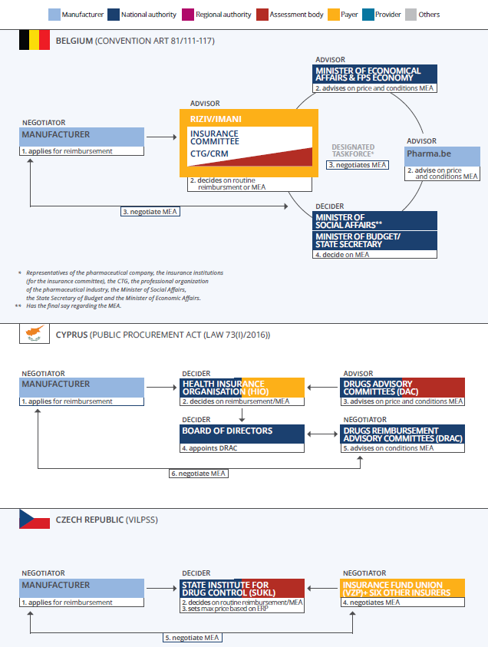

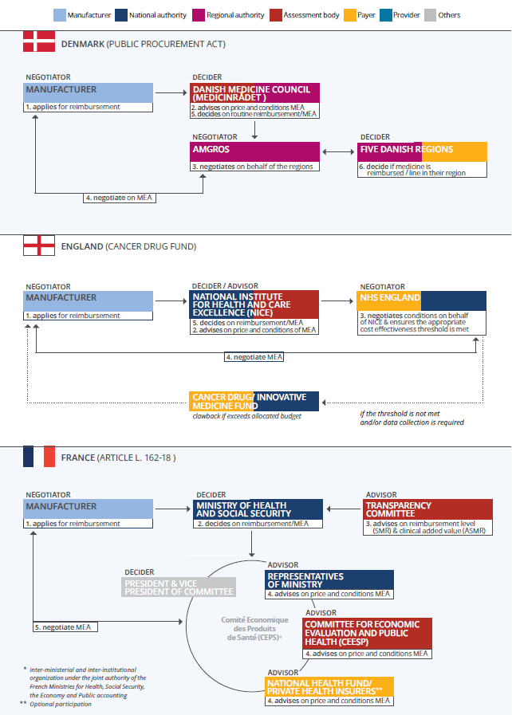

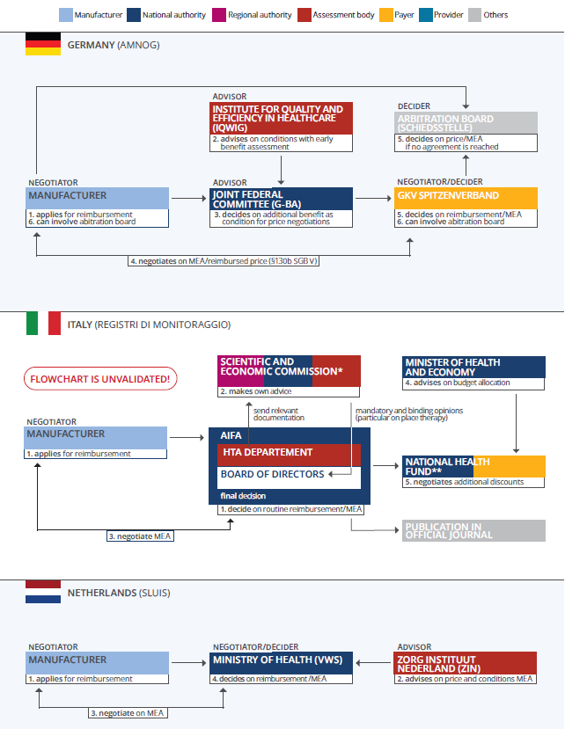

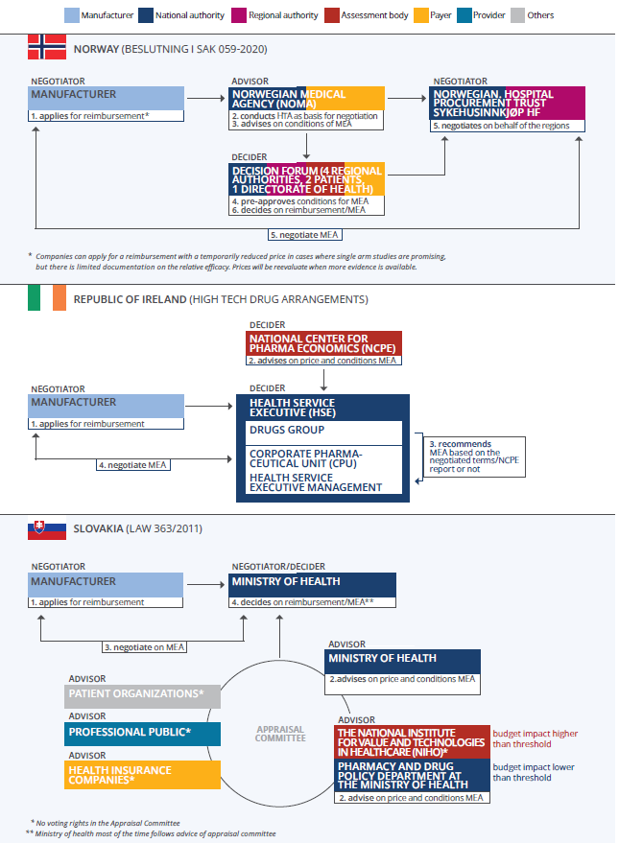

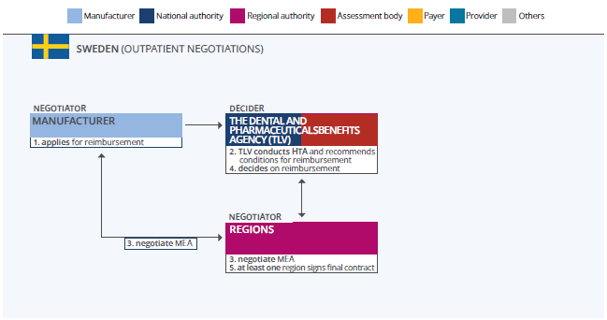
Appendix 5 Financial data
Country | Financial outcomes | 2016 | 2017 | 2018 | 2019 | 2020 | 2021 | 2022 | Source
BE | Average discounts/ price reduction (%) | 18.6 | 25.5 | 27.2 | 39.4 | 40.4 | 53.8 | Changed methodology | (1)
CY | Average discounts/ price reduction (%) | NA | NA | NA | NA | NA | NA | NA | Not reported
CZ | Average discounts/ price reduction (%) | NA | NA | NA | NA | NA | NA | NA | Not reported
DE | Average discounts/ price reduction (%) | NA | NA | 13 | 13 | 12 | 13 | 14 | Data request in personal correspondence
DK | Average discounts/ price reduction (%) | 26.3 | 27.2 | 32.5 | 39.9 | 39.8 | 43 | 44.9 | (2)
ENG | Average discounts/ price reduction (%) | NA | NA | NA | NA | NA | NA | NA | Not published due to confidentiality agreements
FR | Average discounts/ price reduction (%) | Not published | Not published | 22.7 | 25.5 | 26.6 | 23.2 | 25.1 | (3)
IE | Average discounts/ price reduction (%) | 6.24 | 6.12 | 8.70 | 13.17 | 15.96 | Not reported | Not reported | (4)
IT | Average discounts/ price reduction (%) | NA | NA | NA | 4 | 5 | 3 | NA | Calculated using the disclosed financial outcomes from 'Financial outcomes of managed entry agreements for pharmaceuticals in Italy’(5)
NL | Average discounts/ price reduction (%) | NA | NA | 34.15 | 40.13 | 42.17 | 45.81 | 46.04 | Calcualted using 'Voortgangsbrief financiële arrangementen geneesmiddelen'(6)
NO | Average discounts/ price reduction (%) | NA | NA | NA | NA | NA | NA | NA | NA
SE | Average discounts/ price reduction (%) |  | 23.68 | 43.97 | 49.74 | 44.11 | 42.63 | 42.61 | Calculated based on TLV: Besparingar från sidoöverenskommelser (7)
SK | Average discounts/ price reduction (%) | NA | NA | NA | NA | NA | NA | NA | NA
BE | Estimated expenditure without MEA excluding VAT(Billion EUR) | 0.653 | 1.070 | 1.315 | 1.534 | 1.866 | 1.896 | Changed methodology | (1)
CY | Estimated expenditure without MEA excluding VAT(Billion EUR) | NA | NA | NA | NA | NA | NA | NA | Not reported
CZ | Estimated expenditure without MEA excluding VAT(Billion EUR) | NA | NA | NA | NA | NA | NA | NA | Not reported
DE | Estimated expenditure without MEA excluding VAT(Billion EUR) | NA | NA | 10.249 | 12.830 | 15.811 | 19.921 | 23.362 | Data request
DK | Estimated expenditure without MEA excluding VAT(Billion DKK) | 8.76 | 11.56 | 13.1 | 14.74 | 15.36 | 16.41 | 17.23 | (2)
ENG | Estimated expenditure without MEA excluding VAT(Billion EUR) | NA | NA | NA | NA | NA | NA | NA | NA
FR | Estimated expenditure without MEA excluding VAT(Billion EUR) | Incalculable | Incalculable | 8.28234 | 9.44735 | 11.96338 | 19.11987 | 22.15477 | Calculated
IE | Estimated expenditure without MEA excluding VAT(Billion EUR) | 0.38659 | 0.43818 | 0.52394 | 0.58491 | 0.6298 | Not reported | Not reported | (4)
IT | Estimated expenditure without MEA excluding VAT(Billion EUR) | Not found | Incalculable | Incalculable | 2.1307 | 2.1901 | 2.3107 | Incalculable | Calculated using the disclosed financial outcomes from 'Financial outcomes of managed entry agreements for pharmaceuticals in Italy' (5)
NL | Estimated expenditure without MEA excluding VAT(Billion EUR) | NA | NA | 0.759144 | 1.033578 | 1.292564 | 1.479751 | 1.76358 | (6)
NO | Estimated expenditure without MEA excluding VAT(Billion EUR) | NA | NA | NA | NA | NA | NA | NA | NA
SE | Estimated expenditure without MEA excluding VAT(Billion SEC) |  | 4.00 | 6.30 | 6.20 | 6.40 | 6.35 | 3.35 | (7)
SK | Estimated expenditure without MEA excluding VAT(Billion EUR) | NA | NA | Not given | Not given | Not given | Not given | NA | NA
BE | Estimated Net expenditure with MEA excluding VAT (Billion EUR) | 0.531293 | 0.796866 | 0.957396 | 0.929097 | 1.112284 | 0.876731 | NA | (1)
CY | Estimated Net expenditure with MEA excluding VAT (Billion EUR) | NA | NA | NA | NA | NA | NA | NA | Not reported
CZ | Estimated Net expenditure with MEA excluding VAT (Billion EUR) | NA | NA | NA | NA | NA | NA |  | Not reported
DE | Estimated Net expenditure with MEA excluding VAT (Billion EUR) | NA | NA | 8.102 | 10.238 | 12.759 | 15.837 | No | Data request
DK | Estimated Net expenditure with MEA excluding VAT (Billion DKK) | 7.76 | 8.41 | 8.89 | 8.57 | 9.25 | 9.35 | Changed methodology | (2)
ENG | Estimated Net expenditure with MEA excluding VAT (Billion EUR) | Not published in report | Not published in report | 0.05 | 0.168 | 0.291 | 0.329 | No | (8)
FR | Estimated Net expenditure with MEA excluding VAT (Billion EUR) | Incalculable | Incalculable | 6.40266 | 7.03901 | 8.78163 | 14.685 | No | Calculated using CEPS reports (3)
IE | Estimated Net expenditure with MEA excluding VAT (Billion EUR) | 0.362 | 0.411 | 0.478 | 0.508 | 0.529 | Not reported | Not reported | (4)
IT | Estimated Net expenditure with MEA excluding VAT (Billion EUR) | NA | NA | NA | 2.0379 | 2.0955 | 2.2026 | Depending on data entry | (5)
NL | Estimated Net expenditure with MEA excluding VAT (Billion EUR) | NA | NA | 0.499892 | 0.6188 | 0.747474 | 0.801892 | 0.95095 | (6)
NO | Estimated Net expenditure with MEA excluding VAT (Billion EUR) | NA | NA | NA | NA | NA | NA | NA | NA
SE | Estimated Net expenditure with MEA excluding VAT (Billion SEC) |  | 3.05 | 3.53 | 3.12 | 3.58 | 3.64 | 3.35 | Calculated based on TLV: Besparingar från sidoöverenskommelser (7)
SK | Estimated Net expenditure with MEA excluding VAT (Billion EUR) | NA | NA | NA | NA | NA | NA | NA | NA
BE | Mandatory discount included in financial outcomes (Yes(%)/No) | No | No | No | No | No | No | Changed methodology | (1)
CY | Mandatory discount included in financial outcomes (Yes(%)/No) | NA | NA | NA | NA | NA | NA | NA | Not reported
CZ | Mandatory discount included in financial outcomes (Yes(%)/No) | NA | NA | NA | NA | NA | NA | NA | Not reported
DK | Mandatory discount included in financial outcomes (Yes(%)/No) | Unknown | Unknown | Unknown | Unknown | Unknown | Unknown | Unknown | Not reported
DE | Mandatory discount included in financial outcomes (Yes(%)/No) | No | No | No | No | No | No | No | Data request
ENG | Mandatory discount included in financial outcomes (Yes(%)/No) | No | No | No | No | No | No | No | If CDF crosses over the allocated budget of £340 pounds, it gets claimed back from the companies that benefited from the fund. However, the expenditure was until now not over the allocated budget(8)
FR | Mandatory discount included in financial outcomes (Yes(%)/No) | No | No | No | No | No | No | No | NA
IE | Mandatory discount included in financial outcomes (Yes(%)/No) | Yes (5.5%) | Yes (5.5%) | Yes (5.5%) | Yes (5.5%) | Yes (5.5%) | Not reported | Not reported | (4)
IT | Mandatory discount included in financial outcomes (Yes(%)/No) | Depending on data entry | Depending on data entry | Depending on data entry | Depending on data entry | Depending on data entry | Depending on data entry | Depending on data entry | Interview
NL | Mandatory discount included in financial outcomes (Yes(%)/No) | NA | NA | 13.6 | 16.98 | 15.67 | 19.66 | 18.63 | Calcualted using 'Voortgangsbrief financiële arrangementen geneesmiddelen' (6)
NO | Mandatory discount included in financial outcomes (Yes(%)/No) | NA | NA | NA | NA | NA | NA | NA | NA
SE | Mandatory discount included in financial outcomes (Yes(%)/No) | NA | No | No | No | No | No | No | Interview
SK | Mandatory discount included in financial outcomes (Yes(%)/No) | NA | NA | NA | NA | NA | NA | NA | NA
BE | Net reductions/savings excluding VAT (Billion EUR) | 0.121316 | 0.172652 | 0.357571 | 0.605135 | 0.735996 | 1.019539 | Changed methodology | (1)
CY | Net reductions/savings excluding VAT (Billion EUR) | NA | NA | NA | NA | NA | NA | NA | Not reported
CZ | Net reductions/savings excluding VAT (Billion EUR) | NA | NA | NA | NA | NA | NA | NA | Not reported
DE | Net reductions/savings excluding VAT (Billion EUR) | NA | NA | 2.1465 | 2.592 | 3.0525 | 4.08324 | 5.04 | Data request
DK | Net reductions/savings excluding VAT (Billion DKK) | 2.77 | 3.14 | 4.28 | 5.88 | 6.11 | 7.06 | 7.95 | (2)
ENG | Net reductions/savings excluding VAT (Billion EUR) | NA | NA | NA | NA | NA | NA | NA | Not published due to confidentiality agreements
FR | Net reductions/savings excluding VAT (Billion EUR) | 0.98879 | 1.34123 | 1.87968 | 2.40834 | 3.18175 | 4.43487 | 5.56072 | (3)
IE | Net reductions/savings excluding VAT (Billion EUR) | 0.02412 | 0.0268 | 0.04556 | 0.07705 | 0.1005 | Not reported | Not reported | (4)
IT | Net reductions/savings excluding VAT (Billion EUR) | NA | 0.47799 | 0.15588 | 0.09297 | 0.09477 | 0.10827 | 0.07 | (5)
NL | Net reductions/savings excluding VAT (Billion EUR) | NA | NA | 0.259252 | 0.414778 | 0.54509 | 0.677859 | 0.815724 | (6)
NO | Net reductions/savings excluding VAT (Billion EUR) | NA | NA | NA | NA | NA | NA | NA | NA
SE | Net reductions/savings excluding VAT (Billion SEC) | 0.722 | 0.95 | 2.77 | 3.08 | 2.82 | 2.71 | 2.49 | (7)
SK | Net reductions/savings excluding VAT (Billion EUR) | NA | NA | NA | NA | NA | NA | 0.04256 | (9)
BE | VAT included in financial outcomes (Yes(%)/No) | No | No | No | No | No | No | Changed methodology | (1)
CY | VAT included in financial outcomes (Yes(%)/No) | NA | NA | NA | NA | NA | NA | NA | Not reported
CZ | VAT included in financial outcomes (Yes(%)/No) | NA | NA | NA | NA | NA | NA | NA | Not reported
DK | VAT included in financial outcomes (Yes(%)/No) | Unknown | Unknown | Unknown | Unknown | Unknown | Unknown | NA | Not reported
DE | VAT included in financial outcomes (Yes(%)/No) | NA | NA | Yes (19%) | Yes (19%) | Yes (19% /16%) | Yes (16%) | Yes (16%) | Data request
ENG | VAT included in financial outcomes (Yes(%)/No) | Yes, where relevant | Yes, where relevant | Yes, where relevant | Yes, where relevant | Yes, where relevant | Yes, where relevant | Yes, where relevant | VAT is product dependent
FR | VAT included in financial outcomes (Yes(%)/No) | Yes (2,1%) | Yes (2,1%) | Yes (2,1%) | Yes (2,1%) | Yes (2,1%) | Yes (2,1%) | Yes (2,1%) | (3)
IE | VAT included in financial outcomes (Yes(%)/No) | Yes (23%) | Yes (23%) | Yes (23%) | Yes (23%) | Yes (23%) | Not reported | Not reported | (4)
IT | VAT included in financial outcomes (Yes(%)/No) | Yes (10%) | Yes (10%) | Yes (10%) | Yes (10%) | Yes (10%) | Yes (10%) | Yes (10%) | Interview
NL | VAT included in financial outcomes (Yes(%)/No) | NA | NA | Yes (6%) | Yes (9%) | Yes (9%) | Yes (9%) | Yes (9%) | (6)
NO | VAT included in financial outcomes (Yes(%)/No) | NA | NA | NA | NA | NA | NA | NA | NA
SE | VAT included in financial outcomes (Yes(%)/No) | No | No | No | No | No | No | No | Interview
SK | VAT included in financial outcomes (Yes(%)/No) | NA | NA | NA | NA | NA | NA | Yes (20%) | NA

1. RIZIV. MORSE-rapport gegevens 2021: Monitoring Of Reimbursement Significant Expenses 2021 [5-4-2026]. Available from: https://www.riziv.fgov.be/SiteCollectionDocuments/morse_rapport_gegevens_2021.pdf.
2. Amgros. Markedsovervågning 2018 [5-4-2026]. Available from: https://www.amgros.dk/om-amgros/presse-og-analyser/markedsovervaagning/.
3. CEPS. Rapport d’activité 2022 [Available from: https://sante.gouv.fr/ministere/acteurs/instances-rattachees/comite-economique-des-produits-de-sante-ceps/article/rapports-d-activite-du-ceps.
4. S. Prior RS, M. Hennessy, E. Walker. Spending Review 2021: Review of High-Tech Drug Expenditure 2021 [5-4-2026]. Available from: https://assets.gov.ie/static/documents/review-of-high-tech-drug-expenditure.pdf.
5. Trotta F, Guerrizio MA, Di Filippo A, Cangini A. Financial Outcomes of Managed Entry Agreements for Pharmaceuticals in Italy. JAMA Health Forum. 2023;4(12):e234611.
6. VWS. Voortgangsbrief financiële arrangementen geneesmiddelen 2023 [5-4-2026]. Available from: https://open.overheid.nl/documenten/0230958a-aae0-4088-9f3a-420bf4aa609c/file.
7. TLV. Prognos av besparingar från sidoöverenskommelser 2023 [5-4-2026]. Available from: https://www.tlv.se/publikationer/publikationer/2024-06-03-prognos-av-besparingar-fran-sidooverenskommelser-2024-2027.html?query=besparingar.
8. NHS. Cancer Drugs Fund activity update Q4 2023-24 2024 [5-4-2026]. Available from: https://www.england.nhs.uk/long-read/cancer-drugs-fund-activity-update-q4-2023-24/.
9. NIHO. Annual Report on the Activities of the Institute 2022 [5-4-2026]. Available from: https://niho.sk/en/zverejnovanie/.

19% up until 30.06.2020. After 1.7.2021) it was reduced to 16% due to COVID 19 measures.

