Supplementary Material

Simulation methods for the genetic effects
Assume that the measured and unmeasured genetic effects on the log scale are $Y_{1}$ and $Y_{2}$, respectively. We assume that $Y_{i}\sim N(μ_{i}, σ_{i}^{2})$ for $i$ being either 1 or 2, where $μ_{i}=-σ_{i}^{2}/2$, so that $E\left(\exp\left(Y_{i}\right)\right)=1$. Further, we assume that the two effects are independent. To allow for common random numbers, we initially sample for the total genetic effect $k=Y_{1}+Y_{2}$ on the log scale. We then want to sample for $Y_{1}$ given $k$. First, we calculate the normalizing value $ψ=\int_{-∞}^{∞}{ϕ\left(u | μ_{1},σ_{1}^{2}\right)}ϕ(k-u|μ_{2},σ_{2}^{2})du$, which is the area under the bivariate normal distribution for the sum $k$ (where $ϕ()$ is the probability density function for a univariate normal distribution). Second, we calculate the conditional mean for $Y_{1}$, which is $E(Y_{1}|k)=\frac{\int_{-∞}^{∞}{u ϕ\left(u | μ_{1},σ_{1}^{2}\right)}ϕ\left(k-u | μ_{2},σ_{2}^{2}\right)du}{ψ}$. Third, we calculate the conditional variance for $Y_{1}$, which is $var(Y_{1}|k)=\frac{\int_{-∞}^{∞}{{\left(u-E\left(Y_{1} | k\right)\right)}^{2}ϕ\left(u | μ_{1},σ_{1}^{2}\right)}ϕ\left(k-u | μ_{2},σ_{2}^{2}\right)du}{ψ}$. Finally, we sample for $Y_{1}$ assuming that it is normal and given the conditional mean and variance, and calculate $Y_{2}=k-Y_{1}$.

This approach can be readily extended to include correlated genetic effects: consider a bivariate normal distribution $Y\sim MVN(μ,Σ)$ with mean $μ$ and covariance matrix $Σ$. Then, following a similar approach, we have a normalizing value $ψ=\int_{-∞}^{∞}{ϕ\left({\left[u,k-u\right]}^{T} | μ,Σ\right)}du$, $E(Y_{1}|k)=\frac{\int_{-∞}^{∞}{u ϕ\left({\left[u,k-u\right]}^{T} | μ,Σ\right)}du}{ψ}$ and $var(Y_{1}|k)=\frac{\int_{-∞}^{∞}{{\left(u-E\left(Y_{1} | k\right)\right)}^{2}ϕ\left({\left[u,k-u\right]}^{T} | μ,Σ\right)}du}{ψ}$, where $ϕ()$ is the probability density function for a bivariate normal distribution.

Supplementary Table S1: Lifetime expected outcomes and cost-effectiveness from age 50 excluding the upper bound strategies
Strategy | Mean lifetime number of PSA tests | Mean lifetime number of biopsies | Lifetime risk of a prostate cancer diagnosis | Lifetime risk of a prostate cancer death | Life expectancy | Discounted health-sector costs (£) | Discounted quality-adjusted life expectancy | Incremental health-sector costs (£) | Incremental effects | ICER (£ per QALY gained) | Status
No screening | 0.000 | 0.298 | 0.1573 | 0.0564 | 32.555 | 1152.3 | 15.0160 | NA | NA | NA | ND
50 | 0.851 | 0.299 | 0.1574 | 0.0557 | 32.569 | 1198.1 | 15.0198 | 45.8 | 0.0038 | 12050.0 | ND
60 | 0.819 | 0.307 | 0.1595 | 0.0540 | 32.586 | 1256.0 | 15.0221 | 57.9 | 0.0023 | 25586.5 | ND
4-yearly | 4.126 | 0.362 | 0.1669 | 0.0494 | 32.642 | 1547.4 | 15.0321 | 291.4 | 0.0101 | 28932.0 | ND
2-yearly | 6.703 | 0.411 | 0.1688 | 0.0478 | 32.661 | 1727.7 | 15.0352 | 180.3 | 0.0031 | 58638.7 | ND
4-yearly (PRS first, pragmatic) | 2.039 | 0.327 | 0.1646 | 0.0511 | 32.622 | 1446.2 | 15.0286 | NA | NA | NA | ED
50 (PRS first, pragmatic) | 0.429 | 0.299 | 0.1574 | 0.0558 | 32.566 | 1223.3 | 15.0191 | NA | NA | NA | D
70 | 0.719 | 0.328 | 0.1634 | 0.0549 | 32.570 | 1243.2 | 15.0174 | NA | NA | NA | D
2-yearly (PRS first, pragmatic) | 3.298 | 0.352 | 0.1660 | 0.0498 | 32.636 | 1551.8 | 15.0311 | NA | NA | NA | D

Supplementary Table S2: Lifetime expected outcomes and cost-effectiveness from age 50, using EQ-5D rather than PORPUS-U for utility values

Strategy | Mean lifetime number of PSA tests | Mean lifetime number of biopsies | Lifetime risk of a prostate cancer diagnosis | Lifetime risk of a prostate cancer death | Life expectancy | Discounted health-sector costs (£) | Discounted quality-adjusted life expectancy | Incremental health-sector costs (£) | Incremental effects | ICER (£ per QALY gained) | Status
No screening | 0.000 | 0.298 | 0.1573 | 0.0564 | 32.555 | 1064.1 | 14.9870 | NA | NA | NA | ND
50 (PRS first, upper bound) | 0.429 | 0.299 | 0.1574 | 0.0558 | 32.568 | 1096.0 | 14.9896 | 31.9 | 0.0026 | 12161.3 | ND
50 | 0.851 | 0.299 | 0.1574 | 0.0557 | 32.569 | 1111.5 | 14.9898 | 15.5 | 0.0002 | 88259.2 | ND
4-yearly (PRS first, upper bound) | 2.021 | 0.325 | 0.1658 | 0.0502 | 32.632 | 1348.9 | 14.9917 | 237.4 | 0.0019 | 123933.0 | ND
2-yearly (PRS first, upper bound) | 3.261 | 0.350 | 0.1674 | 0.0488 | 32.649 | 1463.4 | 14.9924 | 114.5 | 0.0007 | 173559.4 | ND
2-yearly | 6.703 | 0.411 | 0.1688 | 0.0478 | 32.661 | 1653.3 | 14.9925 | 189.89548 | 0.000120 | 1577652.3 | ND
50 (PRS first, pragmatic) | 0.429 | 0.299 | 0.1574 | 0.0558 | 32.566 | 1136.3 | 14.9893 | NA | NA | NA | D
70 | 0.719 | 0.328 | 0.1634 | 0.0549 | 32.570 | 1156.8 | 14.9853 | NA | NA | NA | D
60 | 0.819 | 0.307 | 0.1595 | 0.0540 | 32.586 | 1171.7 | 14.9895 | NA | NA | NA | D
4-yearly (PRS first, pragmatic) | 2.039 | 0.327 | 0.1646 | 0.0511 | 32.622 | 1366.5 | 14.9910 | NA | NA | NA | D
4-yearly | 4.126 | 0.362 | 0.1669 | 0.0494 | 32.642 | 1470.3 | 14.9920 | NA | NA | NA | D
2-yearly (PRS first, pragmatic) | 3.298 | 0.352 | 0.1660 | 0.0498 | 32.636 | 1474.2 | 14.9916 | NA | NA | NA | D

Supplementary Table S3: Lifetime expected outcomes and cost-effectiveness excluding the upper bound strategies from age 50, using EQ-5D rather than PORPUS-U for utility values

Strategy | Mean lifetime number of PSA tests | Mean lifetime number of biopsies | Lifetime risk of a prostate cancer diagnosis | Lifetime risk of a prostate cancer death | Life expectancy | Discounted health-sector costs (£) | Discounted quality-adjusted life expectancy | Incremental health-sector costs (£) | Incremental effects | ICER (£ per QALY gained) | Status
No screening | 0.000 | 0.298 | 0.1573 | 0.0564 | 32.555 | 1064.1 | 14.9870 | NA | NA | NA | ND
50 | 0.851 | 0.299 | 0.1574 | 0.0557 | 32.569 | 1111.5 | 14.9898 | 47.4 | 0.0028 | 16952.8 | ND
4-yearly | 4.126 | 0.362 | 0.1669 | 0.0494 | 32.642 | 1470.3 | 14.9920 | 358.8 | 0.0022 | 162152.9 | ND
2-yearly | 6.703 | 0.411 | 0.1688 | 0.0478 | 32.661 | 1653.3 | 14.9925 | 183.0 | 0.0005 | 378952.0 | ND
4-yearly (PRS first, pragmatic) | 2.039 | 0.327 | 0.1646 | 0.0511 | 32.622 | 1366.5 | 14.9910 | NA | NA | NA | ED
50 (PRS first, pragmatic) | 0.429 | 0.299 | 0.1574 | 0.0558 | 32.566 | 1136.3 | 14.9893 | NA | NA | NA | D
70 | 0.719 | 0.328 | 0.1634 | 0.0549 | 32.570 | 1156.8 | 14.9853 | NA | NA | NA | D
60 | 0.819 | 0.307 | 0.1595 | 0.0540 | 32.586 | 1171.7 | 14.9895 | NA | NA | NA | D
2-yearly (PRS first, pragmatic) | 3.298 | 0.352 | 0.1660 | 0.0498 | 32.636 | 1474.2 | 14.9916 | NA | NA | NA | D

Supplementary Table S4: EQ-5D health state values used as alternative to PORPUS-U values

Health states | Utility value (EQ-5D) | Lower 95% CI | Upper 95% CI | Duration of state
PSA test | 0.99 | 0.99 | 1 | 1 week
Biopsy (SBx, TBx, TBx/SBx) | 0.9 | 0.87 | 0.94 | 3 weeks
Cancer diagnosis | 0.8 | 0.75 | 0.85 | 1 month
Active surveillance | 0.90 | 0.85 | 0.95 | 7 year
Radical prostatectomy (part 1) | 0.83 | 0.73 | 0.91 | 2 months
Radical prostatectomy (part 2) | 0.89 | 0.88 | 0.91 | 10 months
Radiation therapy (part 1) | 0.82 | 0.75 | 0.88 | 2 months
Radiation therapy (part 2) | 0.83 | 0.81 | 0.85 | 10 months
Androgen deprivation therapy and chemotherapy | 0.73 | 0.68 | 0.77 | 18 months
Post recovery period | 0.86 | 0.84 | 0.88 | 9 year
Palliative therapy | 0.62 | 0.58 | 0.66 | 12 months
Terminal illness | 0.4 | NR | NR | 6 months

Figure S1: Cost-effectiveness acceptability frontier using EQ-5D utility values
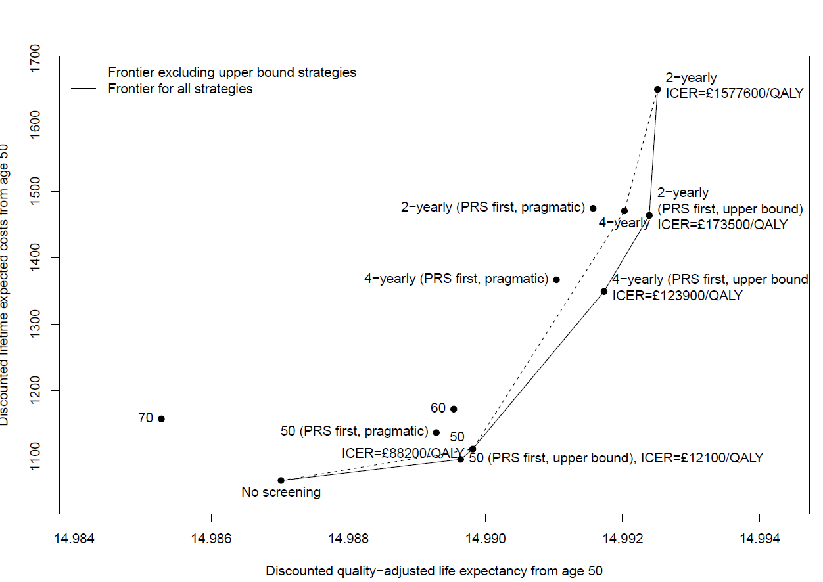

Figure S2: Cost-effectiveness acceptability curve – all strategies

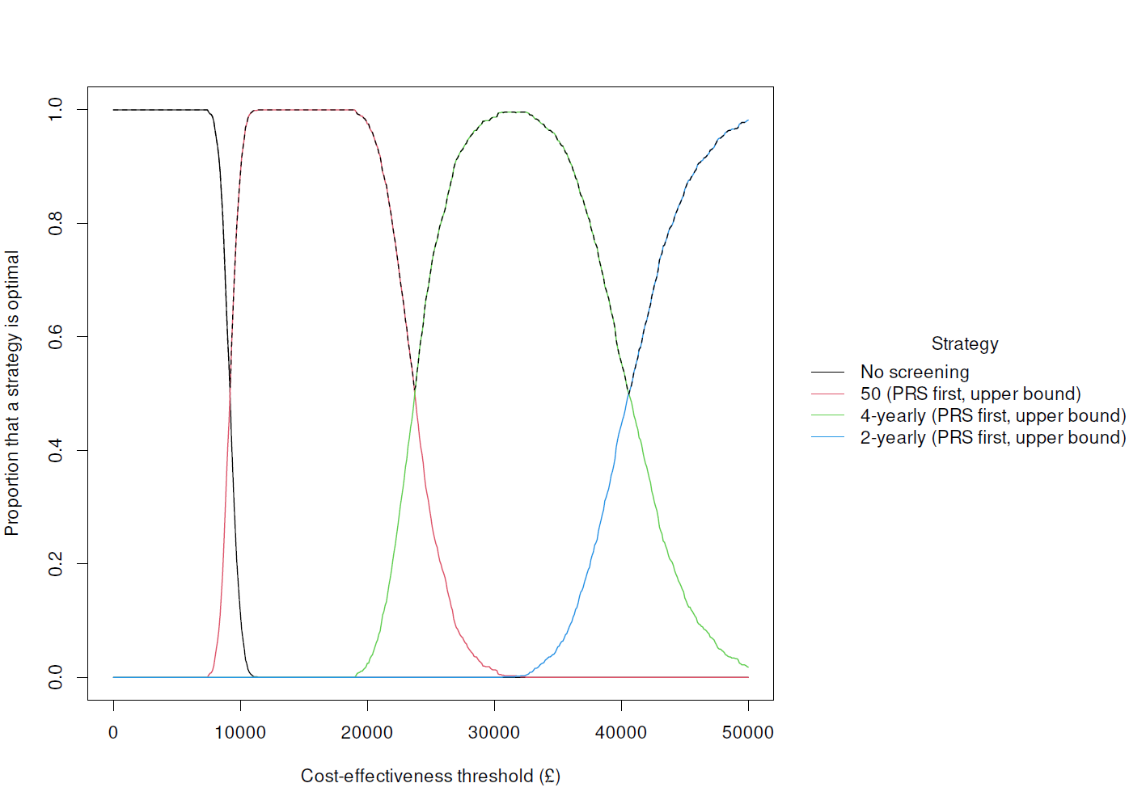

Figure S3: Cost-effectiveness acceptability curve – excluding “Upper bound” strategies

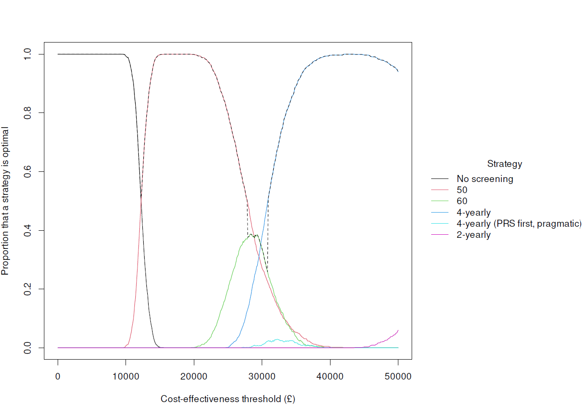

Supplementary Table S5 CHEERS Checklist

Section/topic | Item No | Guidance for reporting | Reported in section
Title
Title | 1 | Identify the study as an economic evaluation and specify the interventions being compared. | P1
Abstract
Abstract | 2 | Provide a structured summary that highlights context, key methods, results, and alternative analyses. | P2
Introduction
Background and objectives | 3 | Give the context for the study, the study question, and its practical relevance for decision making in policy or practice. | P3-4
Methods
Health economic analysis plan | 4 | Indicate whether a health economic analysis plan was developed and where available. | P4
Study population | 5 | Describe characteristics of the study population (such as age range, demographics, socioeconomic, or clinical characteristics). | P4-6
Setting and location | 6 | Provide relevant contextual information that may influence findings. | P4-6
Comparators | 7 | Describe the interventions or strategies being compared and why chosen. | P6-7
Perspective | 8 | State the perspective(s) adopted by the study and why chosen. | P6
Time horizon | 9 | State the time horizon for the study and why appropriate. | P4
Discount rate | 10 | Report the discount rate(s) and reason chosen. | P7
Selection of outcomes | 11 | Describe what outcomes were used as the measure(s) of benefit(s) and harm(s). | P7-8
Measurement of outcomes | 12 | Describe how outcomes used to capture benefit(s) and harm(s) were measured. | P7-8
Valuation of outcomes | 13 | Describe the population and methods used to measure and value outcomes. | P7-8
Measurement and valuation of resources and costs | 14 | Describe how costs were valued. | P7-8
Currency, price date, and conversion | 15 | Report the dates of the estimated resource quantities and unit costs, plus the currency and year of conversion. | P7-8
Rationale and description of model | 16 | If modelling is used, describe in detail and why used. Report if the model is publicly available and where it can be accessed. | P4-10
Analytics and assumptions | 17 | Describe any methods for analysing or statistically transforming data, any extrapolation methods, and approaches for validating any model used. | P4-10
Characterising heterogeneity | 18 | Describe any methods used for estimating how the results of the study vary for subgroups. | NA
Characterising distributional effects | 19 | Describe how impacts are distributed across different individuals or adjustments made to reflect priority populations. | NA
Characterising uncertainty | 20 | Describe methods to characterise any sources of uncertainty in the analysis. | P4-10, P19-20
Approach to engagement with patients and others affected by the study | 21 | Describe any approaches to engage patients or service recipients, the general public, communities, or stakeholders (such as clinicians or payers) in the design of the study. | NA
Study parameters | 22 | Report all analytic inputs (such as values, ranges, references) including uncertainty or distributional assumptions. | P8-9
Summary of main results | 23 | Report the mean values for the main categories of costs and outcomes of interest and summarise them in the most appropriate overall measure. | P10-14
Effect of uncertainty | 24 | Describe how uncertainty about analytic judgments, inputs, or projections affect findings. Report the effect of choice of discount rate and time horizon, if applicable. | P5, P19-20
Effect of engagement with patients and others affected by the study | 25 | Report on any difference patient/service recipient, general public, community, or stakeholder involvement made to the approach or findings of the study | NA
Study findings, limitations, generalisability, and current knowledge | 26 | Report key findings, limitations, ethical or equity considerations not captured, and how these could affect patients, policy, or practice. | P14-20
Other relevant information
Source of funding | 27 | Describe how the study was funded and any role of the funder in the identification, design, conduct, and reporting of the analysis | P21
Conflicts of interest | 28 | Report authors conflicts of interest according to journal or International Committee of Medical Journal Editors requirements. | P21

