Supplemental figures

Supplemental figure 1. Survival projection over a 20-year time horizon for overall survival in the pembrolizumab group, using 11 month follow-up data
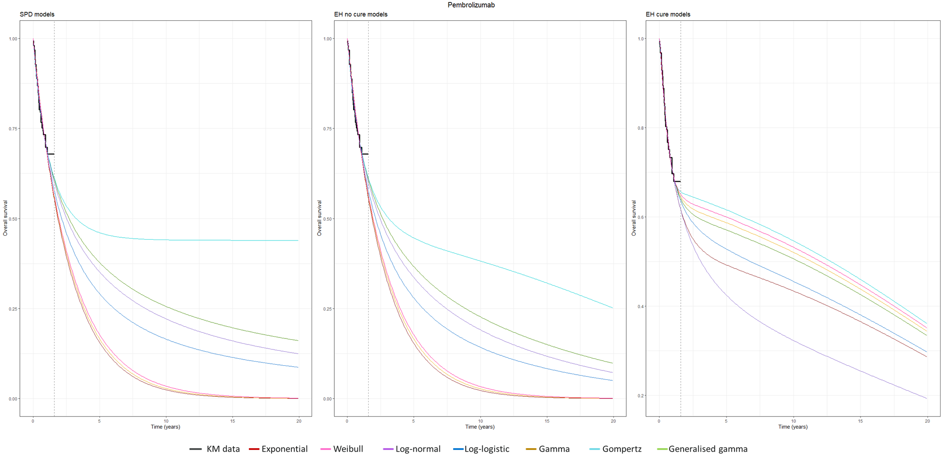
* The vertical dashed lines represent the maximum follow-up of KM data.

 |  | SPD models |  | EH no cure models |  | EH cure models
 | df | AIC | BIC | AIC | BIC | AIC | BIC
Exponential | 1 | 169.16 | 172.19 | 166.11 | 169.15 | 166.85 | 172.92
Weibull | 2 | 171.07 | 177.15 | 168.01 | 174.08 | 167.61 | 176.72
Gamma | 2 | 171.13 | 177.20 | 168.07 | 174.14 | 167.55 | 176.67
Gompertz | 2 | 170.05 | 176.13 | 166.94 | 173.02 | 168.37 | 177.48
Log-normal | 2 | 168.97 | 175.05 | 165.91 | 171.99 | 167.75 | 176.86
Log-logistic | 2 | 170.14 | 176.21 | 167.13 | 173.20 | 167.54 | 176.66
Generalised gamma | 3 | 170.91 | 180.03 | 167.83 | 176.94 | 169.54 | 181.69

Supplemental figure 2. Survival projection over a 20-year time horizon for overall survival in the chemotherapy group, using 11 month follow-up data
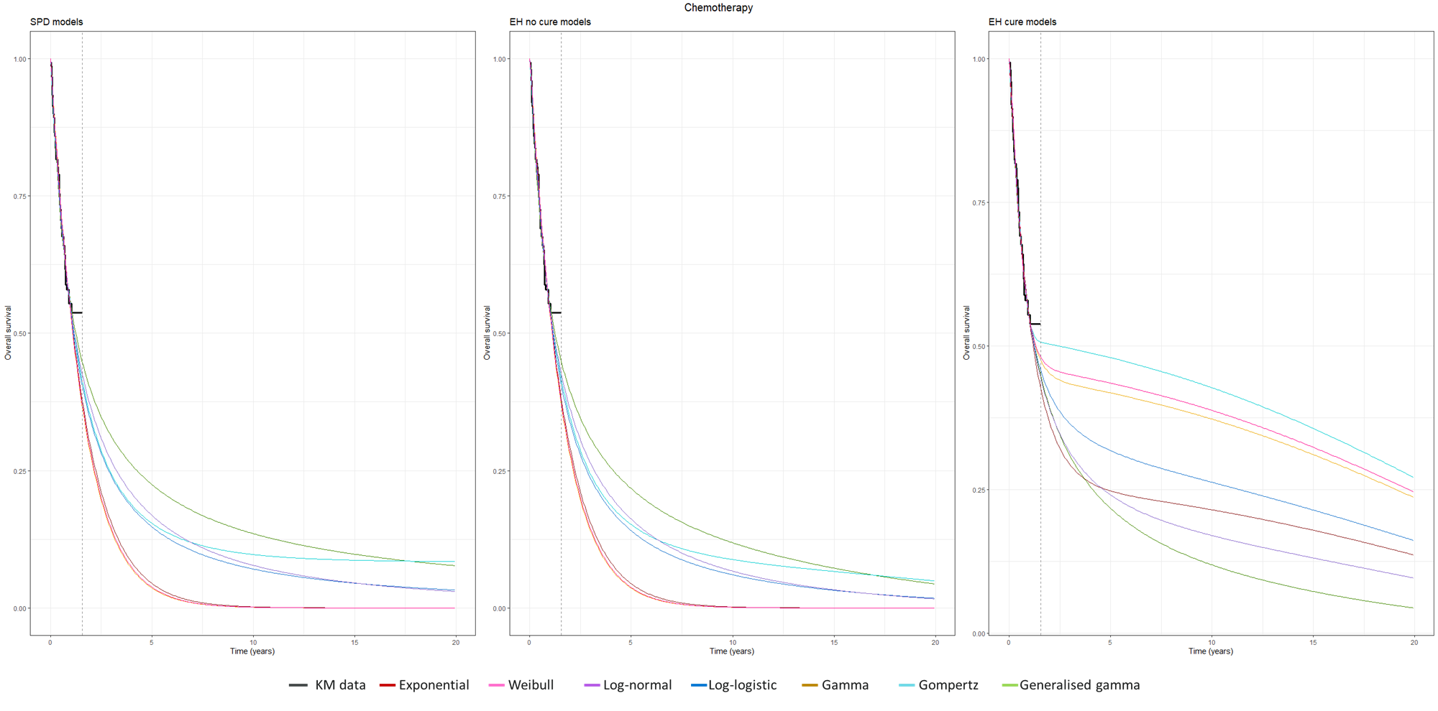
* The vertical dashed lines represent the maximum follow-up of KM data.

 |  | SPD models |  | EH no cure models |  | EH cure models
 | df | AIC | BIC | AIC | BIC | AIC | BIC
Exponential | 1 | 182.00 | 185.01 | 179.65 | 182.66 | 181.15 | 187.19
Weibull | 2 | 183.94 | 189.98 | 181.59 | 187.63 | 181.15 | 190.20
Gamma | 2 | 183.83 | 189.86 | 181.48 | 187.51 | 180.89 | 189.94
Gompertz | 2 | 183.63 | 189.66 | 181.27 | 187.30 | 182.14 | 191.19
Log-normal | 2 | 180.01 | 186.05 | 177.71 | 183.75 | 179.58 | 188.63
Log-logistic | 2 | 182.24 | 188.27 | 179.92 | 185.95 | 181.02 | 190.07
Generalised gamma | 3 | 181.59 | 190.64 | 179.26 | 188.31 | 181.26 | 193.33

Supplemental figure 3. Survival projection over a 20-year time horizon for progression free survival in the pembrolizumab group, using 11 month follow-up data
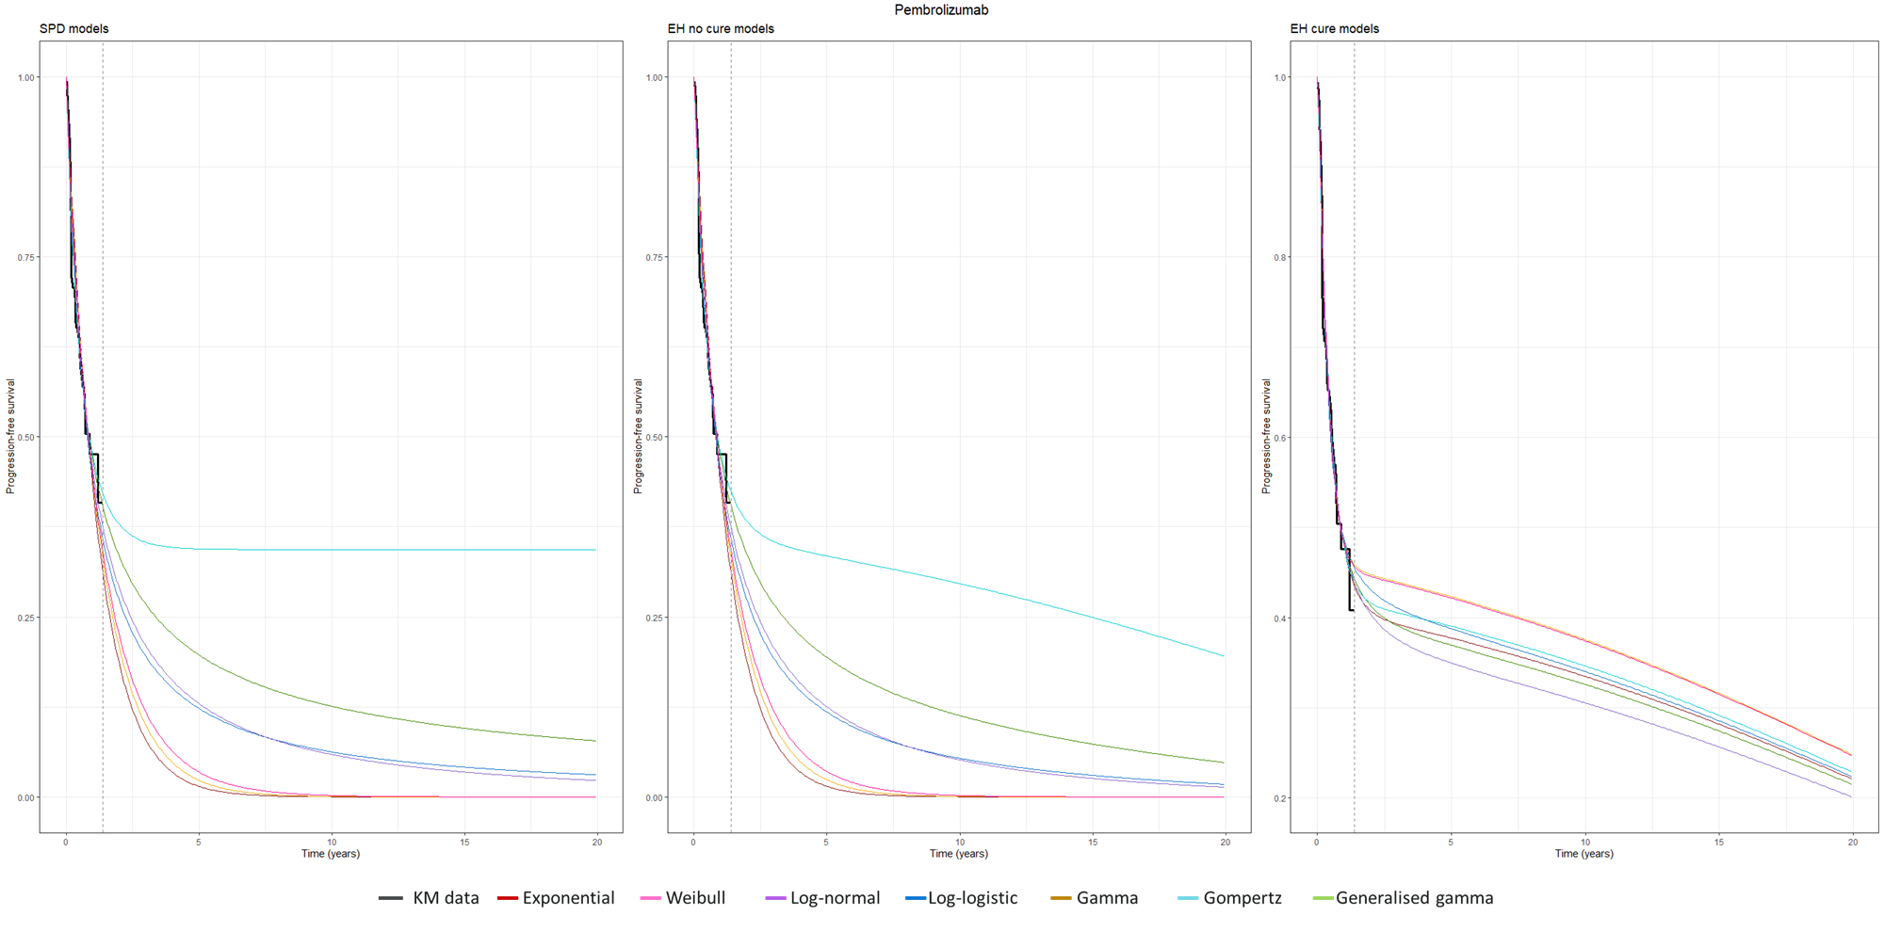
* The vertical dashed lines represent the maximum follow-up of KM data.

 |  | SPD models |  | EH no cure models |  | EH cure models
 | df | AIC | BIC | AIC | BIC | AIC | BIC
Exponential | 1 | 170.33 | 173.37 | 167.29 | 170.33 | 161.19 | 167.26
Weibull | 2 | 170.89 | 176.96 | 167.76 | 173.83 | 160.89 | 170.00
Gamma | 2 | 171.65 | 177.72 | 168.54 | 174.61 | 159.72 | 168.84
Gompertz | 2 | 164.87 | 170.94 | 161.50 | 167.57 | 163.17 | 172.28
Log-normal | 2 | 161.74 | 167.81 | 158.67 | 164.74 | 157.33 | 166.44
Log-logistic | 2 | 165.54 | 171.62 | 162.54 | 168.61 | 157.15 | 166.26
Generalised gamma | 3 | 162.06 | 171.17 | 158.78 | 167.89 | 159.25 | 171.40

Supplemental figure 4. Survival projection over a 20-year time horizon for progression free survival in the chemotherapy group, using 11 month follow-up data
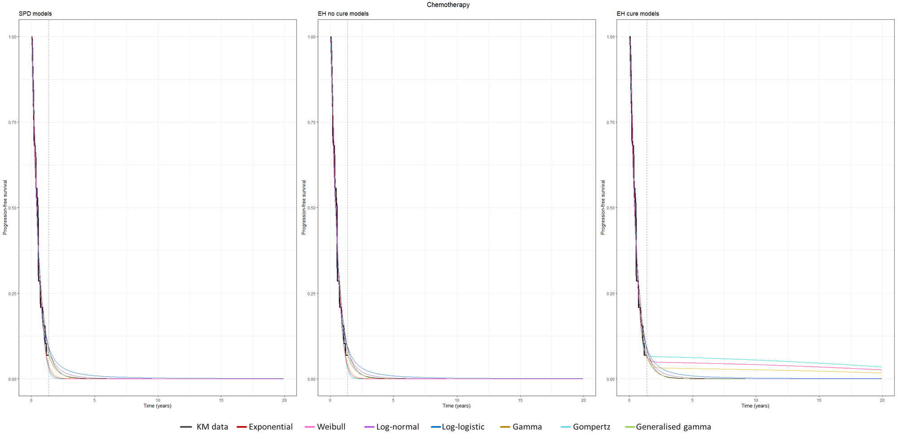
* The vertical dashed lines represent the maximum follow-up of KM data.

 |  | SPD models |  | EH no cure models |  | EH cure models
 | df | AIC | BIC | AIC | BIC | AIC | BIC
Exponential | 1 | 102.15 | 105.17 | 100.47 | 103.48 | 102.47 | 108.50
Weibull | 2 | 88.24 | 94.27 | 86.59 | 92.63 | 87.48 | 96.54
Gamma | 2 | 85.85 | 91.89 | 84.23 | 90.26 | 85.80 | 94.86
Gompertz | 2 | 96.46 | 102.50 | 94.80 | 100.83 | 94.61 | 103.67
Log-normal | 2 | 84.05 | 90.08 | 82.41 | 88.44 | 84.41 | 93.46
Log-logistic | 2 | 87.75 | 93.79 | 86.07 | 92.11 | 88.07 | 97.12
Generalised gamma | 3 | 85.53 | 94.58 | 83.91 | 92.96 | 85.91 | 97.98

Supplemental figure 5. Survival projection over a 40-year time horizon for overall survival in the pembrolizumab group, using 5 year follow-up data
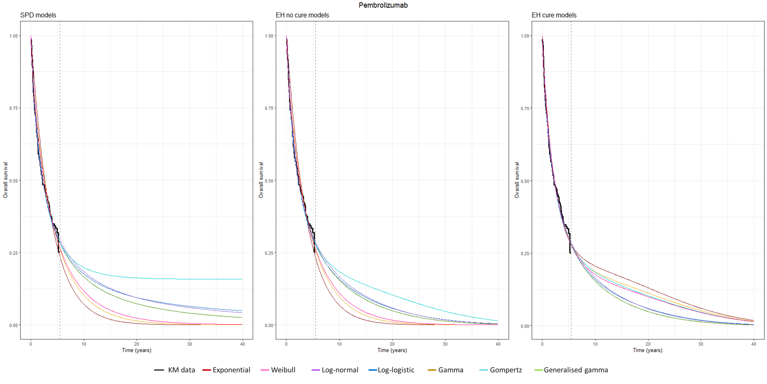
* The vertical dashed lines represent the maximum follow-up of KM data.

 |  | SPD models |  | EH no cure models |  | EH cure models
 | df | AIC | BIC | AIC | BIC | AIC | BIC
Exponential | 1 | 492.10 | 495.14 | 480.34 | 483.37 | 475.21 | 481.28
Weibull | 2 | 487.07 | 493.14 | 475.06 | 481.13 | 475.95 | 485.06
Gamma | 2 | 488.41 | 494.49 | 476.36 | 482.43 | 476.41 | 485.52
Gompertz | 2 | 485.43 | 491.50 | 473.49 | 479.56 | 475.48 | 484.59
Log-normal | 2 | 483.72 | 489.79 | 471.46 | 477.53 | 473.46 | 482.57
Log-logistic | 2 | 484.24 | 490.31 | 472.32 | 478.39 | 474.31 | 483.42
Generalised gamma | 3 | 485.20 | 494.31 | 473.18 | 482.29 | 475.18 | 487.33

Supplemental figure 6. Survival projection over a 40-year time horizon for overall survival in the chemotherapy group, using 5 year follow-up data
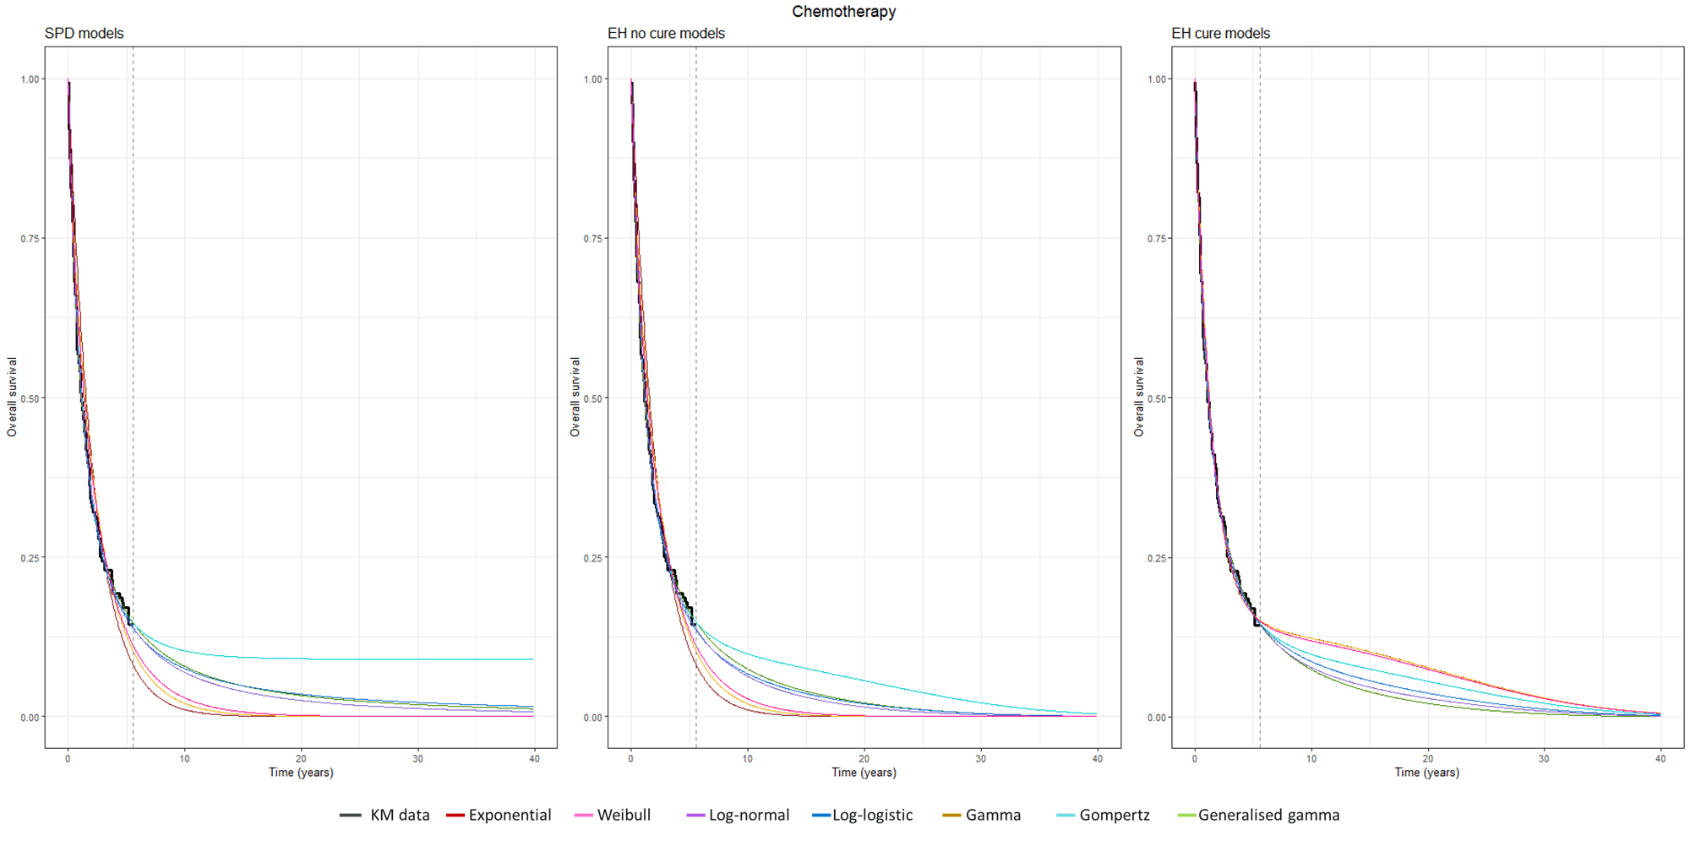
* The vertical dashed lines represent the maximum follow-up of KM data.

 |  | SPD models |  | EH no cure models |  | EH cure models
 | df | AIC | BIC | AIC | BIC | AIC | BIC
Exponential | 1 | 447.53 | 450.55 | 439.92 | 442.94 | 426.64 | 432.67
Weibull | 2 | 440.96 | 446.99 | 433.23 | 439.26 | 428.48 | 437.53
Gamma | 2 | 444.05 | 450.09 | 436.33 | 442.37 | 428.64 | 437.69
Gompertz | 2 | 433.07 | 439.10 | 424.86 | 430.89 | 426.85 | 435.91
Log-normal | 2 | 428.12 | 434.15 | 420.17 | 426.20 | 421.98 | 431.03
Log-logistic | 2 | 431.07 | 437.11 | 423.16 | 429.19 | 424.73 | 433.79
Generalised gamma | 3 | 429.82 | 438.87 | 421.64 | 430.69 | 423.64 | 435.71

Supplemental figure 7. Survival projection over a 40-year time horizon for progression free survival in the pembrolizumab group, using 5 year follow-up data
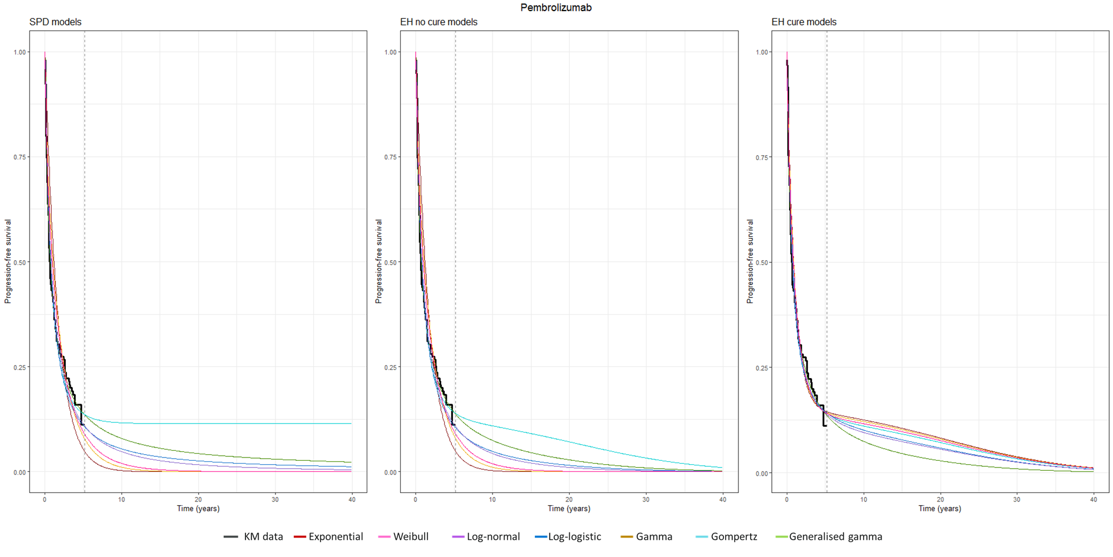
* The vertical dashed lines represent the maximum follow-up of KM data.

 |  | SPD models |  | EH no cure models |  | EH cure models
 | df | AIC | BIC | AIC | BIC | AIC | BIC
Exponential | 1 | 389.52 | 392.55 | 381.50 | 384.54 | 354.52 | 360.60
Weibull | 2 | 370.39 | 376.47 | 362.09 | 368.16 | 353.97 | 363.08
Gamma | 2 | 377.38 | 383.46 | 368.99 | 375.07 | 355.78 | 364.89
Gompertz | 2 | 355.38 | 361.45 | 346.50 | 352.57 | 348.34 | 357.45
Log-normal | 2 | 347.08 | 353.15 | 339.04 | 345.11 | 338.04 | 347.15
Log-logistic | 2 | 351.20 | 357.28 | 343.29 | 349.36 | 341.62 | 350.73
Generalised gamma | 3 | 344.27 | 353.38 | 335.44 | 344.55 | 337.44 | 349.58

Supplemental figure 8. Survival projection over a 40-year time horizon for progression free survival in the chemotherapy group, using 5 year follow-up data
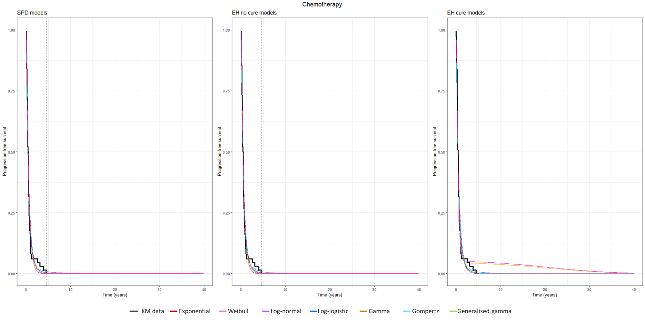
* The vertical dashed lines represent the maximum follow-up of KM data.

 |  | SPD models |  | EH no cure models |  | EH cure models
 | df | AIC | BIC | AIC | BIC | AIC | BIC
Exponential | 1 | 149.92 | 152.94 | 147.40 | 150.41 | 149.40 | 155.43
Weibull | 2 | 147.21 | 153.25 | 144.77 | 150.80 | 134.84 | 143.89
Gamma | 2 | 140.51 | 146.55 | 138.13 | 144.17 | 132.36 | 141.41
Gompertz | 2 | 151.00 | 157.04 | 148.44 | 154.47 | 150.44 | 159.49
Log-normal | 2 | 124.70 | 130.74 | 122.23 | 128.27 | 124.23 | 133.28
Log-logistic | 2 | 121.73 | 127.76 | 119.11 | 125.14 | 121.11 | 130.16
Generalised gamma | 3 | 126.52 | 135.58 | 124.09 | 133.14 | 126.09 | 138.16

Supplemental tables

Supplemental table 1. Validation of reconstructing individual patient level data using the IPDfromKM R package
 | Overall survival |  | Progression free survival
 | Pembrolizumab | Chemotherapy | Pembrolizumab | Chemotherapy
KN024 [5]
Root mean square error (RMSE) | 0.007 | 0.008 | 0.007 | 0.008
Mean absolute error | 0.003 | 0.003 | 0.003 | 0.003
Max absolute error | 0.031 | 0.036 | 0.031 | 0.036
Kolmogorov-Smirnov test statistics (p-value) | 0.08  (0.9853) | 0.04  (1) | 0.08  (0.9853) | 0.04  (1)
Hazard ratio (95% CI) from the reconstruction | 0.60  (0.40 - 0.89) |  | 0.48  (0.36 - 0.64)
Hazard ratio (95% CI) from the publication | 0.60  (0.41 - 0.89) |  | 0.50  (0.37 - 0.68)
KN024 with 5-year update [7]
Root mean square error (RMSE) | 0.002 | 0.002 | 0.003 | 0.003
Mean absolute error | 0.002 | 0.002 | 0.002 | 0.002
Max absolute error | 0.003 | 0.006 | 0.004 | 0.007
Kolmogorov-Smirnov test statistics (p-value) | 0.04  (0.9999) | 0.06  (0.9988) | 0.03  (1) | 0.07  (0.999)
Hazard ratio (95% CI) from the reconstruction | 0.63  (0.49 - 0.82) |  | 0.51  (0.39 - 0.66)
Hazard ratio (95% CI) from the publication | 0.62  (0.48 - 0.81) |  | 0.50  (0.39 - 0.65)
* RMSE, mean and max absolute error are calculated by comparing the reconstructed survival probabilities at each extracted time point against the original estimates based on the published Kaplan-Meier curve, reflecting deviations across the entire survival curve.

Supplemental table 2. Summary of specifying model inputs for deterministic analysis and probabilistic sensitivity analysis
 | Deterministic analysis |  |  |  | Probabilistic sensitivity analysis | Reference
 | Replication to the prior TLV evaluation, based on 11-month interim data | Explorative scenarios
 |  | A) SPD models, based on the 11-month interim data | B) EH models, based on 11-month interim data | C) EH models, based on the 5-year follow-up data
Model setting |  |  |  |  |  | [19, 33]
Intervention vs. control | Pembrolizumab 200 mg every 3 weeks for 35 cycles vs. platinum-based chemotherapy regimens for 4 to 6 cycles
Discount rate for utility | 3% |  |  |  | Uniform distribution in a range of 0 – 5%.
Discount rate for cost | 3% |  |  |  | Uniform distribution in a range of 0 – 5%.
Time horizon (years) | 20 | 40 | 40 | 40 | -
Survival input using standard parametric distribution models† |  |  |  |  |  | [19]
Pembrolizumab OS | Exponential | Log-normal | Log-normal | Log-normal | Normal distribution used to draw random value using mean, se, and lower and upper bounds (95% CI) of the model estimate
Pembrolizumab PFS | Weibull | Log-normal | Log-normal | Log-normal
CT OS | Exponential | Log-normal | Log-normal | Log-normal
CT PFS | Exponential | Log-normal | Log-normal | Log-normal
Probability of adverse events (grade 3+) |  |  |  |  |  | [22, 23]
Anaemia, pembrolizumab (%) | 0.045 |  |  |  | -
Neutropenia, pembrolizumab (%) | 0.000 |  |  |  | -
Pneumonia, pembrolizumab (%) | 0.019 |  |  |  | -
Thrombocytopenia, pembrolizumab (%) | 0.000 |  |  |  | -
Pneumonitis, pembrolizumab (%) | 0.026 |  |  |  | -
Anaemia, CT (%) | 0.233 |  |  |  | -
Neutropenia, CT (%) | 0.180 |  |  |  | -
Pneumonia, CT (%) | 0.073 |  |  |  | -
Thrombocytopenia, CT (%) | 0.120 |  |  |  | -
Pneumonitis, CT (%) | 0.007 |  |  |  | -
Utility input
PF state | 0.863 |  |  |  | Uniform distribution in a range of 0.778 - 0.863. | [6, 34]
PD state | 0.816 |  |  |  | Uniform distribution in a range of 0.668 - 0.816. | [6, 34]
Utility decrement for grade 3+ adverse events | 0.07 |  |  |  | Uniform distribution in a range of 0.03 - 0.11 | [35]
Cost input (SEK)
IV administration | 6,448 |  |  |  | Uniform distribution in a range of -30% - +30% of the base case value | [36]
Drug cost 1L, pembrolizumab per dose | 67,039 |  |  |  |  | [30]
Drug cost 1L, CT per dose | 12,939 |  |  |  |  | [19]
Drug cost 1L, CT maintenance per dose | 23,807 |  |  |  |  | [19]
Drug cost 2L, pembrolizumab arm (one-off) | 57,389 |  |  |  |  | [19]
Drug cost 2L, CT arm (one-off) | 337,097 |  |  |  |  | [19]
PF state cost per cycle | 1,976 |  |  |  |  | [29]
PD state cost per cycle | 4,080 |  |  |  |  | [29]
End of life care cost (one-off) | 82,458 |  |  |  |  | [29, 37]
AE cost per event, anaemia | 19,926 |  |  |  |  | [31]
AE cost per event, neutropenia | 28,642 |  |  |  |  | [31]
AE cost per event, pneumonia | 47,030 |  |  |  |  | [31]
AE cost per event, thrombocytopenia | 16,864 |  |  |  |  | [31]
AE cost per event, pneumonitis | 47,030 |  |  |  |  | [31]
*CT: Chemotherapy, IV: Intravenous, PD: Progressive disease, PF: Progression free, PFS: Progression free survival, OS: Overall survival
Normal distributions were applied, with sampling performed independently from truncated normal distributions defined by the point estimate, standard error, and 95% confidence interval bounds using rtruncnorm package. Correlations between parameters, such as shape and scale, were not modelled. Uniform distributions were applied when variance estimates were not available, with bounds defined by estimates obtained from published sources or by an exploratory range around the base case to avoid imposing unverifiable distributional assumptions.

