DNA barcoding of the invasive alien aquatic weed Heteranthera reniformis Ruiz & Pavon using chloroplast DNA markers

Srijana Thapa Magar¹. Takeshi Fujino^{1,*}. Rie Saito². Thilomi Samarakoon³

¹ Department of Environmental Science and Technology, Graduate School of Science and Engineering, Saitama University, 255 Shimo-Okubo, Sakura-ku, Saitama 338-8570, Japan

² Department of Animal Science, Faculty of Agriculture, Iwate University, 3-18-8 Ueda, Morioka 020-8550, Japan

³ Department of Zoology and Environmental Management, Faculty of Science, University of Kelaniya, Kelaniya 11600, Sri Lanka

* Corresponding author - Takeshi Fujino
fujino@mail.saitama-u.ac.jp

List of Supplementary data

Table S1 Pairwise genetic distances matrix for nucleotide sequences of partial matK sequences retrieved during a blast.
Table S2 Pairwise genetic distances matrix for nucleotide sequences of partial rbcL sequences retrieved during a blast.

Fig. S1 Phylogenetic analysis of partial matK sequences of Heteranthera reniformis and related taxa of Pontederiaceae.
Fig. S2 Phylogenetic analysis of partial rbcL sequences of Heteranthera reniformis and related taxa of Pontederiaceae.

Table S1. Pairwise genetic distances matrix for nucleotide sequences of partial matK sequences retrieved during a blast.

Species | 1 | 2 | 3 | 4 | 5 | 6 | 7 | 8 | 9 | 10 | 11 | 12 | 13 | 14 | 15 | 16
1. Heteranthera reniformis
2. H. callifolia | 0.005
3. Pontederia crassipes | 0.027 | 0.022
4. P. africana | 0.030 | 0.024 | 0.015
5. P. vaginalis | 0.030 | 0.024 | 0.015 | 0.000
6. P. elata | 0.030 | 0.024 | 0.015 | 0.000 | 0.000
7. P. paniculata | 0.030 | 0.024 | 0.026 | 0.025 | 0.025 | 0.025
8. P. valida | 0.032 | 0.026 | 0.016 | 0.001 | 0.001 | 0.001 | 0.026
9. P. hastata | 0.032 | 0.026 | 0.019 | 0.004 | 0.004 | 0.004 | 0.029 | 0.005
10. P. cordata | 0.030 | 0.025 | 0.018 | 0.016 | 0.016 | 0.016 | 0.027 | 0.018 | 0.018
11. P. cyanea | 0.033 | 0.027 | 0.017 | 0.008 | 0.008 | 0.008 | 0.027 | 0.009 | 0.012 | 0.019
12. P. azurea | 0.033 | 0.027 | 0.018 | 0.016 | 0.016 | 0.016 | 0.025 | 0.018 | 0.021 | 0.011 | 0.019
13. P. plantaginea | 0.036 | 0.030 | 0.020 | 0.005 | 0.005 | 0.005 | 0.029 | 0.007 | 0.009 | 0.022 | 0.013 | 0.022
14. P. australasica | 0.036 | 0.030 | 0.020 | 0.011 | 0.011 | 0.011 | 0.030 | 0.012 | 0.015 | 0.022 | 0.005 | 0.022 | 0.016
15. H. gardneri | 0.026 | 0.020 | 0.041 | 0.044 | 0.044 | 0.044 | 0.044 | 0.045 | 0.045 | 0.044 | 0.047 | 0.047 | 0.050 | 0.050
16. H. dubia | 0.013 | 0.008 | 0.026 | 0.030 | 0.030 | 0.030 | 0.030 | 0.032 | 0.032 | 0.027 | 0.033 | 0.033 | 0.036 | 0.036 | 0.026
17. P. korsakowii | 0.036 | 0.030 | 0.020 | 0.005 | 0.005 | 0.005 | 0.030 | 0.007 | 0.009 | 0.022 | 0.013 | 0.022 | 0.011 | 0.016 | 0.050 | 0.036
Notes: The assembled sequences were aligned using the MUSCLE algorithm and were conducted by Molecular Evolutionary Genetic MEGA11 software (Tamura et al. 2021). Tamura’s three-parameter nucleotide substitution model was selected as the best selection was determined by examining Bayesian Information Criterion (BIC) scores. There were 766 positions in the final dataset.

Table S2. Pairwise genetic distances matrix for nucleotide sequences of partial rbcL sequences retrieved during a blast.

Species | 1 | 2 | 3 | 4 | 5 | 6 | 7 | 8 | 9 | 10 | 11 | 12 | 13 | 14 | 15 | 16 | 17 | 18 | 19 | 20 | 21 | 22 | 23 | 24 | 25
1. Heteranthera reniformis
2. H. dubia | 0.004
3. H. callifolia | 0.004 | 0.007
4. Pontederia australasica | 0.006 | 0.006 | 0.009
5. H. limosa | 0.004 | 0.004 | 0.007 | 0.006
6. H. oblongifolia | 0.004 | 0.004 | 0.007 | 0.006 | 0.004
7. P. cyanea | 0.006 | 0.006 | 0.009 | 0.000 | 0.006 | 0.006
8. H. zosterifolia | 0.007 | 0.007 | 0.011 | 0.009 | 0.007 | 0.007 | 0.009
9. H. seubertiana | 0.002 | 0.002 | 0.006 | 0.004 | 0.002 | 0.002 | 0.004 | 0.006
10. H. gardneri | 0.011 | 0.011 | 0.015 | 0.013 | 0.009 | 0.011 | 0.013 | 0.015 | 0.009
11. P. meyeri | 0.011 | 0.011 | 0.015 | 0.006 | 0.011 | 0.011 | 0.006 | 0.015 | 0.009 | 0.019
12. P. vaginalis | 0.013 | 0.013 | 0.017 | 0.007 | 0.013 | 0.013 | 0.007 | 0.017 | 0.011 | 0.021 | 0.013
13. P. hastata | 0.013 | 0.013 | 0.017 | 0.007 | 0.013 | 0.013 | 0.007 | 0.017 | 0.011 | 0.021 | 0.013 | 0.000
14. P. africana | 0.013 | 0.013 | 0.017 | 0.007 | 0.013 | 0.013 | 0.007 | 0.017 | 0.011 | 0.021 | 0.013 | 0.000 | 0.000
15. P. valida | 0.013 | 0.013 | 0.017 | 0.007 | 0.013 | 0.013 | 0.007 | 0.017 | 0.011 | 0.021 | 0.013 | 0.000 | 0.000 | 0.000
16. P. elata | 0.013 | 0.013 | 0.017 | 0.007 | 0.013 | 0.013 | 0.007 | 0.017 | 0.011 | 0.021 | 0.013 | 0.000 | 0.000 | 0.000 | 0.000
17. P. paradoxa | 0.013 | 0.013 | 0.017 | 0.011 | 0.013 | 0.013 | 0.011 | 0.013 | 0.011 | 0.021 | 0.009 | 0.017 | 0.017 | 0.017 | 0.017 | 0.017
18. P. plantaginea | 0.015 | 0.015 | 0.019 | 0.009 | 0.015 | 0.015 | 0.009 | 0.019 | 0.013 | 0.023 | 0.015 | 0.002 | 0.002 | 0.002 | 0.002 | 0.002 | 0.019
19. P. paniculata | 0.017 | 0.017 | 0.021 | 0.011 | 0.017 | 0.017 | 0.011 | 0.017 | 0.015 | 0.025 | 0.009 | 0.019 | 0.019 | 0.019 | 0.019 | 0.019 | 0.007 | 0.021
20. P. korsakowii | 0.019 | 0.019 | 0.023 | 0.013 | 0.019 | 0.019 | 0.013 | 0.023 | 0.017 | 0.027 | 0.019 | 0.006 | 0.006 | 0.006 | 0.006 | 0.006 | 0.023 | 0.004 | 0.025
21. P. cordata | 0.021 | 0.017 | 0.025 | 0.019 | 0.021 | 0.021 | 0.019 | 0.025 | 0.019 | 0.029 | 0.017 | 0.019 | 0.019 | 0.019 | 0.019 | 0.019 | 0.019 | 0.021 | 0.023 | 0.025
22. P. azurea | 0.019 | 0.015 | 0.023 | 0.017 | 0.019 | 0.019 | 0.017 | 0.023 | 0.017 | 0.023 | 0.015 | 0.017 | 0.017 | 0.017 | 0.017 | 0.017 | 0.017 | 0.015 | 0.021 | 0.019 | 0.009
23. H. rotundifolia | 0.006 | 0.006 | 0.009 | 0.008 | 0.006 | 0.006 | 0.008 | 0.009 | 0.004 | 0.013 | 0.013 | 0.015 | 0.015 | 0.015 | 0.015 | 0.015 | 0.015 | 0.017 | 0.019 | 0.021 | 0.019 | 0.021
24. P. heterosperma | 0.019 | 0.015 | 0.023 | 0.017 | 0.019 | 0.019 | 0.017 | 0.023 | 0.017 | 0.023 | 0.015 | 0.017 | 0.017 | 0.017 | 0.017 | 0.017 | 0.017 | 0.015 | 0.021 | 0.019 | 0.009 | 0.000 | 0.021
25. P. sagittata | 0.023 | 0.019 | 0.023 | 0.017 | 0.023 | 0.023 | 0.017 | 0.027 | 0.021 | 0.031 | 0.019 | 0.013 | 0.013 | 0.013 | 0.013 | 0.013 | 0.023 | 0.015 | 0.025 | 0.019 | 0.009 | 0.015 | 0.021 | 0.015
26. P. crassipes | 0.025 | 0.025 | 0.029 | 0.019 | 0.025 | 0.025 | 0.019 | 0.025 | 0.023 | 0.033 | 0.021 | 0.019 | 0.019 | 0.019 | 0.019 | 0.019 | 0.025 | 0.017 | 0.027 | 0.021 | 0.023 | 0.025 | 0.023 | 0.025 | 0.021
Notes: The assembled sequences were aligned using the MUSCLE algorithm and were conducted by Molecular Evolutionary Genetic MEGA11 software (Tamura et al. 2021). Tamura’s 3-parameter model was selected as the best selection was determined by examining Bayesian Information Criterion (BIC) scores. There were 542 positions in the final dataset.
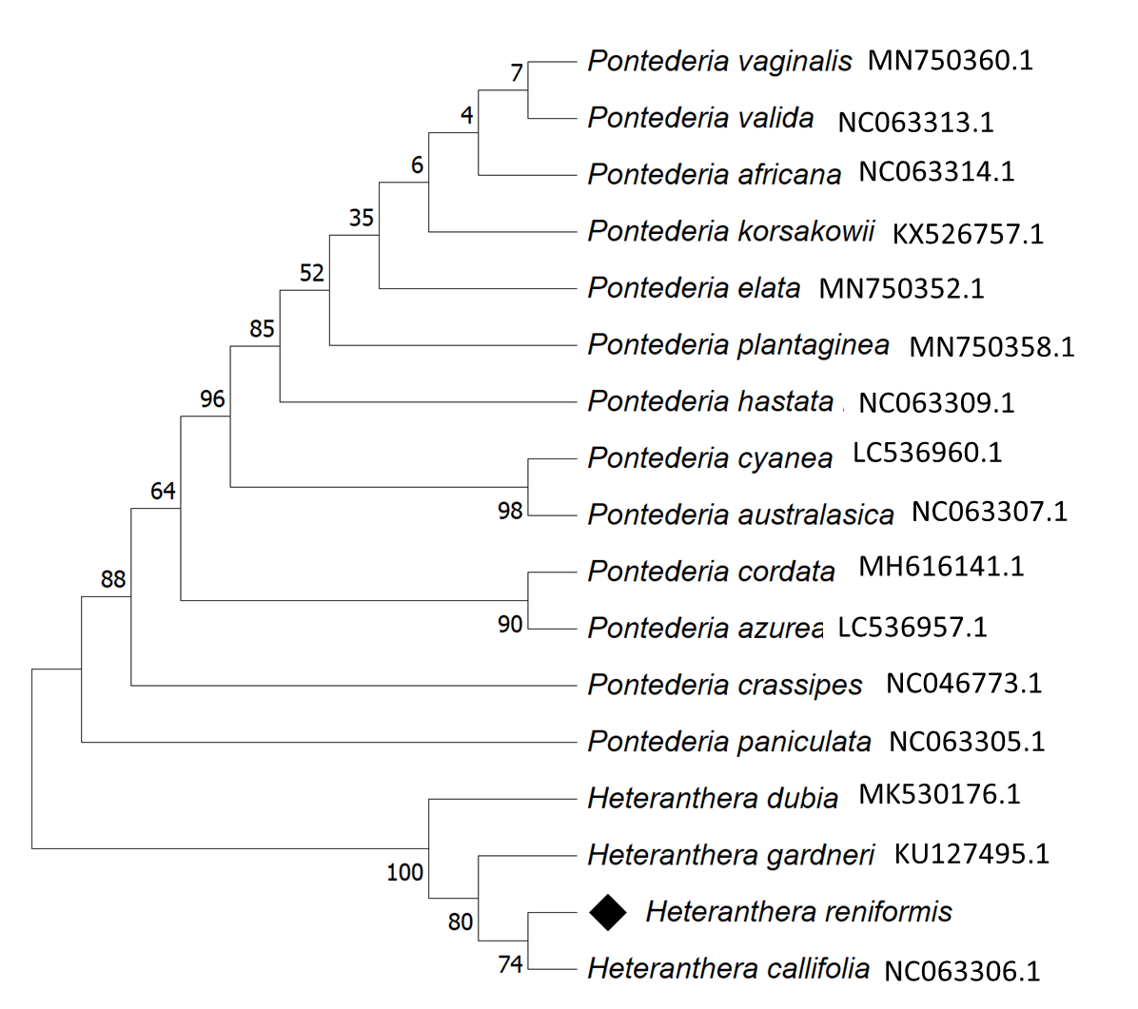
Fig S1. Phylogenetic analysis of partial matK sequences of Heteranthera reniformis and related taxa of Pontederiaceae. The Maximum likelihood (ML) method with Tamura’s 3-parameter model was used for phylogenetic analysis. The bootstrap method with 1000 bootstrap replication was used to validate the tree (Tamura 1992). This analysis involved 17 nucleotide sequences. Codon positions included were 1st + 2nd + 3rd + Noncoding. There was a total of 766 positions in the final dataset. (Tamura’s 3-parameter model was selected as the best selection was determined by examining Bayesian Information Criterion (BIC) scores. The assembled sequences were aligned using the MUSCLE algorithm and were conducted by Molecular Evolutionary Genetic MEGA11 software (Tamura et al. 2021).

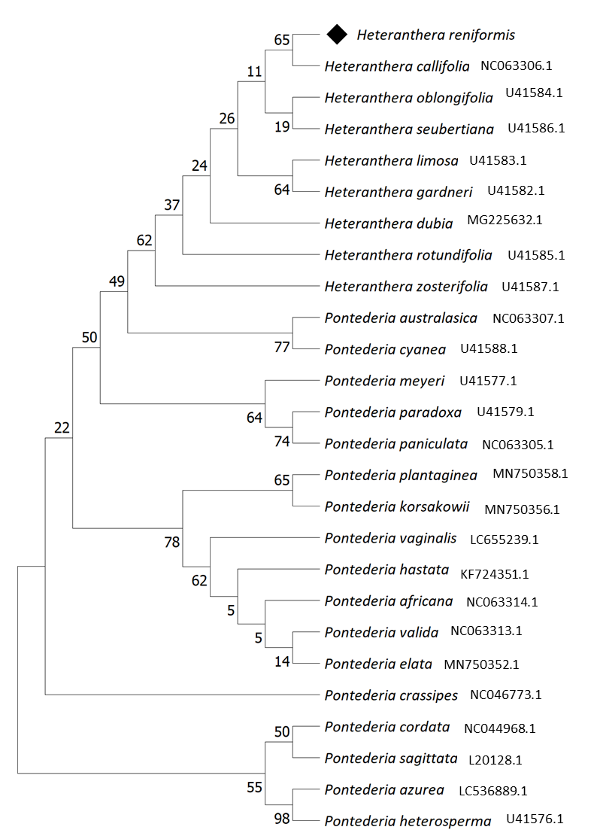
Fig S2. Phylogenetic analysis of partial rbcL sequences of Heteranthera reniformis and related taxa of Pontederiaceae. The Maximum likelihood (ML) method with Tamura’s 3-parameter model was used for phylogenetic analysis. The bootstrap method with 1000 bootstrap replication was used to validate the tree (Tamura 1992). A discrete Gamma distribution was used to model evolutionary rate differences among sites (5 categories (+G, parameter = 0.4471)). The rate variation model allowed some sites to be evolutionarily in-variable (+I, 77.73% sites). This analysis involved 26 nucleotide sequences. Codon positions included were 1st + 2nd + 3rd + Noncoding. There were a total of 542 positions in the final dataset. (Tamura’s 3-parameter model was selected as the best selection was determined by examining Bayesian Information Criterion (BIC) scores)
References
- Tamura, K (1992) Estimation of the number of nucleotide substitutions when there are strong transition-transversion and G+C-content biases. Mol Biol Evol 9(4):678–687.
doi:10.1093/oxfordjournals.molbev.a040752
- Tamura K, Stecher G, Kumar S (2021) MEGA11, Molecular Evolutionary Genetics Analysis version 11. Mol Biol Evol 38:3022–3027. doi:10.1093/molbev/msab120

