Article title: Deforestation impacts on environmental conditions of headwater streams and Ephemeroptera (Insecta) diversity in Southwestern Amazonia
Journal name: Limnology
Authors names: Ana Luiza-Andrade*, Mylena Neves Cardoso, Leandro Juen, Claudia R. T. De Lima, Marcos Roberto Vitoria Cristino, Gabriel Franco Borghetti, Izaias Médice Fernandes, Paulo Vilela Cruz
*Corresponding Author: Universidade Federal de Rondônia (UNIR), Departamento de Biologia, Coleções Zoológicas, Laboratório de Biologia e Diversidade de Insetos (LAbDIn), Programa de Pós-graduação em Conservação e Uso de Recursos Naturais - PPGReN, Porto Velho, Rondônia, Brazil. Laboratório de Biodiversidade e Conservação (LABICON), Universidade Federal de Rondônia (UNIR), Rolim de Moura, Rondônia, Brazil. Email: andradeanaluiz@gmail.com ORCID: 0000-0001-7748-067X

Table S1. Streams sampled in the years 2023–2024, including local environmental variables not selected for the main analyses due to low explanatory power (e.g., low Variance Inflation Factor (VIF) or strong correlation with other predictors). The table also presents genus richness and total abundance of Ephemeroptera per stream.
cod.  Stream | pH | Electrical Conductivity | Dissolved  Oxygen (%) | Width (Wetted) | Abundance | Richness
a2 | 6.673 | 5.667 | 43.97 | 3.133 | 150 | 6
a3 | 5.56 | 2 | 41.43 | 4.033 | 131 | 2
a4 | 6.293 | 12 | 27.43 | 2.65 | 190 | 15
a5 | 7.16 | 13 | 29.63 | 3.067 | 108 | 7
a6 | 7.297 | 33.366 | 28.63 | 9.9 | 346 | 15
a7 | 7.247 | 170 | 26.87 | 3.227 | 51 | 5
a8 | 7.123 | 15 | 26.33 | 4.99 | 273 | 13
a9 | 7.17 | 21.667 | 26.9 | 3.667 | 245 | 13
ua1 | 5.633 | 8.333 | 55.07 | 2.4 | 107 | 16
ua2 | 6.233 | 9.233 | 52.67 | 2.267 | 15 | 4
ua3 | 5.517 | 7 | 55.27 | 2.65 | 31 | 7
ua4 | 6.233 | 10.667 | 62.7 | 5 | 44 | 12
ua5 | 5.994 | 8.967 | 56.88 | 1.467 | 62 | 2
ua6 | 3.833 | 2.333 | 56.87 | 1.773 | 20 | 3
ua7 | 6.766 | 16.333 | 62.27 | 4.387 | 174 | 13
ua8 | 5.9 | 7.333 | 58.13 | 3.5 | 196 | 9
ua9 | 5.5 | 8.667 | 59.09 | 3.547 | 338 | 12
ua10 | 6.056 | 10.778 | 59.83 | 1.683 | 336 | 12
ua11 | 5.819 | 8.926 | 59.02 | 2.897 | 146 | 10
ua12 | 5.791 | 9.457 | 59.31 | 1.983 | 147 | 7
ua13 | 5.888 | 9.72 | 59.39 | 2.697 | 14 | 3

Fig. S1. Correlation matrix of the selected environmental variables. Spearman correlation coefficients are represented by circles, with their size and color intensity indicating the strength of the correlation. Positive correlations are shown in blue, and negative correlations in red. Only the upper triangle of the matrix is displayed, and variables were ordered based on hierarchical clustering ('hclust') to facilitate the visualization of patterns.
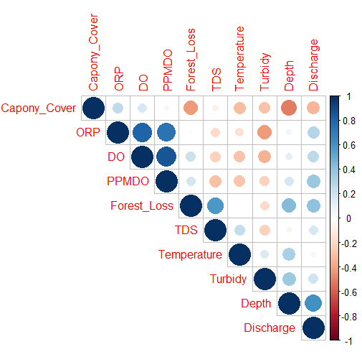

Table S2. Distribution of Ephemeroptera genera in the 21 sampled streams. The table includes the family, genus (with author and year of description), total number of individuals sampled across all streams, and the occurrence rate, representing the percentage of streams where each genus was recorded.
Family |  | Genera (Author) | Occurrence  Rate (%) |  |  |  | Total Individuals Sampled
Baetidae |  | Americabaetis (Kluge, 1992) | 76.19% |  |  |  | 547
 |  | Aturbina (Lugo-Ortiz & McCafferty, 1996) | 23.81% |  |  |  | 26
 |  | Apobaetis (Day, 1955) | 47.62% |  |  |  | 57
 |  | Baetodes (Needham & Murphy, 1924) | 28.57% |  |  |  | 98
 |  | Callibaetis (Eaton, 1881) | 28.57% |  |  |  | 173
 |  | Callibaetoides (Cruz, Salles & Hamada, 2013) | 14.29% |  |  |  | 3
 |  | Camelobaetidius (Demoulin, 1966) | 28.57% |  |  |  | 109
 |  | Cloeodes (Traver, 1938) | 38.10% |  |  |  | 242
 |  | Corinnella (Thomas & Dominique, 2006) | 4.76% |  |  |  | 1
 |  | Cryptonympha (Lugo-Ortiz & McCafferty, 1998) |  |  |  | 33.33% | 131
 |  | Harpagobaetis (Mol, 1986) | 4.76% |  |  |  | 1
 |  | Paracloeodes (Day, 1955) | 28.57% |  |  |  | 61
 |  | Rivudiva (Lugo-Ortiz & McCafferty, 1998) | 14.29% |  |  |  | 41
 |  | Spiritiopsis (Lugo-Ortiz & McCafferty, 1998) |  | 4.76% |  |  | 1
 |  | Varipes (Lugo-Ortiz & McCafferty, 1998) | 9.52% |  |  |  | 2
 |  | Waltzoyphius (McCafferty & Lugo-Ortiz, 1995) |  |  | 61.90% |  | 286
 |  | Zelusia (Lugo-Ortiz & McCafferty, 1998) | 57.14% |  |  |  | 181
Caenidae |  | Brasilocaenis (Puthz, 1975) | 9.52% |  |  |  | 2
 |  | Caenis (Stephens, 1835) | 42.86% |  |  |  | 48
Leptohyphidae |  | Amanahyphes (Salles & Molineri, 2006) | 23.81% |  |  |  | 14
 |  | Leptohyphes (Eaton, 1882) | 4.76% |  |  |  | 2
 |  | Traverhyphes (Molineri, 2001) | 61.90% |  |  |  | 542
 |  | Tricorythodes (Ulmer, 1920) | 19.05% |  |  |  | 76
 |  | Tricorythopsis (Traver, 1958) | 33.33% |  |  |  | 11
Leptophlebiidae |  | Farrodes (Peters, 1971) | 76.19% |  |  |  | 330
 |  | Fittkaulus (Savage & Peters, 1978) | 38.10% |  |  |  | 32
 |  | Hydromastodon (Polegatto & Batista, 2007) | 9.52% |  |  |  | 4
 |  | Miroculis (Edmunds, 1963) | 14.29% |  |  |  | 16
 |  | Paramaka (Savage & Domínguez, 1992) | 14.29% |  |  |  | 69
 |  | Simothraulopsis (Demoulin, 1966) | 4.76% |  |  |  | 6
 |  | Thraulodes (Traver, 1931) | 9.52% |  |  |  | 7
 |  | Ulmeritoides (Traver, 1959) | 14.29% |  |  |  | 4
Polymirtarcyidae |  | Campurus (Eaton, 1868) | 4.76% |  |  |  | 1
TOTAL |  |  | 100% (21 freshwater) |  |  |  | 3124

