Supplementary material
Matteo Dimai
2023-12-09

1 Proof of Theorem 1
The proof follows the ones in Niu and Melenberg (2014) and Boonen and Li (2017).
- For any $θ$, use $m_{x,t}=\left(a_{x}−b_{x}c^{*}\right)+\frac{b_{x}}{d^{*}}d^{*}\left(k_{t}−\sum_{l=1}^{L}{e_{l}^{*}g_{l,t}}+c^{*}\right)+\sum_{l=1}^{L}{\left(c_{l,x}+e_{l}^{*}b_{x}\right)g_{l,t}}$ and construct $θ^{0}$ by letting $d^{*}=\sum_{x=1}^{N}{b_{x}}$, $c^{*}=−\frac{\sum_{t=1}^{T}{k_{t}}}{T}$ and $e_{l}^{*}=cov\left(g_{lt},k_{t}\right)/var\left(g_{lt}\right) \text{for} l=1,…,L$.
- $θ_{0}$ can be transformed back into the original $θ$ by putting:
  - $d^{0}=\frac{1}{d^{*}}$, then ${\tilde{b}}_{x}=\frac{b_{x}}{d^{0}}⇒b_{x}=\frac{{\tilde{b}}_{x}}{d^{*}}$;
  - $c^{0}=−c^{*}d^{*}$, then ${\tilde{a}}_{x}=a_{x}−b_{x}c^{0}⇒a_{x}={\tilde{a}}_{x}−\frac{{\tilde{b}}_{x}}{d^{*}}c^{*}d^{*}=\tilde{a_{x}}−{\tilde{b}}_{x}c^{*}$;
  - $e^{0}=−e^{*}d^{*}$, then ${\tilde{c}}_{l,x}=c_{l,x}+e^{0}b_{x}=c_{l,x}−e^{*}{\tilde{b}}_{x}⇒c_{l,x}={\tilde{c}}_{l,x}+e^{*}{\tilde{b}}_{x}$;
  - It follows that kt=d0kt−l​e0gl,t+c0=1d*kt+d*l​e*gl,t−c*d*⇒kt=d*kt−l​e*gl,t+c*. The parametrization is invariant to $c^{*}$, $d^{*}$ and $e^{*}$.
- Consider $θ≠\tilde{θ}$.
  - If $a_{x}≠{\tilde{a}}_{x}$ for some $x$, then
$$\frac{1}{T}\sum_{t=1}^{T}{m_{x,t}}=a_{x}≠{\tilde{a}}_{x}=\frac{1}{T}\sum_{t=1}^{T}{{\tilde{m}}_{x,t}},$$
  - since $k_{t}$ and $g_{l,t}$ sum to 0 (the singular value decomposition is performed on the scaled matrix of the external variables).
  - If $h_{l,x}≠{\tilde{h}}_{l,x}$ for some $l$ and $x$, since all $g_{l,t}$ are uncorrelated with each other, with $k_{t}$ and sum to 0 over $t$, then
$$\sum_{t=1}^{T}{g_{l,t}m_{x,t}}=h_{l,x}\sum_{t=1}^{T}{{g^{2}}_{l},t}≠{\tilde{h}}_{l,x}\sum_{t=1}^{T}{{g^{2}}_{l},t}=\sum_{t=1}^{T}{g_{l,t}{\tilde{m}}_{x,t}}.$$
  - If $a_{x}={\tilde{a}}_{x}$ and $h_{l,x}={\tilde{h}}_{l,x}$ for all $x$ and $l$, but $k_{t}≠{\tilde{k}}_{t}$ for some $t$, since $\sum_{x=1}^{N}{b_{x}}=1$, it holds that
$$\begin{matrix}\sum_{x=1}^{N}{m_{x,t}} & =k_{t}+\sum_{x=1}^{N}{a_{x}}+\sum_{l=1}^{L}{\sum_{t=1}^{T}{h_{l,x}g_{l,t}}} \\ & ≠{\tilde{k}}_{t}+\sum_{x=1}^{N}{{\tilde{a}}_{x}}+\sum_{l=1}^{L}{\sum_{t=1}^{T}{{\tilde{h}}_{l,x}g_{l,t}}} \\ & =\sum_{x=1}^{N}{{\tilde{m}}_{x,t}}.\end{matrix}$$
  - If $a_{x}={\tilde{a}}_{x}$, $h_{l,x}={\tilde{h}}_{l,x}$ for all $x$ and $l$, $k_{t}={\tilde{k}}_{t}$ for all $t$, but $b_{x}≠{\tilde{b}}_{x}$ for some $x$, since $k≠0$, there exists some $t$ for which $k_{t}={\tilde{k}}_{t}≠0$. Then $\sum_{t=1}^{T}{k_{t}^{2}}=\sum_{t=1}^{T}{{\tilde{k}}_{t}^{2}}$. However, since $k_{t}$ sum to 1 and are uncorrelated with $g_{l,t}$,
$$\begin{matrix}\sum_{t=1}^{T}{k_{t}m_{x,t}} & =b_{x}\sum_{t=1}^{T}{k_{t}^{2}} \\ & ≠{\tilde{b}}_{x}\sum_{t=1}^{T}{{\tilde{k}}_{t}^{2}} \\ & =\sum_{t=1}^{T}{{\tilde{k}}_{t}{\tilde{m}}_{x,t}}.\end{matrix}$$

2 Goodness of fit
A detailed comparison of model fit with regards to both Lee-Carter and Niu-Melenberg models is presented in Table A2.1 and Table A2.2.
Table A2.1: Mean absolute deviation (MAD), mean absolute percentage error (MAPE), Bayesian Information Criterion (BIC) and number of principal components for single-population models and equivalent Lee-Carter models. Countries where the single-population model outperforms the Lee-Carter model are in bold.
Country | MAD | MAPE | BIC | N. PC | MAD  Lee-Carter | MAPE  Lee-Carter | BIC  Lee-Carter
Australia | 28.793 | 3.537 | 20,293 | 2 | 36.354 | 4.601 | 21,222
Austria | 23.353 | 4.190 | 21,217 | 2 | 24.077 | 4.324 | 20,670
Belarus | 34.242 | 3.053 | 10,543 | 2 | 38.198 | 3.447 | 10,201
Belgium | 20.751 | 3.026 | 8,544 | 2 | 24.079 | 3.430 | 8,071
Bulgaria | 38.944 | 4.096 | 24,816 | 2 | 66.527 | 7.500 | 33,162
Chile | 28.053 | 3.993 | 13,360 | 2 | 30.361 | 4.306 | 12,977
Croatia | 16.498 | 4.443 | 7,669 | 2 | 18.686 | 4.820 | 7,203
Czechia | 26.058 | 3.153 | 12,436 | 2 | 28.661 | 3.434 | 12,003
Denmark | 18.213 | 4.584 | 20,102 | 2 | 19.659 | 5.030 | 19,782
East Germany | 52.937 | 4.500 | 27,072 | 2 | 63.075 | 5.306 | 28,771
Estonia | 8.477 | 6.237 | 8,791 | 2 | 9.168 | 6.816 | 8,242
Finland | 18.537 | 5.287 | 20,434 | 2 | 20.235 | 5.788 | 20,220
France | 93.696 | 2.602 | 29,613 | 2 | 103.013 | 2.941 | 30,520
Greece | 29.116 | 3.995 | 19,020 | 2 | 33.468 | 4.627 | 19,181
Hungary | 44.644 | 3.868 | 25,360 | 2 | 83.889 | 7.813 | 38,295
Iceland | 2.557 | Inf | 12,142 | 2 | 2.700 | Inf | 11,586
Ireland | 13.309 | 6.077 | 18,763 | 2 | 15.964 | 7.467 | 19,006
Italy | 97.001 | 2.400 | 28,763 | 2 | 122.555 | 2.965 | 31,317
Japan | 176.346 | 2.493 | 34,846 | 2 | 210.825 | 3.090 | 39,715
Latvia | 10.934 | 4.533 | 9,363 | 2 | 12.104 | 5.003 | 8,821
Lithuania | 14.445 | 4.274 | 9,854 | 2 | 17.885 | 5.099 | 9,641
Netherlands | 28.009 | 3.136 | 21,873 | 2 | 40.706 | 4.415 | 23,620
Norway | 14.298 | 5.188 | 18,977 | 2 | 16.022 | 5.870 | 18,708
Poland | 82.947 | 2.644 | 29,054 | 2 | 106.768 | 3.467 | 33,088
Portugal | 26.201 | 3.730 | 21,839 | 2 | 29.803 | 4.268 | 21,871
Republic of Korea | 51.402 | 2.305 | 8,412 | 2 | 58.558 | 2.589 | 8,063
Russia | 450.430 | 2.518 | 33,633 | 2 | 563.319 | 3.307 | 41,506
Slovakia | 17.663 | 4.034 | 11,642 | 2 | 19.313 | 4.396 | 11,149
Slovenia | 9.292 | 6.565 | 8,533 | 2 | 10.421 | 7.280 | 8,042
Spain | 52.688 | 2.159 | 24,704 | 2 | 59.693 | 2.856 | 25,579
Sweden | 20.364 | 3.639 | 20,451 | 2 | 21.702 | 3.930 | 19,976
Switzerland | 17.157 | 4.396 | 19,892 | 2 | 18.204 | 4.662 | 19,402
Ukraine | 154.880 | 2.591 | 17,090 | 2 | 184.939 | 3.252 | 18,762
United Kingdom | 113.557 | 2.996 | 32,968 | 2 | 139.246 | 3.537 | 35,404
USA | 276.788 | 1.819 | 41,230 | 2 | 497.532 | 3.135 | 72,591
West Germany | 136.440 | 2.807 | 35,219 | 2 | 141.848 | 2.920 | 35,324
A covariate has missing data for 5 years for Canada, making the estimation of a Lee-Carter model impossible.
Table A2.2: Mean absolute deviation (MAD), mean absolute percentage error (MAPE), Bayesian Information Criterion (BIC) and number of principal components for single-population models and equivalent Niu-Melenberg models. Countries where the single-population model outperforms the Lee-Carter model are in bold.
Country | MAD | MAPE | BIC | N. PC | MAD  Niu-Melenberg | MAPE  Niu-Melenberg | BIC  Niu-Melenberg
Australia | 28.793 | 3.537 | 20,293 | 2 | 34.825 | 4.108 | 20,934
Austria | 23.353 | 4.190 | 21,217 | 2 | 23.140 | 4.194 | 20,821
Belarus | 34.242 | 3.053 | 10,543 | 2 | 35.036 | 3.117 | 10,269
Belgium | 20.751 | 3.026 | 8,544 | 2 | 22.746 | 3.262 | 8,320
Bulgaria | 38.944 | 4.096 | 24,816 | 2 | 43.727 | 4.527 | 25,750
Canada | 36.700 | 2.629 | 20,615 | 2 | 51.607 | 3.761 | 22,687
Chile | 28.053 | 3.993 | 13,360 | 2 | 29.247 | 4.128 | 13,121
Croatia | 16.498 | 4.443 | 7,669 | 2 | 17.186 | 4.510 | 7,407
Czechia | 26.058 | 3.153 | 12,436 | 2 | 27.136 | 3.270 | 12,217
Denmark | 18.213 | 4.584 | 20,102 | 2 | 18.484 | 4.725 | 19,801
East Germany | 52.937 | 4.500 | 27,072 | 2 | 53.026 | 4.422 | 26,614
Estonia | 8.477 | 6.237 | 8,791 | 2 | 8.864 | 6.491 | 8,501
Finland | 18.537 | 5.287 | 20,434 | 2 | 19.997 | 5.660 | 20,404
France | 93.696 | 2.602 | 29,613 | 2 | 94.036 | 2.715 | 29,456
Greece | 29.116 | 3.995 | 19,020 | 2 | 29.944 | 4.130 | 18,772
Hungary | 44.644 | 3.868 | 25,360 | 2 | 50.506 | 4.298 | 26,233
Iceland | 2.557 | Inf | 12,142 | 2 | 2.617 | Inf | 11,845
Ireland | 13.309 | 6.077 | 18,763 | 2 | 13.956 | 6.688 | 18,687
Italy | 97.001 | 2.400 | 28,763 | 2 | 108.931 | 2.644 | 29,705
Japan | 176.346 | 2.493 | 34,846 | 2 | 189.605 | 2.836 | 36,546
Latvia | 10.934 | 4.533 | 9,363 | 2 | 11.337 | 4.716 | 9,063
Lithuania | 14.445 | 4.274 | 9,854 | 2 | 14.853 | 4.401 | 9,580
Netherlands | 28.009 | 3.136 | 21,873 | 2 | 32.237 | 3.718 | 22,315
Norway | 14.298 | 5.188 | 18,977 | 2 | 15.198 | 5.623 | 18,862
Poland | 82.947 | 2.644 | 29,054 | 2 | 84.480 | 2.732 | 29,026
Portugal | 26.201 | 3.730 | 21,839 | 2 | 26.846 | 3.752 | 21,536
Republic of Korea | 51.402 | 2.305 | 8,412 | 2 | 54.115 | 2.390 | 8,169
Russia | 450.430 | 2.518 | 33,633 | 2 | 478.080 | 2.739 | 35,484
Slovakia | 17.663 | 4.034 | 11,642 | 2 | 18.368 | 4.189 | 11,376
Slovenia | 9.292 | 6.565 | 8,533 | 2 | 9.740 | 6.764 | 8,258
Spain | 52.688 | 2.159 | 24,704 | 2 | 55.366 | 2.620 | 25,252
Sweden | 20.364 | 3.639 | 20,451 | 2 | 20.758 | 3.786 | 20,165
Switzerland | 17.157 | 4.396 | 19,892 | 2 | 17.666 | 4.519 | 19,635
Ukraine | 154.880 | 2.591 | 17,090 | 2 | 158.623 | 2.670 | 17,130
United Kingdom | 113.557 | 2.996 | 32,968 | 2 | 120.853 | 3.180 | 33,673
USA | 276.788 | 1.819 | 41,230 | 2 | 318.170 | 2.205 | 46,994
West Germany | 136.440 | 2.807 | 35,219 | 2 | 133.902 | 2.642 | 34,393

3 Individual countries
The results for the Netherlands, Spain, Sweden, Poland and the USA are presented. These countries have been chosen as they represent a diverse set of countries with different mortality characteristics: the Netherlands are a Western European country with less linear trends for mortality rates (Stoeldraijer et al., 2013), while Southern Europe is represented by Spain, with the first year of data coinciding with the end of the Franco regime, Poland is a Eastern European country with a strong growth history after the fall of the Communist bloc, Sweden is a Northern European country which was not affected by World War II and the USA are of interest as a big, diverse country with a relatively low life expectancy compared to GDP.

3.1 Netherlands
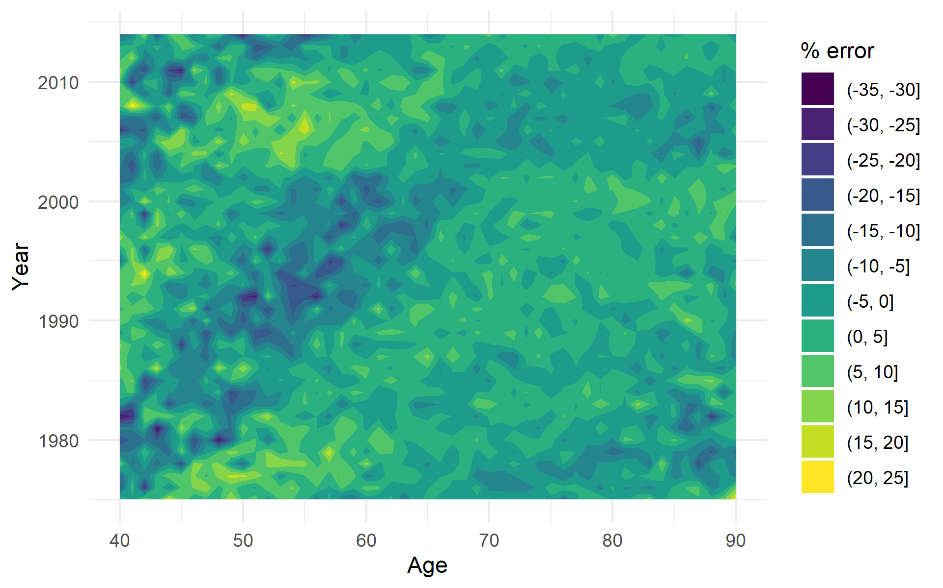
Figure A3.1: Netherlands, actual minus predicted deaths as % of actual deaths by age and year
Figure A3.1 shows the residuals by age and calendar year as a percentage of total deaths. There are no systematic age errors, which would show as vertical lines, or systematic period errors, which would show as horizontal lines. The errors vary at random and the largest percentage errors are in the 40-45 age range, where the absolute number of deaths is smaller and a small error in absolute terms is magnified in percentage terms. There are hints of a small cohort effect (diagonal bands) for the WW2 cohorts, which is mostly gone after year 2000.
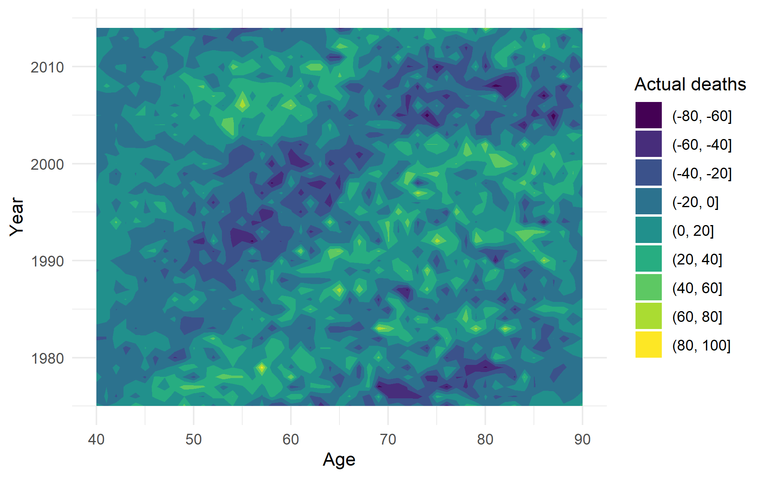
Figure A3.2: Netherlands, actual minus predicted deaths by age and year
The errors in absolute terms, shown in Figure A3.2, show a similar pattern to the percentage errors. No significant structural patterns are visible and the occasional high residuals aren’t clustered together.

3.2 Spain
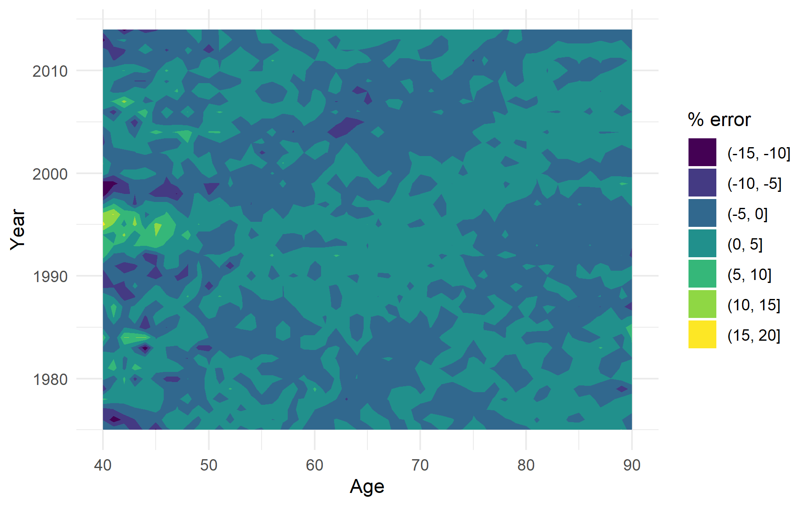
Figure A3.3: Spain, actual minus predicted deaths as % of actual deaths by age and year
For Spain, the percentage difference between the actual and fitted deaths is between -15% and 20%. The largest residuals in percentage terms are for the 40-50 age range around 1995. The timing and age range affected is consistent with the AIDS epidemic and the introduction of new therapies in the mid-90s: moreover, a version of the model comprising the age range 0-90 evidenced a spike in male deaths aged 30-40 in the same years. While the AIDS epidemic has not been explicitly modeled for comparability across countries, it’s a component of mortality that could be straightforwardly added to the SEV model. There are no systematic age or period components visible. The residuals hint at a small cohort effects for those born during the Spanish Civil War.
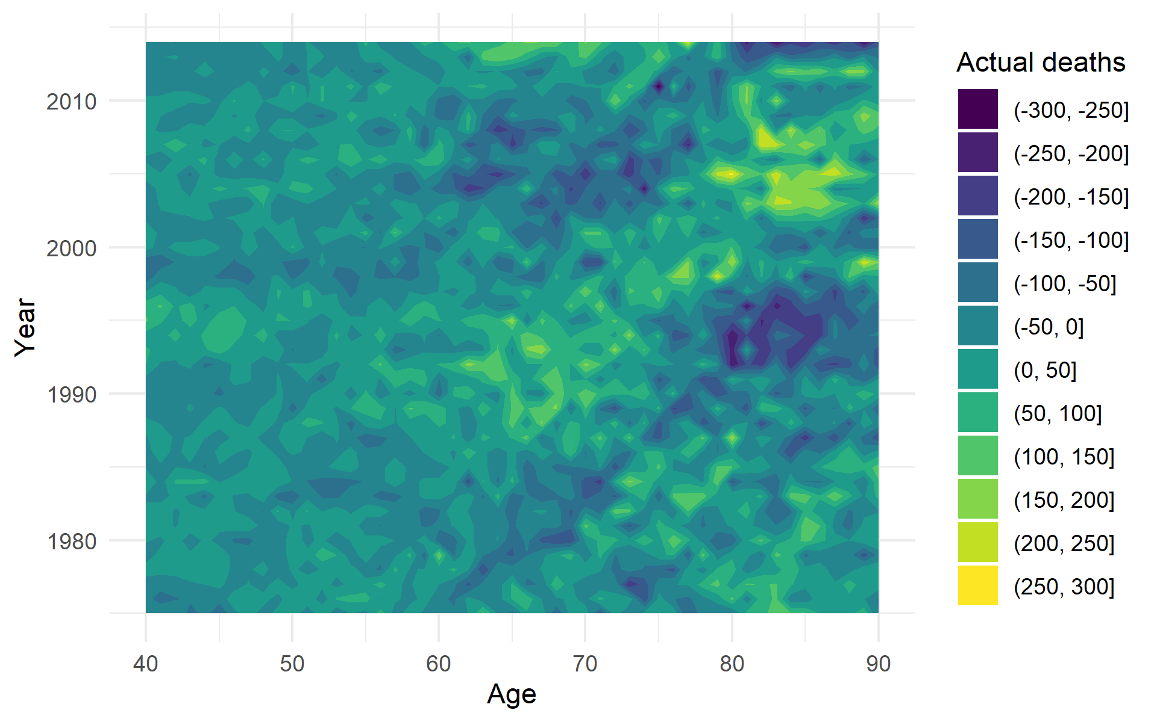
Figure A3.4: Spain, actual minus predicted deaths by age and year
The cohort effect due to the Spanish Civil war remains visible when residuals are calculated as difference in the number of deaths. The range of the residuals is [-300, 300], with the model predicting a higher number of deaths for ages 80+ in the mid-nineties.

3.3 Poland
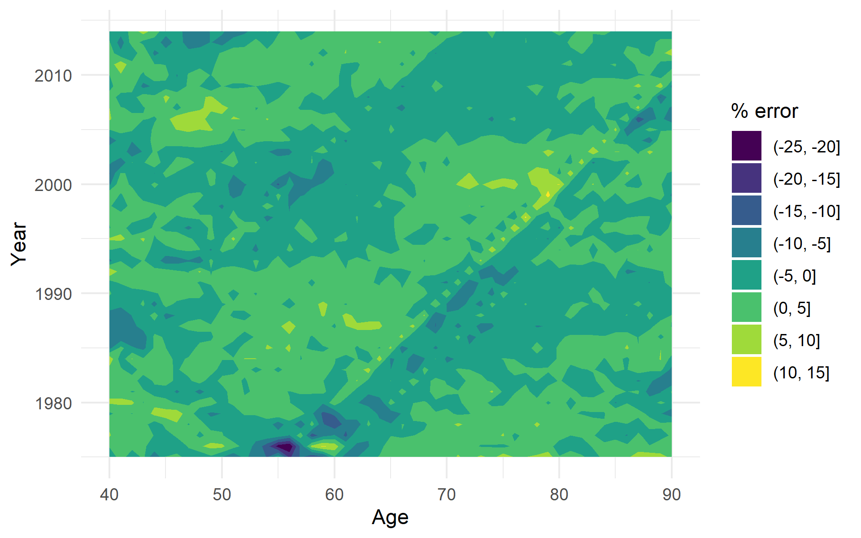
Figure A3.5: Poland, actual minus predicted deaths as % of actual deaths by age and year
The range of percentage residuals for Poland is from -25% to 15%, again comparable with the other countries. The residuals show two prominent cohort effects: one for the cohorts born around 1920 (Polish-Soviet war), a weaker one for the cohorts born during World War 1. No systematic age or period effect is visible, but the model predicts a larger number of deaths in 1975-77 around age 55, the cohorts for which the cohort effects are most prominent in the subsequent years.
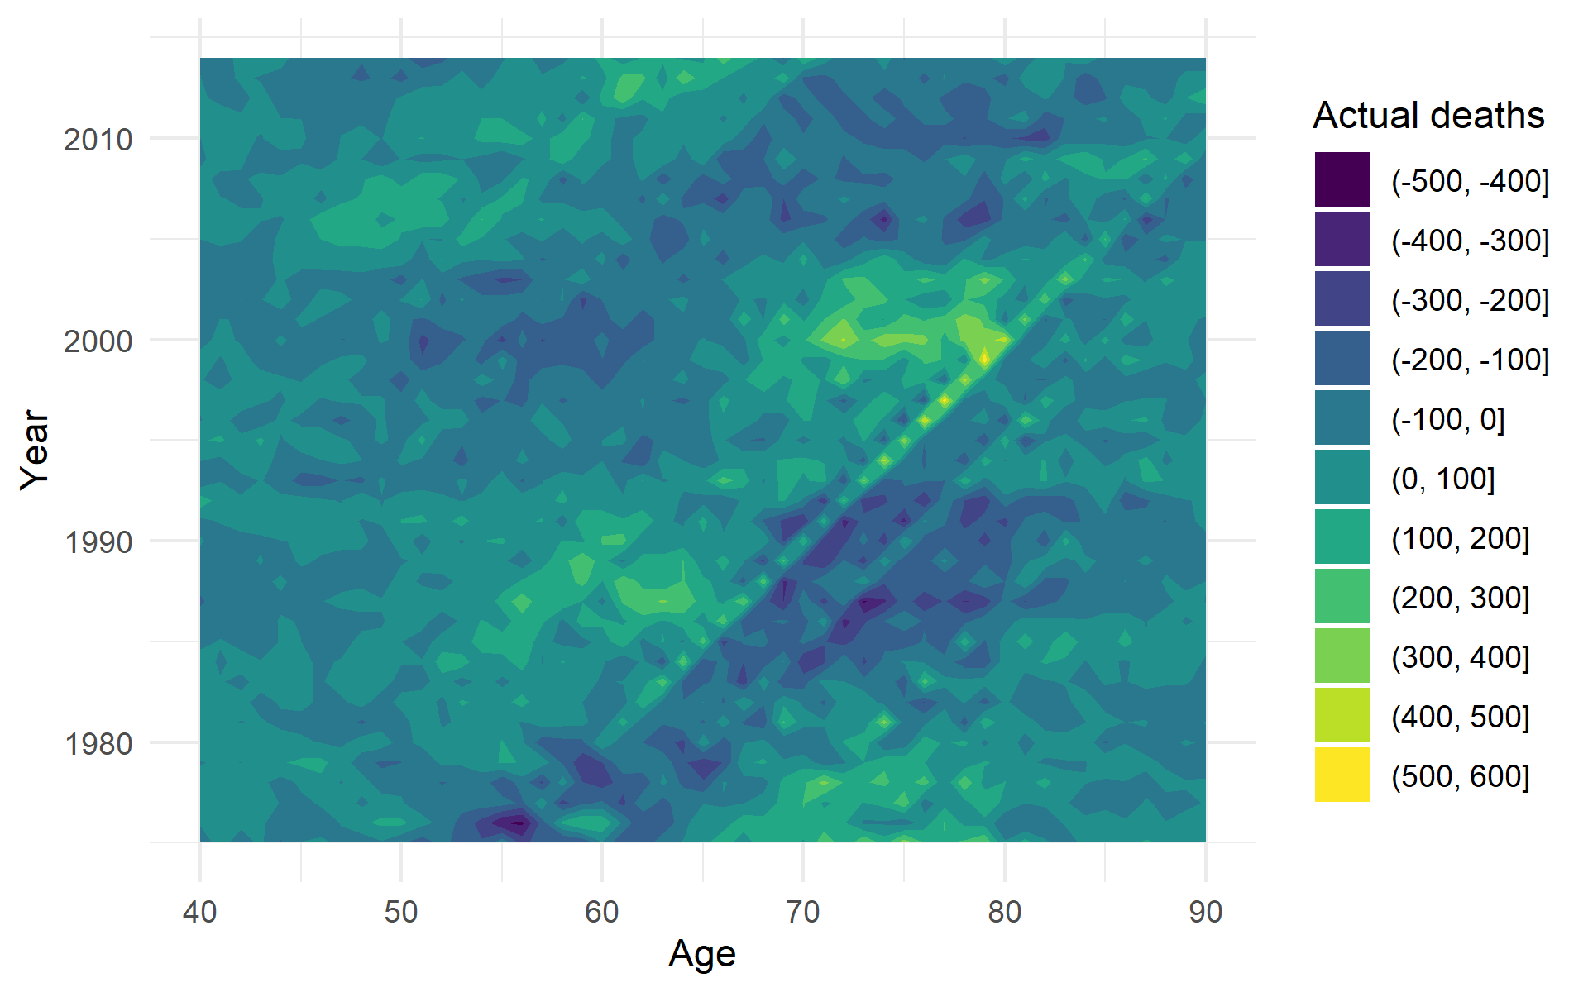
Figure A3.6: Poland, actual minus predicted deaths by age and year
The residual deaths range from -500 to 600 per year, with, again, the biggest errors related to the 1920 and WW1 cohorts. The graph also hints at a weak cohort effect for those born during WW2 and slightly overestimates deaths at ages 70 and higher in years 1988-1992, underestimating the deaths in the same age range around year 2000.

3.4 Sweden
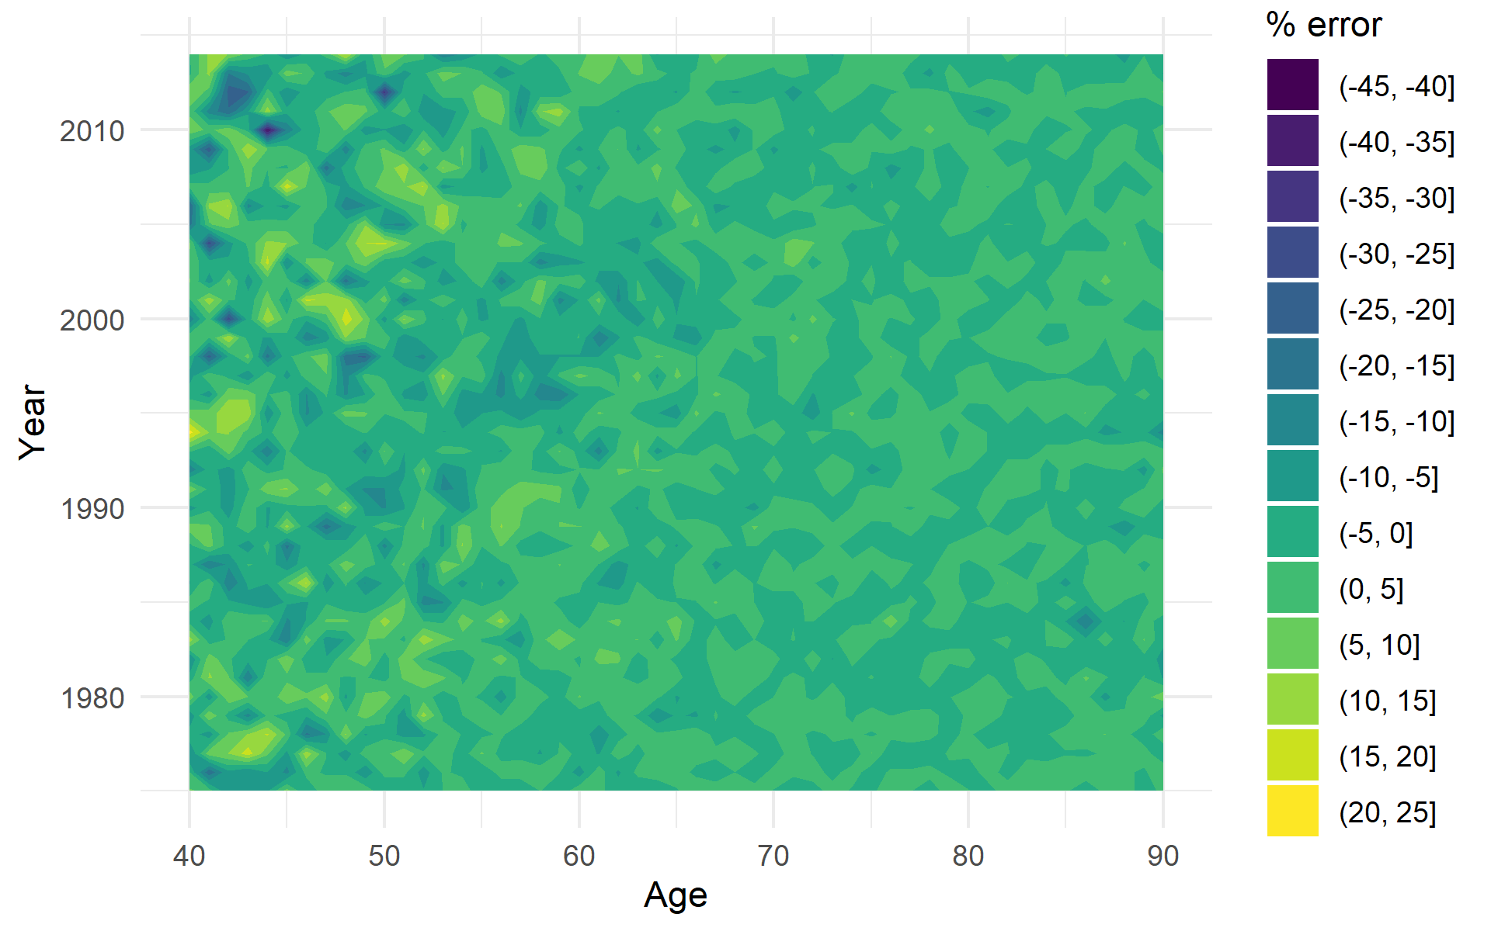
Figure A3.7: Sweden, actual minus predicted deaths as % of actual deaths by age and year
Sweden is the smallest country of the five considered individually and therefore the percentage residuals show the largest range, from -45% to 25%. The largest residuals in percentage occur for ages between 40 and 50 and the residuals appear entirely random, without any age, period or cohort effect.
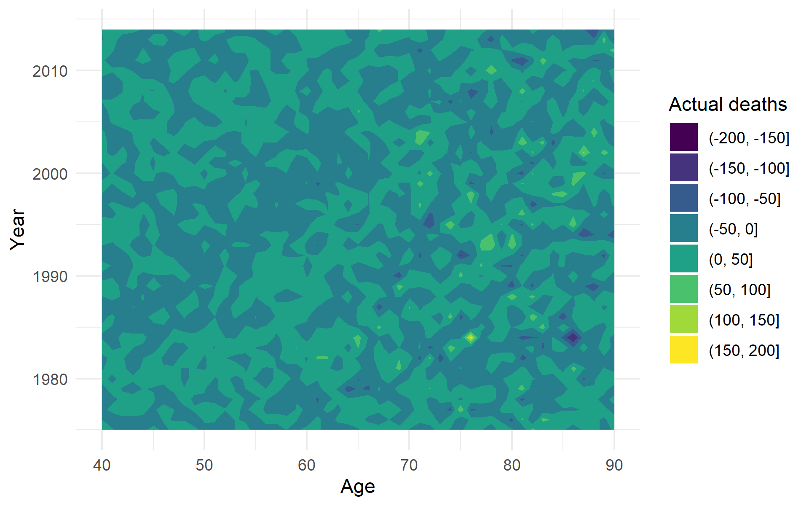
Figure A3.8: Sweden, actual minus predicted deaths by age and year
The absence of any pattern applies to the residual deaths as well. There are two large residuals in 1984 (170 for men aged 76 and -152 for men aged 86) and other smaller residuals scattered without a noticeable pattern.

3.5 USA
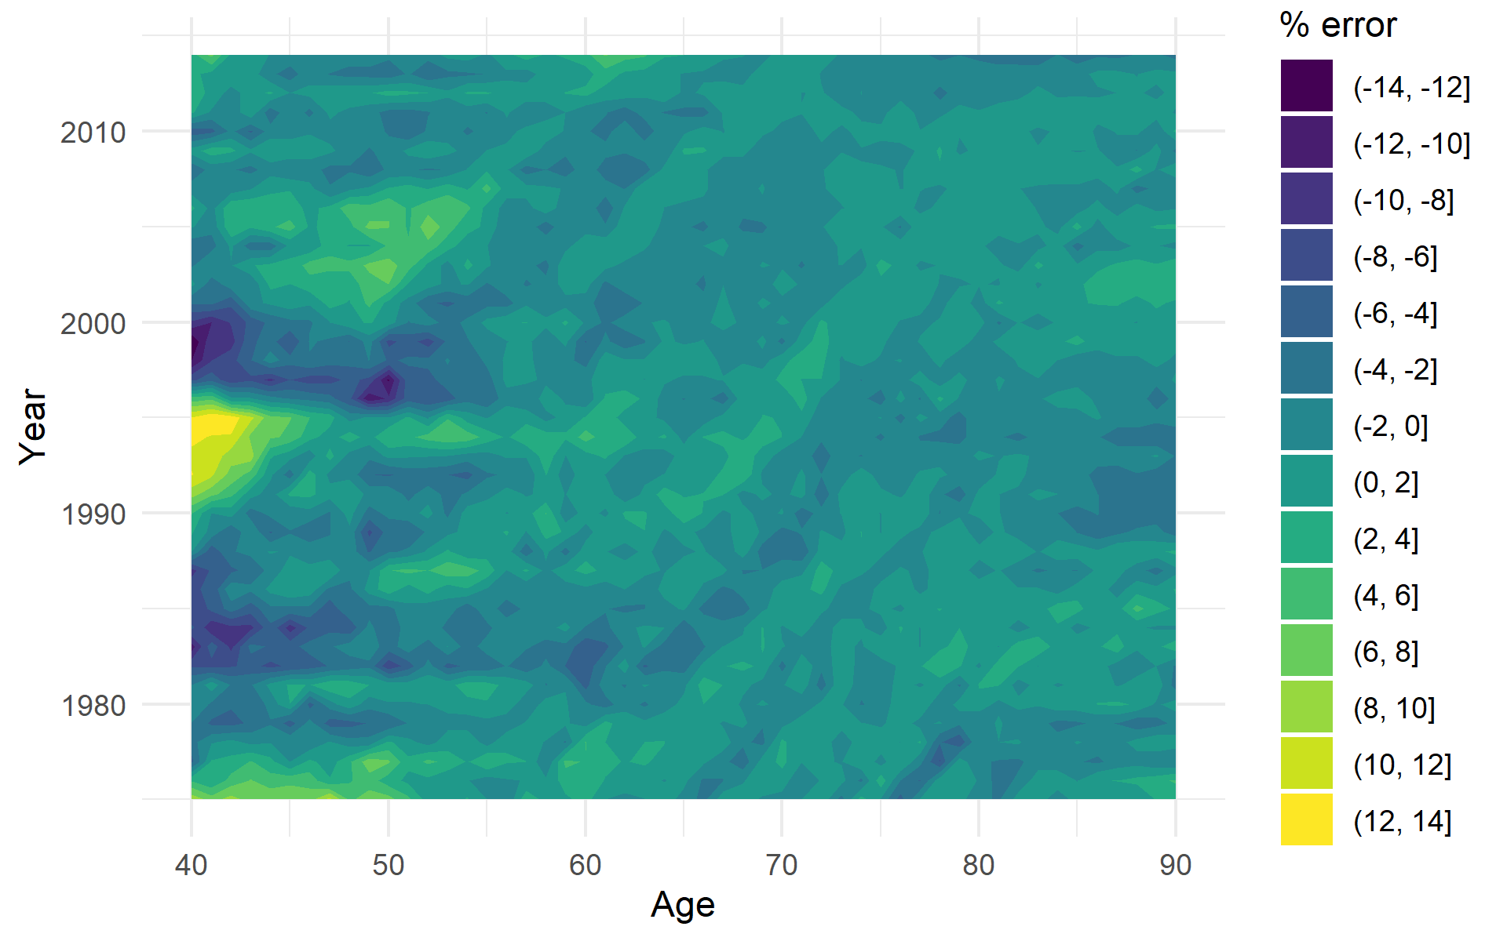
Figure A3.9: USA, actual minus predicted deaths as % of actual deaths by age and year
The United States are the largest country and hence the residuals in percentage terms are the smallest, ranging from -14% to 14%. Large positive residuals are present in the age range 40-50 up to 1995: as with Spain, a timing and age range consistent with the AIDS epidemic. There are several diagonal lines that hint at weak cohort effects.
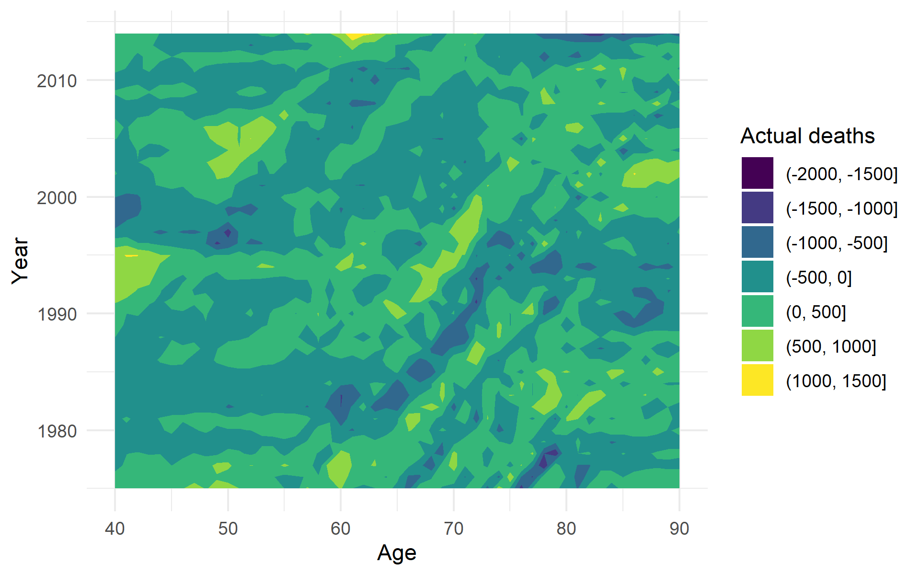
Figure A3.10: USA, actual minus predicted deaths by age and year
Examining the difference in actual and predicted deaths highlights the cohort effects, with the most prominent being the 1918-1919 cohorts. In 2014, the last year of data, the model noticeably underestimates deaths in the 60-65 age range and overestimates them over 75 years of age.

3.6 Age-period term
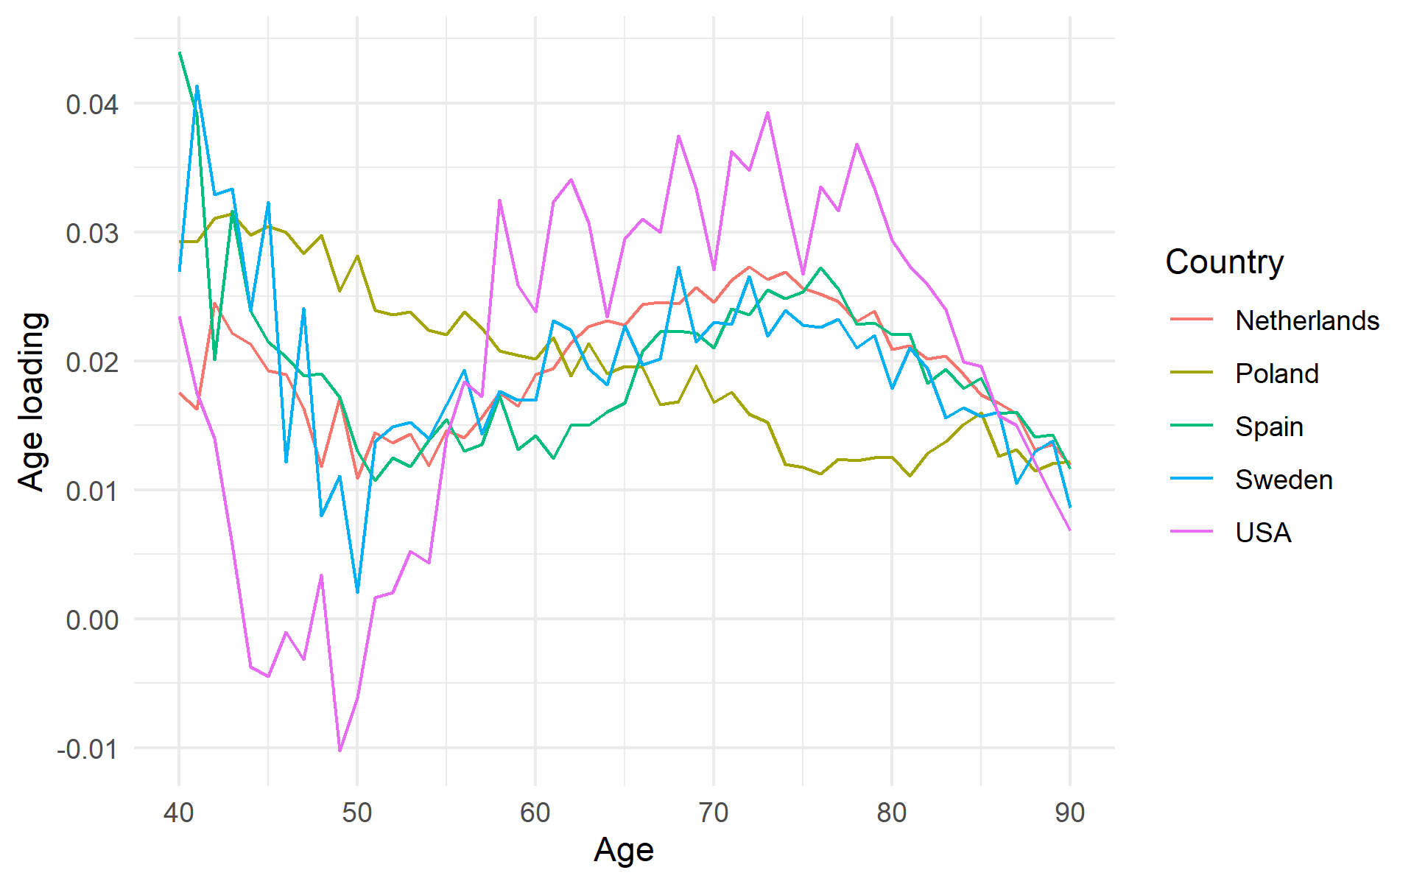
Figure A3.11: Age loadings $b_{x}$ of the country-specific residual age-period term $b_{x}k_{t}$ in five selected countries
The age-period term $b_{x}k_{t}$ fitted to the data should capture residual trends not explained by the external variables. In an ideal situation, these terms will represent country-specific idiosyncrasies and both the age loadings $b_{x}$ and the period terms $k_{t}$ will differ from one country to another. Conversely, similar age loadings and period terms across all countries would point to an omitted variable with a systematic effect on death rates. The age loadings for five selected countries, shown in Figure A3.11, present both commonalities and differences. Poland has slightly higher age loadings at younger ages (40-50), which then decline uniformly towards older ages, thus representing middle-aged mortality. The loadings in other countries decrease from age 40 to a trough between ages 45 and 50, with loadings climbing back up, peaking and then declining to age 90. The Netherlands and Spain exhibit a clear peak around age 72 and 75, respectively, while Sweden and the USA show more of a plateau than a simple peak. The shapes of the loadings across countries differs to the point that they eschew a simple, common interpretation. Given the differences in age loadings, the period term $k_{t}$, shown in Figure A3.12, unsurprisingly shows no single common trend, although with some large fluctuations (Poland in 1982) and broken trends (Netherlands 1975-1993-2010).
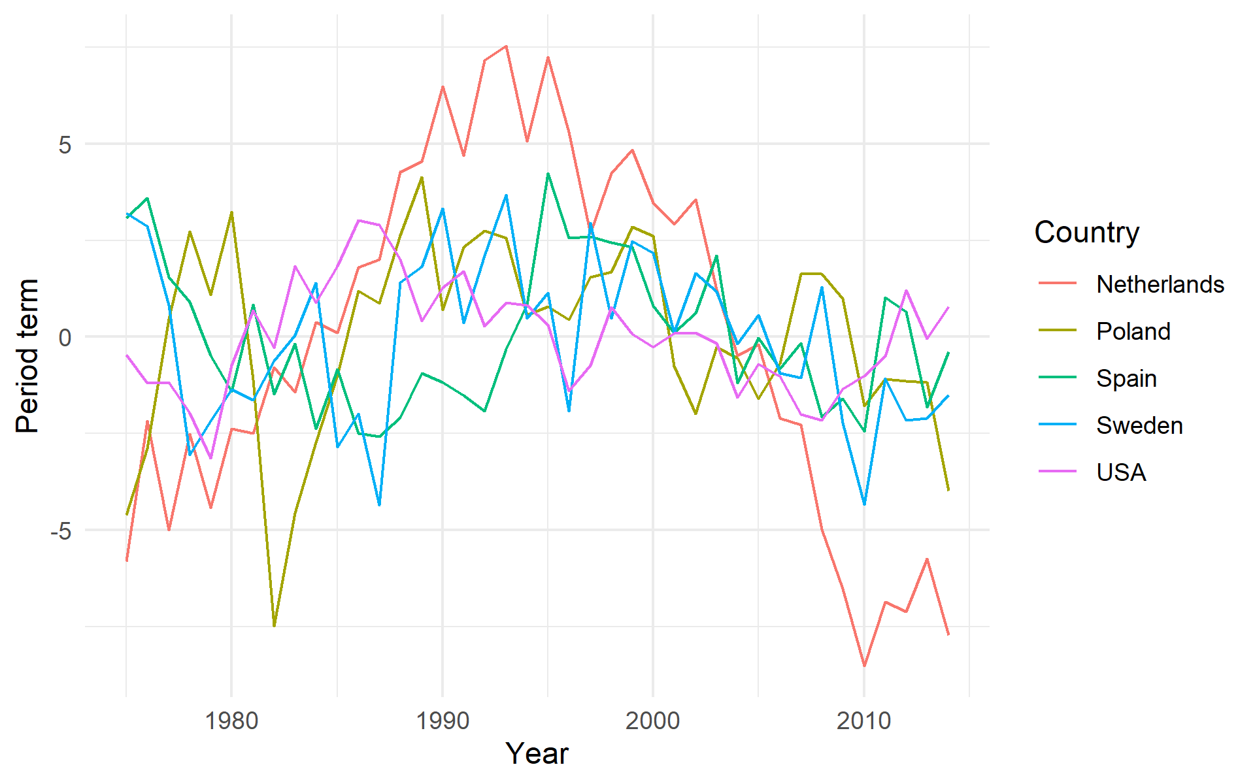
Figure A3.12: Period term $k_{t}$ in five selected countries

