Table S1 Hypothesis and predictions tested through General Linear Model (GLM) and General Linear Mixed Models (GLMMs), where jaguar identity entered as a random factor. Independent variables tested, model names and formulas are presented.
Hypothesis | Prediction | Independent Variables | Model Names | Formulas
Jaguar climbing behavior is related to their sex and age | 1. Cubs climb trees more often than adults  2. Adult female jaguars climb trees more often than adult males | Age (Adult, Cub)  Sex (Female, Male) | 1. Age  2. Sex  3. AgeSex | 1. Climb ~ Age + (1|ID)  2. Climb ~ Sex + (1|ID)  3. Climb ~ Age + Sex + (1|ID)
Jaguar climbing behavior is related to the presence of conspecifics | 1. Jaguars climb more often in the presence of any conspecifics  2. Presence of any conspecific will influence climbing behavior depending on the age of the jaguar  3. Presence of any conspecific will influence climbing behavior depending on the sex of the jaguar | Presence of conspecifics (Yes, No)  Age (Adult, Cub)  Sex (Female, Male) | 4. Presence  5. AgePresence  6. SexPresence  7. AgeSexPresence | 4. Climb ~ Presence + (1|ID)  5. Climb ~ Age + Presence + (1|ID)  6. Climb ~ Sex + Presence + (1|ID)  7. Climb ~ Age + Sex + Presence + (1|ID)
Climbing behavior of adult female jaguars depend on the presence of cubs | Adult females with cubs climb trees more often than single females | Presence of cubs (Yes, No) | 8. Cubs | 8. Climb ~ Cubs + (1|ID)
Climbing behavior of jaguars is related to body mass | Lighter jaguars climb trees more often than heavier ones | Weight (kgs) | 9. Weight | 9. Climb ~ Weight

Table S2 GLMM selection based on AICc. Models marked with an asterisk are equally plausible.
Model name | K | AICc | deltaAICc | AICcWt | Cum.Wt | LL
AgeSexPresence* | 5 | 259.05 | 0.00 | 0.54 | 0.54 | -124.41
AgePresence* | 4 | 259.91 | 0.85 | 0.35 | 0.89 | -125.87
Presence | 3 | 263.77 | 4.72 | 0.05 | 0.94 | -128.84
SexPresence | 4 | 264.51 | 5.46 | 0.04 | 0.97 | -128.17
AgeSex | 4 | 265.80 | 6.75 | 0.02 | 0.99 | -128.82
Age | 3 | 267.06 | 8.00 | 0.01 | 1.00 | -130.48
Null | 2 | 278.43 | 19.37 | 0.00 | 1.00 | -137.19
Sex | 3 | 279.48 | 20.43 | 0.00 | 1.00 | -136.69

Table S3 GLMM selection based on AICc. Model built to test the climbing behavior of adult female jaguars in relation to the presence of cubs. Model selection based on AICc. Models marked with an asterisk are equally plausible.
Model name | K | AICc | deltaAICc | AICcWt | Cum.Wt | LL
Cubs* | 3 | 155.66 | 0.00 | 0.66 | 0.66 | -74.75
Null* | 2 | 157.01 | 1.34 | 0.34 | 1.00 | -76.46

Table S4 Result of GLM built to test the climbing behavior of adult female jaguars in relation to the presence of cubs. Model information: Response variable (Climbed); Type – Generalized linear regression; Error distribution – binomial; Link function – logit; Model fit – χ²(1) = 21.04, p = 0.00, AICc 149.84; Standard error calculation – MLE.
 | Estimate (95% CI) | p value
Intercept | 3.40 (1.05 – 5.75) | 0.005
Weight | -0.06 (-0.10 – 0.02) | 0.001

Table S5 GLM selection based on AICc. Model set built to test jaguar climbing behavior in relation to variables presented in table S1. The top model is marked with an asterisk.
Model name | K | AICc | deltaAICc | AICcWt | Cum.Wt | LL
AgeSexPresence* | 4 | 289.53 | 0.00 | 0.54 | 0.54 | -124.41
SexPresence | 3 | 292.82 | 3.29 | 0.35 | 0.89 | -125.87
Presence | 2 | 301.29 | 11.76 | 0.05 | 0.94 | -128.84
AgeSex | 3 | 301.92 | 12.39 | 0.04 | 0.97 | -128.17
AgePresence | 3 | 302.06 | 12.53 | 0.02 | 0.99 | -128.82
Age | 2 | 315.72 | 26.19 | 0.01 | 1.00 | -130.48
Sex | 2 | 320.56 | 31.03 | 0.00 | 1.00 | -137.19
Null | 1 | 325.01 | 35.48 | 0.00 | 1.00 | -136.69

Table S6 Comparison of results (Odds Ratio) of the two modelling frameworks (GLMM vs GLM) for the same dataset, response variables and effects. The GLMM has the jaguar identity as a random factor (not shown), while the GLM does not. All effects have the same direction, with some difference in magnitude, and the ‘male’ effect is significative in the GLM. Models’ information: Response variable (Climbed); Error distribution – binomial; Link function – logit.
 | Models
Fixed Effects | GLMM | GLM
intercept | 0.09 [0.03, 0.33] *** | 0.33 [0.22, 0.49] ***
Age-Cub | 7.91 [1.65, 38.00] ** | 2.42 [1.14, 5.14] *
Sex-Male | 0.17 [0.02, 1.26] . | 0.24 [0.11, 0.53] ***
Presence-Yes | 3.26 [1.46, 7.26] ** | 3.45 [1.81, 6.57] ***
Observations | 253 | 253
*** p < 0.001; ** p < 0.01; * p < 0.05; . p < 0.10

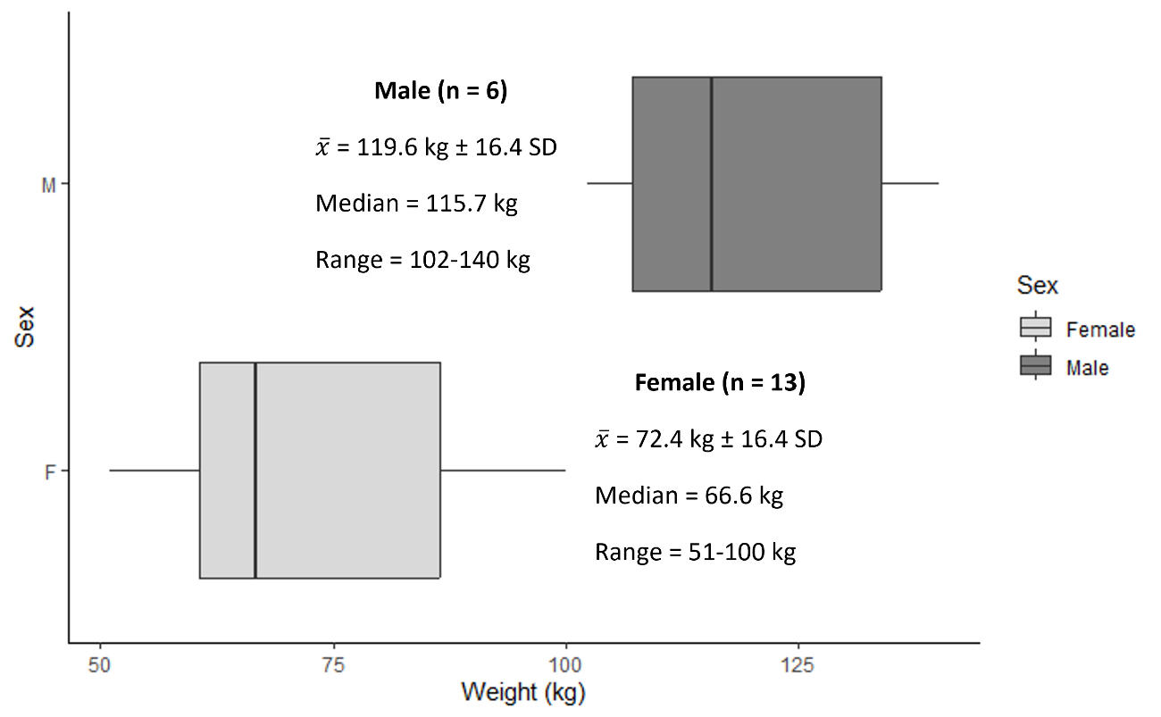
Figure S1 Boxplot of jaguar body weights in the study area showing differences between sexes. A Welch t test revealed that males are significantly heavier than females (t(9.8) = -5.84, p < 0.001).

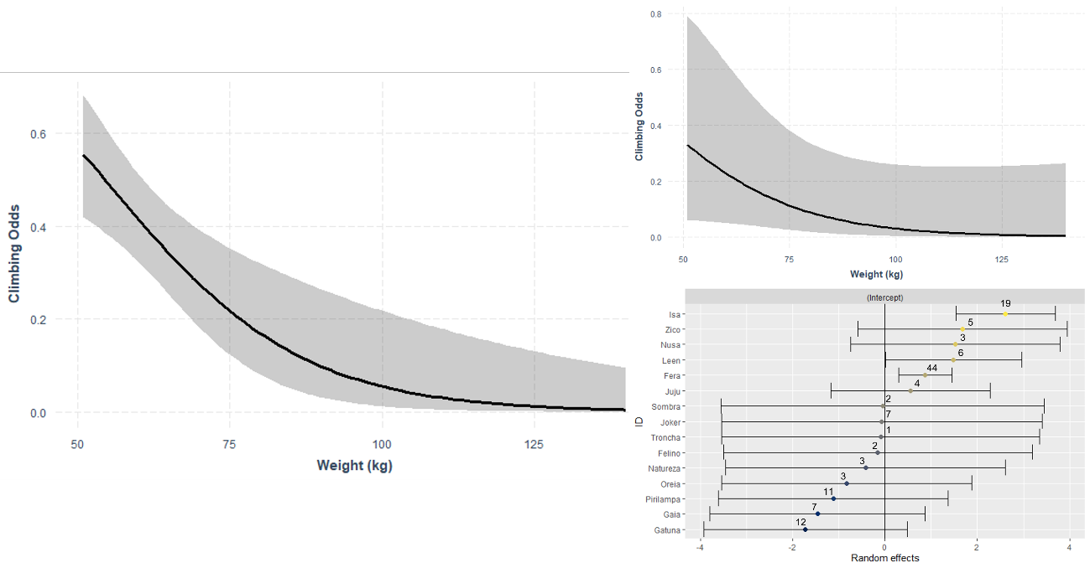
Figure S2 Effect of jaguar body weight on climbing odds. GLM (left) showed significant negative effect (p < 0.005), while the inclusion of jaguar identity in a GLMM (top right) maintained the negative trend, although only marginally significant (p = 0.08). Bottom right indicates the random effect coefficients and confidence intervals of the distinct jaguars; significancy is denoted by confidence intervals not crossing zero. Three adult females (Isa, Leen and Fera) climbed significantly more than the remaining animals. Figures on top of coefficient indicate the number of independent observations.

