Supplemental
Weighted degree Gaussian model:
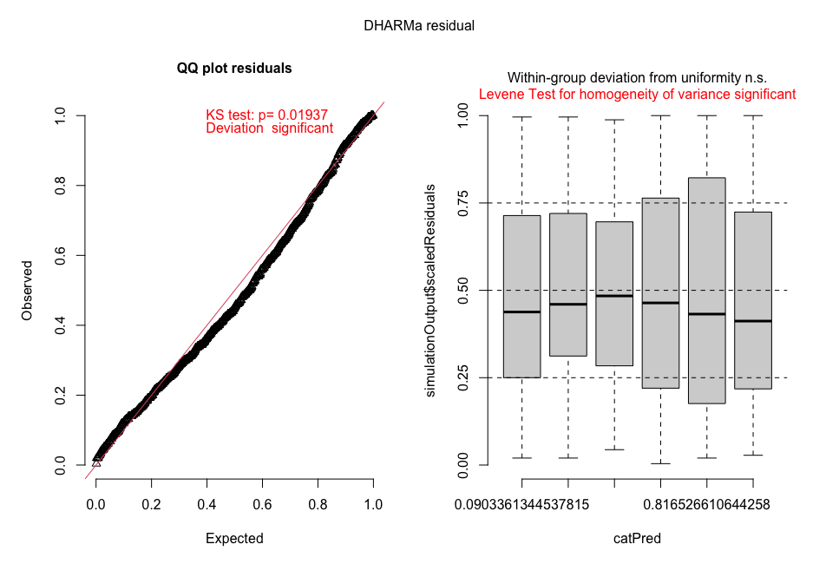
Weighted degree Gamma model:
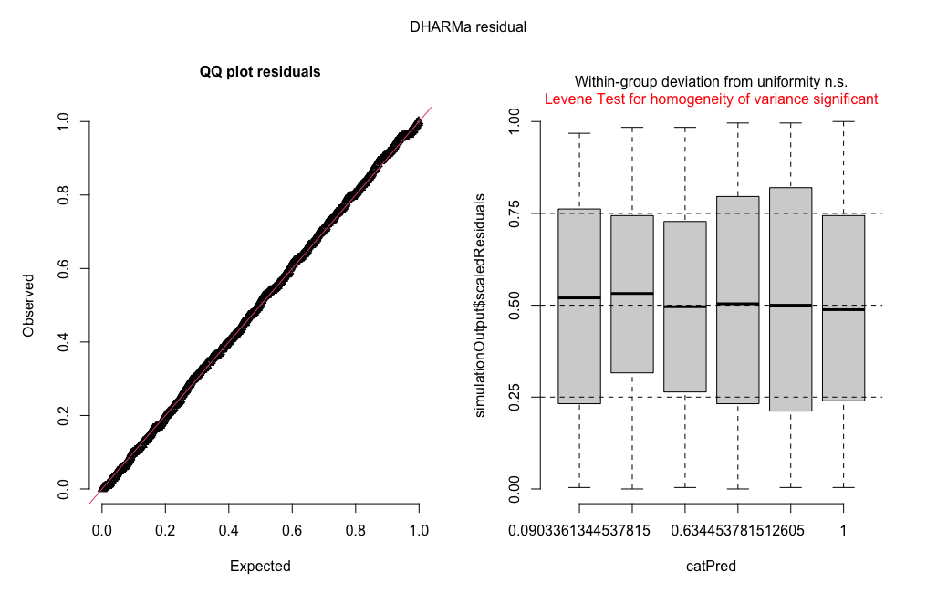

Clustering coefficient binomial with logit link:
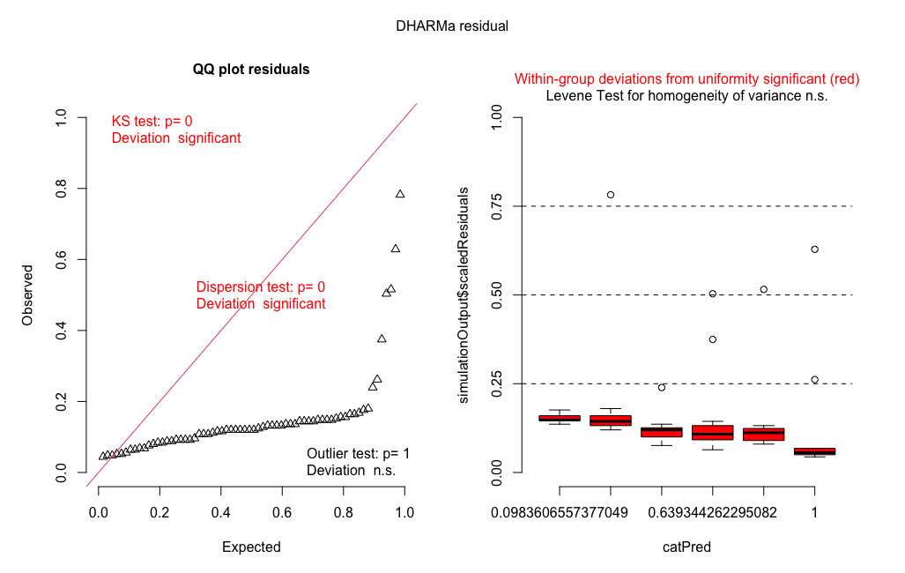

Clustering coefficient Gaussian with logistic transformation of dataset:
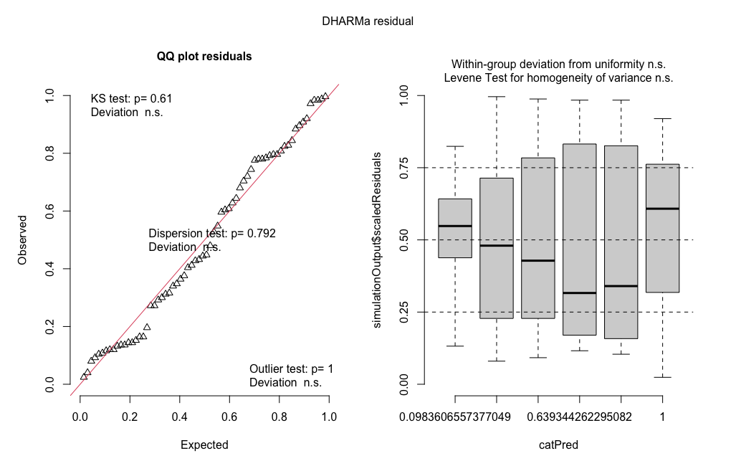

Spatial, zero-inflated beta model:
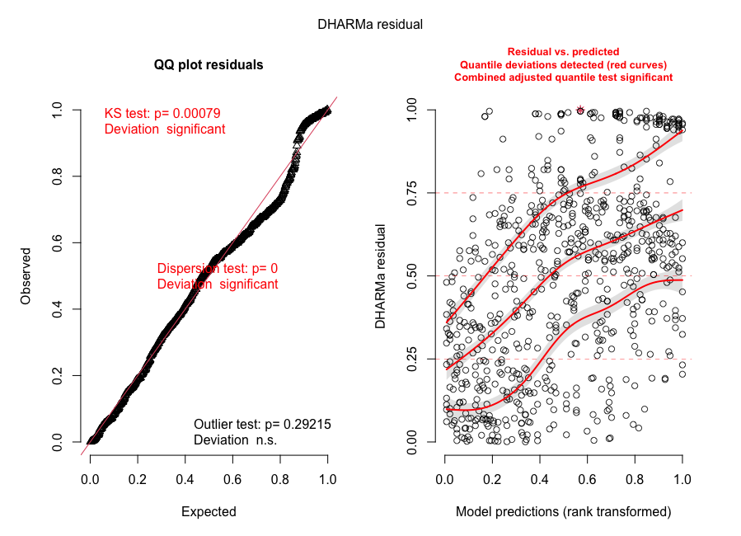

Original spatial model Gaussian with logit transform:
