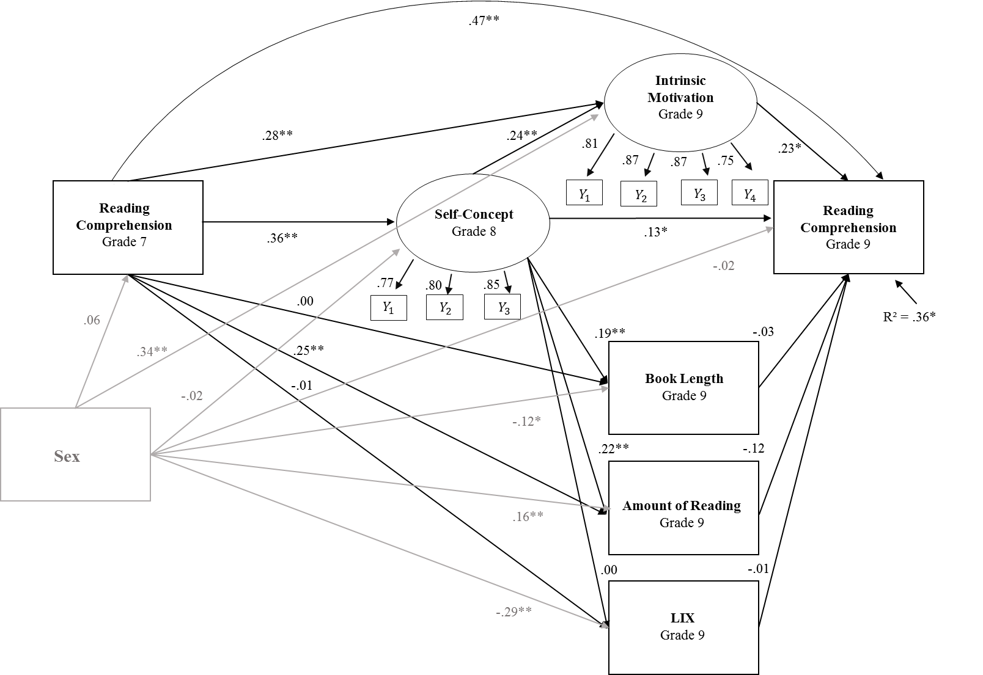

Gender

Figure B:
Structural equation model tested to estimate effects between reading self-concept and reading comprehension controlled for sex.
Note: N = 405; * p < .05; ** p < .01; STDYX Standardized results; gender: 0 = “male”, 1 = “female”; nested data were handled with cluster robust standard errors; Chi² = 114.602, df = 43; RMSEA = .064; CFI = .96; Correlations not pictured in the figure: Book Length and LIX (r = .14, p < .01), Amount of Reading and LIX (r = .04, ns), Amount of Reading and Book Length (r = .09, ns), Amount of Reading and Intrinsic Motivation (r = .53, p < .01), Intrinsic Motivation and LIX (r = .05, ns), Intrinsic Motivation and Book Length (r = .33, p < .01)

