When analyzing the information about books students indicated to have read for enjoyment in the past six month, one challenge was to handle students without valid information on that variables. In our study, we had about 30% of missing information regarding students’ book reading/LIX readability. One explanation for the missing data is that some of the students did read for enjoyment, but were unable to remember the book title or author, or were not motivated/willing to answer this question. In such a case, the best possibility to handle missing values seems to use Full Information Maximum Likelihood (FIML) estimation. Another explanation for a missing value on the book title variable is that the student actually did not read a book for enjoyment in the past six months. One possibility to handle the missing values would be to ignore/delete those students without a valid book title. However, when thinking about this option, it has to be considered that the amount of missing book data is not missing at random, as the missing of the data is closely related to students’ reading enjoyment ( = students with low reading enjoyment are students who do not read for enjoyment). This picture is especially problematic, as in our general model we included both, book related reading behavior and intrinsic reading motivation/reading enjoyment. Therefore, a deletion of all students who indicated not to have read a book would lead to a very selective sample. Or in other words, when only considering those students who read for enjoyment, the results regarding the relation between self-concept, intrinsic reading motivation and reading comprehension might be biased. Balancing the pros and cons of the different possibilities to handle missing book information, in the end, we decided to use the whole sample, as research shows that FIML is the best opportunity to treat missing data/is causing the smallest bias, even when data is not missing at random (Lüdtke, Robitzsch, Trautwein, & Köller, 2007).
Nevertheless, in order to explore different alternatives, we analyzed whether results with respect to mediation effects differ when we exclusively rely on students who indicated to have read a book in the past six month. Figure C shows the results of the model with the selective sample. In sum, we found a similar pattern/similar results compared with our general model including both, intrinsic motivation and reading behavior, except the effect from reading self-concept on reading comprehension. This effect is still comparable in size but is now scarcely missing the 5% level and is not statistically significant (p = 0.07).

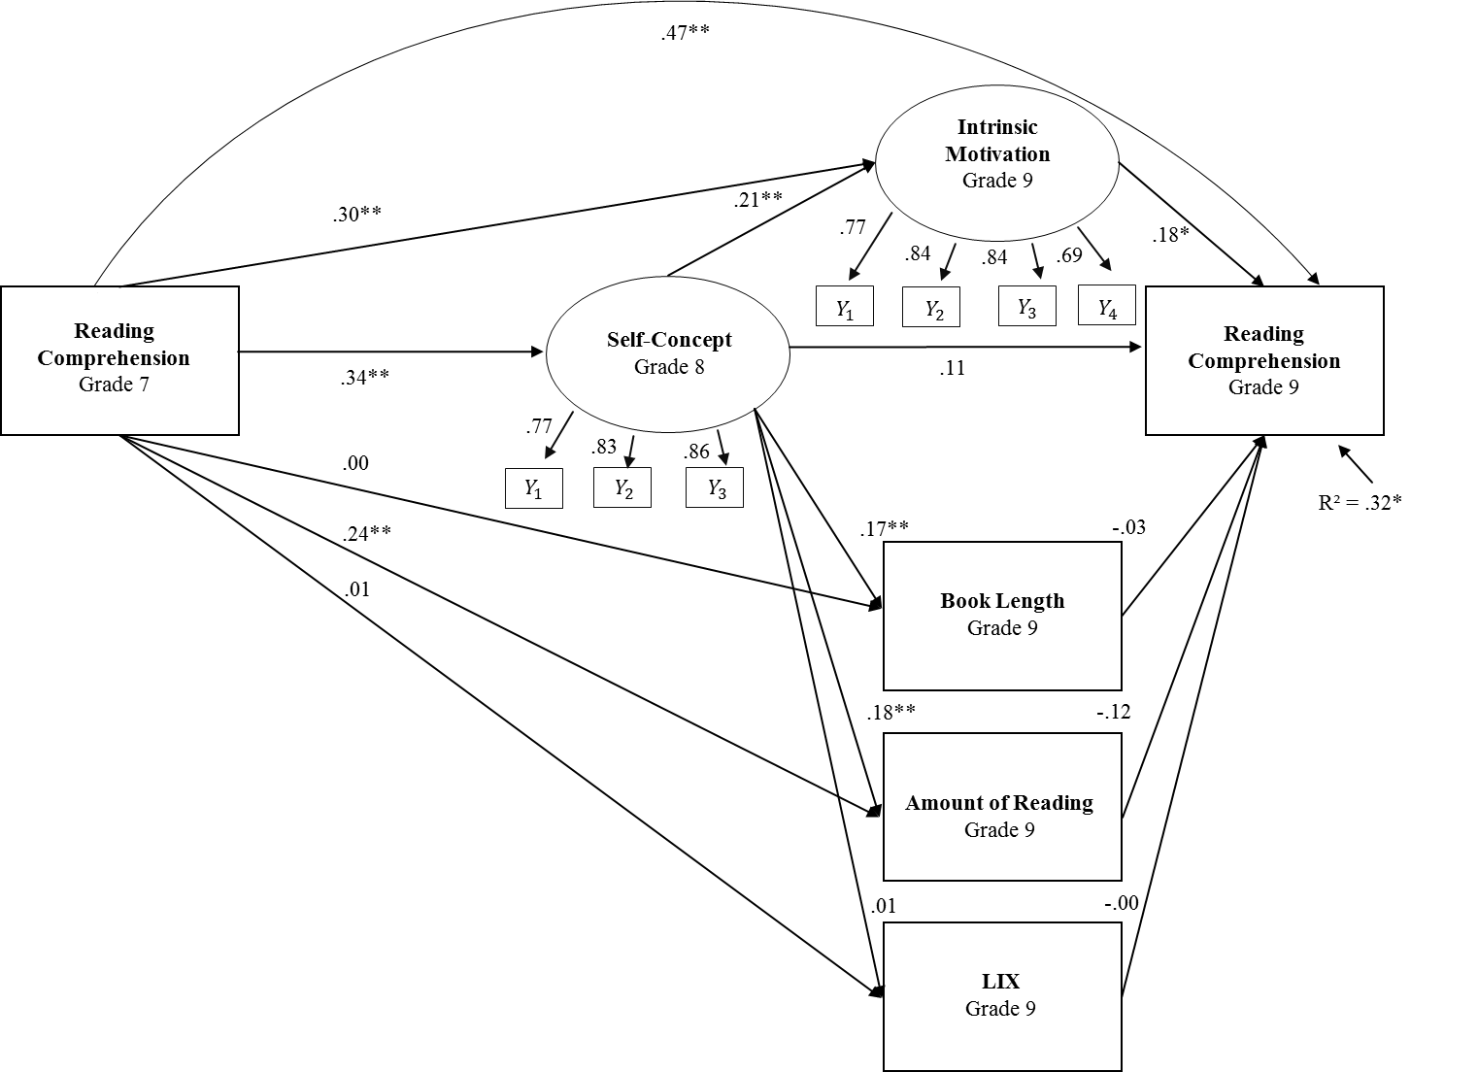

Figure C:
Structural equation model estimating effects between reading self-concept and reading comprehension
Note: N = 336; * p < .05; ** p < .01; STDYX Standardized results; nested data were handled with cluster robust standard errors; Chi² = 93.50, df = 38; RMSEA = .07; CFI = .96; Correlations not pictured in the figure: book length and LIX (r = .17, p < .01), amount of reading and LIX (r = .00, ns), amount of reading and book length (r = .05, ns), amount of reading and intrinsic motivation (r = .50, p < .01), intrinsic motivation and LIX (r = -.05, ns), intrinsic motivation and book length (r = .25, p < .01)

References
Lüdtke, O., Robitzsch, A., Trautwein, U., & Köller, O. (2007). Umgang mit fehlenden Werten in der psychologischen Forschung [Handling of missing data in psychological research: Problems and solutions]. Psychologische Rundschau, 58(2), 103-117. doi: 10.1026/0033-3042.58.2.103

