The influence of SES: Appendix A

Correlation Matrix (2004 cohort)
 |  | GPA8 | Cognitive ability | Migration background | SES | Noncognitive ability | GPA6 | Teacher_satisfaction | Teacher_fairness
Correlation | GPA8 | 1,000 | ,612 | -,036 | ,310 | -,506 | ,818 | ,087 | -,162
Correlation | Cognitive ability | ,612 | 1,000 | -,071 | ,217 | -,391 | ,674 | ,041 | -,070
Correlation | Migration background | -,036 | -,071 | 1,000 | -,027 | -,037 | -,033 | -,034 | ,018
Correlation | SES | ,310 | ,217 | -,027 | 1,000 | -,150 | ,278 | ,061 | -,112
Correlation | Noncognitive ability | -,506 | -,391 | -,037 | -,150 | 1,000 | -,509 | -,159 | ,046
Correlation | GPA Grade 6 | ,818 | ,674 | -,033 | ,278 | -,509 | 1,000 | ,066 | -,114
Correlation | Teacher_satisfaction | ,087 | ,041 | -,034 | ,061 | -,159 | ,066 | 1,000 | -,187
Correlation | Teacher_fairness | -,162 | -,070 | ,018 | -,112 | ,046 | -,114 | -,187 | 1,000
Sig. (1-tailed) | GPA Grade 8 |  | ,000 | ,170 | ,000 | ,000 | ,000 | ,011 | ,000
Sig. (1-tailed) | Cognitive ability | ,000 |  | ,031 | ,000 | ,000 | ,000 | ,144 | ,034
Sig. (1-tailed) | Migration background | ,170 | ,031 |  | ,241 | ,169 | ,195 | ,189 | ,319
Sig. (1-tailed) | SES | ,000 | ,000 | ,241 |  | ,000 | ,000 | ,055 | ,002
Sig. (1-tailed) | Noncognitive ability | ,000 | ,000 | ,169 | ,000 |  | ,000 | ,000 | ,113
Sig. (1-tailed) | GPA6 | ,000 | ,000 | ,195 | ,000 | ,000 |  | ,041 | ,001
Sig. (1-tailed) | Teacher_satisfaction | ,011 | ,144 | ,189 | ,055 | ,000 | ,041 |  | ,000
Sig. (1-tailed) | Teacher_fairness | ,000 | ,034 | ,319 | ,002 | ,113 | ,001 | ,000

Descriptives
 |  |  | Statistic | Std. Error
GPA8 | Mean |  | 38,1386 | ,12494
GPA8 | 95% Confidence Interval for Mean | Lower Bound | 37,8937
GPA8 | 95% Confidence Interval for Mean | Upper Bound | 38,3835
GPA8 | 5% Trimmed Mean |  | 38,8817
GPA8 | Median |  | 40,0000
GPA8 | Variance |  | 134,129
GPA8 | Std. Deviation |  | 11,58142
GPA8 | Minimum |  | ,00
GPA8 | Maximum |  | 60,00
GPA8 | Range |  | 60,00
GPA8 | Interquartile Range |  | 12,50
GPA8 | Skewness |  | -,954 | ,026
GPA8 | Kurtosis |  | 1,393 | ,053

1998: ICC

Intraclass Correlation Coefficient
 | Intraclass Correlation^{b} | 95% Confidence Interval |  | F Test with True Value 0
 | Intraclass Correlation^{b} | Lower Bound | Upper Bound | Value | df1 | df2 | Sig
Single Measures | -,001ª | -,021 | ,019 | ,998 | 9670 | 9670 | ,530
Average Measures | -,002^{c} | -,042 | ,038 | ,998 | 9670 | 9670 | ,530
Two-way mixed effects model where people effects are random and measures effects are fixed.
a. The estimator is the same, whether the interaction effect is present or not.
b. Type C intraclass correlation coefficients using a consistency definition. The between-measure variance is excluded from the denominator variance.
c. This estimate is computed assuming the interaction effect is absent, because it is not estimable otherwise.

2004: models

Intraclass Correlation Coefficient
 | Intraclass Correlation^{b} | 95% Confidence Interval |  | F Test with True Value 0
 | Intraclass Correlation^{b} | Lower Bound | Upper Bound | Value | df1 | df2 | Sig
Single Measures | ,000ª | -,025 | ,024 | ,999 | 6450 | 6450 | ,509
Average Measures | -,001^{c} | -,051 | ,047 | ,999 | 6450 | 6450 | ,509
Two-way mixed effects model where people effects are random and measures effects are fixed.
a. The estimator is the same, whether the interaction effect is present or not.
b. Type C intraclass correlation coefficients using a consistency definition. The between-measure variance is excluded from the denominator variance.
c. This estimate is computed assuming the interaction effect is absent, because it is not estimable otherwise.

R2: .425

Coefficientsª
Model |  | Unstandardized Coefficients |  | Standardized Coefficients | t | Sig.
 |  | B | Std. Error | Beta | t | Sig.
1 | (Constant) | 5,343 | ,538 |  | 9,928 | ,000
1 | Highest educational level (SUN2000) for the combined biological parents and parents living with the child 20131231, 2 categories | 1,533 | ,175 | ,147 | 8,744 | ,000
1 | TotIQ | ,118 | ,005 | ,455 | 25,202 | ,000
1 | TotCON | -,864 | ,064 | -,239 | -13,577 | ,000
a. Dependent Variable: Mathematic numerical grade in school year 8, 2019

Coefficientsª
Model |  | Unstandardized Coefficients |  | Standardized Coefficients | t | Sig.
 |  | B | Std. Error | Beta | t | Sig.
1 | (Constant) | 4,866 | ,672 |  | 7,236 | ,000
1 | Highest educational level (SUN2000) for the combined biological parents and parents living with the child 20131231, 2 categories | 2,068 | ,485 | ,199 | 4,263 | ,000
1 | TotIQ | ,121 | ,005 | ,466 | 23,075 | ,000
1 | TotCON | -,803 | ,082 | -,222 | -9,795 | ,000
1 | Interaction | -,002 | ,001 | -,057 | -1,184 | ,236
a. Dependent Variable: Mathematic numerical grade in school year 8, 2019

Coefficientsª
Model |  | Unstandardized Coefficients |  | Standardized Coefficients | t | Sig.
 |  | B | Std. Error | Beta | t | Sig.
1 | (Constant) | 3,306 | ,836 |  | 3,956 | ,000
1 | Highest educational level (SUN2000) for the combined biological parents and parents living with the child 20131231, 2 categories | 1,707 | ,495 | ,166 | 3,445 | ,001
1 | TotIQ | ,119 | ,005 | ,451 | 21,673 | ,000
1 | TotCON | -,691 | ,089 | -,193 | -7,802 | ,000
1 | Interaction | -,001 | ,001 | -,030 | -,600 | ,548
1 | How true are the following? I easily give up if I get a difficult task to do in school? | ,406 | ,086 | ,090 | 4,737 | ,000
1 | How true are the following? I worry about things that happen in school | ,004 | ,075 | ,001 | ,051 | ,959
1 | How true are the following? I am happy when I am in school | ,002 | ,081 | ,000 | ,024 | ,981
1 | How content are you with the teachers? | ,034 | ,106 | ,006 | ,322 | ,747
1 | How content are you with your health? | -,192 | ,110 | -,033 | -1,742 | ,082
a. Dependent Variable: Mathematic numerical grade in school year 8, 2019

Coefficientsª
Model |  | Unstandardized Coefficients |  | Standardized Coefficients | t | Sig.
 |  | B | Std. Error | Beta | t | Sig.
1 | (Constant) | 2,859 | ,660 |  | 4,329 | ,000
1 | Highest educational level (SUN2000) for the combined biological parents and parents living with the child 20131231, 2 categories | 1,490 | ,175 | ,143 | 8,530 | ,000
1 | TotIQ | ,113 | ,005 | ,436 | 23,825 | ,000
1 | TotCON | -,700 | ,068 | -,194 | -10,294 | ,000
1 | How true are the following? I easily give up if I get a difficult task to do in school? | ,366 | ,085 | ,081 | 4,323 | ,000
1 | How true are the following? Find it difficult to concentrate in lessons | ,265 | ,080 | ,059 | 3,326 | ,001
Notes: R²: 434. Dependent Variable: Mathematic numerical grade in school year 8, 2019.

Coefficientsª
Model |  | Unstandardized Coefficients |  | Standardized Coefficients | t | Sig.
 |  | B | Std. Error | Beta | t | Sig.
1 | (Constant) | 1,069 | ,593 |  | 1,804 | ,071
1 | Highest educational level (SUN2000) for the combined biological parents and parents living with the child 20131231, 2 categories | ,870 | ,158 | ,084 | 5,517 | ,000
1 | TotIQ | ,040 | ,005 | ,155 | 7,736 | ,000
1 | TotCON | -,344 | ,062 | -,095 | -5,525 | ,000
1 | How true are the following? I easily give up if I get a difficult task to do in school? | ,260 | ,076 | ,057 | 3,437 | ,001
1 | How true are the following? Find it difficult to concentrate in lessons | ,208 | ,071 | ,047 | 2,926 | ,003
1 | Mathematic numerical grade in school year 6, 2015-2017 | ,538 | ,022 | ,505 | 24,183 | ,000
Notes: R²: .552. Dependent Variable: Mathematic numerical grade in school year 8, 2019.

Coefficientsª
Model |  | Unstandardized Coefficients |  | Standardized Coefficients | t | Sig. | Collinearity Statistics
 |  | B | Std. Error | Beta | t | Sig. | Tolerance | VIF
1 | (Constant) | 3,434 | ,358 |  | 9,592 | ,000
1 | TotIQ | ,132 | ,003 | ,524 | 43,275 | ,000 | ,565 | 1,770
1 | TotCON | -,653 | ,045 | -,152 | -14,667 | ,000 | ,773 | 1,294
1 | Highest educational level (SUN2000) for the combined biological parents and parents living with the child 20080101, 2 categories | 1,816 | ,194 | ,182 | 9,346 | ,000 | ,217 | 4,600
1 | Interaction | -1,814E-5 | ,000 | -,060 | -2,800 | ,005 | ,179 | 5,602
a. Dependent Variable: Grade 8: Grade in Mathematics - numerical

Coefficientsª
Model |  | Unstandardized Coefficients |  | Standardized Coefficients | t | Sig. | Collinearity Statistics
 |  | B | Std. Error | Beta | t | Sig. | Tolerance | VIF
1 | (Constant) | 1,924 | ,418 |  | 4,603 | ,000
1 | TotIQ | ,125 | ,003 | ,494 | 48,742 | ,000 | ,818 | 1,222
1 | TotCON | -,539 | ,046 | -,125 | -11,771 | ,000 | ,741 | 1,349
1 | Highest educational level (SUN2000) for the combined biological parents and parents living with the child 20080101, 2 categories | 1,304 | ,096 | ,131 | 13,619 | ,000 | ,905 | 1,105
1 | How content are you? In your current school | -,171 | ,065 | -,026 | -2,637 | ,008 | ,896 | 1,116
1 | How true are the following? I easily give up if I get a difficult task to do in school? | ,296 | ,052 | ,059 | 5,677 | ,000 | ,770 | 1,298
1 | How true are the following? Find it difficult to concentrate in lessons | ,233 | ,052 | ,046 | 4,478 | ,000 | ,793 | 1,261
Notes: R²: 405. Dependent Variable: Grade 8: Grade in Mathematics - numerical

Coefficientsª
Model |  | Unstandardized Coefficients |  | Standardized Coefficients | t | Sig. | Collinearity Statistics
 |  | B | Std. Error | Beta | t | Sig. | Tolerance | VIF
1 | (Constant) | 3,128 | ,336 |  | 9,300 | ,000
1 | Cognitive ability | ,139 | ,003 | ,551 | 42,154 | ,000 | ,483 | 2,072
1 | Noncognitive ability | -,703 | ,041 | -,163 | -16,947 | ,000 | ,890 | 1,124
1 | SES | 3,477 | ,401 | ,349 | 8,671 | ,000 | ,051 | 19,657
1 | SESIQ | -,026 | ,005 | -,238 | -5,481 | ,000 | ,044 | 22,833
Notes: Dependent Variable: Grade 8: Grade in Mathematics - numerical

Coefficientsª
Model |  | Unstandardized Coefficients |  | Standardized Coefficients | t | Sig. | Collinearity Statistics
 |  | B | Std. Error | Beta | t | Sig. | Tolerance | VIF
1 | (Constant) | 3,128 | ,336 |  | 9,300 | ,000
1 | Cognitive ability | ,139 | ,003 | ,551 | 42,154 | ,000 | ,483 | 2,072
1 | Noncognitive ability | -,703 | ,041 | -,163 | -16,947 | ,000 | ,890 | 1,124
1 | SES | 3,477 | ,401 | ,349 | 8,671 | ,000 | ,051 | 19,657
1 | SES*Cognitive ability | -,026 | ,005 | -,238 | -5,481 | ,000 | ,044 | 22,833
Notes: Dependent Variable: Grade 8: Grade in Mathematics - numerical

Collinearity Diagnosticsª
Model | Dimension | Eigenvalue | Condition Index | Variance Proportions
 |  |  |  | (Constant) | Highest educational level (SUN2000) for the combined biological parents and parents living with the child 20131231, 2 categories | Migration background 2 categories | TotalCog | Totalnoncog | Teacher_fairnness | Content_teachers
1 | 1 | 5,276 | 1,000 | ,00 | ,01 | ,00 | ,00 | ,00 | ,01 | ,00
1 | 2 | ,985 | 2,314 | ,00 | ,00 | ,00 | ,00 | ,00 | ,00 | ,91
1 | 3 | ,344 | 3,914 | ,00 | ,85 | ,01 | ,00 | ,03 | ,02 | ,01
1 | 4 | ,221 | 4,884 | ,00 | ,00 | ,01 | ,00 | ,05 | ,91 | ,07
1 | 5 | ,110 | 6,929 | ,00 | ,09 | ,08 | ,06 | ,55 | ,03 | ,00
1 | 6 | ,053 | 9,931 | ,01 | ,05 | ,64 | ,23 | ,01 | ,02 | ,00
1 | 7 | ,009 | 23,601 | ,99 | ,00 | ,26 | ,71 | ,36 | ,02 | ,00
a. Dependent Variable: GPA8

Coefficientsª
Model |  | Unstandardized Coefficients |  | Standardized Coefficients | t | Sig.
 |  | B | Std. Error | Beta | t | Sig.
1 | (Constant) | 6,561 | ,723 |  | 9,070 | ,000
1 | Cognitive ability | ,115 | ,005 | ,441 | 23,660 | ,000
1 | Nonognitive ability | -,888 | ,064 | -,246 | -13,825 | ,000
1 | Migration background | -,707 | ,293 | -,051 | -2,413 | ,016
1 | SES | 1,381 | ,564 | ,133 | 2,447 | ,014
1 | MBSESinteraction | ,106 | ,463 | ,012 | ,229 | ,819
Notes. Dependent Variable: Mathematic numerical grade in school year 8, 2019.

Coefficientsª
Model |  | Unstandardized Coefficients |  | Standardized Coefficients | t | Sig.
 |  | B | Std. Error | Beta | t | Sig.
1 | (Constant) | 6,502 | ,676 |  | 9,616 | ,000
1 | Cognitive ability | ,115 | ,005 | ,442 | 23,698 | ,000
1 | Non-cognitive ability | -,887 | ,064 | -,245 | -13,853 | ,000
1 | Migration background | -,666 | ,232 | -,048 | -2,875 | ,004
1 | SES | 1,504 | ,175 | ,144 | 8,578 | ,000
a. Dependent Variable: Mathematic numerical grade in school year 8, 2019.

Coefficientsª
Model |  | Unstandardized Coefficients |  | Standardized Coefficients | t | Sig.
 |  | B | Std. Error | Beta | t | Sig.
1 | (Constant) | 3,989 | ,768 |  | 5,191 | ,000
1 | TotIQ | ,109 | ,005 | ,422 | 22,349 | ,000
1 | TotCON | -,720 | ,068 | -,200 | -10,555 | ,000
1 | Migration background 2 categories | -,680 | ,231 | -,049 | -2,945 | ,003
1 | Highest educational level (SUN2000) for the combined biological parents and parents living with the child 20131231, 2 categories | 1,462 | ,175 | ,141 | 8,369 | ,000
1 | How true are the following? I easily give up if I get a difficult task to do in school? | ,376 | ,085 | ,083 | 4,441 | ,000
1 | How true are the following? Find it difficult to concentrate in lessons | ,268 | ,080 | ,060 | 3,369 | ,001
a. Dependent Variable: Mathematic numerical grade in school year 8, 2019

R2: .436

Coefficientsª
Model |  | Unstandardized Coefficients |  | Standardized Coefficients | t | Sig.
 |  | B | Std. Error | Beta | t | Sig.
1 | (Constant) | 98,654 | 1,765 |  | 55,888 | ,000
1 | TotCON | -4,363 | ,190 | -,310 | -22,988 | ,000
1 | Migration background 2 categories | -12,656 | ,639 | -,235 | -19,818 | ,000
1 | Highest educational level (SUN2000) for the combined biological parents and parents living with the child 20131231, 2 categories | 7,423 | ,494 | ,182 | 15,021 | ,000
1 | How true are the following? I easily give up if I get a difficult task to do in school? | 2,921 | ,251 | ,160 | 11,650 | ,000
1 | How true are the following? Find it difficult to concentrate in lessons | ,172 | ,235 | ,010 | ,732 | ,464
a. Dependent Variable: TotIQ

Figure 1: Distribution of data (1998 cohort)

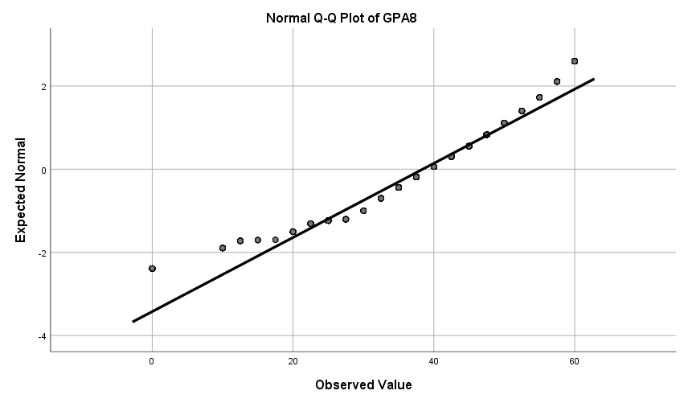

Figure 2: Distribution of data (2004 cohort)
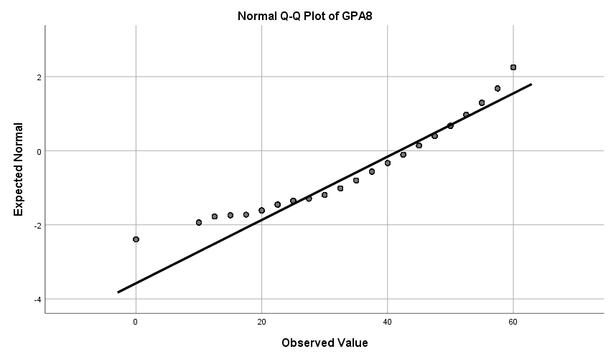

 |  | Unstandardized Coefficients |  | Standardized Coefficients | t | Sig. | 95,0% Confidence Interval for B |  | Collinearity Statistics
 |  | B | Std. Error | Beta | t | Sig. | Lower Bound | Upper Bound | Tolerance | VIF
1 | (Constant) | 25,634 | 1,341 |  | 19,116 | ,000 | 23,004 | 28,264
1 | CogSUM | ,271 | ,011 | ,437 | 23,619 | ,000 | ,248 | ,293 | ,778 | 1,286
1 | NONCogSUM | -2,370 | ,151 | -,287 | -15,724 | ,000 | -2,665 | -2,074 | ,798 | 1,253
1 | Highest educational level (SUN2000) for the combined biological parents and parents living with the child 20131231, 2 categories | 3,522 | ,403 | ,148 | 8,739 | ,000 | 2,732 | 4,313 | ,923 | 1,083
a. Dependent Variable: GPA8

Coefficientsª
Imputation Number | Model |  | Unstandardized Coefficients |  | Standardized Coefficients | t | Sig. | Fraction Missing Info. | Relative Increase Variance | Relative Efficiency
Imputation Number |  |  | B | Std. Error | Beta
Original data | 1 | (Constant) | 25,634 | 1,341 |  | 19,116 | ,000
Original data | 1 | TotalCog | ,271 | ,011 | ,437 | 23,619 | ,000
Original data | 1 | Totalnoncog | -2,370 | ,151 | -,287 | -15,724 | ,000
Original data | 1 | Highest educational level (SUN2000) for the combined biological parents and parents living with the child 20131231, 2 categories | 3,522 | ,403 | ,148 | 8,739 | ,000
1 | 1 | (Constant) | 26,454 | ,611 |  | 43,293 | ,000
1 | 1 | TotalCog | ,271 | ,005 | ,454 | 52,106 | ,000
1 | 1 | Totalnoncog | -2,539 | ,073 | -,296 | -34,580 | ,000
1 | 1 | Highest educational level (SUN2000) for the combined biological parents and parents living with the child 20131231, 2 categories | 2,658 | ,201 | ,106 | 13,212 | ,000
2 | 1 | (Constant) | 25,470 | ,610 |  | 41,738 | ,000
2 | 1 | TotalCog | ,282 | ,005 | ,473 | 54,709 | ,000
2 | 1 | Totalnoncog | -2,469 | ,073 | -,289 | -34,011 | ,000
2 | 1 | Highest educational level (SUN2000) for the combined biological parents and parents living with the child 20131231, 2 categories | 2,535 | ,198 | ,101 | 12,786 | ,000
3 | 1 | (Constant) | 28,139 | ,604 |  | 46,586 | ,000
3 | 1 | TotalCog | ,270 | ,005 | ,447 | 52,597 | ,000
3 | 1 | Totalnoncog | -2,852 | ,072 | -,332 | -39,666 | ,000
3 | 1 | Highest educational level (SUN2000) for the combined biological parents and parents living with the child 20131231, 2 categories | 2,567 | ,199 | ,101 | 12,917 | ,000
4 | 1 | (Constant) | 25,231 | ,602 |  | 41,940 | ,000
4 | 1 | TotalCog | ,292 | ,005 | ,482 | 57,501 | ,000
4 | 1 | Totalnoncog | -2,625 | ,071 | -,303 | -36,716 | ,000
4 | 1 | Highest educational level (SUN2000) for the combined biological parents and parents living with the child 20131231, 2 categories | 2,743 | ,198 | ,106 | 13,861 | ,000
5 | 1 | (Constant) | 28,698 | ,593 |  | 48,420 | ,000
5 | 1 | TotalCog | ,262 | ,005 | ,441 | 52,166 | ,000
5 | 1 | Totalnoncog | -2,873 | ,071 | -,338 | -40,491 | ,000
5 | 1 | Highest educational level (SUN2000) for the combined biological parents and parents living with the child 20131231, 2 categories | 2,792 | ,196 | ,111 | 14,281 | ,000
Pooled | 1 | (Constant) | 26,798 | 1,813 |  | 14,778 | ,000 | ,917 | 8,016 | ,845
Pooled | 1 | TotalCog | ,275 | ,014 |  | 20,165 | ,000 | ,893 | 6,120 | ,848
Pooled | 1 | Totalnoncog | -2,672 | ,213 |  | -12,530 | ,000 | ,914 | 7,750 | ,845
Pooled | 1 | Highest educational level (SUN2000) for the combined biological parents and parents living with the child 20131231, 2 categories | 2,659 | ,232 |  | 11,449 | ,000 | ,296 | ,371 | ,944
a. Dependent Variable: GPA8

Model |  | Unstandardized Coefficients |  | Standardized Coefficients | t | Sig. | 95,0% Confidence Interval for B |  | Collinearity Statistics
 |  | B | Std. Error | Beta | t | Sig. | Lower Bound | Upper Bound | Tolerance | VIF
1 | (Constant) | 23,988 | 2,652 |  | 9,044 | ,000 | 18,786 | 29,189
1 | TotalCog | ,244 | ,030 | ,396 | 8,244 | ,000 | ,186 | ,302 | ,120 | 8,337
1 | Totalnoncog | -2,903 | ,546 | -,352 | -5,317 | ,000 | -3,973 | -1,832 | ,063 | 15,856
1 | Cog_noncog_interaction | ,006 | ,007 | ,056 | ,909 | ,364 | -,007 | ,019 | ,073 | 13,749
1 | SES_centered | ,014 | ,002 | ,146 | 8,423 | ,000 | ,011 | ,018 | ,915 | 1,093
a. Dependent Variable: GPA8

Model |  | Unstandardized Coefficients |  | Standardized Coefficients | t | Sig. | 95,0% Confidence Interval for B |  | Collinearity Statistics
 |  | B | Std. Error | Beta | t | Sig. | Lower Bound | Upper Bound | Tolerance | VIF
1 | (Constant) | 21,949 | 1,461 |  | 15,018 | ,000 | 19,082 | 24,815
1 | TotalCog | ,269 | ,012 | ,436 | 22,989 | ,000 | ,246 | ,292 | ,767 | 1,304
1 | Totalnoncog | -2,426 | ,153 | -,294 | -15,859 | ,000 | -2,726 | -2,126 | ,803 | 1,246
1 | SES_centered | ,014 | ,002 | ,148 | 8,490 | ,000 | ,011 | ,018 | ,906 | 1,104
1 | COGNONCOGSES_nexinteraction | 1,956E-5 | ,000 | ,021 | 1,257 | ,209 | ,000 | ,000 | ,986 | 1,015
a. Dependent Variable: GPA8

